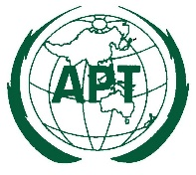 | ASIA-PACIFIC TELECOMMUNITY | Document No.:  ASTAP-34/INP-XX
The 34th APT Standardization Program Forum
(ASTAP-34)
 | 18–22 April 2022, Virtual/Online Meeting | XX February 2022

Source

PROPOSAL Title

