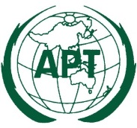 | ASIA-PACIFIC TELECOMMUNITY
 | APT Conference Preparatory Group for WRC-15 (APG-15)

APT Coordination Meetings during RA-15/WRC-15

AGENDA OF THE 2nd APT COORDINATION MEETING FOR RA-15
13:00 – 13:50 Hours, 27 October 2015
Venue: Room C2, ITU Tower Building

- Approval of agenda

- Issues for consideration:

  - Working Methods: Res. ITU-R 1-6, Res. ITU-R 5-6

  - CPM & SC: Res. ITU-R 2-6, Res. ITU-R 38-4

  - Revision of Recommendation ITU-R M.1036-4

  - New Resolutions:
    - Res. ITU-R [IMT. PRINCIPLES]
    - Res. ITU-R [UNAUTHORIZED]
    - Res. ITU-R [IoT]
    - Res. ITU-R [Int.Public.Telecom]
    - Res. ITU-R [Accessibility]
    - Res. ITU-R [EUR/SMALL SAT]

- Any other issues for consideration

- Next coordination meeting

- Closing

____________

