 | ASIA-PACIFIC TELECOMMUNITY | Document No:
 | The 4th Meeting of the APT Conference Preparatory  Group for WRC-19 (APG19-4) | APG19-4/OUT-21  (Rev.1)
 | 7 – 12 January 2019, Busan, Republic of Korea | 12 January 2019

Working Party 3

PRELIMINARY VIEWs on WRC-19 agenda item 1.5

Agenda Item 1.5: to consider the use of the frequency bands 17.7-19.7 GHz (space-to-Earth) and 27.5-29.5 GHz (Earth-to-space) by earth stations in motion communicating with geostationary space stations in the fixed-satellite service and take appropriate action, in accordance with Resolution 158 (WRC-15)

Resolution 158 (WRC-15): Use of the frequency bands 17.7-19.7 GHz (space-to-Earth) and 27.5-29.5 GHz (Earth-to-space) by earth stations in motion communicating with geostationary space stations in the fixed-satellite service

1. Background
Earth stations in motion (ESIM) are earth stations that communicate with GSO FSS space stations but operate on moving platforms such as ships, aircraft and land vehicles. ESIM are intended to provide broadband connectivity.

WRC-15 introduced regulations for ESIM operating in the frequency bands 19.7-20.2 GHz and 29.5-30 GHz, contained in Resolution 156 (WRC-15). Resolution 158 (WRC-15) invites the ITU-R to consider the use of the bands 17.7-19.7 GHz and 27.5-29.5 GHz by ESIM and take appropriate actions.

ITU-R WP 4A developed the draft CPM text for this agenda item which contains the following methods:

Method A This method proposes no changes to the RR and suppression of Resolution 158 (WRC-15).

Method B This method proposes to add a new footnote No. 5.A15 in RR Article 5 and a reference to a new WRC Resolution providing the conditions for the operation of ESIM and protection of the services to which the frequency bands are allocated, and consequential suppression of Resolution 158 (WRC-15).

Throughout the draft new WRC Resolution, there are a number of options and sub-options where no agreement has been reached on some contents.

WP 4A also developed several working documents on the ESIM operation containing ESIM requirements, characteristics, spectrum use of ESIM, compatibility/sharing with other services and regulatory issues and so forth (Annex 12/13/14/15/16/17 to Doc. 4A/826).

APG has noted the work carried out by AWG (APT Wireless Group) (APT/AWG/REP-70), on “The Usage and Future Plans of the Bands 17.7-20.2 GHz and 27.5-30 GHz in the Asia-Pacific Region”.

2. Documents
- Input Documents APG19-4/ INP-17(AUS), INP-21(AUS), INP-24(NZL), INP-44 (MLA&THA), INP-61(J), INP-76_Rev.1(KOR), INP-77(KOR), INP-88(IRN), INP-92(SNG), INP-98(CHN), INP-116(IND)
- Information Documents APG19-4/INF-06(GSA), INF-16(GSMA), INF-18 (MEASAT),
INF-22 (CITEL), INF-23(CEPT), INF-24(RCC), INF-27(NPL)

3. Summary of Discussions
3.1 Summary of APT Members’ views
3.1.1 Australia - Document APG19-4/INP-17
Australia supports development of appropriate technical and operational requirements for earth stations in motion (ESIM) that operate or plan to operate in the frequency bands 17.7-19.7 GHz and 27.5-29.5 GHz, taking into account studies under Resolution 158 (WRC-15) while ensuring protection of, and not imposing undue constraints on, services already allocated in the frequency bands.

ITU-R Working Party 4A has developed a draft example WRC Resolution as a means to address the agenda item (see Document CPM19-2/1). A similar approach was used at WRC-15 in the FSS 29.5-30 GHz and 19.7-20.2 GHz frequency bands included in Resolution 156 (WRC-15).

Australia supports the approach of a new WRC Resolution to address the agenda item noting the protection requirements stated above and included in Resolution 158 (WRC-15). Also noting that the new WRC Resolution was preliminarily agreed but with options wherever consensus could not be reached at the July 2018’s WP 4A meeting. Australia is actively engaged in further developing this Resolution and has proposed modification to the Chapter 3 of the Draft CPM Report for administrations’ consideration at APG 19-4 (APG19-4/INP-21).

Australia supports Method B of the Draft CPM Report (Document CPM19-2/1), subject to the conditions mentioned above.

Australia supports the APT Preliminary View of WRC-19 agenda item 1.5 from the APG19-3 meeting.

3.1.2 New Zealand- Document APG19-4/INP-24
New Zealand has supported the ITU-R studies undertaken in accordance with Resolution 158 (WRC-15) and considers that these should be completed to ensure ongoing protection of existing space and terrestrial services.

In the frequency band 17.7-19.7 GHz, New Zealand is of the view that ESIM shall not claim protection from terrestrial services in the same band. In the frequency band 27.5-29.5 GHz, New Zealand endorses the use of power-flux density limits for the operation of aeronautical-ESIM and a minimum distance requirement from the shoreline for the operation of maritime-ESIM as appropriate mandatory measures to be included in a draft new WRC Resolution. Deploying land-ESIM within national boundaries of an administration is largely a national matter. New Zealand currently does not consider the use of land-ESIM in these frequency bands.

3.1.3 Malaysia and Thailand - Document APG19-4/INP-44
Malaysia and Thailand are of the view that deployment of ESIM in the frequency bands of 17.7-19.7 GHz (space-to-Earth) and 27.5-29.5 GHz (Earth-to-space) will enable expansion of FSS type of applications in providing broadband services to mobile aeronautical and maritime platforms.

In view of the above, Malaysia and Thailand support Method B which proposes addition of a new footnote No. 5.A15 in RR Article 5 and a reference to a new WRC Resolution which will provide the conditions for the operation of ESIM and protection of the existing services to which the frequency bands are allocated, and consequential suppression of Resolution 158 (WRC-15).

However, it is to be noted that the draft new WRC Resolution under Method B has not been discussed and agreed upon entirely by ITU-R WP4A. Malaysia and Thailand are of the view that this additional new footnote does not preclude the use of the frequency bands by any application of the service to which they are allocated and further consideration should be given in finalising the draft new WRC Resolution.

3.1.4 Japan - Document APG19-4/INP-61
Japan supports ITU-R study activities to ensure protection of the existing services allocated in the frequency bands 17.7-19.7 GHz (space-to-Earth) and 27.5-29.5 GHz (Earth-to-space) and their future use, on FS, MS and other FSS systems.

3.1.5 Korea (Republic of) - Document APG19-4/INP-77
The Republic of Korea recognizes that ESIM services could provide its useful services at certain situation and area where terrestrial service could not provide its services. In this regard, the Republic of Korea supports WRC-19 agenda item 1.5. As concluded in the draft CPM Report, however, it is expected that there would be potential interference from ESIM transmitters to receiving stations of terrestrial services. It is also of the view that the transmitting aeronautical and maritime ESIM in the frequency band 27.5-29.5 GHz shall not cause unacceptable interference to any stations in the terrestrial services in this band operating in accordance with the Radio Regulations and shall not affect the future development of these services.
Taking into account mentioned above and alternatives are presented in the draft CPM Report, the Republic of Korea proposes APG19-4 consider the following issues among others and then develop APT preliminary views, which would require to submit to CPM19-2 as APT View.

- Deletion of three options of resolves 1.2.5 in the draft new Resolution [A1.5]
In spite of the implementation of some conditions for ESIM, any transmitting aeronautical or maritime ESIM shall immediately cease or reduce the interference to the acceptable level when unacceptable interference is reported. Therefore, the text exempting the responsibility of ESIM should be removed in the Resolution.
- Minimum distance from the low-water mark
One of the technical conditions of maritime ESIM to protect the terrestrial service is the separation distance from the low-water mark as officially recognized by the coastal State. Currently the draft CPM Report provides [60 – 70/80/120] km, which means the distance was not agreed during the sturdy of the responsible group.
Korea is of the view that 120km is still the appropriate separation distance to protect the terrestrial service from M-ESIM. It is proposed that APG19-4 considers the distance and then put the results of discussion in the APT PV and then submit the results to CPM19-2.
If APG19-4 would not agree the distance of single value during the APG19-4, it is proposed that APG19-4 to keep the current value, [60 -70/80/120] km in the APT PV Common view, so that CPM19-2 could discuss the appropriate value and then APG19-5 revisit this issue.

- Aeronautical ESIM
There are two outstanding issues on the technical condition of A-ESIM. One is the pfd value and the other is the altitude of operation of A-ESIM. These two aspects were discussed during the preparation of the responsible group, but were not sufficiently considered in detail.
Therefore Korea would like to share what Korea analyzes with APT Members and propose APG19-4 consider the analysis. It is also proposed that the results of discussion during the APG19-4 be included in APT preliminary view for further consideration in CPM19-2 and APG19-5.
- pfd value
There are three options for the pfd in the draft CPM Report.
Option 1 has been developed by CEPT and a part of ECC decision, which seems to be intended to protect FS which is being operated in the different spectrum bands from ESIM. In Europe, FS and FSS (including ESIM) use the different bands based on the band segmentation approach within 27.5 – 29.5 GHz by the ECC Decision.
However, many Asia Pacific countries including Korea use or will use MS without such band segmentation. It means Option1 would not be enough to protect MS. That was the reason why the Draft CPM Report has to include three options.
Option 2 was provided by one of the Region 2 country and Option 3 was provided by one of Region 3 country. Both countries use MS heavily.
Korea has studied further to develop a possible composite pfd limit which would reduce the options in two.
The composite pfd limit is as follows;
pfd (δ) = −122.7 (dB(W/m² ·1MHz)) for 0° ≤ δ < 2°
pfd(δ) = −122.7 + 2 * (δ-2) (dB(W/m² ·1MHz)) for 2° ≤ δ < 2.3°
pfd(δ) = −122.6 + 1.5 * (δ-2) (dB(W/m² ·1MHz)) for 2.3° ≤ δ < 7.9°
pfd(δ) = −113.7 (dB(W/m² ·1MHz)) for 7.9° ≤ δ ≤ 90°
where δ is the angle of arrival of the radio-frequency wave (degrees above the horizon).
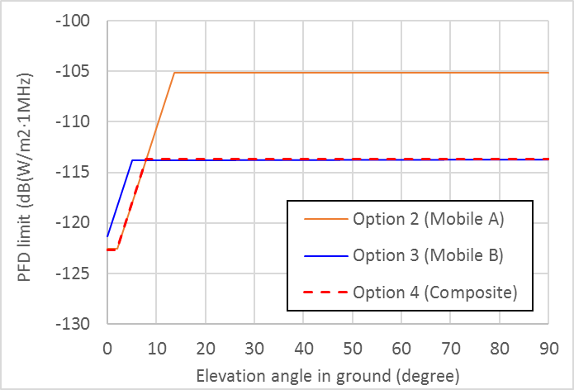
Higher pfd values produced by aeronautical ESIM on surface of the Earth than above pfd limits shall be subject to the prior agreement of the administration within line-of-sight of the aeronautical ESIM. The detailed technical explanation on the composite pfd is provided in Annex1 of this contribution.
Korea proposes that APG19-4 consider the composite pfd limit between Option 2 and 3 and put the discussion result in APT preliminary view. It is also proposed that the discussion results would be submitted to CPM19-2 for the consideration of CPM, as appropriate.
- Altitude
The other outstanding issue is how much altitude of A-ESIM is required to protect the terrestrial service.
One view is pfd limit would be enough to protect the terrestrial service. The other view is pfd limit is not good enough to protect the terrestrial service, because it is not clear how A-ESIM could keep the pfd limit when A-ESIM operates in the ground level, particularly in the airport area where terrestrial MS or FS is heavily used by passengers and/or Airport Operation Authority.
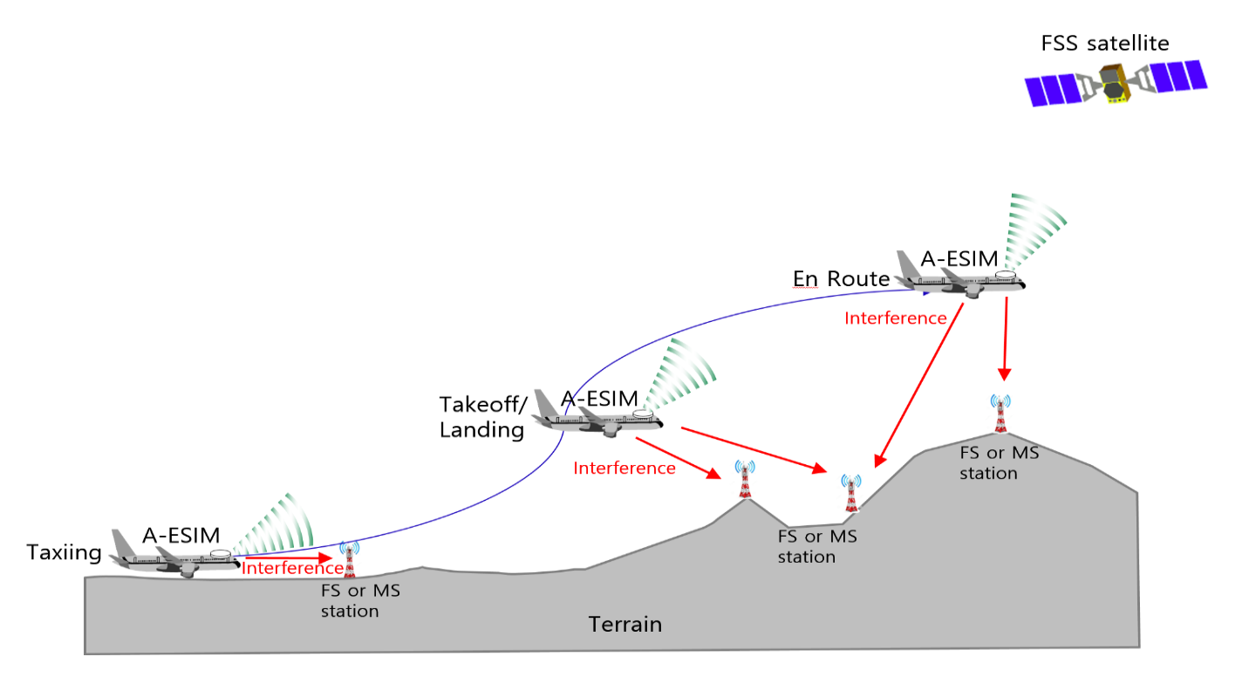

Ground level operation of A-ESIM, in which A-ESIM antenna is normally below the height of airport building, transmits the signal to space station. Then naturally, the transmitted signal comes into the inside of airport building which intends to reach to the space station as a part of main beam of A-ESIM antenna, not the power from the side lobe of antenna.
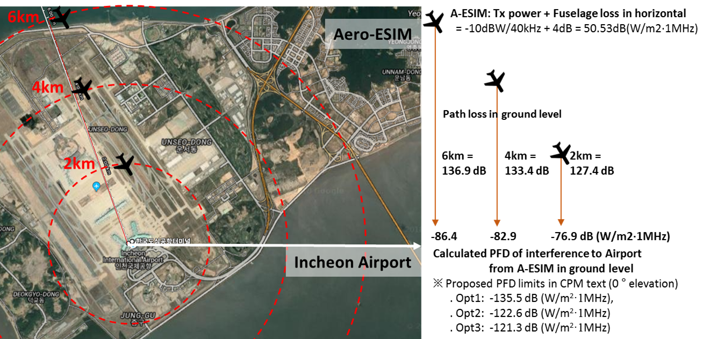

Another reason to regulate the altitude limit on the operation of A-ESIM is it still over the protection criteria during the take off and landing. The technical analysis is provided in the Annex 2 and 3.
It is believed that priority should be given to the altitude limitation to protect the terrestrial service, particularly where band segmentation is not feasible (it is the case in many countries among Asia Pacific area) and pfd limits should be a complimentary aspect to protect the terrestrial service from A-ESIM.
Korea proposes that altitude limitation of A-ESIM should be considered as APG19-4 preliminary view in the Common View as follows;
“Altitude limitation of A-ESIM operation should be considered to protect the terrestrial service in addition to the pfd limits. The exact limits of altitude need to be discussed further.”

Positions for CPM Report
With regard to a draft CPM Report, the Republic of Korea is of the view that some parts should be revised as proposed in APG19-4/INP-76.

3.1.6 Iran (Islamic Republic of) - Document APG19-4/INP-88
In view of outstanding serious concerns/ difficulties and due to the fact that the studies referred to in the attached annexes to the relevant draft CPM text are far from being completed and agreed upon. So, I.R. of Iran strongly believes that before the use and operation of the ESIMs in the frequency bands 17.7-19.7 GHz (space-to-Earth) and 27.5-29.5 GHz (Earth-to-space) with geostationary space stations in the fixed-satellite service, in accordance with Resolution 158 (WRC-15), it is essential that all above mentioned difficulties/concerns be considered in details and find appropriate technical / regulatory solution(s), by general consensus, in order to ensure the protection of the existing and planned other radio services operating especially: FS,MS , etc services in the above mentioned bands as well as in the adjacent bands.
In regard with the course of action to be taken with respect to the eventual upgrading of the WDPDN, Since the Working Party 4A at its previous meeting (Geneva, 03-14 July 2018) did not have time to consider the above mentioned serious concerns/ difficulties, in detail, it is premature to upgrade this WDPDN Report to PDN Report, at this stage.

3.1.7 Singapore - Document APG19-4/INP-92
Singapore supports ITU-R studies to develop the regulatory framework for ESIM operations in the bands 17.7-19.7GHz and 27.5-29.5GHz. However, given that Singapore has plans to deploy mobile services within the 27.5 – 29.5GHz band, guidelines within the regulatory framework should take into consideration both the current use and future availability of other services that are operating in the same frequency band.

It is noted that the ITU-R has examined sharing conditions between ESIM and terrestrial services in the 27.5-29.5 GHz frequency band and concluded that there would be potential interference to receiving stations of terrestrial services from ESIM transmitters. Therefore, aeronautical and maritime ESIM should operate under the specified technical, operational and regulatory conditions to avoid causing unacceptable interference to receiving stations of terrestrial services. In view of the above, Singapore supports Method B of the draft CPM Report.

3.1.8 China (People’s Republic of) - Document APG19-4/INP-98
China supports Method B of the draft CPM text developed by WP4A.
China supports the establishment of regulatory and technical framework for the operation of ESIMs in the 17.7-19.7 GHz and 27.5-29.5 GHz frequency bands, while ensuring that ESIMs, do not cause unacceptable interference to other services and systems operating in the same bands in accordance with the Radio Regulations.
The regulatory and technical framework for ESIMs’ operating needs to be as simple and practicable as possible. The following conditions are considered in the 27.5-29.5 GHz bands as a way forward:
Maritime ESIM – together with other technical conditions, minimum distance of 70 km from the low-water mark officially recognized by coastal states similar to the method adopted in Resolution 902 (WRC-03). ESIM should comply with this minimum distance unless prior agreement of the concerned administrations has been given.
Aeronautical ESIM – together with other technical conditions, the pfd limits on the earth’s surface should be used to ensure protection of terrestrial systems. ESIMs should comply with the pfd limits unless prior agreement of the concerned administrations has been given.
Land ESIM – operating within national boundaries no specific regulatory action or amendments to the Radio Regulations at WRC-19 are needed.
Regarding the 17.7-19.7 GHz band, China is of the view that ESIMs shall not claim protection from the fixed and mobile services in accordance with the Radio Regulations.

3.1.9 India - Document APG19-4/INP-116
India supports sharing study results with terrestrial services conducted by ITU-R. In particular, section 3/1.5/3.2.2 clearly mentions that the ITU-R examined sharing conditions between ESIM and terrestrial services in the 27.5-29.5 GHz frequency band and concluded that there would be potential interference from ESIM transmitters to receiving stations of terrestrial services. Therefore, India is of the view that any type of ESIM services such as aeronautical, maritime and land ESIM should be operated on non-interference and non-protected to/from terrestrial services basis. And practical measures such as pfd limit, altitude limit and separation distance under the specific technical, operational and regulatory conditions should be considered to avoid causing unacceptable interference to receiving stations of terrestrial services.
In this regard, India supports following text in a draft new Resolution [A15] (WRC-19).
- 1.2.2 in resolves, “the transmitting aeronautical and maritime ESIM in the 27.5-29.5 GHz frequency band shall not cause unacceptable interference to “any stations in the terrestrial services” / “any assignments to stations of terrestrial services” in this frequency band operating in accordance with the Radio Regulations and shall not affect the future development of these services and Annex 2 applies;”
- 1.2.3 in resolves, “the transmitting land ESIM in the 27.5-29.5 GHz frequency band shall not cause interference to “any stations in the terrestrial services” / “any assignments to stations of terrestrial services” in this frequency band operating in accordance with the Radio Regulations and shall not affect the future development of these services and Annex 3 applies;”
- Option 1 of 1.2.4 in resolves, “for the implementation of resolves 1.2.2 and 1.2.3 above, the notifying administration responsible for the GSO FSS satellite network with which ESIM communicate shall submit to the Bureau together with the Appendix 4 data referred to in resolves 1.1.2 a commitment undertaking that in case of interference, upon receipt of a report of interference, take necessary action to immediately cease or reduce interference to an acceptable level;”
- Option 1 of 1.2.5 in resolves, “for the implementation of resolves 1.2.2 above, any transmitting aeronautical or maritime ESIM that conforms to the requirements in Annex 2 to this Resolution shall be deemed to have met its obligation to terrestrial stations;”
Maritime ESIM services are aiming to provide its services to ships. India is of the view that ships using maritime ESIM services should not cause critical interferences to current and planned terrestrial services operating using the 27.5-29.5 GHz when providing their services at territory as officially recognized by the coastal State. Taking into account relevant sharing studies conducted by ITU-R, therefore, India supports 120 km as the most suitable minimum distance provided in 1.1 in Part 1 of Annex 2 to draft new Resolution [A15] (WRC-19) in the draft CPM report should be applied to protect all terrestrial services in the 27.5-29.5 GHz band.
1.1 the minimum distances from the low-water mark as officially recognized by the coastal State beyond which maritime ESIM can operate without the prior agreement of any administration is 120 km in the 27.5-29.5 GHz frequency band.
Aeronautical ESIM services are aiming to provide services to aircrafts. India is of the view that aeronautical ESIM services should not cause critical interferences to current and planned terrestrial services using the 27.5-29.5 GHz. This interference occurs when the aeronautical ESIM service would provide their services below certain cruising altitude including taxing, takeoff and landing, standby at airport gates, etc.
Taking into account relevant sharing studies conducted by ITU-R for system A and B, India is of the view that following composite pfd mask that protects both system A and B should be applied under 1.1 in Part 2 of Annex 2 to draft new Resolution [A15] (WRC-19) in the draft CPM report to protect all terrestrial services.
1.1 unless otherwise agreed by the administration concerned, the maximum pfd produced at any point of the surface of the Earth on the territory under the jurisdiction of that administration by emissions from a single aeronautical ESIM shall not exceed:
pfd(δ) = −124.7 (dB(W/m² ⋅ 14 MHz)) for 0° ≤ δ ≤ 0.01°
pfd(δ) = −120.9+1.9∙log10(δ) (dB(W/m² ⋅ 14 MHz)) for 0.01° ≤ δ ≤ 0.3°
pfd(δ) = −116.2+11∙log10(δ) (dB(W/m² ⋅ 14 MHz)) for 0.3° < δ ≤ 1°
pfd(δ) = −116.2+18∙log10(δ) (dB(W/m² ⋅ 14 MHz)) for 1° < δ ≤ 2°
pfd(δ) = −117.9+23.7∙log10(δ) (dB(W/m² ⋅ 14 MHz)) for 2° < δ ≤ 8°
pfd(δ) = −96.5 (dB(W/m² ⋅ 14 MHz)) for 8° < δ ≤ 90.0°
where δ is the angle of arrival of the radio-frequency wave (degrees above the horizon).
Furthermore, Option 1 under 1.2 in Part 2 of Annex 2 to draft new Resolution [A15] (WRC-19) in the draft CPM report should also be applied to protect all terrestrial services.
Option 1
1.2 Unless agreement from concerned administrations, aeronautical ESIM shall not transmit below (X) km of altitude above the territory of the administration concerned.
An example of X = 6 was given.

Land ESIM services are aiming to provide services to vehicles such as trucks, trains, etc. However, India is of the view that land ESIM services will cause critical interferences to current and planned terrestrial services using the 27.5-29.5 GHz when the land ESIM are co-located and adjacent areas with terrestrial services.

3.1.10 Nepal - Document APG19-4/INF-27 (Information only)
In Nepal, the frequency band 17.7-19.7 GHz has been allocated for Fixed Point to Point Microwave Link. In this context, Nepal supports on-going ITU-R studies for regulatory issues and conditions on sharing and compatibility between ESIM and existing services allocated in the frequency bands 17.7-19.7 GHz and 27.5-29.5 GHz to ensure protection of, and not impose undue constraints on the existing services allocated in these bands and their future development.

  - Summary of issues raised during the meeting
- The meeting recognized that ITU-R WP4A has made a considerable effort to develop technical and operational requirements for ESIM by adding a new footnote RR No. 5.A15 and a reference to a new WRC Resolution. It was believed that this approach be relevant to provide necessary regulatory frameworks for ESIM operations. However, it is to be noted that the draft new Resolution has not been discussed and agreed upon entirely by ITU-R WP4A.
- The modifications on the draft CPM text were discussed based on the Input Document INP-21(AUS), INP-76_Rev.1(KOR) and INP-116(IND) and an output document was produced to propose the change to resolves 1.2.4 in the draft WRC Resolution.
- The technical and operational conditions on different types of ESIM were discussed as follows:
  - For maritime ESIM, there is a general agreement on the condition of minimum distance [60-120km] from the low-water mark officially recognized by coastal states.
  - For aeronautical ESIM, it was discussed whether pfd limits are sufficient to ensure protections of terrestrial services. One view is pfd limit would be enough to protect the terrestrial service. The other view is pfd limit is not good enough to protect the terrestrial service, because it is not clear how A-ESIM could keep the pfd limit when A-ESIM operates in the ground level therefore additional altitude limit would be needed to regulate the operation of aeronautical ESIM.
  - For aeronautical ESIM, a possible composite pfd limit was proposed and it was agreed that further study would be needed to evaluate relevance of the proposed pfd limit.
  - For land ESIM, one view is that no specific regulatory action or amendments to the Radio Regulations at WRC-19 are needed as long as it operates within national boundaries while the other view is that the interference to terrestrial services in neighbouring countries by the land ESIM especially deployed in the border areas may be very serious. Therefore, appropriate operational regulatory conditions for land ESIM need to be developed at WRC-19.
- The necessity of three options of resolves 1.2.5 in the draft WRC Resolution was discussed. However, no consensus has been reached in this resolves. It was agreed that further study would be needed on this topic.
- The issue of protection for non-GSO FSS systems was discussed. However, consensus is yet to be reached.
- The proposal to provide further transparency regarding the operation of ESIM via revised resolves 1.1.3 and 1.1.4 of the draft WRC Resolution was discussed. However, no consensus has been reached in these resolves.
- Compliance with pfd limit and minimum altitude limit (in case of Aero ESIM) would not release the notifying administration from its obligation not to cause unacceptable interference and not claim protection from the services to which the above mentioned frequency bands are allocated.
- It was discussed that the issue of responsibility and obligation of various entities involved in the operation of ESIM including administrations authorizing ESIM needs to be addressed and clearly included in Annex 3 to the draft WRC Resolution. Annex 3 stipulates that ESIM operating within the territory/territory water/territory airspace under the jurisdiction of another administration shall only do so if authorized by that administration. However, it is noted that the contents of Annex-3 are yet to be considered by ITU-R WP 4A.

4. APT Preliminary View(s)

Taking into account Resolution 158 (WRC-15), APT Members support studies conducted by ITU-R for regulatory issues and conditions on sharing and compatibility between ESIM and existing services allocated in the frequency bands 17.7-19.7 GHz and 27.5-29.5 GHz not to cause unacceptable interference to and not claim protection from services operating in accordance with the RR in the above mentioned frequency bands.

APT Members in principle support Method-B where a new footnote RR No. 5.A15 with a reference to a new WRC Resolution. However, APT Members note that consensus has not been reached on the new WRC Resolution as there remain a number of “options” in its texts and further improvement would be needed. Therefore, APT Members are encouraged to submit individual and/or joint proposal to further modify the draft Resolution at CPM19-2.

For maritime ESIM, there is a general agreement on the condition of minimum distance within the range from 60 to120km from the low-water mark officially recognized by coastal states. . The exact value is yet to be decided.

The issue of responsibility and obligation of various entities involved in the operation of ESIM including administrations authorizing ESIM needs to be addressed and clearly included in Annex 3 to the draft WRC Resolution.

5. Other View(s) from APT Members
None.

6. Issues for Consideration at Next APG Meeting
Based on the outcome of CPM19-2, APT Members are encouraged to submit contributions to next APG meeting with a view to developing the PACP on this agenda item taking into account:
- the need for and the appropriate values of altitude limit for aeronautical ESIM
- appropriate pfd limit for aeronautical ESIM
- necessity of three options of resolves 1.2.5 in the draft WRC Resolution
- revision of resolves 1.1.3/1.1.4

7. Views from Other Organisations
7.1 Regional Groups
7.1.1 ASMG
See the relevant part of the following document which is their presentation at second ITU inter-regional workshop on WRC-19 preparation held from 20 to 22 November 2018 in Geneva.
Document WRC-19-IRWSP-18/18

    - ATU
See the relevant part of the following document which is their presentation at second ITU inter-regional workshop on WRC-19 preparation held from 20 to 22 November 2018 in Geneva.
Document WRC-19-IRWSP-18/6

    - CEPT
See the relevant part of APG19-4/INF-23.

    - CITEL
See the relevant part of APG19-4/INF-22.

    - RCC
See the relevant part of APG19-4/INF-24.

7.2 International Organisations
7.2.1 ICAO
No views on this agenda item have been received from ICAO.

7.2.2 IMO
No views on this agenda item have been received from IMO.

7.2.3 IARU
No views on this agenda item have been received from IARU.

____________

