APT REPORT

ON

TRAFFIC ACCIDENT RECORD
AND ITS ANALYSIS METHOD’S GUIDELINES IN ASIA

No. APT/ASTAP/REPT-48
Edition: June 2021

Adopted by
The 33rd APT Standardization Program Forum (ASTAP-33)
7 – 15 June 2021, Virtual/Online Meeting

(Source: ASTAP-33/OUT-18)

CONTENTS

1 Scope 3
2 References 3
3 Terms and Definitions 3
3.1 Terms defined in Record Fields 3
4 Abbreviations and Acronyms 6
5 United Nations Sustainable Development Goals and Road Safety 7
5.1 The Status of Other Traffic Accident Record Guidelines 9
5.2 The Questionnaire Result of APT Member on Traffic Accident Record 12
6 Summary of Traffic Accident Record and Analysis Methods in APT region 18
6.1 Key Recommendations for Guideline 18
6.2 Future Recommend Application and Pilots 19
6.3 Future Recommend Usage 20
7 Conclusions 20
Appendix 1: Questionnaire Result of Philippines 21
Appendix 2: Questionnaire Result of Thailand 29

1 Scope
This document is a compilation of report on traffic accdient record and expect analysis use case from various APT Member countries. The scope of the report is as follows:
- Introduction about Road Safety and Traffic Accident Record including the need and benefits for the Traffic Accident Record Guideline
- Traffic Accident Record and Analysis Tools from APT Member countries focusing on the ICT domain
- Possible Future Project or Pilot on Information and Telecommunication Technologies & Solutions in Traffic Accident Record
- Guideline harmonize activities related to Traffic Accident Record in the Asia and Pacific

2 References
The reference to a document within this Report.
- “DATA SYSTEMS: A ROAD SAFETY MANUAL FOR DECISION-MAKERS AND PRACTITIONERS”, World Health Organization, [On-Line] https://apps.who.int/iris/bitstream/handle/10665/44256/9789241598965_eng.pdf?sequence=1, 2010.
- Charles Melhuish, Mirick Paala, “Minimum Set of Road Safety Indicators and APRSO Crash Database”, First Workshop on the Implementation of the Asia-Pacific Road Safety Observatory (APRSO), Asian Development Bank, 2020.
- Chang-Yi Luo, “Experience in Collating and Analysing of Road Safety Data in Asia and the Pacific”, Second Workshop Towards the Establishment of a Road Safety Observatory in Asia-Pacific, UN-ESCAP, 2019.
- Global Status Report on Road Safety 2018, WHO, [On-line] https://www.who.int/violence_injury_prevention/road_safety_status/2018/English-Summary-GSRRS2018.pdf

3 Terms and Definitions

3.1 Terms defined in Record Fields
Term and definition of the record fields are listed in the following. The definition is based on WHO report, “DATA SYSTEMS: A ROAD SAFETY MANUAL FOR DECISION-MAKERS AND PRACTITIONERS”.

Alcohol use suspected
Definition: Law enforcement officer suspects that person involved in the crash has used alcohol.

Age
Definition: The age in years of the person involved in the crash.

Crash location
Definition: The exact location at which the crash occurred. Optimum definition is route name and GPS/GIS coordinates if there is a linear referencing system (LRS), or other mechanism that can relate geographic coordinates to specific locations in road inventory and other files. The minimum requirement for documentation of crash location is the street name, the reference point, distance from reference point and direction from reference point.

GPS (Global Positioning System)
Definition: a system that can show the exact position of a person or thing by using signals from satellites.

Impact type
Definition: Indicates the manner in which the road motor vehicles involved initially collided with each other. The variable refers to the first impact of the crash, if that impact was between two road motor vehicles.
Data values:
1 No impact between motor vehicles: There was no impact between road motor vehicles. Refers to single vehicle crashes, collisions with pedestrians, animals or objects.
2 Rear end impact: The front side of the first vehicle collided with the rear side of the second vehicle.
3 Head on impact: The front sides of both vehicles collided with each other.
4 Angle impact – same direction: Angle impact where the front of the first vehicle collides with the side of the second vehicle.
5 Angle impact – opposite direction: Angle impact where the front of the first vehicle collides with the side of the second vehicle.
6 Angle impact – right angle: Angle impact where the front of the first vehicle collides with the side of the second vehicle.
7 Angle impact – direction not specified: Angle impact where the front of the first vehicle collides with the side of the second vehicle.
8 Side by side impact – same direction: The vehicles collided side by side while travelling in the same direction.
9 Side by side impact – opposite direction: The vehicles collided side by side while travelling in opposite directions.
10 Rear to side impact: The rear end of the first vehicle collided with the side of the second vehicle.
11 Rear to rear impact: The rear ends of both vehicles collided with each other.

Junction
Definition: Indicates whether the crash occurred at a junction (two or more roads intersecting) and defines the type of the junction. In at-grade junctions all roads intersect at the same level. In not-at-grade junctions roads do not intersect at the same level.

Light conditions
Definition: The level of natural and artificial light at the crash location, at the time of the crash.

Road surface conditions
Definition: The condition of the road surface at the time and place of the crash.

Safety equipment
Definition: Describes the use of occupant restraints (Seat-belt), or helmet use by a motorcyclist or bicyclist.

Sex
Definition: Indicates the sex of the person involved in the crash.

Speed limit
Definition: The legal speed limit at the location of the crash.

Traffic control at junction
Definition: Type of traffic control at the junction where crash occurred. Applies only to crashes that occur at a junction.

Type of roadway
Definition: Describes the type of road, whether the road has two directions of travel, and whether the carriageway is physically divided. For crashes occurring at junctions, where the crash cannot be clearly allocated in one road, the road where the vehicle with priority was moving is indicated.

Vehicle type
Definition: The type of vehicle involved in the crash.

Weather conditions
Definition: Prevailing atmospheric conditions at the crash location, at the time of the crash.
Data values:
1 Clear (No hindrance from weather, neither condensation nor intense movement of air. Clear and cloudy sky included)
2 Rain (heavy or light)
3 Snow
4 Fog, mist or smoke
5 Sleet, hail
6 Severe winds (Presence of winds deemed to have an adverse effect on driving conditions)
7 Other weather condition
8 Unknown weather condition

4 Abbreviations and Acronyms
APRSO | Asia-Pacific Road Safety Observatory
DRIVERS | Database on Road Incident Visualization Evaluation Reporting System
SDGs | Sustainable Development Goals

5 United Nations Sustainable Development Goals and Road Safety
In 2015, United Nations has firstly set Sustainable Development Goals (SDGs) on traffic accident, and intended to halve the number of global deaths and injuries from road traffic accidents by 2020. However, as the goal cannot be meet in 2020, the third global ministerial conference on road safety in Stockholm in 2020 extend the road safety goal to 2030. Detail of road safety SDGs in goal 3 and 11 are in the following:

Goal 3: Ensure healthy lives and promote well-being for all at all ages:
3.6. By 2020 (Was changed to 2030), halve the number of global deaths and injuries from road traffic accidents

Goal 11: Make cities and human settlements inclusive, safe, resilient and sustainable:
11.2. By 2030, provide access to safe, affordable, accessible and sustainable transport systems for all, improving road safety, notably by expanding public transport, with special attention to the needs of those in vulnerable situations, women, children, persons with disabilities and older persons.
In Asia-Pacific Telecommunity’s view, how to provide “access to safe, affordable, accessible and sustainable transport systems for all, improving road safety, notably by expanding public transport, with special attention to the needs of those in vulnerable situations, women, children, persons with disabilities and older persons” as goal 11.2 mentioned with ICT advantage should be considered and APT and ASTAP activities can provide the Proof of Concept and solution to contribute to the Asia-Pacific Region.

In 2016, ASEAN Regional Road Safety Strategy and most of APT member countries has set the goal close to UN’s SDG as shown in Table 1 [Source: WHO Global Status Report on Road Safety 2018].
Table 1: APT Members’ Goal on Road Safety
No. | Country/Territory | National Road Safety Goal | WHO estimated rate per 100 000 population
1 | Afghanistan | No | 15.1
2 | Australia | 30% annually (2011-2020) | 5.6
3 | Bangladesh (People's Republic of) | 50% (2011-2020) | 15.3
4 | Bhutan (Kingdom of) | <8 deaths per 10 000 vehicles annually (2013-2018) | 17.4
5 | Brunei Darussalam | NA | NA
6 | Cambodia (Kingdom of) | 50% (2011-2020) | 17.8
7 | China (People's Republic of) | 6% reduction in mortality rate per 10 000  vehicles (2016-2020) | 18.2
8 | Democratic People's Republic of Korea | NA | NA
9 | Fiji (Republic of) | 50% (2011-2020) | 9.6
10 | India (Republic of) | 50% (2011-2020) | 22.6
11 | Indonesia (Republic of) | 50% (2011-2020) | 12.2
12 | Iran (Islamic Republic of) | 10% annually (2011-  2020) | 20.5
13 | Japan | <2 500 deaths (within 24hrs) per year (2016-2020) | 4.1
14 | Kiribati (Republic of) | Zero deaths by 2019 (2016 -  2019) | 4.4
15 | Korea (Republic of) | < 2700 deaths by 2021 (2017-2021) | 9.8
16 | Lao People's Democratic Republic | 50% (2011-2020) | 16.6
17 | Malaysia | 50% (2014-2020) | 23.6
18 | Maldives (Republic of) | No | 0.9
19 | Marshall Islands (Republic of the) | NA | NA
20 | Micronesia (Federated States of) | No | 1.9
21 | Mongolia | 50% (2012-2020) | 14.5
22 | Myanmar (Republic of the Union of) | 50% (2011-2020) | 19.9
23 | Nauru (Republic of) | NA | NA
24 | Nepal (Federal Democratic Republic of) | None | 15.9
25 | New Zealand | Multiple (2010-2020) | 7.8
26 | Pakistan (Islamic Republic of) | None | 14.3
27 | Palau (Republic of) | NA | NA
28 | Papua New Guinea | NA | NA
29 | Philippines (Republic of the) | 50% (2011-2020) | 12.3
30 | Samoa (Independent State of) | <5 deaths per 10 000 vehicles (2011-  2020) | 11.3
31 | Singapore (Republic of) | None | 2.8
32 | Solomon Islands | None | 17.4
33 | Sri Lanka (Democratic Socialist Republic of) | 50% (2011-2020) | 14.9
34 | Thailand (Kingdom of) | ¤ 10 deaths per 100 000 population (2010-2020) | 32.7
35 | Tonga (Kingdom of) | 50% reduction in rate per 100 000  population (2011-2020) | 16.8
36 | Tuvalu | NA | NA
37 | Vanuatu (Republic of) | NA | 15.9
38 | Viet Nam (Socialist Republic of) | 5-10% annually (2012-  2020) | 26.4
According to recent WHO Road Safety Report 2018, global annual road fatality reaches to 1.35 million, 0.2 million more than the level of 2010. Also, traffic accident is the leading killer in the age of 5-29 years.
In order to reduce the traffic accident effectively in APT member countries, it is necessary to understand how accident is happened. Traffic accident record is usually the first hand information to understand what is happened in accident. However, traffic accident record is usually recorded by hand and faces difficulty to database it correctly. By utilizing ICT solutions effectively on digital record and database, it can improve the reliability of traffic accident data.
Furthermore, it is also usually happened that traffic accident record is not fully analyzed due to the poor quality of traffic accident data. By providing basic and common analysis methods such as accident heat map and dangerous vehicle pattern identification, it will help authority to identify the cause of accident and create counter-measure in prompt fashion.
The following is the possible counter-measure that could be generate through the analysis of traffic accident record. In this questionnaire, we would like Questionnaire the expectation of counter-measure and the current traffic accident record status in APT member countries.

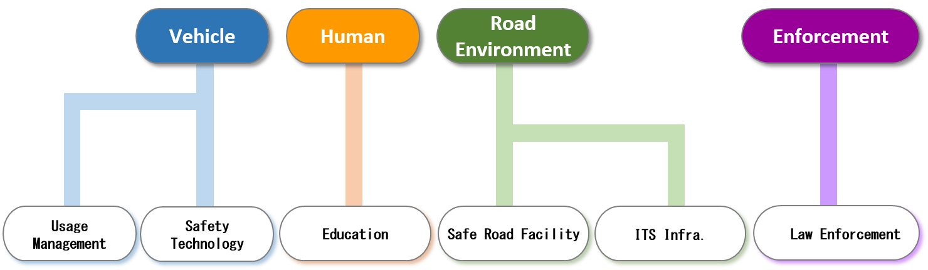
Fig.1 Possible Counter-Measure through Traffic Accident Analysis

In Fig. 1, we can see that the counter-measures can be covered in the aspects of vehicle, human, road environment and enforcement.

In order to find out suitable counter-measure, it is necessary to get suitable crash data for analyzing. However, as countries in the Asia-Pacific region are recording in different format and policy, it is hard to unify the approach to come out with common counter-measure. Activities such as Asia-Pacific Road Safety Observatory (APRSO) addressed the problem on collecting, managing and analyze crash data in the region and is conducting similar activities to set minimum set of road safety indictors in the Asia Pacific region.

5.1 The Status of Other Traffic Accident Record Guidelines
In the past, there are many efforts to set up the requirement of accident record, WHO had set in 2009 and APROS has set in 2020. The detail of WHO and APRSO data set are the following:

WHO Minimum and Additional Data Elements
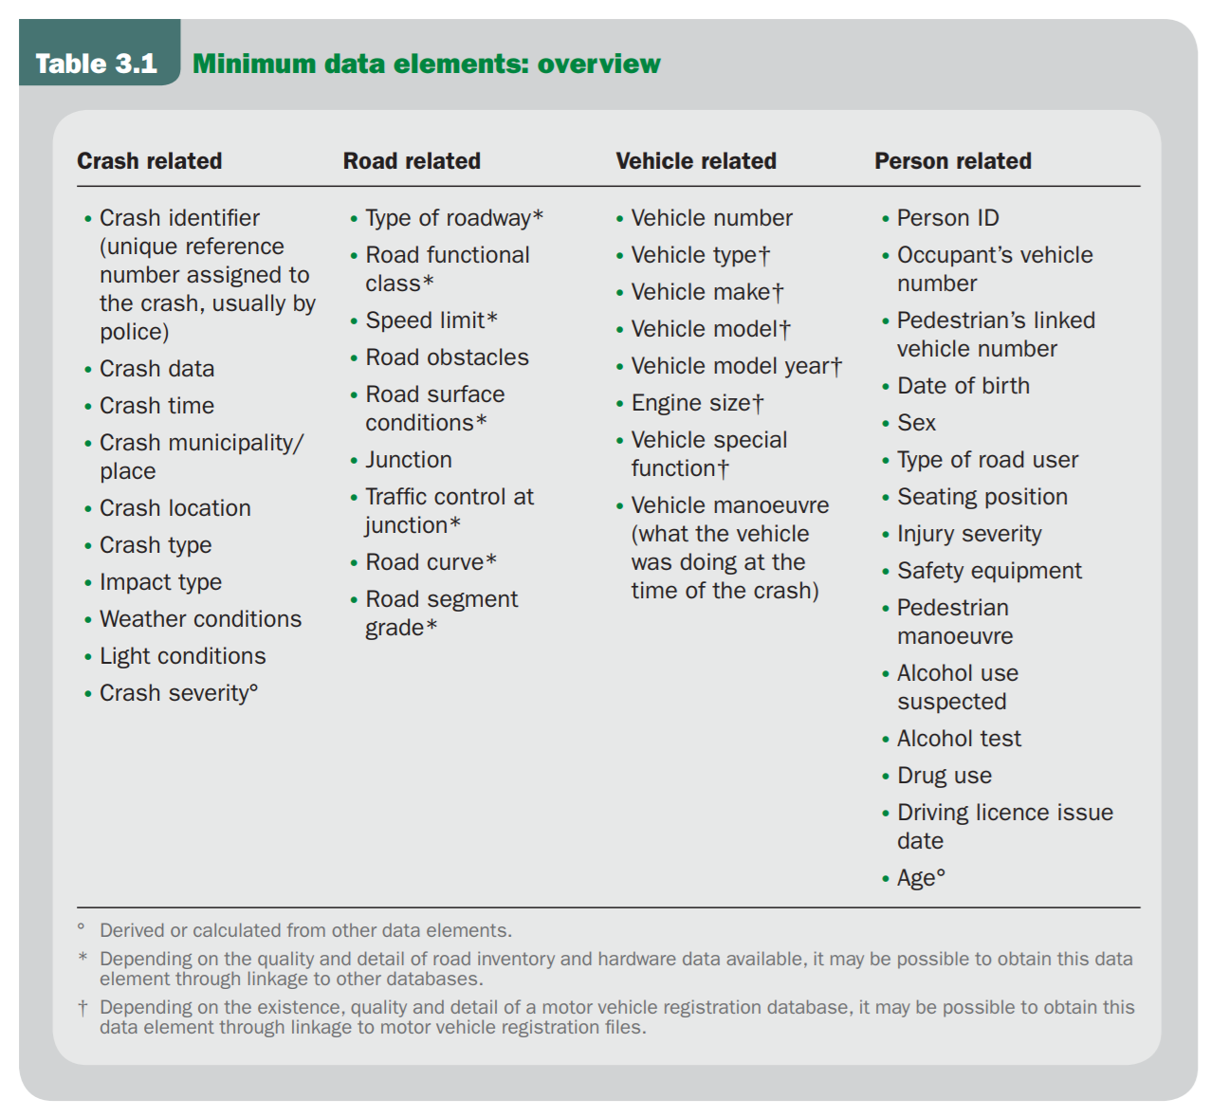
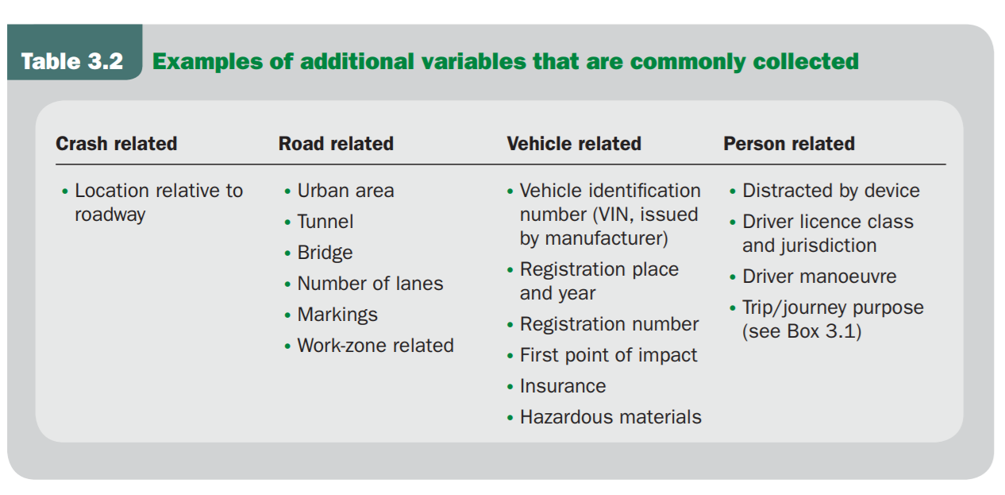

APROS Data set
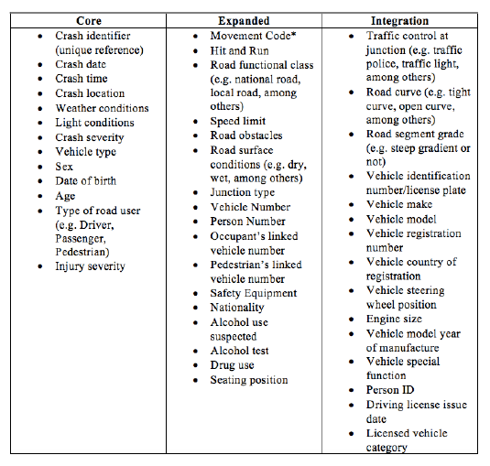

The both data set can serve as reference for this guideline in ASTAP activity. Except for creating totally new guideline, it is necessary to understand the background and purpose of these data set. For realizing the fatalities reduction and counter-measure, sharing best practice among groups and collaborating within the region should be carried. APT and ASTAP should contribute in ICT point of view as well as provide ICT best practice in road safety domain.

5.2 The Questionnaire Result of APT Member on Traffic Accident Record
Questionnaire has been conducted after ASTAP-31 meeting and 2 countries, the Philippines and Thailand has replied. The following is the Questionnaire result summary. For detail Questionnaire result, please refer Appendix 1 and 2 in the end of document.
Result of the Philippines is from the Highway Patrol Group, Philippines National Police. Result of the Thailand is from the Bureau of Traffic Safety, Department of Rural Road, Ministry of Transport. 2 Results are from police and transport sector and we can look into the result to see their needs on the record fields.

In Question 1-1, “In your country, which area you expect to counter-measure through traffic accident analysis (can choose more than one)?”, both of Questionnaire results agree on the expect counter-measure should include Education (Safety Education, Safety Information), Law enforcement (For Basic Road Rule, Violation Control), Road Facility (Improvement of Road Facility, Improvement of Traffic Operation), and Traffic IT Solution (Violation Detect System, Road Side Information Support, System, In-Vehicle Self Support System, Information Exchange Support System). For the Philippines reply, “legislation – laws and ordinance for road safety. Safer vehicle designs for private/public utility vehicles” should also be considered.

In Question 1-2, “In your country, which traffic analysis method is desirable (can choose more than one)?” Both replies agree to “Find out prone accident spot, Find out accident mechanism at accident spot, Find out human cause at accident spot, and Find out the relationship of road facility and traffic operation at accident spot”. For the Philippines reply, “black spot identification – fatal incident areas” is also desirable.
In Question 2-1, “Is accident crash location recorded in GPS format?”, both replies Yes. In Question 2-2, “If YES, how do you transfer crash location to GPS?”, the Philippines replied “By Electronic Device after site”, and Thailand replied “Others: The position of accident is recorded as referenced kilometre. Geographic coordination are secondary calculated from KM-equation of each route”. It shows that at the moment, GPS are recorded at site and was transferred through reference or after site record.
In Question 2-3, “Does accident impact type recorded as following (can choose more than one)? ”, Head on, Rear End, and Angle Impact are agreed by both replies. Philippines result also included Side Swipe and Multi-Collision. Thailand result included Overtaking crash, Pedestrian crash, Obstacle crash, Vehicle runoff: Straight, Vehicle runoff: Curve.
In Question 2-4, “How road/environment categories are recorded (can choose more than one)?”, Philippines replied “Type of roadway (Ex. Highway, Rural), Road Sharp (Ex. Curve, Cross), Junctional (Ex. U turn, T Junction), Traffic control at junction (Ex. Stop sign, Traffic Lights) without Speed Limit, Road surface conditions” and Thailand replied “Road Sharp (Ex. Curve, Cross), Junctional (Ex. U turn, T Junction), Traffic control at junction (Ex. Stop sign, Traffic Lights), Speed Limit, Road surface conditions” without Type of roadway (Ex. Highway, Rural). In Thailand case, as the result is from Department of Rural Road, their record should only limit to rural road.
In Question 2-5, “How accident cause (Ex. inattentive, road defect, lost brakes) are recorded (can choose more than one)?”, Thailand recorded all 4 factors, “Human factors, Environmental Factor, Vehicle Factors, and Illegal Factors”. In Philippines case, Human factors and Vehicle Factors are recorded.
In Question 2-6, “How many human factors are recorded (can choose more than one)?”, Thailand recorded “Inattentive, Wrong Judgement, and Wrong Operation”. Philippines recorded “Wrong Judgement”.
In Question 2-7, “How many environmental factors are recorded (can choose more than one)?”, both recorded all “Under Construction, Road Facility Disorder, Light Condition, Road Surface Damage, and Weather Condition”.
In Question 2-8, “How many vehicle factors are recorded (can choose more than one)?”, both recorded all “Loss Control, Dysfunctional Brake, Vehicle Factors, and Tire Blowouts”.
In Question 2-9, “How many illegal factors are recorded (can choose more than one)?”, both recorded all “Ignore Signal, Over Speeding, Alcohol use suspected, No helmet, and Ignore Stop Sign”.
In Question 2-10, “How many personal information in 1st party are recorded (can choose more than one)?”, both recorded all Sex, Age, and Vehicle Type”. Philippines also recorded “Body injure part”.
In Question 2-11, “How many personal information in 2nd party are recorded (can choose more than one)?”, both recorded all Sex, Age, and Vehicle Type”. Philippines also recorded “Body injure part”.
In Question 2-12, “How many driver status are recorded (can choose more than one)?”, both recorded all “Helmet, Seat belt, and Using mobile phone”.
In Question 3-1, “Is there any under-going project in your country to develop digital record software (definition of digital record in Appendix 1)?”, Thailand replied that “It’s already implemented in our organization for at least 10 years”. Philippines replied they are using “DRIVERS – Database on Road Incident Visualization Evaluation Reporting System”. DRIVERS is a database project which was initiated by World Bank Global Road Safety Facility (GRSP), and initiative projects have been carried at countries such as Philippines, Brazil, Thailand, Vietnam, Bangladesh, India, Laos, and so on.
In Question 3-2, “In the future, if there is free digital record software available, are you or is your organization interested in experiencing it (definition of digital record in Appendix1)?”, Thailand replied “No, I don’t see any incentive for the adoption of new system unless this software is clearly superior. The lack of recording system is not the problem for Thailand as a whole”, and Philippines replied Yes.
In Question 4-1, “Is there any under-going project in your city to develop automated accident analysis software?”, both replied Yes.
In Question 4-2, “In the future, if there is free automated accident analysis software available, are you or is your organization interested in experiencing it?”, both also replied Yes.

The overall results from both countries can be observed that traffic accident analysis indeed can be applied to many counter-measure and to find out the facts of crash. GPS information are generated but the correctness of the location should be investigated further as both countries recorded or transferred after the site.
In the record fields, both countries recorded most of the Questionnaire fields. Some difference should due to the purpose of the organization which records and utilizes the records.
In digital record software, both countries have its own software and implemented for many years. Digital record software is not main issue in both countries. As for the automated accident analysis software, both are developing and also welcome new automated accident analysis software for experiencing.
The result is listed in the Table 2 as following:

Table 2: Result of the Questionnaire
Question 1: Traffic Accident Analysis | Philippines | Thailand
Question 1-1, “In your country, which area you expect to counter-measure through traffic accident analysis (can choose more than one)?”
Education (Safety Education, Safety Information) | ● | ●
Enforcement (For Basic Road Rule, Violation Control) | ● | ●
Road Facility (Improvement of Road Facility, Improvement of Traffic Operation) | ● | ●
Traffic IT Solution (Violation Detect System, Road Side Information Support System, In-Vehicle Self Support System, Information Exchange Support System) | ● | ●
Philippines Comment: “legislation – laws and ordinance for road safety. Safer vehicle designs for private/public utility vehicles”
Question 1-2, “In your country, which traffic analysis method is desirable (can choose more than one)?”
Find out prone accident spot | ● | ●
Find out accident mechanism at accident spot | ● | ●
Find out human cause at accident spot | ● | ●
Find out the relationship of road facility and traffic operation at accident spot | ● | ●
Question 2: Traffic Accident Record Status
Question 2-1, “Is accident crash location recorded in GPS format?” | Yes | Yes
Question 2-2, “If YES, how do you transfer crash location to GPS?” | By Electronic Device after site | Others
Thailand: The position of accident is recorded as referenced kilometre. Geographic coordination are secondary calculated from KM-equation of each route”
Question 2-3, “Does accident impact type recorded as following (can choose more than one)? ”
Head On | ● | ●
Rear End | ● | ●
Angle Impact | ● | ●
Side Swipe | ●
Others |  | Overtaking crash, Pedestrian crash, Obstacle crash, Vehicle runoff: Straight, Vehicle runoff: Curve.
Question 2-4, “How road/environment categories are recorded (can choose more than one)?”
Road Code (Ex. Highway, Rural) | ●
Road Sharp (Ex. Curve, Cross) | ● | ●
Junctional Type (Ex. U turn, T Junction) | ● | ●
Junction Control (Ex. Stop sign, Traffic Lights) | ● | ●
Road Speed Limit |  | ●
Weather | ● | ●
Light | ● | ●
Road surface |  | ●
Question 2-5, “How accident cause (Ex. inattentive, road defect, lost brakes) are recorded (can choose more than one)?”
Human factors | ● | ●
Environmental Factor | ● | ●
Vehicle Factors | ● | ●
Illegal Factors |  | ●
Question 2-6, “How many human factors are recorded (can choose more than one)?”
Inattentive |  | ●
Wrong Judgement | ● | ●
Wrong Operation |  | ●
Question 2-7, “How many environmental factors are recorded (can choose more than one)?”
Under Construction | ● | ●
Road Facility Disorder | ● | ●
Light Condition | ● | ●
Road Surface Damage | ● | ●
Weather Condition | ● | ●
Question 2-8, “How many vehicle factors are recorded (can choose more than one)?”
Loss Control | ● | ●
Dysfunctional Brake | ● | ●
Vehicle Factors | ● | ●
Tire Blowouts | ● | ●
Question 2-9, “How many illegal factors are recorded (can choose more than one)?”
Ignore Signal | ● | ●
Over Speeding | ● | ●
Alcohol use suspected | ● | ●
No helmet | ● | ●
Ignore Stop Sign | ● | ●
Question 2-10, “How many personal information in 1st party are recorded (can choose more than one)?”
Gender | ● | ●
Age | ● | ●
Vehicle Type
Travel purpose
Year for license obtained
Body injure part | ●
Question 2-11, “How many personal information in 2nd party are recorded (can choose more than one)?”
Gender | ● | ●
Age | ● | ●
Vehicle Type
Travel purpose
Year for license obtained
Body injure part | ●
Question 2-12, “How many driver status are recorded (can choose more than one)?”
Helmet | ● | ●
Seat belt | ● | ●
Drunk driving | ● | ●
Using mobile phone | ● | ●
Question 3: Future Vision for Traffic Accident Record
Question 3-1, “Is there any under-going project in your country to develop digital record software (definition of digital record in Appendix 1)?” | Yes | Yes
Thailand Comment “It’s already implemented in our organization for at least 10 years
Philippines comment “DRIVERS – Database on Road Incident Visualization Evaluation Reporting System”.
Question 3-2, “In the future, if there is free digital record software available, are you or is your organization interested in experiencing it (definition of digital record in Appendix1)?” | Yes | No
Thailand comment: “No, I don’t see any incentive for the adoption of new system unless this software is clearly superior. The lack of recording system is not the problem for Thailand as a whole”
Question 4: Future Vision for Traffic Accident Analysis
Question 4-1, “Is there any under-going project in your city to develop automated accident analysis software?” | Yes | Yes
Question 4-2, “In the future, if there is free automated accident analysis software available, are you or is your organization interested in experiencing it?” | Yes | Yes

6 Summary of Traffic Accident Record and Analysis Methods in APT region

6.1 Key Recommendations for Guideline
Through examining HWO, APRSO and Questionnaire result, initial key recommendation for guideline is in the following. Please note that the guideline is a collection of best practice and feedback from various sources, it is not necessary to totally follow the recommendation. Country is recommended to compare their record fields with the guideline and examine if any necessity to expand the record field after consulting experts with possible counter-measure which can be created through the new record field.
Table 3: Key Recommendations for Guideline
Field
Core
Crash ID
Crash Date
Crash Time
Crash Location
Weather Conditions
Light Conditions
Crash Severity
Vehicle Type
Sex
Age
Type of Road User
Injury Severity
Injury Specification
Impact speed
Expanded
Movement Code
crash type
Violations charged
Road Functional class
Speed Limit
Road Obstacles
Road Surface Conditions
Roadway Surface Type
Junction Type
Vehicle No.
Person No.
Safety Equipment
Restraint usage
Helmet use（for PTW)
Alcohol use suspected
Alcohol test
Drug use
Seating position
Integration
Traffic control at junction
Road Curve
Vehicle ID
Vehicle make
Vehicle Model
Vehicle model year of Manufact.
Vehicle special function

6.2 Future Recommend Application and Pilots
In ASTAP point of view, how to utilize ICT solution to prove the effectiveness of counter-measure will be key factor to contribute. Many best practices can be find in international organization such as World Bank GRSF and iRAP. iRAP provide a list of best practice toolkit such as crash types, road users, treatments, management for reference.
The future ICT pilot can be considered in the following:
- Correct Data Recording: Digital Device Record through mobile phone, Digital Platform of Accident related data
- Enforcement: Smart camera system on speed limit, alcohol, helmet, and so on violations
- Education: E-Safety Education and Information on vehicle maintenance, attention, caution, and manner for driving, walking in dedicated zone. Dangerous zone for driving route, accident avoidance information.
- Road Facility: Function improvement to prevent accident, and improvement of traffic operation through data analysis.
- Vehicle improvement: In-vehicle, vehicle to vehicle, and road site communication to prevent accident.

6.3 Future Recommend Usage
The guideline is recommended to utilize in several ways. If the APT member county has no its own database for accident record, it is recommended to apply the guideline at the first hand and improve through its need. If the APT member country had its own database, it is recommended to compare with the guideline fields and investigate if any necessary to improve the current one.
For ICT Application and Pilots, it is recommended to implement according to the status of the APT member. If there is no database, it is firstly recommended to establish its own database. If the record quality is low, it is recommended to utilize digital record tool such as smart phone. If the cause of accident is unknown, it is recommended to analyse through best practice. If the APT member country would like to reduce fatalities, it is recommended to implement 3E (Education, Enforcement, Engineering) approach with ICT solutions recommended in 6.2.

7 Conclusions
This report has summarized Questionnaire from ASTAP-31 result, comparing with WHO and APRSO recommendation and finally come up with the key recommendation for ASTAP future activity. Goals of the report has been achieved as following:
- Introduction about Road Safety and Traffic Accdient Record including the need and benefits for the Traffic Accdient Record Guideline
- Traffic Accdient Record and Analysis Tools from APT Member countries focusing on the ICT domian
- Possible Future Project or Pilot on Information and Telecommunication Technologies & Solutions in Traffic Accdient Record
- Guideline hamonzie activities related to Traffic Accdient Record in the Asia and Pacific

The key recommendation can serve as reference while investigating possible counter-measure of road safety. In future APT project, it is recommended to apply the key recommendation to utilize ICT tools such as digital record device for correct recording, video camera for smart traffic violation and so on.
____________

Appendix 1: Questionnaire Result of Philippines
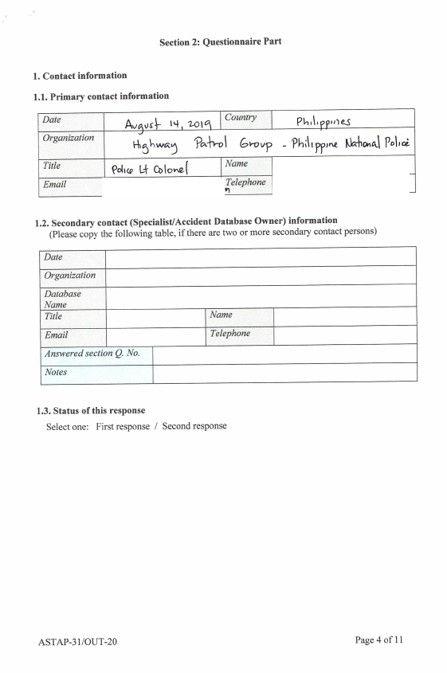

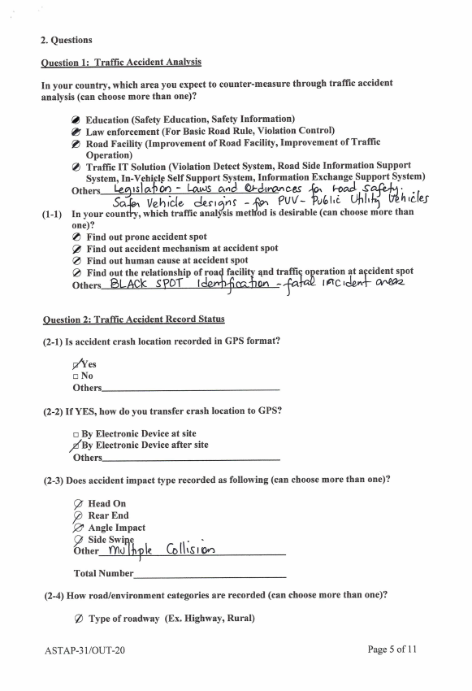

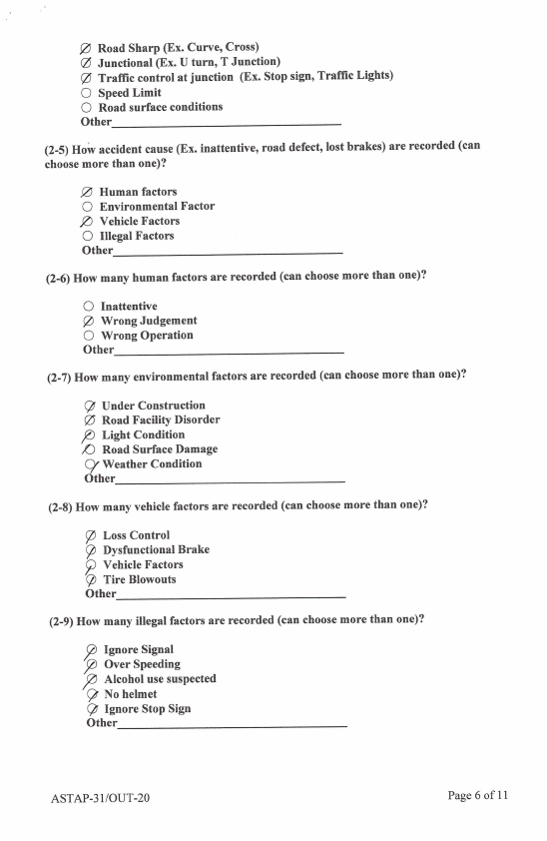

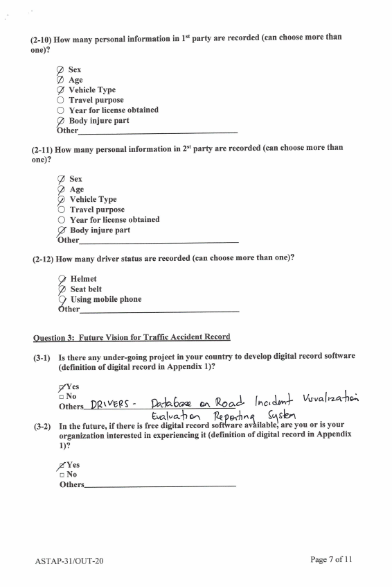

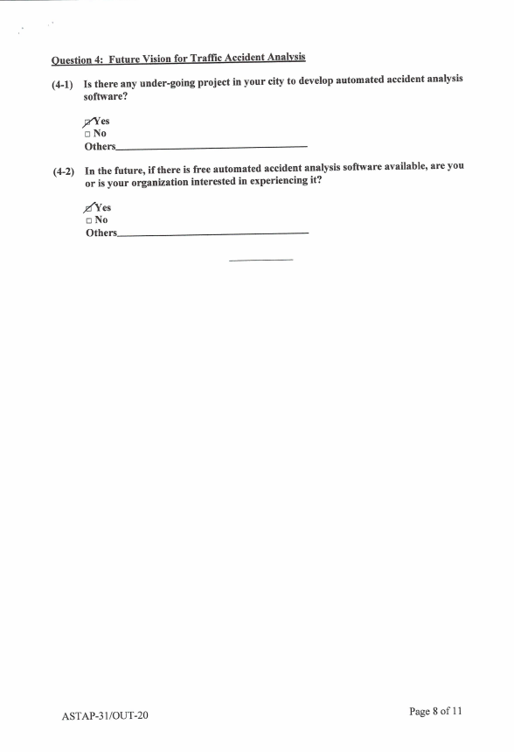

Appendix 2: Questionnaire Result of Thailand



