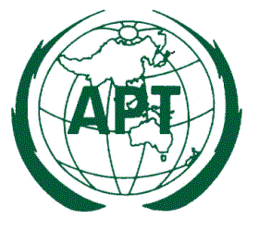
ASIA-PACIFIC TELECOMMUNITY
12/49, Soi 5, Chaengwattana Road, Bangkok 10210, Thailand

Date: 26 September 2013

Subject: Circulation of the Questionnaire Developed at the 22nd APT Standardization Program Forum (ASTAP-22)

Dear Sir/Madam,

I would like to inform you that the 22nd APT Standardization Program Forum (ASTAP-22) was held successfully from 11 to 14 September 2013 in Bangkok, Thailand. ASTAP-22 approved a questionnaire on “Disaster Management Information Common Platform in APT Countries and Disaster Management Communication Systems for Non-Public Institutions” developed by the ASTAP Expert Group on Disaster Risk Management and Relief Systems (EG DRMRS).

This questionnaire intends to invite APT Members, Associate Members and Affiliate Members to provide their valuable inputs on public disaster management information common platform and disaster management communication systems for non-public institutions. Moreover, the Members could arrange possible common solutions in the area for making future guidelines of such systems. The response will be used to construct a comprehensive overview of the common platform, communication systems and to identify future possible common solutions in the area. All the information collected from the Members will be reflected to the status report on public commons in Asia-Pacific region.

You are kindly advised to send back your response on or before 26 October 2013. Please send your response to the Chairman of EG DRMRS, Mr. Susumu TANAKA (s-tanaka@bp.jp.nec.com) with a copy to APT Secretariat at aptastap@apt.int .

Yours sincerely,

(Signed)

Toshiyuki Yamada
Secretary General

Attachment:
Questionnaire on “Disaster Management Information Common Platform in APT Countries and Disaster Management Communication Systems for Non-Public Institutions”

