APT REPORT ON

FREQUENCY USAGE ON THE BANDS 1980-2010 MHZ AND 2170-2200 MHZ IN ASIA PACIFIC REGION

No. APT/AWG/REP-46(Rev.1)
Edition: April 2017

Adopted by

21st Meeting of APT Wireless Group
3 – 7 April 2017
Bangkok, Thailand

(Source: AWG-21/OUT-23)

APT REPORT ON FREQUENCY USAGE of The Bands 1 980-2 010 MHz and 2 170-2 200 MHz in Asia-Pacific Region

Table of Contents

1. Introduction 3
2. Scope 3
3. Vocabulary of terms 3
4. APT member’s current usage status in this band 3
4.1. Australia 3
4.2. Bangladesh 4
4.3. Cambodia 4
4.4. China 4
4.5. Japan 5
4.6. Republic of Korea 5
4.7. Federated States of Micronesia 5
4.8. Singapore 6
4.9. Thailand 6
4.10. Tonga 6
4.11. Vanuatu 7
5. APT member’s future plan in this band 8
5.1. Australia 8
5.2. Bangladesh 8
5.3. Cambodia 8
5.4. China 8
5.5. Japan 8
5.6. Republic of Korea 8
5.7. Federated States of Micronesia 9
5.8. Singapore 9
5.9. Thailand 9
5.10. Tonga 9
5.11. Vanuatu 9
6. Others (Issues to be considered for the use of this band) 10
6.1. Australia 10
6.2. Bangladesh 10
6.3. Cambodia 10
6.4. China 10
6.5. Japan 10
6.6. Republic of Korea 11
6.7. Federated States of Micronesia 12
6.8. Singapore 12
6.9. Thailand 12
6.10. Tonga 12
6.11. Vanuatu 12

Introduction

At the AWG-13 meeting, it was proposed to survey the usage of the bands 1980-2010 MHz and 2170-2200 MHz in Asia Pacific region. It was agreed that this task would address only the survey and not any sharing/co-existence studies.
According to the Table of Frequency Allocations of the Radio Regulations, the frequency bands 1 980-2 010 MHz and 2 170-2 200 MHz are allocated to fixed, mobile and mobile-satellite services on a co-primary basis in all regions. According to RR Nos. 5.388 and 5.351A and Resolution 212 (Rev.WRC-07), the frequency bands 1 980-2 010 MHz and 2 170-2 200 MHz may be used by administrations wishing to implement either the terrestrial or the satellite component of IMT, while it does not preclude the use of these bands by other services to which they are allocated.
With the purpose to share the information on the current usage and future plan of the 1 980-2 010 MHz and 2 170-2 200 MHz bands, it was agreed to conduct this survey in Asia Pacific region at the AWG-14 meeting.
Based on the survey result, whether to conduct the further studies or not could be considered in the future AWG meetings.

Scope

This survey is to collect information of current spectrum usage and future plan in the bands1 980-2 010 MHz and 2 170-2 200 MHz in Asia Pacific region. The survey result would not be associated with any sharing/co-existence studies. Based on the result of the survey, an APT Report on Frequency Usage of the bands 1 980-2 010 MHz and 2 170-2 200 MHz in Asia Pacific Region will be developed for APT Members’ informative purpose only and the collected data will be included into the APT Frequency Information System (AFIS) as well.

Vocabulary of terms
APT Asia Pacific Telecommunity
IMT International Mobile Telecommunications

APT member’s current usage status in this band
Question 1: What is/are current allocation(s) (e.g. mobile service, fixed service, mobile-satellite service), application(s) (e.g. CDMA, UMTS, LTE, GMR, EGAL, etc.) and assigned/licensed in the bands 1980-2010 MHz and 2170-2200 MHz in your country?
Question 2: If there are no services currently used in the bands 1980-2010 MHz and 2170-2200 MHz, what are main reasons for the difficulty to use the bands and/or obstacles to the use of the bands?

Australia
Answer (Q1): The bands 1 980-2 010 and 2 170-2 200 MHz are also allocated to the mobile-satellite service, however as of June 2013 no mobile-satellite service are currently licensed in Australia.
 | Service | Applications | Commercial  Operator | License duration
1 | Fixed service | Point to Point | Broadcast Australia | Expiring 2013
2 | Mobile/Fixed service | Television Outside Broadcasting | FOX Sports | 1 year
3 | Mobile/Fixed service | Television Outside Broadcasting | Thoroughbred Racing Productions | 1 year
4 | Mobile/Fixed service | Television Outside Broadcasting | RIEDEL Communications Australia | Expiring 2013
5 | Mobile/Fixed service | Television Outside Broadcasting | Rapid TV | 1 year
6 | Fixed service | Point to Point | Telstra | 1 year
Answer (Q2): N/A

Bangladesh
Answer (Q1):
 | Service | Applications | Commercial  Operator | License duration
1 | 1980-1985 | Guard band between 3G & CDMA | Auction on process
2 | 1985-1990 | CDMA | SA Tel
3 | 1990-2110 | Center Gap for 3G
4 | 2170-2200 | No service available
Answer (Q2): In our National Frequency Allocation Plan, 2170-2200 MHz is for unidirectional fixed links and IMT Satellite service. At this moment no such service is available in this band.

Cambodia
Answer (Q1): The current allocation is Fixed Service, Multichannel Multipoint Distribution Service (MMDS) Application and assigned frequency 1980-2100MHz
 | Service | Applications | Commercial  Operator | License duration
1 | Fixed | MMDS | Yes | Renew every year
Answer (Q2): There is no application

China
Answer (Q1): Chinese government has decided to assign these frequency bands for MSS application. The satellite system is under trial operation. Several commercial operators have taken part in trial operation.
 | Service | Applications | Commercial  Operator | License duration
1 | Mobile-Satellite Service | Personal Communication
Answer (Q2): N/A

Japan
Answer (Q1):
 | Service | Applications | Commercial  Operator | License duration
1 | MOBILE-SATELLITE | N/A | N/A | N/A
2 | MOBILE | N/A | N/A | N/A
Answer (Q2): A part of these frequency bands is planned to be used by MSS and details of the usage are under consideration/study in Japan.

Republic of Korea
Answer (Q1): Korea allocates the bands 1980-2010 MHz and 2170-2200 MHz to the mobile and mobile satellite services and identifies the utilization of these bands for GMPCS (Global Mobile Personal Communication by Satellite).
 | Service | Applications | Commercial  Operator | License duration
1 | Mobile services | - | - | -
2 | Mobile satellite services | - | - | -
Answer (Q2): There are no commercial services currently used in the bands 1980-2010 MHz and 2170-2200 MHz in Korea.

Federated States of Micronesia
Answer (Q1): KARI (Korea Aerospace and Research Institute) antenna site in FSM is located in Weno, Chuuk to provide efficient and stable mission of KOMPSAT 2. TX:2034.747MHz AND RX: 2209.68 MHz.
 | Service | Applications | Commercial  Operator | License duration
1 | Satellite | VSAT | KARI | One Year  (Subject to renew)
Answer (Q2): No service in used in the band 1980-2010MHz other than what being assigned to KARI

Singapore
Answer (Q1):
 | Service | Applications | Commercial  Operator | License duration
1 | Mobile Satellite | Mobile satellite | No
Answer (Q2): N/A

Thailand
Answer (Q1):
 | Frequency | Allocations | Applications
1 | 1 980- 2 010 | FIXED  MOBILE  MOBILE-SATELLITE  (Earth-to-Space) | None
2 | 2 170-2 200 | FIXED  MOBILE  MOBILE-SATELLITE  (Space-to-Earth) | None
Answer (Q2): There is no international guidance on how the bands 1 980-2 010MHz and 2 170-2 200MHz should be arranged and used. While Footnote 5.388 and 5.351A identify these bands for IMT, to the best of our knowledge, there are currently no internationally harmonized band plan or widely recognized equipment standards for these bands. For example, ITU-R Recommendation M.1036-4, which provides guidance on spectrum arrangements for the terrestrial component of IMT systems, includes arrangements in only the portion 1 980-1 990MHz of the band 1 980-2 010MHz and no arrangements at all in the band 2 170-2 200MHz.
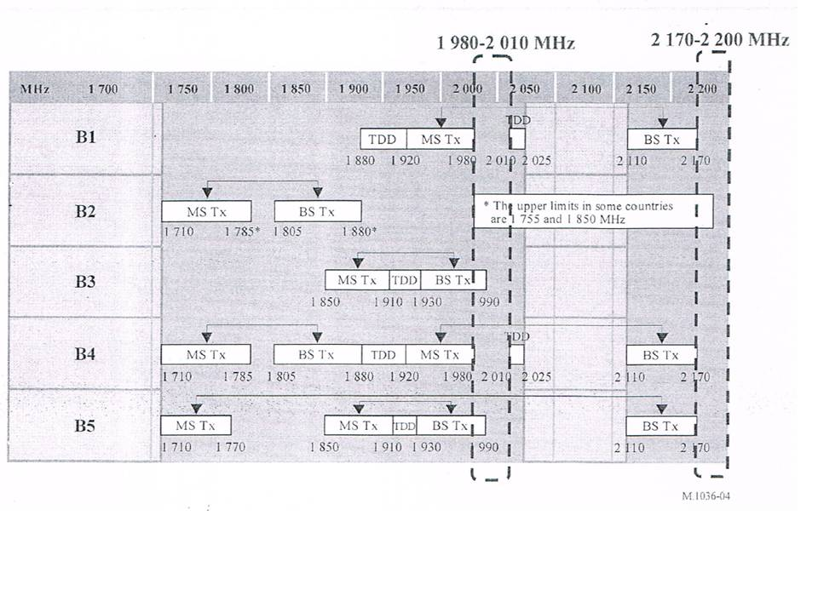

Tonga
Answer (Q1):
 | Service | Applications | Commercial  Operator | License duration
1 | Fix, Mobile, Satellite mob | Satellite Mobiles | 2x Operators | 10 years
2 | Fix, Mobile, Satellite Mob. | Satellite Mobiles | 2x Operators | 10 years
The above assignments are with respect to our National Spectrum Plan.
Answer (Q2): There are two carriers are utilizing these Bands

Vanuatu
Answer (Q1): Both spectrum bands were previously used by Telecom Vanuatu Limited (TVL) for fixed service. The two bands have since been vacated with TVL’s move to higher capacity spectrum band (7GHz band). One link remains in the 2170-2200 MHz band, which it advises, will be vacated soon.
 | Spectrum band MHz | Service | Applications | Commercial Operator | License duration
1 | 1980-2100 | None | NA | NA | NA
2 | 2170-2200 | Fixed | Backhaul | TVL | 2023
Answer (Q2): See answer to Question 1 above. Most of the spectrum in these bands was used by TVL prior to 2008 for fixed service. That spectrum was re-allocated/re-assigned to TVL in 2008 when its monopoly was broken, paving the way for competition. TVL was re-issued with an operator’s licence which expires in 2023. Whether TVL is planning to use the vacated spectrum for the deployment of next generation mobile broadband services or not is not clear, but they still have a legal right to that spectrum.
  - Viet Nam
Answer (Q1):
 | Frequency | Allocations | Applications
1 | 1 980- 2 010 | Fixed  MOBILE  MOBILE-SATELLITE  (Earth-to-Space) | Identified for IMT
2 | 2 170-2 200 | Fixed  MOBILE  MOBILE-SATELLITE  (Space-to-Earth) | Identified for IMT
Answer (Q2):
There are no commercial services currently in the bands 1980-2010 MHz and 2170-2200 MHz in Viet Nam.

APT member’s future plan in this band
Question 3: Do you have planned or potential future services and applications in the bands 1980-2010 MHz and 2170-2200 MHz? (Yes / No)
If you answered “Yes” to Question 3 above, please answer the Question 4.
Question 4: What is/are planned or potential future services and applications in the bands 1980-2010 MHz and 2 170-2 200 MHz?

Australia
Answer (Q3): Yes, the bands 1 980–2 010 MHz and 2 170–2 200 MHz are currently being used for television outside broadcasting (TOB) (see IFC 11/2012 ) while under consideration for mobile broadband services (see: IFC 13/2011).

Answer (Q4):
 | Planned/Future services and applications | Timeline
1 | Mobile broadband | No time frame set

Bangladesh
Answer (Q3): Yes
Answer (Q4):
 | Planned/Future services and applications | Timeline
1 | 1985-1990 MHz for CDMA | Existing
2 | 2170-2200 MHz for IMT Satellite | Not yet palnned.

Cambodia
Answer (Q3): No

China
Answer (Q3): Yes, the bands 1 980–2 010 MHz and 2 170–2 200 MHz are currently being used and planned for MSS application exclusively.
Answer (Q4):
 | Planned/Future services and applications | Timeline
1 | Mobile-Satellite Service | No timeline

Japan
Answer (Q3): Yes. (Under study)
Answer (Q4): A part of these frequency bands is planned to be used by MSS and details of the usage is under consideration/study in Japan.

Republic of Korea
Answer (Q3): Yes
Answer (Q4): Korean government announced the “Mobile Broadband Plan v2.0” on December 31, 2013. The purpose of the plan is to secure more than 1,190 MHz bandwidth for mobile broadband services by 2023. The plan includes ensuring additional 60 MHz spectrum (2x30MHz) to provide terrestrial IMT services by utilizing the bands 1 980-2 010MHz and 2 170-2 200MHz.

 | Potential future services and applications | Timeline
1 | Mobile service | TBD
2 | Mobile satellite services | TBD

The future plan for the bands 1 980-2 010MHz and 2 170-2 200MHz considered by Korean government is shown in following figure:

UL: 1980 – 2010MHz (30MHz)
DL: 2170 – 2200MHz (30MHz)
Tx-Rx Frequency Separation: 190MHz
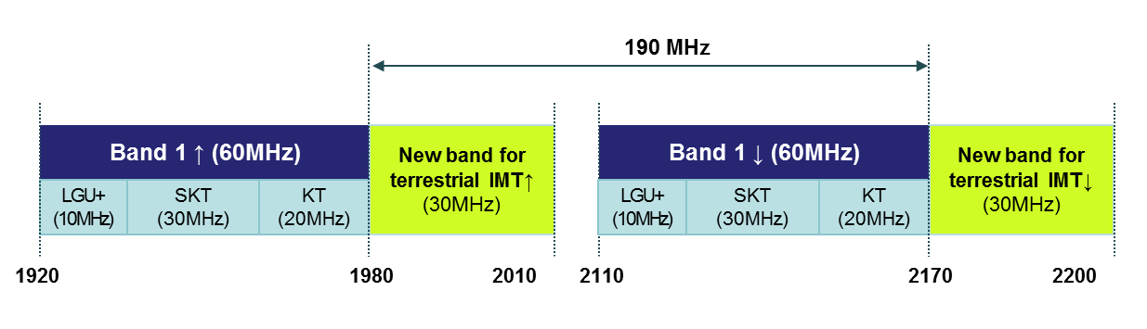
(Frequency bands for new 2.1GHz terrestrial operation in Korea)

HANSAT series satellite networks have been filed to the ITU in this band.

Federated States of Micronesia
Answer (Q3): No

Singapore
Answer (Q3): N/A

Thailand
Answer (Q3): No

Tonga
Answer (Q3): Yes, we are now assigning these two Bands
Answer (Q4):

Vanuatu
Answer (Q3): No, but we will monitor developments in the region and will consider and facilitate any plans that promote regional/international harmonization of services in these bands.

Viet Nam
Answer (Q3): Yes

Answer (Q4):

 | Potential future services and applications | Timeline
1 | IMT services | Has not decided yet.
In Viet Nam, the IMT-2000 core band (i.e. 1920-1980 MHz, 2110-2170 MHz) has been allocated to four mobile operators to deploy 3G WCDMA/HSPA systems for many years. It has been expected for Viet Nam to complete regulation on the permit of the implementation of 4G LTE, LTE-Advanced systems in the core band in the mid-year of 2017.
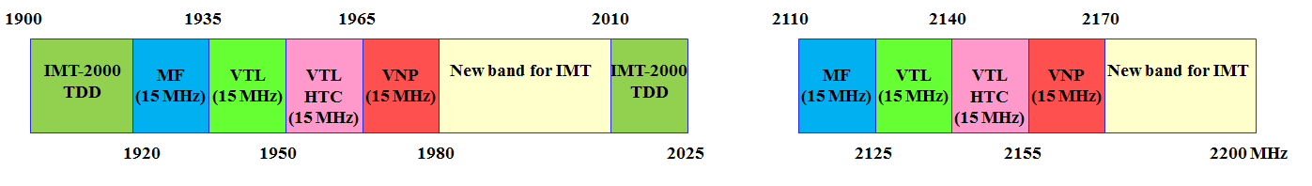
(Note: MF: MobiFone; VTL: Viettel; VNP: Vinaphone)
Band plan of 1900-2025 MHz, 2110-2200 MHz for IMT systems in Viet Nam
The adjacent bands (1980-2010 MHz, 2170-2200 MHz) are vacant for usage until now. Currently, Viet Nam government has identified this band to use for terrestrial IMT to facilitate and harmonize the efficient use of these bands in the updated revision of national frequency allocation table after WRC-15 conference.

Others (Issues to be considered for the use of this band)
Question 5: Do you have any issue to be considered for the use of the bands 1980-2010 MHz and 2170-2200 MHz? What is the issue?

Australia
Answer (Q5): The operation of television outside broadcasting (TOB) services in these bands is on a temporary basis while the band’s future use is considered. Licensees of TOB services will need advanced notice of any requirement to cease operation in these bands. This will require an appropriate relocation period to be given if the bands are to be made available for another use (such as mobile broadband).

Additionally, adjacent band sharing studies will need to be conducted with existing services and applications before the band could be allocated to another service.

Bangladesh
Answer (Q5): Potentiality of CDMA service needs to be considered.

Cambodia
Answer (Q5): None

China
Answer (Q5): Noting that there are FS, MS, and MSS for Primary allocation in the bands 1980-2010 MHz and 2 170-2 200 MHz in the Table of Frequency Allocations of Radio Regulations, an individual administration can decide whether or not these 2 GHz bands be used for FS, MS or MSS.

Satellite component of IMT is irreplaceable to provide global coverage and stable communication during disasters situation. The 1980–2010 MHz and 2170–2200 MHz frequency band is extremely important and known as “the golden band” for satellite component of IMT. In China, these bands are currently being used and planned for MSS application exclusively.
It is noted that ITU-R WP5D is discussing the revision of Recommendation ITU-R M.1036-4(“Frequency arrangements for implementation of the terrestrial component of International Mobile Telecommunications (IMT) in the bands identified for IMT in the Radio Regulations (RR)”). Some Members States proposed to add the 1980–2010 MHz and 2170–2200 MHz bands to the existing frequency arrangements for terrestrial component of IMT. Considering the important role and limited spectrum resource of satellite component of IMT, the administration of China proposed that it is inappropriate to use the 1980-2010 MHz and 2170-2200 MHz frequency bands for the IMT terrestrial services.

It should be noted that there is still debating in WP5D on the inclusion of the 1980–2010 MHz and 2170–2200 MHz bands to the Recommendation ITU-R M.1036-4.

Japan
Answer (Q5):
A part of these frequency bands is planned to be used by MSS and details of the usage is under consideration/study in Japan. Japan believes that it is helpful for APT Members to update the usage of these bands annually for information sharing among the APT region.

Republic of Korea
Answer (Q5): Korea will consider the domestic study result and the trend of the international harmonization for the future usage of the bands 1 980-2 010MHz and 2 170-2 200MHz.

The issues for the international consideration are ITU-R WP5D and 3GPP standardization activities relating to these bands.

At the 16th WP 5D meeting, a draft new revision of Recommendation ITU-R M.1036-4 was developed for frequency arrangements in the bands currently identified for IMT to expand the existing frequency arrangements such as frequency arrangements B1 and B4 by adding the bands 1 980-2 010 MHz and 2 170-2 200 MHz as B6. This is based on contribution of some Members States and Sector Members which are considering using the bands 1 980-2 010 and 2 170-2 200 MHz for the use of IMT (Doc. 5D/232, 5D/353 and 5D/420).

At the 18th WP 5D meeting, two input contributions (Doc. 5D/572 and 5D/587) were considered for the revision of Recommendation ITU-R M.1036-4. The meeting determined that no changes were required at this time in the working document towards a draft revision of Recommendation ITU-R M.1036-4. (Attachment 4.6 of 5D/532) This revision is targeted for the completion by October 2014.

In 3GPP, there have been on-going discussions with the aim to make better usage of 1 980-2 010 MHz and 2 170-2 200 MHz bands and a feasibility study for co-existence with terrestrial component of IMT in these bands. The study on “LTE FDD in the bands 1 980-2 010 MHz and 2 170-2 200 MHz” was approved as Release-12 Study Item on September 2012. The purpose of this study item, targeted for the completion by June 2014, is to facilitate and harmonize the efficient use of these bands for terrestrial IMT. (Latest version of draft technical report for this study item: TR 36.861)

Furthermore, the additional study item for the same bands in the Europe was also approved on December 2012 in 3GPP. Within the European Union, these bands can be used for terrestrial mobile networks operated as a complement to mobile satellite services in the same frequency band. (Latest version of draft technical report for this study item: TR 37.846)

In addition, the following R&D project is ongoing in Korea and the result of this project will be considered.

ETRI and Korean mobile operators (LG Uplus, KT, and SKT) kicked off a collaborative R&D project for the terrestrial use of these bands. The main purpose of this project is to provide an efficient frequency utilization plan for the terrestrial use of these bands in Korea, considering interference issues among adjacent terrestrial IMT as well as coordination issues with adjacent administrations where mobile satellite service are used in these bands. In addition, the R&D project is also doing feasibility study for the roll-out and development of an integrated satellite and terrestrial system in Korea, considering interference issues between satellite and terrestrial components. The system would be innovative space/terrestrial infrastructures with high degree of spectrum utilization and have the ability to provide a variety of benefits that serve the public interest, including multimedia broadband service to handheld or portable terminals and public protection and disaster relief solutions

Federated States of Micronesia
Answer (Q5): None

Singapore
Answer (Q5): Yes, border coordination

Thailand
Answer (Q5): If there were guidance on spectrum arrangements and/or equipment standards for the bands, we could consider planning and implementing the use of the bands to utilize the spectrum efficiently, rather than leaving the bands vacant.

Tonga
Answer (Q5): None

Vanuatu
Answer (Q5): None

  - Viet Nam

Answer (Q5): The issues what need to be considered are ongoing sharing studies in APT/AWG meeting and ITU-R WP5D relating to these bands, especially international frequency coordination with neighboring countries in the cross border.

