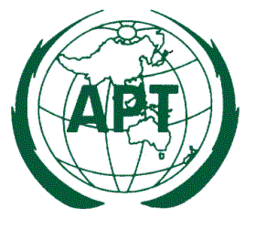

Ref: AWG/2014/AWG16-C2
16 April 2014
Dear Sir/ Madam,

Subject: Request for update information on APT/AWG/REP-07(Rev.2) and APT/AWG/REP-35
APT Reports on “Operation of SRDs (APT/AWG/REP-07 (Rev.2), 09/2012)” and on “Frequency bands for harmonized use of SRDs (APT/AWG/REP-35, 03/2013)” provide valuable information such as technical regulation of 9 countries and implementation status of 15 countries for SRDs in the Asia-Pacific Region. They also provide a number of benefits for SRD end users, manufacturers and regulators, such as:
- greater user confidence in the reliable functioning of devices when travelling abroad;
- a broader manufacturing base and increased volume of equipment (globalisation of markets) resulting in economies of scale and expanded equipment availability;
- improved spectrum utilisation;
- potential reduction in the influx of illegal or non-conforming SRDs into the marketplace of some countries.

During the 16th meeting of APT Wireless Group (AWG-16) held from 18 to 21 March 2014 in Pattaya, Thailand,, it was agreed to update these APT Reports in order to reflect the latest information of each APT Member country.

Therefore, APT Members are kindly requested to update information contained in APT/AWG/REP-07(Rev.2) and APT/AWG/REP-35 relevant to your administration and return it to the APT Secretariat (Email: aptawg@apt.int) prior to the AWG-17 (September, 2014). It is preferred that you provide the updated information comparing to the original texts in APT/AWG/REP-07(Rev.2) and APT/AWG/REP-35 by using the track changes.
For your convenience, APT Reports APT/AWG/REP-07 (Rev.2) and APT/AWG/REP-35 are attached.
I thank you in advance for your cooperation.
Yours sincerely,

(Original signed)

Toshiyuki Yamada
Secretary General
Attachment:

TO: APT Members

