 | ASIA-PACIFIC TELECOMMUNITY
 | The First meeting of SATRC Working Group on Spectrum
 | 07-08 July 2010, Tehran, Islamic Republic of Iran

Document No. : SATRC-WG-SPEC-1/06
Date : 07 July 2010

Communication Regulatory Authority, I.R of IRAN

Introduction to Automated Spectrum Management System

Alireza Darvishi, Mohammad Zomorodi

Introduction and background

When the amount of data is large and the requirements for analytical studies are complex and diverse, automation techniques become a necessity. Automation can also improve the implementation of limited analysis techniques and databases. Computer systems offer the means to store data in a readily retrievable form, to manipulate the data, to produce reports relating to the data and to perform analytical studies.
Nowadays, efficient management of increasing number of spectrum users is possible only by using advanced administrative-technical tools. By means of automated spectrum management system (ASMS) responsible authorities could perform variety of EMC calculation, could handle different scheduled administrative procedures and are able to hold the history of all national spectrum users in an electronic data base. Issuing licenses, notification of frequency assignments to the Radiocommunication Bureau (BR), providing periodic reports, interference resolution, supporting coordination with other administrations, charging frequency users and etc. are some of the capabilities of an ASMS. Moreover, an advanced ASMS facility could be connected to the remote monitoring stations for performing monitoring missions and discovering irregular spectrum utilization as well as quickening resolution of harmful interference.
The Radiocommunication (ITU-R) and the Telecommunication Development (ITU-D) Sectors of the ITU according to requirements specified in Recommendation ITU-R (ITU-R SM.1048) developed, jointly, the BASMS and WinBASMS computer software programs for supporting national spectrum management which have been released in 1995 and 1997 respectively. The SMS4DC is the next generation of WinBASMS which provides more functionality to spectrum management activities of developing countries.

- ASMS (Automation Spectrum Management System) functions

Regardless the size of country and its number of radio frequency users, there is a definite need for using the computerized techniques in the management of radio frequency resource. Although the capability of ASMS should be improved along with the size of data in process, but there are some common functions that shall be covered in an ASMS. These functions include:

- frequency planning;
- frequency allocations;
- frequency assignment and licensing;
- frequency coordination;
- international notification;
- standards, specifications and equipment authorization;
- monitoring activities;
- storing and maintaining spectrum management data;
- statistical and advanced reporting;
- providing an interface for inquiries;
- fees and automatic notification of renewal; and,
- EMC calculations including propagation.

Also advanced ASMS should:
- allow multiple users and have appropriate data security features
- contain advanced engineering calculation features for radio services
- should be capable of using a terrain database for specific engineering calculations
- should, where feasible, operate in the customer’s national language(s)
- its output documents intended for the general population (e.g. Licences) be easily generated in the local language and character set
- include the necessary training and support

A very important part of each spectrum management system is a database which includes various information. Many of these data items are described in the Radiocommunication Data Dictionary (Recommendation ITU-R SM.1413). In the interest of a speedy and economical application of automation to spectrum management, it is advisable that an administration includes only those data elements, data files, and databases that are necessary for it to meet its spectrum management requirements.

- Discussion and examples on some of AMS functions

  - Frequency allocation plan/channel processing

This function should have the following characteristics:
– provide utilities for the maintenance of national frequency allocation plan. Information to be recorded should include ITU primary and secondary services as a minimum;
– provide capability to maintain channelling plans. Utility should be included for the automated generation of channelling plan with user entered parameters (figure 2);
– capability to store and retrieve frequency plan footnotes on all levels;
– retrieval of frequency channel pairs and applicable footnotes confirming with user specified parameters;
– system should be able to access the national frequency allocation plan, channelling plans, footnotes, and other system maintained databases on user supplied parameters;
– provide the allocation table in an automated display that a frequency assignment can be checked against to ensure that it is a valid frequency assignment.

Figure1. A section of frequency allocations chart in Region 3

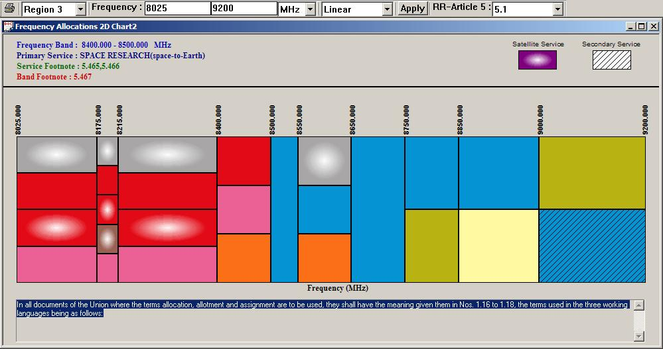

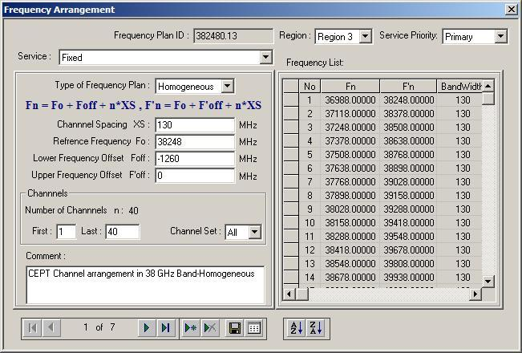
Figure2. Frequency arrangement definition dialog box

  - Licence Processing
No licence should be issued without comparing the proposed frequency assignments to the Table of Frequency Allocations (Article 5 of the Radio Regulations (RR)), regional allotments, national regulations and decisions; regional radio conferences and agreements should also be referenced. National broadcasting plans provided by the administration for sound and video should also be inputs. The system may use occupancy parameters from the database or from monitoring data before providing a licence.
The system should enable the renewal and printing of licences. Licence printing follows a standard format.

  - Fee processing
This function should support the management of financial tasks, such as recording of fee payments, production of invoices, and production of financial statements in statistical or individual format. It should also allow the setting and changing of fee rates.

Figure 3. Billing Information table

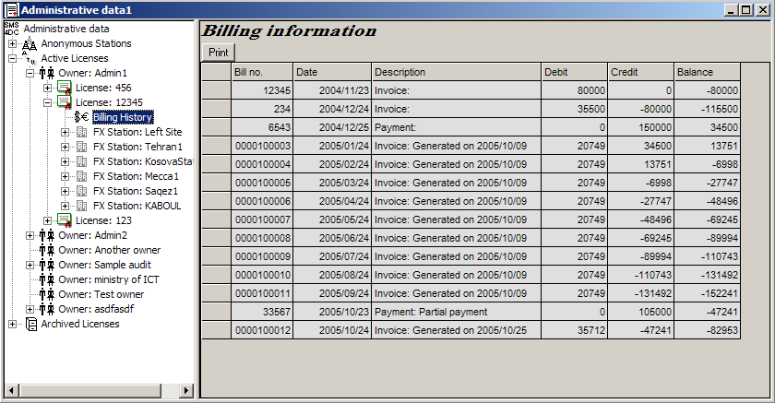

  - Security Processing

Spectrum management staff should, in general, have read access to the data records. This function should restrict update access to specific data records or to certain types of transactions to only those operators who have the proper security access role (Figure 4). The required security roles should be built into the design of the AASMS. The allocation of operators to one of several security roles should be controlled by the password table or by some other mechanism created as each operator is registered by the system administrator.

Figure 4. Menu of User-ID and Password management

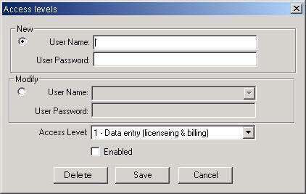
  - Engineering analysis requirements

The AASMS should automatically identify interference-free frequencies for an applicant if such a frequency is available; if not, it should identify the acceptable interference case(Figure 6). Such automatic techniques should be included where practicable. The process is to use appropriate calculations in conformity with commonly used interference assessment methods, frequency-distance functions or tables that allow for the user specification of minimum acceptable distance separations for co- and adjacent channels for each service in each band. It should also be possible to analyse a specific proposed frequency assignment using the same models to determine its interference potential.

Figure 5. a) Dialog box of initial frequency range definition and b) Spreadsheet of concerned stations

(a)
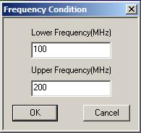

(b)
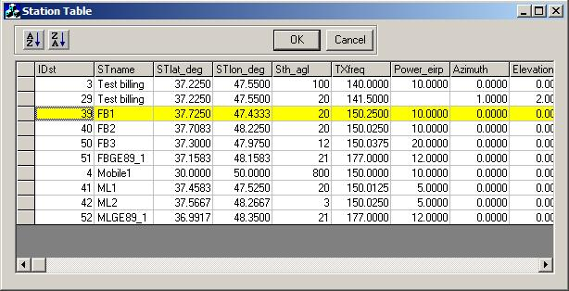

(b)

Figure 6. a) Frequency assignment parameters , b) Result of investigation for assignable frequencies
(a)
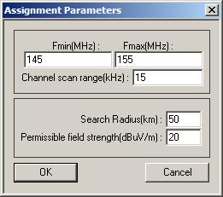

(b)
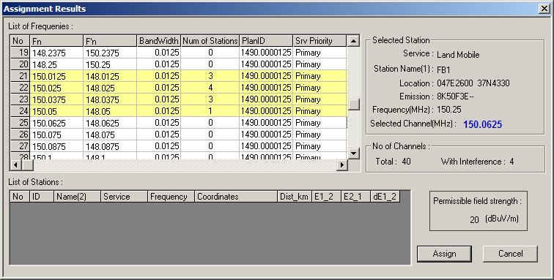

Figure 7. Result of detailed interference calculation for a suspect assignable frequency
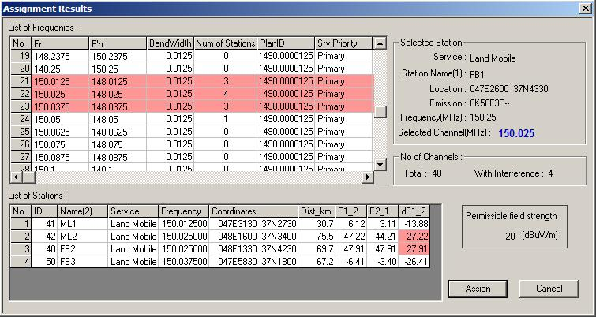

  - Border Coordination
The AASMS should identify licence applications requiring border coordination and automatically create a coordination document to be used for coordination with bordering administrations. The ITU recommends international coordination for certain frequency assignments, depending essentially on the frequency (and power) of the transmitter. Recommendation ITU-R SM.1049 – A method of spectrum management to be used for aiding frequency assignment for terrestrial services in border areas, is a nice example of coordination practices.
The system should check if the area of interference is crossing a border using the ITU-Digitized World Map (IDWM) and the ITU program to plot geographical maps (GEOPLT). IDWM contains: geographical data-coastlines, seas, islands, lakes; political data-borders, regional boundaries. The program provides the name of the country for specific “geo” coordinates, and the distance from a transmitter to the closest border. All available data in IFL and other ITU documents or diskettes should be used to check whether there is overlap with channels allotted by regional agreements such as Stockholm 1961, Rio de Janeiro 1981, and Geneva 1984 (Figure 8).
The system should enable the identification of licence applications requiring border coordination. For this purpose, the field strength coverage in the bordering countries’ transmitters should be calculated, as well as interference. In this manner, the system should support interference calculations and prints forms for coordination.
The system should automatically identify whether stations under evaluation are located in a coordination zone using a GIS-based map. It should also provide a query function to enable on-line viewing of coordination data and status of selected coordination records using user specified parameters.

Figure 8. Result of coordination distance calculation
for GE84 FM sound station in respect to the other GE84 FM sound stations
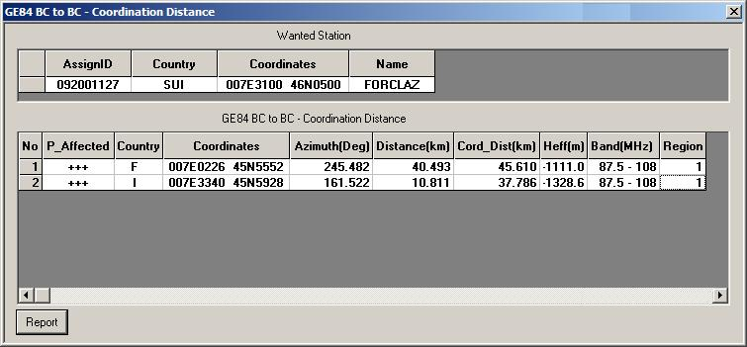

Figure 9. Sample output of BCBT to Digital BC-BT interference calculation
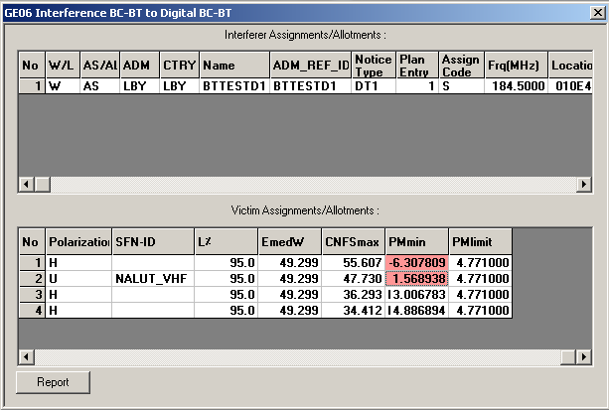
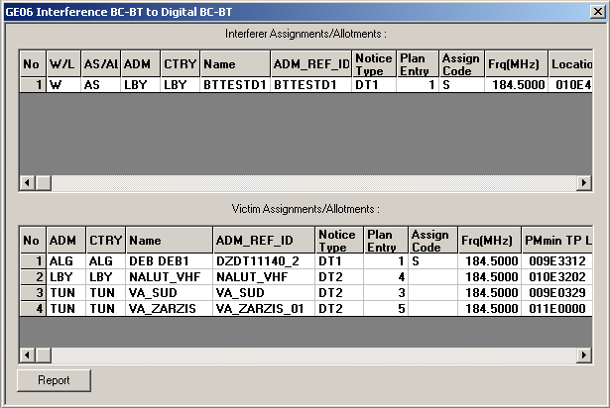

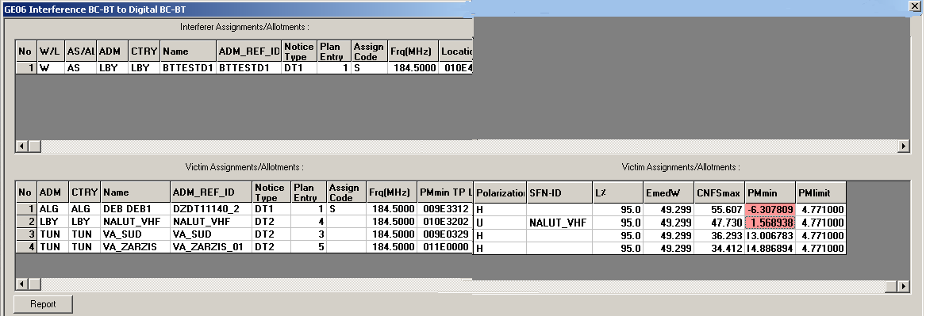

Figure 10. User-defined agreement entry mask a
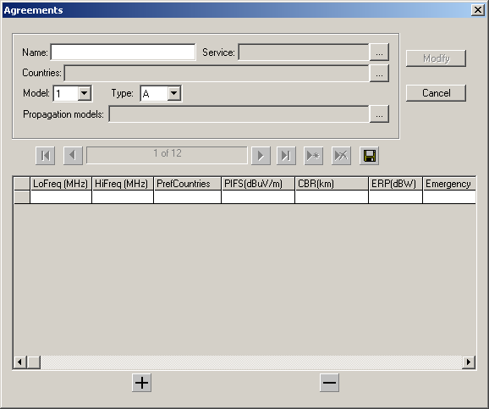

Figure 11. An example of applicable agreement to the selected station
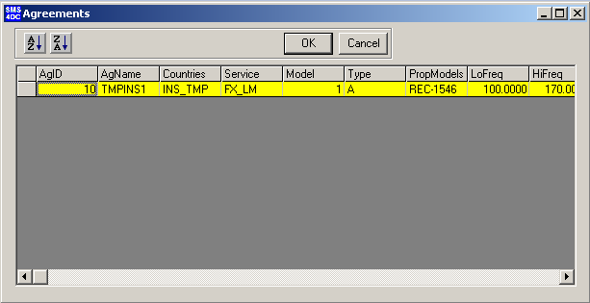

Figure 12. Border coordination result windows for different type of wanted-victim stations configuration
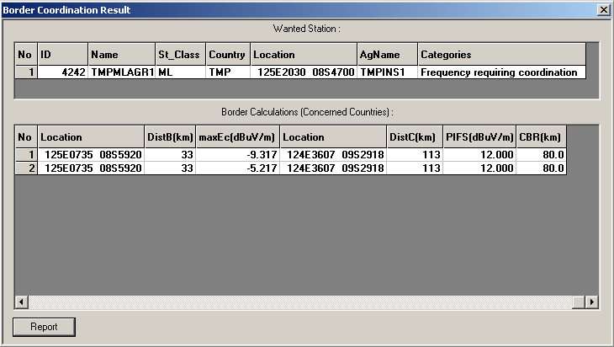
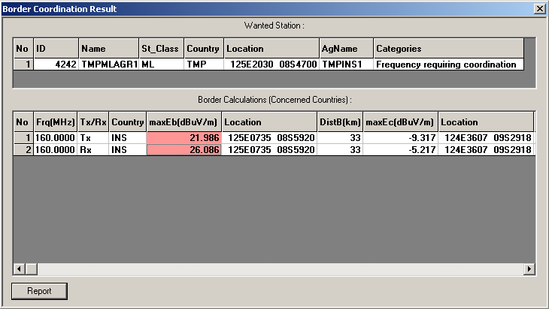
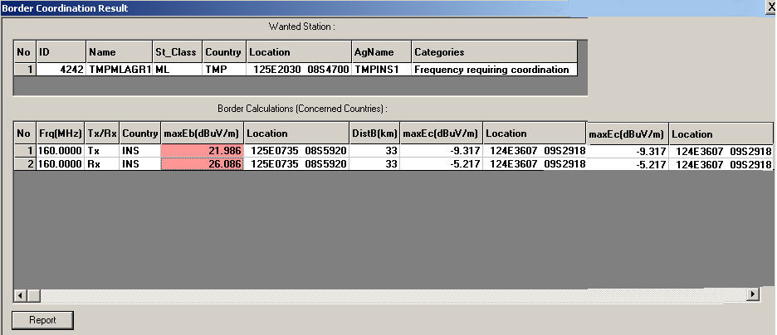

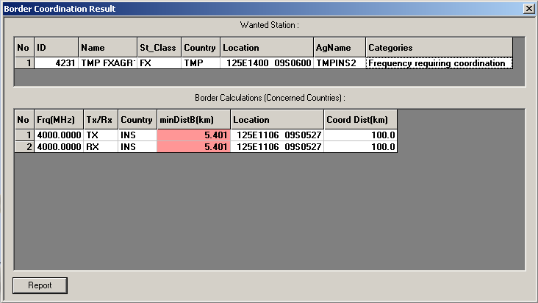

  - Notification to the BR
As required in RR Article 11 – Notification and recording of frequency assignments, the system should automatically identify applications requiring BR notification and create appropriate notification forms (Figure 13) suitable for submission to the BR according to RR Appendix 4.

Figure 13- Sample of notification form for terrestrial stations in the fix service
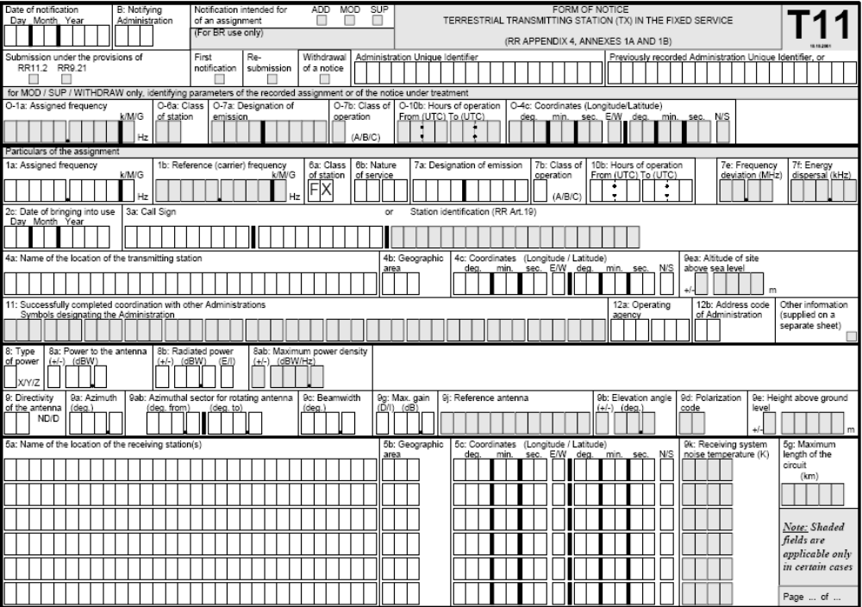

  - Monitoring
The AASMS should provide spectrum management data to the monitoring system to assist the operators. The monitoring data should be available to the spectrum managers.
As described in Recommendation ITU-R SM.1050 – Tasks of a monitoring service, monitoring assists spectrum management by being its eyes and ears, enabling the verification of proper technical and operational characteristics of authorized (and unauthorized) transmitters, the detection and location of unauthorized transmitters, the identification and resolution of interference problems, and the validation of propagation and sharing models.

  - Geographic map display functions

The AASMS should include the software for the storage, processing and display of geographic data and terrain/topography data. The system should be capable of accepting map data in standard formats.

The basis for EMC analysis is the profile estimation along the interference and wanted signal paths.
The system should calculate the estimated field strengths for any contour from the transmitter, e.g. every 25 m, 50 m, 100 m ..., depending on the DTM pixel resolution.

- Transition from old management approach to ASMS

The conversion from manual to automated analysis techniques has numerous advantages and becomes indispensable as the data processed becomes voluminous. Before starting the transition to an automated system, the following factors should be taken into account:
- there is an infrastructure that should be analyzed, planned and carried out before starting an automated system.
- the changeover from a manual to an automated process will initially create new types of problems,
- the initial period of system development and implementation may be costly. The user
should realize that it requires time before he can receive all the advantages and
financial benefits of an automated system;

Summary and Conclusions
As the cost of maintaining manual spectrum management systems increases with the growth in data volume, number of transactions and number and complexity of analytical operations, the use of automated spectrum management systems becomes essential. Computer systems are now available that have the necessary processing capabilities and data storage capabilities to offer substantial performance at reasonable cost.
_______________

