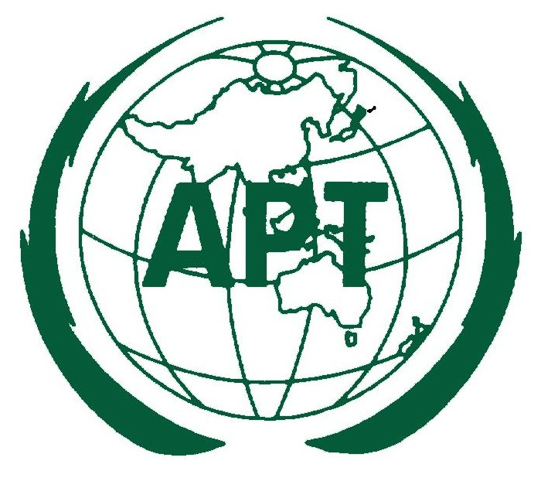 | ASIA-PACIFIC TELECOMMUNITY  2nd APT Preparatory Meeting for WTDC-14 (WTDC14-2)  23-25 October 2013, Australia | Document  WTDC14-3/INP-02  22 July 2013

Chair of Working Group 2 (WG2)

issue PAPER WG2

- ABSTRACT

The 1st and 2nd APT preparatory meetings for WTDC-14 considered the structure and terms of reference for the Working Groups. According to decisions of these meetings, Working Group 2 (WG2) will consider Regional Initiatives, “WSIS+10 Review Process”, Study Groups and Associated Questions and ITU-D working methods.

This issues paper intends to stimulate discussion in order to identify possible matters for APT Common Proposals relevant to WG2. APT Members are encouraged to actively participate in discussions and provide comments on this paper.

- INTRODUCTION:

The 1st APT Preparatory Meeting for WTDC-14 was held in Seoul, Republic of Korea, from 3-4 April 2013 and agreed to the structure and terms of reference for the preparatory process.

The ITU held its Asia-Pacific Regional Preparatory Meeting for WTDC-14 (RPM-ASP) in Phnom Penh, Cambodia, from 29 April - 2 May 2013, followed by the 2nd APT Preparatory Meeting for WTDC-14 on 3 May 2013.

As a result of discussions during the RPM-ASP, the 2nd APT preparatory meeting for WTDC-14 agreed to revise the structure and terms of reference for the Working Groups. The terms of reference for WG2 are as follows:

- To review and update the regional initiatives developed at ITU RPM-ASP taking into account outputs from other regions
- To consider matters relating to study groups and associated Questions taking into account the strategic goals and objectives of the ITU in particular to those of ITU-D
- To consider issues related to WSIS and “WSIS+10 review process”
- To consider issues related to the ITU-D working methods, particularly in regard to the organisation of and procedures associated with meetings of the Telecommunication Development Advisory Group and study groups, in the interests of optimising and enhancing their effectiveness and efficiency during the forthcoming cycle
- To consider Resolutions, Recommendations and Decisions relating to ITU-D relevant to the activities of this WG

- DISCUSSION OF ISSUES:

During the RPM-ASP a number of issues relevant to WG2 were discussed and should be taken into account in the APT preparatory process. These included discussions relating to the Asia-Pacific Regional Initiatives, ITU-D Study Groups and ITU-D working methods.

The ITU RPM-ASP agreed on five Asia-Pacific Regional Initiatives for 2015-2019, to be reviewed in the APT preparatory process as needed and confirmed at WTDC-14.

The RPM-ASP also considered a number of contributions relating to ITU-D working methods and ITU-D Study Groups. The meeting acknowledged that ITU-D study questions should be streamlined to maximise efficiency and avoid duplication, aligned with the strategic priorities of the ITU-D and considered in coordination with the other ITU Sectors.

These outcomes are included below as possible areas for WG2 activity in preparing for WTDC-14. APT Members may wish to consider these issues further or provide additional matters for consideration relevant to WG2.

- SUMMARY OF PROPOSALS FOR FURTHER DISCUSSION AND ACTION

Based on contributions from APT Members to the WTDC-14 preparatory meetings to date, the following issues may be appropriate for further discussion in WG2. APT Members are also encouraged to raise any other issues relevant to WG2.

Issue | Description | Possible actions
Asia-Pacific Regional Initiatives | Contributions to the RPM-ASP on this issue were from ABU (Doc 4), Nepal (Doc 6), Australia (Doc 20, 21, 22), Federated States of Micronesia, Fiji, Tonga, Tuvalu, Vanuatu (Doc 30), Japan (Doc 31), China (Doc 36), Republic of Korea (Doc 37) and Vietnam, (Doc 38, 39). The initiatives agreed by the RPM-ASP are:  - Unique ICT needs of least developed countries (LDCs), Small Island Developing States (SIDs) including Pacific Islands Countries and landlocked developing countries  - Emergency telecommunications  - Harnessing the benefits of new technologies  - Broadband access and uptake in urban and rural areas  - Policy and regulation in the Asia-Pacific region | Review or update the Regional Initiatives as needed.  The full text of the regional initiatives agreed at the RPM-ASP is at Attachment A.
ITU-D Study Groups and Questions | The following proposals were made to the RPM-ASP in ITU-D study areas:  - India (Doc 28) proposed to continue study of Question 23/1 on strategies and policies concerning human exposure to electromagnetic fields’ in the next study cycle.  - Telecom Regulatory Authority of India (Doc 11) proposed that, in coordination with ITU-T Study Group 3, there was a role for ITU-D on issues related to international mobile roaming, particularly regarding tariffs and charging information.  - Telecom Regulatory Authority of India (Doc 14) proposed that ITU-D could consider activity on Quality of Experience such as developing a framework or model.  - Telecom Regulatory Authority of India (Doc 15) proposed that ITU-D could consider establishing a framework for open access to cable landing stations.  - Telecom Regulatory Authority of India (Doc 16) proposed that ITU-D could consider activity relating to standards for triple play services.  - Telecom Regulatory Authority of India (Doc 17) proposed that ITU-D could undertake a study on technical standards for set top box interoperability.  - Telecom Regulatory Authority of India (Doc 12) proposed a study to develop a platform for collaboration among countries relating to application services development.  - India (Doc 29) proposed that a new study group questions could be used to identify and assess the use and application of broadband networks for development and further assess the implications on broadband services in terms of availability and cost effectiveness. | APT Members may wish to further consider the proposals for study that were submitted to the RPM-ASP.  It was stressed during the RPM-ASP that all proposals for study should take into account the work of other ITU Sectors.
ITU-D Working Methods and TDAG | China (Doc 36) suggested a number of issues for consideration to the RPM-ASP regarding ITU-D working methods. These included strengthening capacity building, building project support from study groups, enhancing regional capacity building, establishing focus groups for hot topics and attracting new members from industry. | APT Members may wish to further consider the issues that were raised at the RPM-ASP.
WSIS and WSIS+10 review process | To date there have been no proposals from APT Members on this issue | APT Members may wish to consider this issue
ITU-D Resolutions, Recommendations and Decisions relevant to WG2 | To date there have been no proposals from APT Members on this issue | APT Members may wish to consider this issue

- CONCLUSIONS

The WG2 Chair and Vice-Chair welcome comments and suggestions from APT Members in relation to this issues paper. It is anticipated that this paper will assist APT Members to prepare proposals for the 3rd APT Preparatory Meeting for WTDC-14.

Chair | Vice Chair
Australia  Ms Carmen Ball  Assistant Director, ITU & Treaties  Department of Broadband, Communications and the Digital Economy  Tel: +61 2 6271 1444  Email: carmen.Ball@dbcde.gov.au | Japan  Mr Ken Sugawara  Director, Technical Cooperation  Ministry of Internal Affairs and Communications  E-mail: k-sugawara@soumu.go.jp

ATTACHMENT A: RPM-ASP AGRED REGIONAL INITIATIVES

Regional Initiatives for Asia and the Pacific
Unique ICT needs of least developed countries (LDCs), Small Island Developing States (SIDS) including Pacific Islands Countries and landlocked developing countries
Objective: To provide special assistance to LDCs, SIDS, Pacific Islands Countries, and LLDCs in order to meet their priority ICT requirements.

Expected Results:
- Improved infrastructure and enhanced access to affordable ICT services
- Improved enabling environment to facilitate the ICT development
- Appropriate national, sub-regional and regional frameworks for cybersecurity
- Enhanced skills of relevant human resources
- Addressed specific issues and challenges in the Pacific Islands Countries
Emergency Telecommunications
Objective: To provide assistance to Member States at all phases of disaster management, i.e. disaster preparedness including early warning, disaster response/relief, and rehabilitation of telecommunication networks.

Expected Results:
- Identification of suitable technologies to be used for emergency communications
- Creation of common databases to share information on emergency communications
- Design of national and sub-regional emergency communication plans taking into account the impact of climate change
- Development of appropriate policy, regulatory and legislative frameworks on emergency communications at national and regional level
- Availability of dedicated set of equipment for emergency radio communication in the Asia-Pacific region
- Capacity building in relation to emergency telecommunications and disaster preparedness
- Mechanism for sharing information and best practices on utilizing ICTs for disaster preparedness, disaster response/relief, and reconstruction among countries in the region and others
Harnessing the benefits of New Technologies
Objective: To assist ITU Member States in utilizing new technologies and address human and technical capacity challenges related to new and emerging issues such as spectrum management, digital broadcasting, IPv6 transition, accessibility, combating spam, number misuse, green technologies and other emerging technical issues.

Expected Results:
- Assistance in the development of frameworks for new and emerging technical issues as well as for utilizing new technologies in the following areas, but not limited to:
  - Digital broadcasting
  - Next Generation Network
  - Transition to IPv6
  - Digital literacy and inclusions for all (e.g. PwDs, etc.)
  - ICT applications
  - Multi-lingual local contents
  - Accredited laboratory
  - Spectrum management and monitoring
  - Combating spam and cybersecurity
  - Number misuse
  - Green technologies
- Raised awareness and enhanced skills in relation to new technologies and technical issues as identified and others as requested
- Expert and technical assistance to Members on resolving technical issues as identified and others as requested
- Identification of new and emerging technical issues which could be the focus of further expertise, assistance and capacity building exercises.
Broadband Access and Uptake, in urban and rural areas
Objective: To assist Member States in the development of broadband access in urban and rural areas and to support system construction to resolve social issues using ICT applications, including e-Health

Expected Results:
- National broadband policies to meet the requirements of developing countries
- Improved broadband infrastructure and access to affordable ICT services in urban and rural areas, including remote and hilly terrains as well as remote islands
- Development of ICT applications that can support multilingualism and address local needs
- Enhanced skills in the area of broadband communication networks for the relevant human resources
- Implementation of solutions providing cost-effective broadband infrastructure, addressing the deployment and operational challenges in rural and remote areas, including remote islands
- International cooperation on multi-stakeholders’ empowerment of ICT volunteers
- Capacity building and deployment of cost-effective e-Health services in rural and remote areas thereby reducing operational and administrative costs
- Accelerating evolution and deployment of next generation network infrastructure including mobile/wireless communication networks, in-land/submarine optical fibre cable networks, and Internet networks for both national and regional connectivity
- Studies and assistance on effective utilization and optimization of optical fibre cable networks especially submarine cable networks
- Studies on traffic categorization and offering of Necessary content bundles to reach more lower income groups
Policy and Regulation in the Asia-Pacific region
Objectives: To assist Member States in developing of appropriate policy and regulatory frameworks, enhancing skills, increasing information sharing and strengthening regulatory cooperation.

Expected Results:
- Development of appropriate policy, regulatory and legislative frameworks, including telecommunication/ICT, Cybersecurity international roaming, spectrum management, digital broadcasting, Next Generation Regulation, IPv6, convergence aspects, and etc.
- Enhancing the skills of relevant human resources
- Promotion of regulatory cooperation and information sharing.

