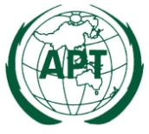 | ASIA-PACIFIC TELECOMMUNITY  2nd APT Preparatory Meeting for WTDC-14 (WTDC14-2)  23-25 October 2013, Gold Coast, Australia | Document  WTDC14-3/INP-03 Rev1  16 Sep 2013

Chair of Working Group 3 (WG3)

issue PAPER WG3

- ABSTRACT

The 1st and 2nd APT preparatory meetings for WTDC-14 considered the structure and terms of reference for the Working Groups. According to decisions of these meetings, Working Group 3 (WG3) will consider ITU-D Strategic Plan, Declaration and other issues not covered by WG1 and WG2.

This issue paper intends to stimulate discussion in order to identify possible matters for APT Common Proposals relevant to WG3. APT Members are encouraged to actively participate in discussions and provide comments on this paper.

- INTRODUCTION:

The 1st APT Preparatory Meeting for WTDC-14 was held in Seoul, Republic of Korea, from 3-4 April 2013 and agreed to the structure and terms of reference for the preparatory process.

The ITU held its Asia-Pacific Regional Preparatory Meeting for WTDC-14 (RPM-ASP) in Phnom Penh, Cambodia, from 29 April - 2 May 2013, followed by the 2nd APT Preparatory Meeting for WTDC-14 on 3 May 2013.

As a result of discussions during the RPM-ASP, the 2nd APT preparatory meeting for WTDC-14 agreed to revise the structure and terms of reference for the Working Groups. The terms of reference for WG3 are as follows:

- To identify key strategies required for the regional ICT development, including general policy and cooperation among memberships.
- To identify any issues that need stronger support and commitment of the countries and to prepare draft input for Declaration and Action Plan of the Conference.
- To review the ITU-D Strategic Plan considering the development initiatives of the region taking into account the strategic goals and objectives of the ITU
- To assess the achievements of the relevant parts of the Hyderabad Action Plan
- To consider Resolutions, Recommendations and Decisions relating to ITU-D relevant to the activities of this WG
- To consider any other matters not covered by WG1 and WG2

- DISCUSSION OF ISSUES:

i. During the RPM-ASP a number of issues relevant to WG3 were discussed and should be taken into account in the APT preparatory process. These included discussions relating to implementation of the Hyderabad Action Plan in the ASP region and provides an overview of current ICT trends, with particular focus on the status of ICT, the evolution of the ICT Development Index (IDI) and broadband development both worldwide and in the ASP region.
ii. Also the ITU Secretariat presented the Results Based Management approach for the information and consideration of the Members as well as the current ITU-D strategic framework. The aspects and contributions discussed during the RPM are summarized in the next section.
iii. Further, the working group 3, within the scope of its mandate, presents a few additional areas for further discussion of the Membership. These areas are proposed due to their relevance to complement ITU-D’s key strategies to fulfill the Union’s mission.

- Building synergy among the Telecommunications/ICT facilitators may play a key role in optimal use of resources. Being the Specialized agency of UN, the ITU could play a leading role as part of ITU-D strategy to bring synergy among other UN organizations and other International organizations working towards Telecommunications/ICT development. This is presented as an area of further discussion for the ITU-D future strategy under Annex III.

- Telecommunication/ ICT policies, strategies play an important role in building the frameworks and creating the base for the Telecommunications/ICT development in a country. A proactive mapping of these policies and an indicative analysis of gaps in different countries could help the developing countries for creating a way forward. Under Annex IV, the issue is presented for further discussion and APT members comments.

- Capacity building in creating ICT skillsets is crucial to achieve broader Telecommunication/ICT enabled socio-economic development. ITU membership for Academia is one of the important strategies in this direction. In spite of this noble objective, the enrolment for membership from Academia has not really taken off. A brief on the subject is presented at Annex V for further discussion and comments from the Members.

APT Members may consider to offer comments on these discussion areas and further may like to provide additional issues, if any, for consideration relevant to WG3.

- SUMMARY OF PROPOSALS FOR FURTHER DISCUSSION AND ACTION

Based on contributions from APT Members to the Asia-Pacific Regional Preparatory Meeting for WTDC-14 (RPM-ASP) to date, the following issues may be appropriate for further discussion in WG3. APT Members are also encouraged to raise any other issues relevant to WG3.

Issue | Contributions to the RPM-ASP | Possible actions
I.Key strategies required for the regional ICT development, including general policy and cooperation among memberships. | Contributions to the RPM-ASP on this issue were from:  Document 5: The document titled International collaboration on multi stakeholder empowerment of ICT Volunteers was introduced by Indonesia. This document contains a proposal to adopt and replicate initiatives on ICT Volunteers into the ITU Development Programme in order to leverage the multi-stakeholder ICT empowerment in the Asia-Pacific region. It aims to build a mechanism for international cooperation to promote and encourage ICT volunteerism in areas such as education, ICT literacy, disaster and relief programs and other similar voluntary activities.  Document 10: The document titled Regional co-operation in leveraging benefits of telecom/ICT in other sectors was introduced by the Telecom Regulatory Authority of India. Growth in ICT/telecom sector can have enormous social and economic implications for the developed and less developed countries of the world. Tele-education, tele-medicine, Mobile- banking are a few examples of these. But these services are greatly country specific and not bound to serve the interests of other countries at large. Considering the limitation of resources, mutual co-operation can be proved highly beneficial for the development of developing nations. In this context, it suggests to enhance co-operation among the regional nations to better utilize the available resources. | To review or update the documents as needed.  APT Members may wish to further consider the issues that were raised at the RPM-ASP.  Strengthening regional cooperation and specific issues with proposals.  From international telecommunications perspective, among several things of importance, high roaming charges still pose a barrier for enhanced usage of telecommunication services. Regional cooperation plays a critical role in several similar issues by bringing policy makers together to find solutions in developing Telecommunications usage between the regional partners.  APT members may like to offer their comments with specific proposals for ITU role.
II. To identify any Issues that need stronger support and commitment of the countries and to prepare draft input for Declaration and Action Plan of the Conference | To date there have been no proposals from APT Members on this issue | APT Members may wish to further consider the proposals for study that were submitted to the RPM-ASP.
III. To review ITU-D Strategic Plan considering the development initiatives of the region taking into account the strategic goals and objectives of the ITU | Annex One and Annex Two were proposed at RPM-ASP regarding the ITU-D Strategic Plan. | APT Members may wish to further consider the issues that were raised at the RPM-ASP.  To review or update RESOLUTION 71 (Rev. Guadalajara, 2010 in consideration of the ITU-D Strategic Plan as needed.
IV.Assess the achievements of the relevant parts of the Hyderabad Action Plan | Tow documents (Doc2 and 3) were presented by BDT regarding the results achieved through the various type of activities undertaken by BDT.  Moreover, the result of analysis of ICT achievements of the various countries in ASP region were presented.  To date there have been no proposals from APT Members on this issue | Review the Doc.2 and Doc.3 and provide a APT views in this regard.
V.Resolutions, Recommendations and Decisions relating to ITU-D relevant to the activities of this WG | To date there have been no proposals from APT Members on this issue | 1 To identify Resolutions, Recommendations and Decisions relating to ITU-D  2 APT Members may wish to modify Resolutions, Recommendations and Decisions relating to ITU-D or propose new proposals
VI.Any other matters not covered by WG1 and WG2 | Document 7 and Document 8 were proposed regarding the results of WTSA-12 and WCIT-12 that relate to the work of ITU-D | WG3 may utilize these documents to facilitate the preparation of the WTDC-14 contributions, while taking into account the outcomes of both conferences having implications for the ITU-D future work.  APT Members may wish to add any new issue

- CONCLUSIONS

The WG3 Chair and Vice-Chair welcome comments and suggestions from APT Members in relation to this issues paper. With regard to issues proposed for discussion, some relevant inputs have been received from Australia. These inputs are presented along with some clarifications from the Working Group (Annexure VI) for information to the Members. It is anticipated that this paper will assist APT Members to prepare proposals for the 3rd APT Preparatory Meeting for WTDC-14.

Chairman | Vice Chairman
Islamic Rep of Iran  Mr. Hossein Fallah Josheghani  Director General  Ministry of Information and Communications  Technology  P.O. Box 15598-4415  Tehran, Islamic Republic of Iran  Tel: +9821 8838 2215  Fax: +9821 8846 8999  E-mail: fallah@cra.ir | India  Mr. Kishore Babu YGSC  Director (International Relations)  Department of Telecommunications  Ministry of Communications and Information Technology  Government of India  Tel: +91 11 2371 1872  Fax: +91 11 2371 5022  E-mail: dirir2-dot@nic.in

ANNEX I
ITU-D Strategic Plan

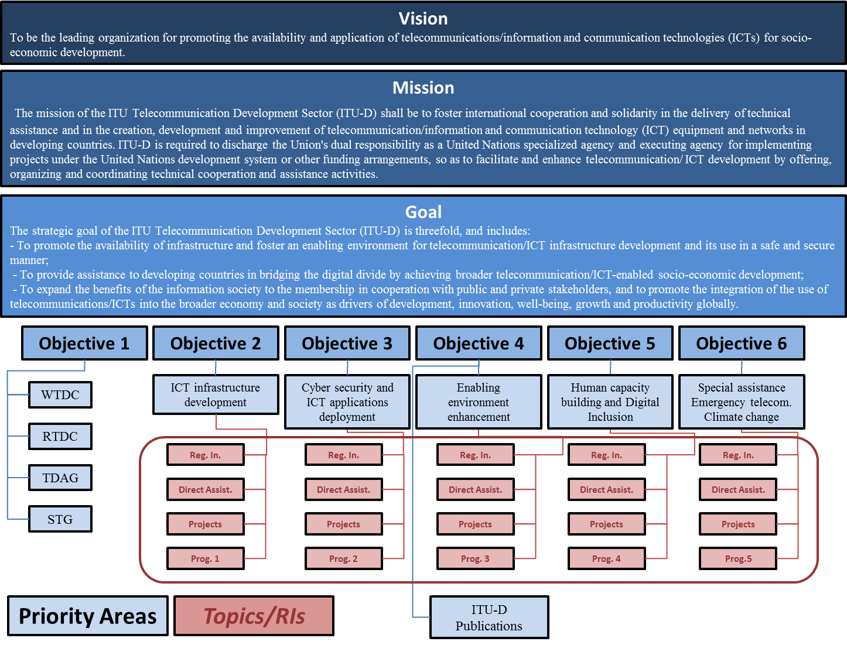
ANNEX II

Framework for determining the future objectives and topics for ITU-D work

CURRENT OBJECTIVES | OUTPUTS  2011-2014 | PRIORITY AREAS AND TOPICS OF ASP REGION | NEW PROPOSAL OF OBJECTIVES TO WTDC 2014
OBJECTIVE 2  “To assist the membership in maximizing the utilization of appropriate new technologies, including broadband, to develop their telecommunication/ICT infrastructures and services, and to design and deploy resilient telecommunication/ICT network infrastructures.” | - PROGRAMME 1  -RDF, events, workshops  - Conformation and interoperability  - Transition from analogue to digital broadcasting  - Broadband wireless infrastructure  - Spectrum management  - REGIONAL INITIATIVES  - DIRECT ASSISTANCE  - PROJECTS | TO BE EXAMINED AND ANALYZED TAKING INTO ACCOUNT INPUTS FROM MEMBERS (TO BE CONTINUED)  Current Proposals  - Broadband networks  - Next generation infrastructure  - Infrastructure in rural areas  - Human exposure to electromagnetic fields  - Interoperability of services  - Wireless broadband planning  - IPv6 deployment  - Infrastructure sharing  - Energy efficiency  - E-Waste | TO BE FURTHER DEVELOPED DURING THE PREPARATORY PROCESS TO WTDC 2014
OBJECTIVE 3  “To foster the development of strategies to enhance the deployment, and the safe, secure, and affordable use of ICT applications and services towards mainstreaming telecommunications/ICTs in the broader economy and society.” | OUTPUT IN DOC. 2 (REV. 1)  - CYBERSECURITY AND ICT APPLICATIONS DEPLOYMENT  - Enhanced and new e-health  - ICT for Governance  - Assisatnce provided to deploy ICT Applications on Mobile Platforms  - Cybersecurity  - PROJECTS | TO BE EXAMINED AND ANALYZED TAKING INTO ACCOUNT INPUTS FROM MEMBERS (TO BE CONTINUED)  Current Proposals  - Cloud computing  - e-Health  - e-Education  - m-Payments  - m-Governance  - Child online protection  - Security of networks | TO BE FURTHER DEVELOPED DURING THE PREPARATORY PROCESS TO WTDC 2014
Objective 4  “To assist the membership to create and maintain an enabling policy and regulatory environment, including the establishment and implementation of sustainable national policies, strategies and plans, through sharing best practices and collecting and disseminating statistical information on telecommunication/ICT developments.” | OUTPUT IN DOC. 2 (REV. 1) | TO BE EXAMINED AND ANALYZED TAKING INTO ACCOUNT INPUTS FROM MEMBERS (TO BE CONTINUED)  Current Proposals  - Tariff policies  - Quality of experience  - Regulatory framework for Cable Landing Station (CLS)  - Regulatory models  - Triple play services  - Cybersecurity  - User related issues | TO BE FURTHER DEVELOPED DURING THE PREPARATORY PROCESS TO WTDC 2014
Objective 5  “To build human and institutional capacity in order to improve skills in the development and use of telecommunication/ICT networks and applications, and to foster digital inclusion for people with special needs, such as persons with disabilities, through awareness raising, training activities, sharing information and know-how and the production and distribution of relevant publications.” | OUTPUT IN DOC. 2 (REV. 1) | TO BE EXAMINED AND ANALYZED TAKING INTO ACCOUNT INPUTS FROM MEMBERS (TO BE CONTINUED)  Current Proposals  - Multi stakeholder empowerment of ICT Volunteers  - Centers of Excellence  - Human exposure to electromagnetic fields | TO BE FURTHER DEVELOPED DURING THE PREPARATORY PROCESS TO WTDC 2014
Objective 6  “To provide concentrated and special assistance to least developed countries (LDCs) and countries in special need, and to assist ITU Member States in responding to climate change and integrating telecommunications/ICTs in disaster management.” | OUTPUT IN DOC. 2 (REV. 1) | TO BE EXAMINED AND ANALYZED TAKING INTO ACCOUNT INPUTS FROM MEMBERS (TO BE CONTINUED)  Current Proposals  - Unique needs of SIDS, LDCs and LLDCs | TO BE FURTHER DEVELOPED DURING THE PREPARATORY PROCESS TO WTDC 2014

ANNEX III

Context of focused use of Resources to achieve Universal access in Telecommunications / ICTs

i. The main mission of ITU states that ITU as a preeminent Intergovernmental organization with membership from Member States, Sector members and associates enables and fosters growth of Telecommunication networks and services to facilitate universal access.

ii. The ITU strategy document (ANNEX TO RESOLUTION 71 (Rev. Guadalajara, 2010)
Strategic plan for the Union for 2012-2015) under sub head, The changing telecommunications / ICT environment and its implications for the Union, clause no. 2.2.3 states “the need to make optimal use of the established scarce financial and human resources available for the Union's activities and to make every effort to enhance these resources required in order for ITU to meet its responsibilities and challenges for the benefit of its membership, particularly developing countries”.

iii. Further, need for effective and efficient use of human, financial and capital resources of the union is taken as Objective 4 of the General Secretariat.

Synergy among facilitators

iv. In this context, synergy is critical among the international and intergovernmental organizations working towards Telecommunication/ICT development in the world and specifically for the developing countries. As we progress to accomplish the mission, it is observed that different agencies and organizations such as ITU, World Bank, Other units of UN, IFC etc have been working and contributing in Telecommunications/ICTs in developing countries.

v. The Tunis agenda (Document no. WSIS-05/TUNIS/DoC/6 (Rev. 1) Annex indicates possible Moderators/Facilitators for different action lines. There are several action lines which have multiple agencies as facilitators along with ITU.

vi. Further, from the world bank report 2012-15, there are many aspects and development activities telecommunications for the region and specific to countries that are planned and being implemented. For example even the world bank (WB) strategy has identified its strategy as:

vii. Going forward the WB will follow a new ICT strategy, comprising three pillars. It will promote ICTs to transform services for greater development impact—strengthening accountability and governance, improving public services, and enabling more inclusive private delivery of services (Transform pillar). It will advance ICTs to improve competitiveness and accelerate innovation across the economy and target skills development for ICT-related jobs (a large portion known to be going to women) to improve productivity (Innovate pillar). And it will scale up its support for policy reforms and private and public-private ventures to catalyze investment in broadband infrastructure and expand access to broadband services, including for women (Connect pillar). A gist of WBG interventions are presented in fig 1.

Issue for the Discussion

viii. On similar lines there may be many other International agencies working on development of ICTs on different fronts. Appreciating the fact that resources are limited whereas the objective of ITU on universal access is enormous considering that it also includes broadband access. . Hence there is an inherent need to have a new program exclusively to build synergy on the work happening in Telecommunications/ICTs under various organizations at international level for different countries. ITU being the lead, preeminent intergovernmental organization on Telecommunications/ICTs, the ITU should initiate a 6th program on building synergy among various global organizations working on the subjects covered in the programs from 1 to 5.

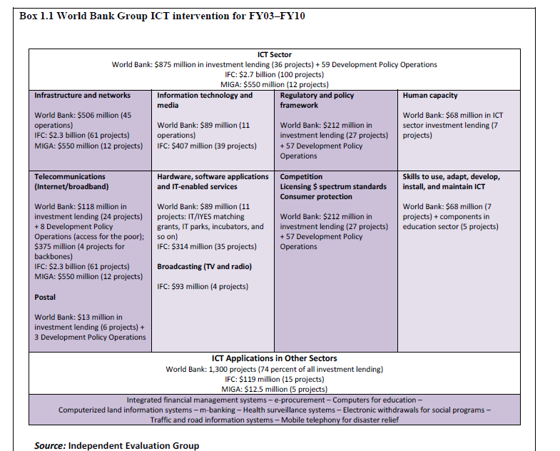
Fig. 1

ix. The outcome of the synergy program is to map on the activities of various agencies on Telecommunications/ICTs on each country and region so that efforts and resources are accentuated and focused.

x. This will accomplish the following objectives:

- Visibility about what is to be accomplished in specific countries.
- Optimal and focused use of resources
- Synergy among the programs

xi. It is suggested that this could be driven by the ITU-D’s innovaiotn and partnership department (IP) considering the synergy activities it is already doing between ITU-D study groups, Programs and special initiatives.

Comments, Suggestions or Contributions are invited from the APT members on the subject.

The following 5 programmes are appropriately identified by the ITU Membership during WTDC-10; Programme 1: Information and communication infrastructure and technology development ; Programme 2: Cybersecurity, ICT applications and IP-based network-related issues ; Programme 3: Enabling environment ; Programme 4: Capacity building and digital inclusion ; Programme 5: Least developed countries, countries in special need, emergency telecommunications and climate change adaptation.
ANNEX IV

A Repository and indicative analysis of Policies as part of creating Enabling Environment

Context – Enabling Policy and Regulatory environment

i. The first strategic goal of ITU-D speaks about fostering enabling environment for telecommunication / ICT infrastructure for development. Further, the focus of objective 4 is on creating and maintaining enabling policy and regulatory environment including the establishment and implementation of sustainable national polices, strategies and plans..

ii. The ICT success stories and various research reports underscore the importance of enabling environment for creation and application of Telecommunication / ICT infrastructure. Aptly, the ITU data also includes some indicators on availability of national broadband policies. The WSIS Action line C6 gives special importance for the open, efficient and secure policy and regulatory environment. The action line also stresses the urgency of adapting frameworks and enabling policies. The ITU is working through direct assistance, sharing best practices in developing policies

Issue for the discussion

iii. In this context, recognizing that availability of Telecommunication/ICT policies is an important contributor for enabling environment, it is proposed that the ITU should take up mapping of various policies in the countries (under different categories such as mobile services, broad band services, converged services, security aspects etc.) and make them available at a repository. A proactive indicative analysis of gaps in the policies in respective areas could be made available to the developing countries.

iv. The above will accomplish the following objectives:

- It provides visibility to the members on policies available on the subject in different countries.
- Strategically enables policy makers of the Members for a quick analysis of policy gaps in their enabling environment.
- Provides a methodology and systematic assessment of status of policies in the context of enabling environment.

Comments, Suggestions or Contributions are invited from the APT members on the subject.

ANNEX V

Capacity development at Grassroots level

i. The objective 5 of ITU-D speaks about building human and institutional capacity in order to improve skills in the development and use of telecommunication/ICT networks and applications…

ii. The ITU-D strategy document provides the details of outputs under the objective 5 that it will make available high quality training resources, materials and curricula in telecommunication and ICTs.

iii. The ITU Membership for Academia reflects the spirit of objective 5 to make academic institutions part of ITU activities and empower them with its resources taking capacity building to the gross root level. This is supposed to have the following impact;

- Enrich the curricula of the academic institutes in Telecommunications/ICTs.
- Make high quality resources available to a bigger audience enabling larger participation of students and academic fraternity in the ITU activities.
- Accomplishing important objective of expanding the benefits of information society to the membership (ITU-D strategic goal)

Issue for discussion

iv. In spite of the best intentions, the fact is, the academia membership has actually not taken off. Currently, the academia membership is 61 (16 ITU-D, 15 ITU-R, 41 ITU-T; Univ: 16 ITU-D, 15 ITU-R, 41 ITU-T; The situation demands a new strategy and a different level of engagement to create ITU relevance for the academic institutions.

Comments, Suggestions or Contributions are invited from the APT members on the subject.

ANNEX VI

With regard to issues proposed for discussion, some relevant inputs have been received from Australia. These inputs are presented below along with some clarifications from the Working Group for information to the Members.

- Building synergies

- Comments from Australia:
Australia agrees that building synergies is important for ensuring the work of the ITU-D is effective. Australia considers this to be an ongoing issue and as such, the issues paper could benefit from reflecting on existing work. For example, there are a number of existing WTDC Resolutions of relevance, including Resolution 21 (coordination and collaboration with regional organisations), Resolution 30 (role of ITU-D in implementing outcomes of the WSIS) and Resolution 32 (international and regional cooperation on regional initiatives).

- Comments from the Working Group
As observed by Australia, building synergy is important for ensuring the work of ITU-D to be effective. The WTDC resolution 21, 30 and 32 are relevant and they state the following.

- The said resolutions speak on :

Resolution 21 – Coordination and collaboration with regional organizations –
Resolution 30 – role of ITU telecommunication development sector in implementing the outcomes of the world summit on the information society
Resolution 32 – International and regional cooperation on regional initiatives

b. The above resolutions also speaks about partner and facilitator roles defined for ITU in conjunction with other organizations identified to accomplish WSIS targets. We are yet to analyze any outcome documents on synergies built based on above resolutions on ITU-D engagement with other international organizations. Further, with respect to internal coordination with other two sectors (T& R), liaison statements are issued to exchange the status and mutual cooperation on common areas of interest. However, with regard to other international organizations, we may need to develop plans (if already not done) chalking out engagement plans and strategy for development in ICTs. We appreciate the update from BDT that it has organized several activities and workshops with UNIDO, ASEAN, WHO, UNODC, UNESCAP, UNESCO etc., (Document RPM-ASP13/2 Rev.1-E 11 April 2013). Further, there is no other information with respect to other ITU-D programs. The draft issue paper also mentions about some ICT projects being implemented under world bank. This may be the case with other international organizations as well.

c. Further, as explained in the issue paper, monitoring for synergy is a constant process and it requires focused approach. The resolution 32 also states that (para d under considering) ‘the continued lack of funding from the united nations development programme (UNDP) and other international financial institutions further impedes the implementation of international cooperation projects for regional initiatives’. In this context, it would be beneficial as part of strategy to develop strategic partnership plans with other international organizations on working and funding on ICTs in developing countries.

- Mapping Telecommunication Policies

- Comments from Australia

In relation to this issue Australia would highlight the ongoing work of the ICT EYE. This interactive tool provides information on telecommunication/ICT indicators and statistics, regulatory and policy information, national tariff policies and costing practices among other things. It is an output of the ITU-D under Objective 4 (enabling environment). Australia suggests that it might be useful to reflect this existing tool in the issues paper.

- Comments from Working Group

The ICT EYE is a very good interactive tool providing information on statistics, Regulatory and Tariff information. However, the ICT eye does not provide the information with respect to Telecommunication policy contents. For example, if we would like to check specific policy details the weblinks may not work as the case may be, as changes are dynamic.

As suggested, we will include the details of the tool, ICT eye, in the issues paper while seeking inputs from the Members.
Suppose, if we would like to know on ‘consumer protection’ what measures are taken, the ICT eye may not be able to offer instantly, though it serves good purpose on several other issues for comparison of whether there is such a policy or not. The context raised in the issue paper is about policies form the base of enabling environment. Here we are trying to look at the analysis of policies to identify areas to work on further to support the developing countries.

- ITU Academia Membership

- Comments from Australia:

Australia considers that this issue covers all ITU sectors, not only the ITU-D. As such, it would be more appropriate to consider in the context of PP-14 preparations.

- Comments from Working Group

As rightly observed, academia membership issue is applicable to all ITU sectors and not only to the ITU-D. However, the academia membership is different for different sectors. As on today, the academia membership for different sectors is: ITUD-16; ITU-R-15; ITUT-42. Further, what is offered to academia from different ITU sectors is significantly different by nature as one deals with technical standards and other deals with development aspects of ICTs. As, Academia membership for ITU-D is development oriented and not technology centred, the strategy and approach to attract Membership may vary with respect to other sectors. Hence, the inputs are sought on the subject as part of this issue paper.

We thank Australia for raising the issues to bring clarity and forward the discussion on the subject.

