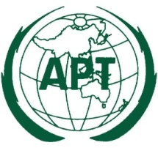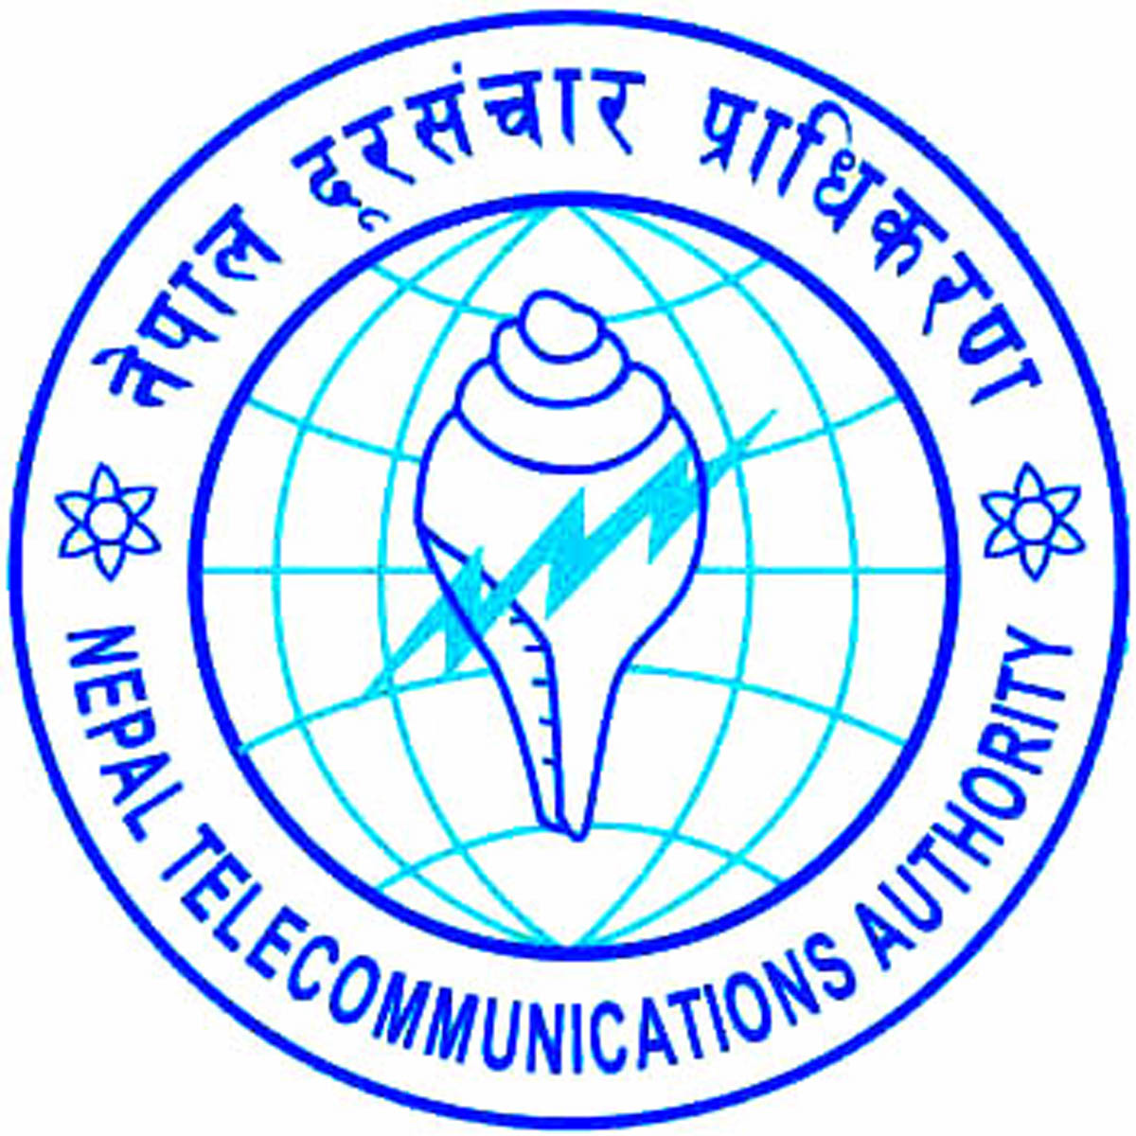
Workshop of the SATRC Working Group on Policy, Regulation and Services
21 – 23 December 2015, Pokhara, Nepal

PARTICIPANT’S INFORMATION
Workshop of South Asian Telecommunication Regulators’ Council (SATRC) Working Group on “Policy, Regulation and Services” would be held from 21-23 December 2015 in Pokhara, Nepal. The event will be organized by the Asia-Pacific Telecommunity (APT) and hosted by Nepal Telecommunications Authority (NTA)

Followings are the information for the participants.

1. Venue
Venue: Hotel Pokhara Grande

Address: Pardi, Pokhara
Tel: +977-61-460210
Fax: +977-61-460211
Website: www.pokharagrande.com

2. Participation:
All SATRC Members and Affiliate Members from STARC countries can attend the meeting free of charge by completing online Registration Form available at http://www.apt.int/content/online-registration. For making necessary arrangement you are kindly requested to register online by 7 December 2015 .

3. Hotel Accommodation:
There are more than 250 tourist category hotels and lodges in Pokhara of which two (the Fulbari Resort and Pokhara Grande) are ranked 5-star. Pokhara provides lodging and food from backpackers to deluxe ranges.
For the convenience of the participants, it is recommended to stay in the following assigned hotel. The details are mentioned below:-
Name of the Hotel | Room Type | Room Rate per night
Hotel Pokhara Grande  Pardi, Pokhara | Deluxe Room | Single: USD 80 + 24.3% taxes on B/B per night  Double: USD 90 + 24.3% taxes on B/B per night
Note:
- The prices are subject to availability and subject to change.
- Airport pick-up available upon prior intimation. Managed by Hotel.
- Breakfast included in room rates.

For Room reservation you are requested to contact Ms. Riya Thapa, Asst. Sales Manager (se@pokharagrande.com) or Mr. Hiranya Prasad Bastakoti (hpbastakoti@nta.gov.np), Assistant Director, ICT development and International Relation, Nepal Telecommunications Authority (NTA). For any assistance SATRC Secretariat can be contacted.

You are kindly requested to finalize the hotel reservation and other necessary arrangement by the 1 December 2015. Secretariat may not be able to guarantee hotel reservation after the closing date.

4. Meeting Website Meeting Documents and Contribution Guideline:
Related information about the meeting and provisional meeting documents will be available at the APT Website: www.apt.int/2015-SATRC-WSPRS.

For any information on the documentation please contact:
Mr. Forhadul Parvez
Project Coordinator, Radiocommunication
Phone: +66 2 573 0044 (Ext: 117)
E-mail: parvez@apt.int

APT encourages the use of electronic documents during the meeting. Members are encouraged to carry their Laptop computers for the meeting.

5. Immigration Requirements
Participants must be in possession of a valid passport or travel document with a minimum validity of six months beyond the period of stay and need to check visa requirements before entering the country. Participants are also advised to obtain, before the commencement of their journey, and where necessary, transit visas for countries en route to Nepal. As the visa requirements change from time to time, it is advisable to check your visa requirements with the nearest Nepali Embassy before departure.
Visa supporting letter can be issued on request. Please submit the following information along with a copy of passport to local secretariat coordinator for the visa supporting letter.
Full Name
Passport Number
Date of Issue
Date of Expiry
Nationality
Date of Birth

6. Registration:
The registration counter will be set up in the foyer of the meeting hall commencing at 09:00 hours on 21 December 2015 at the meeting venue.

7. Arrival and Transportation:
Considering the travel distance to Pokhara, it is advised that the participants to arrive Kathmandu on 19 December 2015 and stay overnight at Kathmandu. On 20 December 2015, participants will go to Pokhara by bus arranged by NTA. The same will be in case of departure from Pokhara. Travel time by bus will be approximately 6 hours. Delegates will go back to Kathmandu on 24 December 2015 by bus arranged by NTA and will stay overnight in Kathmandu or take flight from Kathmandu to final destination.
During the transit in Kathmandu delegates are requested to stay at the following hotel from where the bus will depart to and arrive from Pokhara:
Name of the Hotel | Room Type | Room Rate per night
Hotel Manang  Thamel, Kathmandu  For reservation please contact Local Secretariat. | Standard Room | Single: USD 55 + 24.3% taxes on B/B per night including Breakfast  Double: USD 60 + 24.3% taxes on B/B per night including Breakfast
The above mentioned hotel also provides Airport pick-up and drop to/from hotel subject to prior intimation.
Flight from Kathmandu to Pokhara: A number of domestic flights available everyday between Kathmandu and Pokhara. Among those are Yeti Airlines (www.yetiairlines.com) and Buddha Air (www.buddhaair.com). Participants who wants to use flights to save time can arrange their own flights from website at their own cost and own arrangements. The venue hotel provides airport (Pokhara) pick-up and drop to/from hotel subject to prior intimation.
For any further arrangements or difficulties, NTA office can be contacted. All participants are requested to contact NTA secretariat for any assistance in making the arrangement.

8. Practical Information about Pokhara
Pokhara lies in the centre of Kaski District, Gandaki Zone. Pokhara is the second largest city of Nepal with an area of 55.66 km2 and a population of around 255,000 according to 2011 census. However, the Pokhara valley has an area of 125 km2. The city is located at an altitude of 727 meters to 980 meters and approximately 200 km west of the country's capital, Kathmandu. Three out of the ten highest mountains in the world — Dhaulagiri, Annapurna I and Manaslu — are within 48 Kms. of the city. Due to its proximity to the Annapurna mountain range, the city is also a base for trekkers undertaking the Annapurna Circuit through the ACAP region of the Annapurna ranges in the Himalayas.
It is the second most expensive city in the country after Kathmandu.
Pokhara is in the northwestern corner of the Pokhara Valley, which is a widening of the Seti Gandaki valley that lies in the midland region of the Himalayas. In this region the mountains rise very quickly and within 30 km, the elevation rises from 1,000 m to over 7,500 m. Seti Gandaki is the main river flowing through the city. Seti Gandaki (White River) and its tributaries have created several gorges and canyons in and around the whole city which gives intriguingly long sections of terrace features to the city and surrounding areas. These long sections of terraces are interrupted by gorges which are hundreds of meters deep.
In the south, the city borders on Phewa Tal (4.4 km2) at an elevation of about 827 m above sea level. 3 Eight-thousand meter tall peaks (Dhaulagiri, Annapurna, Manaslu) can be seen from the city. The Machhapuchhre (Fishtail) with an elevation of 6,993 m is the closest to the city. The porous underground of the Pokhara valley favours the formation of caves and several caves can be found within the city limits. The famous caves are Mahendra Gupha (Cave) and Bat Cave. In the south of the city, a tributary of the Seti flowing out of the Phewa Lake disappears at Patale Chhango, also called Davis Falls, after someone who supposedly fell into the falls into an underground gorge, to reappear 500 metres further south.
9. Weather
The climate of the city is sub-tropical; however, the elevation keeps temperatures moderate. Summer temperatures average between 25 to 33 °C, in winter around - 2 to 15 °C. Pokhara and nearby areas receive a high amount of precipitation. Summer is humid and mild; most precipitation occurs during the monsoon season (July - September). Snowfall is not observed in the valley, but surrounding hills experience occasional snowfall in the winter.Winter and spring skies are generally clear and sunny.
Average Temperature during December in Pokhara
Maximum | Minimum | Daily Mean | Average Precipitation
21°C | 8°C | 14 °C | 22 mm

10. Language
Nepali is the official language and English is widely used throughout Nepal.

11. Time Zone
GMT + 5:45 hours

12. Banks & Currency
The unit of currency is Nepali Rupees which comes in denominations of 1, 2, 5, 10, 20, 50, 100, 500 and 1000. Please use authorized money changers and banks to change currency. They will issue a certificate of exchange which is required at the time of re-conversion of any unused currency. The currency may be exchanged at the airport on arrival. Foreign Exchange Rate is approximately NRs.106 to USD 1 (as on September 14th, 2015)

Most hotels and departmental shops accept credit cards.

13. Insurance
Due to procedural difficulties and budgetary constraints, APT is not able to bear the cost of insurance for the participants, any medical expenses or any other expenses. APT therefore requests your Administrations/organizations to kindly make necessary arrangements for insurance and medical coverage of your participants before travel.

14. Contact Information:

APT Secretariat  Mr. Forhadul Parvez  Project Coordinator, Radiocommunication  Asia Pacific Telecommunity  APT Secretariat  12/49 Soi:5 Chaengwatana Road  Bangkok 10210 Thailand  Phone: +66 2 573 0044 (Ext.:117)  Fax: + 66 2 573 7479  E-mail: parvez@apt.int; parvez@ties.itu.int | Local Secretariat  Mr. Hiranya Prasad Bastakoti  Assistant Director  ICT development and International Relation,  Nepal Telecommunications Authority (NTA)  Tel: +977-1-4255474, 4256054  Mob: +977-9851175117  E-Mail: hpbastakoti@nta.gov.np

