|  |  |  |  |
| --- | --- | --- | --- |
| APTlogogreen3 | ASIA-PACIFIC TELECOMMUNITY | | **Document:** |
| **The 21st Meeting of the APT Wireless Group (AWG-21)** | **AWG-21/INP-42** | |
| 3 – 7 April 2017, Bangkok, Thailand | 17 March 2017 | |

Nokia Pte Ltd Singapore, Ericsson Thailand, Ericsson Vietnam and Qualcomm Hong Kong

**STATUS UPDATE on 3GPP LTE V2X STANDARDS and PROPOSED MODIFICATIONs TO THE WORKING DOCUMENT TOWARD REVISION OF APT REPORT ON “THE USAGE OF ITS in APT COUNTRIES”**

**1 Introduction**

During AWG-20 in August 2016, the status of 3GPP work on specifying the standards for ITS using LTE V2X technology was reported in TG-ITS. (AWG-20/INP-60)

The text regarding the 3GPP activity on the LTE V2X standardization and the reference to the completed technical repots were included in the working document toward revision of APT Report on *’The usage of ITS in APT countries‘* (**APT/AWG/REP-18 Rev.2**). (AWG-20/TMP-44).

Since AWG-20, 3GPP TSG-RAN has worked on finalizing the technical specifications for LTE V2X radio access and completed the set of core specifications, first V2V related specifications in 3GPP TSG-RAN#73 meeting in September 2017 and overall V2X specifications in 3GPP TSG-RAN#75 meeting in March 2017.

In Table 1, the relevant 3GPP specifications on the service, architecture and radio access specifications are listed for information.

**Table 1 3GPP specifications on LTE V2X service, architecture and radio access network**

|  |  |
| --- | --- |
| 22 Series  (Service Requirements) | TS 22.185 Service requirements for V2X services  TR 22.885 Study on LTE support for Vehicle to Everything (V2X) services, 3GPP |
| 23 Series (Architecture) | TS 23.285 Architecture enhancements for V2X services  TR 23.785 Study on architecture enhancements for LTE support of V2X services |
| 36 Series  (Radio Access) | TS 36.101 Evolved Universal Terrestrial Radio Access (E-UTRA); User Equipment (UE) radio transmission and reception  TS 36.133 Evolved Universal Terrestrial Radio Access (E-UTRA); Requirements for support of radio resource management  TS 36.211 Evolved Universal Terrestrial Radio Access (E-UTRA); Physical Channels and Modulation  TS 36.212 Evolved Universal Terrestrial Radio Access (E-UTRA); Multiplexing and channel coding  TS 36.213 Evolved Universal Terrestrial Radio Access (E-UTRA); Physical layer procedures  TS 36.214 Evolved Universal Terrestrial Radio Access (E-UTRA); Physical layer;  Measurements  TS 36.300 Evolved Universal Terrestrial Radio Access (E-UTRA) and Evolved Universal Terrestrial Radio Access Network (E-UTRAN); Overall description;  Stage 2  TS 36.302 Evolved Universal Terrestrial Radio Access (E-UTRA); Services provided by the physical layer  TS 36.304 Evolved Universal Terrestrial Radio Access (E-UTRA); User Equipment (UE) procedures in idle mode  TS 36.306 Evolved Universal Terrestrial Radio Access (E-UTRA); User Equipment (UE) radio access capabilities  TS 36.321 Evolved Universal Terrestrial Radio Access (E-UTRA); Medium Access Control (MAC) protocol specification  TS 36.322 Evolved Universal Terrestrial Radio Access (E-UTRA); Radio Link Control (RLC) protocol specification  TS 36.323 Evolved Universal Terrestrial Radio Access (E-UTRA); Packet Data Convergence Protocol (PDCP) specification  TS 36.331 Evolved Universal Terrestrial Radio Access (E-UTRA); Radio Resource Control (RRC); Protocol specification  TS 36.413 Evolved Universal Terrestrial Radio Access Network (E-UTRAN); S1 application protocol (S1AP)  TS 36.423 Evolved Universal Terrestrial Radio Access Network (E-UTRAN); X2 application protocol (X2AP)  TR 36.785 Vehicle to Vehicle (V2V) services based on LTE sidelink; User Equipment (UE) radio transmission and reception  TR 36.786 V2X Services based on LTE; User Equipment (UE) radio transmission and reception  TR 36.885 Study on LTE-based V2X services, 3GPP |

**2 Proposal**

It is proposed to revise the activity summary of 3GPP in clause 6, update the reference to the standard specifications in clause 6.1.3 regarding LTE V2X and the related acronyms in clause 3 It is also proposed to include the use-cases descriptions for advanced ITS radiocommunications in clause 6.

Attachment: 1

TG ITS

**WORKING DOCUMENT TOWARD REVISION OF APT REPORT ON**

**“THE USAGE OF ITS in APT COUNTRIES”**

**(APT REPORT#18 (REV.2))**

[Source: AWG-20/INP-37 (rev.1)]

TABLE OF CONTENTS

1 Scope

2 Related documents

3 List of acronyms and abbreviations

4 Overview of ITS radiocommunication and automotive radar

4.1 ITS radiocommunication

4.1.1 Terms and definitions

4.1.2 Technical characteristics

4.2 Automotive radar

4.2.1 Terms and definitions

4.2.2 Technical characteristics

5 [Legacy] ITS radiocommunications - ETC

5.1 Overview

5.1.1 Technical characteristics

5.1.2 Frequency usage

5.1.3 Standardization

5.1.4 Applications

5.2 Asia-Pacific

5.2.1 Technical characteristics

5.2.2 Frequency usage

5.2.3 Standardization

5.2.4 Applications

6 Advanced ITS radiocommunications

6.1 Overview

6.1.1 Technical characteristics

6.1.2 Frequency usage

6.1.3 Standardization

6.1.4 Applications

6.2 Asia-Pacific

6.2.1 Technical characteristics

6.2.2 Frequency usage

6.2.3 Standardization

6.2.4 Applications Millimeter-wave automotive radar

7.1 Overview

7.1.1 Technical characteristics

7.1.2 Frequency usage

7.1.3 Standardization

7.1.4 Applications

7.2 Asia-Pacific

7.2.1 Technical characteristics

7.2.2 Frequency usage

7.2.3 Standardization

7.2.4 Applications

8 Conclusions

*[Editor’s note: All the texts may be addressed in future contributions to this document.]*

*[Editor’s note: Renumbering is required for the figures and tables.]*

**1 Scope**

This report addresses the usages of Intelligent Transport Systems (ITS) radiocommunication applications, such as vehicle to infrastructure, vehicle to vehicle, vehicle to pedestrian communications for road safety applications and automotive radars for collision avoidance in APT Member countries.

**2 Related documents**

**ITU-R Recommendations:**

ITU-R M.1890 Intelligent transport systems – Guidelines and objectives

ITU-R M.1452 Millimetre wave radiocommunication systems for Intelligent Transport   
 Systems applications

ITU-R M.1453 Intelligent Transport Systems – dedicated short-range communications   
 at 5.8 GHz

ITU-R M.2057 Systems characteristics of automotive radars operating in the frequency   
 band 76-81 GHz for intelligent transport systems applications

ITU-R M.2084 Radio interface standards of vehicle-to-vehicle and   
 vehicle-to-infrastructure communications for Intelligent Transport System   
 applications

**ITU-R Report:**

ITU-R M.2228 Advanced intelligent transport systems (ITS) radiocommunications

ITU-R M.2322 Systems characteristics and compatibility of automotive radars operating in the frequency band 77.5-78 GHz for sharing studies

**ITU-R Handbook:**

Land Mobile (including Wireless Access) - Volume 4: Intelligent   
 Transport Systems

**3 List of acronyms and abbreviations**

3GPP The 3rd Generation Partnership Project

APT Asia-Pacific Telecommunity

ARIB Association of Radio Industries and Businesses

ATIS Alliance for Telecommunications Industry Solutions

AWG APT Wireless Group

CCSA China Communications Standards Association

CEN European Committee for Standardization

CEPT European Conference of Postal and Telecommunications Administrations

ECC Electronic Communications Committee

ETSI European Telecommunications Standards Institute

FCC Federal Communications Commission

IEEE Institute of Electrical and Electronics Engineers

ISO International Organization for Standardization

ITS Intelligent Transport Systems

LTE Long Term Evolution

LTE-V2X LTE based Vehicle to Infrastructure/Vehicle/Network/Pedestrians and others

RLAN Radio Local Area Network

TIA Telecommunications Industry Association

TSAC Telecommunications Standards Advisory Committee

TTA Telecommunication Technology Association

WLAN Wireless Local Area Network

C-ITS Cooperative ITS communication

V2I Vehicle to Infrastructure

V2N Vehicle to Network

V2P Vehicle to Pedestrians and Vulnerable Road Users

V2V Vehicle to Vehicle

V2X  Vehicle to Everything. This addresses V2I, V2N, V2P and V2V

**4 Overview of ITS radiocommunication and automotive radar**

Since several decades ago, traffic congestion has been increasing all over the world as a result of increased motorization, urbanization, population growth, and changes in population density. Congestion reduces efficiency of transportation infrastructure and increases travel time, air pollution, and fuel consumption. Interest in Intelligent Transport Systems (ITS) comes from the problems caused by traffic congestion and a synergy of new information technology for simulation, real-time control, and communications networks. Namely, ITS is systems to support transportation of goods and humans with information and communication technologies in order to efficiently and safely use the transport infrastructure and transport means (cars, trains, planes, ships)[1].

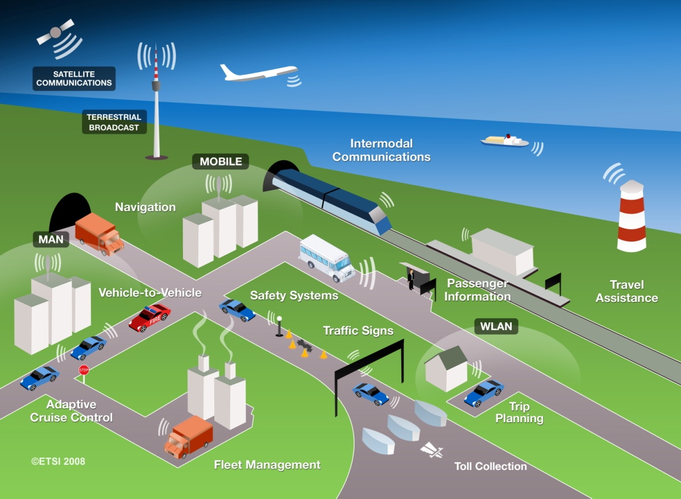

**Figure 1 Communication technologies and services for ITS[2]**

ITS have been standardized and studied in various standards development organizations. As an international level, ITU-R ISO TC 204, and IEEE are working on developing the standards and recommendations.

In Asia-Pacific, AWG is working as a regional level as well as ARIB, TTA, TSAC and other standard organizations in each countries and regions. In Europe, ETSI TC ITS and CEN TC278 are working as a regional level.

This Report identifies current and planned usage of ITS technologies, frequency bands, status of applications deployment in APT member countries.

Based on the major deployed ITS systems in the world were classified as electronic toll collection, automotive radar, and vehicle information & communication. In this report, we described applications overview, established standards, frequency plan, and implication in each ITS system.

**4.1 ITS radiocommunication**

Electronic toll collection allows for the manual in-lane toll collection process to be automated in such a way that drivers do not have to stop and pay cash at a toll booth. ETC systems improve traffic flow at toll plazas, and the level of pollution by reducing fuel consumption. In addition, allowing traffic to pass through the gate without stopping can increase road capacity by three or four times and relieve traffic congestion at the tollgate. It is also expected that ETC systems will reduce the operating costs of toll roads by replacing manual toll collection.

Since 1994, Vehicle Information and Communication System (VICS) has been using in Japan for delivering traffic and travel information to road vehicle drivers.

Nowadays, to extend beyond the existing ITS applications and to achieve traffic safety and reduce the environmental impact by the transportation sector, vehicle-to-vehicle (V2V), vehicle-to-infrastructure (V2I), infrastructure-to-vehicle (I2V) communications are studied. According to this progress, ITU-R WP 5A has developed report on advanced ITS radiocommunication[3]. In the report, legacy ITS and advanced ITS are classified by its technical characteristics as shown in Table 1, Wireless Access in Vehicular Environments (WAVE) and Continuous Access for Land Mobiles (CALM) technologies could be inclusive in advanced ITS category.

**4.1.1 Terms and definitions**

*[Editor’s note: Text to be added]*

**4.1.2 Technical characteristics**

**Table 1 Technical characteristic of legacy ITS and advanced ITS**

|  |  |  |
| --- | --- | --- |
| **Items** | **Legacy ITS** | **Advanced ITS** |
| Technologies | DSRC | WAVE, CALM, LTE-V2X |
| Vehicular networking | V2I | V2I, V2V, V2N, V2P |
| Radio performance | Radio coverage: Max. 100 m  Data rate: ~ 4 Mbps  Packet size: ~100 bytes | Radio coverage: Max. 1 000 m  Data rate: Max. 27 Mbps  Packet size: Max. 2 kbytes  Latency: within 100 msec  (V2V/V2I/V2N)  Within 1000msec (V2P) |

**4.2 Automotive radar**

Automotive radar facilitates various functions which increase the driver’s safety and convenience.

Exact measurement of distance and relative speed of objects in front, beside, or behind the car allows the realization of systems which improve the driver’s ability to perceive objects during bad optical visibility or objects hidden in the blind spot during parking or changing lanes. Radar technology has proved its ability for automotive applications for several years. Automotive radar systems are of two categories according to the applications and frequency band

− Adaptive Cruise Control 'long-range radar' (usually operating at 76 GHz band).   
This enables a vehicle to maintain a cruising distance from a vehicle in front.

− Anti-collision 'short-range radar' (usually operating at 24 GHz and 79 GHz bands).   
This is being developed as part of a system to warn the driver of a pending collision, enabling avoiding action to be taken. In the event where collision is inevitable, the vehicle may prepare itself (for example by applying brakes, pre-tensioning seat belts) to minimize injury to passengers and others.

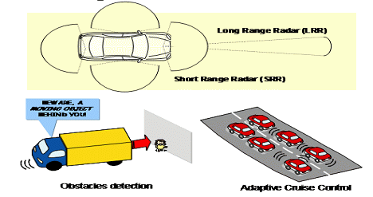

**Figure 2 Automotive radar**

**4.2.1 Terms and definitions**

*[Editor’s note: Text to be added]*

**4.2.2 Technical characteristics**

*[Editor’s note: Text to be added]*

**5 [Legacy] ITS radiocommunication - ETC**

*[Editor’s note: Text to be added]*

**5.1 Overview**

Electronic toll collection allows for the manual in-lane toll collection process to be automated in such a way that drivers do not have to stop and pay cash at a toll booth. ETC systems improve traffic flow at toll plazas, and the level of pollution by reducing fuel consumption. In addition, allowing traffic to pass through the gate without stopping can increase road capacity by three or four times and relieve traffic congestion at the tollgate. It is also expected that ETC systems will reduce the operating costs of toll roads by replacing manual toll collection.

There are many similar words related to ETC. In Europe, Electronic Fee Collection (EFC) is popularly used. They think that EFC covers ETC, Electronic Parking System (EPS), Electronic Road Pricing (ERP). ERP is usually referred to the electronic toll collection scheme adopted in Singapore for purposes of congestion pricing. To avoid confusion, these terminologies need to be clearly defined.

**5.1.1 Technical characteristics**

DSRC refers to a dedicated short range communication between a roadside infrastructure and vehicles or mobile platforms for ITS applications.

The two major components of DSRC are on-board equipment (OBE) and roadside equipment (RSE).

**On-board equipment (OBE):** OBE is attached near the dashboard or on the windshield of the vehicle, and consists of radiocommunication circuits, an application processing circuit and so on. It usually has a human-machine interface, including switches, displays and buzzer.

**Roadside equipment (RSE):** RSE is installed above or alongside the road and communicates with passing OBE by use of radio signals. RSE consists of radiocommunication circuits, an application processing circuit and so on. It usually has a link to the roadside infrastructure to exchange data.

DSRC systems operate by transmitting radio signals for the exchange of data between vehicle mounted OBE and RSE. This exchange of data demands high reliability and user privacy as it may involve financial and other transactions.

**5.1.2 Frequency usage**

*[Editor’s note: Text to be added]*

**5.1.3 Standardization**

**Table 2 Global Standard on ETC**

|  |  |  |
| --- | --- | --- |
| **SDO** | **Standard No.** | **Standard Title** |
| ITU | ITU-R M.1453-2 | Intelligent transport systems – dedicated short range communications at 5.8 GHz |

Dedicated Short Range Communication (DSRC) refers to any short-range radiocommunication technology from a roadside infrastructure to a vehicle or a mobile platform [4]. Although DSRC can be applied to various application of ITS (e.g. parking payment, gas (fuel) payment, in-vehicle signing, traffic information, etc), ETC is the most typical one. Table 2 shows the established DSRC standards.

**5.1.4 Applications**

DSRC is the use of non-voice radio techniques to transfer data over short distances between roadside and mobile radio units to perform operations related to the improvement of traffic flow, traffic safety and other intelligent transport service applications in a variety of public and commercial environments. DSRC services include vehicle control systems, traffic management systems, traveller information systems, public transportation systems, fleet management systems, emergency management systems and electronic payment services.

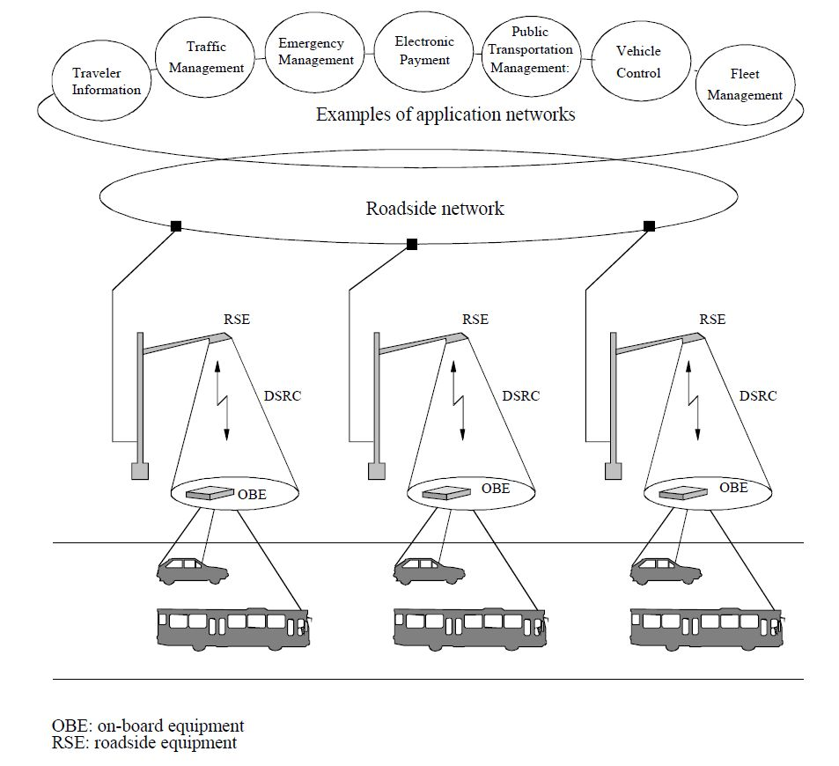

**Figure 3 Interrelation of DSRC with ITS communication networks**

**5.2 Asia-Pacific**

**5.2.1 Technical characteristics**

**(1) Active (transceiver) method**

The Japanese DSRC System adopts the active (transceiver) method. For the active (transceiver) method, the on-board equipment (OBE) is equipped with the same functions as roadside equipment (RSE) which is equipped with devices necessary for radiocommunication. More specifically, both RSE and OBE incorporate a 5.8 GHz band carrier frequency oscillator and have the same functionality for radio transmission. Figure [4] shows a typical block diagram for the OBE’s radio circuitry. The upper half of Figure [4] is the receiver, the lower half is the transmitter and the processing unit is to the right. The transmission and reception antennas may be shared. The OBE in the active (transceiver) method receives radio signals from the RSE with the antenna on the upper left. Each signal received passes through each functional block and is processed by the main processing unit as reception data. The transmission signal from the OBE is the 5.8 GHz band carrier signal from oscillator A modulated with transmission data. The signal is sent from the antenna on the bottomleft.

The active (transceiver) method can easily realize small or large communication zones by controlling the directivity of transmission antenna. Figure [5] shows examples of flexible communication zones forming in the typical configuration of the ETC gate. The footprint (communication zone) of an ETC antenna is very small (typically 3 m x 4 m). On the other hand, a large footprint of up to 30 meters in length can be realized by approach antenna for information dissemination. The Bit Error Rate (BER) within the footprints is very low (Less than 10-6). The main feature of the active (transceiver) method is a flexible zone forming, in addition to large volumes of information to be communicated with high reliability. These characteristics are indispensable for various ITS application services using DSRC.

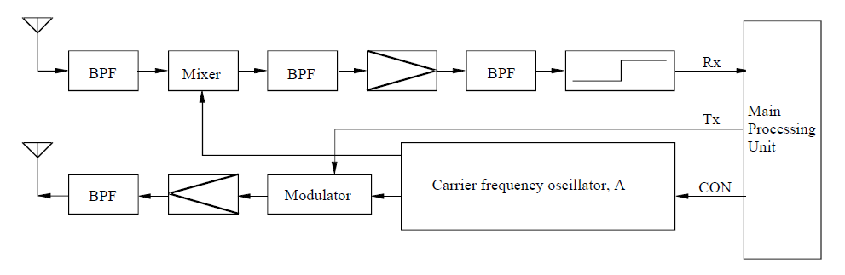

**Figure 4 Typical configuration of OBE in active transceiver method**

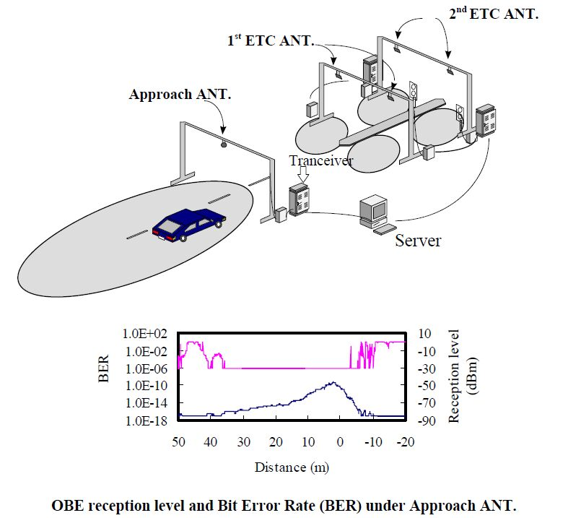

**Figure 5 Examples of DSRC antenna footprints in typical ETC toll gate**

**(2) Technical characteristics of the Chinese ETC System**

The Chinese ETC System adopts the active (transceiver) method. Both RSE and OBE work in 5.8 GHz band. Two classes are specified in the physical layer. Class A with ASK modulation should meet the basic requirement of ETC application. Class B with FSK modulation should meet the requirement of high speed data transmission. Technical characteristics of downlink and uplink are shown in Table 3 and 4, respectively.

**Table 3. Technical characteristics of downlink**

|  |  |  |  |
| --- | --- | --- | --- |
| **Item** | | **Class A** | **Class B** |
| Carrier frequencies | Channel 1 | 5.830 GHz | 5.830 GHz |
| Channel 2 | 5.840 GHz | 5.840 GHz |
| Allowable occupied bandwidth | | ≤5 MHz | ≤5 MHz |
| Modulation method | | ASK | FSK |
| Data transmission speed (bit rate) | | 256 kbit/s | 1 Mbit/s |
| Data coding | | FM0 | Manchester |
| e.i.r.p. | | ≤ +33 dBm | ≤ +33 dBm |

**Table 4. Technical characteristics of uplink**

|  |  |  |  |
| --- | --- | --- | --- |
| **Item** | | **Class A** | **Class B** |
| Carrier frequencies | Channel 1 | 5.790 GHz | 5.790 GHz |
| Channel 2 | 5.800 GHz | 5.800 GHz |
| Allowable occupied bandwidth | | ≤5 MHz | ≤5 MHz |
| Modulation method | | ASK | FSK |
| Data transmission speed (bit rate) | | 512 kbit/s | 1 Mbit/s |
| Data coding | | FM0 | Manchester |
| e.i.r.p. | | ≤ +10 dBm | ≤ +10 dBm |

**5.2.2 Frequency usage**

The usage status of ETC in APT countries is shown in Table 5. Many APT countries adopted ETC in frequency band of 2.4, 5.8, 5.9 and 24 GHz. For ETC in some APT countries, DSRC technology and 5.8GHz band has been used.

**Table 5 Frequency usage for ETC in Asia-Pacific**

|  |  |  |  |  |
| --- | --- | --- | --- | --- |
| **Country** | **Frequency Band** | **Technology/**  **Standard** | **Service** | **Deployment or plan Year** |
| Australia | 5,725-5,795 MHz,  5,815-5,875 MHz,  24-24.25 GHz | - | Electronic tolling | - |
| China | 5,725-5,850 MHz | DSRC | ETC (Electronic Toll Collection) | Enacted in 2003 |
| Hong Kong | 2,400 – 2,4835 MHz | Exemption from Licensing Order | Electronic toll collection services | 1998 |
| Japan | 5,770-5,850 MHz | ETC (Electronic Toll Collection) | Collect highway toll (Communication) | Enacted in 1997 |
| DSRC  (Dedicated Short Range Communication) | -Collect highway toll - Provide various information (Communication, Broadcast) | Enacted in 2001  (Revised 2007) |
| Korea | 5,795-5,815 MHz | DSRC/  TTA Standard  (TTAS.KO-06.0025/R1) | ETC (Electronic Toll Collection)  BIS(Bus Information System) | 2006  (Highpass Tolling) |
| Singapore | 2,350-2,483.5 MHz | - | Electronic Road Pricing (ERP) Systems | 1998 |
| 5,855 – 5,925 MHz | DSRC  (Dedicated Short Range Communication) | Next Generation Electronic Road Pricing (ERP) Systems | 2020 (estimated) |
| Thailand | 5.470-5.850 GHz | Compliance Standard:  ETSI EN 300 440-1 or FCC Part 15.247 or  FCC Part 15.249 | RFID (e.g. Electronic Toll Collection) | 2008 |

**5.2.3 Standardization**

**Table 6 Standards for ETC in Asia-Pacific**

|  |  |  |
| --- | --- | --- |
| **SDO** | **Standard No.** | **Standard Title** |
| TTA | TTAS.KO-06.0025/R1 | Standard of DSRC Radio Communication between Road-side Equipment and On-board Equipment in 5.8 GHz band |
| TTAS.KO-06.0052/R1 | Test specification for DSRC L2 at 5.8 GHz |
| TTAS.KO-06.0053/R1 | Test specification for DSRC L7 at 5.8 GHz |
| ARIB | STD-T75 | Dedicated Short Range Communication (DSRC) System |
| SAC (Standardi-zation Administra-tion of China) | GB/T 20851.1-2007 | Electrical toll collection – Dedicated short range communication – Part 1: Physical layer |
| GB/T 20851.2-2007 | Electrical toll collection – Dedicated short range communication – Part 2: Data link layer |
| GB/T 20851.3-2007 | Electrical toll collection – Dedicated short range communication – Part 3: Application layer |
| GB/T 20851.4-2007 | Electrical toll collection – Dedicated short range communication – Part 4: Equipment application |
| GB/T 20851.5-2007 | Electrical toll collection – Dedicated short range communication – Part 5: Test methods of the main parameters in physical layer |
| TSAC | IDA TS DSRC | Technical Specification for Dedicated Short-Range Communications in Intelligent Transportation Systems |

**5.2.4 Applications**

As in Europe, Electronic toll collection (ETC) using DSRC is a forerunner of ITS applications in Japan. ETC service in Japan started in March 2001 and by the end of March 2003, the service covered approximately 900 toll gates through which 90% of expressway users pass. This indicates that the service was deployed nationwide in approximately two years. As of the end of March 2004, the number of toll gates increased to 1 300 and as of December 2005, the number of OBEs (ETC subscribers) reached ten million.

The rapid increase in ETC subscribers provides for favourable conditions for various applications to be served by DSRC technology using the same OBE (On board equipment). Research and development are underway through cooperation between the public and industries to develop multiple-purpose on-board equipment that realizes a variety of DSRC services.

1

**Figure 6 DSRC multiple applications being studied in Japan**

The following nine application fields are being studied in Japan to extend applications in the vehicle. (Refer to Figure 6):

(1) Parking lot management

(2) Gas filling station

(3) Convenience store

(4) Drive-through

(5) Logistics management

(6) Pedestrian support

(7) Specific region entry charging (Zone tolling)

(8) Information providing: semi-stationary state

(9) Information providing: high speed

**6 Advanced ITS radiocommunication**

*[Editor’s note: Text to be added]*

**6.1 Overview**

Since 1994, Vehicle Information and Communication System (VICS) was used in Japan for delivering traffic and travel information to road vehicle drivers. China started to develop trials of LTE based V2X communication technology (LTE-V2X) to verify road safety and non-road safety applications from 2015.

Nowadays, to extend beyond the existing ITS applications and to achieve traffic safety and reduce the environmental impact by the transportation sector, vehicle-to-vehicle (V2V), vehicle-to-infrastructure (V2I) communications are studied. According to this progress, ITU-R WP5A has developed report on advanced ITS radiocommunications [8]. In the report, legacy ITS and advanced ITS are classified by its technical characteristics as shown in table 8. Wireless Access in Vehicular Environments (WAVE), Continuous Access for Land Mobiles (CALM) and LTE based V2X (LTE-V2X) technologies could be inclusive in advanced ITS category.

Advanced ITS is also supported by 3GPP technologies and worldwide standards. 3GPP has developed standard specifications to enable the use of LTE mobile networks to provide connectivity between vehicles, roadside infrastructure and the people inside and around the connected vehicles, i.e. targeting all main V2X use cases and system requirements: Vehicle-to-vehicle (V2V), vehicle-to-pedestrian (V2P), and vehicle-to-infrastructure (V2I). The work item “Support for V2V services based on LTE sidelink” was completed in September 2016. The work item “LTE-based V2X services” has been completed in March 2017 within the 3GPP Release14 timeframe (to be frozen in June 2017).

3GPP Release 14 LTE-V2X specifies the vehicle-to-everything (V2X) system and radio access requirements, where both PC5 (device-to-device direct link) and Uu (link between base station and device) are included, supporting transmission in existing mobile allocations up to 6 GHz (e.g. the ITS 5.9 GHz band). Direct communication without network assistance is also supported, as shown in Figure 7.

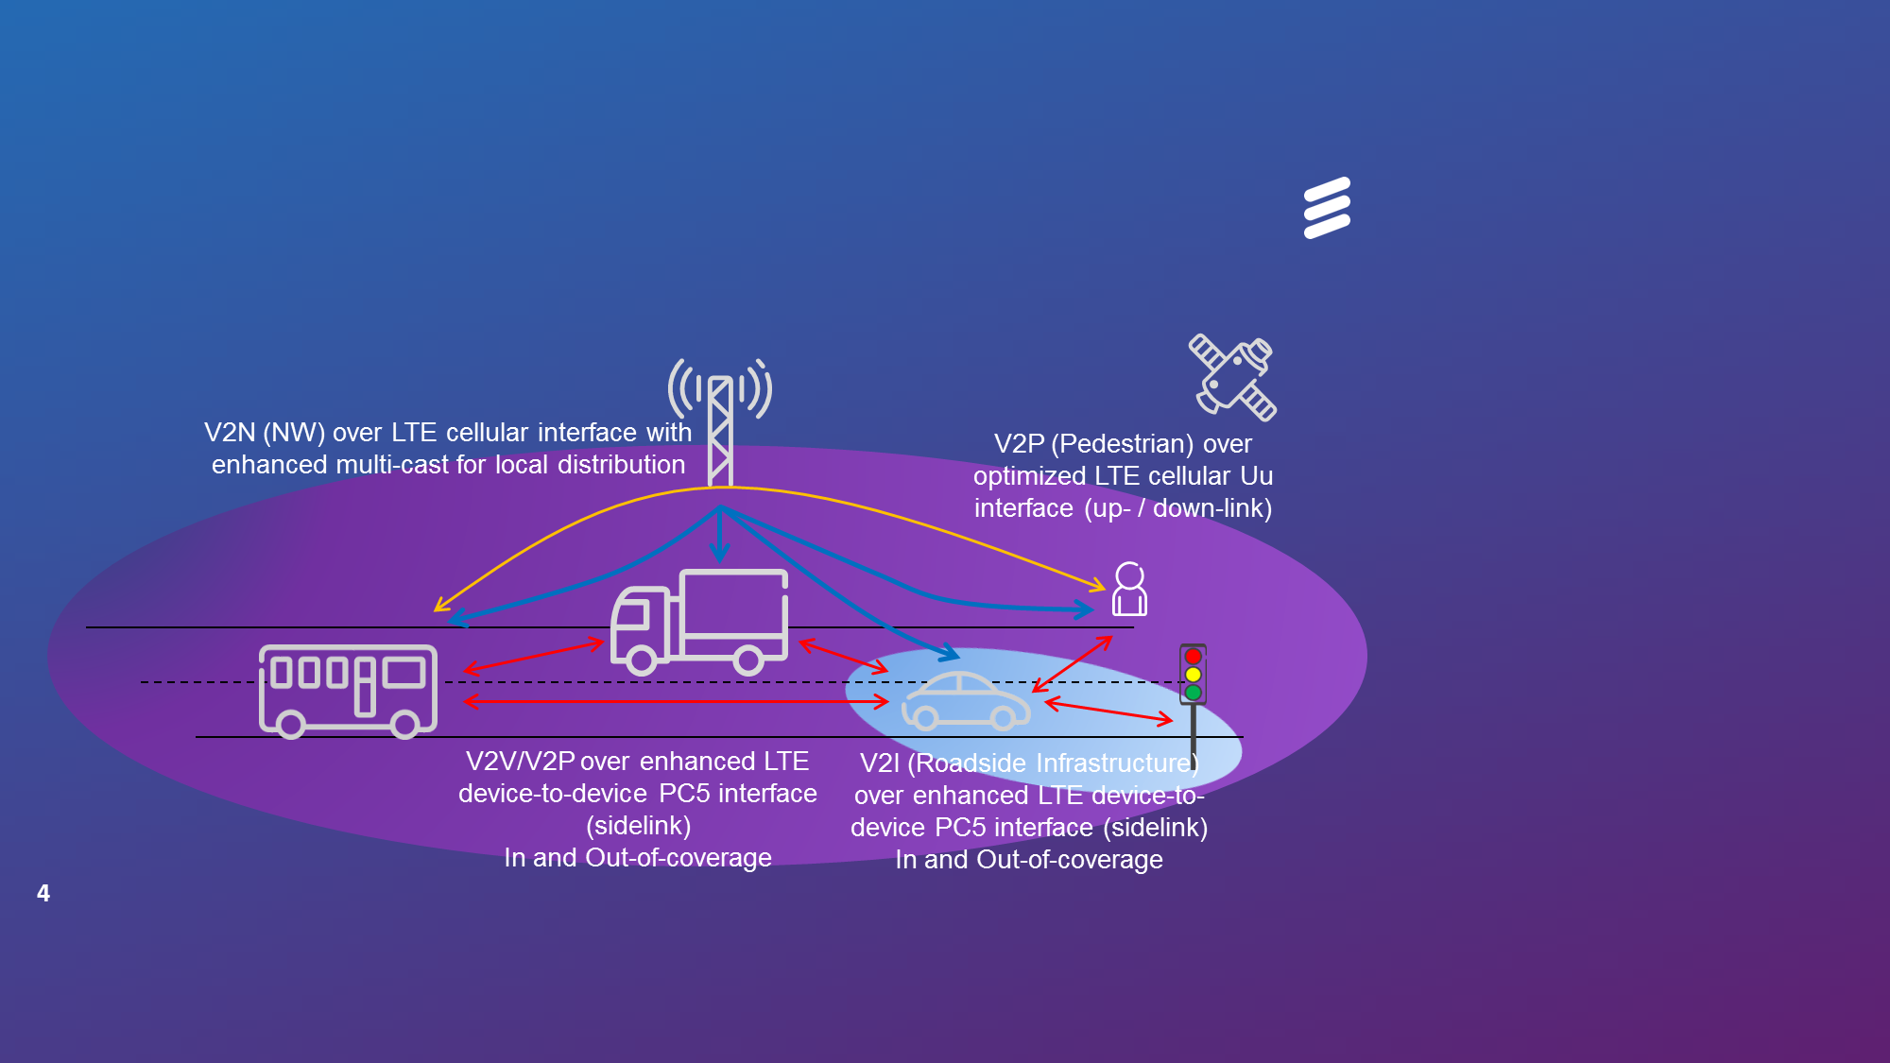

Figure 7 V2X communication over LTE-PC5 interface and LTE-Uu interface

3GPP is also looking at continuously evolving the V2X services in its coming releases including 5G; therefore, further enhancements such as enhanced safety use cases with improved reliability, extended range, lower latency, etc. are also expected from Release-15 onward.

**6.1.1 Technical characteristics**

**Table 7 Technical characteristic of Advanced ITS**

|  |  |  |
| --- | --- | --- |
| **Items** | **Legacy ITS (DSRC)** | **Advanced ITS (WAVE, CALM, etc)** |
| **Technologies** | **DSRC** | **WAVE, CALM, LTE-V2X** |
| Vehicular networking | V2I | V2I, V2V, V2N, V2P |
| Radio performance | Radio coverage : Max. 100 m  Data rate : ~ 4 Mbps  Packet size : ~100 bytes | Radio coverage : Max. 1 000 m  Data rate : Max. 27 Mbps  Packet size : Max. 2 kbytes  Latency : within 100 msec  (V2V/V2I/V2N)  Within 1000msec (V2P) |

**6.1.2 Frequency usage**

Among APT countries, Japan is studying 5.8GHz band for V2V communication to transmit safety information meanwhile 700 MHz band is already in service. Also, Korea assigned 5.855~5.925 GHz for C-ITS (V2V and V2I communications) in 2016. China is also studying spectrum related aspects on LTE based V2X communication technology in 5.9GHz band, where V2X communication includesV2V, V2I, V2P, V2N applications. ITS spectrum study is under developing in multiple standard organizations in China, where the study includes ITS use cases, spectrum need, and coexistence study with incumbent services, the outcome will be developed in the end of 2016.

On the other hand, Europe plans to use of the 5.855~5.925 GHz frequency band for C-ITS (V2V and V2I communication) according to the ECC decision in 2008, and the U.S. use the frequency band 5.850~5.925 GHz for the WAVE providing ITS applications with specific channels for safety. For interoperability and global harmonization, some APT countries are (e.g. Australia, Singapore) also considering these band for cooperative ITS systems.

Regards these activities, in Australia, the investigation has carefully examined the constraints created by existing and future service coordination requirements. These include, for example, the fixed-satellite service concerns over the unknown compounding effects of aggregated roadside and onboard units which could constructively interfere with the FSS, and/or raise the overall noise floor within which the FSS operates. Moreover, the need to protect intelligent transport systems may severely limit the deployment of future FSS earth stations in the band 5,850-5,925 MHz. While studies have indicated these impacts will be minimal, mitigation and appropriate licensing strategies are under consideration.

**6.1.3 Standardization**

**Table 8 Global Standards on Advanced ITS radiocommunication**

| **SDO** | **Standard No.** | **Title** |
| --- | --- | --- |
| ITU | ITU-R M.1890 | Intelligent transport systems - Guidelines and objectives |
| Report ITU-R M.2228 | Advanced intelligent transport systems (ITS) radiocommunications |
| ITU-R M.2084 | Radio interface standards of vehicle-to-vehicle and vehicle-to-infrastructure communication for intelligent transport systems applications |
| ETSI | [TR 102 638](http://webapp.etsi.org/WorkProgram/Frame_WorkItemList.asp?SearchPage=TRUE&butExpertSearch=++Search++&qETSI_STANDARD_TYPE=&qETSI_NUMBER=102+638&qTB_ID=&qINCLUDE_SUB_TB=True&includeNonActiveTB=FALSE&qWKI_REFERENCE=&qTITLE=&qSCOPE=&qCURRENT_STATE_CODE=&qSTOP_FLG=N&qSTART_CURRENT_STATUS_CODE=&qEND_CURRENT_STATUS_CODE=&qFROM_MIL_DAY=&qFROM_MIL_MONTH=&qFROM_MIL_YEAR=&qTO_MIL_DAY=&qTO_MIL_MONTH=&qTO_MIL_YEAR=&qOPERATOR_TS=&qRAPTR_NAME=&qRAPTR_ORGANISATION=&qKEYWORD_BOOLEAN=OR&qKEYWORD=&qPROJECT_BOOLEAN=OR&qPROJECT_CODE=&includeSubProjectCode=FALSE&qSTF_List=&qDIRECTIVE=&qMandate_List=&qSORT=HIGHVERSION&qREPORT_TYPE=SUMMARY&optDisplay=10&titleType=all) | Intelligent Transport Systems (ITS); Vehicular Communications; Basic Set of Applications; Definitions |
| [TS 102 637 series](http://webapp.etsi.org/WorkProgram/Frame_WorkItemList.asp?SearchPage=TRUE&butExpertSearch=++Search++&qETSI_STANDARD_TYPE=%27TS%27&qETSI_NUMBER=102+637&qTB_ID=&qINCLUDE_SUB_TB=True&includeNonActiveTB=FALSE&qWKI_REFERENCE=&qTITLE=&qSCOPE=&qCURRENT_STATE_CODE=&qSTOP_FLG=N&qSTART_CURRENT_STATUS_CODE=&qEND_CURRENT_STATUS_CODE=&qFROM_MIL_DAY=&qFROM_MIL_MONTH=&qFROM_MIL_YEAR=&qTO_MIL_DAY=&qTO_MIL_MONTH=&qTO_MIL_YEAR=&qOPERATOR_TS=&qRAPTR_NAME=&qRAPTR_ORGANISATION=&qKEYWORD_BOOLEAN=OR&qKEYWORD=&qPROJECT_BOOLEAN=OR&qPROJECT_CODE=&includeSubProjectCode=FALSE&qSTF_List=&qDIRECTIVE=&qMandate_List=&qSORT=HIGHVERSION&qREPORT_TYPE=SUMMARY&optDisplay=10&titleType=all) | Intelligent Transport Systems (ITS); Vehicular Communications; Basic Set of Applications |
| [EN 302 665](http://webapp.etsi.org/WorkProgram/Frame_WorkItemList.asp?SearchPage=TRUE&butExpertSearch=++Search++&qETSI_STANDARD_TYPE=&qETSI_NUMBER=302+665&qTB_ID=&qINCLUDE_SUB_TB=True&includeNonActiveTB=FALSE&qWKI_REFERENCE=&qTITLE=&qSCOPE=&qCURRENT_STATE_CODE=&qSTOP_FLG=N&qSTART_CURRENT_STATUS_CODE=&qEND_CURRENT_STATUS_CODE=&qFROM_MIL_DAY=&qFROM_MIL_MONTH=&qFROM_MIL_YEAR=&qTO_MIL_DAY=&qTO_MIL_MONTH=&qTO_MIL_YEAR=&qOPERATOR_TS=&qRAPTR_NAME=&qRAPTR_ORGANISATION=&qKEYWORD_BOOLEAN=OR&qKEYWORD=&qPROJECT_BOOLEAN=OR&qPROJECT_CODE=&includeSubProjectCode=FALSE&qSTF_List=&qDIRECTIVE=&qMandate_List=&qSORT=HIGHVERSION&qREPORT_TYPE=SUMMARY&optDisplay=10&titleType=all) | Intelligent Transport Systems (ITS); Communications Architecture |
| [TS 102 636 series](http://webapp.etsi.org/WorkProgram/Frame_WorkItemList.asp?SearchPage=TRUE&butExpertSearch=++Search++&qETSI_STANDARD_TYPE=&qETSI_NUMBER=102+636&qTB_ID=&qINCLUDE_SUB_TB=True&includeNonActiveTB=FALSE&qWKI_REFERENCE=&qTITLE=&qSCOPE=&qCURRENT_STATE_CODE=&qSTOP_FLG=N&qSTART_CURRENT_STATUS_CODE=&qEND_CURRENT_STATUS_CODE=&qFROM_MIL_DAY=&qFROM_MIL_MONTH=&qFROM_MIL_YEAR=&qTO_MIL_DAY=&qTO_MIL_MONTH=&qTO_MIL_YEAR=&qOPERATOR_TS=&qRAPTR_NAME=&qRAPTR_ORGANISATION=&qKEYWORD_BOOLEAN=OR&qKEYWORD=&qPROJECT_BOOLEAN=OR&qPROJECT_CODE=&includeSubProjectCode=FALSE&qSTF_List=&qDIRECTIVE=&qMandate_List=&qSORT=HIGHVERSION&qREPORT_TYPE=SUMMARY&optDisplay=10&titleType=all) | Intelligent Transport Systems (ITS); Vehicular Communications; GeoNetworking; |
| EN 302 571 | Intelligent Transport Systems (ITS); Radiocommunications equipment operating in the 5 855 5 925 MHz frequency band; Harmonised Standard covering the essential requirements of article 3.2 of Directive 2014/53/EU |
| [ES 202 663](http://webapp.etsi.org/WorkProgram/Frame_WorkItemList.asp?SearchPage=TRUE&butExpertSearch=++Search++&qETSI_STANDARD_TYPE=&qETSI_NUMBER=202+663+&qTB_ID=&qINCLUDE_SUB_TB=True&includeNonActiveTB=FALSE&qWKI_REFERENCE=&qTITLE=&qSCOPE=&qCURRENT_STATE_CODE=&qSTOP_FLG=N&qSTART_CURRENT_STATUS_CODE=&qEND_CURRENT_STATUS_CODE=&qFROM_MIL_DAY=&qFROM_MIL_MONTH=&qFROM_MIL_YEAR=&qTO_MIL_DAY=&qTO_MIL_MONTH=&qTO_MIL_YEAR=&qOPERATOR_TS=&qRAPTR_NAME=&qRAPTR_ORGANISATION=&qKEYWORD_BOOLEAN=OR&qKEYWORD=&qPROJECT_BOOLEAN=OR&qPROJECT_CODE=&includeSubProjectCode=FALSE&qSTF_List=&qDIRECTIVE=&qMandate_List=&qSORT=HIGHVERSION&qREPORT_TYPE=SUMMARY&optDisplay=10&titleType=all) | Intelligent Transport Systems (ITS); European profile standard for the physical and medium access control layer of Intelligent Transport Systems operating in the 5 GHz frequency band |
| IEEE | IEEE 802.11-2012 | Wireless LAN Medium Access Control (MAC) and Physical Layer (PHY) Specifications |
| IEEE 1609 | Family of Standards for Wireless Access in Vehicular Environments (WAVE) |
| - IEEE 1609.0-2012 - IEEE Guide for WAVE – Architecture |
| - IEEE 1609.2 -20162016- IEEE Standard for WAVE - Security Services for Applications and Management Messages |
| - IEEE 1609.3 -2016– IEEE Standard for WAVE - Networking Services |
| - IEEE 1609.4 -20162016- IEEE Standard for WAVE - Multi-Channel Operations |
| - IEEE 1609.11-2010 – IEEE Standard for WAVE – Over-the-Air Electronic Payment Data Exchange Protocol for ITS |
| - IEEE 1609.12-2016 – IEEE Standard for WAVE – Identifier Allocations |
| SAE | J2735-2009 | Dedicated Short Range Communications (DSRC) Message Set Dictionary |
| 3GPP | 22 Series | TS 22.185 Service requirements for V2X services  TR 22.885 Study on LTE support for Vehicle to Everything (V2X) services, 3GPP |
| 23 Series | TS 23.285 Architecture enhancements for V2X services  TR 23.785 Study on architecture enhancements for LTE support of V2X services |
| 36 Series | TS 36.101 Evolved Universal Terrestrial Radio Access (E-UTRA); User Equipment (UE) radio transmission and reception  TS 36.133 Evolved Universal Terrestrial Radio Access (E-UTRA); Requirements for support of radio resource management  TS 36.211 Evolved Universal Terrestrial Radio Access (E-UTRA); Physical Channels and Modulation  TS 36.212 Evolved Universal Terrestrial Radio Access (E-UTRA); Multiplexing and channel coding  TS 36.213 Evolved Universal Terrestrial Radio Access (E-UTRA); Physical layer procedures  TS 36.214 Evolved Universal Terrestrial Radio Access (E-UTRA); Physical layer;  Measurements  TS 36.300 Evolved Universal Terrestrial Radio Access (E-UTRA) and Evolved Universal Terrestrial Radio Access Network (E-UTRAN); Overall description;  Stage 2  TS 36.302 Evolved Universal Terrestrial Radio Access (E-UTRA); Services provided by the physical layer  TS 36.304 Evolved Universal Terrestrial Radio Access (E-UTRA); User Equipment (UE) procedures in idle mode  TS 36.306 Evolved Universal Terrestrial Radio Access (E-UTRA); User Equipment (UE) radio access capabilities  TS 36.321 Evolved Universal Terrestrial Radio Access (E-UTRA); Medium Access Control (MAC) protocol specification  TS 36.322 Evolved Universal Terrestrial Radio Access (E-UTRA); Radio Link Control (RLC) protocol specification  TS 36.323 Evolved Universal Terrestrial Radio Access (E-UTRA); Packet Data Convergence Protocol (PDCP) specification  TS 36.331 Evolved Universal Terrestrial Radio Access (E-UTRA); Radio Resource Control (RRC); Protocol specification  TS 36.413 Evolved Universal Terrestrial Radio Access Network (E-UTRAN); S1 application protocol (S1AP)  TS 36.423 Evolved Universal Terrestrial Radio Access Network (E-UTRAN); X2 application protocol (X2AP)  TR 36.785 Vehicle to Vehicle (V2V) services based on LTE sidelink; User Equipment (UE) radio transmission and reception  TR 36.786 V2X Services based on LTE; User Equipment (UE) radio transmission and reception  TR 36.885 Study on LTE-based V2X services, 3GPP |

**6.1.4 Applications**

**6.1.4.1 Safety ITS applications[1]**

**6.1.4.1.1** Forward Collision Warning (FCW)1

This application is intended to warn the driver of the host vehicle in case of an impending rear-end collision with a remote vehicle ahead in traffic in the same lane and direction of travel. Using the V2V Service, this application is intended to help drivers in avoiding or mitigating rear-end vehicle collisions in the forward path of travel.

**6.1.4.1.2** Control Loss Warning (CLW)1

This application enables a host vehicle to broadcast a self-generated control loss event to surrounding remote vehicles. Upon receiving such event information, a remote vehicle determines the relevance of the event and provides a warning to the driver, if appropriate.

**6.1.4.1.3** Emergency Vehicle Warning1

Emergency vehicle warning service enables each vehicle to acquire the location, speed and direction information of a surrounding emergency vehicle (e.g. ambulance) to assist safety operation like allowing ambulance path to get free.

**6.1.4.1.4** V2VEmergency Stop1

This use case describes vehicles V2V communication used in case of emergency stop to trigger safer behaviour for other cars in proximity of the stationary vehicle.

**6.1.4.1.5** Wrong way driving warning1

This use case describes V2V communication used between two vehicles driving in opposite directions warning wrong way driving and trigger safer behaviour for cars in proximity.

**6.1.4.1.6** V2I Emergency Stop1

This use case describes V2I communication where a Service RSU notifies vehicles in vicinity in case of emergency stop to trigger safer behavior

**6.1.4.1.7** Vulnerable Road User (VRU) Safety1

This use case describes the scenario whereby a vehicular and a pedestrian are both equipped with V2P capabilities, and the vehicle detects the pedestrian's presence and alerts the driver, if an imminent threat is present. This capability extends the safety benefit of V2X to pedestrians and other vulnerable road users, e.g. bicyclists, wheelchair users, etc.

**6.1.4.1.8** Cooperative Adaptive Cruise Control1

This use case describes the scenario whereby a vehicle with V2V capability joins and leaves a group of corporative-adaptive-cruise-control (CACC) vehicles. This provides convenience and safety benefits to participating vehicles and also has societal benefits to improve road congestion and fuel efficiency.

**6.1.4.2 Non-Safety ITS applications**1

**6.1.4.2.1** Automated Parking System1

The Automated Parking System (APS) contains a database which provides real-time information to vehicles in a metropolitan area on availability of parking spots, be it on the street or in public parking garages. Connected vehicles help maintain the real-time database of the occupancy of parking spaces, which can be accessed by means of smartphones and connected vehicles. APS allows a driver to reserve an available parking space, be guided to it via a navigation application, and make a hands-free payment for parking.

**6.1.4.2.2** Queue Warning1

A queue of vehicles on the road may pose a potential danger and cause delay of traffic, e.g. when a turning queue extends to other lanes. Using the V2I Service, the queue information can be made available to other drivers beforehand. This minimizes the likelihood of crashes and allows for mitigation actions.

**6.1.4.2.3** Traffic Flow Optimisation1

This use case describes vehicles V2N (Vehicle-to-Network) communication to a centralised ITS server referred here to as “entity” to optimise traffic flow when approaching intersections. This use case addresses the situation when approaching the vehicle has to stop even though there are no other cars around at an intersection or has to slow down because of explicit traffic lights signal absence.

*[Editor’s note: Text to be added]*

**6.2 Asia-Pacific**

**6.2.1 Technical characteristics**

*[Editor’s note: Text to be added]*

**6.2.2 Frequency usage**

**Table 9 Frequency usage on Advanced ITS radiocommunication in Asia-Pacific**

|  |  |  |  |  |
| --- | --- | --- | --- | --- |
| **Country** | **Frequency Band** | **Technology/**  **Standard** | **Service** | **Deployment or plan Year** |
| Japan | 76-90 MHz  (FM multiplex broadcasting) | VICS (Vehicle Information and Communications System) | Traffic information | Enacted in 1994 |
| 2,499.7 MHz (Radio beacon) |
| 5,770-5,850 MHz | Vehicle-to-Vehicle communications system | Safety information  (Communications) | Guidelines for field experiment in 2007 |
| 700 MHz band | V2V/V2I communications system | Enacted in 2011 |
| Korea | 5.855~5.925 GHz | V2V/V2I communication | Vehicle Safety  C-ITS | Enacted in 2016 |
| China | 5.905-5.925 GHz | LTE based V2X | V2X communication | Field  Experiment |

**6.2.3 Standardization**

**Table 10 Standards on Advanced ITS radiocommunication in Asia-Pacific**

|  |  |  |
| --- | --- | --- |
| **SDO** | **Standard No.** | **Standard Title** |
| TTA | TTAS.KO-06.0175/R1 | Vehicle Communication System Stage1: Requirements |
| TTAS.KO-06.0193/R1 | Vehicle Communication SystemStage2: Architecture |
| TTAS.KO-06.0216/R1 | Vehicle Communication System Stage3 : PHY/MAC |
| TTAS.KO-06.0234/R1 | Vehicle Communication System State 3 : Networking |
| TTAK.KO-06.0242/R1 | Vehicle Communication System Stage3 : Application Protocol Interface |
| TTAK KO-06.0344 | In-Vehicle Signage System for Vehicle Safety Guidance Stage 1: Requirements |
| TTAK KO-06.0344-Part2 | In-Vehicle Signage System for Vehicle Safety Guidance Stage 2: Data Exchange |
| ARIB | STD-T109 | 700 MHz Band Intelligent Transport Systems |
| CCSA | TBD | TBD |

**6.2.4 Applications**

*[Editor’s note: Text to be added]*

**7 Millimeter-wave automotive radar**

*[Editor’s note: Text to be added]*

**7.1 Overview**

*[Editor’s note: Text on 79 GHz short-range high resolution radar should be added.]*

Sensor technologies for monitoring and identifying objects near vehicles are the most important safety-related base technologies for developing systems that will accommodate this purpose. Various types of sensors have been studied and developed, and through this research and development, it has become clear that a RADAR (Radio Detection and Ranging) using radio waves is suitable for this objective. An international effort to regulate short-range radar for automotive applications is crucial for ensuring stable radar operations and effective use of frequency resources. In accordance with the Radio Regulation, the 60 GHz (60-61 GHz) and 76 GHz (76-77 GHz) bands were considered suitable for radar system due to the radio wave absorption characteristics in the atmosphere as described above. The 76 GHz band has already been assigned by the Federal Communications Commission (FCC) for automotive radars in the United States of America. The Ministry of Internal Affairs and Communications (MIC) in Japan has assigned the 60 GHz and 76 GHz bands for low power, short-range automotive radars. Furthermore, in accordance with European spectrum requirements for RTTT established in 2002, ETSI has adopted a European standard for low power vehicle radar operating in the 76-77 GHz band (EN 301 091) in 1998. In 2000, Recommendation ITU-R M.1452 for low power, short-range automotive radar operating in the 60 GHz, and 76 GHz bands was approved and published.

In Europe, Ultra wide band (UWB) short range radar (SRR) operating at 24 GHz (22-29 GHz) is considered to be a key technology for the rapid and cost-effective introduction of many intelligent vehicle safety systems. In January 2005, the European Commission decided on the time-limited (until 1 July 2013) use of the 24 GHz range radio spectrum band for the ultra-wide band part of short-range vehicle radar equipment. After this deadline SRR equipment is intended to operate in the frequency band 79 GHz (77 - 81 GHz) on a permanent base, see ECC/DEC/(04)03. Applications operating around the 24 GHz band would increasingly suffer significant levels of harmful interference if a certain level of penetration of vehicles using the 24 GHz range radio spectrum band for short-range radars was to be exceeded. According to CEPT (European Conference of Postal and Telecommunications Administrations), the sharing between earth exploration satellite services and short-range vehicle radar could only be feasible on a temporary basis.

**7.1.1 Technical characteristics**

**(1) Low Power Automotive Radar at 60 GHz and 76 GHz**

Today the frequency allocation for automotive radar application is in a rebuilding phase. Due to technological and commercial constraints the frequency allocation for these safety related applications has been done in the beginning of the last decade in the range of 24 GHz. In Europe e.g. this allocation has been done as an intermediate solution due to the incompatibility with the Radio Astronomy Service, EESS, the Fixed Service and military applications. Therefore the cut-off date of 1st July 2013 has been defined. In July 2011 the EC extends the cut-off date (with modified technical parameter) until 1st January 2018 to allow the car manufacturer a seamless implementation of the 79 GHz technology. The technological evolution during the last years leads to the fact that with a similar effort a higher performance can be reached today.

**(2) High Resolution Automotive Radar at 79 GHz**

The industries are trying to seek globally or regionally harmonized frequency allocations for new vehicle radar technologies. The following frequency allocation is under consideration and the relevant study work has been undertaken by ITU-R WP 5A/B:

– 77 GHz to 81 GHz Short Range Radar (SRR) < 150 meter (high resolution)

**(3) Ultra Wide Band (UWB) Radar**

UWB technology employs very narrow or short duration pulses that result in very large or wideband transmission bandwidths (refer to Figure 9, “UWB monocycle time and frequency domains”). Generally UWB is defined as the radio signal whose fractional bandwidth is greater than 20% of the centre frequency or the 10 dB bandwidth occupies 500 MHz or more of spectrum. With appropriate technical standards, UWB devices can operate using spectrum occupied by existing radio services without causing interference, thereby permitting scarce spectrum resources to be used more efficiently.

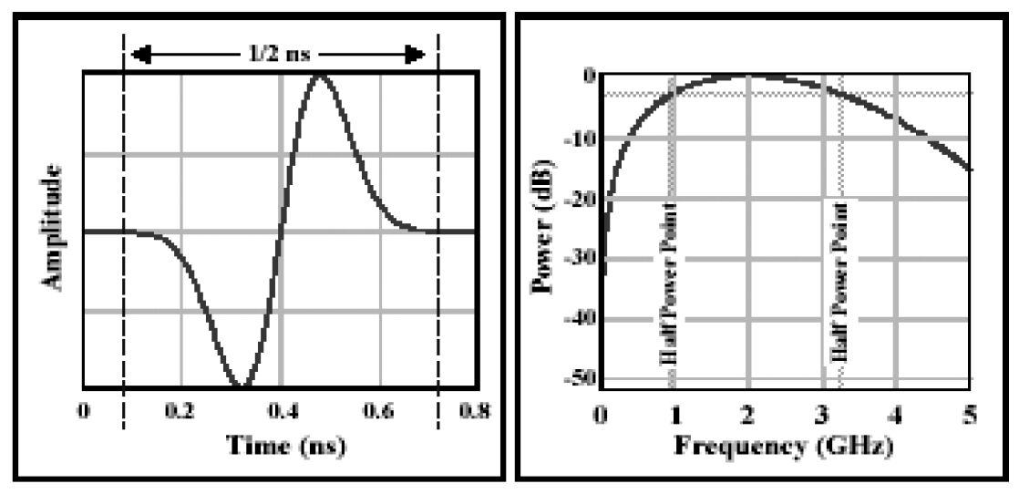

**Figure 9 UWB monocycle time and frequency domains   
(UWB, "A possible area for standards", GSC 8 Presentation by FCC.)**

**(4) Road radar**

Incident detection service deployed in Korea enables drivers in vehicles to receive real-time information for unexpected road situation (obstacle, stopped and wrong way vehicle, frozen-road etc.) through real-time and automatic detection system using radar sensors to prevent unexpected accidents. It also provides traffic information within 1 km from radar sensor. It supports driver in heavy rains and foggy weather to receive real–time information by incident detection system.

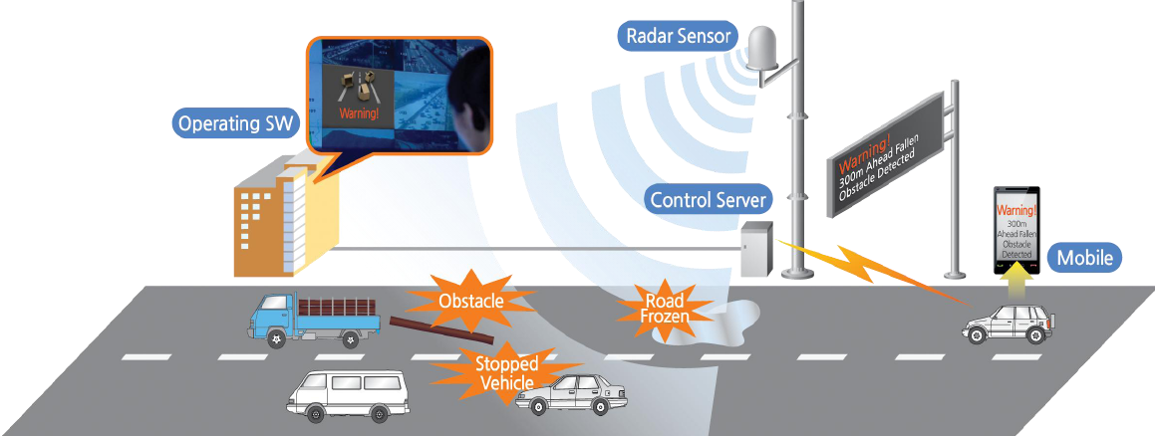

**Figure 10 Incident detection service**

Characteristics of 34 GHz incident detection radar are given in Table 13.

**7.1.2 Frequency usage**

Today the frequency allocation for automotive radar application is in a rebuilding phase. Due to technological and commercial constraints the frequency allocation for these safety related applications has been done in the beginning of the last decade in the range of 24 GHz. In Europe e.g. this allocation has been done as an intermediate solution due to the incompatibility with the Radio Astronomy Service, EESS, the Fixed Service and military applications. Therefore the cut-off date of 1st July 2013 has been defined. In July 2011 the EC extends the cut-off date (with modified technical parameter) until 1st January 2018 to allow the car manufacturer a seamless implementation of the 79 GHz technology. The technological evolution during the last years leads to the fact that with a similar effort a higher performance can be reached today.

The industries are trying to seek globally or regionally harmonized frequency allocations for new vehicle radar technologies. The following frequency allocations are under consideration and the relevant study work is undertaken by ITU-R WPs 5A and 5B5:

* 76 GHz to 77 GHz Long Range Radar (LRR) > 150 meter
* 77 GHz to 81 GHz Short Range Radar (SRR) < 150 meter (high resolution)

**Table 11 Global frequency usage on millimetre-wave automotive radar**

|  |  |  |  |  |  |  |
| --- | --- | --- | --- | --- | --- | --- |
|  | 76 to 77 GHz | | | 77 to 81 GHz | | |
|  | Regulation | Standard | Report/Notes | Regulation | Standard | Report/Notes |
| ITU | Recommendation ITU-R M.1452 |  | Report ITU-R SM.2067 | Recommendation ITU-R M.1452-2 |  |  |

**7.1.3 Standardization**

**Table 12 Global standard on millimetre-wave automotive radar**

|  |  |  |
| --- | --- | --- |
| **SDO** | **Standard No.** | **Standard Title** |
| ITU | ITU-R M.1452-2 | Millimetre wave radiocommunication systems for intelligent transport system applications |
| ITU-R M.2057 | Systems characteristics of automotive radars operating in the frequency band 76-81 GHz for intelligent transport systems applications |
| Report: ITU-R M.2322 | Systems Characteristics and Compatibility of Automotive Radars Operating in the 77.5-78 GHz Band for Sharing Studies |

**7.1.4 Applications**

*[Editor’s note: Text to be added]*

**7.2 Asia-Pacific**

**7.2.1 Technical characteristics**

*[Editor’s note: Text to be added]*

**(1) Incident detection radar**

Characteristics of 34 GHz incident detection radar are given in Table 13.

**Table 13 Road radar system**

| **Characteristic(Parameter)** | **Value** |
| --- | --- |
| **Operational characteristics** | |
| Application/Service | Road Incident Detection System |
| Typical installation | Road Side Pole(or gantry) |
| **Technical Characteristics** | |
| Max. range | 1 000 m |
| Frequency range | 34.275~34.875 GHz |
| Specified bandwidth (typical) | Up to 600 MHz |
| Peak Power (e.i.r.p) | Up to +55 dBm |
| Mean Power (e.i.r.p) | Up to +45 dBm |

**7.2.2 Frequency usage**

In APT countries, frequency bands of 24, 60, 76 and 79 GHz has been used. For global harmonization of ITS, APT countries like Australia are considering European activities which use 79 GHz as a permanent band. Also, Hong Kong is considering the plan to open the 79 GHz band for automotive radar systems utilizing ultra-wideband technology. In March 2010, the Ministry of Internal Affairs and Communications (MIC) in Japan has started a study group in the Information and Communications Council for the introduction of high-resolution radar in the 79 GHz frequency band for national use, and has allocated 78-81 GHz band for high-resolution radar in December 2012. [5]

**Table 14 Frequency usage on millimetre-wave automotive radar in Asia-Pacific**

|  |  |  |  |  |  |  |
| --- | --- | --- | --- | --- | --- | --- |
|  | **76 to 77 GHz** | | | **77 to 81 GHz** | | |
|  | **Regulation** | **Standard** | **Report/Notes** | **Regulation** | **Standard** | **Report/Notes** |
| Korea, Republic of | Rules on Radio Equipment (Article 29 Paragraph 9)(2013-01-03)” |  |  |  |  |  |
| China | Technical Specification for Micropower (Short Distance) Radio Equipments, part XIV |  |  |  |  |  |
| Japan |  | ARIB STD-T48 |  |  | ARIB STD-T111 |  |
| Singapore |  | IDA TS SRD |  |  | IDA TS UWB |  |
| Taiwan | LP002 2005-0324 |  |  |  |  |  |
| Thailand | NTC TS 1011-2549 |  |  |  |  |  |

**7.2.3 Standardization**

**Table 15 Standards on millimetre-wave automotive radar in Asia-Pacific**

|  |  |  |
| --- | --- | --- |
| **SDO** | **Standard No.** | **Standard Title** |
| ARIB | STD-T111 | 79GHz Band High-Resolution Radar |

**7.2.4 Applications**

**Table 16 Usage status of automotive radar in Asia-Pacific**

|  |  |  |  |  |
| --- | --- | --- | --- | --- |
| **Country** | **Frequency Band** | **Technology/**  **Standard** | **Service** | **Deployment or plan Year** |
| Australia | 22–26.5 GHz |  | Ultra-wideband short-range vehicle radar (UWB SRR) systems for collision avoidance | - |
| 76–77 GHz |  | Long-range vehicle radar (intelligent cruise control) |  |
| China | 76-77 GHz | Radar | Vehicular range radar | Enacted in 2005 |
| 24.25-26.65 GHz | Radar | Vehicular range radar | Enacted in 2012 |
| Hong Kong | 76 – 77 GHz | Exemption from Licensing Order | Vehicular radar systems | 2005 |
| Japan | 22-29 GHz | Quasi-millimeter, Millimeter wave system | Detect obstacles (Sensor) | Enacted in 2010 |
| 60.5 GHz/76.5 GHz | Enacted in 1997 |
| 78-81 GHz | Enacted in 2012 |
| Korea | 76-77 GHz | Radar | Vehicular collision avoidance radar | 2008 |
| 24.25-26.65 GHz | Radar | Vehicular collision avoidance radar | 2012 |
| Singapore | 76-77 GHz | Radar | Short Range radar systems such as automatic cruise control and collision warning systems for vehicle | 2002 |
| 77-81 GHz | Radar | Vehicular Radar | 2008 |
| Thailand | 5.725-5.875 GHz | - | Radar Application | Regulation adopted in 2007 |
| 24.05 – 24.25 GHz | - | Radar Application | Regulation adopted in 2007 |
| 76-81 GHz | - | Radar Application | Regulation adopted in 2007 |
| 76-77 GHz | Compliance Standard: FCC Part 15.253 or EN 301 091-1 | Vehicle Radar Application | Regulation adopted in 2006 |

**8 Conclusions**

*[Editor’s note: Text to be added, such as on millimeter radar.]*

Intelligent transport systems attract many people’s interest because it could improve the safety of road traffic, ensure smoother traffic, reduce environmental burdens, and stimulate regional economic activity, etc. From the survey results, major deployed ITS systems in APT countries were classified as electronic toll collection, automotive radar, and vehicle information & communication. As the importance of car safety is increasing, cooperative system is widely considered for international deployment. Especially in Europe and North America, frequency band 5 855--5 925MHz was assigned for cooperative systems and many development project was performed. Radiocommunication technologies for cooperative system will be used to automated driving.

Regarding these activities, APT countries should study the optimal frequency spectrum for cooperative systems and try to reach regional/international harmonization of spectrum arrangements.

**References**

[1] ETSI EN 302 665 V1.1.0, “Intelligent Transport Systems (ITS); Communications Architecture”

[2] <http://www.etsi.org/website/Technologies/IntelligentTransportSystems.aspx>

[3] ITU-R Report M.2228, “Advanced Intelligent Transport Systems (ITS) radiocommunication”

[4] ITU-R Recommendation M.1453, “Intelligent Transport Systems – dedicated   
 short-range communications at 5.8 GHz”

[5] ITU-R Recommendation M.1452 “Millimetre wave radiocommunication systems   
 for Intelligent Transport Systems applications”

___________________

1. 3GPP TR 22.885 Study on LTE support for Vehicle to Everything (V2X) services