 | ASIA-PACIFIC TELECOMMUNITY | Document No.:
 | The 23rd Meeting of the APT Wireless Group (AWG-23) | AWG-23/INP-24
 | 9 – 13 April 2018, Da Nang City, Socialist Republic of Viet Nam | 29 March 2018

New Zealand

Response to QUESTIONNAIRE ON REGULATORY INFORMATION FOR IMPLEMENTATION IMT NETWORK IN ASIA-PACIFIC REGION

Question 1:
Institution/Company Information and Profile

Name of the institution : Ministry of Business, Innovation and Employment
Name of contact person : Nima Farhang
Mailing Address : 15 Stout Street, Wellington 6011, New Zealand
Phone : +64 4 901 1211
Email Address : Radio.Spectrum@mbie.govt.nz
My institution is : Regulator

Remarks from New Zealand
This response from New Zealand only contains regulatory information on the most recent IMT spectrum auction in the 700 MHz band that was conducted in 2013/14.

Question 2:
Which IMT technology being use and will be used or technology neutral in these bands?
Please fill in the frequency bands used for IMT and specify which IMT technology (e.g. WCDMA, HSPA, LTE, LTE-A, TDD-LTE, 3GPP Release 10, …) being used, if not IMT please answer “non-IMT”.

Frequency band  (MHz) | Frequency Block (MHz) |  | Operator | IMT Technology | Channel bandwidth (MHz)
 | Uplink | Downlink
703 – 748 / 758 – 803 | 703 – 723 | 758 – 778 | Spark NZ | FDD-LTE | 20
 | 723 – 738 | 778 – 793 | Vodafone NZ Ltd | FDD-LTE | 15
 | 738 – 748 | 793 – 803 | Two Degrees Mobile Ltd | FDD-LTE | 10

Question 3:
Please provide (or refer to) characteristics, and protection criteria, for implementing the IMT systems/networks in Question 2, and similar information for non-IMT services, within the IMT band and in the neighbouring bands.

About the IMT services in (703–748/758–803 MHz):
- In general, New Zealand adopted a technology-flexible approach where the type of technology used is not regulated within the spectrum blocks assigned to each mobile network operator.
- Given the harmonisation of the APT 700 MHz band plan for IMT, the technical characteristics of the spectrum blocks are configured in a frequency pairing arrangement to suit FDD-LTE.
- Protection criteria for preventing the intra-band interference between IMT systems, as well as inter-band interference between IMT systems and other radiocommunication services in adjacent frequency bands, are enforced in the form of emission mask for each spectrum block.
- These out-of-band emission masks, formally known as “Adjacent Frequencies Emission Limit” (AFEL), are derived based on 3GPP specifications, such as 3GPP 36.104 and 3GPP 36.101.
- The diagram below shows an example of the spectrum emission mask for uplink transmission where the mobile network operator amalgamated four blocks of 5 MHz within 703-723MHz:
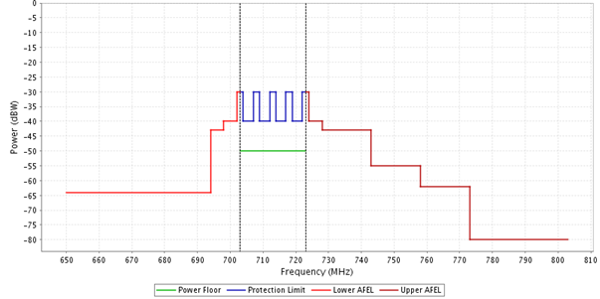
Figure 1: Spectrum emission mask for 703-723 MHz
- The diagram below shows an example of the spectrum emission mask for downlink transmission where another mobile network operator amalgamated two blocks of 5 MHz within 793-803MHz:
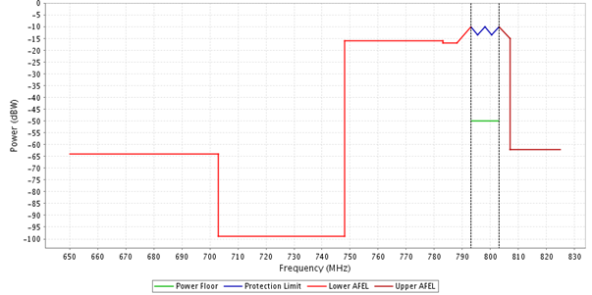
Figure 2: Spectrum emission mask for 793-803 MHz

About the neighbouring non-IMT service:
- A guard band is considered for protection of interference between IMT and non-IMT systems in neighbouring bands.
- For the size of guard bands, please refer to next question.

Question 4:
Which case of coexistence as illustrated below and the technical conditions must be applied to each IMT block (e.g power limit, emission mask for spectrum block, pfd limit, …) to support technology neutrality and spectrum efficiency?

Case A: coexistence between IMT block and IMT in adjacent block in same IMT band
Case B: coexistence between IMT block and non-IMT in adjacent block in same IMT band
Case C: coexistence between IMT block in IMT band and non-IMT block in adjacent band
Case D: coexistence between IMT block and non-IMT block co-channel but adjacent geographical area
Case E: coexistence between IMT block and other IMT block co-channel but adjacent geographical area

Frequency band (MHz) | Case | Technical condition
622 – 698 (Currently unused) / 703 – 748 (IMT mobile transmit) | C | 5 MHz guard band
703 – 748 / 758 – 803 | A | Spectrum emission mask
758 – 803 (IMT base transmit) / 806 – 812 (Fixed links) | C | 3 MHz guard band

____________

