
The 5th Meeting of Working Group of Management Committee
on APT Legal Instruments (WGMC-5)
24-26 July 2018, Bangkok, Thailand

INFORMATION FOR PARTICIPANTS

The 5th Meeting of Working Group of Management Committee on APT Legal Instruments (WGMC-5) is scheduled to be held from 24 to 26 July 2018 at the APT Headquarters in Bangkok, Thailand. Please find the following information for the convenience of the participants.

VENUE
The Meeting will be held at APT Headquarters, Bangkok, Thailand. The contact details of the APT are as follows:

ASIA-PACIFIC TELECOMMUNITY
Address: 12/49 Soi 5, Chaeng Watthana Road, Lak Si
Bangkok 10210, Thailand
Telephone: +66 2 5730044
Telefax: +66 2 5737479
E-mail: aptwgmc@apt.int

PARTICIPATION:

All APT Members, Associate Members and Affiliate Members can participate in the meeting by registering online through the APT Website.

Associate Members and Affiliate Members can attend the meeting with “Observer” status.

REGISTRATION:
Registration can be done online at http://www.apt.int/content/online-registration. Preferred date to receive your registration by APT Secretariat is 22 June 2018 for making necessary arrangements. On-site registration and distribution of badges will commence from 9:00 hours on Tuesday 24 July 2018. The registration desk will be located outside the meeting room. Participations are required to bring their passports or other photo identification to receive their badges.

HOTEL ACCOMMODATION RATE & RESERVATION
The following Hotels are recommended for participants to stay at during the Meeting.

- CENTARA GRAND AT CENTRAL PLAZA LADPRAO BANGKOK
Address: 1695 Phaholyothin Road, Chatuchak,
Bangkok 10900, Thailand
Telephone: +66 2 5411234
E-mail: governmentsales@chr.co.th

The rates are:

Room Type | Room Rate
Deluxe Single | THB 3,500 net/room/night (included breakfast and internet access)
Deluxe Twin | THB 3,800 net/room/night (included breakfast and internet access)
*The prices are net inclusive of 10% service charge and 7% VAT.

For hotel reservation at Centara Grand at Central Plaza Ladprao, please send the hotel reservation form directly to e-mail address: governmentsales@chr.co.th with a copy to warrawan@apt.int.

Please double-click the below hotel reservation form of the Centara Central Plaza Ladprao.
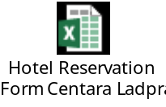

- CENTRA GOVERNMENT COMPLEX HOTEL CHAENG WATTHANA
Address: 120 Mu 3 Convention Centre Building, Government Complex
Chaeng Watthana Road, Laksi
Bangkok 10210, Thailand
Telephone: +66 2 143 1234
E-mail: rsvncgc@chr.co.th

The rates are:

Room Type | Room Rate
Centra Superior  Single/Twin | THB 1,750 net/room/night (included breakfast and internet access)
Centra Deluxe  Single/Twin | THB 2,250 net/room/night (included breakfast and internet access)
Centra Suite Single/Twin | THB 3,000 net/room/night (included breakfast and internet access)
*The price is net inclusive of 10% service charge and 7% VAT.

Please send the Hotel Reservation form to e-mail address: rsvncgc@chr.co.th with a copy to warrawan@apt.int.

Please double-click the below hotel reservation form of the Centra Government Complex Hotel Chaeng Watthana.

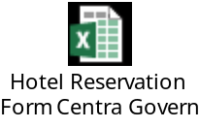

Rounds trip transportation from the Centra Government Complex to the APT Headquarters will be provided by the hotel.

In order to be eligible for the special rates given above, please make your hotel booking at the earliest possible date and not later than 22 June 2018.

DOCUMENTS AND INTERNET FACILITIES
Meeting documents will be available on-line at the APT website, http://www.apt.int and wireless Internet will be available at the meeting room.

APT encourages all participants to bring their own laptops for paperless and electronic working during the meeting. Limited number of computers (with Internet access) and printers will be available for use by the participants during the meeting.

WIRELESS LAN

Internet Access over wireless network will be available during the meeting. Participants who wish to utilize wireless facility are kindly requested to bring their own laptop computers with Wi-Fi capability.

TRANSPORTATION FROM THE AIRPORT TO THE HOTEL:
Delegates are requested to use public transportation facilities of the Suvarnabhumi International Airport, Thailand. For more information, please visit website: http://www.bangkokairportonline.com/.

For your general information, the following transportation is available from Suvarnabhumi International Airport to the Hotel:

- Public Meter Taxi, is located on 1st floor of the Arrival Hall, entrance 4 and 7. Fare shown on meter, plus THB 50 surcharge for boarding at the airport, plus any expressway toll charges.

- Airport Limousine Service, the limousine service to various destinations in the city, is located at the arrival floor of the airport.

It takes about 50 minutes by car from Suvarnabhumi International Airport to hotels.

VISA AND IMMIGRATION INFORMATION:
Thailand’s visa requirements may vary for the citizens of different countries. Please check the visa requirements with a Royal Thai Embassy or a Royal Thai Consulate-General in your respective country in advance. Kindly visit http://www.mfa.go.th/main/en/services/4908 for more details. If you require a visa supporting letter from the APT, please contact: aptadmin@apt.int

INSURANCE:
Due to the procedural difficulties and budgetary constraints, the APT is not able to bear the cost of insurance for the participants, any medical expenses or any other expenses. APT, therefore, requests your administrations/organizations to kindly make necessary arrangements for insurance and medical coverage of your participants before travel.

PRACTICAL INFORMATION:

Bangkok is always among the world’s top tourist destinations. The city is a true tourist paradise, proved by the growing number of travelers coming each year. There are a great variety of tourist places in Bangkok, mostly historical attractions and temples with elaborate architecture and art. Famous temples are Wat Phra Kaew, Wat Pho, Wat Arun, Wat Phu Khao Thong, Wat Ratchanadda, Wat Traimit, Wat Benchamabophit, Wat Bowon, and Wat Sutat.

There are also palaces, museums, parks, and a big array of shopping places, from luxury malls to flea and street markets like Chatuchak Weekend Market, Sampeng Market, and Pahurat Textile Market. Bangkok nightlife is another highlight that has attracted many of tourists from all over the world.

Bangkok is also surrounded by many interesting provinces worth visiting.
- The north of Bangkok borders Nonthaburi and Pathum Thani Provinces, with tourist attractions like Koh Kret and Lotus Museum.
- The east of the city is next to Chachoengsao, a small province which is full of interesting places and activities. Tourists can pay homage to Luang Pho Sothon Buddha Image at Wat Sothon Wararam Worawihan, watch flying foxes or fruit bats at Wat Pho, see the golden church at Wat Paknam Jolo, and pray to the giant reclining Ganesh statue at Wat Saman Rattanaram. There are also old markets for you to visit and shop such as Ban Mai Market, Nakhon Nuang Khet Market, and Khlong Suan Market.
- The south of the city borders Samut Prakan Province and the Gulf of Thailand, with tourist attractions like Bang Pu, Ancient City, and Samut Prakan Crocodile Farm and Zoo.
- The west of the city is next to Samut Sakhon and Nakhon Pathom Provinces. Tourist attractions include Don Kai Dee Benjarong Village, Phra Pathom Chedi, Sanam Chandra Palace, Don Wai Floating Market, Sampran Riverside, and Thai Human Imagery Museum.
* Source: Tourism Authority of Thailand

Weather: Average temperature in July is between 27 and 35 degrees Celsius.
Time Zone: GMT + 7 hours.
Banks & Currency: The unit of Thai currency is Thai Baht (THB). The exchange rate as of April 2018 is THB 31.27 to USD 1.

Electricity: Supply voltage is 220V, 50Hz. A standard grounded Thai outlet supports European 2-pin plugs and earthed and unearthed American plugs (see picture). Please bring the right adapter for your equipment.

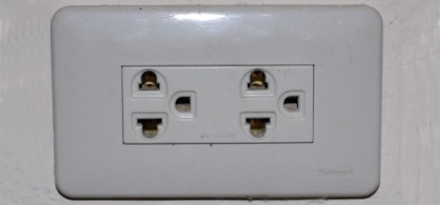

CONTACT INFORMATION:
APT Secretariat
Asia Pacific Telecommunity (APT)
12/49 Soi 5 Chaeng Watthana Road
Bangkok 10210, Thailand
Tel: +662 573 0044
Fax: +662 573 7479
Email: aptwgmc@apt.int

MAP TO APT

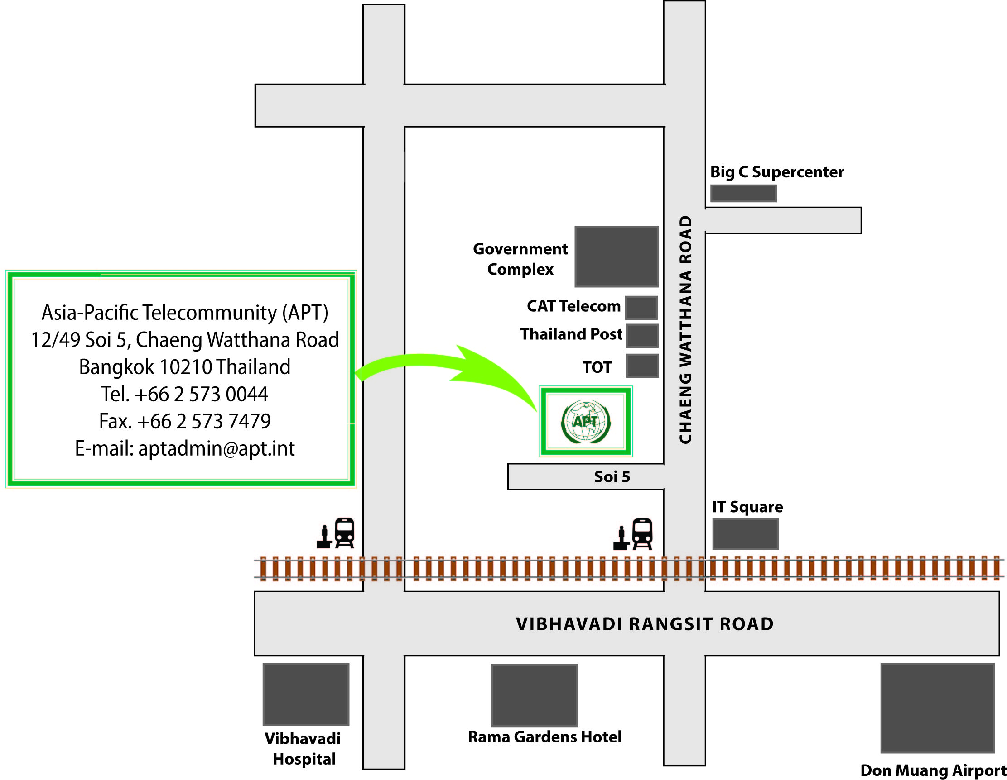
MAP TO CENTARA GRAND AT CENTRAL PLAZA LADPRAO BANGKOK
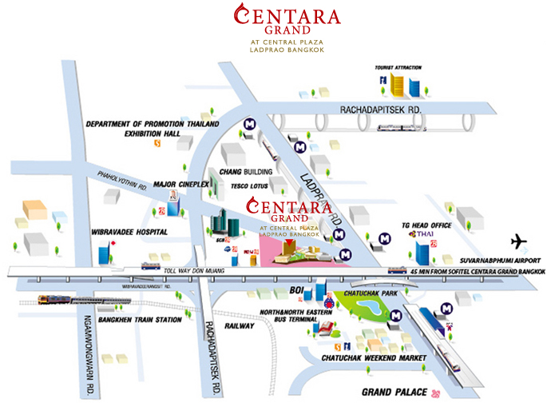
MAP TO CENTRA GOVERNMENT COMPLEX HOTEL CHAENG WATTHANA 

