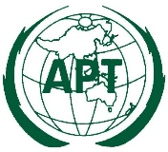 | ASIA-PACIFIC TELECOMMUNITY | Document:  APT PP18-4/INP-xx
 | 4th Meeting of the APT Preparatory Group for PP-18 (APT PP18-4)
 | 27 – 30 August 2018, Kuala Lumpur, Malaysia | Xx August 2018

Source

Title

Summary:
Please complete the fields with short summary not exceeding 100 words.

INTRODUCTION
Please complete the fields with short summary preferably not exceeding 250 words.

PROPOSAL

APT Member Administration would like to propose …

PACP no.
MOD

RESOLUTION xxx (Rev. xxx)
Title of the Resolution
The Plenipotentiary Conference of the International Telecommunication Union (Guadalajara, 2018),

