 | ASIA-PACIFIC TELECOMMUNITY | Document:
 | The 4th Meeting of the APT Conference Preparatory Group for WRC-19 (APG19-4) | APG19-4/INF-07
 | 7 – 12 January 2019, Busan, Republic of Korea | 24 December 2018

Ericsson (Thailand) Limited, Ericsson Vietnam Co., Ltd.,
Intel Microelectronics (Thailand) Limited, Nokia Pte Ltd., Qualcomm International and Samsung Electronics Co., Limited

GSA Views on WRC-19 AI 1.13 and the need to take realistic IMT equipment characteristics into account in sharing studies

- Summary
The GSA would like to bring to the attention of administrations the issue of necessary ‘margin’ to define realistic base stations characteristics, how this has a significant impact on agenda item 1.13 and in particular the level needed to protect adjacent Earth Exploration Satellite Services (Passive).
Studies have proposed a range of levels needed for IMT-2020 Base Stations unwanted emissions in order to protect EESS(p) systems in 23.6 – 24.0 GHz. The GSA would like to point out that the majority of these studies have not addressed the issue of ‘margin’, as defined below, as they have assumed that all base stations are emitting unwanted emissions at exactly the same level, which can then be used as a required level for EESS(p) protection. In reality this can obviously not be achieved. If -34 dBW/200 MHz (as an example for the purposes of this discussion) is included in the Radio Regulations, it will be applied to all base stations using the frequency band 24.25 – 27.5 GHz. In other words, it is a level which all equipment must never exceed. This means in this case that a margin of 6-8 dB would be added into the design of the equipment to take into account measurement uncertainties, variations in manufacturing, deployment variations due to temperature performance and ageing variations over time. For this reason manufacturers add a margin so that this ‘absolute’ value is never exceeded. Such a margin needs to be taken into account in the sharing studies to provide results that properly reflect reality.
Therefore a margin of 6-8 dB needs to factored into those studies which have not already included such a margin, For example, for studies assuming that all base stations have exactly the same level of unwanted emissions and proposing a protection level of -42 dBW/200MHz then -34/36 dBW/200 MHz in the Radio Regulations would provide the same protection to EESS(Passive) when taking into account realistic base station design.
-34 to -36 dBW/200 MHz in the Radio Regulations for Base Stations = -42 dBW/200MHz actual interference level if a 6 to 8 dB margin is taken into account.
GSA therefore would therefore encourage administrations to factor in the margin when determining the absolute (never to be exceeded) level to be included in the Radio Regulations, to avoid overly conservative restrictions on IMT-2020 equipment, implying a large guardband between IMT-2020 and EESS(p). The guard band is the subject of a separate more detailed discussion but in summary unwanted emission limits of -42 dBW/200 MHz for Base Stations without a margin being factored in are not workable for the IMT industry. This will seriously hamper the performance of network and in practice, can make a large part of the 26 GHz band unusable. 3GPP has been studying the feasibility of meeting more stringent unwanted emission limits than their baseline requirement. It would be interesting to consider if the ITU-R and WRC has considered this ‘margin’ issue in previous discussions for different frequency bands. It is noted that a previous WRC has considered such margin based on ITU-R Report RS.2336.
Similar margins/effects as described in this paper for IMT-2020 base stations also exist for IMT-2020 terminals. Due to measurement and calibration uncertainties, as well as variations due to yield requirements in the production process, not all terminals will produce unwanted emissions right up to the specified regulatory limit. Instead there will be a distribution of emission levels with some terminals operating close to the limit whereas other terminals will operate further below the limit, to ensure that all terminals within the distribution will indeed meet the regulatory limit. Therefore, for a large population of terminals as relevant for aggregate interference scenarios, the aggregate total emissions will always be a few dBs below the actual regulatory limit and this margin should be taken into account when developing the regulatory conditions.

Annex: Detailed consideration of necessary design margins

A margin is added into the design of equipment so that manufacturers can ensure that base stations and terminals do not exceed the regulatory limits. In general, the margin depends on the case, the limit itself, the output power, the size of the blocks being considered, the frequency separation, etc. For this particular frequency range around 26 GHz it is expected that aa margin of 6-8 dB is added into the design of IMT-2020 base station equipment to take into account variations in manufacturing, deployment temperature and ageing variations performance over time. So, for example, the vast majority of the base stations would perform closer to -42 dBW/200 MHz (6-8 dB even more conservative than the regulatory limit (in this example) of-34 dBW/200 MHz) but a small percentage would perform closer to -34 dBW/200 MHz due to manufacturing variations, performance variations from ageing or being deployed in hot places etc. As confidence and experience grows over time in the manufacturing and deployment of leading edge mmWave components and base stations then this margin may be tightened and reduced to around 6 dB.

It is assumed in the sharing studies that all base stations and UEs have exactly the same unwanted emission characteristics. This is not a realistic approach, as there is variation in the production of equipment, and a certain margin is necessary in comparison with any stipulated requirement to ensure that all or a very large part of the equipment meets the required level, i.e. maintaining a certain yield in the production. Furthermore, margins are needed to ensure that variations due to temperature and age do not result in unwanted emissions exceeding the requirements in the regulation. In addition, measurement uncertainties imply that there is a need for an additional margin. In summary, any design must include margins to cover at least ageing, temperature dependence, production variations and measurement uncertainties. Simulation analysis shows that a conservative assumption of a 3 dB margin for ageing, temperature and measurement uncertainties and a production spread of 2 dB standard deviation for a 95% production yield provides a relaxation of 6 dB for the EESS(p) protection requirement. For more details, readers are referred to Document TG5/1 386, Section 1.12.3.4.

Figure 1 below illustrates how the interference is reduced from -158 dBW to -164/166dBW from IMT-2020 into EESS(p) when this margin is not taken into account.

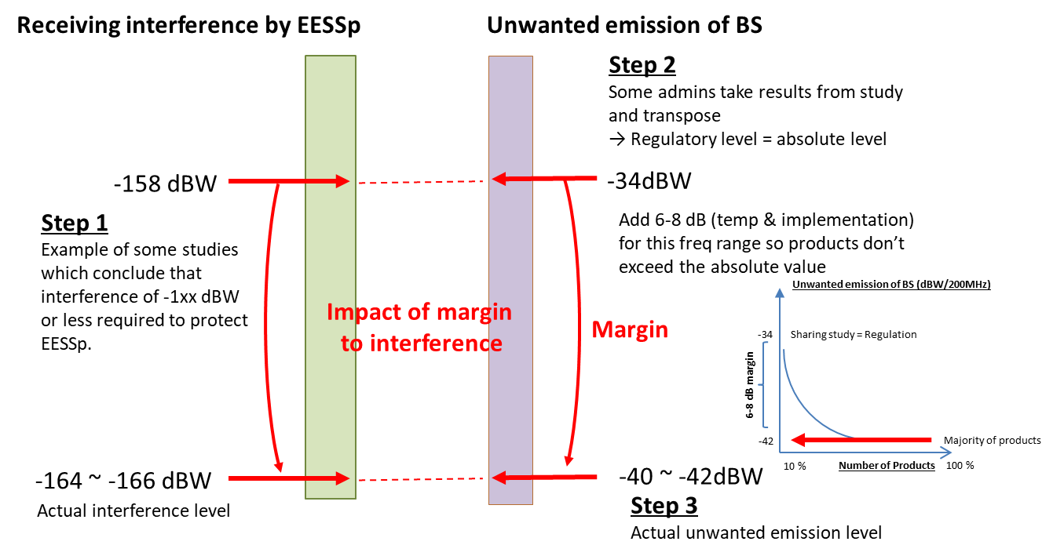

Figure 1: Illustration of actual interference and margin

This document has been discussed and agreed by GSA (Global mobile Suppliers Association, https://gsacom.com/), whose members include Ericsson, Huawei, Intel, Nokia, Qualcomm and Samsung.

