|  |  |  |
| --- | --- | --- |
|  | ASIA-PACIFIC TELECOMMUNITY | **Document No:** |
| **The 4th Meeting of the APT Conference Preparatory Group for WRC-19 (APG19-4)** | **APG19-4/INF-14** |
| 7 – 12 January 2019, Busan, Republic of Korea | **31 December 2018** |

World Meteorological Organization (WMO)

**ELEMENTS related to the protection of eess (passive) under wrc-19 agenda item 1.13**

The present document provides elements related to the protection of the EESS (passive) service from IMT-2020 unwanted emissions and is appealing all worldwide Administrations not to take any decision related to IMT-2020 that could put at risk these unique natural resources for spaceborne passive sensing of the atmosphere and the Earth’s surface.

The present document is focusing on the case of the 23.6-24 GHz “passive” band, but similar conclusions can be drawn for the other bands.

Consideration should be given to WMO Resolution 29 (Congress-17) and ITU Resolution 673 (rev. WRC-12).

APG19-4 is invited to take into consideration the present document when reviewing its position on WRC-19 Agenda item 1.13.

____________

# introduction

Agenda item 1.13 calls for sharing and compatibility studies between IMT-2020 applications and incumbent services, including studies with respect to services in adjacent bands.

Taking into account the various bands listed in Resolution 238 (WRC-15), the following cases are considered for the protection of EESS (passive) systems:

|  |  |
| --- | --- |
| EESS (passive) band | 5G IMT band |
| 23.6-24 GHz | 24.25-27.5 GHz |
| 31.3-31.8 GHz | 31.8-33.4 GHz |
| 36-37 GHz | 37-40.5 GHz |
| 50.2-50.4 GHz | 47.2-50.2 GHz and 50.4-52.6 GHz |
| 52.6-54.25 GHz | 50.4-52.6 GHz |
| 86-92 GHz | 81-86 GHz |

Current ITU-R studies in all frequency bands show that only an important reduction of IMT-2020 unwanted emission can ensure protection of EESS (passive) sensors, in particular for the case of the 23.6-24 GHz “passive” band.

The present document is focusing on the case of the 23.6-24 GHz “passive” band, but similar conclusions can be drawn for the other bands.

At current stage, WMO and space agencies operating EESS (passive) sensors (e.g. ESA and EUMETSAT) in the passive bands listed in the table above are highly concerned that the current specifications for IMT-2020 are largely insufficient to ensure protection of EESS (passive) sensors and are appealing all worldwide Administrations not to take any decision related to IMT-2020 that could put at risk these unique natural resource for spaceborne passive sensing of the atmosphere and the Earth surface;

To this respect, consideration should be given to the following reference Resolutions:

* WMO Resolution 29 (Congress-17) on “Radio frequencies for meteorological and related environmental activities” (see Annex 4)
* ITU Resolution 673 (rev. WRC-12) on “The importance of Earth observation radiocommunication applications” (see Annex 5)

*[Editor’s note : for clarity, whenever the present document mentions the “TG 5/1 Report”, it means document 5-1/478, i.e. the final Chairman’s Report of the August 2018 TG 5/1 meeting.]*

# eess (passive)

2.1 EESS (passive) sensors

The list of EESS (passive) sensors described in Recommendation ITU-R RS.1861 have been used as a representative list of sensors in the compatibility studies. Although it is not an exhaustive list of existing sensors, but more a family of sensor types assumed to cover all different sensors, it well covers the existing sensors in operation as well as those currently under development and soon to enter into operation in the next years.

| Parameter | Unit | Syst F1 | Syst F2 | Syst F3 | Syst F4 | Syst F5 | Syst F6 | Syst F7 | Syst F8 |
| --- | --- | --- | --- | --- | --- | --- | --- | --- | --- |
| Type of sensor |  | Conical | Conical | Conical | Cross-track | Cross-track | Conical | Push-broom | Conical |
| Satellite orbit | km | 817 | 705 | 828 | 833 | 824 | 835 | 850 | 699.6 |
| Nadir angle | ° | 44.5 | 47.5 | 46.6 | ± 48.3 | ± 52.7 | 55.4 | ± 50 | 47.5 |
| Antenna gain | dBi | 40 | 46.7 | 52 | 34.4 | 30.4 | 43 | 45 | 48.5 |
| Footprint size | km² | 1 880 | 452 | 170 | 1 847 nadir  9 298 outer | 4 394 nadir  35 983 outer | 2 432 | 201 nadir  201 outer | 306 |

Furthermore, it should be highlighted that, under the WMO auspices, measured data from passive sensors operated by all space agencies (US NOAA and NASA, Roshydromet, Roscosmos, JAXA, ESA, EUMETSAT, KMA, ISRO, …) are exchanged and made available to all agencies and meteorological services, meaning that all sensors are of the same importance for all agencies.

The protection of EESS (passive) from IMT-2020 hence needs to be ensured on a global basis and with a long term perspective, taking into account all possible existing, under development and future sensors, since any IMT-2020 identification in the 24.25-27.5 GHz band will not be limited in time but will be a “no way back” decision. To this respect, the definition of the relevant IMT-2020 stations maximum unwanted emission levels in the band 23.6-24 GHz has to be addressed in the light of the protection of all EESS (passive) sensors listed in Recommendation ITU-R RS.1861.

It is to be noted that compatibility analysis presented in ITU-R TG5/1 conclude that the level of interference from IMT-2020 is very similar for sensors F2, F3 and F8 in Recommendation ITU-R RS.1861 (see Annex 3).

2.2 Impact of interference on Climate Observations

The observation of the global climate requires the inclusion of satellite measurements as described in the "Implementation Plan for the Global Observing System for Climate in Support of the UNFCCC". Consequently, satellites play an essential role in the Global Climate Observation System (GCOS). GCOS has developed a climate monitoring principles (GCOS) which defines the so-called "essential climate variables" (ECV) and publishes related requirements for resolution, availability and accuracy. The European Copernicus Climate Change Service (C3S), the European element of the Global Framework for Climate Change, also focuses on satellites to monitor the global climate.

For the processing of the instrument data, complex recalibrations and reprocessing of the data are undertaken in order to meet the very high quality requirements for climatic data sets, in particular temporal stability and low noise behaviour. Such activities lead to so-called Climate Data Records (CDRs). In particular, microwave sensors, such as AMSU on Metop, MWI and MWS on Metop-SG, have a special significance in this context as they allow the observation of various ECVs.

The case of incremental interference over time, going from non-detectable to a low level interference signals is impossible to discriminate from the actual geophysical information. Thus there is the risk to mismatch an interference induced signal as an actual climate signal. The accuracy of measurements for climate monitoring is quite stringent, meaning that non-identified interference could be misinterpreted as an actual climate signal.

2.3 Impact of interference at Measurement Data Level

In general, the effect of such interference is very difficult to detect as the level of interference would slowly rise over time with the increasing density of IMT-2020 deployment. The degradation of the measurements would consequently also only slowly increase unnoticed until a point is reached at which the measured data in certain areas can no longer be considered realistic and are rendered unusable in forecasting or in climate monitoring models. Unfortunately, when such a level of interference is reached, the deployment of the interfering service, in this case IMT-2020 mobile systems, would already be so far advanced that no realistic mitigation action could be applied to reduce the interference to acceptable levels.

Also the effect is very difficult to predict and with this, mitigating its impact, as this implies to model the impact that those interferences will have on the instrument performance and this might need very complex instrument models and performance degradation analysis.

In addition, such interference can cause serious problems for a microwave sensor unable to separate corrupted and uncorrupted portions of an observation. Interference will always result in an increase of the mean power when compared to the geophysical background. Only cases of interference with power levels obviously inconsistent with natural radiation can be detected; however the corresponding measurements are lost during post-processing removing the affected observations.

The problematic case is when low level interference is present, since it can be difficult to separate this kind of interference from actual geophysical information. Interference, in this case, might be treated erroneously as just another anomaly in the input data without specifically being suspected. This can have an impact both in case of direct assimilation of the radiances into numerical weather prediction (NWP) models or for applications related to geophysical parameter retrievals.

2.4 Socio-Economic Benefits

Polar orbiting satellites with its passive sensors, due to their global coverage have the most significant positive impact on Numerical Weather Prediction (NWP). The Initial Joint Polar System (IJPS), shared by EUMETSAT and NOAA, currently accounts for around 45% of the total error reduction on Day 1 forecasts achieved by all types of observation (including passive sensors like AMSU on EUMETSAT Metop and later MWI and MWS on Metop-SG), ingested in real-time by NWP models.

According to studies from UK, the instruments on the two operational Metop satellites alone already account for a 44% improvement of the total error reduction on Day 1 forecasts. All NGSO MetSat satellites together account for an improvement of the total error reduction on Day 1 forecasts of 74%. These are nowadays vital for the National Meteorological Services of all WMO Member and provide a huge socio-economic benefit to the world population (warnings and life saving, transportations, agriculture, energy, ….).

The EUMETSAT and NOAA polar-orbiting satellites are and continue to be one of the most important sources of satellite observations for all weather forecasts based on NWP until the 2040 time frame with a large direct socio-economic benefit to countries and Regions and with leveraged additional benefits through its integration into the Joint Polar System and cooperation in the context of CGMS and WMO.

Recent studies in Europe confirmed that Metop satellites major contribution to the performance of Numerical Weather Prediction (NWP) of 44% of the improvement of the total error reduction on Day 1 forecasts, represent a significant portion of the high socio-economic total benefits of weather forecasting (estimated at €61.4 billion per year in the European Union) in the order of €4.9 billion per year.

2.5 EESS (passive) specificities

* EESS (passive) requires the measurement of naturally-occurring radiations which contain essential information on the physical process under investigation, produced by the Earth’s surface and its atmosphere.
* measurements are used to determine the evolution of the Earth’s atmosphere on a global basis. As such, weather forecast or climate analysis over a certain region or country are not based on measurements over this region or country. As far as interference is concerned, every single country has hence a responsibility vis-à-vis the global community
* The relevant frequency bands are determined by fixed physical properties (molecular resonance) that cannot hence be changed or ignored, nor are these physical properties able to be duplicated in other bands. Therefore, these frequency bands are an important natural resource.
* Even low levels of interference received by a passive sensor may degrade its data. To this respect, most frequency bands used for EESS (passive) are covered by RR N° 5.340 :

*“5.340 All emissions are prohibited in the following bands: ….”*

* EESS (passive) sensors are radiometers that measure all emissions sources (noise-like) within a band and as such, are in most cases not able to discriminate between natural and man-made radiations.
* Radio Frequency Interference (RFI) received by a passive sensor can be classified into three different categories (see ITU-R Report RS.2165):

1 High levels of RFI that are obviously inconsistent with natural radiation. As such, these can be detected, but the corresponding measurements are lost.

2 Very low levels of RFI below protection criteria, that cannot be detected by on-board passive sensors, and hence do not have impact on the output products.

3 Low levels of RFI that cannot be discriminated from natural radiations and hence represent very serious problem since degraded or incorrect data would be accepted as valid.

Therefore, being impossible to rely on interference detection and hence mitigation, EESS (passive) community can only rely on compatibility studies performed with the highest level of confidence (i.e. with assumptions based on evidences) to ensure protection of EESS (passive) sensors.

# compatibility studies assumptions

If most assumptions and parameters used in the compatibility studies between EESS (passive) and IMT-2020 systems were agreed (see TG 5/1 Report Annex 1 and Annex 3 (part 2)), few of them have been focusing number of comments, putting some study results into question:

* IMT-2020 antenna pattern in the unwanted emission domain
* Number of IMT-2020 Base Stations
* Apportionment of the EESS (passive) protection criteria
  1. IMT-2020 antenna pattern

As far as ITM-2020 antenna pattern is concerned, for adjacent frequency band situations, TG 5/1 has agreed that the baseline assumption is the one given in Recommendation ITU-R M.2101 (section 5) that states that *“in an adjacent frequency band situation with IMT as the interfering system, the antenna pattern for the unwanted emission can be assumed to have a similar antenna pattern as a single antenna element.”*

It should be noted that this Recommendation M.2101 is the reference WP 5D document for IMT-2020.

During the course of TG 5/1 discussions, the IMT-2020 community argued that such assumption may not be relevant anymore but that, on the contrary, the IMT-2020 antenna pattern may still be “beamformed” in the unwanted emission domain.

As can be seen on the figure below, this assumption has an important impact on compatibility analysis and was not supported by any evidence, in particular measurement data provided by the IMT industry, despite repeated requests from Administrations.

To this respect, TG 5/1 recognised the use of “beamformed” antenna pattern in some compatibility studies but agreed to associate this with some caveats, stating (see Annex 3):

*“Some studies performed a sensitivity analysis using a beamformed antenna model in the unwanted emission domain. In the absence of IMT-2020 antenna measurement data it was agreed in TG 5/1 that:*

*– The antenna pattern may remain beamformed to some extent in the adjacent frequency band.*

*– The Recommendation ITU-R M.2101 model applicable to beamforming gain may in that case underestimate the side lobe levels (e.g., some simulations have shown that, for an 8 × 8 array simplified AAS antenna design model with one slant dipole elements, the side lobes closest to the main beam, ITU-R M.2101 appears to be a reasonable match but side lobes further from the main beam would be underestimated).*

*– The “variance” of the interference distribution is much wider compared to the use of a single element pattern and hence a conclusion on average interference would not be appropriate”*

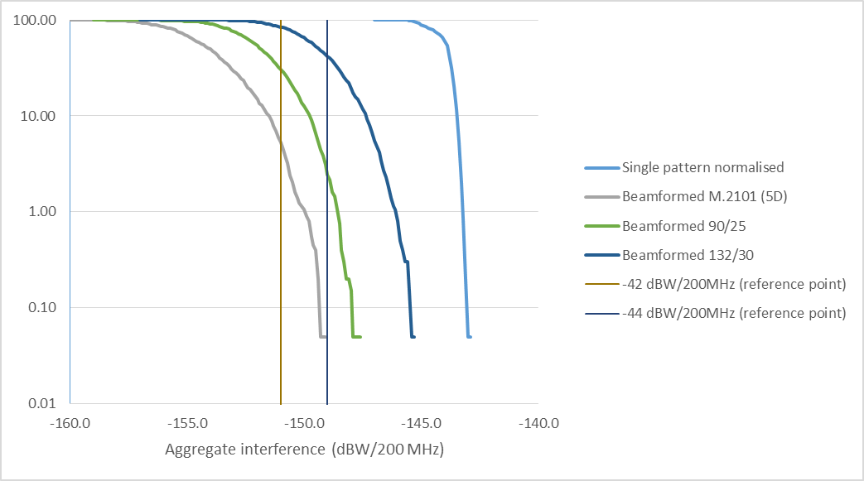

The above figure (see details in Annex 1) compares EESS (passive) interference distributions for a single set of assumptions but different scenarios related to the IMT-2020 antenna pattern. It clearly shows that, compared to the baseline single element pattern (light blue curve), the effect of considering a “beamformed” IMT antenna pattern cannot be neglected and can lead to an underestimation of the interference to EESS (passive) by 7 to 8 dB.

It can also be noted that when considering “beamformed” antenna, the issue of Base Stations antenna pointing cannot be neglected anymore. The analysis in Annex 2 show that this could also lead to several dBs increase of the interference to EESS (passive) sensors.

Facing these large differences, WMO and the scientific community would however not be opposing consideration of such “beamformed” antenna pattern, as far as such an assumption is supported by evidence and that a relevant antenna model is provided. These conditions are currently not fulfilled and hence only compatibility analysis between IMT-2020 and EESS (passive) considering a single element antenna pattern (TG 5/1 baseline) can be taken as representative. (see in particular Annex 1 to Study B (ESA-EUMETSAT) in Attachment 2 to Annex 3 to TG 5/1 Report).

* 1. Number of IMT-2020 base stations

The assumptions related to the IMT-2020 networks deployments have been duly provided by WP 5D to TG 5/1, in term of density of Base Stations per km² and global associated deployment factors over large area.

When considering the relatively small size of EESS (passive) footprints, TG 5/1 has agreed as a baseline to consider 2 example deployment methods relevant for this scenario (see Annex 1 to TG 5/1 report). This baseline has been used in all studies.

TG 5/1 also agreed that sensitivity analysis could be performed to consider, among others, a possible redistribution of the number of BS calculated for a region or country (number based on WP 5D elements) within the targeted urban and suburban areas, i.e. using population distribution database.

Such sensitivity analysis has been performed by WMO and the scientific community (see details in Study B in Attachment 2 to Annex 3 to TG 5/1 Report), considering France and Paris region, leading to different numbers of BS within the EESS (passive) footprint, as given in table below for sensor F3.

|  |  |
| --- | --- |
| **Scenario** | **Nb of BS in sensor F3 footprint (170 km²)** |
| **TG 5/1 Baseline** | 406 |
| **Medium case**  (population redistribution, capped to a maximum of 10 BS/km²) | 1443 |
| **Worst case**  (population redistribution, not capped) | 3059 |

The following has to be noted with regard to the WMO and scientific compatibility studies:

* their conclusions are based on the “medium case”, presenting a difference of about 5.5 dB compared to calculations based on the baseline approach.
* in no way it is an increase of the total number of BS per country or region, only a redistribution of the number of BS provided by WP 5D within the urban and suburban areas, that are the target for mmWave IMT-2020 networks.

As a comparison, with the baseline deployment, a number of 406 BS are considered within the 170 km² footprint of the EESS (passive) F3 sensor. Such an area is representative of a portion of the Paris region, representing a population of more than 4 Millions inhabitants, as shown on the figure below.

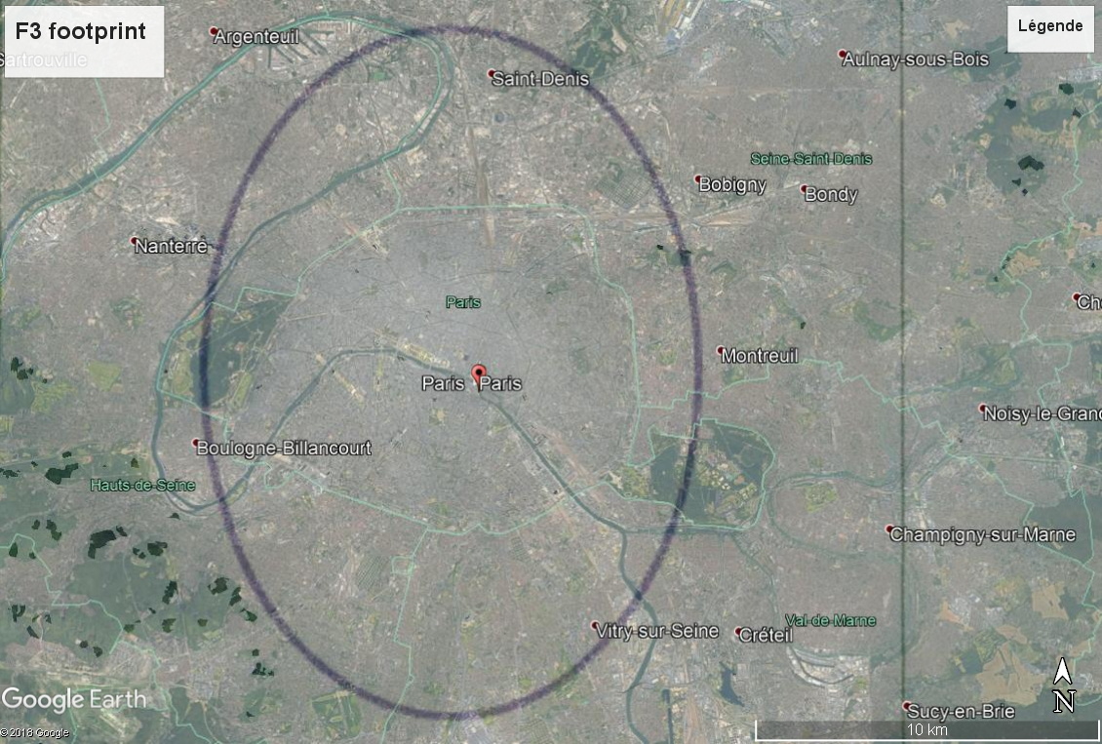

Under this assumption of 406 BS, and taking into account the various “activity factors” considered in the studies (20% loading factor and 80%/20% TDD factor), the current studies for sensor F3 are representative of a situation for which, at a given time, 65 BS and 49 UE would be simultaneously active. For more than 4 Millions inhabitants, this is 1 BS for more than 62000 inhab. and 1 UE for more than 82000 inhab..

One can probably raise questions about the relevance and representativeness of these numbers, in the light of the importance and priority given to IMT-2020 in the band 24.25-27.5 GHz.

* 1. Apportionment of EESS (passive) protection criteria

The agreement in TG 5/1 is that parameters and assumptions coming from ITU-R expert groups (WPs 5D, 7C, …) are to be taken into account.

EESS (passive) protection criteria are given in Recommendation ITU-R RS.2017. These interference criteria represent the total interference levels admissible by EESS (passive) sensors from all sources (aggregate interference) and, as such, cannot be given to a single source.

If IMT-2020 is identified in the 24.25-27.5 GHz band, the impact of their unwanted emissions will add to already existing interference from other services in various bands (FS, FSS, ISS, …) and a relevant apportionment of the interference criteria is to be made. This was taken into account within ITU-R WP 7C to address the necessary apportionment level and to provide to TG 5/1 (in document 5-1/177) the proposed apportionment factors to be applied for the different EESS (passive) bands.

For the specific case of the 24.25-27.5 GHz band, the necessary apportionment factor has been proposed by WP7C to be set at 3 dB.

Surprisingly, a number of compatibility studies presented so far within ITU-R TG 5/1 are currently denying this necessary apportionment factor, hence leading to artificially underestimating the impact of IMT-2020 interference on EESS (passive).

# Current status of WMO and scientific community studies

WMO and scientific community (ESA and EUMETSAT in particular) have been deeply involved in the ITU-R studies between EESS(passive) and IMT-2020 and the latest status of their compatibility analysis related to the protection of EESS (passive) in the 23.6-24 GHz band can be found as Study B (and its annexes 1 and 2) in Attachment 2 to Annex 3 to the TG 5/1 Report.

This analysis concludes that EESS (passive) sensor protection will require the IMT-2020 stations operated in the 24.25 – 27.5 GHz band to respect the following maximum unwanted emission levels in the band 23.6-24 GHz:

* For BS : -54 dBW/200 MHz
* For UE : -50 dBW/200 MHz

These studies are consistent with TG 5/1 agreement on study assumptions, including a sensitivity analysis on population-based redistribution of IMT-2020 base stations.

At this stage, and without new compelling elements, in particular on relevant IMT-2020 antenna model, it is maintained that these levels would be necessary to ensure protection of all existing and EESS (passive) sensors under development in the band 23.6-24 GHz.

# Current status of TG 5/1 studies

A number of different studies have been presented in TG 5/1 on this specific issue of the compatibility between 26 GHz IMT-2020 and EESS (passive) in the band 23.6-24 GHz.

The studies are currently compiled in Attachment 2 to Annex 3 to TG 5/1 Report on “SHARING AND COMPATIBILITY OF PASSIVE SERVICES IN ADJACENT FREQUENCY BANDS AND IMT OPERATING IN THE 24.25-27.5 GHz FREQUENCY RANGE” and the overall conclusion related to EESS (passive) is given in its section 2.1 (reiterated in Annex 3 of the present document).

These various studies present quite large differences in term of results, but the TG 5/1 conclusions make it clear that these differences are due to differences in assumptions, departing from the TG 5/1 agreed baseline.

It is also worth noting that compatibility studies using baseline assumptions (i.e. single element pattern, baseline BS distribution, apportionment of EESS (passive) protection criteria), namely studies A (France), B (ESA-EUMETSAT), I (Brazil), L (Ericsson) and M (Nokia) depict very similar results, leading to the following range of necessary IMT-2020 stations unwanted emissions levels:

* For BS : from -42 to -49 dBW/200 MHz (-48 for Study B)
* For UE :from -38 to -45 dBW/200 MHz (-44 for Study B)

# situation in Europe

Among WRC-19 regional preparatory groups, CEPT has already made its final decision on compatibility conditions between IMT-2020 and EESS (passive).

Indeed, CEPT adopted at July 2018 ECC meeting the ECC Decision (18)06 regulating, among others, the necessary IMT-2020 stations unwanted emissions levels in the 23.6-24 GHz band at the following levels:

* For BS : -42 dBW/200 MHz
* For UE : -38 dBW/200 MHz

Recognising that the band 24.25-27.5 GHz is the key band for IMT-2020 in Europe (for mmWave bands), this final decision on IMT-2020 unwanted emission levels is a balanced sharing of burden between IMT-2020 and EESS (passive). It would indeed be hard to believe that such a decision would have been taken by European Administrations if they were not convinced that these levels would allow IMT-2020 to be used in this key band.

It is worth noting that these levels were adopted after public consultation, stressing the following comment:

*“Although other values for these limits were proposed, the values that have been included in square brackets in the draft ECC decision reflect considerations within ECC on how best to ensure protection of passive EESS sensors while avoiding undue constraints on 5G base stations and terminal stations. “*

WMO (through EUMETNET, the European Meteorological organisation), ESA and EUMETSAT have been deeply involved in CEPT work and made the following comments regarding the above levels:

* These levels (i.e. -42/-44 dBW/200 MHz for BS) are already based on very optimistic set of assumptions (in favour of IMT-2020) to facilitate compatibility with passive sensors and already represent a huge back-off (10 to 12 dB) from the required protection levels as concluded in the ESA-EUMETSAT-EUMETNET compatibility studies;
* A number of factors (antenna pattern and pointing, number of BS) can easily lead to an increase of the interference distributions (IMT-2020 antenna pattern, IMT-2020 BS antenna pointing and number of BS) and their impact cannot be neglected and could lead to a need for a much lower value than -42/-44 dBW/200 MHz for BS;
* Considering the above, ESA, EUMETSAT and EUMETNET cannot compromise any further on those proposed levels and will therefore not accept any further relaxation of these levels, i.e; -42/-44 dBW/200 MHz for BS and -38/-40 dBW/200 MHz for UE.

# conclusions

WMO and the scientific community are not opposed to an identification of the band 24.25 – 27.5 GHz for IMT-2020 but are appealing worldwide administrations to duly take into account EESS (passive) protection requirements, taking into account in particular WMO Resolution 29 (Cg-17) (sse annex 4) and WRC Resolution 673 (see annex 5).

It makes no doubt that unconstrained IMT-2020 unwanted emission in the 23.6 – 24 GHz will strongly endanger EESS (passive) operations and the availability of this frequency band that is a unique natural resource. On the other hand, it may be agreed that the unwanted emission levels required to ensure a full protection of EESS (passive) (i.e. -54 dBW/200 MHz) could lead to important level of constraints on IMT-2020.

Most probably, only a balanced sharing of burden between IMT-2020 and EESS (passive) would allow to solve the issue. Consistently with our statements made within CEPT, WMO and the scientific community have to state clearly that:

* The levels agreed within CEPT (-42 dBW/200 MHz for BS) are already based on very optimistic set of assumptions (in favour of IMT-2020) to facilitate compatibility with passive sensors and already represent a huge back-off (10 to 12 dB) from the required EESS (passive) protection levels;
* A number of factors (antenna pattern and pointing, number of BS) can easily lead to an increase of the interference distributions (IMT-2020 antenna pattern, IMT-2020 BS antenna pointing and number of BS) and their impact cannot be neglected and could lead to a need for a much lower value than -42 dBW/200 MHz for BS;
* They cannot compromise any further and therefore cannot accept any further relaxation of unwanted emission levels of -42 dBW/200 MHz for BS and -38 dBW/200 MHz for UE. These levels indeed constitute the absolute minimum to provide a certain level of protection to passive sensors.

However, without new compelling elements (e.g. antenna pattern measurements), in particular on relevant IMT-2020 antenna model, only the levels -54 dBW/200 MHz (BS) and -50 dBW/200 MHz (UE) would fully ensure protection of all existing and under development EESS (passive) sensors in the band 23.6-24 GHz;

The following table provides an overview on the unwanted emission levels initially proposed for IMT-2020 (left column), the required levels to ensure passive senor protection (right column) and the concessions that would have to be made to reach the levels currently proposed in draft ECC Decision (18) FF.

|  |  |  |  |  |  |  |  |  |
| --- | --- | --- | --- | --- | --- | --- | --- | --- |
|  | Recommendation ITU-R SM.329 Category A / B levels | 5D incoming unwanted emission level | IMT unwanted emission into the passive band (reference level) based on 5G parameters | Required improvement of 5G unwanted emissions | ECC Decision (18)06 | Gain for 5G by just changing the measurement bandwidth | Concession on the protection of passive sensors | ESA/  EUMETSAT/  EUMETNET study result |
| BS | -13 (dBm//MHz)  -30 (dBm//MHz) | -13 (dBm//MHz) | -23.8  (dBW/200 MHz) | 18.2 / 20.2 dB | -42dBW/200 MHz | 5 to 10 dB | 12.2 / 10.2 dB | -54.2  (dBW/200 MHz) |
| UE | -13 (dBm//MHz)  -30 (dBm//MHz) | -13 (dBm//MHz) | -20  (dBW/200 MHz) | 18 / 20 dB | -38 dBW/200 MHz | 5 to 10 dB | 12.4 / 10.4 dB | -50.4  (dBW/200 MHz) |
| Comment | = -20 / -37 (dBW/200 MHz) | = -20  (dBW/200 MHz) | BS emission mask:20 MHz ≤ Δ*f* < 400 MHz:  = -26.4 (dBW/200 MHz)  Δ*f* > 400 MHz:  = -20 (dBW/200 MHz) |  |  |  |  |  |

# Annex 1: IMT-2020 antenna model

1-a: The issue of the IMT-2020 antenna model was addressed in an ESA-EUMETSAT input to last TG 5/1 meeting (see document 5-1/357), demonstrating that, based on information presenting IMT 5G antenna modelling and measurements, the beamformed model from M.2101 is unable to provide a relevant description of such antenna, in particular in the side lobes domain.

1-b: Considering the antenna model given in Recommendation ITU-R M.2101, the following technical considerations need to be taken raised:

* This model is associated to a number of basic parameters (single element gain, single element aperture, nb of elements, front-to-back ratio)
* Current parameters used in the studies were provided by WP 5D but are not consistent with the law of physics, such as the association of a 5 dBi gain and an 65° aperture for the single element.
* Indeed, for a 5 dBi gain, the relevant aperture should be of 132°. This has an important impact on the beamformed antenna side lobes.
* Also, the front-to-back ratio (i.e. the difference between the maximum and minimum gains of the single element) has an obvious impact on the side lobe levels. It is quite odd that, for a similar single element gain of 5 dBi, WP 5D provided different figures of aperture and front-to-back ratio for BS and UE, 65°/30 dB and 90°/25 dB, respectively.

1-c: In order to assess the impact of the IMT-2020 antenna pattern with a sensitivity analysis (consistently with TG5/1 conclusions), additional simulations have been performed using different sets of basic parameters to be used with the antenna model given in Recommendation ITU-R M.2101:

* Scenario 1 : only changing the single element aperture from 65 to 132° for BS (parameters for UE unchanged)
* Scenario 2 : changing the single element from 65 to 90° and the front-to-back ratio to 25 dB for BS (i.e. same parameters than for UE) (parameters for UE unchanged)

A description of the resulting pattern are given below (scenario 1 (left figure) and scenario 2 (right figure)), compared to the “basic” M.2101 pattern using 5D elements and the modelling made by Orange within TG 5/1.

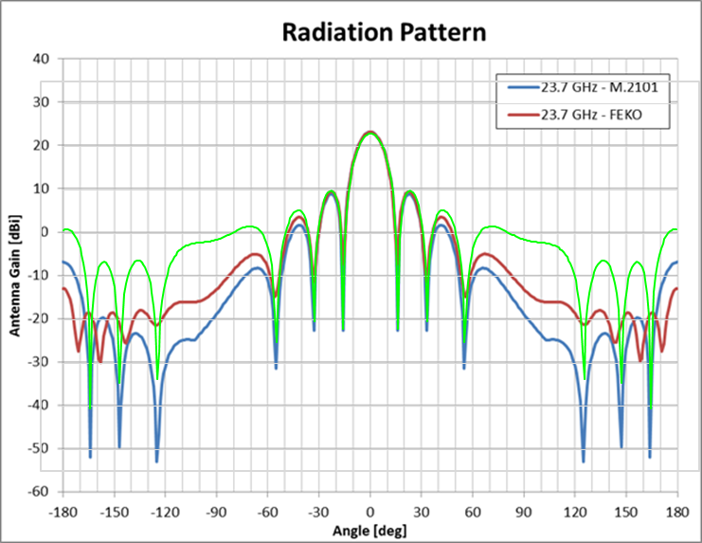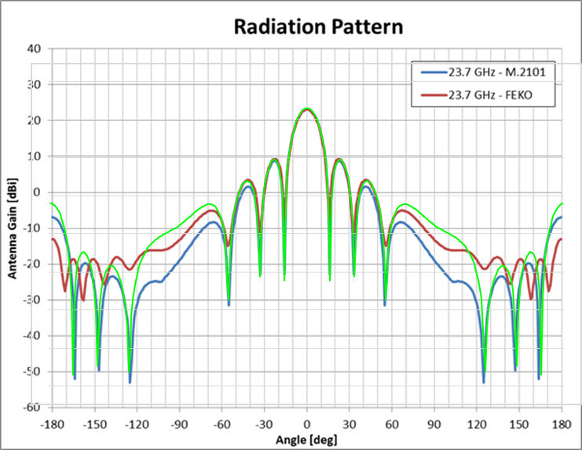

1-d: The following figure compares the simulation results for these two alternative beamformed antenna models (132/30 and 90/25) with the similar results using the single element pattern (TG 5/1 baseline) as well as the basic M.2101 model using 5D elements (for sensor F3, 406 BS and apportionment of the EESS (passive) protection criteria).



1-e: These results confirm the quite important impact of the IMT-2020 pattern side lobes when considering a beamformed antenna, impact that hence cannot be neglected.

# Annex 2: IMT-2020 BS antenna pointing

2-a: The issue of the IMT-2020 antenna BS pointing was addressed in an an ESA-EUMETSAT input to last TG 5/1 meeting (see document 5-1/357) showing that the 5G BS gain toward EESS (passive) sensors is highly sensitive to this elevation. It also shows that even considering single entry case, small increase in elevation will have important impact on interference to EESS (passive) sensors.

This analysis concludes that a limit in maximum electrical pointing of IMT BS above the horizon will have to be considered.

2-b: For the current TG 5/1 assumptions, the average gain for the BS case have been calculated based on the baseline single element antenna pattern (5 dBi) with fixed mechanical downtilt of 10°. The electrical tilt has hence no impact on the 5G BS gain toward EESS (passive) sensors. For beamformed antenna, one can easily understand that such gain will be impacted by the 5G BS beam electrical pointing angle.

2-c: At this stage, when calculating interference to EESS (passive) sensors, assumptions made about UE deployment over the cell are that all UE are at 1.5 m height. With a BS height at 6 or 10 m, this means that all electrical BS pointing are within the negative domain. This looks rather optimistic, in particular in the light of most information papers on 5G, depicting number of scenarios with positive elevations, in particular in urban area, e.g indoor UE at different floors, outdoor UE depending on area topology or even drones.

2-d: In order to assess the impact of the IMT-2020 BS antenna pointing, additional simulations have been performed using different UE deployment over the cell with very low percentage of UE presenting a positive elevation (both scenario with M.2101 beamformed pattern with basic 5D parameters):

* Scenario 1 : 99% UE at 1.5m height and 1% evenly distributed between 6 and 22.5 m (this last figure being consistent with recently adopted ITU-R Report M.2412 on “Guidelines for evaluation of radio interface technologies for IMT-2020”)
* Scenario 2 : 97% UE at 1.5m height and 3% evenly distributed between 6 and 22.5 m

2-e: The following figure compares the simulation results for these two alternative UE deployment (“up 1%” and “up 3%”) with the results using the single element pattern (TG 5/1 baseline) as well as the basic M.2101 model using 5D elements (for sensor F3, 406 BS and apportionment of the EESS (passive) protection criteria).



2-f: These results confirm the quite important impact of the IMT-2020 BS antenna pointing, even with very low percentage of UE presenting a positive elevation, showing in particular in this case that the “beamformed” antenna scenario could present higher interference level compared to the “single element” scenario. Such impact cannot be neglected.

2-g: Taking into account elements related to the pointing of the beamfomed antenna (as above) and improved sidelobes (described in Annex 1), additional simulations have been performed to assess their combined effect, leading to the following scenarios:

- Scenario 1: improved sidelobes “90/25” and 1% pointing upward

- Scenario 2: improved sidelobes “90/25” and 3% pointing upward

- Scenario 3: improved sidelobes “132/30” and 1% pointing upward

- Scenario 4: improved sidelobes “132/30” and 3% pointing upward



2-h: These results confirm the important impact of the combined effect of IMT-2020 BS antenna pointing and improved side lobes of beamformed pattern showing in particular in this case that the “beamformed” antenna scenario could present higher interference level compared to the “single element” scenario. Such impact, that can represent an interference increase by 5 to 10 dB cannot be neglected.

# Annex 3

# TG 5/1 conclusions on compatibility between IMT-2020 and EESS (passive) in the 23.6-24 GHz.

(abstract from August 2018 TG 5/1 meeting chairman’s Report (document 5-1/478 – Attachment 2 to Annex 3)

**…/…**

**2 Summary and analysis of the results of studies**

**2.1 EESS (passive)**

Ten studies were performed in relation to compatibility between IMT-2020 in the 24.25‑27.5 GHz frequency band and EESS (passive) in the frequency band 23.6-24.0 GHz, leading to a range of unwanted emission levels that would be necessary to protect the EESS (passive). While some of the studies were performed on all sensors in Rec. ITU-R RS.1861 operating in the 23.6-24.0 GHz frequency band, the results below are based on the most restrictive Sensor F3. Results obtained for the other sensors are similar (F2 and F8) or less restrictive. All results are expressed in interference exceedance as well as corresponding levels of unwanted emissions.

**Single element antenna pattern**

Some studies considered the IMT single element antenna pattern from Recommendation ITU-R M.2101:

Five studies showed that the levels of interference exceedance for Sensor F3 were (applying the apportionment value of 3 dB of the EESS (passive) protection criteria):

– Study A: 22.5 dB, i.e. ‑42/-46 dB(W/200 MHz) for UE and BS, respectively.

– Study B: 24.5 dB, i.e. ‑44/-48 dB(W/200 MHz) for UE and BS, respectively.

– Study I: 21.9 to 24.4 dB (variation due to not normalized/normalized), i.e.   
-42 to ‑44 dB(W/200 MHz) for UE and BS (total).

– Study L: 18.5 to 25.2 dB (variation due to normalized/not normalized and percentage of distribution 50% to 99%), i.e. -38.5 to ‑45 dB(W/200 MHz) for UE, and   
-42 to ‑49 dB(W/200 MHz) for BS.

– Study M: 17.7 to 23 dB, (variation due to normalized/not normalized and percentage of distribution 50% to 99%) i.e. -38 to ‑43 dB(W/200 MHz) for UE, and of -42 to   
-47 dB(W/200 MHz) for BS.

Three studies showed that the levels of interference exceedance for Sensor F3 were (assuming no apportionment of the EESS (passive) protection criteria):

– Study F: 15.6 dB (Considering a split of the interference of 90% for BS and 10% for UE), i.e. ‑40/-30 dB(W/200 MHz) for BS and UE, respectively.

– Study H: 16.4 dB, i.e. ‑36/-40 dB(W/200 MHz) for UE and BS, respectively.

– Study J: 19.4 to 20.4 dB (variation due to different percentile of unwanted emission level; 90th to 99th) , i.e. -36.4 to ‑35.4 dB(W/200 MHz) for UE, and of -40.1 to   
-39.1 dB(W/200 MHz) for BS.

In addition, Studies A and B performed a sensitivity analysis considering a population-based redistribution of the IMT-2020 base stations (capped to a maximum of 10 BS/km²) and showed that the levels of interference exceedance for Sensor F3 were (applying the apportionment value of 3 dB of the EESS (passive) protection criteria):

– Study A: 31 dB i.e. ‑51/‑55 dB(W/200 MHz) for UE and BS, respectively.

– Study B: 30.4 dB ‑50/‑54 dB(W/200 MHz) for UE and BS, respectively.

Moreover, Studies A and B considered a 2 dB “multi-operator interference factor” to cover the interference falling into the EESS (passive) frequency band 23.6-24.0 GHz from multiple IMT-2020 operators’ channels using the entire 24.25-27.5 GHz frequency band for outdoor deployments and including the possible impact of outdoor UEs connected to indoor BS.

**Beamforming antenna model**

Some studies performed a sensitivity analysis using a beamforming antenna model in the unwanted emission domain. In the absence of IMT-2020 antenna measurement data it was agreed in ITU-R that:

– The antenna pattern may remain beamforming to some extent in the adjacent frequency band.

– The Recommendation ITU-R M.2101 model applicable to beamforming gain may in that case underestimate the side lobe levels (e.g., some simulations have shown that, for an 8 × 8 array simplified AAS antenna design model with one slant dipole elements, the side lobes closest to the main beam, IT-R M.2101 appears to be a reasonable match but side lobes further from the main beam would be underestimated).

– The “variance” of the interference distribution is much wider compared to the use of a single element pattern and hence a conclusion on average interference would not be appropriate.

Five studies showed that the levels of interference exceedance for Sensor F3 were (applying the apportionment value of 3 dB of the EESS (passive) protection criteria):

– Studies A and J: 18 dB i.e. ‑38/‑42 dB(W/200 MHz) for UE and BS, respectively. These studies also considered a multi-operator interference factor.

– Study I: 21.1 to 22.6 dB (variation due to not normalized/normalized), i.e.   
-41 to ‑42 dB(W/200 MHz) for BS and UE (total).

– Study L: 11 to 15.7 dB (variation due to normalized/not normalized and percentage of distribution 50% to 99%), i.e. -31 to ‑36 dB(W/200 MHz) for UE and   
-35 to ‑39 dB(W/200 MHz) for BS.

– Study M: 13.5 to 18 dB (variation due to normalized/not normalized and percentage of distribution 50% to 99%), i.e. -33 to ‑39 dB(W/200 MHz) for UE and   
-37 to ‑42 dB(W/200 MHz) for BS.

Five studies considered an IMT-2020 beamforming antenna pattern, assuming no apportionment, and showed that the levels of interference exceedance for Sensor F3 were:

– Study C: TBD dB, i.e. TBD dB(W/200MHz) for UE and BS respectively. Additional work is needed on Study C.[1]

– Study F: 9.2 dB (Considering a split of the interference of 90% for BS and 10% for UE), ‑32/‑33 dB(W/200 MHz) for UE and BS, respectively.

– Study G: 9 to 14 dB (for an interference probability from 1% to 10%), i.e.   
-29 to ‑34 dB(W/200 MHz) for UE and -32 to ‑35 dB(W/200 MHz) for BS.

– Study H: 10.9 dB (Considering a split of the interference of 80% of BS and 20% of UE), i.e. ‑34.7/-30.9 dB(W/200 MHz) for BS and UE, respectively.

– Study J: 10.1 to 13.8 dB (variation due to with and without normalisation at different percentiles of unwanted emission levels, 90% to 99%), i.e. -33.8 to ‑30.1 dB(W/200 MHz) for UE and -37.5 to ‑33.8 dB(W/200 MHz) for BS.

Two studies evaluated the permissible interference criteria levels over the measurement area as prescribed in Rec. ITU-R RS.2017 for Sensor F3:

– Study C: TBD dB, i.e. TBD dB(W/200 MHz) for IMT stations. Additional work is needed on Study C.

– Study G: 9 to 14 dB (for an interference probability from 1% to 10%), i.e. -29 to   
-34 dB(W/200 MHz) for UE and -32 to ‑35 dB(W/200 MHz) for BS.

Study L considered an IMT unwanted emission distribution (mean value –30/‑26.3 dB(W/200 MHz) per BS/UE, a standard deviation of 2 dB instead of the baseline fixed value for Sensor F3 and showed the level of exceedance was (including apportionment) 6.4 to 9.7 dB, i.e. ‑26.4 to -29.7 dB(W/200 MHz) for UE, and -30.1 to ‑33.4 dB(W/200 MHz) for BS.

Study B also considered the possible impact of the second harmonic of the IMT‑2020 stations operating in the 24.25-27.5 GHz frequency band falling in the 50.2-50.4 GHz and 52.6‑54.25 GHz EESS (passive) frequency bands, in particular from IMT‑2020 base stations.

**…/…**

# Annex 4

# WMO Resolution 29 (Congress-17) on “Radio frequencies for meteorological and related environmental activities”



# Annex 5

# ITU Resolution 673 (rev. wrc-12)

RESOLUTION 673 (Rev.WRC‑12)

**The importance of Earth observation radiocommunication applications**

The World Radiocommunication Conference (Geneva, 2012),

*considering*

*a)* that the collection and exchange of Earth observation data are essential for maintaining and improving the accuracy of weather forecasts, which contribute to the protection of life and preservation of property throughout the world;

*b)* that Earth observation data are also essential for monitoring and predicting climate changes, for disaster prediction, monitoring and mitigation, for increasing the understanding, modelling and verification of all aspects of climate change, and for related policy-making;

*c)* that Earth observations are also used to obtain pertinent data regarding natural resources, this being particularly crucial for the benefit of developing countries;

*d)* that observations of the Earth’s surface are also used for a large variety of other applications (e.g. urban developments, utilities deployments, agriculture, security);

*e)* that many observations are performed over the entire world which require spectrum-related issues to be considered on a worldwide basis;

*f)* that the importance of Earth observation radiocommunication applications has been stressed by a number of international bodies such as the World Meteorological Organization (WMO), the Intergovernmental Panel on Climate Change (IPCC) and the Group on Earth Observation (GEO), and that ITU‑R collaboration with these bodies is essential;

*g)* that, although meteorological and Earth observation satellites are currently operated by only a limited number of countries, the data and/or related analyses resulting from their operation are distributed and used globally, in particular by national weather services in developed and developing countries and by climate change-related organizations;

*h)* that Earth observations are performed for the benefit of the whole international community and the data are generally made available at no cost,

*recalling*

*a)* the Plan of Action of the World Summit on the Information Society (Geneva, 2003), on e‑environment, calling for the establishment of monitoring systems, using information and communication technologies (ICT), to forecast and monitor the impact of natural and man-made disasters, particularly in developing countries, least developed countries and small economies;

*b)* Resolution 136 (Rev. Guadalajara, 2010) of the Plenipotentiary Conference, on the use of telecommunications/information and communication technologies for monitoring and management in emergency and disaster situations for early warning, prevention, mitigation and relief;

*c)* Resolution 182 (Guadalajara, 2010) of the Plenipotentiary Conference, on the role of telecommunications/information and communication technologies on climate change and the protection of the environment,

*recognizing*

*a)* Recommendations ITU‑R RS.1859 “Use of remote sensing systems for data collection to be used in the event of natural disasters and similar emergencies” and ITU‑R RS.1883 “Use of remote sensing systems in the study of climate change and the effects thereof”;

*b)* the Report on Question ITU‑D 22/2 “Utilization of ICT for disaster management, resources and active and passive space-based sensing systems as they apply to disaster and emergency relief situations”;

*c)* joint WMO-ITU Handbook on “Use of Radio Spectrum for Meteorology: Weather, Water and Climate Monitoring and Prediction” and ITU‑R Handbook on “Earth exploration-satellite service”,

*further recognizing*

Report ITU‑R RS.2178 “The essential role and global importance of radio spectrum use for Earth observations and for related applications”,

*noting*

*a)* that *in situ* and remote Earth observation capabilities depend on the availability of radio frequencies under a number of radio services, allowing for a wide range of passive and active applications on satellite- or ground-based platforms (see Report ITU‑R RS.2178);

*b)* that, according to the United Nations Framework Convention on Climate Change (UNFCCC), more than 90 per cent of natural disasters are climate- or weather-related;

*c)* that for certain Earth observation applications, long-term consistency of measurements is essential (e.g. climate change);

*d)* that certain frequency bands used by Earth observation applications have unique physical characteristics (e.g. spectral lines), so that migration to alternative frequency bands is not possible;

*e)* that some essential passive frequency bands are covered by No. **5.340** of the Radio Regulations;

*f)* that some essential passive Earth observation sensors could suffer from interference resulting in erroneous data or even complete loss of data,

*resolves*

1 to continue to recognize that the use of spectrum by Earth observation applications has a considerable societal and economic value;

2 to urge administrations to take into account Earth observation radio-frequency requirements and in particular protection of the Earth observation systems in the related frequency bands;

3 to encourage administrations to consider the importance of the use and availability of spectrum for Earth observation applications prior to taking decisions that would negatively impact the operation of these applications.

-------------------

1. An update will be provided to CPM19-2.