 | ASIA-PACIFIC TELECOMMUNITY | Document No:
 | The 4th Meeting of the APT Conference Preparatory Group for WRC-19 (APG19-4) | APG19-4/INF-15
 | 7 – 12 January 2019, Busan, Republic of Korea | 31 December 2018

Viasat, Inc.
Information document on SATELLITE IN THE 5G ECOSYSTEM
Introduction
5G has been conceived as an ecosystem of many technologies – a network of networks – in which satellite plays a vital role in accelerating opportunity, maximizing network potential, and extending network reach.
The global Internet approach has been a powerful driver in providing world-changing economic opportunities. By integrating the unique benefits of every kind of network – copper, fiber, terrestrial wireless, and satellite – the Internet has become a global force that has created as much economic growth in 15 years as the industrial age created in 50 years. This network of networks approach has been instrumental not only because it takes advantage of the unique capability of every available technology at the core of the network to extend its reach (fiber, copper, and satellite), but also through the variety of access technologies at the edge of the network – Wi-Fi, cable, DSL, LTE, and satellite to name a few.
This ecosystem approach has proven to be essential for leveraging the unique benefits of each type of network technology to expand the reach and capability of the Internet. The combination of cellular, Wi-Fi, satellite and other advances are enabling this same kind of ecosystem approach to be extended to the wireless world – both in the core of the network and at its edges – to expand the capabilities of mobile and fixed end user devices and the locations they operate.
At the dawn of the 5G world, advancing this 5G ecosystem architecture is even more vital. Too often, however, the only aspect of next generation wireless technology that is focused on is the last 100 meter access link to the end user device. A myopic view of 5G – especially when it comes to spectrum – can limit its potential. Only through a holistic view of 5G, and a broad understanding of the comprehensive nature of the entire 5G ecosystem, can the full power and potential of next-generation wireless opportunity be realized. That’s because 5G is not a step change from 4G, nor is it just a technological shift. It’s a paradigm shift in the way we think about high speed mobile broadband networks. Today’s 5G vision encompasses a broad technology ecosystem – with multiple network technologies supporting a global infrastructure including traditional mobile wireless networks, satellite, Wi-Fi, and small cells.
The 5G network is envisioned as an access network-agnostic architecture that includes new cellular wireless access technologies (for the last 100 meter access), but also existing fixed wireless networks, Wi-Fi and satellite networks. These multiple access technologies are critical for optimizing the many different use cases envisioned for next generation networks. With advanced concepts of a unified user identity, users can be authenticated regardless of access technology enabling a seamless experience. The access technology and network technology are not inextricably linked but are decoupled to provide more flexibility for users and applications regardless, for example, if they are on a cellular network or Wi-Fi network. This multi-access capability can, for example, enable traffic to be offloaded from the mobile access network to other networks (for example to a satellite enabled Wi-Fi endpoint).
This 5G ecosystem approach is also essential for expanding the reach of 5G networks. By taking advantage of satellite’s geographically independent cost structure to extend connectivity, for example in underserved and unserved areas, satellite systems can accelerate the commercially viable deployment of 5G networks and extend scalable and efficient 5G network solutions globally. This is especially critical in areas that may not be economically or otherwise connected via terrestrial networks. Network diversity is also essential for ensuring network resiliency and continuity of service across geographies and enabling 5G devices to connect on truly mobile platforms including onboard aircraft, high-speed trains, sea-going vessels, and land-based vehicles that are beyond the reach of a cell site.
In order to fundamentally expand what networks are capable of achieving, and the places they are capable of reaching, a holistic approach is necessary to advance the entire 5G ecosystem of technologies. Harnessing the capabilities of satellite technology maximizes the reach and capabilities of 5G networks. Doing so also maximizes the ability of the 5G ecosystem to solve bigger problems – like extending high speed access to the next billion people, improving network resiliency, and enabling ubiquitous connectivity in the air, across the seas, and around the globe.
Nowhere is this more critical than in spectrum policy decisions. Having a holistic approach to spectrum policy that takes into account the unique capabilities of each technology is essential. This paper outlines the key spectrum decisions that enable the 5G opportunity to be maximized by embracing a holistic approach to the 5G ecosystem, and a holistic approach to the spectrum policy that accompanies this network of networks.
Next Gen Wireless Networks
It is important to be clear on the goals for the 5G ecosystem: To enable a connected world with ubiquitous access to the Internet by providing hyper mobility on land, sea and air for all people everywhere. This is more than just about the edge devices or the radio access; it is about providing a complete global network infrastructure.
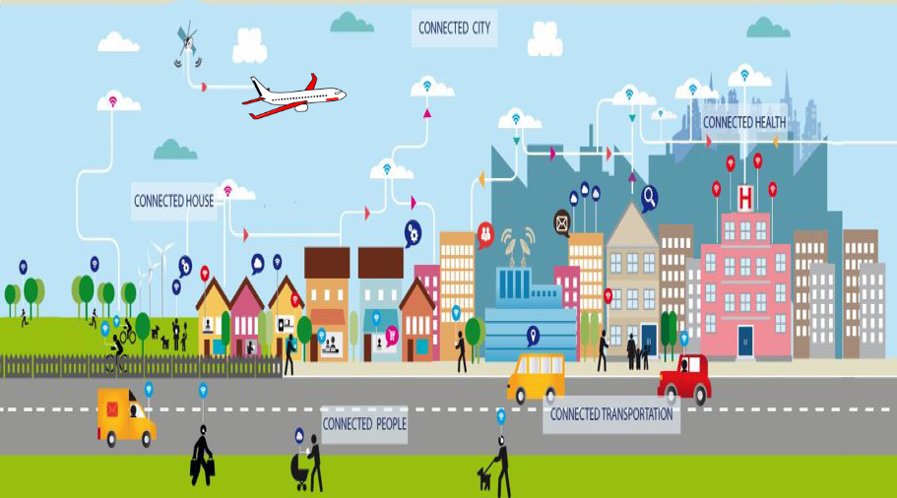

Figure 1: The Connected World

Clearly, this cannot be done with one wireless access technology or with one network. There will continue to be extensive use of multiple wireless technologies such as Wi-Fi, point-to- multipoint links, satellites and, of course, cellular. They all play an essential role in building an infrastructure that is adaptable to the ever-expanding new applications and environments.
Similarly, network infrastructure will continue to rely upon fiber, cable, microwave, satellite, HAPS (High Altitude Platforms) and mm-wave technologies to deliver on the ubiquitous and robustness promise. These hybrid networks must now enable greater capabilities to ensure security and accessibility and adaptive performance with simple hand-offs between peer networks.
With this more complete perspective of 5G we can now put in context a balanced roadmap to future wireless technologies which will include satellite, microwave, mm-wave, cellular and Wi-Fi networks that will collectively compete for the broadening demand for new applications. Each of these networks provides its unique value in user management, security and capabilities, yet each also connects to the global Internet in a consistent way to exchange data using compatible user authentication models.
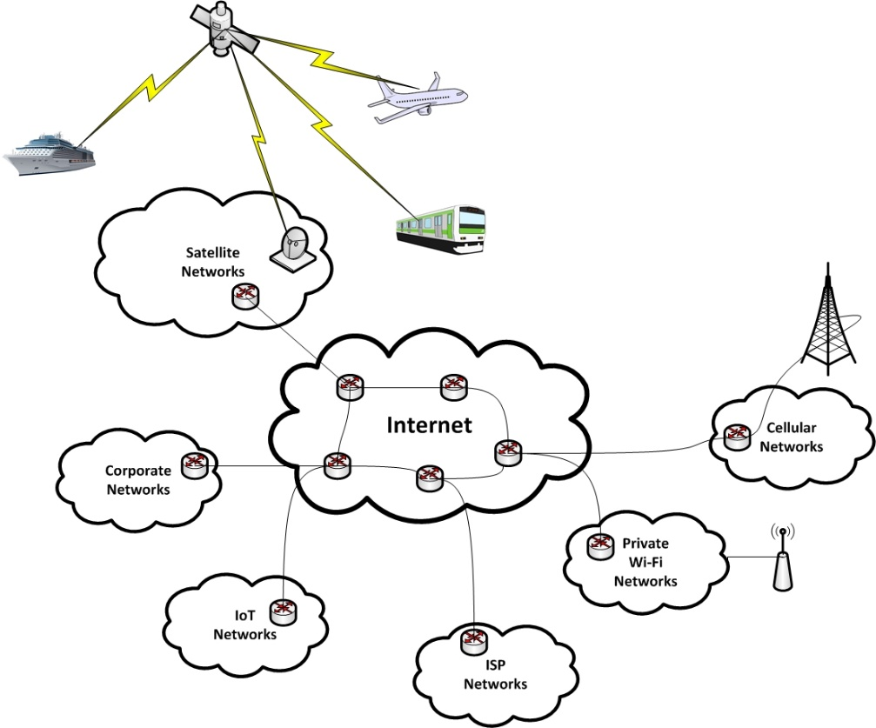

Figure 2: 5G Ecosystem – Network of Networks

This network infrastructure is invisible to most users but plays a critical role in delivering performance, security, value-added features, and authentication for the user. While most users rely heavily on their mobile devices, few realize that 63% of all mobile data actually is ‘offloaded’ to Wi-Fi and the Internet using unlicensed spectrum. As mobile data demand increases so will this offload to unlicensed spectrum. By 2021, Cisco predicts that 5G cellular devices will represent only 0.2% of all connected devices in the world and will account for only 1.5% of network traffic. Cisco also predicts that by 2021 the total of all IP Internet traffic will exceed 84 exabytes of data, 50% will be Wi-Fi, 30% will be fixed and only 20% will be mobile data.
It is this diversity of wireless access technologies as well as the inter-connectivity of network topologies that ensures a robust and resilient network ecosystem.
Current Satellite Capabilities
Both geostationary (GSO) and non-geostationary (NGSO) satellite networks have their specific benefits for the 5G ecosystem. Innovation is driven by development of High Throughput Satellite (HTS) systems in various types of orbits (GSO, MEO, LEO). HTS systems today deliver substantial improvements in throughput, capacity and cost, as well as provide flexible, global and high-performance services. This is done by utilizing concentrated spot beams, wideband payloads, increased frequency re-use and higher frequency bands to significantly increase capacity and speeds over wide areas. HTS networks are operating on a global basis and can provide broadband service with speeds in excess of 100 Mbit/s to the end user.

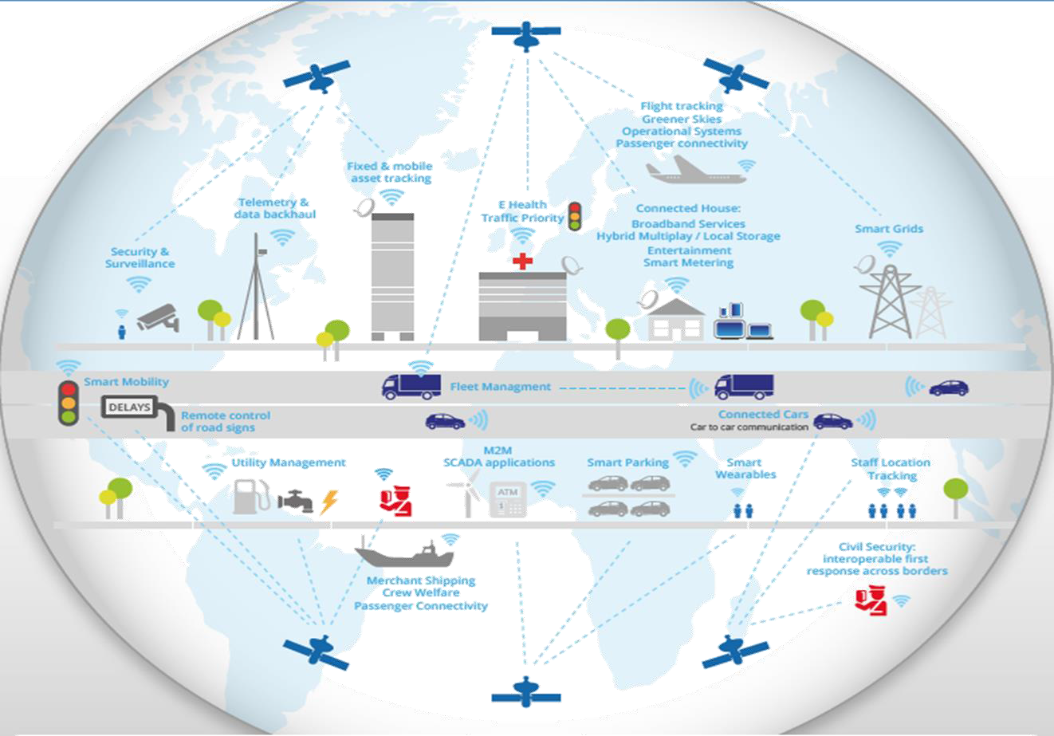

Figure 3: Satellites in the 5G Ecosystem

In addition to the developments in the space segment, there are technical developments in the satellite ground segment with evolutions both in the network platforms and satellite communication terminals and antennas. Satellite already has and will further adopt technologies and standards necessary to deliver the types of services needed in the 5G ecosystem, including in the areas of service delivery, network-slicing, orchestration, mobile edge computing, security, interoperability and resource virtualization in order to transparently support end-to-end service delivery to vertical applications. Furthermore, a new wave of flat panel antenna technology is emerging for satellite communications. These antennas have removed mechanical components, relying on software and electronics for steering, making them available for mobile platforms like cars, boats, planes and more.

Advanced Satellite Network Technology
Advanced satellite technology includes support for virtual network operators, traffic management, intelligent routing, quality of services, and other features. Some of these features are nearly unique to satellite communications, such as acceleration services to mitigate the impact of latency. Some, such as traffic enforcement, service accounting, and media services (including content rights management) are common among most access networks. Some, such as mobility services, are similar to those employed in cellular systems but are tailored to the much larger reach of satellites.
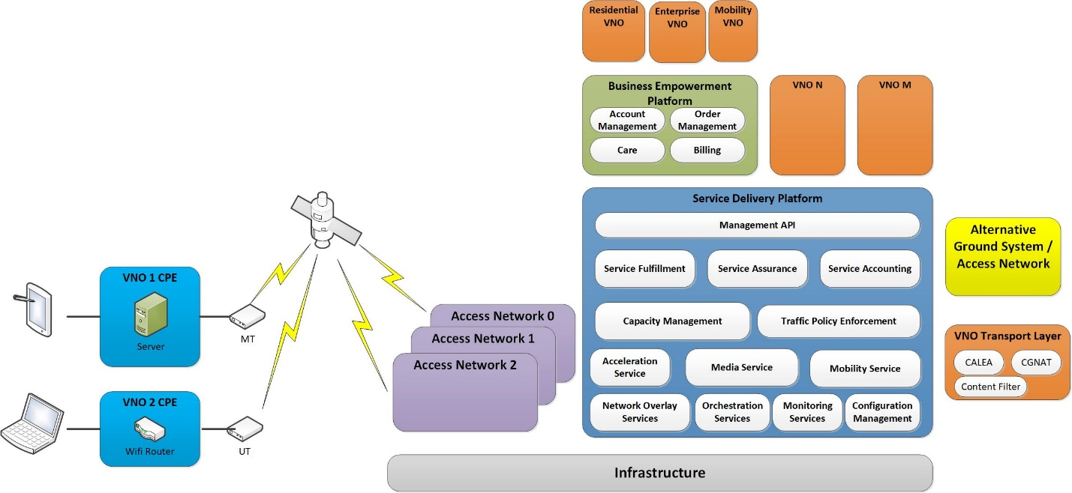

Figure 4: Satellite Ground System Components

Data can be routed between satellite beams within a satellite network, between satellite networks, and between satellite and terrestrial networks. This allows consistent, seamless connectivity for individual users whether they are in the air, on the water, in a vehicle or train, at home, in town, or in the office. The networks support multicast as well as unicast data efficiently.
Advanced satellite systems also include dynamic configuration management elements to enable flexible adaptation of device behavior suitable for operating across networks. This allows the networks to adapt over time and to change behavior as necessary to compensate for link dynamics.
Satellite Spectrum Technological Advancements
Commercial satellite networks have relied on access to the 27.5 – 30 GHz band (Ka Band) for over two decades to provide critical connectivity around the world. Today, over 130 GSO Ka band satellites are now in orbit, providing a wide range of services. Many more Ka band satellites (both GSO and NGSO) are under construction to meet the growing demand for service, and need to use the full 2.5 gigahertz of Ka band spectrum both to meet this demand, and because the Ka band orbital arc is becoming increasingly congested. While satellite use of the Ka band has grown exponentially in the past few decades, the terrestrial mobile service simply did not develop in the Ka band, even though the ITU’s Table of Frequency Allocations also provided an opportunity for that to occur.
For next generation satellites to provide high capacity connectivity, they need continued access to spectrum, and to employ the existing technologies that allow the spectrum to be used up to its technological limit. Modern satellite technology has developed to the point where it extensively employs frequency reuse technologies in which the same frequency band is used by one satellite to provide connectivity to many diverse locations at the same time by creating separate spatially isolated or orthogonal beams. Similarly, many different satellites use the same frequency band to provide connectivity to the same location. This is possible because each ground-to-satellite connection is from a different direction. The ground antenna can be a traditional parabolic dish, a horn array with mechanical steering, or an electrically-steered phased array.
In fact, satellite technology has advanced to the point that today’s satellite broadband systems are approaching “Shannon’s Limit” in terms of spectral efficiency. Access to adequate spectrum is now the primary limiting factor in extending satellite broadband networks to address all of the unserved and underserved around the world, no matter whether they live in metropolitan areas or remote communities.
Benefits for Consumers, Businesses, and Governments Provided by Satellite Today: Vertical Examples
As we enter a golden age of next gen satellite vast new opportunities come into view
Satellite is a vital part of the 5G ecosystem and is uniquely situated to solve key digital inclusion challenges, and expand global digital opportunity. As the world is blanketed with high speed broadband access, the opportunities become even greater, the technologies more transformative, and the impacts even more profound. Satellite systems already offer speeds today of up to 100 Mbit/s. Satellites currently under construction are capable of offering 1 Gbit/s, lightning-fast broadband speeds.
Connecting the unconnected: Today, more than ever, access to high speed broadband is an opportunity equalizer and economic accelerator. What once was a luxury is a necessity today. However, 3.9 billion people around the globe still do not have access to the Internet, and around one-third of the world’s inhabitants still do not own a personal mobile phone. High-quality and cost-effective satellite broadband is playing an increasingly important role in addressing this digital divide across the globe, for the unserved and underserved who exist everywhere, including in the most rural and remote areas of the world where it remains uneconomical for terrestrial or cellular services to build. The nature of satellite's wide coverage ensures that all communities within a satellite network's footprint receive the same quality of service, whether they are in metropolitan areas or remote communities.
- In many cases, the digitally disconnected are the ones who can benefit most when they gain access to the global Internet and are digitally included. Connecting these people is essential for supporting freedom of information and speech, accelerating developing economies, improving access to education, empowering women and minorities, and advancing democratic societies. This is why the UN’s 2030 Agenda for Sustainable Development has recognized that “global interconnectedness has great potential to accelerate human progress, to bridge the digital divide and to develop knowledge societies,” and the UN’s Human Rights Council has declared Internet access to be a basic human right. Satellite technology helps meet these objectives by blanketing the globe with this digital opportunity, extending access beyond the reach of terrestrial networks, and transforming the economics of global broadband reach. Indeed, among the UN's Sustainable Development Goals, the achievement of 38 targets depends upon universal and affordable access to broadband and the technologies needed to access broadband. Satellite systems not only play an essential role in extending broadband connectivity globally, they also provide the connectivity for extending scalable and efficient network solutions globally. By taking advantage of satellite’s geographically independent cost structure to extend connectivity, satellite today is helping provide connectivity to tens of millions of fixed and mobile end-user devices everywhere, including areas that are not adequately connected via terrestrial networks.
- It is also why the ITU’s recently concluded Plenipotentiary Conference in Dubai, UAE, adopted modifications to Resolution 203 on Connectivity to broadband networks (Rev. Dubai, 2018) inviting Member States “to facilitate connectivity to satellite and terrestrial broadband networks, including enabling access to spectrum, as appropriate, as one important component of access to broadband services and applications, including to remote, underserved and unserved areas.”

Enabling communications on the move. Satellite broadband is helping expand economic opportunity everywhere – on the ground, in the air, across the seas, and around the globe. Advances in technology make it possible today to deliver high-speed satellite broadband communications to consumers and businesses on the move – whether on an airplane (while waiting to take off, and at 35,000 feet), on a ship in the middle of the ocean, on a tractor in a remote and rural farm, on a bus or train in a city, or in an emergency vehicle speeding down the freeway on the way to a hospital. Already more than a thousand airplanes flying billions of air miles are accessing satellite-enabled high-speed Wi-Fi capable of streaming Internet and movies right to the seat. Wi-Fi on aircraft has become so popular that there are often more connected devices than passengers on planes. Well over 60 million electronic devices already connect every year to satellite-enabled Wi-Fi on airplanes and this number is expected to increase exponentially to hundreds of millions in just the next 3-5 years as more aircraft become connected. Satellite’s unique ability to provide connectivity across moving platforms is essential for enabling people with 5G devices to connect while on the move.
Extending Wi-Fi service. Satellite-based Wi-Fi services today connect users in metropolitan areas as well as unserved and underserved markets within the satellite network’s coverage area. Satellite-based Wi-Fi is extending high-speed broadband access in unique ways to urban city centers, community recreation centers, airports, stores and shops. At the same time, large numbers of towns and villages worldwide have little to no Internet access. To address these broadband-challenged locations, satellite-powered hotspot service connects people in small villages and towns to the online world – affordably and reliably. Many people in these villages and towns have mobile smartphones, yet many do not have Internet service. By bringing a satellite-powered community 5G Wi-Fi service to these villages, made available through a shared satellite terminal, the residents gain access to high-speed connectivity. For example, today nearly one million people in thousands of locations that don’t have 3G or 4G services can now connect their smartphones thanks to satellite-powered community Wi-Fi hotspots.
Unlocking new digital health opportunities. With too many people living in areas with only sporadic and even diminishing access to quality health care, satellite broadband technologies that span distance today are extending connected care everywhere. What was once a dream is now becoming a reality, that is, no one should be forced to put their life at risk simply because they live too far from a doctor. Satellite technology is cost-effectively overcoming a rural physician shortage, extending experts to where they are needed most, and delivering services regardless of where the doctor or patient is physically located. For example, satellites today are being used to connect ambulances in transit to doctors in hospitals to improve patient outcomes.
Improving disaster recovery and relief. Satellites networks provide high capacity and instantaneous connection to any place within their wide coverage areas. They are less vulnerable to physical attacks and natural disasters than terrestrial systems and satellite terminals can be rapidly deployed. Satellite networks can be especially important for improving 5G service resiliency, and for rapid deployments of high-speed wireless connectivity in emergencies and for disaster relief.
Advancing a new era of precision agriculture. Satellite broadband is helping enable a whole new generation of precision agriculture opportunities driven by broadband that enables remote farms –especially with livestock sensors, soil monitors, and autonomous farming equipment – far beyond where cell sites are likely to ever be deployed. Autonomous farm equipment, already enabled by satellite positioning technology, often needs connectivity far beyond the line of site of a cell site.
Enabling competition. Just as it has with radio and television services in the past, Ka-band enabled satellite broadband services today are providing market-based competition to terrestrial broadband services. Satellite broadband brings additional service package options, greater capacity for video downloads and streaming, competitive pricing per gigabit, and innovative services to consumers who often have few choices from terrestrial providers. It is essential that satellite networks have secured access to sufficient spectrum to meet consumer demand, without having terrestrial competitors as a gatekeeper for spectrum access.

A holistic approach to 5G users access needs is essential
In order to maximize 5G high-speed broadband opportunities for everyone, it is critical that a holistic approach to the 5G future be considered. This means taking a comprehensive view of spectrum policy across the 5G ecosystem to ensure secure access to the spectrum needed by all technologies to enable universally-available advanced broadband services, including to densely populated cities and underserved and unserved areas, wherever located.
- 5G solutions must ensure global digital inclusion. As noted above, today some 3.9 billion people do not have access to the Internet, and around one-third of the world’s inhabitants still do not own a personal mobile phone. This lack of access has created a growing digital chasm between urban and rural, the wealthier and the less well off, and between developed and developing countries. It’s one of the reasons that embracing a holistic network of networks approach to 5G is essential – enabling the whole panoply of network technologies to work together to extend the reach of broadband connectivity. As satellite systems with over one terabit per second of capacity now under construction are deployed and provide affordable broadband service to everyone, they will play an even more important role in extending digital connectivity to all communities and all citizens, wherever they are located, and wherever they may travel. Thus, to extend and project the reach of 5G broadband access, both vital satellite technologies and reliable spectrum access for satellites are essential.

- A global spectrum strategy (that preserves critical Ka band spectrum for satellite) is essential for advancing digital opportunities. Taking a holistic and harmonized approach to spectrum access is critical for ensuring that ubiquitous and consistently high-quality connectivity is spread in the broadest possible ways. At the last ITU World Radiocommunication Conference in 2015 (WRC-15), global leaders took the critical step of providing certainty for existing satellite uses in the Ka-band by declining to study the possible introduction of 5G into the 27.5-29.5 GHz portion of the Ka band (28 GHz). The WRC-15’s foundational decisions to preserve the 28 GHz band for satellite growth was based on the recognition that the 28 GHz band is essential for delivering high-speed satellite broadband to end users; and the demand for this spectrum is only increasing. European leaders have built upon this framework and harmonized the 28 GHz band for broadband satellite, which makes the band unavailable for 5G terrestrial access. In the wake of the WRC-15 decision, the satellite industry has invested billions in deploying many new networks that operate in the 28 GHz band (as well as the adjacent 29.5-30 GHz band segment), the benefits of which are described above. Technical studies from both 5G and satellite interests show that the 5G terrestrial access being proposed is incompatible with existing satellite operations in the 28 GHz band. Nevertheless, terrestrial wireless network manufacturers and carriers have suggested reopening the debate and repurposing the 28 GHz band for 5G terrestrial access. Continued certainty on use of the Ka band, including the 28 GHz band, is essential both for the continued operation of existing satellite broadband, and enabling the continued provision of satellite services as a part of the 5G network of networks, to extend the 5G opportunity. Thus, satellite broadband must be allowed to flourish and innovate in the Ka band with the certainty that the spectrum will not be opened for incompatible services.

- This is not a choice between terrestrial 5G and satellite-enabled broadband. There is more than enough spectrum for terrestrial 5G services in other bands being explored as a part of the WRC-19 agenda without denying satellite broadband the 28 GHz band spectrum that it currently uses. In fact, as a variety of 5G interests have indicated, the low and mid-band spectrum, beyond the 33+ gigahertz that the WRC-19 will consider, is much more attractive for 5G terrestrial access. 5G can be accommodated in 33 gigahertz of spectrum that the ITU is studying for use in 5G that doesn’t include the 28 GHz band or the adjacent 29.5-30 GHz part of the Ka band.

- Satellite access to the 28 GHz band is essential to prevent a balkanization of digital opportunity. Sterilizing the 28 GHz band with unilateral national 5G spectrum strategies could severely impede opportunities everywhere – particularly in neighboring countries. The coverage areas and economies of scale necessary to bridge the digital divide require satellite broadband to have a broad footprint. One of the major advantages of satellite communications is that their beams can cover large areas, across borders. The only logical solution is for countries to continue to embrace satellite broadband use of the 28 GHz band and not make it available for incompatible 5G cellular use. Failure to do so would mean that true 5G – and the broad benefits of its network of networks approach – could not be delivered to all the world’s population, and the vast satellite-enabled broadband opportunity would be balkanized and curtailed.
____________

McKinsey, The great Transformer: The impact of the Internet on economic growth and prosperity. https://www.mckinsey.com/~/media/McKinsey/Industries/High%20Tech/Our%20Insights/The%20great%20transformer/MGI_Impact_of_Internet_on_economic_growth.ashx
Wireless Broadband Alliance, 5G networks. https://www.wballiance.com/wireless-broadband-alliance-calls-for-industry-cooperation-to-harmonize-the-integration-approaches-of-wi-fi-with-5g/
ECC Report 280, Satellite Solutions for 5G, at 11, https://www.ecodocdb.dk/download/e1f5f839-ba17/ECCRep280.pdf.
CISCO: Global Mobile Data Traffic Forecast Update, 2016–2021 White Paper
ECC Report 280, Satellite Solutions for 5G, at 13, https://www.ecodocdb.dk/download/e1f5f839-ba17/ECCRep280.pdf.
See https://www.gaussianwaves.com/2008/04/channel-capacity/. Today’s satellite systems provide actual transmissions at near the maximum capacity that theoretically can be achieved over a given amount of spectrum. This means that making more spectrum available is the only way to increase satellite capacity and serve more end users.
These points were recently highlighted by Dr. Pace, the Executive Secretary of the White House National Space Council: “The United States has a strong and entrepreneurial satellite communications industry, available to engage in global competition…. The United States has a strong and entrepreneurial satellite communications industry, available to engage in global competition… There’s an urgent need to provide reasonable protections for satellite gateway earth stations in certain frequency bands, as well as protection for satellite end user terminals in core satellite bands … It’s for those these reasons that the National Space Council is examining how the Department of State, Commerce and the FCC can better coordinate to ensure the protection and stewardship of spectrum necessary for space commerce. https://spacenews.com/space-council-seeking-to-protect-satellite-spectrum/.
https://www.itu.int/dms_pub/itu-s/opb/pol/S-POL-BROADBAND.18-2017-PDF-E.pdf
https://sustainabledevelopment.un.org/post2015/transformingourworld
https://www.article19.org/data/files/Internet_Statement_Adopted.pdf
Among the UN’s Sustainable Development Goals (SDGs) there are no fewer than 38 targets whose achievement will depend upon universal and affordable access to ICT and Broadband. https://www.broadbandcommission.org/about/Pages/default.aspx
https://www.itu.int/dms_pub/itu-s/opb/pol/S-POL-BROADBAND.18-2017-PDF-E.pdf
https://news.itu.int/broadband-sustainable-development/
The current WRC Agenda for the 2019 Conference has identified several bands under WRC 2018 Agenda Item 1.13 for possible identification for terrestrial IMT-2020 (also known as 5G). These bands include: 24.25-27.5 GHz, 37-40.5 GHz, 42.5-43.5 GHz, 45.5-47 GHz, 47.2-50.2 GHz, 50.4-52.6 GHz, 66-76 GHz and 81-86 GHz (Proposed IMT Bands). Other bands (31.8-33.4 GHz, 40.5-42.5 GHz and 47-47.2 GHz) are being considered for co-primary allocation to the mobile service and identification as well to the terrestrial component of IMT.

