|  |  |  |
| --- | --- | --- |
| APTlogogreen3 | ASIA-PACIFIC TELECOMMUNITY | **Document No.:** |
| **The 4th Meeting of the APT Conference Preparatory Group for WRC-19 (APG19-4)** | **APG19-4/INP-67** |
| 7 – 12 January 2019, Busan, Republic of Korea | **28 December 2018** |

Japan

**Further consideration and UPDATE to [For condition A2e, Option 7] of Draft Resolution [A113-IMT 26 GHZ] contained in Section 2/1.13/5.13.2 of Draft CPM text on Agenda item 1.13 of WRC-19**

# 1 Introduction

ITU-R Task Group 5/1 (TG 5/1) is responsible for conducting sharing and compatibility studies, and development of draft CPM text for WRC-19 agenda item 1.13, in accordance with Resolution **238 (WRC-15)**. At the final meeting of TG 5/1 (August 2018), the draft CPM text was finalized (Annex 2 to Document [5-1/478](https://www.itu.int/md/R15-TG5.1-C-0478/en)), and it has been captured in [the Draft CPM Report](https://www.itu.int/md/R15-CPM19.02-C-0001/en) based on the review of the CPM 19 Management Team.

# 2 Background

## **Consideration on FSS (E-s) protection measures in the 24.25-27.5 GHz band**

In the draft CPM text, “Summary and analysis of the results of ITU-R studies in the frequency range 24.25-27.5 GHz between FSS and IMT” (see **2/1.13/3.2.1.3** of [the Draft CPM Report](https://www.itu.int/md/R15-CPM19.02-C-0001/en)) concluded on aggregate interference from IMT stations into FSS space stations that “*All studies show that sharing is feasible* *when using the baseline parameters.*” and Japan supports this conclusion. These “**baseline parameters**“ are shown in TABLE-1 below, which are extracted from Study C (made by Japan) in Attachment 3 to Annex 3 to Document [5-1/478](https://www.itu.int/md/R15-TG5.1-C-0478/en)).

TABLE-1

Baseline parameters of IMT base stations

| Parameter | BS | Note |
| --- | --- | --- |
| Maximum antenna input power | −85.0 dB(W/Hz) | Calculated from Table 10 in Attachment 2 to Doc. 5-1/36 (WP 5D)  5 dB(m/MHz) = −25 dB(W/MHz),  28 dB(m/200 MHz) = −2 dB(W/200MHz) < before Ohmic loss> |
| Array ohmic loss | 3 dB |  |
| Maximum antenna gain | 23 dBi | Calculated from Table 10 in Attachment 2 to Doc. 5-1/36 (WP 5D)  8×8 antenna array |
| Maximum e.i.r.p. density | −65.0 dB(W/Hz) | Calculated from Table 10 in Attachment 2 to Doc. 5-1/36 (WP 5D)  25 dB(m/MHz) = −5 dB(W/MHz),  48 dB(m/200 MHz) = 18 dB(W/200MHz) |
| Antenna Pattern | Rec. ITU-R M. 2101 | |
| Deployment ratio | 0.12 (BSs/km2) | Calculated from Table 14 in Attachment 2 to Doc. 5-1/36 (WP 5D)  BS density: 10 BSs/km2 (suburban), 30 BSs/km2 (urban)  Ra: 3% (suburban), 7% (urban), Rb: 5%  (Ds_BS_suburban × Ra_suburban + Ds_BS_urban × Ra_urban) × Rb |
| Network loading factor | 20% | 20% for wide area analysis |
| TDD activity factor | 80% |  |

Taking into account the summary and analysis of the results of ITU-R studies above, the following draft CPM texts for Section **4** (**Methods to satisfy the agenda item**) and Section **5** (**Regulatory and procedural considerations**) were developed by TG 5/1:

* In Section **4**, “Condition A2e: Protection measures for the ISS and FSS (Earth-to-space) receiving space stations (contained **Options 1** to **9**)” (see **2/1.13/4.1.2.5** of Annex 2 to [the Draft CPM Report](https://www.itu.int/md/R15-CPM19.02-C-0001/en)) and,
* In Section **5**, “For the relevant condition(s) and option(s) of Method A2 [DRAFT NEW RESOLUTION [A113-IMT 26 GHZ] (WRC-19) (including *A2e Options 1 to 8*) ]” (see **2/1.13/5.13.2** of [the Draft CPM Report](https://www.itu.int/md/R15-CPM19.02-C-0001/en)).

In the above Section **5**, the following Japanese proposed texts, based on “**epfd↑ (at the satellite orbit) concept**”, were included in DRAFT NEW RESOLUTION [A113-IMT 26 GHZ] (WRC-19), as *[For Condition A2e,* ***Option 7****]*:

*resolves*

1a9 that, in order to protect satellite reception in the frequency band 24.25-27.5 GHz, administrations implementing IMT system(s) within their territory ensure that the equivalent power flux-density (see ANNEX 1a9), epfd↑, produced at any point in the geostationary-satellite orbit by emissions from all the IMT base stations in their territory in the frequency bands listed in Table **X**, for all conditions and for all methods of modulation, shall not exceed the limits given in Table **X** for the specified percentages of time. These limits relate to the equivalent power flux-density which would be obtained under free-space propagation conditions (with appropriate losses and degradations, if applicable), into a reference antenna and in the reference bandwidth specified in Table **X**, for all pointing directions towards the Earth’s surface visible from any given location in the geostationary-satellite orbit;

TABLE **X**

**Limits to the epfd↑ radiated by IMT base stations in the mobile service in certain frequency bands**

| **Frequency bands** | **epfd↑ (dB(W/m2))** | **Percentage of time, probability or location** | **Reference bandwidth (MHz)** | **Reference antenna beamwidth and reference radiation pattern (see ANNEX 1a9)** |
| --- | --- | --- | --- | --- |
| 24.65 – 25.25 GHz | [TBD] | [TBD] | [TBD] | [0.8°] Recommendation ITU‑R S.672-4, *Ls* = [−25] |
| 27.0 – 27.5 GHz | [TBD] | [TBD] | [TBD] | [0.8°] Recommendation ITU‑R S.672-4, *Ls* = [−25] |

*invites ITU‑R*

7 to continue its studies and to develop ITU-R Recommendations and Reports, as appropriate, for a suitable methodology to calculate the epfd↑ level produced by all IMT base stations within the territory of an administration referred to in *resolves* 1a9 above;

*instructs the Director of the Radiocommunication Bureau*

to provide administrations with the software to calculate and validate the epfd↑ level produced by all IMT base stations within the territory of the concerned administration in accordance with ITU-R Recommendations and Reports developed by *invites ITU-R* 7 above and any technical means, training and manuals, along with any assistance requested by administrations to enable them to comply with *resolves* 1a9 above.

# 3 Consideration

In sub-Sections **2/1.13/4.1.2.5** and in DRAFT NEW RESOLUTION [A113-IMT 26 GHZ(WRC-19)] of **2/1.13/5.13.2** of [the draft CPM Report](https://www.itu.int/md/R15-CPM19.02-C-0001/en), there are 3 types of Options as follows:

* **Option 7** proposed “**epfd↑ concept**” (detailed in the above)
* **Options 1** to **8** (except for the above **Option 7**) proposed to introduce “***the particular technical conditions on IMT systems***” (such as certain limits for maximum total radiated power (TRP), antenna tilts (mechanical/electrical), antenna pattern, deployment limit and/or angular e.i.r.p. mask), in order to control the emissions of IMT base stations in the skyward direction (i.e. GSO arc direction).
* **Option 9** in sub-Section **2/1.13/4.1.2.5** of draft CPM text proposed “***No condition to IMT systems***”.

According to *considering l)* (i.e. “*the need to protect existing services and to allow for their continued development when considering frequency bands for possible additional allocations to any service*”) of Resolution **238 (WRC-15)**, Japan supports to protect the services to which the band is allocated on a primary basis (in this case, the protection of FSS (E-s)).

On the other hand, Japan does not support to impose a number of particular technical conditions on IMT systems as “hard limits” in the RR since stipulating these limits in the RR are not favorable for flexible deployment/operation of IMT systems.

Japan also notes that the above **Option 9** would not be preferable for those administrations which consider that “*View 1: This option contradicts the results of sharing and compatibility studies, which* *were based on limitations of the IMT‑2020 e.i.r.p. and the assumption that the elevation angle of the IMT‑2020 BS antenna main beam is lower than 0 degree. The impact of the IMT‑2020 BS antenna main beam, pointing in the upper-hemisphere without any e.i.r.p. limit, was not assessed, however it is possible in accordance with this option. This option does not ensure the protection of the ISS and FSS.”*

Furthermore, it is noted that, comparing the “**baseline parameters**” in TABLE-1 above and the “**current limits in the Radio Regulations**” in TABLE-2 below, the limits in TABLE-2 are much higher than the baseline parameters in TABLE-1. If “No condition” is applied, in principle, IMT stations could be operated with the values close to the limits in TABLE-2. Then, it is concerned that “**No condition**” may not ensure the protection of FSS (E-s), taking into account the results of sharing study (i.e. *when using the baseline parameters*) performed by TG 5/1.

TABLE-2

Current limits applicable to terrestrial (both Fixed and Mobile) station in the band 24.25-27.5 GHz

| Parameter | Value | Note |
| --- | --- | --- |
| Maximum Antenna Input Power | +10 (dBW) | Mandatory Limit in RR No. **21.5** (above 10 GHz) |
| Maximum e.i.r.p. | +55 (dBW) | Mandatory Limit in RR No. **21.3** |
| Maximum e.i.r.p. density | +24 (dBW/MHz) | Non-Mandatory Limit in RR No. **21.2** in the band 25.25-27.5 GHz |
| Antenna Pattern | Not specified | |
| Deployment ratio | Not specified | |

On the other hand, **Options 1** to **8** (except the above **Option 7**) would also not be preferable for some administrations, since imposing the particular technical conditions on each individual IMT station as “hard limits” in the RR would not be beneficial for the development of IMT.

As a consequence, Japan believes **Option 7** could be a compromised solution for those who support **Options 1** to **8** (except **Option 7**) or **Option 9**.

# 4 Conclusion

It is worth noting that, in the band 24.25-27.5 GHz, mandatory “**epfd↑ limits**” at the geostationary-satellite orbit by emissions from all the IMT base stations in the territory of the administration implementing IMT system(s) are introduced in order to secure the adequate protection for FSS (E-s), while in order also to allow flexibility for IMT deployment/operation in this band, as indicated in the draft CPM text as **Option 7**.

In addition, Japan would like to update the values of **epfd↑ limit** at the geostationary-satellite orbit by emissions from all the IMT base stations in the territory of an administration implementing IMT system(s) (see TABLE X below), taking into account the **ATTACHMENT** to this contribution.

TABLE **X** (updated)

**Limits to the epfd↑ radiated by IMT base stations in the mobile service in certain frequency bands**

| **Frequency bands** | **epfd↑ (dB(W/m2))** | **Percentage of time, probability or location** | **Reference bandwidth (MHz)** | **Reference antenna beamwidth and reference radiation pattern (see ANNEX 1a9)** |
| --- | --- | --- | --- | --- |
| 24.65 – 25.25 GHz | [−151.6+10 log (α)] | [80%] | [1] | [0.8°] Recommendation ITU‑R S.672-4,  *Ls* = [−25] |
| 27.0 –  27.5 GHz |

where α is defined as follow:

For the case where “Land mass area of an administration implementing IMT system(s) (km2)” ≥ “Area covered by −3dB contour of reference antenna beam (towards 15 degrees elevation angle) (i.e. 1,135,833 (km2))”:

α = 1 ;

For the case where “Land mass area of an administration implementing IMT system(s) (km2)” < “Area covered by −3dB contour of reference antenna beam (towards 15 degrees elevation angle) (i.e. 1,135,833 (km2))”:

α =

Furthermore, “**epfd↑ concept**” had been introduced around WRC-2000 in conjunction with operational limits in the uplink earth stations for Non-GSO system in Article **22** of the RR, but this concept might be complex and confusing for some administrations to understand.

Therefore, Japan would be happy to explain in detail the above our proposals to such administrations which have interest in this proposal, at any time during this APG19-4 meeting. If you wish so, please contact persons indicating in the 1st page of this document.

ANNEX 1a9

The equivalent power flux-density is defined as the sum of the power flux‑densities produced at a geostationary-satellite system receive station in the geostationary orbit by all the transmit IMT base stations within its territory, taking into account the off-axis discrimination of a reference receiving antenna assumed to be pointing in its nominal direction. The equivalent power flux-density is calculated using the following formula:

$$epfd=10log\left[\sum_{i=1}^{N_{a}}{{10}^{\frac{P_{i}-A_{bs,i}-A_{g,i}-L_{clutter,i}-PD}{10}}}∙\frac{G_{t}\left(θ_{i}\right)}{{4πd}_{i}^{2}}∙\frac{G_{r}\left(φ_{i}\right)}{G_{r,max}}\right]$$

where:

*Na*: number of simultaneously transmit IMT base stations within its territory, taking into account network loading factor (0.2) and a reference receiving antenna beam pattern assumed to be pointing in its nominal direction (i.e. number of all concerned IMT base stations × Networking loading factor (0.2))

*i*:index of the transmit IMT base station

*Pi*: RF power averaged by TDD activity factor (0.8), at the input of the antenna of the transmit IMT base station (dBW) in the reference bandwidth (i.e. maximum RF power – 0.97 (=10log (0.8)) (dBW))

*Abs, i:* the attenuation due to beam spreading (dB) over the interference path from the simulated IMT deployment location (n) to the satellite detailed in Recommendation ITU-R P.619

*Ag, i:* the attenuation due to atmospheric gasses (dB) over the interference path from the simulated IMT deployment location (n) to the satellite detailed in Recommendation ITU‑R P.619

*Lclutter, i:* the average clutter loss in the interference path for location (n) (dB), calculated using the entire cumulative distribution of clutter losses as detailed in Recommendation ITU-R P.2108

*PD:* the polarization discrimination (dB)

θ*i*: off-axis angle between the boresight of the transmit IMT base station and the direction of the geostationary-satellite system receive station

*Gt*(θ*i*):transmit antenna gain (as a ratio) of the IMT base station in the direction of the geostationary-satellite system receive station

*di*: distance (m) between the transmit IMT base station and the geostationary-satellite system receive station

φ*i*: off-axis angle between the boresight of the antenna of the geostationary-satellite system receive station and the direction of the *i*-th IMT base transmit station

*Gr*(φ*i*):receive antenna gain (as a ratio) of the geostationary-satellite system receive station in the direction of the *i*-th transmit IMT base station

*Gr,max*: maximum gain (as a ratio) of the antenna of the geostationary-satellite system receive station

*epfd*:computed equivalent power flux-density (dB(W/m2)) in the reference bandwidth.

Note: Recommendation ITU‑R S.672‑4 shall be used only for the calculation of interference from IMT base stations in the mobile service into geostationary-satellite systems in the fixed-satellite service. In all cases of *Ls*, the parabolic main beam equation shall start at zero.

Attachment

**Proposed equivalent power flux-density limit** **at the geostationary-satellite orbit by emissions from all the IMT-2020 stations** **in the territory of the concerned administration**

#### 1. Methodology for calculation of equivalent power flux-density

The methodology to calculate equivalent power flux-density from IMT‑2020 base stations towards FSS satellite station is as follows:

i)

The following equation (A-1) is repeated for all IMT stations (*i*) within the visible Earth (for *i*=1, 2,.. *N*).

${I_{i}= P_{IMT} + G_{IMT,i}-{PL}_{i}- A_{bs,i}-A_{g,i}-L}_{clutter, i}- {PD-Loss}_{body} +G_{sat,i}(dBW/Hz)$*i*={1,2…*N*} (A‑1)

where:

*Ii*: is the interference power spectrum density (dB(W/Hz)) received at the satellite from each IMT‑2020 station deployed in location (*i*);

*PIMT*: is the transmit power (dB(W/Hz)) of an IMT‑2020 station. For BS this is the maximum power, for UE this is the power which can be calculated using the up-link simulation methodology detailed in Recommendation ITU-R M.2101;

*GIMT,i*: is the IMT‑2020 station antenna gain (dBi) corresponding to the elevation angle to the satellite, which can be calculated using the simulation methodology detailed in Recommendation ITU-R M.2101;

*PL,i*: is the free space basic transmission loss (dB) over the interference path from the simulated IMT‑2020 deployed location (*i*) to the satellite detailed in Recommendation ITU-R P.619;

*Abs,i*: is the attenuation due to beam spreading (dB) over the interference path from the simulated IMT‑2020 deployed location (*i*) to the satellite detailed in Recommendation ITU-R P.619;

*Ag,i*: is the attenuation due to atmospheric gasses (dB) over the interference path from the simulated IMT‑2020 deployed location (*i*) to the satellite detailed in Recommendation ITU-R P.619;

*Lclutter,i*: is the average clutter loss in the interference path for location (*i*) (dB), calculated using the entire cumulative distribution of clutter losses as detailed in Recommendation ITU-R P.2108;

*PD*: is the polarization discrimination (dB);

*Lossbody*: is the loss due to the user’s body (only applicable where considering transmission from UEs) (dB);

*Gsat,n*: is the gain of the satellite receive antenna (dBi) in the direction of the IMT‑2020 deployed location (*i*);

*N*: is the number of IMT‑2020 BS or UE stations simulated.

ii)

The aggregated interference power density from BSs or UEs are calculated by equations (A-2a) and (A-2b), respectively.

$I_{agg_BS}=10\log_{10}\left(P_{DL}∙\sum_{i=1}^{N_{BS}∙{ A}_{f}}{{10}^{\frac{I_{BS, i}}{10}}}\right)$ (A-2a)

$I_{agg_UE}=10\log_{10}\left(P_{UL}∙\sum_{i=1}^{N_{UE}∙{ A}_{f}}{{10}^{\frac{I_{UE,i}}{10}}}\right)$ (A-2b)

where:

*Iagg_BS*: is the aggregated interference power density at the satellite receiver from IMT‑2020 BSs (dB(W/MHz));

*Iagg_UE*: is the aggregated interference power density at the satellite receiver from IMT‑2020 UEs (dB(W/MHz));

*PDL*: is BS TDD activity factor (as a ratio);

*PUL*: is UE TDD activity factor (as a ratio);

*NBS*: is the number of IMT-2020 BSs to be deployed within the visible Earth;

*NUE*: is the number of IMT-2020 UEs to be deployed within the visible Earth;

*Af*: is the IMT‑2020 network loading factor (as a ratio);

*IBS,i*: is the interference power spectrum density (dB(W/Hz)) received at the satellite from each IMT‑2020 BS deployed in location (*i*);

*IUE,i*: is the interference power spectrum density (dB(W/Hz)) received at the satellite from each IMT‑2020 UE deployed in location (*i*);

The total aggregated interference power density from all BSs and UEs is calculated by equation (A-3).

$I_{agg}= {10}^{\frac{I_{agg_BS}}{10}}+{10}^{\frac{I_{agg_UE}}{10}}$ (A-3)

where:

*Iagg*: is the aggregated interference power density at the satellite receiver (dB(W/Hz));

iii)

The ratio of the aggregated interference power to the receiver system noise, *I*/*N*, is obtained by equation (A-4).

                dB (A-4)

where:

*k*: is Boltzmann’s constant = -228.6 dB(W/K/Hz);

*Tsys*: is satellite system noise temperature (K).

**iv)**

The equivalent power flux-density from IMT base stations or IMT UEs are calculated by equation (A-5).

${epfd}_{BS;UE}={10log}_{10}\left[\sum_{i=1}^{N_{a}}{{10}^{\frac{P_{i}-A_{bs,i}-A_{g,i}-L_{clutter,i}-PD-{Loss}_{body}}{10}}}∙\frac{G_{t}\left(θ_{i}\right)}{{4πd}_{i}^{2}}∙\frac{G_{r}\left(φ_{i}\right)}{G_{r,max}}\right]$ (A-5)

where:

*Na*: number of simultaneously transmit IMT stations within its territory, taking into account network loading factor and a reference receiving antenna beam pattern assumed to be pointing in its nominal direction (i.e. number of all concerned IMT stations × Networking loading factor)

*Pi*: RF power averaged by TDD activity factor, at the input of the antenna of the transmit IMT base station (dBW) in the reference bandwidth

θ*i*: off-axis angle between the boresight of the transmit IMT station and the direction of the geostationary-satellite system receive station

*Gt*(θ*i*):transmit antenna gain (as a ratio) of the IMT station in the direction of the geostationary-satellite system receive station

*di*: distance (m) between the transmit IMT station and the geostationary-satellite system receive station

φ*i*: off-axis angle between the boresight of the antenna of the geostationary-satellite system receive station and the direction of the *i*-th IMT transmit station

*Gr*(φ*i*):receive antenna gain (as a ratio) of the geostationary-satellite system receive station in the direction of the *i*-th transmit IMT station

*Gr,max*: maximum gain (as a ratio) of the antenna of the geostationary-satellite system receive station

*epfdBS*:computed equivalent power flux-density (dB(W/m2)) from IMT BSs in the reference bandwidth.

*epfdUE*:computed equivalent power flux-density (dB(W/m2)) from IMT UEs in the reference bandwidth.

From equations (A-2a), (A-2b) and (A-5), the equivalent power flux-density is expressed by equation (A-6).

${epfd}_{BS;UE}={I_{agg_BS;UE}+10log}_{10}\left(\frac{4π}{λ^{2}}\right)-10\log_{10}G_{r,max}$ (A-6)

where:

λ: is wave length (m).

#### 2. Calculation example of equivalent power flux-density based on Study C in Attachment 3 to Annex 3 to Document 5-1/478

Aggregate *I/N* from an IMT network towards the satellite whose main beam pointing is 15 degrees elevation angle is shown in Figure A-1, where assuming the network loading factor of 20 % and the TDD activity factor of 80 % for BSs and 20 % for UEs. The simulations were performed with 10 000 snapshots based on Recommendation ITU-R M.2101. Mean values of the aggregate *I/N* are derived as in Table A-1. It is noted that interference margin is 16.4 dB from the result of *I/N* for BSs and UEs in visible earth, assuming the FSS protection criteria (*I/N* -10.5 dB) for mean value.

Figure A-1

Aggregate *I/N* from IMT network deployed within −3 dB or −6dB footprints and visible earth of the satellite whose main beam pointing is 15 degrees elevation angle (with random clutter loss)

a) Aggregate *I/N* from BSs b) Aggregate *I/N* from UEs

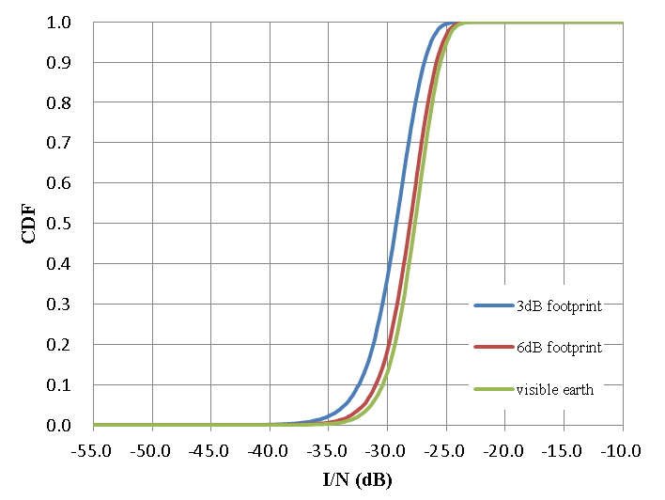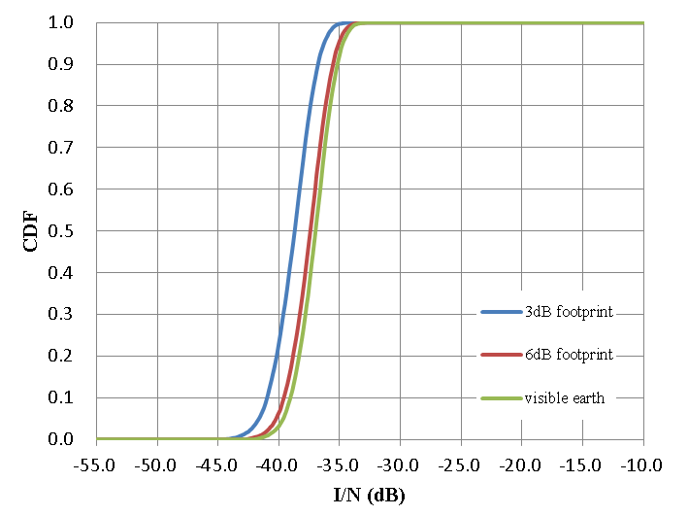

Table A-1

Mean values of aggregate *I/N* from IMT network deployed within −3 dB or −6 dB footprints and visible earth of the satellite whose main beam pointing is 15 degrees elevation angle (with random clutter loss)

|  |  |  |  |  |
| --- | --- | --- | --- | --- |
|  |  | −3 dB footprint | −6 dB footprint | Visible earth |
| Mean values of aggregate *I/N* from IMT network towards the satellite whose main beam pointing is 15 degrees elevation angle (with random clutter loss) (dB) | BSs | -28.9 | -27.8 | -27.4 |
| UEs | -38.5 | -37.2 | -36.8 |
| BSs and UEs | -28.4 | -27.3 | -26.9 |

The epfd value for IMT base stations deployed within −3 dB footprint of the satellite whose main beam pointing is 15 degrees elevation angle is derived from the aggregate *I/N* using the equations (A-4) and (A-6) as in Table A-2. The epfd value is scaled to that for IMT base stations deployed within the territory of Japan based on the area of the territory (378,000 km2) relative to the area of the −3 dB footprint (1,135,833 km2).

Total number of base stations within -3 dB footprint or within Japan are calculated, assuming the BS density values and the consideration of that for large area provided by ITU-R Working Party 5D as described in Note 1 of Table A-2.

Figure A-2 is a footprint example of the FSS satellite main beam (0.8 degree beamwidth) whose pointing is 15 degrees elevation angle centred in Tokyo.

Table A-2

*I/N*, aggregate interference and epfd derived from the results of IMT network deployed within −3 dB footprint of the satellite whose main beam pointing is 15 degrees elevation angle (with random clutter loss)

|  |  |  |  |  |  |
| --- | --- | --- | --- | --- | --- |
|  | Number of BSs(1) |  | ***I/N* (dB)** | ***Iagg* (dBW/Hz)** | **epfd (dB(W/(m2∙MHz)))** |
| *I/N*, *Iagg* and epfd from IMT stations deployed within −3 dB footprint (1,135,833 km2) of the satellite whose main beam pointing is 15 degrees elevation | 136,300 | BSs | -28.9 | -231.5 | **-168.0** |
| UEs | -38.5 | -241.1 | -177.6 |
| BSs and UEs | -28.4 | -231.0 | -167.5 |
| Scaled *I/N*, *Iagg* and epfd to the territory of Japan (378,000 km2) resulted from relative area to that of −3 dB footprint | 45,360 | BSs | -33.7 | -236.3 | -172.8 |
| UEs | -43.3 | -245.9 | -182.4 |
| BSs and UEs | -33.2 | -235.8 | -172.3 |
| Note 1: Calculated from Table 14 in Attachment 2 to Doc. 5-1/36 (WP 5D)  BS density: 10 BSs/km2 (suburban), 30 BSs/km2 (urban)  Ra: 3% (suburban), 7% (urban)  Rb: 5%  Number of BSs within -3 dB footprint = (Ds_BS_suburban * Ra_suburban + Ds_BS_urban * Ra_urban) * Rb * S-3dB  = 0.12 BSs/km2 * 1,135,833 km2  Number of BSs within Japan = (Ds_BS_suburban * Ra_suburban + Ds_BS_urban * Ra_urban) * Rb * SJapan  = 0.12 BSs/km2 * 378,000 km2 | | | | | |

Figure A-2

Footprint example of the FSS satellite main beam (0.8 degree beamwidth) whose pointing is 15 degrees elevation angle centred in Tokyo

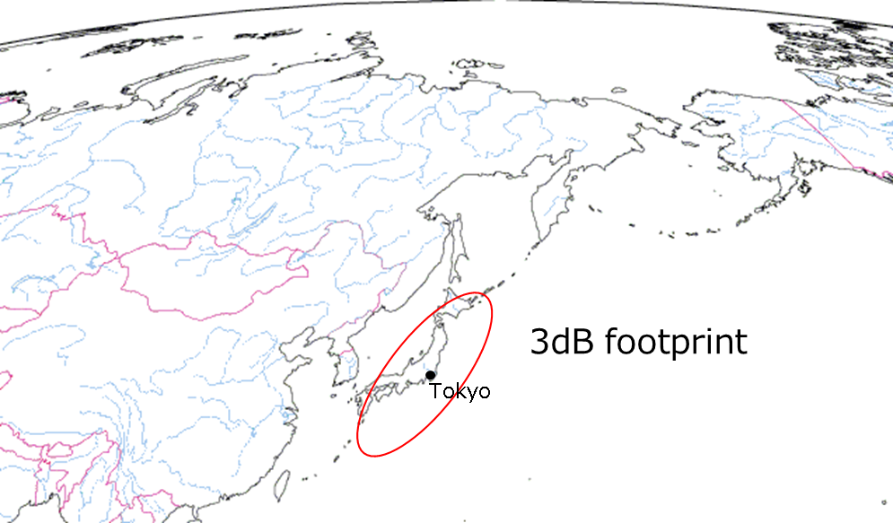

**-3dB footprint**

#### 3. Proposed equivalent power flux-density limit

**3.1 Derivation of epfd limit calculated from the FSS protection criteria**

The epfd limit that should be satisfied by IMT base stations within −3 dB footprint of the satellite is calculated in Table A-3. The epfd value of -149.6 dB(W/(m2∙MHz)) corresponding to the FSS protection criteria (*I/N* -10.5 dB) is distributed based on contribution of −3 dB footprint relative to visible earth (-1.5 dB). It is furthermore distributed based on interference contribution of BSs relative to both BSs and UEs (-0.5 dB).

Table A-3

Derivation of epfd limit calculated from the FSS protection criteria

|  |  |  |  |  |  |
| --- | --- | --- | --- | --- | --- |
|  |  | ***I/N* (dB)** | ***Iagg* (dBW/Hz)** | **epfd (dB(W/(m2∙MHz)))** | Derivation of values |
| (1) | FSS protection criteria | -10.5 | -213.1 | -149.6 |  |
| (2) | Contribution of -3 dB footprint relative to visible earth (-1.5 dB) | -12.0 | -214.6 | -151.1 | (1)-1.5 dB |
| (3) | Contribution of BSs relative to both BSs and UEs (-0.5 dB) | -12.5 | -215.1 | **-151.6** | (2)-0.5 dB |

The epfd limit is proposed from the Table A-3, considering the area of the territory of a concerned administration as equation (A-7).

$epfd limit =\left\{\begin{matrix}-151.6 dB(W/m^{2}/MHz), if S_{adm}≥ S_{-3dB} \\ -151.6 +10\log\left(\frac{S_{adm}}{S_{-3dB}}\right)dB(W/m^{2}/MHz), if S_{adm}< S_{-3dB}\end{matrix}\right.$ (A-7)

$S_{adm}$: area of territory of an administration

$S_{-3dB}$: area of −3 dB footprint of satellite whose main beam pointing is 15 degrees elevation angle (1,135,833 km2)

**3.2 Evaluation for derivation of epfd limit calculated from the interference results of IMT base stations in Japan**

As an example, the epfd limit for Japan is derived from equation (A-7) as follows:  
epfd limit for Japan = −151.6+10*log*(378,000/1,135,833) = −156.4 dB(W/(m2∙MHz)).

It corresponds to the epfd value that is calculated from the interference results of IMT base stations in Japan with adding the margin of sharing study result in TG 5/1 as in Table A-4.

Table A-4

Derivation of epfd limit calculated from the interference results of IMT base stations in the territory of Japan

|  |  |  |  |  |  |
| --- | --- | --- | --- | --- | --- |
|  |  | ***I/N* (dB)** | ***Iagg* (dBW/Hz)** | **epfd (dB(W/(m2∙MHz)))** | Derivation of values |
| (1) | Scaled *I/N*, *Iagg* and epfd to the territory of Japan (378,000 km2) | -33.7 | -236.3 | -172.8 | See Table A-2 |
| (2) | Addition of margin   * 16.4 dB interference margin resulted from Study C in Attachment 3 to Annex 3 to Document 5-1/478, TG5/1 sharing study | -17.3 | -219.9 | **-156.4** | (1)+16.4dB |

#### 4. Conclusion

The value of −151.6 dB(W/(m2∙MHz)) is proposed for the equivalent power flux-density limit at the geostationary-satellite orbit by emissions from all the IMT-2020 base stations within a territory of the concerned administration that overlaps -3dB footprint of a satellite and the territory is larger than 1,135,833 km2 in the frequency bands 24.65-25.25 GHz and 27.0-27.5GHz. The value of −151.6 + 10*log* (Sadm / S-3 dB) dB(W/(m2∙MHz)) is also proposed for that within a territory of the concerned administration that is smaller than 1,135,833 km2.

____________