 | ASIA-PACIFIC TELECOMMUNITY | Document No.:
 | The 4th Meeting of the APT Conference Preparatory Group for WRC-19 (APG19-4) | APG19-4/INP-70
 | 7 – 12 January 2019, Busan, Republic of Korea | 28 January 2018

Japan

considerations on WRC-19 agenda item 7, Issue G

Updating the reference situation for region 1 and 3 networks under RR Appendices 30 and 30A when provisionally recorded assignments are converted into definitive recorded assignments

Agenda Item 7:
7 to consider possible changes, and other options, in response to Resolution 86 (Rev. Marrakesh, 2002) of the Plenipotentiary Conference, an advance publication, coordination, notification and recording procedures for frequency assignments pertaining to satellite networks, in accordance with Resolution 86 (Rev.WRC-07), in order to facilitate rational, efficient and economical use of radio frequencies and any associated orbits, including the geostationary satellite orbit;
Resolution 86 (Rev.WRC-07) – Implementation of Resolution 86 (Rev. Marrakesh, 2002) of the Plenipotentiary Conference

1. Background
Issue G deals with updating the reference situation for Region 1 and 3 networks under RR Appendices 30 and 30A when provisionally recorded assignments are converted into definitive recorded assignments.
§ 4.1.18 of Appendices 30 and 30A of the Radio Regulations prescribes that in the case of recording in the List with outstanding coordination requirements, this recording shall be provisional, but that the entry shall be changed from provisional to definitive recording in the List if the Bureau is informed that the new assignment in the Regions 1 and 3 List has been in use, together with the assignment which was the basis for the disagreement, for at least four months without any complaint of harmful interference being made. When the provisional recording becomes definitive, the reference situation of the interfered-with network will be updated. Similar provisions are found in respect of Region 2 in § 4.2.21A.
Several views were contributed to ITU-R WP4A and the draft CPM text was finalized by WP4A (See Section 2 Documents). The methods are as follows.

- Method G1 for Regions 1 and 3
MOD
4.1.18bis When requesting the application of § 4.1.18, the notifying administration shall undertake to meet the requirements of § 4.1.20 and provide to the administration in respect of which § 4.1.18 is applied, with a copy to the Bureau, a description of the steps by which it undertakes to meet these requirements. Once an assignment is entered in the List provisionally under the provisions of § 4.1.18, the calculation of the equivalent protection margin (EPM)9 of an assignment in the Regions 1 and 3 List or for which the procedure of Article 4 has been initiated and which was the basis for the disagreement shall not take into account the interference produced by the assignment for which the provisions of § 4.1.18 have been applied. When the recording of an assignment entered into the List is changed from provisional to definitive in accordance with § 4.1.18, but there is still continuing disagreement between the administrations, the Bureau will consult with the administration responsible for the assignments which were the basis for the disagreement and will only update the EPM to take into account interference produced by the assignment for which the provisions of § 4.1.18 have been applied with the agreement of the administration responsible for the assignments which were the basis for the disagreement. (WRC-19)

- Method G2 for Regions 1 and 3
MOD
4.1.18 If, in spite of the application of § 4.1.16 and 4.1.17, there is still continuing disagreement proven by correspondence ADD XX and the assignment which was the basis of the disagreement is not an assignment in the Regions 1 and 3 Plan, or in the Region 2 Plan or for which the procedure of § 4.2 has been initiated, and if the notifying administration insists that the proposed assignment be included in the Regions 1 and 3 List if the EPM degradation is less than 5 dB, the Bureau shall provisionally enter the assignment in the Regions 1 and 3 List with an indication of those administrations whose assignments were the basis of the disagreement; however, the entry shall be changed from provisional to definitive recording in the List only if the Bureau is informed that the new assignment in the Regions 1 and 3 List has been in use, together with the assignment which was the basis for the disagreement, and both assignments have been in operation with the notified parameters values ADD YY for at least four months without any complaint of harmful interference being made. (WRC-19)

MOD
4.1.18bis When requesting the application of § 4.1.18, the notifying administration shall undertake to meet the requirements of § 4.1.20 and provide to the administration in respect of which § 4.1.18 is applied, with a copy to the Bureau, a description of the steps by which it undertakes to meet these requirements.ADD ZZ Once an assignment is entered in the List provisionally under the provisions of § 4.1.18, the calculation of the equivalent protection margin (EPM)9 of an assignment in the Regions 1 and 3 List or for which the procedure of Article 4 has been initiated and which was the basis for the disagreement shall not take into account the calculated interference impact due to the assignment for which the provisions of § 4.1.18 have been applied. (WRC-19)

ADD
DRAFT NEW RESOLUTION [A7(G)-YYY] (WRC-19)
Relating to the procedure for application of the provisions in paragraphs 4.1.18 and 4.1.18bis in Article 4 of Appendices 30 and 30A
The World Radiocommunication Conference (Sharm el-Sheikh, 2019),
considering
a) that the provisions in paragraphs 4.1.18 and 4.1.18bis in Article 4 of Appendices 30 and 30A are giving an opportunity to assignments identified as potentially affected to enter definitively in the Appendices 30 and 30A Lists for Regions 1 and 3 to obtain protection from the new submitted assignments in case of continuing disagreement;
b) that the provisions in paragraphs 4.1.18 and 4.1.18bis in Article 4 of Appendices 30 and 30A are not enough defined in their details and this gives rise to some uncertainty in their application from one side and creates an opportunity for manipulation of the measurement results on the other;
c) that there is an increasing need for specifying a clear guidance for the application of the provisions, defined in considering a) in order any suspicion in their improper use to be avoided,
considering further
a) that it is not realistic the provisions in paragraphs 4.1.18 and 4.1.18bis in Article 4 of Appendices 30 and 30A to be applied at high levels of the identified EPM (Equivalent Protection Margin) Degradation;
b) that it is not acceptable to apply for the provisions in paragraphs 4.1.18 and 4.1.18bis in Article 4 of Appendices 30 and 30A if there has been no demonstration for continuing disagreement by the administration(s) identified as potentially affected,
noting
a) that there is an increasing overload of BSS Planned bands in some part of the geostationary orbit because of the numerous BSS networks for additional use submitted under the provisions of Article 4 of Appendices 30 and 30A;
b) that many national assignments in the BSS and FL Plans are blocked by closely situated networks for additional use of the planned bands;
c) that there are administrations which are not keen to give coordination agreement even for a very low excess of the coordination criteria, in this case of EPM Degradation;
d) that continuously evolving progress in technologies related to the BSS networks leads to increasing remoteness of real system capabilities to deal with interference from the technical parameters of the BSS networks in Appendices 30 and 30A on the basis of which the need for coordination is identified by the Radiocommunication Bureau,
recognizing
a) that there are in Appendix 10 of the Radio Regulations a description of some parameters of mainly terrestrial stations for measurement purposes and by the view of interference impact;
b) that there is some guidance in Report ITU-R SM.2181 for presentation of the measurement results of emissions from space stations that can be used for description of measured parameters values for the purpose of paragraphs 4.1.18 and 4.1.18bis,
resolves
that an administration may submit a request for provisions of paragraph 4.1.18 to be applied to its BSS/FL network in case of:
a) this network is identified as affecting but causing EPM degradation of no more than 5 dB of the reference situation at any Test Point of other BSS/FL network(s), and
b) continuing disagreement is available with the notifying administration of the identified as potentially affected BSS/FL network(s) proven by at least three letters/faxes or coordination meetings with proposal to this administration for coordination agreement sent by the notifying administration of the network identified as potentially affecting.
ANNEX TO DRAFT NEW RESOLUTION [A7(G)-YYY] (WRC-19)
1 An administration which assignment(s) is included provisionally in the Regions 1 and 3 List of Appendix 30 or 30A as a result of a request for application of the provisions of paragraph 4.1.18 wishing to change the recording from provisional to definitive recording in the List has to provide for transmission of this assignment under the following conditions:
1.1 Informs the notifying administration(s) of the potentially affected network(s), with a copy to the Bureau, for the time period, which has to be at least 4 months, intended to carry out transmission of assignment(s) identified as potentially affecting, indicating exactly which of them will be subject of transmission;
1.2 Both or all involved administrations must provide transmission of the specified assignment(s) during the agreed time period with the notified values of its parameters;
1.3 At the end of the agreed time period a report has to be prepared and sent to the Radiocommunication Bureau by the initiating administration comprising information of:
a) e.i.r.p. value of the transmitted assignment(s) wishing to be definitively recorded in the List, beginning with 10 dB lower than and increasing up to the notified values of e.i.r.p. observing the requirements in paragraph 4.1.20 to avoid harmful interference to any recorded assignment in the Master Register;
b) measured carrier levels at the output of the receiving antenna with notified parameters at least three different points in the service area(s) of the assignments of the network identified as potentially affecting and the network(s) identified as potentially affected, subject to continuing disagreement from its notifying administrations;
c) measured values of any other networks related parameters aiming to prove that the assignment subject to the submission under the provisions of paragraph 4.1.18 has no interference impact on the network(s) identified as potentially affected as measured C/N, C/(N+I), BER, etc. for the emission(s) of this network at several levels of e.i.r.p. of the subject assignment;
1.4 The Radiocommunication Bureau has to examine the submitted measurement report and if no degradation of the reception of the emission(s) of the network assignment(s) identified as potentially affected is found, the Bureau shall continue as in 4.1.18 with the updating of the reference situation of the corresponding assignment(s) of this network(s) and to convert the provisional status in the Regions 1 and 3 List(s) of the assignment(s) identified as potentially affecting and which is the subject to the measurement report into definitive recording.

- Method G3 for Regions 1 and 3
NOC
4.1.18
NOC
4.1.18bis

2. Documents
Doc.4A/183, Germany (Federal Republic of), Spain, France, Luxembourg, Norway, Sweden, (22 September 2016)
Doc.4A/243, Norway, (29 March 2017)
Doc.4A/245, J, (30 March 2017)
Doc.4A/268, HOL, (21 April 2017)
Doc.4A/280, USA, (24 April 2017)
Doc.4A/292, Bulgaria, (25 April 2017)
Doc.4A/364, Annex 39, WP4A Chairman, (22 May 2017)
Doc.4A/399, J, (3 October 2017)
Doc.4A/519, Annex 39, WP4A Chairman, (8 November 2017)
Doc.4A/547, J, (7 February 2018)
Doc.4A/675, Annex 39, WP4A Chairman, (8 March 2018)
Doc.APG19-3/OUT-14, APG19, WP3, (15 March 2018)
Doc.4A/710, J, (21 June 2018)
Doc.4A/826, Annex 36, WP4A Chairman, (20 July 2018)

3. Discussions
Japan submitted its study results to ITU-R WP4A meeting (Doc.4A/710, J, (21 June 2018)) for consideration on the pfd (power flux-density) criterion and EPM (Equivalent Protection Margin) criterion. The applicability of the two criteria was shown, that is, when the orbital separation of the wanted and interfering space stations was small (about 3 degrees) the EPM criterion was the one that determines the coordination was required or not (Except for part B of Fig. 1), on the other hand when the separation was large (exceeding about 6 degrees) it is the pfd criterion.
Then, it was shown that the EPM criterion contributes to alleviate the problem of "sensitive satellite network" and contribute to the efficient use of the geostationary satellite orbit.
In Fig. 1, which is almost same as Fig. 7 of Doc.4A/710, 57 dBW of Ce.i.r.p. is a nominal value for the BSS Plan. Now, let us consider an existing satellite, Sat P. Then a new Sat. Q which has 51.5dBW of Ce.i.r.p. and a 3 deg. of orbital separation with Sat. P enters in the List with definitive status , since Sat. Q does not cause harmful interference to Sat. P with nominal Ce.i.r.p. However, the reference EPM of Sat. Q with low Ce.i.r.p becomes very low, eg. -15dB, under the EPM criterion, then it allows -124.1 dB(W/(m2･MHz)) as the threshold pfd value. On the other hand, the threshold pfd value under the pfd criterion is -136.1 dB(W/(m2･MHz)). The difference between the two criteria is about 12 dB. Then the next satellite, Sat. R, can enter the List without coordination with Sat. Q under the EPM criterion (See part C of Fig. 1).
Therefore, the EPM criterion shall be maintained and the reference EPM value should be updated properly.
FIGURE 1
Example of EPM and pfd criteria in terms of threshold pfd
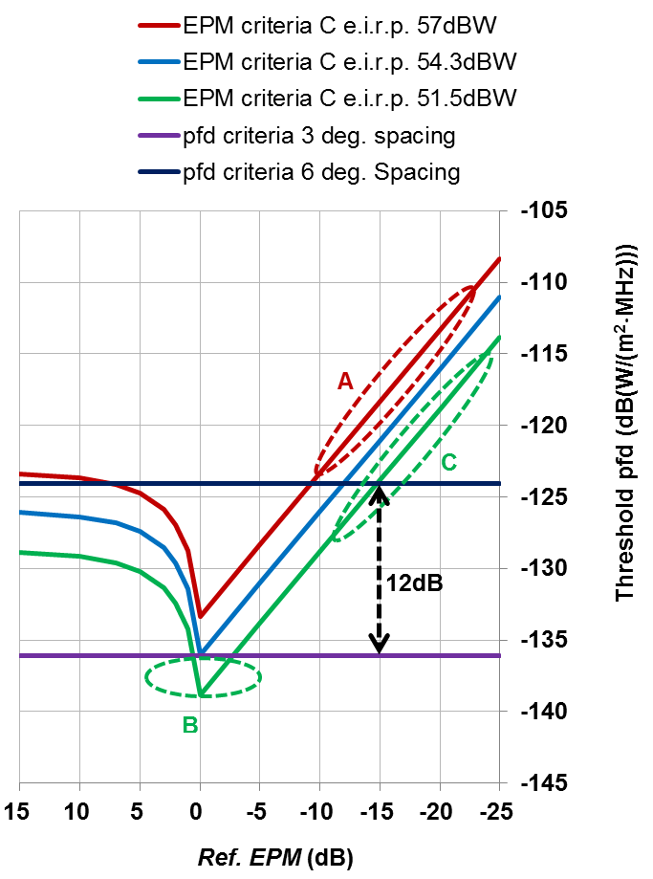

As a consequence of the study results above, the following text was added to Method G3 (NOC) of the CPM text for Ag. 7, Issue G (Doc.4A/826, Annex 36).

3/7/7.4.3 Method G3
The EPM criterion contributes to alleviate the problem of "sensitive satellite network" having very low transmitting power. In not updating the reference EPM for a “sensitive satellite network” with still not having a very low reference EPM, this network would continue to enjoy a higher degree of sensitivity against later submissions and, in respect of the EPM criterion, triggering more coordination than if the reference EPM was updated.
The current provisions of AP30/30A contribute to update the reference EPM of satellite networks including “sensitive satellite networks”, therefore, this method prescribes that the current provisions of AP30/30A §§ 4.1.18 – 4.1.20 should be kept unchanged.

Method G1 of the CPM text for Ag. 7, Issue G (Doc.4A/826, Annex 36) prescribes as follows:
When a network has entered into the List using § 4.1.18, and when the recording of the associated assignments transitions from provisional to definitive while there is still disagreement, the reference situation of the interfered-with network should be updated in consultation with, and only with the agreement of, the affected administration.
It is generally very difficult to obtain an agreement from the affected administration. It results in a situation that EPM is never updated and therefore the EPM criterion is useless. Under this situation, the EPM criterion would be suppressed in the future. Therefore, Japan does not support Method G1.
Even though the EPM value of the existing (senior) satellite (Sat. L) becomes low due to the application of § 4.1.18 and § 4.1.18bis by a later coming (junior) satellite (Sat. M) against Sat.L (See part A of Fig. 1), Sat. L has a chance to recover its EPM by applying § 4.1.20 against Sat. M. If Sat. M does not emit the wave and the EPM of Sat .L degrades, Sat. L can request the elimination of the virtual interference from Sat. M by applying RR AP30/30A § 4.1.20. In any case, Sat .L needs to monitor the waves from Sat. M.
One of the problems in the current § 4.1.18 is that Sat. M with rather high e.i.r.p. applies § 4.1.18 against Sat. L. Then Sat. L suffers a low EPM and it would not be identified as affected by further later coming satellite (Sat. N) under the EPM criterion. Method G1 seems to alleviate this problem, since Sat. L maintains a high EPM and it is identified as affected by Sat. N. However, if Sat. N applies § 4.1.18 against Sat. L, then Sat. L can not be protected effectively. Although Sat L can apply § 4.1.20 against Sat. N, Sat. L should have applied § 4.1.20 against Sat. M and solved the problem at the first stage.

4. Conclusion
Japan has views on the Issue G of WRC-19 Ag. 7 as follows.
- With respect to updating the AP30/30A reference situation (Issue G), Japan supports to maintain EPM criterion (RR Appendix 30) and update the reference EPM properly, since the EPM criterion contributes to alleviate the problem of "sensitive satellite network" having very low transmitting power and contribute to the efficient use of the geostationary satellite orbit.
- Japan considers the modification of No. 4.1.18bis of RR Appendices 30 and 30A, where the reference situation of the interfered-with network should be updated in consultation with, and only with the agreement of, the affected administration, leads to the abolition of the EPM criteria in the future.
- Japan supports NOC (Method G3). Even though the EPM value of a senior satellite (Sat. L) becomes low due to the application of § 4.1.18 and § 4.1.18bis by a junior satellite (Sat. M) against Sat. L, Sat. L has a chance to recover its EPM by applying § 4.1.20 against Sat. M. If Sat. M does not emit the wave and the EPM of Sat .L degrades,, Sat. L can request the elimination of the virtual interference from Sat. M by applying RR AP30/30A § 4.1.20.
____________

XX Three or more attempts to obtain agreement by correspondence and/or by meetings including the assistance by the Bureau. (WRC-19)
YY This shall be proven by measurements results sent to the Bureau. The procedure is subject to draft new Resolution [A7(G)-YYY] (WRC-19). (WRC-19)
ZZ They shall be proven by measurements results sent to the Bureau. The procedure is subject to draft new Resolution [A7(G)-YYY] (WRC-19). (WRC-19)
Refer to Appendix 10 and Report ITU-R SM.2181.

