

**APT REPORT ON**

**Technical and operational Analysis for USING high altitude platform station as imt base stations (HIBS) in the frequency bands below 2.7 GHz identified for IMT**

**No. APT/AWG/REP-92  
Edition: July 2019**

**Adopted by**

**25th Meeting of APT Wireless Group  
1 – 5 July 2019, Tangerang, Indonesia**

***(Source: AWG-25/OUT-10 (Rev.1))***

**APT report on   
Technical and operational Analysis for USING high altitude platform station as imt base stations (HIBS) in the frequency bands below 2.7 GHz identified for IMT**

**1 Introduction**

In light of growing demand for broadband, there is a need for a solution to provide broadband access to underserved areas with minimal ground-level infrastructure and maintenance. At WRC-15, Resolution 160 was adopted to study how to facilitate access to global broadband applications delivered by high altitude platform station in the fixed service and there is ongoing study under WRC-19 Agenda Item 1.14 on high altitude platform station using frequency bands above 6 GHz for broadband delivery.

At the same time, to utilize its capability to provide service to a large footprint (wider than 30,000 km2) at low latency (1/30 of LEO and 1/1800 of GEO[1]), high altitude platform station may also be used as IMT base stations in the frequency bands below 2.7 GHz for providing mobile connectivity to underserved areas. Especially in providing connectivity for IoT, which is expected to become widespread in 2020 and beyond, mobile network operators (MNOs) are expected to meet the requirement for wider area coverage using their spectrum and at a reasonable cost. Indeed, satellite systems could also achieve wider area coverage, but it is difficult to have low latency similar to ground-based IMT network against high altitude platform station systems.

At WRC-2000, the bands 1 885-1 980 MHz, 2 010-2 025 MHz and 2 110-2 170 MHz in Region 1 and 3 and the bands 1 885-1 980 MHz and 2 110-2 160 MHz in Region 2 were identified in the mobile service for high altitude platform station operating as IMT base stations in RR No.**5.388A** and Resolution **221 (Rev.WRC-07)** stipulates technical conditions for high altitude platform station IMT base stations necessary for the protection of ground-based IMT stations in neighboring countries and other services based on the sharing and compatibility studies with IMT-2000. Since 2000, there has been a tremendous growth in the deployment of IMT systems and significant improvement in its radio access technology (i.e. IMT-Advanced and IMT-2020). In view of these advancements, it should be studied whether any changes are necessary to existing high altitude platform station identification.

Moreover, currently many MNOs provide services using multiple IMT frequency bands and thus many user terminals support multiple bands.

Therefore, some APT members propose to study on possible additional identification for using high altitude platform station as IMT base stations may be required within existing bands in the frequency ranges below 2.7 GHz identified for IMT to allow flexible use of frequency bands by MNOs (especially those who do not have the 2 GHz band).

In order to facilitate understanding for the above considerations, this report provides possible benefits and analysis of technical, operational and regulatory aspects for using high altitude platform station as IMT base stations (hereinafter “HIBS”).

**2 Possible usage scenarios and benefits of HIBS**

This chapter describes the current situation and the future prospects for the “underserved areas”, or areas which are difficult to cover by ground-based IMT base stations, along with the assumed effects of using HIBS in those areas for different usage scenarios.

**2.1 Underserved areas**

Population coverage has traditionally been used as a metric for IMT service areas and “underserved areas” can be described as areas where it is difficult to provide mobile connectivity to the residents. Economic challenges (e.g. very small population covered, lack of backhaul connectivity and power supply, etc.) and opposition from land owners and local communities to the construction of base stations/cell towers are some of the reasons why those areas cannot be covered by ground-based IMT base stations. Areas where IMT base stations, power supply and backhaul connectivity have been damaged by natural disasters can also become temporary “underserved areas.”

Meanwhile, mobile connectivity is becoming widespread, connecting not only people but also objects (IoT: Internet of things, IoE: Internet of Everything). Sensor networks which combine different types of sensors and IoT technology based on IMT systems (eMTC: enhanced Machine-Type Communication, NB-IoT: Narrowband IoT) are expected to be used widely including in unpopulated areas. By providing mobile connectivity that can be accessed by existing IMT user terminals in areas where ground-based IMT base stations could not cover (e.g. in midair (for drones) and coastal areas), we can also expect new industries to emerge. From this standpoint, these areas which are not targeted for population coverage by current ground-based IMT base stations can also be included as future “underserved areas.”

**2.2 Possible usage scenario and benefit**

**2.2.1 Coverage enhancement for rural areas**

Mobile coverage enhancement not only leads to increased competitiveness and revenue for MNOs but past studies show that it also contributes to the country’s economic growth. GSMA’s report “Benefits of network competition and complementary policies to promote mobile broadband coverage[2]” describes the close correlation between broadband penetration and GDP growth.

In the UK, the government imposed 90% of geographic coverage obligation on the 4 MNOs for voice service by the end of 2017 to support the country’s economic growth and all MNOs met this requirement[3]. However, according to Ofcom’s latest report[4], challenges remain especially in rural areas where securing power for base stations and backhaul connectivity can be difficult and the actual geographic coverage of voice service is reported to be lower than 90%.

By using HIBS in addition to ground-based IMT base stations, MNOs can cover these areas in economically efficient way and contribute to the country's economic growth.

(For example, 1 HIBS can cover 100 km in radius which is equivalent to the area covered by 942 macro cell base stations (3 base stations can cover 100 km2).)

Furthermore, especially in rural areas, MNOs can reduce their costs by replacing costly ground-based IMT base stations which serve only a small number of users with HIBS.

**2.2.2 Safety and security**

By ensuring ubiquity through coverage enhancement including deserted areas, MNOs will be able to provide mobile connectivity to users regardless of time, place or circumstances. Thus, users will be able to connect emergency call wherever they are, whether in case of troubles such as a sudden car breakdown or when they are lost.

In addition, in a situation where ground-based IMT base stations have been damaged by natural disasters and cannot be restored quickly due to lack of access to the affected areas, communication networks can be restored quickly by covering those areas with HIBS.

In this way, HIBS can contribute to national safety and security. Satellites also have wide area coverage and are robust against natural disasters but the important point here is that in addition to these features, HIBS can connect with user terminals that users carry all the time. Capability to provide connection to ordinary mobile phones is an essential requirement for safety and security and therefore HIBS is certainly well-suited for such usage.

* + 1. **Internet of Things**

Introduction of ICT in maintenance and management of public infrastructures such as roads (pavements), bridges and dams are becoming widespread. One of the applications is the deployment of sensor network using IMT-based IoT technology and HIBS, infrastructures in both urban areas and rural/deserted areas can be managed on the same sensor network. This idea can be applied not only to artificial structures but also to natural objects which are difficult for people to get close to or to constantly monitor. For example, such sensor network may be used for volcanic activity monitoring network for eruption forecasting purpose.

Another usage scenario is sensor network for large-scale agriculture and livestock farming. In addition to automation and streamlining of process based on big data collection and analysis, such use can lead to the development of a new industry in this area.

In this way, HIBS will be able to support efficient management and maintenance of domestic artificial structures and natural objects and to contribute to the development of the farming industry by expanding the reach of IoT services.

* + 1. **Drones and mobile connectivity around the coast**

Drones for industrial use are expected to be used for wide range of fields including logistics. Some drones that have been introduced use ground-based IMT base stations for communication. However, since the deployment of ground-based IMT base stations are basically not optimized to communicate with objects up in the air, interferences caused by the uplink signals from drones to IMT base stations other than those that they are communicating with and coverage holes are ongoing challenges of these systems. By using HIBS to provide drone connectivity, these problems can be avoided and can support increasing the usage of drones that use IMT-based communication.

Another use case would be to provide mobile connectivity to passengers and crew on fishing boats, passenger boats and transport vessels in the coastal area. Enabling access to the analytical results of the data on coastal waters on a real-time basis can support to increase fishing efficiency and enabling access to ordinary mobile phones on board ships and vessels can lead to the creation of new industries.

* + 1. **IMT Network Service**

HIBS deployment can follow at least 3 options as follows:

a. HIBS as element of a new MNO(s).

b. HIBS as eNodeB(s) or gNB(s) of existing MNO(s).

c. HIBS as repeater of ground-based eNodeB(s) or gNB(s) of existing MNO(s).

* + 1. **Event service**

HIBS can also be deployed above a venue, for example stadium, holiday scenic spots or exhibition place, to provide a high capacity which caused by the sudden increase of people traffic. The rapid deployment of HIBS can augment the terrestrial infrastructure of network to satisfy the unusual network capacity requirement during short periods of time.

**3 Architecture of HIBS**

**3.1 Regulatory definition**

According to Article 1.66A of the Radio Regulations, terminology of high altitude platform station is defined as “*a station located on an object at an altitude of 20 to 50 km and at a specified, nominal, fixed point relative to the Earth*” and the service in which it operates is not specified.

As for the object used to carry high altitude platform station, or high altitude platform station carriers, their operating altitude range is limited but there is no regulatory difference by their types and characteristics. In other words, although different types of unmanned aircraft systems (UAS) are currently being considered, from a regulatory perspective, there is no need to consider the differences and HIBS can be understood as IMT base stations located at high altitude, or what is called super macro-cell base stations.

**3.2 Carrier of HIBS**

In the stratosphere at an altitude of 20 to 50 km where HIBS operate, there is little convection and keeping flying objects in place is relatively easy. Thus, airship-type HIBS carriers have originally been considered and fixed-wing solar-powered planes are also being considered recently. There is some convection in the stratosphere and HIBS carriers will need to control their positions while in operation. HIBS carriers will repeat the cycle of using solar power to use their propulsion systems and to charge secondary batteries simultaneously during daytime and using the power of the secondary batteries to control their positions during night-time. Therefore, power generation and battery charging capability are very important for the long-term stable operation of HIBS. When HIBS were studied in the past, this essential capability for the continuous operation, and not telecommunication technology, was one of the factors that prevented the introduction of commercial systems. Currently various industries such as the power generation industry and the automotive industry are promoting the development of solar power generation technology and secondary battery technology. These technological advancements are expected to enable a stable continuous flight for several months making it possible for operating HIBS.

**3.3 System architecture**

Figure 1 shows a system level diagram for HIBS (Heavier Than Air platform is just an illustration). Mobile service bands below 2.7GHz will be used for the service link between HIBS and user equipment (UE). Fixed service bands already identified for high altitude platform station or which will be identified under WRC-19 Agenda Item 1.14 will be used for the feeder link between HIBS and gateway (GW) station. In addition, inter-HIBS links and satellite links may also be considered for feeder link of HIBS as shown in Figure 1.

A HIBS has an area of about 7800km2(Radius = 50km). However, large area such as desert and ocean need to expand the communication coverage by aggregate HIBS. The Inter-HIBS links which connect between each HIBS and the satellite links which connect between HIBS and satellite are required to perform as backhaul links which may solve the arduous or impossible tasks to establish the stations in underserved areas. Inter-HIBS links and the links from HIBS to gateway (GW) are regarded as feeder links of HIBS.

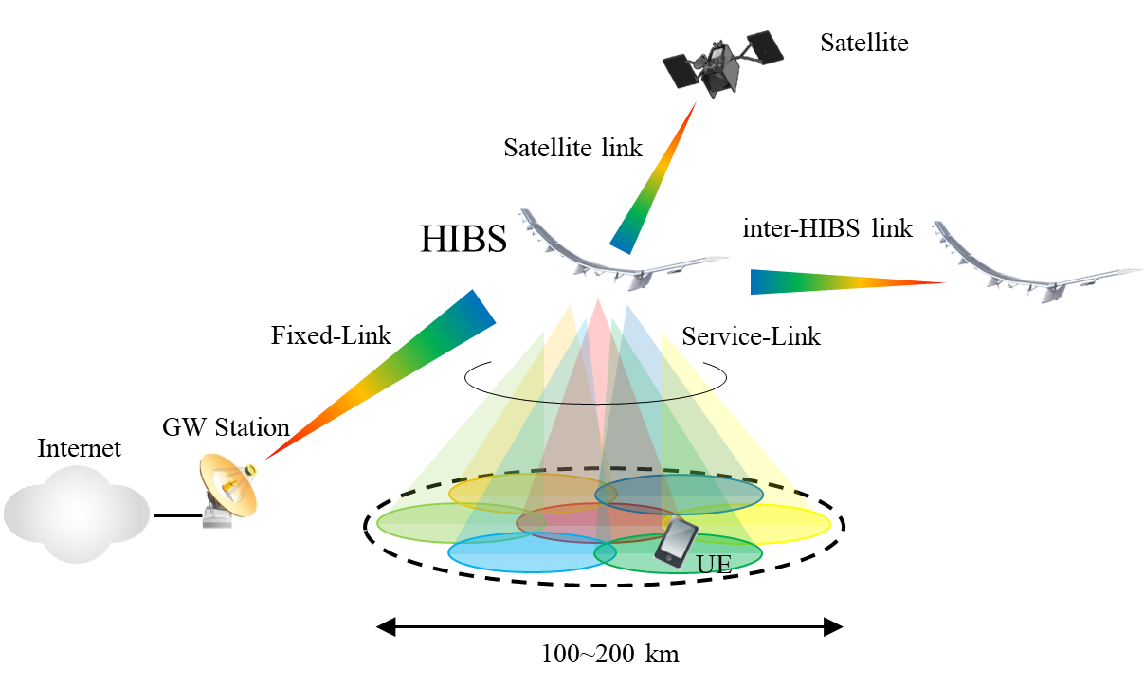

**Figure 1 HIBS systems level diagram**

Service link coverage of one HIBS is assumed to be around 100 km in radius at maximum and under single-beam operation, ordinary mobile phones cannot be connected at the cell edge due to low antenna gain to cover wide area with a single beam. Therefore, multi-beam operation, which allows to use high-gain antenna such as sector or phased-array antenna, will be the basic principle of HIBS operation.

Two types of HIBS are assumed: repeater (frequency converter) type and base station type as shown in Figure 2.



**Figure 2 Types of HIBS**

The equipment configuration of Repeater-type HIBS is simple, so it has advantages from the viewpoint of light weight, low power consumption, and failure tolerance. On top of that, any type of base stations (Enhanced NodeB ( eNB ) or next Generation NodeB (gNB)) for terrestrial mobile communications services can be used as it is without complying with severe stratosphere environment.

Base Station-type HIBS will use a fixed wireless access system for its backhaul communications, so its spectrum usage efficiency outperforms that of simple Repeater-type. In addition, the communications distance between its base station and UE is shorter compared to Repeater-type because the base station is placed on high altitude platform station different from the ground via repeater in the case of Repeater-type, which means the maximum coverage area can be wider from the viewpoint of communications distance limitation (e.g. 100 km in the case of IMT-Advanced systems)

**3.4 System characteristics**

Table 1 shows the proposed deployment and system related characteristics of IMT-Advanced based HIBS for service links to be used in the technical studies at future WRC study sessions. Characteristics for feeder links will be the same as those used in the ITU-R studies[5].

**Table 1 Deployment and system related parameters of IMT-Advanced based HIBS**

|  |  |  |  |
| --- | --- | --- | --- |
|  | **Unit** | **System 1** | **System 2** |
| Deployment scenarios |  | Spot-area deployment | Wide-area deployment |
| Frequency Bands | M | 2 GHz | 2 GHz |
| Occupied Bandwidth | MHz | 18 | 18 |
| Platform Altitude | km | 20 | 20 |
| HIBS area Radius | km | 100 | 100 |
| Inter-HIBS distance | km | N/A | 173 |
| Number of cells/HIBS |  | 7 | 7 |
| Number of co-frequency cells |  | 7 | 7 |
| Polarization |  | V/H | V/H |
| Platform Antenna Gain | dBi | 6 (1st layer）  15 (2nd layer） | 6 (1st layer）  15 (2nd layer） |
| Platform Antenna Pattern |  | (1st layer)  *b* ＝40 degrees  (horizontal/vertical)  LN＝-20 dB  LF＝-30 dBi  (2nd layer)  *b* ＝20 degrees (horizontal)   / 10 degrees (vertical)  LN＝-20 dB  LF＝-30 dBi | (1st layer)  *b* ＝40 degrees  (horizontal/vertical)  LN＝-20 dB  LF＝-30 dBi  (2nd layer)  *b* ＝20 degrees (horizontal)   / 10 degrees (vertical)  LN＝-20 dB  LF＝-30 dBi |
| Platform Antenna tilt | Deg | 90 (1st layer)  20 (2nd layer) | 90 (1st layer)  20 (2nd layer) |
| Platform Antenna Diameter |  | N/A | N/A |
| Platform e.i.r.p./cell | dBW | 19 (1st layer)  28 (2nd layer) | 19 (1st layer)  28 (2nd layer) |
| Platform e.i.r.p. Spectral Density/cell | dBW/ MHz | 6.4 (1st layer)  15.4 (2nd layer) | 6.4 (1st layer)  15.4 (2nd layer) |

**3.5 Link budget example**

Link budget example where a UE is located at 100 km distant from high altitude platform station is shown in Table 2. It shows that the link budget is sufficient for ordinary mobile phones to be used in communication systems based on high altitude platform station even at the distance of 100 km.

**Table 2 Link budget example in 2 GHz frequency band**

|  |  |  |  |
| --- | --- | --- | --- |
|  |  | System 1 | |
|  |  | DL (HIBS🡪UE) | UL (UE🡪HIBS) |
| Tx power | dBm | 43 | 23 |
| Tx antenna gain | dBi | 17 | 0 |
| Propagation loss | dB | 138.5 | 138.5 |
| Rx antenna gain | dBi | 0 | 17 |
| Fade margin | dB | 10 | 10 |
| Received power | dBm | -88.5 | -108.5 |
| Channel bandwidth | MHz | 18 | 0.18 |
| Total noise power  (including NF) | dBm | -96.5 | -116.5 |
| Received SNR | dB | 8 | 8 |

**4 Current status and future plan of the frequency bands in APT countries**

At its 23rd meeting in April 2018, AWG developed the questionnaire on current status and future plan related to HAPS in APT countries and 11 administrations responded.

**4.1 Current status and future plan of the frequency bands specifically identified to HIBS**

Table 3 shows a summary of current status and future plan of the frequency bands in RR No.5.388A.

**Table 3 current status and future plan of the frequency bands in RR No.5.388A**

|  |  |  |  |  |  |  |  |
| --- | --- | --- | --- | --- | --- | --- | --- |
| **RR** | **Frequency Ranges** | **Have HAPS trials** | | | **Have future plan for HAPS** | | |
| **Yes** | **No** | **Not sure** | **Yes** | **No** | **Not sure** |
| 5.388A | 1 885-1 980 MHz |  | AUS  BGD  BRM  CHN  INS  IRN  J  KOR  NZL  THA  VTN |  |  | AUS  KOR  VTN  INS | BGD  BRM  CHN  IRN  J  NZL  THA |
| 5.388A | 2 010-2 025 MHz |  | AUS  BGD  BRM  CHN  INS  IRN  J  KOR  NZL  THA  VTN |  |  | AUS  KOR  VTN | BGD  BRM  CHN  INS  IRN  J  NZL  THA |
| 5.388A | 2 110-2 170 MHz |  | AUS  BGD  BRM  CHN  INS  IRN  J  KOR  NZL  THA  VTN |  |  | AUS  KOR  VTN | BGD  BRM  CHN  INS  IRN  J  NZL  THA |

**4.2 Current status and future plan of the frequency bands identified to IMT**

Table 4 to 16 shows a summary of current status and future plan of the frequency bands identified to IMT.

**Table 4 current status and future plan of the frequency band 450-470 MHz (RR No.5.286AA)**

|  |  |  |  |  |  |
| --- | --- | --- | --- | --- | --- |
| **IMT or Services currently using and future planned** | | **Interest in introduction of HAPS IMT** | | | **Concerned services or systems in terms of sharing and compatibility with HAPS IMT base stations** |
| **Yes** | **No** | **Not sure** |
| IMT | BGD  BRM  INS  THA  VTN | BMR | AUS  KOR  NZL  VTN | BGD  CHN  INS  IRN  J  THA | * **(AUS)** Land Mobile system Fixed Point to Point Point to Multi-Point (heavy use in high and medium density areas) * **(BRM)** Data rate will be the issue * **(CHN)** Fixed Mobile (Other than IMT) Wireless Train Dispatching System Meteorological-satellite (space-to-Earth) |
| FIXED | AUS  CHN  INS  J  NZL  THA |
| MOBILE (other than IMT) | AUS  CHN  INS  IRN  J  KOR  NZL  THA |
| * Civil WLL Applications (BGD) * Wireless Train Dispatching System (CHN) * Meteorological-satellite (space-to-Earth) (CHN) * Special government service (INS) | |

**Table 5 current status and future plan of the frequency band 470-698 MHz (RR No.5.296A)**

|  |  |  |  |  |  |
| --- | --- | --- | --- | --- | --- |
| **IMT or Services currently using and future planned** | | **Interest in introduction of HAPS IMT** | | | **Concerned services or systems in terms of sharing and compatibility with HAPS IMT base stations** |
| **Yes** | **No** | **Not sure** |
| IMT | INS | BRM | AUS  KOR  VTN | BGD  CHN  INS  IRN  J  NZL  THA | * **(AUS)** Land Mobile system Fixed Point to Point Point to Multi-Point (heavy use in high and medium density areas)  TV Broadcasting (heavy use) * **(BRM)** Payload will be the issue * **(CHN)** Fixed Mobile(Other than IMT) Broadcasting Space research service Radionavigation Radiolocation Radio astronomy service * **(NZL)** TBD |
| FIXED | AUS  CHN  INS  NZL  THA |
| MOBILE (other than IMT) | AUS  CHN  INS  J  NZL  THA |
| BROADCASTING | AUS  BGD  BRM  CHN  INS  IRN  J  KOR  NZL  THA  VTN |
| RADIONAVIGATION | INS |
| * Wireless Microphones (AUS) * PMR (BGD) * Civil WLL Applications (BGD) * Governmental Mobile Systems Radio Service (BGD) * Space research service (CHN) * Radionavigation (CHN) * Radiolocation (CHN) * Radio astronomy service (CHN) * Others (KOR) | |

**Table 6 current status and future plan of the frequency band 610-698 MHz (RR No.5.296A)**

|  |  |  |  |  |  |
| --- | --- | --- | --- | --- | --- |
| **IMT or Services currently using and future planned** | | **Interest in introduction of HAPS IMT** | | | **Concerned services or systems in terms of sharing and compatibility with HAPS IMT base stations** |
| **Yes** | **No** | **Not sure** |
| IMT | INS  NZL | BRM | AUS  KOR  VTN | BGD  CHN  INS  IRN  J  NZL  THA | * **(AUS)** TV Broadcasting (heavy use) * **(BRM)** Payload will be the issue * **(CHN)** Broadcasting Radio astronomy service * **(NZL)** TBD |
| FIXED | INS  THA |
| MOBILE (other than IMT) | INS  J |
| BROADCASTING | AUS  BGD  BRM  CHN  INS  IRN  J  KOR  NZL  THA  VTN |
| * Wireless Microphones (AUS) * Radio astronomy service (CHN) * Digital TV (INS) * Others (KOR) | |

**Table 7 current status and future plan of the frequency band 698-790MHz (RR No.5.313A)**

|  |  |  |  |  |  |
| --- | --- | --- | --- | --- | --- |
| **IMT or Services currently using and future planned** | | **Interest in introduction of HAPS IMT** | | | **Concerned services or systems in terms of sharing and compatibility with HAPS IMT base stations** |
| **Yes** | **No** | **Not sure** |
| IMT | AUS  BGD  BRM  IRN (future planned)  J  KOR  NZL  THA  VTN | J | AUS  KOR  VTN | BGD  BRM  CHN  INS  IRN  NZL  THA | * **(AUS)** IMT (heavy use) Fixed Point-to-Multipoint Land Mobile * **(CHN)** Broadcasting * **(NZL)** TBD |
| FIXED | AUS  INS |
| MOBILE (other than IMT) | AUS  INS  J  KOR  THA |
| BROADCASTING | CHN  INS  IRN  J  THA |
| * Others (KOR) | |

**Table 8 current status and future plan of the frequency band 790-960 MHz (RR No.5.317A)**

|  |  |  |  |  |  |
| --- | --- | --- | --- | --- | --- |
| **IMT or Services currently using and future planned** | | **Interest in introduction of HAPS IMT** | | | **Concerned services or systems in terms of sharing and compatibility with HAPS IMT base stations** |
| **Yes** | **No** | **Not sure** |
| IMT | AUS  BGD  BRM  CHN  INS  IRN  J  KOR  NZL  THA  VTN | J | AUS  KOR  VTN | BGD  BRM  CHN  INS  IRN  NZL  THA | * **(AUS)** IMT (heavy use) Fixed Point-to-Multipoint Fixed Point-to-Point Land Mobile * **(CHN)** IMT, 825-835/870-880MHz, 889-915/934-960MHz Fixed Mobile(Other than IMT) Broadcasting,  Aviation navigation service * **(NZL)** TBD |
| FIXED | AUS  CHN  INS  NZL  THA |
| MOBILE (other than IMT) | AUS  CHN  INS  J  KOR  NZL  THA |
| BROADCASTING | CHN  INS |
| * Trunk Civil mobile applications (BGD) * Civil fixed and mobile service (BGD) * Governmental mobile applications (police systems) (BGD) * Governmental Cellular mobile applications (BGD) * Cellular mobile applications, Civil fixed and mobile systems (BGD) * GSM 900 systems (BGD) * RFID (BGD) * Governmental fixed and mobile applications (BGD) * EGSM systems (BGD) * Aviation navigation service (CHN) | |

**Table 9 current status and future plan of the frequency band 1 427-1 452 MHz (RR No.5.341C)**

|  |  |  |  |  |  |
| --- | --- | --- | --- | --- | --- |
| **IMT or Services currently using and future planned** | | **Interest in introduction of HAPS IMT** | | | **Concerned services or systems in terms of sharing and compatibility with HAPS IMT base stations** |
| **Yes** | **No** | **Not sure** |
| IMT | BRM  IRN (future planned)  J  NZL  THA  VTN | J | AUS  KOR  VTN | BGD  BRM  CHN  INS  IRN  NZL  THA | * **(AUS)** Fixed Point-to-Multipoint Fixed Point-to-Point Fixed receivers Aeronautical * **(CHN)** Fixed Mobile (Other than IMT) * **(NZL)** TBD |
| SPACE OPERATION (Earth-to-space) | AUS |
| FIXED | AUS  CHN  INS  NZL  THA |
| MOBILE (other than IMT) | CHN  INS  NZL |
| * Aeronautical (AUS) * Broadcasting fixed links (BGD) * Others (KOR) | |

**Table 10 current status and future plan of the frequency band 1 452- 1492 MHz (RR No.5.346A)**

|  |  |  |  |  |  |
| --- | --- | --- | --- | --- | --- |
| **IMT or Services currently using and future planned** | | **Interest in introduction of HAPS IMT** | | | **Concerned services or systems in terms of sharing and compatibility with HAPS IMT base stations** |
| **Yes** | **No** | **Not sure** |
| IMT | BRM  IRN (future planned)  J  NZL  THA  VTN | J | AUS  CHN  KOR  VTN | BGD  BRM  INS  IRN  NZL  THA | * **(AUS)** Fixed Point-to-Multipoint Fixed Point-to-Point * **(CHN)** Fixed Mobile (Other than IMT) Broadcasting Broadcasting satellite * **(NZL)** TBD |
| FIXED | AUS  CHN  INS  NZL  THA |
| MOBILE (other than IMT) | CHN  INS  NZL |
| BROADCASTING | CHN  INS |
| BROADCASTING-SATELLITE | CHN |
| * Reserved for digital audio broadcasting   Channel=0.25-0.50-1-2-3.5 (BGD)   * Fixed and mobile civil applications in support of broadcasting and governmental fixed and mobile applications until band is used for broadcasting (BGD) * Others (KOR) | |

**Table 11 current status and future plan of the frequency band 1 492-1 518 MHz (RR No.5.341C)**

|  |  |  |  |  |  |
| --- | --- | --- | --- | --- | --- |
| **IMT or Services currently using and future planned** | | **Interest in introduction of HAPS IMT** | | | **Concerned services or systems in terms of sharing and compatibility with HAPS IMT base stations** |
| **Yes** | **No** | **Not sure** |
| IMT | BRM  IRN (future planned)  J  NZL  THA  VTN | J | AUS  KOR  VTN | BGD  BRM  CHN  INS  IRN  NZL  THA | * **(AUS)** Fixed Point-to-Multipoint Fixed Point-to-Point * **(CHN)** Fixed Mobile (Other than IMT) * **(NZL)** TBD |
| FIXED | AUS  BGD  CHN  INS  NZL  THA |
| MOBILE (other than IMT) | BGD  CHN  INS  NZL |
| * Others (KOR) | |

**Table 12 current status and future plan of the frequency band 1 710-1 885 MHz (RR No.5.384A)**

|  |  |  |  |  |  |
| --- | --- | --- | --- | --- | --- |
| **IMT or Services currently using and future planned** | | **Interest in introduction of HAPS IMT** | | | **Concerned services or systems in terms of sharing and compatibility with HAPS IMT base stations** |
| **Yes** | **No** | **Not sure** |
| IMT | AUS  BGD (TDD)  BRM  CHN  INS  IRN  J  KOR  NZL  THA  VTN | J | AUS  KOR  VTN | BGD  BRM  CHN  INS  IRN  NZL  THA | * **(AUS)** IMT (heavy use) Fixed Point-to-Multipoint Fixed Point-to-Point Aeronautical Mobile * **(CHN)** IMT,1710-1785/1805-1880MHz,1880-1885MHz * **(NZL)** TBD |
| FIXED | AUS  INS  NZL  THA |
| MOBILE (other than IMT) | INS |
| * Aeronautical (AUS) * Earth Station Transmit (AUS) * GSM-1800 (BGD) * Governmental Systems (BGD) * Others (KOR) * IMT TDD (INS) | |

**Table 13 current status and future plan of the frequency band 1 885-2 025 MHz (RR No.5.388)**

|  |  |  |  |  |  |
| --- | --- | --- | --- | --- | --- |
| **IMT or Services currently using and future planned** | | **Interest in introduction of HAPS IMT** | | | **Concerned services or systems in terms of sharing and compatibility with HAPS IMT base stations** |
| **Yes** | **No** | **Not sure** |
| IMT | AUS  BGD (TDD, FDD, Satellite)  BRM  CHN  INS  IRN  J  KOR  NZL  THA  VTN | J | AUS  CHN  KOR  VTN | BGD  BRM  INS  IRN  NZL  THA | * **(AUS)** IMT (heavy use) Fixed Point-to-Multipoint Fixed Point-to-Point Television Outside (TOB/ENG) Broadcasting * **(CHN)** IMT,1885-1980MHz, 2010-2025MHz Mobile-satellite (Earth to Space) * **(NZL)** TBD |
| FIXED | AUS  INS  THA |
| MOBILE (other than IMT) | AUS  INS  J |
| MOBILE-SATELLITE (Earth-to-space) | CHN  INS  J  NZL |
| * Civil WLL CDMA Applications (BGD) * IMT TDD (INS) * SRD (1 900-1 906) (THA) | |

**Table 14 current status and future plan of the frequency band 2 110-2 200 MHz (RR No.5.388)**

|  |  |  |  |  |  |
| --- | --- | --- | --- | --- | --- |
| **IMT or Services currently using and future planned** | | **Interest in introduction of HAPS IMT** | | | **Concerned services or systems in terms of sharing and compatibility with HAPS IMT base stations** |
| **Yes** | **No** | **Not sure** |
| IMT | AUS  BGD (FDD, Satellite)  BRM  CHN  INS  IRN  J  KOR  NZL  THA  VTN | J | AUS  CHN  KOR  VTN | BGD  BRM  INS  IRN  NZL  THA | * **(AUS)** IMT Fixed Point-to-Multipoint Fixed Point-to-Point Television Outside Broadcasting (TOB/ENG) Satellite Earth Stations * **(CHN)** IMT,2110-2170MHz Space research service (deep space) Mobile-satellite (Space to Earth) * **(J)** MSS (s-E), 2190-2195MHz. Widely covered including Maritime * **(NZL)** TBD |
| FIXED | AUS  INS  THA |
| MOBILE (other than IMT) | AUS  INS |
| SPACE RESEARCH (deep space) | AUS  CHN |
| MOBILE-SATELLITE (space-to-Earth) | CHN  INS  J  NZL |
| * Unidirectional Fixed Links (BGD) * MSS IMT (INS) | |

**Table 15 current status and future plan of the frequency band 2 300-2400 MHz (RR No.5.384A)**

|  |  |  |  |  |  |
| --- | --- | --- | --- | --- | --- |
| **IMT or Services currently using and future planned** | | **Interest in introduction of HAPS IMT** | | | **Concerned services or systems in terms of sharing and compatibility with HAPS IMT base stations** |
| **Yes** | **No** | **Not sure** |
| IMT | AUS  BGD (TDD)  CHN  INS  J  KOR  NZL  THA  VTN | BRM  J | AUS  CHN  KOR  VTN | BGD  BRM  INS  IRN  NZL  THA | * **(AUS)** IMT (TDD) (heavy use) * **(CHN)** IMT, 2300-2400MHz Fixed Radiolocation * **(NZL)** TBD |
| FIXED | CHN  INS  IRN |
| MOBILE (other than IMT) | INS  J  THA |
| RADIOLOCATION | CHN  INS |
| * BWA (Broadband Wireless Access) (INS) | |

**Table 16 current status and future plan of the frequency band 2 500-2690 MHz (RR No.5.384A)**

|  |  |  |  |  |  |
| --- | --- | --- | --- | --- | --- |
| **IMT or Services currently using and future planned** | | **Interest in introduction of HAPS IMT** | | | **Concerned services or systems in terms of sharing and compatibility with HAPS IMT base stations** |
| **Yes** | **No** | **Not sure** |
| IMT | AUS  BGD (FDD, TDD)  CHN  INS  IRN  J  KOR  NZL  THA  VTN | BRM  J | AUS  KOR  VTN | BGD  BRM  CHN  INS  IRN  NZL  THA | * **(AUS)** IMT (heavy use) Fixed Point-to-Multipoint * **(CHN)** IMT, 2500-2690MHz Fixed-satellite (space to earth) Mobile-satellite (space to earth) Broadcasting satellite Fixed-satellite (earth to space) Mobile-satellite (earth to space) * **(J)** MSS(s-E), 2500-2535MHz. Widely covered including Maritime MSS(E-s), 2655-2690MHz. Aggregative interferences from HAPS IMT base stations need to be evaluated * **(NZL)** TBD |
| FIXED | AUS  INS  J  THA |
| MOBILE (other than IMT) | BRM  CHN  INS |
| FIXED-SATELLITE (space-to-Earth) | CHN  INS |
| MOBILE-SATELLITE (space-to-Earth) | CHN  INS  J |
| BROADCASTING-SATELLITE | CHN  INS |
| FIXED-SATELLITE(Earth-to-space) | CHN  INS |
| MOBILE-SATELLITE(Earth-to-space) | CHN  INS  J |
| * BWA (Broadband Wireless Acess) (INS) * *Broadcasting （*THA*）* | |

**5 Sharing with ground-based IMT systems in the same country and of the same operator**

Conditions for sharing between HIBS and ground-based IMT base stations and other services in neighboring countries are already stipulated in Resolution **221 (Rev.WRC-07)**. ITU-R Working Party 5D (WP 5D) has agreed to start developing a working document towards a preliminary draft new ITU-R Report on “Co-channel sharing analysis involving IMT-Advanced systems using HAPS as base stations in accordance with RR No. 5.388A”.. Therefore, it should be payed close attention to the ongoing studies in WP 5D with respect to sharing between different countries. WP5D only considered IMT-Advanced based HIBS. However, with the IMT-2020 system developed rapidly, it is necessary to consider IMT-2020 as well. This section describes the sharing scenario where an MNO deploys both ground-based IMT base stations and HIBS using its own spectrum.

As shown in Figure 3, considering the difference in coverage areas between HIBS and ground-based IMT base stations, interference can be avoided through frequency, geographic or time-domain separation. The three domain separation scenarios are described in more detail below.



**Figure 3 Interference avoidance scenarios between ground-based IMT BS and HIBS**

* **Frequency-domain separation：**  
  MNOs may not be using all of their own spectrum in their service area, especially in rural areas. In such case, HIBS and ground-based IMT base stations can coexist by using different frequency bands (e.g. 1.7 GHz for HIBS, 900 MHz and 2.1 GHz for ground-base stations). Even when MNOs are using all of their own frequency bands in certain area, HIBS and ground-based IMT base stations may also coexist by separating in a frequency band (e.g. 5 MHz bandwidth for HIBS, 10 MHz bandwidth for ground-based IMT base stations in a frequency band).
* **Geographic-domain separation:**  
  As described in Section 2.2, one of the usage scenarios of HIBS would be to cover areas that are currently not covered by ground-based IMT base stations. Therefore, it would be feasible to use the same frequency (co-channel) when implementing appropriate separation distance between HIBS and ground-based IMT base stations based on the results of the sharing studies.
* **Time-domain separation：**In a case where neither frequency nor geographic-domain separation can be implemented, time-domain separation can be implemented by aligning the time-slots between ground-based IMT base stations and HIBS. Slots will be divided between ground-based IMT base stations and HIBS in advance to avoid the co-channel interference.
* **Sharing with HetNet technologies：**  
  Another approach to share the same frequency between HIBS and ground-based IMT systems is to use HetNet (Heterogeneous Networks) technologies, which have already been used to share the same frequency between macro and small cells in ground-based IMT systems. In HetNet, the co-channel interference between them can be avoided by allocating different radio resources in the time or frequency domain. On top of that, the radio resource allocation for each HIBS and ground-based IMT systems can be dynamically changed depending on the amount of each traffic in order to efficiently utilize frequency.

**6 Analysis on necessary studies in the future WRC-23 meeting and next ITU-R study period**

**6.1 APT members’ views on necessary studies on HIBS**

In the responses of the questionnaire in AWG-24, following views were expressed by administration with regard to required technical studies for substantial consideration for the introduction of HIBS below 2.7 GHz.

1. Australia

* The frequency ranges identified in the above tables are used by a number of different applications in Australia that include but not limited to services operating under the Fixed, Mobile, Space Research, ‘Broadcasting’ and ‘Aeronautical’ identifications.
* In all cases, compatibility studies should be undertaken to ensure the protection of, and no additional constraints placed on, existing or future services in the frequency ranges under consideration (and adjacent bands as appropriate). Australia’s view is that it would ultimately need to be shown that the impact of HAPS-borne IMT stations is equal to/less than that of currently deployed IMT base stations.

1. Myanmar

* Improvement in technology and universal service to all underserved areas, HAPS will be one of the solutions to overcome the difficulties to administration. This concept is not new and enough mature to implement. It will be the opportunity to the mobile operators to broaden their services to a new horizon.

1. New Zealand

* Considering that ITU-R Working Party 5D is planning to review Recommendation [ITU-R M.1456](https://www.itu.int/rec/R-REC-M.1456/en) by updating the evolution in IMT technologies (from IMT-2000 to IMT-Advanced), it would be sensible to include characteristics of IMT-2020 also in this update.
* In terms of coexistence study, it would be necessary to study the impact of HAPS as IMT base station (Operator A) when being deployed in the same geographical area but in adjacent channel of the same frequency band with another IMT network (Operator B) based only on terrestrial base stations.

1. Indonesia

* Indonesia is still considering for the future application pursuant to our national infrastructure requirements, and taking into account the views as listed below, for our future studies.
* Compatibility study with all Satellite Services and all Mobile Services

1. China

* If IMT ground base stations and HAPS IMT can be deployed within same geographical areas using the same frequency, the coexistence between IMT systems and HAPS IMT should be taken into consideration in Chapter 3 of the Report.
* It’s necessary to perform studies on the platform and device capability requirements for HAPS IMT systems, such as the payload of HAPS, the duration of staying in the air, the ability of power supply, the IMT device capabilities working in extreme environment, etc.
* When using HAPS to carry IMT systems, whether special requirements on terminal capabilities, for example power level, are needed.
* When HAPS IMT base stations are deployed near the border line between two countries, cross-border interference should be taken into consideration.

1. Korea

* Noting that networks for terrestrial IMT have been widely deployed and actively used in the frequency bands around and below 2GHz in many countries including Republic of Korea, careful studies on sharing and compatibility need to be carried out for consideration of the introduction of HAPS as IMT base stations in those bands. There should be enough consideration not to cause negative impacts on existing services in neighboring countries and within those countries intending to introduce HAPS as IMT base stations.

1. Viet Nam

* As discussed in the AWG-23 meeting, the issues relating to security and territorial sovereignty need to be carefully considered before licensing for HAPS operation. AWG-24 should continue develop technical operation requirement and concerning frame work policies of using HAPS in APT region.

1. Bangladesh

* Conducting few test and trials in the bordering areas between the neighboring countries those are interested for the deployment of HAPS.

1. Japan

* Considering that HIBS would be used as a part of terrestrial IMT network, the ideal way would be to allow the use of HIBS in multiple frequency bands identified for IMT so that each administration would have the flexibility to choose their frequency band for HIBS based on the frequency bands being used or planned to be used for the terrestrial IMT network in their country. From this perspective, Japan proposed all of the existing frequency bands below 2.7 GHz identified for IMT as the candidate frequency bands to be considered under the proposed new agenda item in Japan’s previous contribution to APG19-4. Then the feasibility of HIBS in each frequency band would need to be assessed taking into account the result of the sharing and compatibility studies to be conducted once the proposed new agenda item is adopted at WRC-19.
* Meanwhile, there are some frequency bands in which studies in ITU-R have concluded that sharing between ground-based IMT and existing services is difficult in a wide area. Report ITU-R BT. 2337 has concluded that sharing between ground-based IMT service and broadcasting service is difficult in 470-694/698 MHz both in and outside the GE06 planning area. Thus, sharing between HIBS and broadcasting service is also expected to be difficult in this band and therefore Japan’s view is that it would be appropriate to exclude this frequency band from the candidate frequency bands to be considered under the proposed new agenda item.

**6.2 Study on HIBS specific spectrum needs**

HIBS is expected to be complementary for terrestrial IMT networks.

Currently many terrestrial IMT networks are using multiple frequency bands below 2.7 GHz identified for IMT, however most of those frequency bands cannot be used for HIBS in accordance with RR 4.23 other than the frequency bands 1 885-1 980 MHz, 2 010-2 025 MHz and 2 110-2 170 MHz in Region 1 and 3 and the bands 1 885-1 980 MHz and 2 110-2 160 MHz in Region 2 which is identified in RR No.5.388A. To achieve the benefits of HIBS described in Section 2 for IMT networks, additional frequency bands may be considered for HIBS in the frequency bands identified for IMT below 2.7 GHz.

Additional spectrum needs for service link for HIBS should be studied taking into account the above situation and the existing identification to HIBS in accordance with footnote 5.388A.

**6.3 Sharing and compatibility studies with other services and systems in other countries**

As shown in Figure 4, for its feeder-link (backhaul connection), HIBS will use frequency bands already identified or being studied under WRC-19 Agenda Item 1.14 for HAPS in the fixed service. UE to be used to provide service and which will connect to HIBS are expected to be the same as the ones used in ground-based IMT systems.

Therefore, possible interference scenario to be assessed in sharing studies would be between HIBS and services in neighboring countries.



**Figure 4 Interferecen scenario between HIBS and other services and systems in other countries**

**6.3.1 Concerned services and systems in the frequency bands identified for IMT below 2.7 GHz**

Table 17 summaries concerned services or systems in the frequency bands identified for IMT below 2.7GHz which were provided by Administrations in APT region. Some frequency bands may be considered at APG19-5 as candidate frequency bands for HIBS. [6]

**Table 17 Concerned services and systems in the frequency bands identified for IMT below 2.7 GHz**

|  |  |  |  |
| --- | --- | --- | --- |
| RR | Frequency Range | Service | System |
| 5.286AA | 450-470MHz | FIXED | Fixed Point to Point |
| Point to Multi-Point |
| MOBILE | Land Mobile system |
| Wireless Train Dispatching System |
|  | Maritime mobile system |
| Meteorological-satellite (space-to-Earth) |  |
| 5.296A | 470-698 MHz | FIXED | Fixed Point to Point |
| Point to Multi-Point |
| MOBILE | Land Mobile system |
| BROADCASTING | TV Broadcasting |
| Space research |  |
| Radionavigation |  |
| Radiolocation |  |
| Radio astronomy |  |
| 5.296A | 610-698 MHz | BROADCASTING | TV Broadcasting |
| Radio astronomy |  |
| 5.313A | 698-790 MHz | FIXED | Point-to-Multipoint |
| MOBILE | IMT |
| Land Mobile system |
| BROADCASTING |  |
| 5.317A | 790-960 MHz | FIXED | Point-to-Multipoint |
| Point-to-Point |
| MOBILE | IMT |
| Land Mobile system |
| BROADCASTING |  |
| Aviation navigation |  |
| 5.341C | 1 427-1 452 MHz | FIXED | Point-to-Multipoint |
| Point-to-Point |
| Fixed receivers |
| MOBILE |  |
| Aeronautical mobile |  |
| 5.346A | 1 452-1 492 MHz | FIXED | Point-to-Multipoint |
| Point-to-Point |
| MOBILE |  |
| BROADCASTING |  |
| BROADCASTING-SATELLITE |  |
| 5.341C | 1 492-1 518 MHz | FIXED | Point-to-Multipoint |
| Point-to-Point |
| MOBILE |  |
| 5.384A | 1 710-1 885 MHz | FIXED | Point-to-Multipoint |
| Point-to-Point |
| MOBILE | IMT |
| Aeronautical mobile |  |
| 5.388 | 1 885-2 025 MHz | FIXED | Point-to-Multipoint |
| Point-to-Point |
| MOBILE | IMT |
| BROADCASTING | Television Outside (TOB/ENG) |
| MOBILE-SATELLITE (Earth-to-space) | Personal communication |
| 5.388 | 2 110- 2 200 MHz | FIXED | Point-to-Multipoint |
| Point-to-Point |
| MOBILE | IMT |
| BROADCASTING | Television Outside (TOB/ENG) |
| MOBILE-SATELLITE (space-to-Earth) | Personal communication |
| SPACE RESEARCH (deep space) |  |
| 5.384A | 2 300-2 400 MHz | FIXED |  |
| MOBILE | IMT |
| RADIOLOCATION |  |
| 5.384A | 2 500-2 690 MHz | FIXED | Point-to-Multipoint |
| MOBILE | IMT |
| FIXED-SATELLITE (space-to-Earth) |  |
| MOBILE-SATELLITE (space-to-Earth) |  |
| BROADCASTING-SATELLITE |  |
| FIXED-SATELLITE (Earth-to-space) |  |
| MOBILE-SATELLITE (Earth-to-space) |  |

**6.3.2 Example of sharing study between HIBS and existing IMT systems in 2110-2170 MHz**

Based on Resolution 221 (Rev.WRC-07) and Recommendation ITU-R M.1456 (05/2000), pfd limit would be appropriate for protection of existing IMT systems in neighboring countries.

Annex 2 provides examples of the methodology and results of PFD values to protect existing IMT systems in 2110-2170MHz.

ANNEX 1

**REsponse to the questionnaire ON current status and future plan related to HAPS in APT countries**

**1 Introduction**

High altitude platform station (HAPS) is a station located on an object at an altitude of 20 to 50 km and at a specified, nominal, fixed point relative to the Earth. Considering that a large number of people remain unconnected, there is a need for greater connectivity and telecommunication services in underserved communities and in rural and remote areas. This challenge has focused attention on many tools in the connectivity toolkit. HAPS is also a possible mean to deal with the challenge by providing mobile services in remote areas, including mountainous, coastal and sandy desert areas.

An identification for HAPS as IMT base stations has been added in Radio Regulation. According to Resolution 221 (Rev.WRC-07), in Regions 1 and 3, the bands 1 885-1 980 MHz, 2 010-2 025 MHz and 2 110-2 170 MHz and, in Region 2, the bands 1 885-1 980 MHz and 2 110-2 160 MHz may be used by HAPS as base stations to provide International Mobile Telecommunications (IMT).

At the last meeting of APT Conference Preparatory Group (APG19-3), a proposal contributed from Japan (APG19-3/INP-54) was considered as an initial idea for inclusion in the agenda of future WRC meeting. The proposal is to consider identification to use HAPS as base stations to provide IMT in the frequency bands below 2.7 GHz that have been already identified to IMT, and whether changes are needed to the set of existing bands identified for use by HAPS IMT base stations. APG19-3 invited AWG to develop further technical information and inform APG the results of its studies in a timely manner for consideration.

**2 Objective of the Questionnaire**

To facilitate the study of the existing and future operation of HAPS in the frequency band below 2.7 GHz in the Asia Pacific region and to support discussion of a possible future WRC-23 Agenda Item in APG19, and collect the information of service-link in mobile service and feeder-link in fixed service, AWG-23 developed this questionnaire to collect the information on the current status and future plan of implementation and deployment relating to HAPS in APT countries.

**3 Summary of the respondents**

Eleven administrations responded to the questionnaire. The detailed responses could be found in the following input contributions:

|  |  |
| --- | --- |
| Country | Document |
| Australia | [AWG-24-INP-07](https://www.apt.int/sites/default/files/2018/09/AWG-24-INP-07_AUS2_-_HAPS__Australian_response_to_Questionnaire.docx) |
| Iran | [AWG-24-INP-13](https://www.apt.int/sites/default/files/2018/09/AWG-24-INP-13_IRANresponsetoQuestionnaire_on_HAPS.docx) |
| Thailand | [AWG-24-INP-20 (Rev.1)](https://www.apt.int/sites/default/files/2018/09/AWG-24-INP-20Rev.1_Thailand-HAPS_Questionnaire.docx) |
| Myanmar | [AWG-24-INP-25](https://www.apt.int/sites/default/files/2018/09/AWG-24-INP-25_Myanmar_HAPS_Response.docx) |
| New Zealand | [AWG-24-INP-26](https://www.apt.int/sites/default/files/2018/09/AWG-24-INP-26_NZL_HAPS__response.docx) |
| Indonesia | [AWG-24-INP-39](https://www.apt.int/sites/default/files/2018/09/AWG-INP-39_INS_Response_to_Questionnaire_HAPS_IICF.docx) |
| China | [AWG-24-INP-65 (Rev.1)](https://www.apt.int/sites/default/files/2018/09/AWG-24-INP-65_Rev.1_China_HAPS.docx) |
| Japan | [AWG-24-INP-84](https://www.apt.int/sites/default/files/2018/09/AWG-24-INP-84_Japan19_0.docx)/AWG-25-INP-30 |
| Korea | [AWG-24-INP-87](https://www.apt.int/sites/default/files/2018/09/AWG-24-INP-87_KOR_Response_to_HAPS_Questionniare.docx) |
| Viet Nam | [AWG-24-INP-98 (Rev.1)](https://www.apt.int/sites/default/files/2018/09/AWG-24-INP-98_rev1_VTN_Questionnaire_on_HAPS.docx) |
| Bangladesh | [AWG-24-INP-117](https://www.apt.int/sites/default/files/2018/09/AWG-24-INP-117_Bangladesh2.docx) |

ANNEX 2

**examples methodology and results of PFD values to protect existing ground-based IMT systems in 2 GHz PROVIDED BY jAPAN**

**1 PFD calculation for single-entry interference**

The pfd calculation for single-entry HIBS to protect ground-based IMT mobile stations in 2 GHz is provided in Table A2-1.

TABLE A2-1

**Calculation result of PFD values for HIBS to protect IMT mobile stations**

| **Parameter** | **Unit** |  | **Remarks** |
| --- | --- | --- | --- |
| Number of HIBS |  | 1 |  |
| Frequency | MHz | 2140 |  |
| 10log(λ2/4π) | m2 | -28.1 |  |
| Noise spectral density | dBW/MHz | -134.8 | Using noise figure of 9 dB and assuming receiver noise temperature of 300 K |
| Protection criterion (*I/N*) | dB | -6 | Report ITU-R M.2292 |
| Interferences level to satisfy the protection criterion | dBW/MHz | -140.8 |  |
| Maximum mobile station antenna gain | dBi | -3 | Report ITU-R M.2292 |
| Body loss | dB | 4 | Report ITU-R M.2292 |
| Antenna discrimination loss | dB | 0 |  |
| PFD value | dBW/m²·MHz | -105.7 |  |

Note:

The PFD calculation formula is listed as follows:

PFD (dB(W/m²·MHz)) = Noise spectrum density (dB(W/MHz)) + I/N (dB) - Maximum antenna gain (dBi) + Body loss (dB) + Antenna discrimination loss (dB) - 10log(λ2/4π).

**2. Analysis on the multiple HIBS effect**

**2.1 HIBS deployments and interference scenario**

Figure A2-1 shows single and twelve (12) HIBS deployments and the relative relation between HIBS and a ground-based IMT mobile station (victim station). The horizontal separation distance *Dh* is defined the distance from the nadir of the nearest HIBS (HIBS1-1) to the victim station.

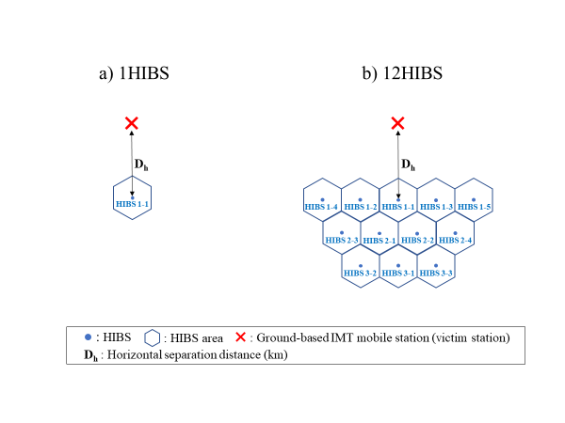

**Figure A2-1 Relative relations between HIBS and victim station**

Figure A2-2 and A2-3 show the positional relation between the HIBS antenna and the victim station in the horizontal and vertical directions. The direction of the maximum horizonal antenna gain of HIBS 1-1 is arranged toward the victim station for the worst case interference analysis.

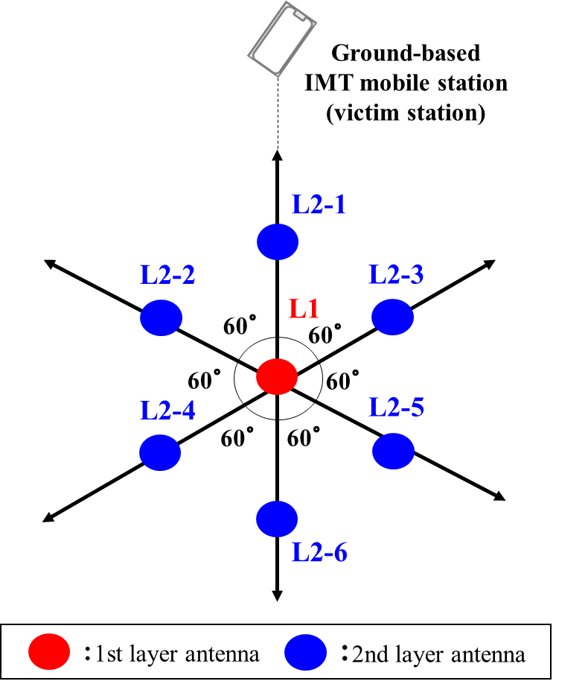

**Figure A2-2 Positional relations between HIBS antenna and victim station (horizontal direction)**

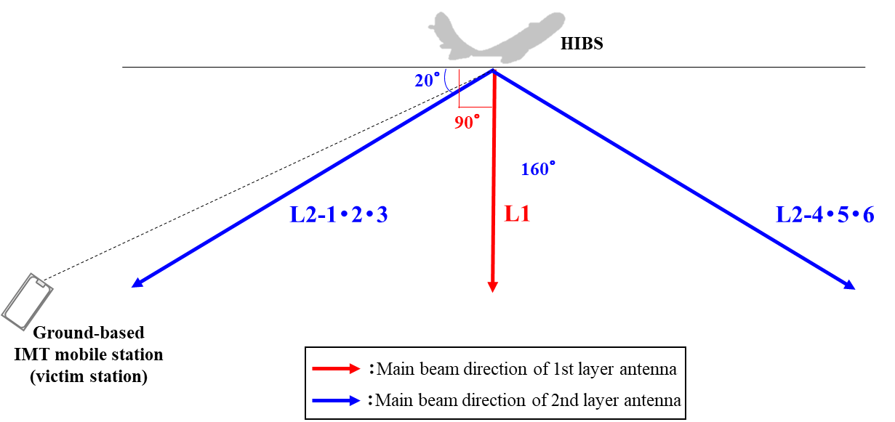

**Figure A2-3 Positional relations between HIBS antenna and victim station (vertical direction)**

**2.2 Calculation of horizontal separation distance**

The separation distance D between HIBS and the victim station for calculating PFD value at the receiving point is calculated by the horizontal separation distance *Dh* (see also Figure A2-4) as follows:

$D=\sqrt{R^{2}+{\left(R+H\right)}^{2}-2R(R+H)cos⁡(\frac{D_{h}}{R})}$ (km)

where :

*R*: Earth radius = 6378 km

*H*： Platform Altitude (km)



**Figure A2-4 Separation distance from HIBS to ground-based IMT mobile stations**

When the horizontal separation distance exceeds 500 km, the elevation angle (θ) between HIBS and the victim station becomes 0° or less, which is out of visible range. For this reason, it is considered that the victim station would not be influenced by the interference from HIBS, in the case of the propagation effects such as the reflection of atmosphere and ground surface as well as mountain diffraction are not taken into consideration and free-space propagation is employed.

**2.3 PFD calculation for aggregate interference**

Aggregated PFD values (PFDagg) from multiple HIBS is computed using the following equation:

${PFD}_{agg}=10log⁡(\sum_{m}{\sum_{n}{{EIRP}_{m,n}/{ADL}_{m,n}/4πD_{m}^{2}}})$ (dBW/m²·MHz)

where :

*EIRPm,n* transmit e.i.r.p of Celln in HIBSm (W/MHz)

*ADLm,n* angular discrimination of Celln in HIBSm

*Dm* separation distance between HIBSm and the victim station (m)

The calculation result of aggregated PFD values is as shown in Figure A2-5.

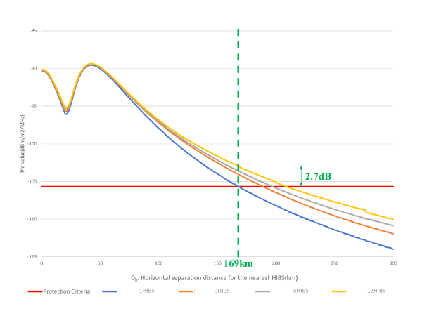

**Figure A2-5 Calculation result of aggregated PFD values**

Based on the calculation result, the required horizontal separation distance *Dh* to satisfy PFD value in Table A2-1 is 169 km in the single HIBS deployment scenario.

At this horizontal separation distance of 169 km, the interference power increment relating to the increase of HIBS number is 2.7 dB (12 HIBS). It can be seen that the increment is comparatively limited since the interference from the nearest HIBS of the victim station is dominant. In addition, although the increment rises toward far side of the horizontal separation distance, PFD value is satisfied to protect the victim station and no interference occur in such area. Moreover, when the HIBS number is increased to more than 12, it is expected that those HIBS would not contribute the increment of aggregate interference because the horizontal separation distance between the additional HIBS and victim station will exceed 500 km and become out of the visible range. Based on the above analysis, it is considered that 3 dB is sufficient as the aggregate effect even taking the possible margin into account.

**3 Conclusion**

Bases on the results of the single-entry interference and aggregate effect, the PFD value of -108.7 dBW/m²·MHz is derived to protect ground-based IMT mobile stations in other countries in 2 GHz frequency band from HIBS.

Note: Propagation effects are not included in the above PFD value.

___________

1. Comparing the altitude with HIBS (20 km), LEO (600 km) and GEO (36,000 km).
2. https://www.gsma.com/publicpolicy/wp-content/uploads/2015/02/Benefits-of-network-competition-and-complementary-policies-to-promote-mobile-broadband-coverage-Report.pdf
3. https://www.ofcom.org.uk/spectrum/information/cellular-coverage
4. https://www.ofcom.org.uk/__data/assets/pdf_file/0017/113543/Connected-Nations-update-Spring-2018.pdf
5. Report ITU-R F. 2439-0(11/2018) (https://www.itu.int/dms_pub/itu-r/opb/rep/R-REP-F.2439-2018-MSW-E.docx)
6. Note: This summary is based on the responses of the questionnaire received in AWG-24 and further meeting.