

**APT REPORT ON**

**SHARING AND COMPATIBILITY STUDIES FOR IMT ABOVE 24 GHZ FOR APT REGION**

**No. APT/AWG/REP-99  
Edition: July 2019**

**Adopted by**

**25th Meeting of APT Wireless Group  
1 – 5 July 2019, Tangerang, Indonesia**

***(Source: AWG-25/OUT-25)***

**APT REPORT ON**

**SHARING AND COMPATIBILITY STUDIES FOR IMT ABOVE 24 GHZ FOR APT REGION**

1. **Introduction**

This Report addresses the analysis study on the results of ITU-R TG5/1, the responsible group of the WRC-19 Agenda Item 1.13. This Report is developed to provide a comprehensive information to APT Memebrs, which would assist the Members’ internal preparation and/or regional and global discussion.

During the TG5/1 study, conditions for the protection of EESS (23.6-24 GHz) and FSS (24.65-25.25 GHz and 27-27.5 GHz, Earth to space) were the area which expects further discussion when WRC-19 considers the bands 24.25 to 27.5GHz. AWG also had a survey on the use of bands above 24GHz, which will be produced as a separate AWG Report. Based on the above situation, this Report only addresses some selected bands and some selected services.

It should be noted that this Report does not necessarily be interpreted that APT supports these selected bands under WRC-19 Agenda Item nor support these selected bands only. APT view on Agenda Item 1.13 shall be developed by APG in future. APG will consider the other bands as appropriate. This Report merely provides the information to assist APT Members on this particular band(s).

Therefore, the Report provides the analysis of sharing and compatibility studies by TG5/1 taking into account current existing services/applications deployed in APT region.Note that the analysis of technical conditions provided in this report is simply intended to describe studies that have been undertaken in relevant ITU-R study groups. The intent of that analysis is neither to provide any alternative analysis, nor is to challenge or question the methods or parameters used in ITU-R studies related to WRC-19 Agenda Item 1.13.

In a number of Sub-sections of Section 4 of this Report text appears in […]. This square-bracketed text concerns material copied from the referenced ITU-R TG5/1 Report and does not indicate text developed in AWG that was not agreed.

1. **Existing services / applications in APT region**

The existing services / applications in the frequency band above 24GHz are summarized in Table 1 and are taken into account for sharing and compatibility studies in this report in order to introduce IMT. The lower power /short range applications are excluded due to not critical cross boarder interference among countries.

**Table 1: Summary of existing service / application**

|  |  |  |
| --- | --- | --- |
| Frequency bands | | (Freq.) Application |
| Range | Service |
| 24.25 -27.5  GHz | FS | * (24.25-27) Fixed link (BGD) * (24.25-27.5) P-P for backhaul (IRN) * (24.25-24.45, 24.65-27,5) Fixed link (VTN) * (24.25-24.45, 25.5-27.5) Commercial FWA (MLA) * (24.45-27) LMDS (CHN) * (25.25-27) FWA system (JPN) * (25.35-27) LMDS for Broadcast/Wireless Cable (PHL) * (25.5-26.5) Broadband WLL systems, (26.5-27.5) CATV Distribution systems (KOR) |
| RNS | * (24.25-24.65) ASDE (Airport Surface Detection Equipment) (JPN) * (24.25-24.65) Radionavigation system (CHN) |
| ISS | * (24.45-24.75) Inter Satellite Link, (25.25-27.5) Data relay satellite (CHN) |
| FSS (E-s) | * (24.65-25.25, 27-27.5) FSS (CHN) * (27-27.5) Satellite communication (uplink) (JPN) * (27-27.5) Commercial FSS (THA) * (27-27.5) Gateway Earth stations (AUS) * (27-27.5) Broadband VSAT, Broadband Gateway, Backhaul, Satellite News Gathering (MLA) * (27-27.5) FSS (NZL, BGD, IND) |
| EESS (s-E) | * (25.5-27) Data transmission (CHN) * (25.5-27) EESS Earth stations at few locations (IND) |
| SRS (s-E) | * (25.7-27) Space research Earth station receivers (AUS) * (25.5-27) Space research receiving station (CHN) |
| RLS* | * (24.25-24.65) Radar (CHN) |
| 31.8-33.4  GHz | FS | * (31.8-33.4) Point-to-point telecommunication (INS) * (31.8-33.4) Fixed link (BGD) |
| RNS | * (31.8-33.4) Radionavigation system (CHN) |
| SRS  (ds, s-E) | * (31.8-32.3) Space research (deep space) Earth station receivers (AUS) * (31.8-32.3) Space Research Receiving Station (CHN) |
| ISS | * (32.3-33) Inter-satellite Link (CHN) |
| EESS(p) | * (31.5-31.8) EESS passive (AUS) |
| RLS* | * (31.8-33.4) Radar (CHN) |
| 37 - 43.5  GHz | FS | * (37-39.5) PTP for Backhaul (IRN) * (37-40) Fixed Local Relay Systems (KOR) * (37-39.5) P-P telecommunication (INS) * (37-39.5) Fixed “38 GHz” band (NZL) * (37-39.5) Fixed Relays, Point –to- Point Microwave Radio System (PHL) * (37-43.5) Fixed link (BGD) * (37.5-39.5) Public and General Service (relay), (38-39.5) FWA system, (41-42) TVOB (JPN) * (37.506-38.178 / 38.766-39.438) Point-to-point links (AUS) * (38.5-42.5) LMDS (PHL) * (40.5-42.3) FWA (Light license), (42.3-42.5) BWA (CHN) |
| EESS(p) | * (36-37) EESS passive (AUS) |
| SRS(s-E) | * (37-38) Space Research Receiving Station (CHN) |
| FSS(s-E) | * (37.5-40.5, 42.5-43.5) FSS (CHN) |
| RAS | * (42.5-43.5) VLBI. Etc (CHN) |
| 66 - 71 GHz | INTER-SATELLITE |  |
| MOBILE |  |
| MOBILE-SATELLITE |  |
| RADIONAVIGATION |  |
| RADIONAVIGATION-SATELLITE |  |
| 71 - 76 GHz | FIXED | * (71-76) fixed links (IRN, KOR, MAL, INS, NZL, PHL, BGD) * (71.25-75.875) Self-coordinated point-to-point links (AUS) * (74-76) fixed links (THA) |
| FIXED-SATELLITE (space-to-Earth) |  |
| MOBILE | * (71-76) High speed wireless transmission system (JPN) |
| MOBILE-SATELLITE (space-to-Earth) |  |
| BROADCASTING |  |
| BROADCASTING-SATELLITE |  |
| 81 - 86 GHz | FIXED 5.338A | * (81-86) fixed links (IRN, KOR, THA, MAL, INS, NZL, PHL, BGD) * (81.125-85.875) Self-coordinated point-to-point links (AUS) |
| FIXED-SATELLITE (Earth-to-space) |  |
| MOBILE | * (81-84) High speed wireless transmission system (JPN) |
| MOBILE-SATELLITE (Earth-to-space) |  |
| RADIO ASTRONOMY |  |

*\* Not allocated in ITU-R RR*

1. **Summary of sharing and compatibility studies by TG5/1 for APT region**

Based on the result of survey for usage in the frequency ranges above 24.25 GHz, the existing and planned services in the Asia pacific region are summarized and linked to relevant working documents on sharing and compatibility studies between them and IMT which have been conducted in TG5/1.

**Table 2: Relevant TG 5/1 working document for each existing service in APT region**

|  |  |  |  |
| --- | --- | --- | --- |
| **Freq. ranges** | **Existing service for protection from IMT** | | |
| **Interested existing service  in APT countries** | **TG5/1 Working document  in chairman’s report** | **Used frequency bands** |
| 24.25 -27.5  GHz | * Fixed links1) * FSS (E- s) 1) * EESS/SRS (s-E) * EESS (passive) * Inter-satellite links      * Radionavigation | * Annex 03 Part 5 * Annex 03 Part 32) * Annex 03 Part 1 * Annex 03 Part 2 * Annex 03 Part 4 * Not studied | * 24.25 - 27.5 GHz * 27 - 27.5GHz * 25.5 – 27 GHz * 23.6 – 24 GHz * 24.45 – 24.75 GHz   / 25.25 – 27 GHz   * 24.25 – 24.64 GHz |
| 31.8-33.4 GHz | * EESS (passive) 1) * Space research   (deep space)   * Radionavigation * FS PTP (P-P) system * ISS | * Annex 04 Part 3 * Annex 04 Part 2 * Annex 04 Part 1 * Not studied * Not studied | * 31.5 – 31.8 GHz * 31.8 – 32.3 GHz * 31.8 – 33.4 GHz * 31.8 – 33.4 GHz * 32.3 – 33 GHz |
| 37 - 43.5 GHz | * Fixed link1) * EESS (passive)1) * Fixed satellite (s-E) * Fixed satellite (E-s) * Space research * Radio astronomy | * Annex 05 Part 4 * Annex 05 Part 3 * Annex 05 Part 12)**2)** * Annex 06 * Annex 05 Part 2 * Annex 05 Part 2 | * 37 – 43.5 GHz * 36 – 37 GHz * 37.5-42 GHz * 42.5-43.5 GHz * 37 – 38 GHz * 42.5 – 43.5 GHz |
| 66 – 71  GHz | * ISS * MSS (E-s) | * Annex 11 * Annex 11 | * 66-71 GHz * 66-71 GHz |
| 1. – 76   GHz | * FS * RLS (automotive radar) * FSS (s-E) | * Annex 12 Part 1 * Annex 12 Part 2 * Annex 12 Part 3 | * 71-76 GHz * 76-81 GHz * 71-76 GHz |
| 81 – 86  GHz | * EESS (p) * FS * RAS (in-band) * RAS (adj-band) * RLS (automotive radar) * FSS (E-s) | * Annex 13 Part 1 * Annex 13 Part 2 * Annex 13 Part 3 * Annex 13 Part 4 * Annex 13 Part 5 * Annex 13 Part 6 | * 86-92 GHz * 71-76 GHz * 81-86 GHz * 86-92 GHz * 76-81 GHz * 81-86 GHz |
| *1) Mainly concerned services / applications by some administrations*  *2) TG5/1 working documents contain sharing and compatibility studies for FSS in frequency bands 24.75 – 25.25 GHz and 40.5 – 42.5 GHz, which were not replied by any APT countries for FSS usage.* | | | |

1. **Analysis on the specific technical conditions as protection measures**
   1. **Frequency range 24.25 -27.5 GHz**
      1. **EESS (passive) Service in the frequency band 23.6 -24GHz**
         1. **Summary of technical conditions**

The TG5/1 study investigated limits of unwanted emission power in the frequency band 23.6-24 GHz from IMT base stations and IMT mobile stations in the frequency band 24.25-27.5 GHz. And various unwanted emission levels from -30.1 to -55 dB (W/200MHz) for BS and from -26.4 to -51 dB(W/200MHz) for UE were received by TG 5/1. TG5/1 Chairman’s Report pointed out that such differences mainly come from different assumptions and considerations of antenna beamforming in adjacent bands, apportionment, multi-operator factor and etc.

Based on above TG5/1 studies, five options are provided in the Report of the CPM to WRC-19 as protection measures for EESS (passive) in the frequency band 23.6-24GHz

* Option 1: Introduce in Table 1-1 of Resolution 750 (Rev.WRC-19) limits on unwanted emissions in the frequency band 23.6-24 GHz from IMT BSs and IMT mobile stations within the 24.25-27.5 GHz frequency band (see Section 2/1.13/3.2.1) and add a cross-reference to Resolution 750 (Rev.WRC 19) in the RR footnote that identifies the frequency band for IMT and revise RR No. 5.338A accordingly.
* Option 2: Introduce in Table 1-2 of Resolution 750 (Rev.WRC-19) limits on unwanted emissions in the frequency band 23.6-24 GHz from IMT base stations and IMT mobile stations within the 24.25-27.5 GHz frequency band (see section 2/1.13/3.2.1) and add a cross-reference to Resolution 750 (Rev.WRC 19) in the RR footnote that identifies the frequency band for IMT and revise RR No. 5.338A accordingly.
* Option 3: To develop a WRC Recommendation to include limits on unwanted emissions in the frequency band 23.6-24 GHz from IMT BSs and IMT mobile stations within the 24.25-27.5 GHz frequency band, as appropriate. If RA-19 adopts an ITU-R Recommendation on this issue, the WRC Recommendation described in this option might not be required anymore.
* Option 4: To develop a WRC Recommendation to include limits on unwanted emissions in the frequency band 23.6-24 GHz from IMT BSs and IMT mobile stations within the 24.25 27.5 GHz frequency band, as appropriate. Table 1-2 of Resolution 750 (Rev.WRC 15) on “Recommended maximum level of unwanted emission power from active service stations in a specified bandwidth within the EESS (passive) band” to be shifted to this draft new Recommendation, and to delete Table 1-2 from Resolution 750 (Rev.WRC-15). If RA-19 adopts an ITU-R Recommendation on this issue, the WRC Recommendation described in this option might not be required anymore.
* Option 5: No condition is necessary.
  + - 1. **Analysis on technical conditions**

Several unwanted emission levels of IMT stations have been provided to TG5/1.Table 3 shows the summary of technical assumptions and unwanted emission levels.

**Table 3: Summary of technical assumptions and unwanted emission level**

|  |  |  |  |  |  |
| --- | --- | --- | --- | --- | --- |
| Index | IMT stations | | Ant. pattern | Apportionment | Multi-channel |
| BS | UE |
| 1 CEPT (414) | -42 | -38 | BF | Applied | Applied |
| 2 KOR (417) | -20 | -20 | BF | Not applied | Not applied |
| 3 RUS (432) | -49.3 | -45.5 | Single | Applied | Applied |
| 4 Multi countries1) (470) | -32 - -37 | -28 - -30 | BF | Not applied | Not applied |
| 5 Multi countries2) (472) | -32 | -29 | BF | Not applied | Not applied |
| 6 Ericsson (471) | -34  -32 | -31  -29 | BF  BF | Not applied  Not applied | Applied  Not applied |
| 7 ESA (260) | -54 | -50 | Single | Applied | Applied |
| 8 USA(433)/ B(437) | TBD | TBD | NA | NA | NA |
| *1) Cameroon (Republic of), Ghana, Kenya (Republic of), Nigeria (Federal Republic of), Senegal (Republic of), South Africa (Republic of), Zimbabwe (Republic of)*  *2) Cameroon (Republic of), Egypt (Arab Republic of), Saudi Arabia (Kingdom of) and United Arab Emirates* | | | | | |

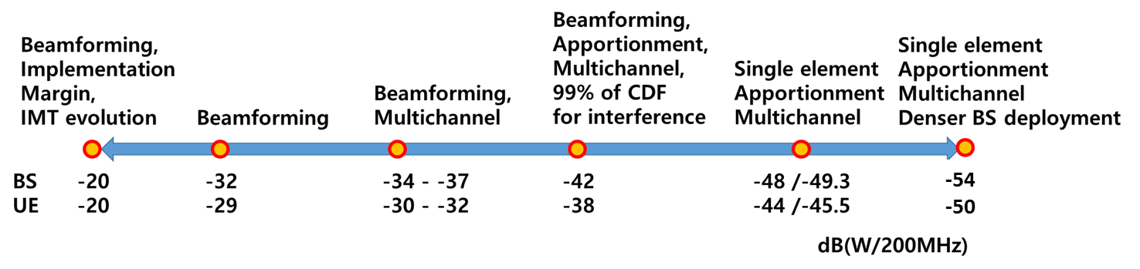

Those values are derived according to whether to apply some technical parameters such as Antenna pattern of IMT in the adjacent band, apportionment of interference criteria between services, aggregation interference from multichannel of IMT and etc.

* Antenna pattern of IMT in the adjacent band: Single element pattern VS. Beamforming pattern

As Chinese (Study H) and Korean (Study F) studies have shown that beamforming pattern can mitigate the unwanted emission level as much as 7.6 dB and 6.4 dB, respectively. IMT systems in the above 24GHz will use the Active Antenna system (AAS) which functions of beamforming. Therefore, it would be practical to include the beamforming pattern.

* Apportionment of interference criteria between services: 0 dB (not applied) or 3dB

Protection criteria provided by WP 7B mean total interference level, so additional 3dB attenuation is required to both interfering services in case of causing similar interference level by both adjacent services simultaneously. But if there is no service below 23.4GHz or much lower interference for other service than IMT is caused, it would not be applied (i.e. 0 dB)

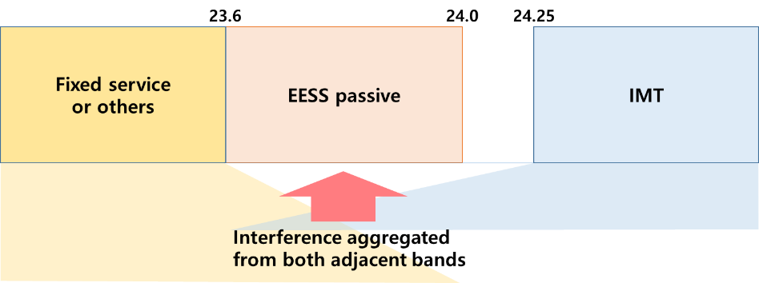

* Aggregate interference from multichannel of IMT: 2 dB or 0dB (not applied)

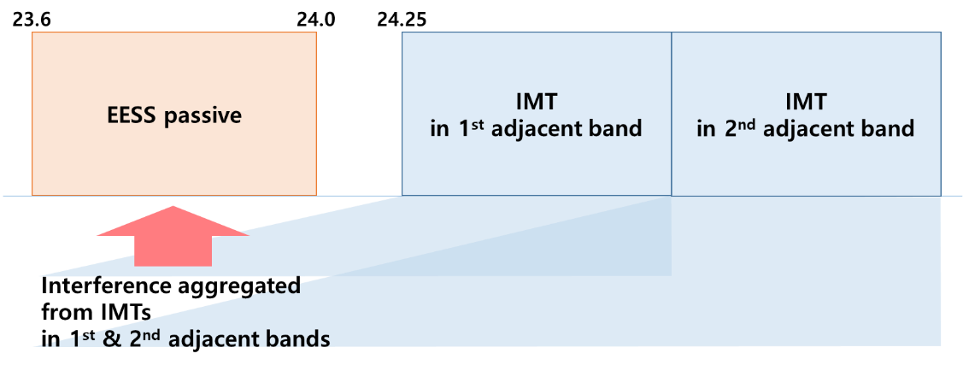

* + - 1. **Impact of implementation from analysis by 3GPP RAN4 (See Annex 3)**

3GPP RAN4 reviewed the implementation feasibility to meet lower unwanted emission level than the baseline value for spurious emissions of both IMT base station (BS) and mobile station (UE) as Total Radiated Power (TRP) provided by WP 5D as -13dBm/MHz (equal to -20dBW/200MHz). If stringent unwanted emission level lower than -37dBW/200MHz for IMT BS is required, it can be achievable with following conditions:

* More than 1.5GHz guard band
* 3~4 dB insertion loss, i.e causing a 20% performance reduction in cell edge of IMT

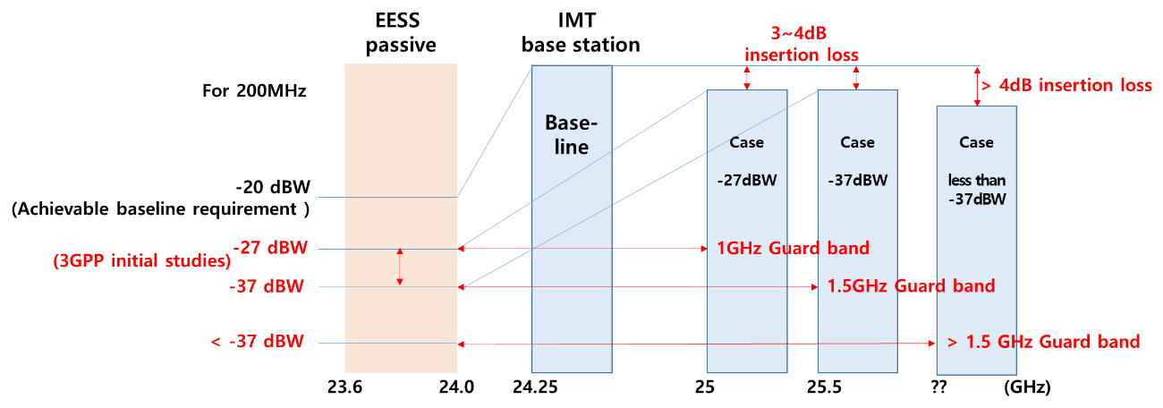

* + 1. **Fixed-Satellite Service in the band 24.65 - 25.25GHz and 27 - 27.5GHz**
       1. **Summary of technical conditions**

The following four technical conditions are selected for the consideration of technical aspects.

* Maximum TRP of IMT base stations with range of [25/35/37/46/TBD] dBm/200 MHz
* Antenna beam elevation angle of IMT base station; not be higher than 0 degree below the horizon with regard to [normally] electrical tilt / mechanical tilt / combined tilt (electrical and mechanical),
* Antenna pattern shall comply with Recommendation ITU-R M.2101
* Equivalent power flux-density limit (see Annex2), epfd↑, at GSO orbit
* BS density (TBD, value was not proposed)
* No technical conditions are required considering studies show sharing is feasible between IMT and FSS.

With conditions, several options are summarized briefly in Table 4.

**Table 4: Technical conditions adopted by options for protection measures**

|  |  |  |  |  |  |  |
| --- | --- | --- | --- | --- | --- | --- |
| Opt. | Max. TRP of BS  (dBW/200MHz) | BS beam elevation angle direction | E.I.R.P mask  of BS | epfd↑at GSO orbit | BS density | |
| 1 | [25/35/37/46/TBD] | [Normally] electrical and  mechanical tilt, separately |  |  |  | |
| 2 | [25/35/37/46/TBD] | elevation angle based on pattern of ITU-R M.2101 |  |  |  | |
| 3 | [35/37] | [Normally] combined tilt |  |  |  | |
| 4 |  | Normally combined and  mechanical tilt, separately |  |  | √ | |
| 5 | [25/35/37/46/TBD] | mechanical tilt | X |  | √ | |
| 6 |  |  | √1) |  |  | |
| 7 |  |  |  | √2) |  | |
| 8 | √ |  |  |  |  | |
| 9 |  |  |  |  |  | |
| *1) eirp mask for emission is proposed below*   |  |  | | --- | --- | | *Elevation angle* | *Maximum e.i.r.p.* | | *the interference would be increased up to 5 dB or up to 3 dB respectively* | *the interference would be increased up to 5 dB or up to 3 dB respectively* | | *15<Θ≤25* | *34 dB(m/200 MHz)* | | *25<Θ≤55* | *34-0.43(Θ-25) dB(m/200 MHz)* | | *55<Θ≤90* | *21.1 dB(m/200 MHz)* |   *2) Administrations implementing IMT system(s) within their territory ensure that the equivalent power flux-density (see Annex2), epfd↑, produced at any point in the geostationary-satellite orbit by emissions from all the IMT base stations in their territory in the frequency bands listed in the table below, for all conditions and for all methods of modulation, shall not exceed the limits given in the table below for the specified percentages of time. These limits relate to the equivalent power flux-density which would be obtained under free-space propagation conditions (with appropriate losses and degradations, if applicable), into a reference antenna and in the reference bandwidth specified in the table below, for all pointing directions towards the Earth’s surface visible from any given location in the geostationary-satellite orbit.*   | *Frequency bands* | *epfd↑ (dB(W/m2))* | *Percentage of time, probability or location* | *Reference bandwidth (MHz)* | *Reference antenna beamwidth and reference radiation pattern (See Annex)* | | --- | --- | --- | --- | --- | | *24.65-25.25 GHz* | *[TBD]* | *[TBD]* | *[TBD]* | *[0.8°] Recommendation ITU‑R S.672-4, Ls = [-25]* | | *27.0-27.5 GHz* | *[TBD]* | *[TBD]* | *[TBD]* | *[0.8°] Recommendation ITU‑R S.672-4, Ls = [-25]* | | | | | | |

* + - 1. **Analysis on technical conditions**

The protection criteria for FSS are submitted to TG5/1 as follows;

* Long term: -10.5 dB I/N (exceeded up to 20% or I/N average)
* Short term: -6 dB I/N for 0.6% or 0 dB I/N for 0.02% with not exceeded percentile of time, location or probability

In TG5/1 study, the baseline case means that TG5/1 has used the information from WP5D. Non-baseline case has used the information from individual study.

**Maximum TRP of IMT base stations**

The interference level arriving at the FSS receiver is associated with the Total Radiated Power (TRP) of IMT base stations. Generally speaking, high TRP will generate high interference level towards FSS receiver and reflects to high I/N values.

The studies result in *I/N* ranged from -40.62 dB to -19 dB for the baseline case. Specifically, for considering short-term criteria, several studies result in *I/N* values ranging from -28.3 dB to -15.8 dB, which correspond to maximum TRP power levels ranging from 47.3 to 34.8 dBm/200MHz.

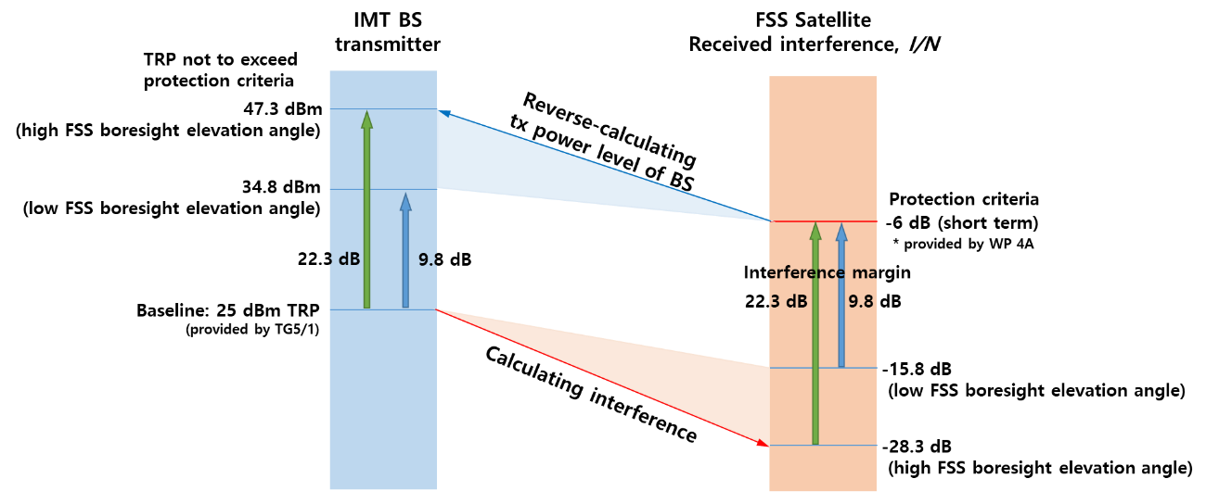

For considering long-term criteria, as a case of FSS boresight elevation angles in the range of 10° to 30°, several studies result in *I/N* values in the range -30.3 dB to -24.3 dB, which correspond to maximum TRP power levels ranging from 44.8 to 38.8 dBm/200MHz.

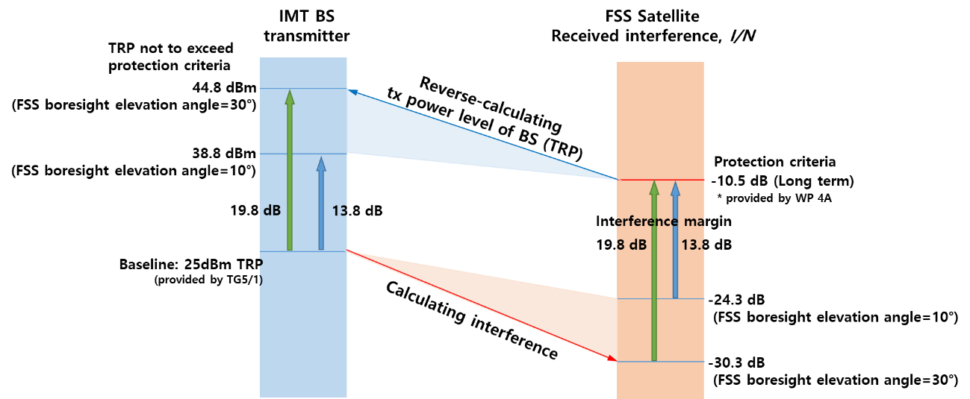

Some studies apply apportionment of interference criteria between 5G and other services up to 4.7 dB which causes up to 4.7dB reduction for maximum transmitter power.

For non-baseline cases, several studies have been conducted with different assumptions from TG5/1, i.e. 5 dB higher antenna element conducted power or 16x16 array antenna elements for beamforming (TG5/1 uses 8x8 16x16 array antenna elements for beamforming). With that, those studies provide that the interference would be increased up to 5 dB or up to 3 dB respectively. Other several studies consider assumptions with more overloading IMT deployment by increasing density of BS, BS network loading and no clutter, additionally. And then interference I/N would be as high as -15 to -7.6 dB, which corresponds to maximum transmitter power level of 28 to 23.4 dBm/200MHz

* + 1. **Inter-Satellite Service in the band 24.45 - 24.75 GHz and 25.25 - 27 GHz** 
       1. **Summary of technical conditions**

Options for protection measures for the ISS receiving space stations are summarized briefly in Table 5.

**Table 5: Technical conditions adopted by options for protection measures**

|  |  |  |  |  |  |  |  |
| --- | --- | --- | --- | --- | --- | --- | --- |
| Opt. | Max. TRP of BS  (dBW/200MHz) | BS beam elevation angle | Antenna pattern | E.I.R.P mask  of BS | epfd↑at GSO orbit | BS density | |
| 1 | [25/28/31/37] | The main beam elevation shall not be higher than 0 degrees relative to the horizon;  The mechanical tilt shall be below −10 degrees relative to the horizon. | being kept within the limits of approximation envelope according to Recommendation ITU-R M.2101. |  |  | 1 200 BSs per 10 000 km² for outdoor hot spots | |
| 2 | [37/40/46] | The main beam elevation shall not be higher than 0 degrees relative to the horizontal. |  |  |  |  | |
| 3 | [25/28/31/37] | The mechanical tilt shall be below −10 degrees relative to the horizon and the main beam elevation shall not to be higher than 0 degrees relative to the horizontal. | complying with Recommendation ITU-R M.2101. |  |  |  | |
| 4 | Alternatively to Options 1, 2 and 3, the elements contained in these options could also be included in a WRC Recommendation. | | | | | | |
| 5 |  | The outdoor BSs’ main beam elevation shall be not above the horizon and the mechanical pointing shall be below the horizon (except when the antenna of BS is only receiving). |  |  |  |  | |
| 6 |  | The outdoor BSs’ main beam elevation normally[1] shall be not above the horizon and the mechanical pointing shall be below the horizon (except when the antenna of BS is only receiving).  [1] Only a very limited number of indoor terminals with positive elevation will be communicating with BSs. |  |  |  |  | |
| 7 |  |  |  | √1) |  |  |
| 8 |  |  |  |  | √2) |  | |
| 9 | No condition is necessary. | | | | | | |
| *1) The e.i.r.p. masks for the IMT base stations’ emissions:*   | *Elevation angle* | *Maximum e.i.r.p. dB(W/200 MHz)* | | --- | --- | | *5 ≤ Θ ≤ 15* | *17 − 1.3(Θ − 5)* | | *15 < Θ ≤ 25* | *4* | | *25 < Θ ≤ 55* | *4 − 0.43(Θ − 25)* | | *55 < Θ ≤ 90* | *−8.9* |   *2) Administrations implementing IMT system(s) within their territory ensure, in accordance with the definition in Annex 1 and calculation methodology contained in Annex 2 to this Resolution, that the equivalent power flux-density, epfd↑, produced at any point in the geostationary-satellite orbit by emissions from all the IMT base stations in their territory in the frequency bands listed in the following table, for all conditions and for all methods of modulation, shall not exceed the limits given in the following table for the specified percentages of time. These limits relate to the equivalent power flux-density which would be obtained under free-space propagation conditions (with appropriate losses and degradations, if applicable), into a reference antenna and in the reference bandwidth specified in the following table, for all pointing directions towards the Earth’s surface visible from any given location in the geostationary-satellite orbit;* | | | | | | | |

| *Frequency bands* | *epfd↑ (dB(W/m2))* | *Percentage of time, probability or location* | *Reference bandwidth (MHz)* | *Reference antenna beamwidth and reference radiation pattern (see Annex 1)* |
| --- | --- | --- | --- | --- |
| *24.65-25.25 GHz* | *[−151.6 + 10 log (α)]* | *[80%]* | *[1]* | *[0.8°] Recommendation ITU‑R S.672-4,  Ls = [−25]* |
| *27.0-27.5 GHz* |

* + - 1. **Summary of TG5/1 Studies**

In TG5/1 study, six sharing and compatibility studies were provided that assessed the aggregate interference from IMT 2020 stations into data relay satellite (DRS) systems in the 25.25-27.5 GHz frequency range under the following three assumptions.

**Assumption 1:** no apportionment, 3 dB polarization loss, three different DRS systems (Chinese Data Tracking and Relay System (CTDRS), European Data Relay System (EDRS) and Tracking and Data Relay Satellite (TDRS)), as well as different orbital locations and DRS beam pointing elevation angles.

There were four studies based on Assumption 1. The results showed a positive interference margin of 12.2 to 25 dB. Two of these studies assessed aggregate interference levels within the visibility area of a DRS satellite (based on 99.9% I/N value or I/N value from a single snapshot or mean I/N value) and performed a sensitivity analysis on the antenna array (16×16 antenna array or 5 dB higher per antenna element power) and found an interference margin of 9.5 to 18.4 dB. One of these studies also considered a sensitivity analysis on a population redistribution, which derived a margin of 8.2 to 10.2 dB for BS with 8×8 array and minimal elevation angle of 20 degrees towards the DRS satellite for IMT-2020 deployments.

**Assumption 2:** 7 dB apportionment, 1.5 dB polarization loss, three different DRS systems (CTDRS, EDRS and TDRS), as well as different orbital locations and DRS beam pointing elevation angles.

Under Assumption 2, a fifth study considered a statistical calculation based on BS antenna panel random positioning with antenna normalization, deriving an interference margin of 10.2 dB for EDRS.

**Assumption 3:** 7 dB apportionment, 1.5 dB polarization loss, normalization of IMT-2020 antenna gain patterns and a DRS beam pointing elevation angle of 10 degrees.

The results of a sixth study showed interference margins of -1.5 and 0.7 dB for two different DRS systems (EDRS and TDRS) using Assumptions 3. This study also contained a set of sensitivity analysis, e.g. a 16×16 antenna array and a 5 dB higher per antenna element power, which is similar to the other five studies. The study also considered IMT characteristics other than those provided by the involved ITU-R groups and in the clarifications and guidance developed by ITU-R on how to use the parameters in the studies as follows: A network loading factor of 50% resulted in a 3.5 dB increase in interference; the use of three sectors per BS resulted in a 4.1 dB increase; the application of all of the above-mentioned factors together resulted in an increase of interference up to 15.6 dB. Furthermore, 10% of outdoor users with a height from 10 m to 30 m resulted in an increase of interference by 3.5 and 8 dB for 8×8 and 16×16 antenna arrays, respectively. In order to compensate for the negative margins, this study proposed an e.i.r.p. mask as a mitigation technique to ensure the compatibility of IMT-2020 with ISS space stations.

* + 1. **EESS/SRS (S-e) in the band 25.5 - 27 GHz**
       1. **Summary of technical conditions**

Five options are provided in the Report of the CPM to WRC-19 based on TG5/1 studies as protection measures for EESS/SRS (space-to-earth) in the 25.5-27 GHz frequency band.

* Option 1: Reflect in the WRC Resolution corresponding to the IMT identification of this frequency band:

1. to invite ITU-R to develop an ITU-R Recommendation to assist administrations in protecting existing and future SRS/EESS earth stations operating in the frequency band 25.5 27 GHz;
2. in addition, administrations should be invited to adopt provisions to protect other services from IMT networks and to ensure the possibility of deploying future SRS/EESS earth stations.

* Option 2: In addition to Option 1, modify RR No. 5.536A, 5.536B and 5.536C so that these provisions do not apply to IMT stations.
* Option 3: Reflect in the WRC Resolution corresponding to the IMT identification of this frequency band:

1. to invite ITU-R to develop an ITU-R Recommendation to assist administrations in protecting existing and future SRS/EESS earth stations operating in the frequency band 25.5-27 GHz and incorporate this Recommendation into the RR by reference;

* Option 4: Protection of other services (in-band and/or adjacent band) by IMT should be contained in a WRC Resolution cross-referenced in the footnote in RR Article 5 in which the frequency band is identified for IMT.
* Option 5: No condition is necessary.
  + - 1. **Summary of TG5/1 Studies**

**EESS**

In TG 5/1 study, some studies performed a non-site-specific aggregate analysis with Monte Carlo simulations. The separation distance was found to be in the range of 0.2-1.0 km in urban and suburban (including suburban open-space) scenarios. Some studies performed a non-site-specific single-entry worst-case analysis, which evaluated the interference caused by a single base station (BS) in front of the earth station with Monte Carlo simulations. The separation distance was shown to be less than 0.8 km. Two other single-entry studies used a deterministic analysis method, assuming the IMT BS antenna main beam pointed towards the EESS earth stations. A separation distance in the range 0.2-1.7 km were derived.

Three studies addressed the separation distances that would be required around a number of specific EESS earth stations located in the USA, Europe and China, considering either one single BS whose antenna panel was oriented towards the victim earth station, or a cluster of up to 31 BSs with random antenna panel orientations. These studies led to the following separation distances for 8×8 antenna BSs:

* 3.9-6.0 km for EESS earth stations tracking non-geostationary-satellite orbit (non-GSO) satellites;
* 3.0-7.0 km for EESS earth stations tracking geostationary-satellite orbit (GSO) satellites.

**SRS**

In TG 5/1 study, some studies performed a non-site-specific aggregate analysis with Monte Carlo simulations. The separation distance was found to be in the range of 0.8-2.0 km in urban, suburban (including suburban open-space) scenarios.

Two studies addressed the separation distances that would be required around a number of specific SRS earth stations, considering either one single BS whose antenna panel was oriented towards the victim earth station, or a cluster of up to 31 BSs with random antenna panel orientations. The separation distance would be in the range of 23.8-92.0 km for SRS earth stations, based on the assumptions used in the studies.

* 1. **Frequency range 37 - 43.5 GHz**
     1. **EESS (passive) in the band 36-37 GHz**
        1. **Summary of technical conditions**

Two options are provided in the Report of the CPM to WRC-19 based on TG5/1 studies as protection measures for EESS (passive) in the 36-37 GHz frequency band.

* Option 1: Introduce mandatory limits on unwanted emissions in the frequency band 36-37 GHz from IMT BSs and IMT mobile stations within the 37-40.5 GHz frequency band in the WRC Resolution corresponding to the IMT identification of this frequency band.
* Option2: No condition is necessary.
  + - 1. **Summary of TG5/1 Studies**

In TG 5/1 study, four studies between the EESS/SRS (passive) in the frequency band 36-37 GHz and IMT in the frequency band 37-43.5 GHz have been provided. These studies showed that Sensor H3 is the most sensitive to aggregated interference from IMT systems. Three studies did not consider apportionment of the EESS (passive) protection criteria, deriving that when the unwanted emission level of IMT stations is -13 dB(m/MHz), i.e. -43 dB(W/MHz), the aggregate level interference exceedance for Sensor H3, were -4 to 17.4 dB for UE and 5 to 16.7 dB for BS, corresponding to levels of unwanted emissions of -23 to -37.6 dB(W/100 MHz) for UE, and -28 to -36.9 dB(W/100 MHz) for BS depending on the assumptions used (in particular single element or beam forming antenna pattern). These values apply for a single pixel, whereas Rec. ITU-R RS.2017 allows for 0.1% in time or area of the 10 000 000 km² measurement area to exceed the -166 dB(W/100 MHz) interference criterion, and hence 66 pixels of Sensor H3 be ‘excluded’, thus resulting in a less stringent emissions limit being required.

The fourth study considered the single element IMT antenna pattern, the 3 dB apportionment of the EESS (passive) protection criteria, as well as a 2 dB factor for multi-operator aggregation to account for the interference from other IMT-2020 operators’ networks. The results showed that the levels of interference exceedance is 26.1 to 32.3 dB, corresponding to levels of unwanted emissions for UE and BS of −46/−47 dB(W/100 MHz) to −52.2/−53.2 dB(W/100 MHz), respectively.

* 1. **Frequency range 66 - 71GHz**
     1. **ISS**

The study provides a single-entry worst-case analysis for both the BS and UE case for the interference scenario where the ISS data relay satellite (DRS) is at 1° elevation and at 80° elevation. These two cases would emphasise two different situations; the situation where the atmospheric loss is minimised, and the situation where the antenna gain of the base station is maximised. The study shows an interference threshold margin towards the DRS in the range of 38 dB to 127 dB, assuming a protection criterion Io­/No of ‑10 dB.

Therefore, it can be assumed that co-existence between IMT-2020 and ISS in the 66-71 GHz band is feasible without additional technical or regulatory constraints on IMT.

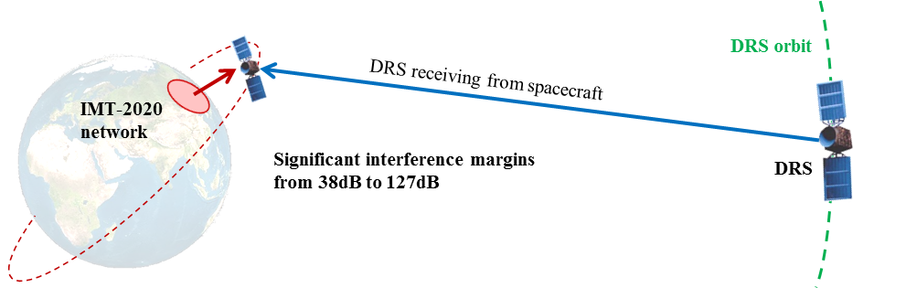

Considering the significant interference margins (38 dB to 127 dB) of the protection threshold of DRS, it can be assumed that co-existence between IMT-2020 and ISS in the 66-71 GHz band is feasible.

* + 1. **MSS (E-s)**

One study provided a single-entry analysis for a worst-case scenario to evaluate the interference level from IMT-2020 to a MSS receiving satellite, when IMT-2020 is deployed based on the characteristics provided by the involved ITU-R groups. This study considered the potential interference from the IMT-2020 base station (BS) and user equipment (UE) to the MSS receiving satellite in a geostationary orbit (GSO); where the range of elevation angles to the MSS satellite is from the horizon at 0° elevation to 90° elevation (zenith). In this study, the potential interference level was assessed as no protection criteria for MSS was available for this frequency band in ITU-R. This analysis shows that the interference level from IMT-2020 is from ‑347 dB(W/MHz) down to ‑176 dB(W/MHz), considering the following assumptions: IMT-2020 BS antenna is pointing lower than 1.8° below the horizon and the IMT-2020 UE is pointing upwards directly to the satellite, the total output powers of BS and UE considered are 27 dB(m/200 MHz) and 18 dB(m/200 MHz) respectively (based on the characteristics provided by the involved ITU-R groups).

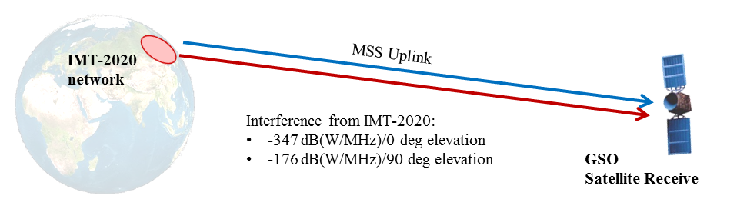

The interference level from IMT-2020 is from ‑347 dB(W/MHz) down to ‑176 dB(W/MHz), where the range of elevation angles to the MSS satellite is from the horizon at 0° elevation to 90° elevation (zenith). Noted that no protection criteria for MSS was available for this frequency band in ITU-R.

* 1. **Frequency range 71 - 76GHz**
     1. **FS**

Statistical studies for a single entry IMT BS case, for different antenna heights of FS receiver where the IMT BS is within the beam of the FS receiver, show that a separation distance of 970 to 260 m for antenna heights of 10 to 40 m respectively, will ensure that the protection criteria for the FS receiver are met. Alternatively, a separation distance of 250 meter with an azimuth offset of antenna boresights between IMT BS and FS receiver will also ensure that the protection criterion is met.

Statistical studies for the aggregated case show that for different antenna heights of FS receiver (from 10 to 40 meter), a separation distance of 720 m from a FS receiver at 10 m will ensure that the protection criteria are met, in general, without separation distances for the aggregate case.

In summary, despite a strong interference potential when an IMT BS is located precisely in the FS receiver antenna boresight direction, the potential interference to FS receiver is limited and sharing would be feasible.

The main coexistence problem in practice is likely to be with fixed links. The E-band plans for fixed links uses 71-76 GHz paired with 81-86 GHz. Links in the E-band are likely to be operated in the same urban and busy areas as IMT. As MBB data rates increase, the band will play a key role in providing backhaul for 4G and 5G. Therefore, the fixed service should be maintained and protected in this band.

Sharing the band between FS links and IMT access is feasible due to the excellent spatial isolation which can be achieved in this band.

The TG5/1 results show that for antenna heights of the FS system higher than 10 m, the interference from the IMT system into the FS station would be below the threshold (Study C in the Attachment 1 to Annex 12 to Task Group 5/1 Chairman’s Report). For an FS antenna height of 10m, a separation of 720 metres would be required (see figure below, copy of FIGURE C-2 in the Chairman´s report).

I/N curves at the FS receiver from the IMT network,

FS antenna at 10 m, 25 m and 40 m, respectively



In the light of this, there would be two alternative approaches to protect FS, one for scenarios where the FS antenna is above 10 metres and one for scenarios with FS antenna below 10 metres:

Scenario 1: Spatial vertical isolation >10 m

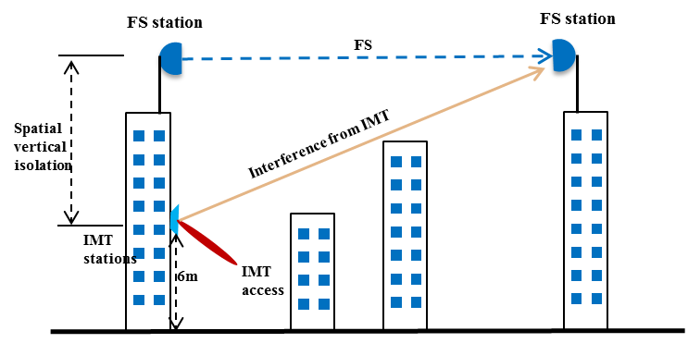

Scenario 2: Separation between FS antenna and center of IMT coverage area

(when smaller spatial vertical isolation, 10m for FS, 6m for IMT)

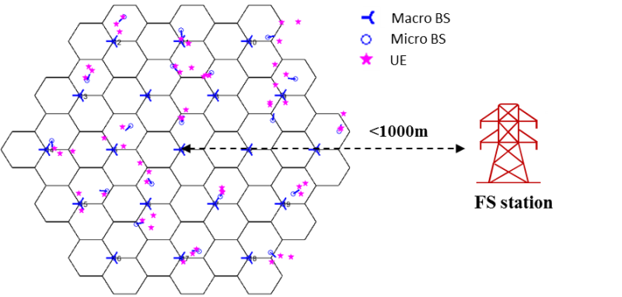

* + 1. **RLS (automotive radar)**

Two studies were received which deal with the compatibility between IMT-2020 in the frequency bands 71-76 GHz and 81-86 GHz and automotive radar in the frequency band 76-77 GHz (i.e. Radar A of Category 1 from Recommendation ITU-R M.2057). Study A gives a range of IMT unwanted emission levels that are assumed to provide appropriate protection of the automotive radars while Study B uses various IMT-2020 unwanted emission levels to assess the probability of interference.

The IMT stations’ spurious emission level assumed in both studies is a constant value over the operating band of automotive radars.

Study A assumed a 99% applicability of the protection criterion of I/N = -6 dB and did not apply antenna normalisation. The baseline and sensitivity analysis took into account different propagation models (Rec ITU-R M.2412 and P.452); the sensitivity analysis considered the potential effects of the surrounding obstacles. The statistics used for deriving the IMT-2020 maximum unwanted emission limits included the interference cases to automotive radars in the range of 300 m from the BS while the assumed BS cell radius was 100 m.

Study A has shown that to protect automotive radars operating in the 76-77 GHz frequency band, IMT-2020 stations need to comply with the following maximum unwanted emission levels in the band 76-77 GHz:

For baseline analysis:

* For BS: - 24.5 dBm/MHz (equivalent to -31.5 dBW/200 MHz);
* For UE: -13 dBm/MHz (equivalent to -20 dBW/200 MHz).

For sensitivity analysis:

* For BS: -22.6 dBm/MHz (equivalent to -29.6 dBW/200 MHz);
* For UE: -13 dBm/MHz (equivalent to -20 dBW/200 MHz).

The maximum additional isolation required for the IMT BS unwanted emissions in the frequency band 76-77 GHz for all studied cases is within the range 11.5 dB (baseline) to 9.6 dB (sensitivity analysis). No additional isolation is required for the IMT UE.

Study B found it was not possible to define the value of the unwanted emission limits of IMT-2020 appropriately, taking into account the information provided by the involved groups. Study B reflects that there is no model available for the roll-off of the IMT-2020 unwanted emissions in this out of band domain, no measurement of the IMT-2020 antenna pattern in adjacent bands and also concluded that there was no information about the foreseen deployment of IMT-2020 UEs with respect to vehicles for these bands. Notwithstanding that, the study concluded that an unwanted emission limit more stringent than ‑30 dBm/MHz (equivalent to more than 17 dB additional isolation) for both BS and UE is necessary to protect automotive radars in the radiolocation service in the frequency band 76-77 GHz.

It is proposed to introduce in the RR unwanted emission limits into 76-81GHz from IMT-2020 stations (BS and UE) operating on the frequency band 71-76GHz. (see Table 6)

**Table 6: Limits of unwanted emission power into 76-81 GHz from IMT stations**

| **Station** | **76-77 GHz**  **dB(W/200 MHz)** | **77-81 GHz**  **dB(W/200 MHz)** |
| --- | --- | --- |
| IMT base station | [-31.5/TBD] | [-33/TBD] |
| IMT terminal station | [-20/TBD] | [-35/TBD] |

* + 1. **FSS (s-E)**

A statistical aggregate interference study from the IMT BSs towards FSS earth stations has been performed in the 71-76 GHz frequency band. The results show that with the separation distance of 250 m around the FSS earth station, the aggregate interference level does not exceed the FSS long term interference threshold, based on the assumptions and input parameters used in this study.

Therefore, according to the results of the study where a long-term interference threshold was applied, it can be assumed that co-existence between IMT‑2020 and FSS in the 71-76 GHz band is feasible.

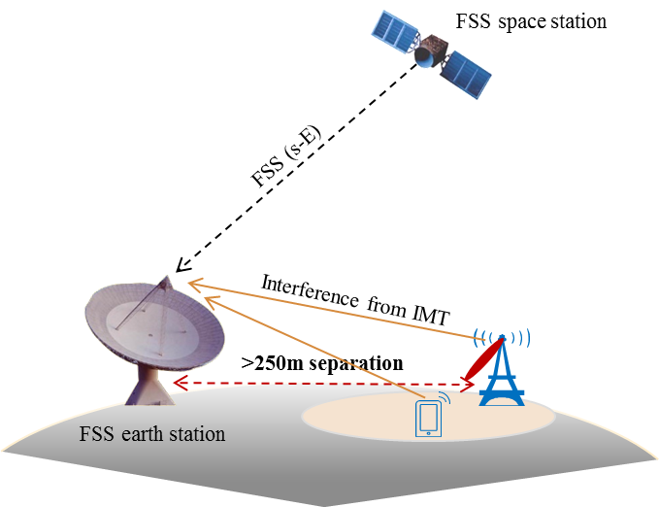

With the separation distance of 250 m around the FSS earth station, the aggregate interference level does not exceed the FSS long term interference threshold.

* 1. **Frequency range 81 - 86GHz**
     1. **EESS (passive)**

Three studies were received in relation to the compatibility between IMT-2020 in the 81-86 GHz band and the EESS (passive) in the band 86-92 GHz, leading to a range of unwanted emission levels that would be necessary to protect the EESS (passive). The results below are based on the most restrictive Sensor L3.

Studies A and C considered the IMT single element antenna pattern of Rec. ITU-R M.2101. It is shown that the levels of interference exceedance for Sensor L3 are:

* Study A: 23.6 dB (assuming normalization of antenna pattern, apportionment of EESS protection criteria, and multi-operator interference factors), corresponding to levels of unwanted emissions for UE and BS of ‑43.5/‑43.6 dB(W/100 MHz), respectively.
* Study C: 11.3 dB, corresponding to levels of unwanted emissions for UE and BS of ‑31.2/-31.3 dB(W/100 MHz), respectively.

In addition, Studies A performed a sensitivity analysis considering a population-based redistribution of the IMT-2020 base stations (capped to a maximum of 10 BS/km²) and show that the levels of interference exceedance for Sensor L3 is (assuming normalization of antenna pattern, apportionment of EESS protection criteria, and multi-operator interference factors):

* Study A: 29.9 dB, corresponding to levels of unwanted emissions for UE and BS of ‑49.8/‑49.9 dB(W/100 MHz), respectively.

Study C performed a sensitivity analysis using a beamforming antenna model in the unwanted emission domain (not considering normalization of antenna pattern, apportionment of EESS protection criteria nor multi-operator interference factors). In the absence of IMT-2020 antenna measurement data it was agreed in TG 5/1 that:

* The antenna pattern may remain beamformed to some extent in the adjacent frequency band.
* The Recommendation ITU-R M.2101 model applicable to beamforming gain may in that case underestimate the sidelobe levels (e.g., some simulations have shown that, for an 8 × 8 array simplified AAS antenna design model with one slant dipole elements, the Recommendation ITU-R M.2101 model appears to be a reasonable match for the sidelobes closest to the main beam, but sidelobes further from the main beam would be underestimated by this model).
* The “variance” of the interference distribution is much wider compared to the use of a single element pattern and hence conclusion on average interference would not be appropriate.

It is shown in Study C that the levels of interference exceedance for Sensor L3 are -1.3 dB (i.e. no restriction for IMT systems), corresponding to levels of unwanted emissions for UE and BS of -19.9/-20 dB(W/100 MHz), respectively.

* + 1. **FS**

Statistical studies for a single entry IMT BS case, for different antenna heights of FS receiver where the IMT BS is within the beam of the FS receiver, show that a separation distance of 970 to 260 m for antenna heights of 10 to 40 m respectively, will ensure that the protection criteria for the FS receiver are met. Alternatively, a separation distance of 250 meter with an azimuth offset of antenna boresights between IMT BS and FS receiver will also ensure that the protection criterion is met.

Statistical studies for the aggregated case show that for different antenna heights of FS receiver (from 10 to 40 meter), a separation distance of 720 m from a FS receiver at 10 m will ensure that the protection criteria are met, in general, without separation distances for the aggregate case.

In summary, despite a strong interference potential when an IMT BS is located precisely in the FS receiver antenna boresight direction, the potential interference to FS receiver is limited and sharing would be feasible.

The main coexistence problem in practice is likely to be with fixed links. The E-band plans for fixed links uses 71-76 GHz paired with 81-86 GHz. Links in the E-band are likely to be operated in the same urban and busy areas as IMT. As MBB data rates increase, the band will play a key role in providing backhaul for 4G and 5G. Therefore, the fixed service should be maintained and protected in this band.

Sharing the band between FS links and IMT access is feasible due to the excellent spatial isolation which can be achieved in this band.

The TG5/1 results show that for antenna heights of the FS system higher than 10 m, the interference from the IMT system into the FS station would be below the threshold (Study C in the Attachment 1 to Annex 12 to Task Group 5/1 Chairman’s Report). For an FS antenna height of 10m, a separation of 720 metres would be required (see figure below, copy of FIGURE C-2 in the Chairman´s report).

I/N curves at the FS receiver from the IMT network,

FS antenna at 10 m, 25 m and 40 m, respectively



In the light of this, there would be two alternative approaches to protect FS, one for scenarios where the FS antenna is above 10 metres and one for scenarios with FS antenna below 10 metres:

Scenario 1: Spatial vertical isolation >10 m



Scenario 2: Separation between FS antenna and center of IMT coverage area

(when smaller spatial vertical isolation, 10m for FS, 6m for IMT)



* + 1. **RAS (in-band)**

Two sharing studies between RAS and IMT in the frequency band 81-86 GHz were provided to ITU-R.

Statistical results show that if the combined aggregate interference of both base stations and user equipment is considered, separation distances are 20.5 km for a sub-urban only environment and range from 35 to 49 km for mixed urban/sub-urban environments. This range is mainly due to the differences in assumed polarization loss (3 or 0 dB) and clutter loss probability (average or 2%).

It should be noted that no detailed terrain profiles were used in these studies. Taking into account detailed terrain profiles around RAS stations would lead to different separation distances for RAS stations on a case-by-case basis.

* + 1. **A separation distance between IMT-2020 stations and RAS is required (in-band: <50km).****RAS (adjacent-band)**

Two compatibility studies between the RAS in the frequency range 76-94 GHz and IMT in the frequency band 81-86 GHz were provided to ITU-R.

For both studies a -13 dB(m/MHz) level of unwanted emissions is assumed for both IMT-2020 base stations and user equipment. Statistical results show that if the combined aggregated interference of both base stations and user equipment is considered, separation distances are 1.5 km for a sub-urban only environment and range from 6 to 29 km for mixed urban/sub-urban environments. This range is mainly due to differences in assumed polarization loss (3 or 0 dB) and antenna gain normalization.

It should be noted that no detailed terrain profiles were used in these studies. Taking into account detailed terrain profiles around RAS stations would lead to different separation distances for RAS stations on a case-by-case basis.

A separation distance between IMT-2020 stations and RAS is required (adjacent-band: <30km).

* + 1. **RLS (automative rader)**

Two studies were received which deal with the compatibility between IMT-2020 in the frequency bands 71-76 GHz and 81-86 GHz and automotive radar in the frequency band 77-81 GHz (i.e. Radar D of Category 2 from Recommendation ITU-R M.2057). Study A gives a range of IMT unwanted emission levels that are assumed to provide appropriate protection of the automotive radars while Study B uses various IMT-2020 unwanted emission levels to assess the probability of interference.

The IMT stations’ spurious emission level assumed in both studies is a constant value over the operating band of automotive radars.

Study A assumed a 99% applicability of the protection criterion of I/N = -6 dB and did not apply antenna normalisation.

Study A has shown that to protect automotive radars operating in the 77-81 GHz frequeny band, IMT-2020 stations need to comply with the maximum unwanted emission levels in the frequency band 77-81 GHz:

* For BS: - 26.5 dBm/MHz (equivalent to -33 dBW/200 MHz);
* For UE: -28 dBm/MHz (equivalent to -35 dBW/200 MHz).

The maximum additional isolation required for the IMT-2020 unwanted emissions in the frequency band 77-81 GHz for all studied cases are 13.5 dB for the BS and 15 dB for the UE.

Study B found it was not possible to define the value of the IMT-2020 unwanted emission limits appropriately taking into account information provided by the involved groups. Study B reflects that there is no model available for the roll-off of the IMT-2020 unwanted emissions in this out of band domain, no measurement of the IMT-2020 antenna pattern in adjacent bands and also concluded that there was no information about the foreseen deployment of IMT-2020 UEs with respect to vehicles for these bands. Notwithstanding that, the study concluded that an unwanted emission limit more stringent than ‑30 dBm/MHz (equivalent to more than 17 dB additional isolation) for both BS and UE is necessary to protect automotive radars in the radiolocation service in the band 77-81 GHz.

It is proposed to introduce in the RR unwanted emission limits into 76-81GHz from IMT-2020 stations (BS and UE) operating on the frequency band 71-76GHz. (see Table 7)

**Table 7:Limits of unwanted emission power into 76-81 GHz from IMT stations**

| **Station** | **76-77 GHz**  **dB(W/200 MHz)** | **77-81 GHz**  **dB(W/200 MHz)** |
| --- | --- | --- |
| IMT base station | [-31.5/TBD] | [-33/TBD] |
| IMT terminal station | [-20/TBD] | [-35/TBD] |

* + 1. **FSS (E-s)**

Aggregate interference simulations from IMT BSs towards FSS space station has been performed in the 81-86 GHz frequency band. The results show that the FSS long-term interference threshold is not exceeded by IMT-2020 BS deployments. Also, aggregate interference simulations from FSS earth stations towards an IMT BS has been performed in the 81-86 GHz frequency band. The results show that with the separation distance of 250 m around the IMT BS, the aggregate interference level does not exceed the IMT BS interference threshold, based on the assumptions and input parameters used in this study.

Co-existence between IMT‑2020 and FSS in the 81-86 GHz band is feasible

1. **Summary**

This report summarizes sharing and compatibility studies conducted by TG5/1 focusing on concerned services in selected frequency ranges in APT region, as well as potential impacts brought by those technical conditions to the implementation of IMT in these bands, which would assist APT Members’ internal preparation and/or regional and global discussion.

**Annex 1: TRP vs. EIRP**

AAS is a beamforming antenna based on an antenna array and consists of a number of identical radiating elements located in the yz-plane with a fixed separation distance (λ/ 2)

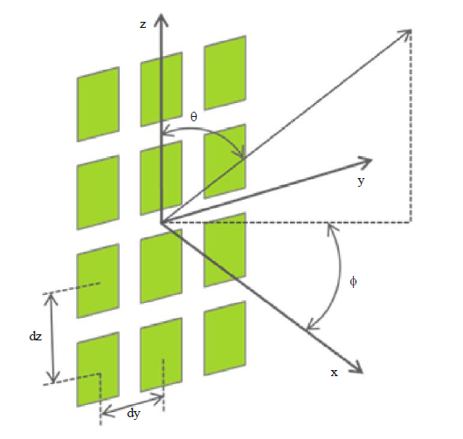

TRP is the total sum power level radiated to all angle.

$Total Radiated Power=\frac{1}{4π}\int_{0}^{2π}{\int_{0}^{π}{P_{E}\left(θ,φ\right)\sin\left(θ\right)dθdφ}}$ and

Where

$θ$: Elevation angle from 0 to 180 degree

$φ$: Azimuth angel from -180 to 180 degree

$P_{E}\left(θ,φ\right)$: power level with given elevation angle($θ$) and azimuth angle ($φ)$

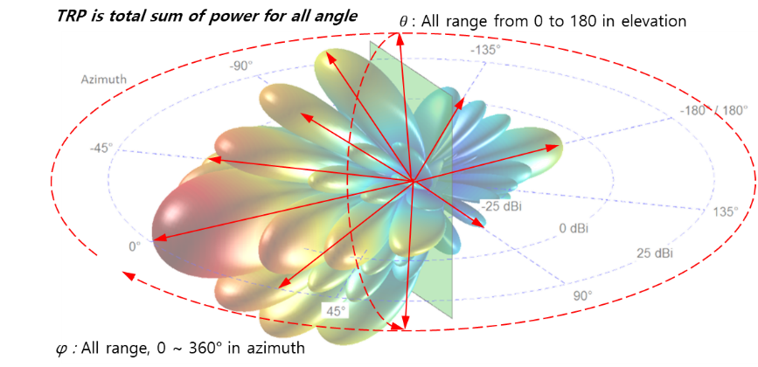

EIRP (Equivalent Isolated Radiated Power) is a power level in main beam direction.

*EIPR = $P_{E}\left(90, 0\right)$*

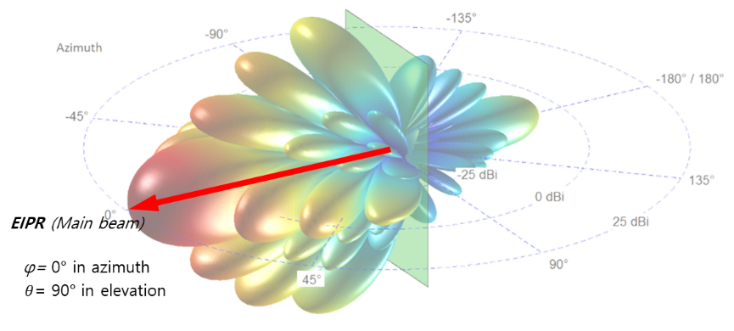

**Annex 2: epfd limit in CPM text**

The equivalent power flux-density is defined as the sum of the power flux‑densities produced at a geostationary-satellite system receive station in the geostationary orbit by all the transmit IMT base stations within its territory, taking into account the off-axis discrimination of a reference receiving antenna assumed to be pointing in its nominal direction. The equivalent power flux-density is calculated using the following formula:

$$epfd={10log}_{10}\left[\sum_{i=1}^{N_{a}}{{10}^{\frac{P_{i}-A_{bs,i}-A_{g,i}-L_{clutter,i}-PD}{10}}}∙\frac{G_{t}\left(θ_{i}\right)}{{4πd}_{i}^{2}}∙\frac{G_{r}\left(φ_{i}\right)}{G_{r,max}}\right]$$

where:

*Na*: number of simultaneously transmit IMT base stations within its territory, taking into account network loading factor (0.2) and a reference receiving antenna beam pattern assumed to be pointing in its nominal direction (i.e. number of all concerned IMT base stations × Networking loading factor (0.2))

*i*:index of the transmit IMT base station

*Pi*: RF power averaged by TDD activity factor (0.8), at the input of the antenna of the transmit IMT base station (dBW) in the reference bandwidth (i.e. maximum RF power – 0.97 (=10log (0.8)) (dBW))

*Abs, i:* the attenuation due to beam spreading (dB) over the interference path from the simulated IMT deployment location (n) to the satellite detailed in Recommendation ITU-R P.619

*Ag, i:* the attenuation due to atmospheric gasses (dB) over the interference path from the simulated IMT deployment location (n) to the satellite detailed in Recommendation ITU-R P.619

*Lclutter, i:* the average clutter loss in the interference path for location (n) (dB), calculated using the entire cumulative distribution of clutter losses as detailed in Recommendation ITU-R P.2108

*PD:* the polarization discrimination (dB)

θ*i*: off-axis angle between the boresight of the transmit IMT base station and the direction of the geostationary-satellite system receive station

*Gt*(θ*i*):transmit antenna gain (as a ratio) of the IMT base station in the direction of the geostationary-satellite system receive station

*di*: distance (m) between the transmit IMT base station and the geostationary-satellite system receive station

φ*i*: off-axis angle between the boresight of the antenna of the geostationary-satellite system receive station and the direction of the *i*-th IMT base transmit station

*Gr*(φ*i*):receive antenna gain (as a ratio) of the geostationary-satellite system receive station in the direction of the *i*-th transmit IMT base ile station

*Gr,max*: maximum gain (as a ratio) of the antenna of the geostationary-satellite system receive station

*epfd*:computed equivalent power flux-density (dB(W/m2)) in the reference bandwidth.

** For this Table, reference patterns of Recommendation ITU‑R S.672‑4 shall be used only for the calculation of interference from IMT base stations in the mobile service into geostationary-satellite systems in the fixed-satellite service. In all cases of *Ls*, the parabolic main beam equation shall start at zero.

**Annex 3: RAN4 overview on unwanted emission level**

In its Reply Liaison statement to Working Party 5D (Doc5D/784), RAN4 has further studied the requests and the following is an overview of the present status of the work:

* 13 dBm/MHz is the achievable baseline requirement for mm wave spurious emissions for both UE and BS. The emission limit is expressed as Total Radiated Power (TRP).
* An additional requirement to protect specific sensitive services (e.g. passive services) is under discussion in RAN4 and several observations were already given in the previous LS from 3GPP (R4-1710084). In addition to those preliminary observations made, the following can be said:

• For BS, further considerations have been made of PA power efficiency, transmitter linearization and filtering in relation to achieving a stricter spurious emission requirement in specific bands. Taking into account the higher output power that needs to be achieved from a BS in comparison with terminals, frequency separation between the considered passive system (23.6-24 GHz) and 24.25-27.5 GHz NR band, and the fundamental technology limits for reaching the suppression needed, RAN4 is considering the possibility of an additional requirement for protecting the considered frequency range. 3GPP RAN4 is for this purpose considering emission levels in the range ‑27 to ‑32 dBW/200MHz.

• 3GPP RAN4 has studied impacts on NR system performance and coverage for achieving a BS emission level lower than the baseline level in specific bands. While an optimization can be made between the selected implementation, complexity and system performance feasible for mm-wave bands, tighter limits may require power back-off and/or additional guard bands, leading to loss in coverage, capacity and spectrum utilization. It is shown in [1] based on two different filter implementations that a filter giving 20 dB additional suppression (achieving approximately ‑37 dBW/200 MHz) would give 3-4 dB insertion loss (DL Tx power reduction and UL loss of Rx sensitivity) and would also require a 1-1.5 GHz transition region (guard band). Furthermore, it has been shown what is the impact on the performance (cell edge user DL throughput) of NR system for achieving an emission level in the range of ‑27 to ‑37 dBW/200MHz to protect EESS (passive) services operating in 23.6-24 GHz [2]. As can be observed in Figure 1, the DL Tx power reduction of 7 dB would lead to cell edge user DL throughput loss of 36% in reference to baseline power parameters. In case of DL Tx power is even larger, a cell edge user DL throughput loss of up to 80% would be expected.

Figure 1 Cell edge user throughput loss in reference to DL Tx power reduction

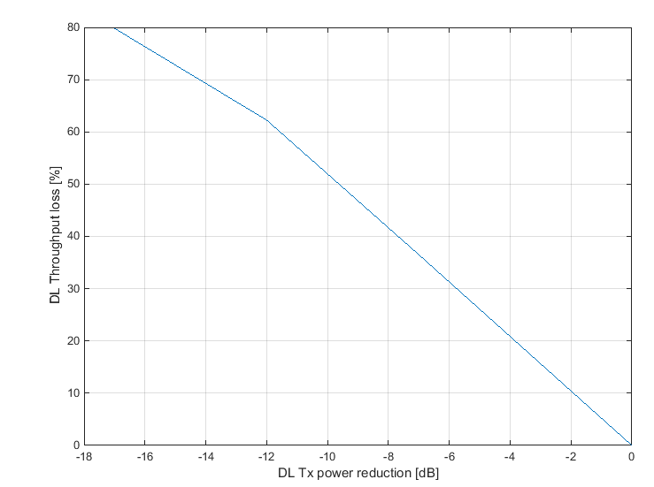

For user terminals, RAN4 observed the emissions are possibly not flat within 200 MHz measurement bandwidth and thus a different more stringent emission level in the protected band with larger measurement BW (e.g. 200 MHz) is feasible. RAN4 is currently considering the possibility to specify a requirement to be applied for protection of specific frequency ranges in which passive services operate. Depending on the frequency separation to the protected bands, achieving the more stringent level might require mechanisms such as power back off and/or resource scheduling restrictions. RAN4 studied the amount of power reduction needed to achieve an emission level of -37 dBW/200 MHz. Based on the preliminary analysis carried out in [3], up to 4 dB power reduction is needed to meet the target emission level. The required power reduction has direct impact on achievable UL throughput and coverage. In the scenario analyzed in [3], up to 20% median throughput degradation and 50% cell edge throughput degradation were observed. The cell edge throughput loss is directly related to the UL coverage degradation. In particular, it was observed that the coverage loss due to the 4 dB power reduction is severe in outdoor scenarios, thus directly affecting mmW NR deployments.

__________