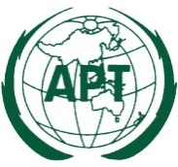 | ASIA-PACIFIC TELECOMMUNITY | Document No:
 | 32nd APT Standardization Program Forum  (ASTAP-32) | ASTAP-32/INP-xx
 | 10-11 November 2020, Virtual Meeting | xx September 2020

Resource

title

