 | ASIA-PACIFIC TELECOMMUNITY | Document No:
 | The 2nd Meeting of the APT Conference Preparatory Group for WRC-23 (APG23-2) | APG23-2/INF-14
 | 19 – 23 April 2021, Virtual/Online Meeting | 23 March 2021

Chairman, DG on AI 1.7

brief on wrc-23 agenda item 1.7

(Note: This brief was developed for information purpose only. It does not necessarily express the view of APG-23)

Agenda Item 1.7:
To consider a new aeronautical mobile-satellite (R) service (AMS(R)S) allocation in accordance with Resolution 428 (WRC-19) for both the Earth-to-space and space-to-Earth directions of aeronautical VHF communications in all or part of the frequency band 117.975-137 MHz, while preventing any undue constraints on existing VHF systems operating in the AM(R)S, the ARNS, and in adjacent frequency bands;

Relevant Resolutions and Responsible/Contributing ITU-R Groups
Resolution 428 (WRC-19)  Studies on a possible new allocation to  the aeronautical mobile satellite (R)  service within the frequency band  117.975-137 MHz in order to support  aeronautical VHF communications in  the Earth-to-space and space-to-Earth  directions | resolves to invite ITU-R  1 to define the relevant technical characteristics and to study, taking into account considering c) and taking into account No. 5.200, compatibility between potential new AMS(R)S systems that operate within the frequency band 117.975-137 MHz in the Earth-to-space and space-to-Earth directions and existing primary services in band and in adjacent frequency bands, while ensuring protection of systems using existing primary services in those frequency bands and not constraining planned usage of those systems;  2 to take into account the results of the studies, to provide technical and regulatory recommendations relative to a possible new allocation to AMS(R)S within the frequency band 117.975-137 MHz, taking into consideration the responsibility of ICAO in noting b),  invites the 2023 World Radiocommunication Conference  to consider the results of the studies and take appropriate actions, including possible primary allocation to AMS(R)S within the frequency band 117.975-137 MHz,  invites Member States and Sector Members  to participate actively in the studies and to submit characteristics of any current and planned systems to be studied, as appropriate,  invites the International Civil Aviation Organization  to participate in the studies by providing aeronautical operational requirements and relevant available technical characteristics to be taken into account in ITU-R studies and to take into account the sharing and compatibility conclusions at ITU-R in the SARPs to be developed for AMS(R)S,  invites the Secretary-General  to bring this Resolution to the attention of ICAO.

Responsible group | Contributing group
WP 5B  Note: See relevant text in CPM23-1 meeting report (Annex 4 to CA/251 Administrative Circular) on how to facilitate the work related to satellite. | WP 3M, WP 4C, WP 7B

1. Background Information

At WRC-19, contributions from 3 regional groups namely CITEL (IAP/11A24A13), CEPT (EUR/16A24) and APT (ACP/24A24A6) initiated the WRC-23 agenda item 1.7.

Recap of Resolution 428 (WRC-19)

considering
- that the optimization of air traffic management (ATM) over oceanic and remote areas necessitates appropriate aeronautical surveillance and communication means, in order to meet the required communication performance for reduced separation minima, without modification to aircraft equipment;
- that the availability of appropriate communication means is still an issue over oceanic and remote areas, where there is currently no suitable solution to provide aeronautical VHF services;
- that, to meet the evolving requirements of modern civil aviation, satellite systems may be used for the relay of VHF communications compliant with International Civil Aviation Organization (ICAO) standards, operating under the aeronautical mobile (R) service (AM(R)S), in order to complement terrestrial communication infrastructures when aircraft are operating in oceanic and remote areas;
- that the VHF channels have become congested in some areas and the new aeronautical mobile-satellite (R) service (AMS(R)S) system would need to operate in such a manner as not to constrain existing systems;
- that the frequency band 1 087.7-1 092.3 MHz was allocated to the AMS(R)S (Earth-to-space) on a primary basis in order to extend reception of Automatic Dependent Surveillance Broadcast (ADS-B) signals beyond terrestrial line-of-sight, thereby facilitating the availability of surveillance means anywhere in the world;
- that aeronautical VHF communications, when available in geographically remote and oceanic areas, may be used in combination with satellite ADS-B to support radar-like separation of aircraft, thus greatly improving airspace capacity, efficiency and safety,

recognizing
- that the frequency band 108-117.975 MHz is allocated on a primary basis to the aeronautical radionavigation service (ARNS), and to the AM(R)S in accordance with Resolution (Rev.WRC-12);
- that the frequency band 117.975-137 MHz is allocated on a primary basis to the AM(R)S and is used by air-ground, air-air and ground-air systems operated in accordance with ICAO Standards and Recommended Practices (SARPs), providing critical voice and data communications for ATM on a global basis;
- that under Nos. 5.201 and 5.202, the frequency bands 132-136 MHz and 136-137 MHz are also allocated in several countries to the aeronautical mobile (OR) service on a primary basis;
- that the AM(R)S VHF frequency band (117.975-137 MHz) is currently used by air traffic communication and airline operational communication;
- that the frequency band 117.975-137 MHz is only used by systems that operate in accordance with recognized international aeronautical standards,

noting
- that Annex 10 to the Convention on International Civil Aviation contains SARPs for safety aeronautical radionavigation and radiocommunication systems used by international civil aviation;
- that the development of compatibility criteria between new AMS(R)S systems proposed for operations in the frequency band 117.975-137 MHz and ICAO-standardized aeronautical systems in this frequency band is the responsibility of ICAO;
- that there are SARPs developed by ICAO detailing frequency assignment planning criteria for VHF air-ground communication systems;
- that feeder links of AMS(R)S systems may be accommodated in the fixed-satellite service,

Overview of the operational concept for Space-based aeronautical VHF
Figure 1 is an illustration of the space-based VHF communication concept.
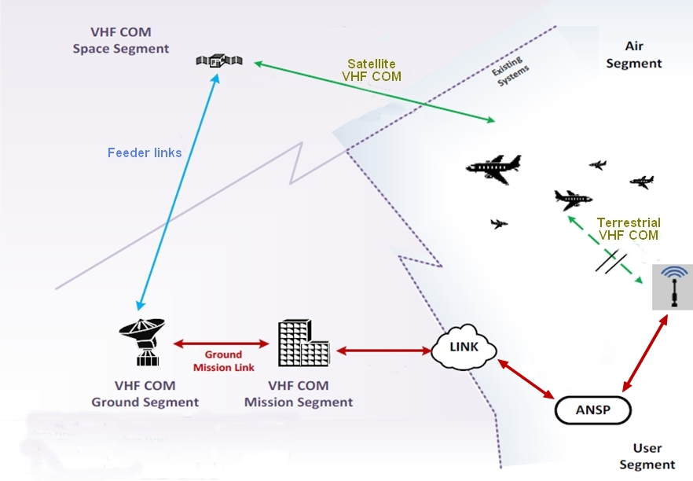
Figure 1: The space-based VHF communication concept

The space segment is able to receive and transmit to standard VHF radios already installed on aircraft, and is designed to behave as if it were just another VHF-tower located in the sky. This allows an extended VHF coverage into the oceanic and remote areas which are currently not covered by VHF terrestrial towers.

2. Information on on-going ITU-R Study

At CPM23-1, the Conference had designated ITU Working Party 5B (WP 5B) as the group responsible for WRC-23 agenda item 1.7.

24th WP 5B Meeting (July 2020)
WP 5B meeting debated how the WP should be structured in light of the invitation from CPM to establish a new WG chaired by a satellite expert to address WRC-23 agenda items 1.6, 1.7 and 1.8 and the practicality of finding appropriate chairs. It was agreed that issues related to WRC-23 agenda items 1.6 and 1.7 would be handled in the aeronautical WG and that those related to WRC-23 agenda item 1.8 would be addressed through an ad-hoc of plenary group.
The following structure to be used with the desire to find satellite experts to chair work with respect to WRC-23 agenda items 1.6 and 1.7.
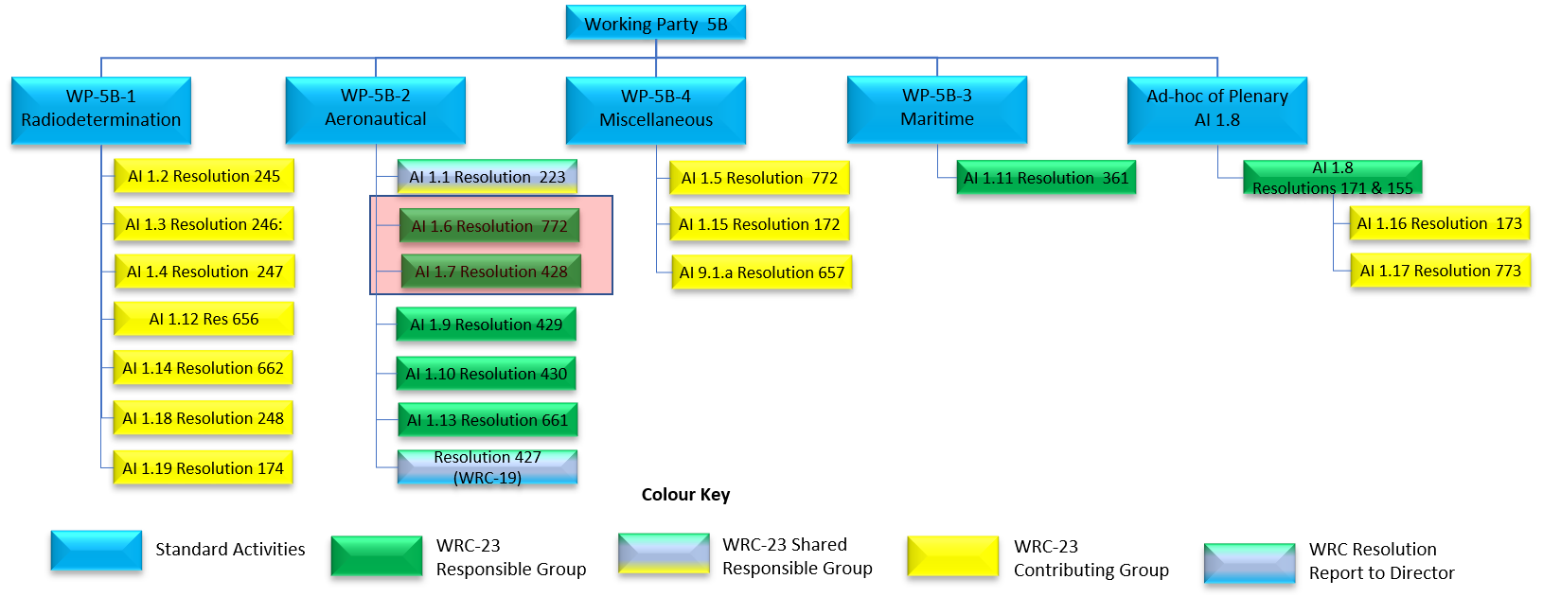

Input documents: 5B/43, 5B/72, 5B/78
Output document: 4C/36

Documents 5B/43 & 5B/78 proposed a framework for a new ITU-R Report with an introductory part and some information on the progress of the activities in Singapore on this topic. However, due to time limitation in this virtual meeting that did not permit consideration in detail on the framework for a new ITU-R Report it was agreed these documents would be carried forward to the next WP 5B meeting and ask Administrations to base their contribution on this topic on this document.
The draft liaison statement to the contributing groups proposed in Document 5B/72 was considered, reviewed and agreed after some adjustments.

25th WP 5B Meeting (November 2020)
Input documents: 5B/43, 5B/78, 5B/112, 5B/118, 5B/125, 5B/146, 5B/152, 5B/186, 5B/187, 5B/190, 5B/191, 5B/214
Output document: 3L/34
Annex 3 (Draft CPM text) to Report 5B/225-E
Annex 26 (WD PDN Report ITU-R M.[SPACE-VHF]) to Report 5B/225-E
Annex 40 (Liaison to ICAO) to Report 5B/225-E

5B/152 proposed to complete the new ITU-R Report with elements extracted from the RR in the concerned frequency band. 5B/190 contained preliminary technical characteristics and initial budget links between Earth station aboard the aircraft and the space station. Some of these technical assumptions are expected to be adjusted by the relevant expert groups. Consequently, based on 5B/186, a liaison statement was agreed to be sent questions to ICAO on antenna pattern for aircraft VHF antenna, Aircraft VHF receiver performance requirement and required availability performance, and based on 5B/187, a reply liaison statement asks to WP 3L further details on ionospheric losses.
Additionally, a WD towards a PDN Report ITU-R M.[SPACE-VHF] was generated by merging the received contributions on this issue, and a draft CPM text was initiated.

Liaison Statements (LS)
LS to WP 4C, 7B, 3M and 3L (August 2020) – Document 4C/36
- To support the required sharing and compatibility studies to be carried out within WP 5B, the contributing Working Parties responsible for potentially affected services, as identified by CPM23-1, are requested to provide the relevant information, including technical and operational characteristics and protection criteria for the respective services allocated in, or adjacent to, the frequency band 117.975-137 MHz.
- Working Parties 3M and 3L are invited to provide information on the relevant propagation models that could be used for the studies. In particular, as ionospheric effects may be important at the frequency band 117.975-137 MHz, information is needed regarding their prediction and quantification in relation to a given link availability for all ranges of latitude and elevation. Any information on the use and applicability of Recommendation ITU-R P.531 to that effect would be much appreciated.
- WP 5B has also invited the membership to provide characteristics and protection criteria for radiocommunication systems operating and intended to operate in the future in the frequency band subject to WRC-23 agenda item 1.7. These characteristics are intended to be used in sharing and compatibility studies and could also be used for updating existing or developing new Recommendations/Reports, as appropriate.
LS from WP 3L (August 2020) – Document 5B/112
- WP 3L would like to bring to the attention of WP 5B that ionospheric propagation is affected by many physical conditions other than location. In accessing the range of ionospheric behaviour for this new system it may also be necessary to examine ionospheric conditions as a function of time of year, time of day, solar cycle, and geomagnetic conditions.
- Recommendation ITU-R P.531-14 is indeed applicable for the frequency band in question and appropriate for trans-ionospheric propagation predictions.
- For planning purposes Recommendation ITU-R P.531-14 recommends NeQuick2 to estimate the TEC and the use of equation 6 to predict the potential phase rotation through the ionosphere.
- It is recommended that Global Ionospheric Scintillation Model (GISM) be used to predict the effects of scintillation on a given link geometry.
LS from WP 7B (September 2020) – Document 5B/125
- WP 7B would like to note that frequency band 137-138 MHz is allocated to the space operation service (SOS), space research service (SRS) and meteorological satellite service (MetSat) on a primary basis in the space-to-Earth direction, for which compatibility studies should be performed under WRC-23 agenda item 1.7.
- WP 7B has invited the membership to provide characteristics and protection criteria for SOS, SRS and MetSat systems operating and intended to operate in the future in the frequency band 137-138 MHz and plans to provide a detailed response to the requested information at the next meeting of WP 7B, which is currently scheduled for 15-23 April 2021.
LS from WP 4C (November 2020) – Document 5B/214
- WP 4C would like to note that the frequency bands 137-137.025 MHz and 137.175-137.825 MHz are allocated to the mobile-satellite service (MSS) on a primary basis in the space-to-Earth direction, for which compatibility studies should be performed under WRC-23 agenda item 1.7. It is also worthwhile to mention that the above mobile-satellite service must comply with the EPFD limits provided in Resolution 739 (Rev.WRC-15) in order to protect the radio astronomy service in certain adjacent and nearby frequency bands.
- WP 4C would like to bring to the attention of WP 5B that some characteristics or protection criteria of the above mobile-satellite service can be found in the following recommendations.
M.1230 Performance objectives for space-to-Earth links operating in the mobile-satellite service with non-geostationary satellites in the 137-138 MHz band
M.1231 Interference criteria for space-to-Earth links operating in the mobile-satellite service with non-geostationary satellites in the 137-138 MHz band
M.1232 Sharing criteria for space-to-Earth links operating in the mobile-satellite service with non-geostationary satellites in the 137-138 MHz band.

Other relevant recommendations that could be considered for future sharing studies include:
M.1039 Co-frequency sharing between stations in the mobile service below 1 GHz and mobile earth stations of non-geostationary mobile-satellite systems (Earth-space) using frequency division multiple access (FDMA)
M.1389 Methods for achieving coordinated use of spectrum by multiple non-geostationary mobile-satellite service systems below 1 GHz and sharing with other services in existing mobile-satellite service allocations
M.1583 Interference calculations between non-geostationary mobile-satellite service or radionavigation-satellite service systems and radio astronomy telescope sites.

LS to WP 3L (November 2020) – Document 3L/34
- WP 5B would be grateful to be kept informed on any future version of GISM that could provide results anytime (day/month/year) and anywhere (including at elevation angles below 10 degrees) for the VHF band and to be kept informed of any evolution of Recommendation ITU-R P.531 that may be relevant to its work.
- WP 5B is considering the following levels of ionospheric losses to be used in the studies and asks WP 3L to provide any comment it may have on these considerations:
- A low level of 3 dB attenuation losses corresponding to medium latitude regions.
- A medium level of 5 dB attenuation losses for high latitude regions.
- A high level of 10 dB attenuation losses for low latitude regions.

LS to ICAO (November 2020) – Annex 40 to Report 5B/225
- Working Party 5B would like to know if measured (i.e. taking account of aircraft body) receiving and transmitting VHF antenna radiation patterns can be provided by ICAO, both for upper and lower aircraft VHF antennas. Ideally, several typical patterns would be desirable, for the different classes of aircraft that fly over oceanic and remote areas (from small transoceanic business jets to large aircraft).
- Working Party 5B would like to get confirmation from ICAO on which aircraft VHF receiver sensitivity is the most relevant to be used for the studies
- 30 microvolts per metre (ICAO Annex 10, extended range VHF facilities), or
- -93 dBm to achieve a SINAD of 6 dB (EUROCAE and RTCA)

- Working Party 5B would like to know from ICAO if a reference availability target can be identified for aeronautical VHF voice communications, and if such a reference could depend upon time and location.

Meeting Schedule
26th WP 5B scheduled to be a virtual meeting, 10-21 May 2021
27th WP 5B [November 2021]
28th WP 5B [May 2022]
29th WP 5B [November 2022]
30th WP 5B [May 2023]

3. Position of the Regional Group

- ATU

- ASMG (July 2020)
Follow and support the studies while ensuring the inclusion of appropriate conditions to protect existing services without imposing undue restrictions on them.

- CEPT (December 2020)
To be developed

- CITEL (December 2020)
To be developed

- RCC (December 2020)
The RCC Administrations do not oppose the new allocation of all or part of the frequency band 117.975-137 MHz to aeronautical mobile-satellite (R) service on the primary basis to develop aeronautical VHF communications systems for both Earth-to-space and space-to-Earth directions provided that unacceptable constraints shall not be imposed on existing VHF systems operating in AM(R)S, ARNS and systems operating in adjacent frequency bands.

4. Position of International Organizations

- ICAO (November 2020)
Draft Position:
- To support ITU-R studies and the definition of relevant technical characteristics as called for by Resolution 428 (WRC-19).
- To support a global allocation to the aeronautical mobile satellite (route) service for both the Earth-to-space and space-to-Earth directions in the frequency band 117.975-137 MHz and that the use of the allocation be limited to the relaying of aeronautical VHF air traffic management communications.
- To support that those systems shall operate in accordance with international Standards and Recommended Practices and procedures established in accordance with the Convention on International Civil Aviation.
- To ensure that any change to the regulatory provisions and spectrum allocation resulting from this agenda item do not adversely impact the operation of existing VHF systems in the band 117.975-137 MHz operating in the AM(R)S, including regional usage of terrestrial VHF, nor require any changes to aircraft equipage or to existing installations.

