 | ASIA-PACIFIC TELECOMMUNITY | Document No:
 | The 2nd Meeting of the APT Conference Preparatory Group for WRC-23 (APG23-2) | APG23-2/INF-24
 | 19 – 23 April 2021, Virtual/Online Meeting | 06 April 2021

Chairman, DG on AI 9.1.b

brief on wrc-23 agenda item 9.1.b

(Note: This brief was developed for information purpose only. It does not necessarily express the view of APG-23)

Agenda Item 9.1.B:
R​eview of the amateur service and the amateur-satellite service allocations in the frequency band 1 240 1 300 MHz to determine if additional measures are required to ensure protection of the radionavigation-satellite (space-to-Earth) service operating in the same band in accordance with Resolution 774 (WRC-19)

Relevant Resolutions and Responsible/Contributing ITU-R Groups
Resolution 774 (WRC-19)  Studies on technical and operational measures to be applied in the frequency band 1 240-1 300 MHz to ensure the protection of the radionavigation-satellite service (space-to-Earth) | resolves to invite ITU-R  1 to perform the detailed review of the different systems and applications used in the amateur service and amateur-satellite service allocations within the frequency band 1 240-1 300 MHz;  2 taking into account the results of the above review, to study possible technical and operational measures to ensure the protection of RNSS (space-to-Earth) receivers from the amateur and amateur-satellite services within the frequency band 1 240-1 300 MHz, without considering the removal of these amateur and amateur-satellite services allocations,  instructs the Director of the Radiocommunication Bureau  to include the results of these studies in his Report to WRC-23 for the purpose of considering appropriate actions in response to resolves to invite ITU-R above.

Responsible group | Contributing group
WP 5A | WP 3M, WP 4C (responsible for developing studies on resolves to invite ITU R 2 and sending this to WP 5A)

1. Background Information
- Which regional organization initiated this Agenda Item: This agenda item was proposed by CEPT.

- Other relevant information for understanding of the Agenda Item

- Introduction (Source: Working document towards A preliminary draft new Report ITU-R M.[AMATEUR.CHARACTERISTICS])
The frequency band 1 240-1 300 MHz is allocated worldwide to the amateur service on a secondary basis and has been used for a range of applications. The amateur-satellite service (Earth-to-space) may operate in the frequency band 1 260-1 270 MHz under No. 5.282 of the Radio Regulations.
The frequency band 1 240-1 300 MHz is also allocated worldwide to the radionavigation-satellite service (RNSS) in the space-to-Earth direction on a primary basis. Many RNSS systems are operational and various types of RNSS receivers are being in use. Report ITU-R M.2458 summarizes the RNSS applications in this frequency band.

Some cases of harmful interference caused by emissions from the stations in the amateur service into RNSS (space-to-Earth) receivers have been observed. Furthermore, number of similar interference cases may be increased, unless proper guidelines to protect RNSS (space-to-Earth) from the amateur and amateur-satellite services are implemented. Thus, this potential interference issues need to be studied.

In this regard, Resolution 774 (WRC-19) invites ITU-R to study possible technical and operational measures to ensure the protection of RNSS (space-to-Earth) receivers from the amateur and amateur-satellite services in the frequency band 1 240-1 300 MHz, without considering the removal of these amateur and amateur-satellite service allocations.

- History of the allocations to the amateur and amateur-satellite services
An amateur service allocation of 1 215-1 300 MHz was made on a primary, exclusive basis at the 1947 International Radio Conference in Atlantic City. At the World Administrative Radio Conference (WARC), Geneva, 1959, the allocation was changed to radiolocation primary and amateur secondary. narrowed to 1 240-1 300 MHz. At the 1979 WARC radionavigation-satellite(space-to-Earth) was added to 1 240-1 260 MHz as a primary service and an amateur-satellite allocation (Earth-to-space) was added at 1 260-1 270 MHz. The radionavigation-satellite service was added to 1 260-1 300 MHz at the World Radiocommunication Conference, Istanbul, 2000. Also in 2000 the earth-exploration satellite service and space research service were added to 1 215-1 300 MHz as primary services but with certain constraints to protect other primary services including the radionavigation service, which is allocated by footnote in a very large number of countries (Source: IARU R1).

- Current status of the table of frequency allocations related to this agenda item in Radio Regulation.

Allocation to services
Region 1 | Region 2 | Region 3
1 240-1 300 EARTH EXPLORATION-SATELLITE (active)
RADIOLOCATION
RADIONAVIGATION-SATELLITE (space-to-Earth) (space-to-space) 5.328B 5.329 5.329A
SPACE RESEARCH (active)
Amateur
5.282 5.330 5.331 5.332 5.335 5.335A

5.282 In the bands 435-438 MHz, 1 260-1 270 MHz, 2 400-2 450 MHz, 3 400-3 410 MHz (in Regions 2 and 3 only) and 5 650-5 670 MHz, the amateur-satellite service may operate subject to not causing harmful interference to other services operating in accordance with the Table (see No. 5.43). Administrations authorizing such use shall ensure that any harmful interference caused by emissions from a station in the amateur-satellite service is immediately eliminated in accordance with the provisions of No. 25.11. The use of the bands 1 260-1 270 MHz and 5 650-5 670 MHz by the amateur-satellite service is limited to the Earth-to-space direction.

5.328B The use of the bands 1 164-1 300 MHz, 1 559-1 610 MHz and 5 010-5 030 MHz by systems and networks in the radionavigation-satellite service for which complete coordination or notification information, as appropriate, is received by the Radiocommunication Bureau after 1 January 2005 is subject to the application of the provisions of Nos. 9.12, 9.12A and 9.13. Resolution 610 (WRC-03)* shall also apply; however, in the case of radionavigation-satellite service (space-to-space) networks and systems, Resolution 610 (WRC-03)* shall only apply to transmitting space stations. In accordance with No. 5.329A, for systems and networks in the radionavigation-satellite service (space-to-space) in the bands 1 215-1 300 MHz and 1 559-1 610 MHz, the provisions of Nos. 9.7, 9.12, 9.12A and 9.13 shall only apply with respect to other systems and networks in the radionavigation-satellite service (space-to-space). (WRC-07)
5.329 Use of the radionavigation-satellite service in the frequency band 1 215-1 300 MHz shall be subject to the condition that no harmful interference is caused to, and no protection is claimed from, the radionavigation service authorized under No. 5.331. Furthermore, the use of the radionavigation-satellite service in the frequency band 1 215-1 300 MHz shall be subject to the condition that no harmful interference is caused to the radiolocation service. No. 5.43 shall not apply in respect of the radiolocation service. Resolution 608 (Rev.WRC-19) shall apply. (WRC-19)
5.329A Use of systems in the radionavigation-satellite service (space-to-space) operating in the bands 1 215-1 300 MHz and 1 559-1 610 MHz is not intended to provide safety service applications, and shall not impose any additional constraints on radionavigation-satellite service (space-to-Earth) systems or on other services operating in accordance with the Table of Frequency Allocations. (WRC-07)
5.330 Additional allocation: in Angola, Saudi Arabia, Bahrain, Bangladesh, Cameroon, China, Djibouti, Egypt, the United Arab Emirates, Eritrea, Ethiopia, Guyana, India, Indonesia, Iran (Islamic Republic of), Iraq, Israel, Japan, Jordan, Kuwait, Nepal, Oman, Pakistan, the Philippines, Qatar, the Syrian Arab Republic, Somalia, Sudan, South Sudan, Chad, Togo and Yemen, the band 1 215-1 300 MHz is also allocated to the fixed and mobile services on a primary basis. (WRC-12)
5.331 Additional allocation: in Algeria, Germany, Saudi Arabia, Australia, Austria, Bahrain, Belarus, Belgium, Benin, Bosnia and Herzegovina, Brazil, Burkina Faso, Burundi, Cameroon, China, Korea (Rep. of), Croatia, Denmark, Egypt, the United Arab Emirates, Estonia, the Russian Federation, Finland, France, Ghana, Greece, Guinea, Equatorial Guinea, Hungary, India, Indonesia, Iran (Islamic Republic of), Iraq, Ireland, Israel, Jordan, Kenya, Kuwait, Lesotho, Latvia, Lebanon, Liechtenstein, Lithuania, Luxembourg, North Macedonia, Madagascar, Mali, Mauritania, Montenegro, Nigeria, Norway, Oman, Pakistan, the Kingdom of the Netherlands, Poland, Portugal, Qatar, the Syrian Arab Republic, Dem. People’s Rep. of Korea, Slovakia, the United Kingdom, Serbia, Slovenia, Somalia, Sudan, South Sudan, Sri Lanka, South Africa, Sweden, Switzerland, Thailand, Togo, Turkey, Venezuela and Viet Nam, the frequency band 1 215-1 300 MHz is also allocated to the radionavigation service on a primary basis. In Canada and the United States, the frequency band 1 240-1 300 MHz is also allocated to the radionavigation service, and use of the radionavigation service shall be limited to the aeronautical radionavigation service. (WRC-19)
5.332 In the band 1 215-1 260 MHz, active spaceborne sensors in the Earth exploration-satellite and space research services shall not cause harmful interference to, claim protection from, or otherwise impose constraints on operation or development of the radiolocation service, the radionavigation-satellite service and other services allocated on a primary basis. (WRC-2000)
5.335 In Canada and the United States in the band 1 240-1 300 MHz, active spaceborne sensors in the Earth exploration-satellite and space research services shall not cause interference to, claim protection from, or otherwise impose constraints on operation or development of the aeronautical radionavigation service. (WRC-97)
5.335A In the band 1 260-1 300 MHz, active spaceborne sensors in the Earth exploration-satellite and space research services shall not cause harmful interference to, claim protection from, or otherwise impose constraints on operation or development of the radiolocation service and other services allocated by footnotes on a primary basis. (WRC-2000)

- Frequency Usage status of RNSS

Figure 1. GPS, GLONASS and Galileo navigational frequency bands

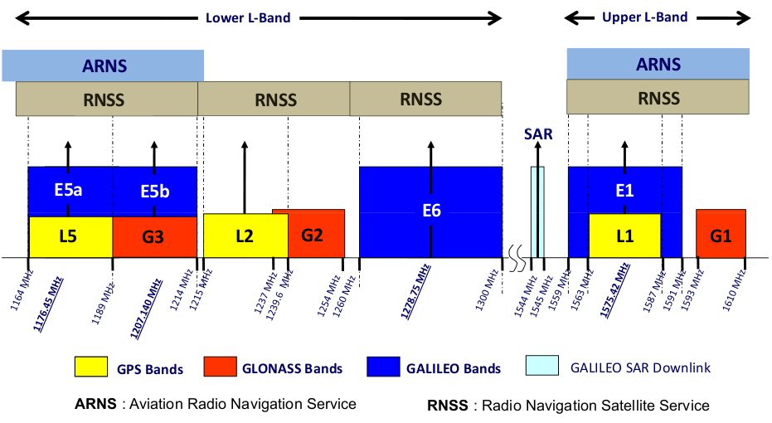
Source : https://gssc.esa.int/navipedia/index.php/GNSS_signal

Figure 2. GNSS Frequency bands

The band 1240-1260 MHz is currently used by the Russian Federation GLONASS system, while the band 1 250-1280 MHz is used by the Chinese COMPASS system and the band 1 260-1 300 MHz is used by the European Galileo system as well as the Japanese QZSS system. The same band is also planned to be used by the Korean KPS.

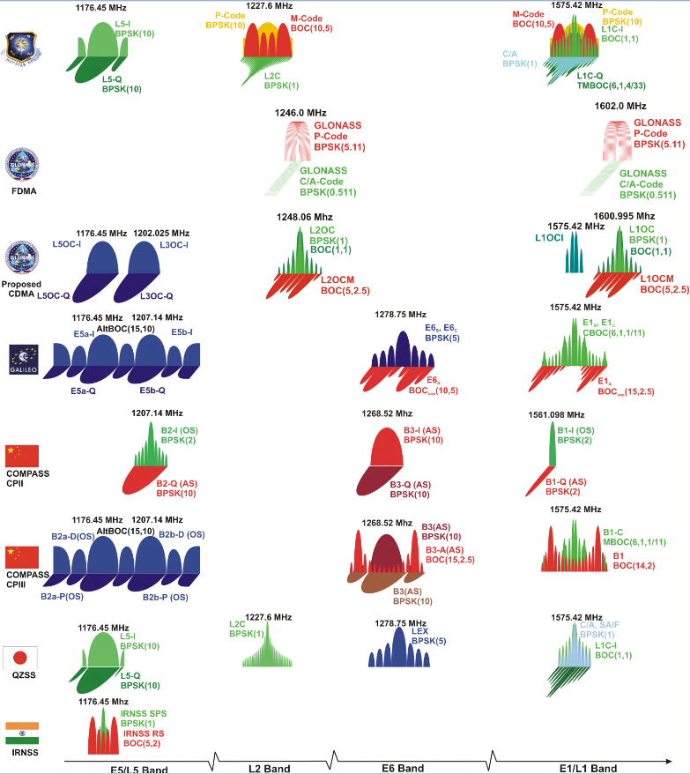
Source : Stefan Wallner

According to recent information one of Galileo’s next major steps is the active utilization of the GALILEO E6B/C signal offering dual-frequency accuracies (E1/E6) and a commercial service in the frequency range 1 260-1 300 MHz.

- RNSS related Reference links
- GPS: https://www.gps.gov/systems/gps/space/#orbits
- GLONASS: https://www.glonass-iac.ru/en/GLONASS/
- Galileo: https://ec.europa.eu/growth/sectors/space/galileo/launches_en
- Beidou: http://en.beidou.gov.cn/
- QZSS: https://qzss.go.jp/en/
- NAVIC: https://en.wikipedia.org/wiki/Indian_Regional_Navigation_Satellite_System

- List of relevant ITU-R Reports/Recommendations, APT Reports/Recommendations and ongoing studies, e.g. working documents from ITU-R and/or AWG:
- Recommendation ITU-R M.1732 – Characteristics of systems operating in the amateur and amateur-satellite services for use in sharing studies
- Recommendation ITU-R M.1787 – Description of systems and networks in the radio-navigation-satellite service (space-to-Earth and space-to-space) and technical characteristics of transmitting space stations operating in the bands 1 164-1 215 MHz, 1 215-1 300 MHz and 1 559-1 610 MHz
- Recommendation ITU-R M.2030 – Evaluation method for pulsed interference from relevant radio sources other than in the Radionavigation-satellite service to the Radionavigation-satellite service systems and networks operating in the 1 164-1 215 MHz, 1 215-1 300 MHz and 1 559-1 610 MHz frequency bands
- Report ITU-R M.2458 – Radionavigation-satellite service applications in the 1 164-1 215 MHz, 1 215-1 300 MHz and 1 559-1 610 MHz frequency bands
- Study Question ITU-R 288/4 – Related results of the WP 4C work on the Study Question on characteristics and operational requirements of radionavigation-satellite systems
- Study Question ITU-R 48-7/5 – Related results of the WP 5A work on the Study Question on techniques and frequency usage in the amateur service and amateur-satellite service
- Handbook ITU-R 52 – Amateur and amateur-satellite services
- IARU R1 band plan for the band 1 240-1 300 MHz
http://iaru-r1.org/index.php/spectrum-and-band-plans/uhf/23-centimeter
- Recommendation ITU-R S.465 – Reference radiation pattern of earth station antennas in the fixed-satellite service for use in coordination and interference assessment in the frequency range from 2 to 31 GHz
- Recommendation ITU-R RS.2311 – Pulsed radio frequency signal impact measurements and possible mitigation techniques between Earth exploration-satellite service (active) systems and RNSS systems and networks in the band 1 215-1 300 MHz
- Recommendation ITU-R M.2305 – Consideration of aggregate radio frequency interference event potentials from multiple Earth exploration-satellite service systems on radionavigation-satellite service receivers operating in the 1 215-1 300 MHz frequency band
- Recommendation ITU-R M.2284 – Compatibility of radio-navigation satellite service (space-to-Earth) systems and radars operating in the frequency band 1 215-1 300 MHz
- Recommendation ITU-R M.1902 – Characteristics and protection criteria for receiving earth stations in the radionavigation-satellite service (space-to-Earth) operating in the band 1 215-1 300 MHz
- Recommendation ITU-R M.2220 – Calculation method to determine aggregate interference parameters of pulsed RF systems operating in and near the bands 1 164-1 215 MHz and 1 215-1 300 MHz that may impact radionavigation-satellite service airborne and ground-based receivers operating in those frequency bands
- Recommendation ITU-R P.1546-6 – Method for point-to-area predictions for terrestrial services in the frequency range 30 MHz to 4 000 MHz

2. Information on on-going ITU-R Study
- What documents are being developed by the responsible group: Revising the existing ITU-R Report(s), ITU-R Recommendation(s) or developing a PDNR or a working document

- ITU-R WP5A: Continued the work on the draft work plan for activities covering WRC-23 agenda item 9.1 topic b). Updated the elements of a working document towards a preliminary draft new Report ITU-R M.[AMATEUR.CHARACTERISTICS] (Annex 10 to Doc. 5A/221). Generated two liaison statements on topic 9.1 b) to other ITU-R groups. Updated editorial revisions to the information document “Guide to the use of ITU-R texts relating to the amateur and amateur-satellite services” which can be found on the WP 5A webpage.

- WORKING DOCUMENT TOWARDS Preliminary draft CPM text
for WRC-23 Agenda Item 9.1 TOPIC B): CPM23-1 in its report CA/251, split the work on agenda item 9.1b between WP 4C and WP 5A with WP 5A being the responsible group. WP 4C was responsible for the detailed interference analysis required by resolves to invite ITU-R 2 of Resolution 774 (WRC-19) between stations of the amateur service and receivers of the radionavigation-satellite service. The results of the studies undertaken by WP 4C were sent to WP 5A so that it could draft the CPM text for WRC-23 and produce a final ITU-R report on the agenda item. WP 5A was also responsible for the review amateur service applications and development of appropriate and relevant parameters of amateur service stations for the studies undertaken by WP 4C.

- ELEMENTS OF A WORKING DOCUMENT TOWARDS A Preliminary Draft New Report ITU-R M.[AMATEUR.CHARACTERISTICS]: A preliminary draft new Report ITU-R M.[AMATEUR.CHARACTERISTICS] is in preparation in ITU-R Working Party 5A. The current version of the working document is Annex 10 to Document 5A/221-E (Chairman’s Report) dated 23 November 2020. The document provides a comprehensive illustration of how the band is used by amateurs.

- ITU-R WP4C: In support of WP 4C’s responsibility for developing studies on resolves to invite the ITU Radiocommunication Sector 2 of Resolution 774 (WRC-19) associated with WRC-23 agenda item 9.1, topic b), WP 4C produced three output documents. The meeting developed an updated Work Plan for addressing this topic based on the Work Plan in Document 4C/109, Annex 14. In response to two liaison statements from WP 5A (Docs 4C/119 and 4C/120), the meeting developed a reply liaison statement and sent it to WP 5A with copy to WP 3M for information. Finally, based on received input documents (Docs 4C/119 (WP 5A), 4C/140 (F, I), 4C/147 (D) and 4C/148 (D)), WP 4C produced a working document towards a preliminary draft new Report ITU-R M.[Amateur-RNSS] to document its work on the studies for WRC-23 agenda item 9.1, topic b). This document will eventually include complete relevant amateur/amateur-satellite transmitter parameters and interference scenarios agreed with WP 5A, relevant RNSS receiver parameters and protection criteria developed in WP 4C, analysis methodologies employing propagation models discussed with WP 3M, and the results of studies once completed.

- WORKING DOCUMENT TOWARDS A PRELIMINARY DRAFT NEW
REPORT ITU-R M.[AMATEUR-RNSS]: WP 4C has developed possible elements for a working document towards a preliminary draft new Report (WD-PDNRep ITU-R M.[Amateur-RNSS]), available in Annex 9 to Document 4C/109, which will eventually include relevant amateur/amateur-satellite transmitter parameters and interference scenarios agreed with WP 5A, relevant RNSS receiver parameters and protection criteria developed in WP 4C, analysis methodologies employing propagation models discussed with WP 3M, and the results of studies once completed. At this stage, propagation models proposed for consideration in this working document are free space loss or the Okumura-Hata model described in Recommendation ITU-R P.1546. WP 4C will update its studies with the use of propagation models proposed by WP 3M when assessing the co-existence between the amateur service and the amateur-satellite service with the radionavigation-satellite service in the frequency band 1 240-1 300 MHz.

- Contentious issues in ITU-R meeting (list all issues up in the beginning and then update (removal or addition) later stage): [TBD]

- Hyperlink to the relevant part of the webpage of ITU-R Preparatory Studies for WRC-23

3. Position of the Regional Group (if available)
- ATU

- ASMG

- CEPT

- CITEL

- RCC

4. Position of International Organizations (if available)

- IARU R1
- The IARU has spoken against the WRC-23 agenda item proposals made in the European WRC preparatory process (taking place in CPG PTA). IARU believes that a WRC agenda item is not the most efficient means to develop the solutions and guidance to solve any coexistence issue between the GNSS and the Amateur Service.
- Preliminary IARU position on WRC-23 Agenda Item 9.1 Topic B
- During many years of operational experience, the secondary amateur and amateur satellite services have successfully co-existed with all the primary services in the range 1 240-1 300 MHz with very few issues. In cases where certain applications (in particular wide bandwidth, high duty cycle applications) could increase the potential for interference, careful spectrum management and national licensing conditions have minimised any risk. Radio amateurs have successfully co-existed and innovated in this frequency range for many years and IARU believes that the regulatory status of the amateur and amateur satellite services in this range is already clear. Therefore any additional regulatory, operational or technical measures incorporated into the Radio Regulations are unnecessary. Any recommendations resulting from studies under Resolution 774 can be applied on a national basis and should be based on realistic assumptions, proportionate in scope and carefully justified so as not to unnecessarily inhibit development of the amateur services.

* Note by the Secretariat: This Resolution was revised by WRC-19.
https://www.iaru-r1.org/spectrum/iaru-and-itu/wrc-23-page/wrc-23-agenda-item-9-1b/
https://www.iaru-r1.org/wp-content/uploads/2021/02/20210304-Public-Prelim.pdf

