

**APT REPORT ON**

**LOW POWER WIDE AREA NETWORK (LPWAN) FOR THE INTERNET OF THINGS BASED ON NON-CELLULAR TECHNOLOGIES**

**No. APT/AWG/REP-106  
Edition: April 2021**

**Adopted by**

**27th Meeting of APT Wireless Group  
22 – 30 March 2021, Virtual/Online Meeting**

***(Source: AWG-27/OUT-07)***

**APT REPORT ON**

**LOW POWER WIDE AREA NETWORK (LPWAN) FOR THE INTERNET**

**OF THINGS BASED ON NON-CELLULAR TECHNOLOGIES**

# Introduction

Internet of Things (IoT) has been defined in Recommendation ITU-T Y.2060 as a global infrastructure for the information society, enabling advanced services by interconnecting (physical and virtual) things based on existing and evolving interoperable information and communication technologies.

IoT is a new form of interactions between devices and applications, or among devices, that do not necessarily require human interaction. IoT applications can be found in different vertical market areas (key identified market areas including, but not limited to, smart home, smart water, smart energy, smart cities, smart agriculture, smart manufacturing, wearables, smart logistics and distributions, security services, emergency management, etc).

Growing demand for a simple, low cost, low power and long-range wireless technology for massive IoT led to development of new wireless systems with the generic name of Low-Power Wide-Area Network (LPWAN). LPWAN systems relies on number of proprietary and/or open standard technologies, and their technical and operational characteristics make them suitable to facilitate massive IoT applications.

Technical and operational aspects of LPWAN for Massive Type Communication (MTC) and IoT in the frequency ranges harmonised for SRD operation have been addressed in the ITU-R Report SM.2423. LPWAN IoT network targets to the low power consumption, wide-area coverage, small message payload and sparse message interval scenarios. The technology nature makes LPWAN perfectly fit with the unlicensed/licensed share bands shared between different technologies which need not intensively occupy the spectrum resource.

The scope of this document is related to the LPWAN for MTC and IoT using radio technologies other than IMT in the frequency ranges for short range device operation as follows:

1. To provide information on technical characteristics, standards and frequency bands for LPWAN IoT.
2. To study the technical and operational aspects such as
3. Compatibility studies and field tests on coexistence between the LPWAN IoT and incumbents radio systems in the same and adjacent frequency bands, for sustainable development of IoT services.
4. Operational issues encountered in LPWAN IoT deployment and its solutions (if any).
5. To study the potential harmonisation opportunities on the frequency range and technical specification for the deployment of LPWAN IoT.

# Abbreviations

APT Asia-Pacific Telecommunity

AWG APT Wireless Group

EIRP Equivalent Isotopically Radiated Power

ERP Equivalent Radiated Power

ETSI European Telecommunications Standards Institute

IoT Internet of Things

ISM Industrial, Scientific and Medical

ITU International Telecommunication Union

LBT Listen Before Talk

LPWAN Low Power Wide Area Network

MTC Machine Type Communication

SRD Short Range Device

# Relevant APT/AWG and ITU-R Recommendations and Reports

* [1] ITU-R Resolution 66-1 on “Studies related to wireless systems and applications for the development of the Internet of Things”;
* [2] ITU-R Report SM.2423 on “Technical and operational aspects of low-power wide-area networks for machine-type communication and the Internet of Things in frequency ranges harmonised for SRD operation”;
* [3] APT/AWG/REP-35 (Rev.1) “APT Report on “Frequency bands for harmonized use of SRDs”;
* [4] APT/AWG/REP-86 (Rev.1) “APT Survey on Current Status and Future Plan of Implementation and Development of Internet of Things in Asia Pacific Countries”.

# Technical Characteristics, Standards and Frequency Bands for LPWAN IoT

## Technical Characteristics of LPWAN IoT

LPWAN aims to support devices operating on a single battery for an extended period (e.g. 10 years or more) over a distance in the range of kilometres to occasionally transmit small amount of data.

LPWAN is typically organised in a star topology where multiple devices communicate with a single access station. The communication between the device and access station is mainly uplink communication. However, downlink communication could be initiated for some use cases.

It is important to have specific technical requirements for LPWAN IoT equipment to comply with in the unlicensed spectrum. As such, the LPWAN IoT equipment with common operating parameters such as output power, spectrum access techniques, spurious emission and modulation bandwidth are able to co-share the spectrum.

* **Transmitter output power / radiated power**

Typical EIRP values range between 200 mW to 4 W for the access station and 5 mW to 500 mW for end-devices.

* **Antenna gain**

Most of the transmitters use omnidirectional antenna. Typically, end devices have 0 dBi antennas, while access stations exhibit better antenna gain.

* **Modulation bandwidth**

This parameter depends on the technology used, ranging from 100 Hz to 500 kHz.

* **Spectrum access technique**

In order to make maximum use of the available channels and to share spectrum between equipment with similar technical parameters, frequency hopping, duty cycle or LBT technique shall be used.

This restriction ensures appropriate sharing between all LPWAN and other technologies users in the shared spectrum. Typically, a duty cycle limit ranging from 1 % to 10 %, and the number of frequency hopping channels is set in proportion to the available allocated spectrum.

* **Spurious emission**

The LPWAN IoT equipment shall comply with the spurious emission requirement indicated in the Recommendation ITU-R SM.329 for SRD.

Table 1. Spurious emission limits recommended by ITU-R

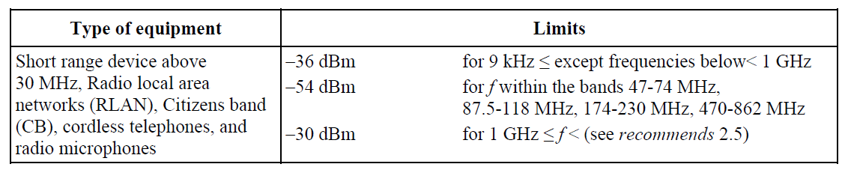

Similar spurious emission limits indicated in the European standards, ETSI EN 300 220-1 for radio equipment operating in the 25 MHz to 1000 MHz frequency range, in the table 2.

Table 2. Spurious emission limits indicated by ETSI EN 300 220-1

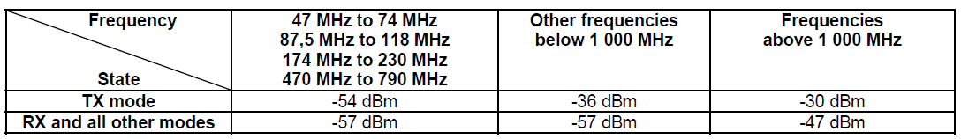

## Frequency Bands for LPWAN IoT

Specifically, the LPWAN is designed to operate in a shared spectrum environment, particularly the sub-1 GHz spectrum of the ISM or non-ISM frequency bands. These frequency bands offer propagation characteristics, which allows wide area coverage and better penetration deep into buildings with a low transmit power.

Most of the devices connecting to LPWAN use the same ecosystem of chipsets and modules as those used for the existing SRD market. This commonality, combined with existing regional harmonisation of SRD bands, contributes to LPWAN increasing the manufacturing economies of scale.

* **ITU Region 1**

In European countries, most of the LPWAN infrastructures are operated in the 865 – 870 MHz SRD band, some LPWANs operate in the 433.05-434.79 MHz. In particular, in the 865 - 870 MHz band, they rely on the 865 – 868.6 MHz band at 25 mW ERP and 869.4 – 869.65 MHz and partially 865 – 868 MHz bands at 500 mW ERP, all ranges having duty cycle restriction - Equipment should comply with the Harmonised Standards (i.e. ETSI EN 300 220).

* **ITU Region 2**

The LPWAN infrastructures are typically operated in the 902 – 928 MHz unlicensed frequency band with a transmit power up to 4 W EIRP.

* **ITU Region 3: APT Regions**

In APT countries, LPWAN infrastructures are operated on a country specific allocated un-licensed spectrum, range between 915 MHz to 935 MHz and 433.05-434.79 MHz.

Table 3. Frequency used for LPWAN in some APT countries

| **Country or Territory** | **Frequency Range (*)** |
| --- | --- |
| Australia | 915 – 935 MHz |
| Brunei Darussalam | 920 – 925 MHz |
| Hong Kong, China | 920 – 925 MHz |
| Indonesia | 920 – 923 MHz |
| Japan | 915 – 930 MHz |
| South Korea | 917 – 923.5 MHz |
| Laos | 918 – 923 MHz |
| Malaysia | 916 – 924 MHz |
| Myanmar | 919 – 923 MHz |
| New Zealand | 915 – 928 MHz |
| Papua New Guinea | 915 – 928 MHz |
| Singapore | 920 – 925 MHz |
| Thailand | 920 – 925 MHz |
| (*): Some APT countries may also use 433.05-434.79 MHz frequency range for LPWAN [4]. | |

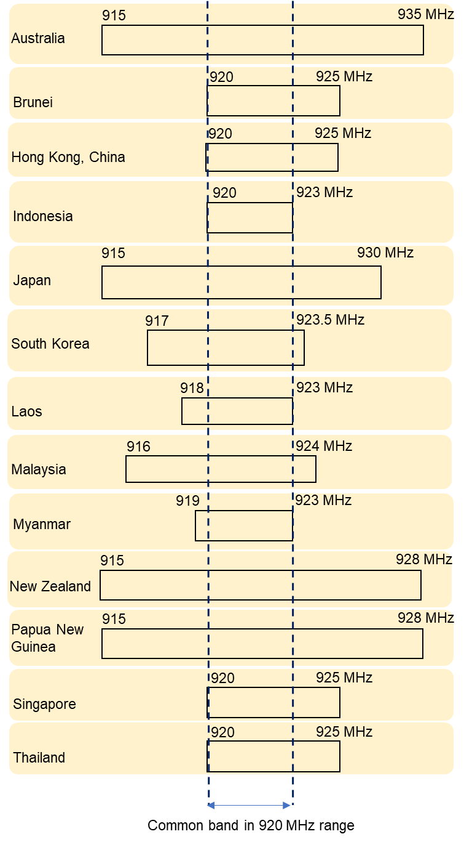

Figure 1. Illustration of frequency **used for** LPWAN in 920 MHz frequency range in some APT countries

# Technical and Operational Aspects

Due to the operation of LPWAN in the frequency band shared with other short range radiocommunication devices in principle of not causing harmful interference to and not claiming protection from harmful interference by a licensed radio station, LPWAN needs to ensure the appropriate technical and operational conditions (e.g. Allowed maximum main transmitting output power, maximum spurious emission, duty cycle limitation, etc.) which may be decided by each Administration based on interference protection criteria for licensed radio stations.

The technical and operational conditions for LPWAN vary in frequency bands and may differ from countries to countries. APT/AWG/REP-86 (Rev.1) provides this type of detailed information in some APT countries.

Appendix A presents case studies No. A1 and A2 which was performed by some APT Administrations on the laboratory and field test to assess impacts from LPWAN operating in the 920 MHz frequency range to the mobile cellular system operating in the frequency band 880-915 MHz (Uplink) and 925-960 MHz (Downlink):

* For case study A1 (Indonesia) of Appendix A: Based on the trial results from three different scenarios (conducted test, anechoic chamber test, and field test measurement) described in the case study A1, LPWAN non-cellular system in 920-923 MHz band can coexist with mobile cellular system in 900 MHz band (3GPP Band 8) with the requirement of a proper filter specifications at the Gateway device of LPWAN non-cellular system. A minimum out-of-band rejection at the level of 50 dB measured in the frequency of 915 MHz and 925 MHz could be considered as a mandatory technical requirement of LPWAN non-cellular gateway operate in 920-923 MHz band.
* For case study A2 (Viet Nam) of Appendix A: The field test results described in the case study A2 showed that high power transmitters of LPWAN (eg. 500 mW EIRP) in the 920 MHz frequency range may cause harmful interference to GSM systems (Downlink) in the adjacent bands in some circumstances. The interference can be eliminated by setting an appropriate guard band (eg. 2 MHz) between two types of system and/or decreasing transmitter output power of LPWAN systems.

# Possible Harmonised Use of Spectrum for LPWAN IoT based on non-cellular technologies

Spectrum harmonisation can bring several socio-economic advantages such as:

* Broader manufacturing base and increase volume of equipment resulting in economies of scale and expanded equipment availability
* Reduced cost of devices for customers and solution providers, particularly for cross border logistic tracking use cases.

The frequency band 920-923 MHz may be considered as a common band for LPWAN based on non-cellular technologies in the tuning range 915-935 MHz. The frequency range 433.05-434.79 MHz may be considered for LPWAN IoT usage based on non-cellular technologies, if appropriate.

# APPENDIX A. CASE STUDIES ON THE INTERFERENCE ASSESSMENT FROM LPWAN 920 MHz TO OTHER RADIO SYSTEMS

**A1. Case study A1 (Indonesia)**

**A1.1. Introduction**

Indonesia conducted an LPWAN non-cellular technology trial in the 900 MHz frequency bands with three scenarios. The objectives of the trial were to check the compatibility between IoT (LPWAN non-cellular) and Mobile Cellular in adjacent channel in the 900 MHz bands.The first scenario is conducted test, the second scenario is anechoic chamber test and the last scenario is field tests.

**A1.2. Technical and Operational Aspects**

The spurious emission is used as the parameter for the compatibility between IoT (LPWAN non-cellular) and Mobile Cellular in adjacent channel in the 900 MHz bands. There were two types of LPWAN non-cellular technology systems under the test with the technical specification as described in Table 4.

Table 4. Two types of LPWAN non-cellular technology systems tested

|  |  |  |  |
| --- | --- | --- | --- |
|  | | **Type 1** | **Type 2** |
| Operating frequency band | | 920 – 923 MHz | 920 – 923 MHz |
| Bandwidth | | 250 kHz | 200 kHz |
| Max. RF output power (EIRP) | End node | 250 mW | 200 mW |
| Gateway | 500 mW | 500 mW |
| Duty cycle | End node | 1% | 1% |
| Gateway | 10% | 10% |
| Number of devices | End node | 7 | 10 |
| Gateway | 1 | 1 |



Figure 2. 900 MHz band plan in Indonesia

In this trial, the 900 MHz cellular base station used was GSM900 (UL) and UMTS900 (DL). Based on ETSI TS 136 104 v14.3.0 standard, the power of any spurious emission shall not exceed the limits of Table 5 for E-UTRA Base Station (BS) in order to coexist with GSM900. Here, E-UTRA system approached as LPWAN non-cellular system. The maximum level of spurious emission on GSM900 is -61 dBm on the Uplink and -57 dBm on the Downlink.

Table 5. BS Spurious emissions limits for E-UTRA BS for co-existence with systems operating in 900 MHz frequency band

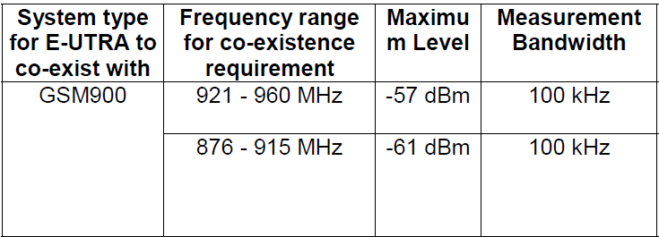

In order to avoid the spurious emission not to reach the maximum level described in Table 5, a filter in LPWAN non-cellular gateway is applied. The specifications of the filter that is installed in the LPWAN non-cellular gateway are as shown in Figure 3:

* Insertion loss max = 4 dB.
* Rejection filter in the frequency 915 MHz = 60 dB
* Rejection filter in the frequency 925 MHz = 50 dB

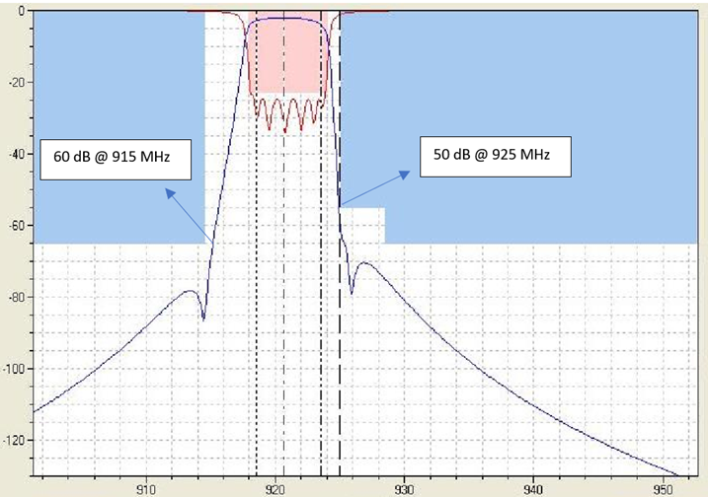

Figure 3. Band Pass Filter Specification

Besides having to comply with the value in Table 5, spurious emission limits is referring to the European standards, ETSI EN 300 220-1 for radio equipment operating in the 25 MHz to 1000 MHz frequency range, as shown in Table 6 below.

Table 6. Spurious domain emission limits



**A1.3. Results of Trial**

**a. Conducted Test**

~~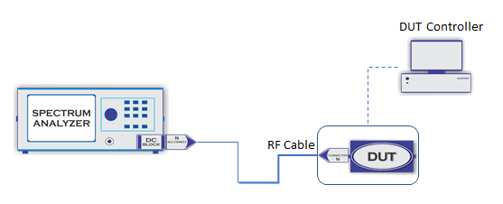~~

Figure 4. Conducted Test

The purpose of the conducted test was to measure the LPWAN non-cellular spurious emission level at GSM900 frequency band. Based on ETSI EN 300 220-1 V3.1.1 standard, spurious emission level must not exceed -36 dBm. This measurement scenario as described in Figure 4 applied only on LPWAN non-cellular gateway. The measurement results are presented in Table 7.

Table 7. Conducted Test Measurement Results

|  |  |  |  |  |  |
| --- | --- | --- | --- | --- | --- |
| **Type** | **Transmit Frequency Center** (MHz) | **Channel Power** (dBm) | **Measured Frequency** | **Unwanted Emission** (dBm) | **Note** |
| **1** | 920.1 | 25.54 | 909 ≤ f ≤ 914.00 MHz | -73.12 | Comply  (not exceed  -36 dBm) |
| 929.00 ≤ f ≤ 933.50 MHz | -74.04 |
| **2** | 922.3 | 26.08 | 790 ≤ f ≤ 915.12 MHz | -67.53 |
| 923.50 MHz ≤ f ≤ 1.0000 GHz | -67.79 |

**b. Anechoic Chamber Test**

The anechoic chamber test as shown in Figure 4 was used to make isolation from unwanted signals, and to minimize noise being reflected during measurement. The parameters of the test are Power Ratio and Spurious Emission Level.

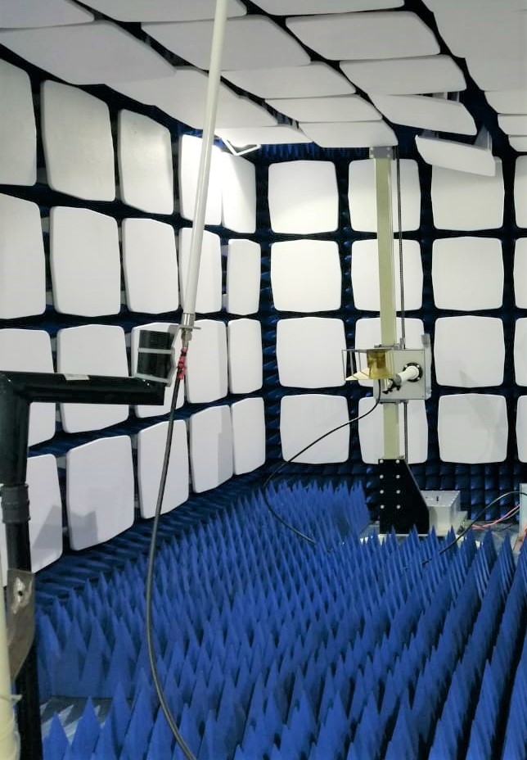

Figure 5. Anechoic Chamber Test

Power ratio is a ratio between the received power level and the unwanted spurious power level from the adjacent channel as shown in Figure 6. The value of ratio varies differently, and it depends on the carrier power level from the measurement results obtained.



Figure 6. Power Ratio Definition.

the formula for Power Ratio is:

(1)

$$Power Ratio \left(dBc\right)=Carrier Power Level \left(dBm\right)-Limit Level Spurious (dBm)$$

From the equation (1), the value of the power ratio in dBc units is defined as the decibel relative to the carrier power level. Table 8 shows the power ratio for End Node and Gateway for both LPWAN non-cellular technologies. The power ratio is obtained from the calculation of the carrier power level measured in conducted test minus the spurious emission limit based on ETSI EN 300 220 v.3.1.1.

Since the conducted test for the end node couldn’t be applied, the carrier power level is obtained based on technical specification of the equipment.

Table 8. Power Ratio

|  |  |  |  |  |
| --- | --- | --- | --- | --- |
| **Measurement** | **Type** | **Transmit Frequency Center** (MHz) | **Carrier Power Level** (dBm) | **Power Ratio** (dBc) |
| End Node | 1 | 920.2 | 20 | 56 |
| 2 | 922.3 | 22 | 58 |
| Gateway | 1 | 920.2 | 25.36 | 61.36 |
| 2 | 922.3 | 23.55 | 59.55 |

The power ratio obtained in Table 8 then is used as the comparation for anechoic chamber test measurement. The anechoic chamber test measurement result shall not exceed the power ratio obtained in Table 8. The anechoic chamber test measurement results for End Node and Gateway are shown in Table 9 and Table 10.

Table 9. End Node Measurement Results

|  |  |  |  |  |  |  |  |  |
| --- | --- | --- | --- | --- | --- | --- | --- | --- |
| **Frequency** (MHz) | **Type** | **Power Level** (dBm) | **Unwanted Emission at measured frequency** (dBm) | | **Power Ratio** (dBc) | **Result Power Ratio** (dBc) | | **Note** |
| 880  ≤ f ≤  915 MHz | 925  ≤ f ≤  960 MHz | 880  ≤ f ≤  915 MHz | 925   ≤ f ≤ 960 MHz |
| 920 - 923 | 1 | -23.34 | -84.14 | -85.52 | 56 | 60.8 | 62.18 | Comply |
| 2 | -19.81 | -85.72 | -81.02 | 58 | 72.2 | 67.5 |

Table 10. Gateway Measurement Results

|  |  |  |  |  |  |  |  |  |
| --- | --- | --- | --- | --- | --- | --- | --- | --- |
| **Frequency** (MHz) | **Type** | **Power Level** (dBm) | **Unwanted Emission at measured frequency** (dBm) | | **Power Ratio** (dBc) | **Result Power Ratio** (dBc) | | **Note** |
| 880  ≤ f ≤  915 MHz | 925  ≤ f ≤  960 MHz | 880  ≤ f ≤  915 MHz | 925   ≤ f ≤  960 MHz |
| 920 - 923 | 1 | -13.30 | -84.61 | -76.54 | 61.36 | 71.31 | 63.24 | Comply |
| 2 | -13.52 | -85.72 | -81.02 | 59.55 | 72.2 | 67.5 |

**c. Field Test**

The field test is applied to compare the downlink signals from the cellular base station in 900 MHz band and from the LPWAN non-cellular gateway. The field test configuration is described in Figure 7. Adjacent Channel Selectivity (ACS) shown in Figure 8 is used as the parameter in this field test. Based on 3GPP TS 36.101 V8.0.0 (2007-12), ACS is the ratio of the receive filter attenuation on the assigned channel frequency to the receive filter attenuation on the adjacent channel(s). ACS value must be < 45 dB. The distance of the cellular base station and LPWAN non-cellular gateway is ± 2.2 km.



Figure 7. Configuration of Field Test Scenario.



Figure 8. Adjacent Channel Selectivity

(2)

$ACS (dB)=Carrier Power (LPWAN)-Carrier Power (Cellular)$

The field test measurement results are shown in the following Table 11:

Table 11. Field test measurement results

|  |  |  |  |  |  |
| --- | --- | --- | --- | --- | --- |
| **No.** | **Measurement Distance** | **Carrier Power** | | **Value ACS**  (dB) | **Note** |
| **LPWAN 921.500 MHz**  (dBm) | **Cellular**  **927.500 MHz**  (dBm) |
| 1. | 3 meters from End Node | -25.00 | -63.70 | 38.70 | Comply |
| 2. | 7 meters from Gateway | -42.07 | -62.40 | 20.33 | Comply |
| 3. | 150 meters from Gateway | -62.80 | -88.83 | 26.03 | Comply |

**A1.4. Conclusion**

Based on the results from three different scenarios (conducted test, anechoic chamber test, and field test measurement), LPWAN non-cellular system in 920-923 MHz band can coexist with mobile cellular system in 900 MHz band (3GPP Band 8) with the requirement of a proper filter specifications at the Gateway device of LPWAN non-cellular system. In Indonesia, we set a provision regarding minimum out-of-band rejection at the level of 50 dB measured in the frequency of 915 MHz and 925 MHz as a mandatory technical requirement of LPWAN non-cellular gateway.

**A2. Case study A2 (Viet Nam)**

This case study is conducted by the Administration of Viet Nam. The objectives of the field test were to study the impacts from LPWAN networks operating in the 920 MHz frequency range to GSM mobile system (frequency band 880-915/925-960 MHz) and find out regulatory and technical solutions for coexistence between two kinds of systems.

There was two kinds of LPWAN systems under the test with their technical parameters as the following table:

Table 12. Technical parameters of LPWAN systems in the field test

|  |  |  |
| --- | --- | --- |
|  | **System A** | **System B** |
| Operating frequency band | 920 – 923.4 MHz | 920-923.4 MHz |
| Bandwidth | 200 kHz | 125 kHz |
| RF output power | 500 mW EIRP | 500 mW EIRP |
| Duty cycle and number of messages/one minute | 10% for Base station  1% for End node (*) | 10% for Base station  1% for End node (*) |
| Number of devices | 01 Gateway and 21 end nodes | 01 Gateway and 21 end nodes |
| (*): In order to determine the harmful interference effect under the strictest conditions, the end nodes of system A were configured to transmit the maximum of 3 messages per one minute, twelve times higher than normal mode; the number corresponding to system B is 12 messages per one minute, two times higher than normal mode. | | |

**A2.1 Interference assessment from LPWAN systems to GSM 900 MHz Downlink**

The Rx frequency of GSM UE was locked on the frequency 925.1 MHz (the edge frequency of 900 MHz DL band) to assess the potential interference from the LPWAN systems. The interferer (LPWAN Tx) and the victim (GSM UE Rx) were spaced 1m and 3m apart.

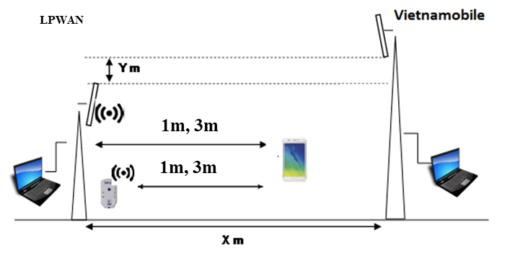

Figure 9. Test case between LPWAN systems and GSM 900 UE Rx

Frequency parameters for configuration in the field test are as follows:

|  |  |  |  |  |
| --- | --- | --- | --- | --- |
| **Scenarios No.** | **Operating frequency (System A) (MHz)** | **Operating frequency (System B) (MHz)** | **Separation distance (IoT vs TEMS)**  **(m)** | **GSM Downlink (TEMS device)** |
| 1 | No transmit and receive | |  | Locked TEMS device to operate on the edge frequency channel of 900 MHz DL band (ie. 925.1 MHz) |
| 2 | BS: 922.3 and 923.4  UE: 920.8 | BS: 922.0 – 923.4  UE: 922.0 – 923.4 | 3 (m) |
| 3 | BS: 922.3 and 923.4  UE: 920.8 | BS: 922.0 – 923.4  UE: 922.0 – 923.4 | 1 (m) |
| 4 | BS: 922.3  UE: 920.8 | BS: 920.6 – 922.0  UE: 920.6 – 922.0 | 1 (m) |

Measured results by spectrum analyzer and statistical quality of signal reception level at mobile devices (TEMS equipment) of GSM 900 MHz network (Downlink) as shown in the following table:

Table 13. Quality of signal reception level at TEMS equipment

|  |  |  |  |
| --- | --- | --- | --- |
| **Scenarios** | **Separation distance (IoT vs TEMS) (m)** | **RF output power IoT (mW EIRP)** | **TEMS analysis** |
| % samples with RxQual below 4 level (*) |
| No. 1 | N/A | 0 | 62.3 |
| No. 2 | 03 (m) | System A: 500  System B: 500 | 65 |
| No. 3 | 01 (m) | System A: 500  System B: 500 | 47,0 |
| No. 4 | 01 (m) | System A: 500  System B: 500 | 61.8 |
| (*): As accepted by a Viet Nam mobile network operator, Rx Quality indicator below 4 meant that the network would be under normal operation status. | | | |

The evaluation parameters affecting interference on mobile communication networks (Downlink) based on the received signal quality index (Rx Qual) and the C/I index and evaluating signal spectrum, intermodulation products appear in the downlink band of GSM900 network.

**A2.2 Interference assessment from LPWAN to GSM 900 MHz Uplink**

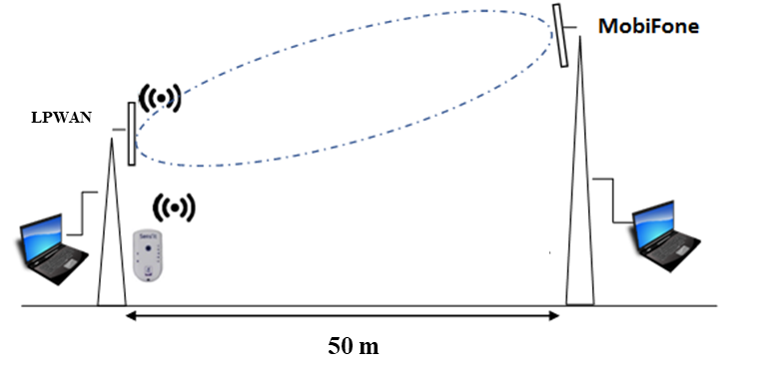

Figure 10. Test case between LPWAN and GSM BS Rx

The distance separation between the LPWAN devices (Operating frequency 920.6-922.3 MHz, Tx output power level was configured to 1 W EIRP) and GSM 900 MHz BS Rx in the field test was 50m.

The uplink interference index of the GSM 900 MHz base station at the time before and after the deployment of LPWAN devices were observed in the GSM network quality monitoring system. The evaluation parameters affecting interference on mobile communication networks (Downlink) based on the uplink monitoring index at base station (ICM band), evaluating signal spectrum and intermodulation products appearing in the uplink band GSM network.

**A2.3 Discussion**

**a. Interference from LPWAN 920 MHz to GSM 900 MHz Downlink**

At a distance of 03 meters between GSM UE 900 MHz (915-960 MHz Downlink) and LPWAN systems and 1.5 MHz guard band (GB) between two systems, the GSM 900 MHz system (Downlink) operated on the normal status without having significant interference from LPWAN systems transmitting at the RF output power 500 mW EIRP. For a distance of 01 meter and 1.5 MHz guard band, the external interference from LPWAN systems (RF output power 500 mW EIRP) caused blocking phenomenon to GSM UE Receiver and degrade the quality of GSM receiver.

At a distance of 1 meter and 2.6 MHz guard band between two kinds of systems above, the GSM 900 MHz system (Downlink) operated on the normal status without having the effect of interference from LPWAN systems transmitting at the RF output power 500 mW EIRP.

**b. Interference from LPWAN 920 MHz to GSM 900 MHz Uplink**

At a separation distance of 50 meters and 5 MHz guard band between GSM BS 900 MHz (880-915 MHz Uplink) and LPWAN systems, the GSM 900 MHz BS Rx in the field test operated on the normal status without observing any harmful interference notification from the LPWAN devices.

**A2.4 Conclusion**

The field test results showed that high power transmitters of LPWAN (eg. 500 mW EIRP) in the 920 MHz may cause harmful interference to GSM systems (Downlink) in the adjacent bands in some circumstances. The interference can be eliminated by setting an appropriate guard band (eg. 2 MHz) between two types of system or decreasing transmitter output power of LPWAN systems.