

**APT REPORT ON**

**RAILWAY RADIOCOMMUNICATION SYSTEM FOR PASSENGERS’ ACCESS TO INFORMATION AND INTERNET SERVICES IN SOME APT COUNTRIES**

**No. APT/AWG/REP-107  
Edition: April 2021**

**Adopted by**

**27th Meeting of APT Wireless Group  
22 – 30 March 2021, Virtual/Online Meeting**

***(Source: AWG-27/OUT-14)***

**APT REPORT ON**

**RAILWAY RADIOCOMMUNICATION SYSTEM FOR PASSENGERS’ ACCESS TO INFORMATION AND INTERNET SERVICES IN SOME APT COUNTRIES**

# 1. Scope

With the increasing speed of railway transportation, the growing demand of providing effective connectivity services for railway passengers brings up challenging requirements. This report provides information on national implementation experiences of some APT countries on railway radiocommunication system (other than RSTT) which could enable passengers’ access to information and Internet services. One case study is also provided as information in this report.

# 2. Information on national implementation experiences of some APT Members

## 2.1 Experiences in Republic of Korea

### 2.1.1 Introduction

130,000 persons (6000 persons/hour) pass through Seoul station (METRO) in one day. There must be at least 500 persons on a train or platform. People on the train or platform used to consume mobile data, chatting with friends, streaming movies, playing Internet games, and reading news.

Considering mobile data and railway population trends, wireless Internet service on train and platform need more than 100 Mbps. It is not enough to provide wireless Internet service on train and platform utilizing the existing RSTT and the future RSTT below 1 GHz. It is necessary to find out new frequency and technology.

Seoul city has launched ‘*Seoul Subway Telecommunication Service Enhancement Project*’ to improve the quality of the public Internet service that the people on train and platform can access public Internet freely. **Mobile hotspot network (MHN)** was adopted as candidate technology for the project in Sep. 2017 and passed bench mark test in 2018.

The MHN technology was developed as a backhaul technology for railway communication[1] [2]. It is a mobile communication technology that uses a wide frequency range of the millimeter band to provide high capacity data services to public transportation. Feasibility test were firstly conducted in 2016, and demonstration records the data rate above 1.2 Gbps in 2017.

The project is in phase of preparing trial service.

* Network operator was contracted and will install the MHN system for trial service at one subway line in Seoul.
* Railway operator provides places and utilities to the network operator and collects annual costs from it.
* People on trains and stations can connect to public Internet with their own devices.

**Figure 1: METRO station population trend (Passengers get on and off) (Seoul, Korea)**

### 2.1.2 System Description of MHN

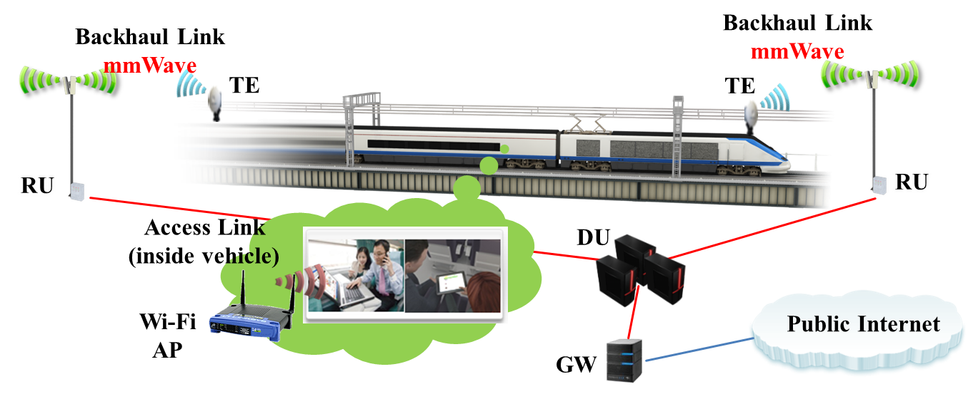

**Figure 2: Backhaul System for Mobile Internet Service**

As an example, Figure 2 depicts MHN (Mobile Hotspot Network) System. MHN System consists of TE (Terminal Equipment), RU (Radio Unit), DU (Digital Unit), and GW (Gateway). The TE is connected to Wi-Fi AP in the vehicle, and forms a radio link with a RU. RUs are connected to DUs by optical fiber. DUs are connected to the gateway to provide public Internet service. Passenger’s premise terminal can be connected to public Internet through Wi-Fi AP. [1]

In early 2018, Korea government changed regulation of FACS (Flexible Access Common Spectrum). The frequency between 22 GHz and 23.6 GHz is designated as FACS. Before the change, the MHN system is verified using other bands (ex. 25 GHz, 32 GHz). Currently, a new frequency based MHN system has been developed for Seoul METRO trial service. The system parameter in demonstration of 2017 is shown in Table 2-1.

**Table 2-1: Example of System parameter of MHN**

|  |  |
| --- | --- |
| **Parameters** | **Value** |
| Structure | 10 ms frame, 5 subframes/frame, 8 slots/subframe, 40 symbols/slot |
| Operating Speed of the train | Less than 80 km/h |
| Operating Scenario | Unidirectional non-SFN |
| Cell size | Less than 1.2 km |
| Cell distance | 200~1200 |
| Number of the base stations | 5 |
| Back haul type | Optical fiber |
| General cell hand over strategy | Hard handover |
| Link adaptation strategy | Inner loop link adaptation with periodic CQI feedback |
| Terminal type | Mobile (fixed on train) |
| Data traffic type | UDP (throughput test) or TCP/IP |
| Modulation | QPSK, 16QAM, 64QAM |
| Coding | CRC, Turbo |
| Carrier frequency | 24 – 26.5 GHz |
| Frequency bandwidth | 500 MHz |
| Number of component carrier | 4 (125 MHz) |
| Duplex Mode | TDD (Time Division Duplex) |
| Data Throughput | Downlink Link (DL): 1.26 Gbps  Uplink Link (UL): 180 Mbps |
| Transmission Mode | DL: TX & RX diversity  UL: Receive diversity |
| RF transmit & receive path | 2T2R (RU), 1T2R (TE) |
| Connection between DU & RU | Radio over fiber |
| Coverage | >300m (curved path), >500m (straight path) |
| TX power | 100 mW |
| Antenna gain | 16 dBi (TX), 22 dBi (RX) |

System architecture of MHN in railway environment is shown in Figure 3.

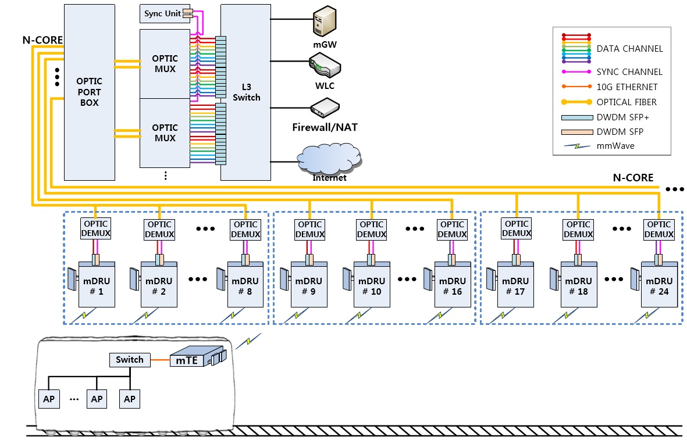

**Figure 3: MHN System optimized in Subway/Railway environment**

### 2.1.3 Relevant field test

MHN system has been tested in the running subway trains of Seoul subway Line 8. Figure 4 shows a train path of Seoul subway Line 8 where the MHN systems were tested. There are three stations, Jamsil, Seokchon and Songpa from left to right in the figure. Four RUs were installed between the Jamsil St. and Seokchon St. to cover the curved path. An RU was installed near the Songpa St. for the straight path. The locations of the five radio units were determined by a wave propagation test using FACS-based MHN prototypes before the field trial.

A TE was installed in the engine room of the running train just behind the front window. If the TE approaches the Jamsil St., it starts a random access to attach to network. As the train runs through the route in the figure, the TE receives and transmits signals from/to the RUs on the nearest RUs. When it passes the RU, it carries out the handover procedure to connect to the next cell until it passes through the last RU.

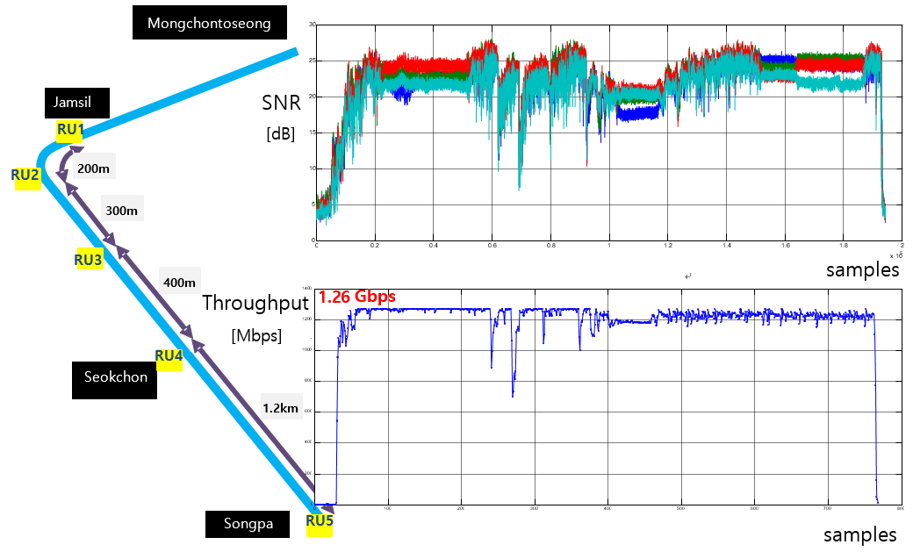

**Figure 4: MHN field trial**

Above figure also depicts downlink signal to noise ratio and throughput in physical layer. The maximum throughput is 1.26 Gbps and average SNR is above 20 dB. Figure 5 shows the captured screen of monitoring PC in the train.

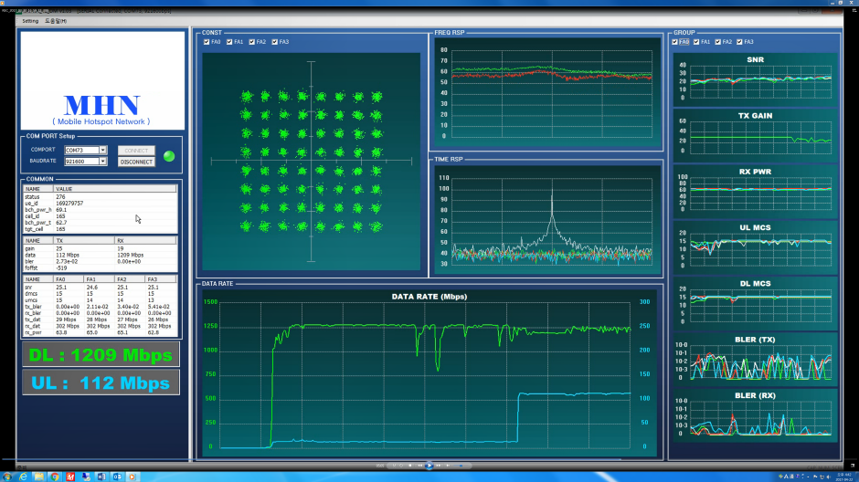

**Figure 5: Measured performance of the MHN system in a field trial**

# 3. Case study related to railway radiocommunication system for passengers’ access to information and Internet services (for information)

To satisfy the demand of providing information and Internet services in railway radiocommunication system, it is important to guarantee the performance in high speed train scenario.

Based on LTE system, which is already proved to provide outstanding and extensively validated performance in commercial network, 3GPP introduced enhanced performance requirement, specific system design and simulation result in the 3GPP Technical report36.878 version 13.0.0 Release 13-“Study on performance enhancements for high speed scenario in LTE” [3]. In that Report relevant simulation results under Unidirectional Single Frequency Network (SFN) scenario has been provided.

In the abovementioned simulation, the Unidirectional SFN scenario is built based on the deployment that directional antennas are used to provide a stable downlink carrier frequency as experienced by the UE when travelling at high speed. The intention to use Unidirectional SFN scenario is to serve not only existing HST requirements (UE speed up to 350 km/h) but also potential future requirements (UE speed up to 500 km/h and 750 km/h). To evaluate the system performance in such scenario, the throughput achieved for Physical Downlink Shared Channel (PDSCH) demodulation and decoding is selected as the major metric.

The simulation result shows that the performance of the legacy UE in a Unidirectional SFN is almost independent of the investigated UE speeds (350, 500, 750 km/h), with only a slight tendency of degraded performance as speed increases. For more detailed information, please see Annex 1.

# 4. Summary

This report has introduced information of one national implementation experiences on radiocommunication system (other than RSTT) for providing passengers’ access to information and Internet services. One relevant case study on physical downlink shared channel performance in the unidirectional single frequency network scenario was also provided in this report, for information only. With the rapid evolution of technology, more challenging requirements will be raised and drive the development of railway radiocommunication system to provide better performance to well enable passengers’ access to information and Internet services

# 5. Bibliography

[1] S. W. Choi, H. Chung, J. Kim, J. Ahn, and I. Kim, “Mobile hotspot network system for high-speed railway communications using millimeter waves,” ETRI J., vol. 38, no. 6, pp. 1052-1063, Dec. 2016.

[2] J. Kim, M. Schmieder, M. Peter, H. Chung, S. W. Choi, I. Kim, and Y. Han, “A comprehensive study on mmwave-based mobile hotspot network system for high-speed train communications,” IEEE Trans. Veh. Technol., vol. 68, no. 3, pp. 2087–2101, Mar. 2019.

[3] 3GPP Technical report 36.878 version 13.0.0 Release 13, “Study on performance enhancements for high speed scenario in LTE”.

# ANNEX 1

# relevant features and performance evaluation Studies on LTE system BASE ON 3GPP Standards for passengers’ access to information and internet services

Note: This Annex is for information.

## A1.1 Introduction on radio communication systems based on relevant 3GPP standards

3GPP LTE systems are today available with large industrial eco-system and many years of industrial practices across the world. LTE evolves continuously to achieve higher performance and wider feasibility (LTE-Advanced and LTE-Advanced Pro), while constantly reducing cost of all IMT services and applications, bringing large economic benefit to APT countries by saving cost. Additionally, as LTE systems are today existing commercial networks serving almost all Asia-pacific countries, this system employment for high-speed trains passenger’s networking will provide value and an advantage as a system with seamless interworking connections that any other technology can simply not offer.

To guarantee the performance under high speed moving, 3GPP provided enhanced performance requirement, specific system design and evaluations in [“Technical Specification Group Radio Access Network; Study on performance enhancements for high speed scenario in LTE (Release 13)”](http://www.3gpp.org/ftp/Specs/archive/36_series/36.878/36878-d00.zip). Detailed information can be found in the rest sub-sections of Annex 1.

3GPP had also studied using LTE technologies to provide connectivity at the scenario of high-speed train. It has work item called by “Performance enhancements for high speed scenario in LTE (Release 14)”. It specified requirements for UE Radio Resource Management (RRM), User-Equipment (UE) demodulation and Base Station (BS) demodulation, and the target moving speed is at least 350 km/h and at most 750 km/h, depending on candidate solution.

Technical features of 3GPP include unidirectional Remote Radio-Head (RRH) arrangement and the frequency pre-compensation solutions. Simulation results for Unidirectional Single Frequency Network (SFN) have been provided. The performance of the legacy UE in a Unidirectional SFN is almost independent of the investigated UE speeds (350, 500, 750 km/h), with only a slight tendency of degraded performance as speed increases.

For 5G IMT system, 3GPP also covered this scenario by its defined high-speed scenario. LTE and 5G IMT are a choice for system and technology for passengers’ access to information and internet Services at trains. More specific information can be found in Annex 1. It is clear that 3GPP LTE for high speed trains are combining outstanding and extensively validated performance with cost-efficient technical solutions to allow passengers to connect to internet and communications in general. And 3GPP had carried out many discussions on further improve the service quality by LTE networks under the subject of high-mobility services.

In 3GPP Release 16, there is NR support for high speed train scenario specifying enhanced RRM and demodulation requirements to support the speed of up to 500 km/h and the carrier frequency is up to 3.6 GHz. To have further performance enhancement for NR HST (high speed train), work items “Enhanced NR support for high speed train scenario for frequency range 1 (FR1)” and “NR support for high speed train scenario in frequency range 2 (FR2)” are proposed in Release 17 to support new and challenging demands for such scenarios. Specifically, carrier aggregation will be adopted to increase the throughput. Considering the impact of high speed and challenging millimeter wave frequency range, FR2 RRM and demodulation requirements will be further specified.

## A1.2 Description of unidirectional SFN scenario (RRHs sharing the same cell id, beams aligned in same direction)

In this section the channel model for the Unidirectional RRH arrangement for SFN is described in terms of time-variable Doppler shifts, tap delays and relative received power levels. The channel model is based on a 3-tap propagation model, see Figure A1-1. For this model, Down-Link (DL) transmission (TX) and Up-Link (UL) reception (RX) beams, respectively, are aligned in the same direction along the high-speed train track, and for the baseline configuration the DL TX and UL RX beams are oriented in the same direction along the track.



**Figure A1-1: Unidirectional SFN scenario in baseline configuration, using a 3-tap channel.**

For a good performance, it is essential that side-lobes directed towards the track are received at lower power than the signal from the main-lobe. Hence the antenna characteristics and particularly the antenna radiation pattern is of importance, and is a limiting factor for which geometries with respect to inter-site distance (DS) and minimum track-to-RRH distance (Dmin) , that can be supported. For the evaluation of the Unidirectional SFN scenario, an exemplary antenna with Front to Back Ratio (FBR) and (Front to Side Ratio) FSR of somewhat more than 30 dB has been selected, although antennas with lower FBR and/or FSR can be used, provided that DS and Dmin are chosen accordingly. The antenna radiation pattern of the exemplary antenna is shown in Figure A1-2 and described further below.



**Figure A1-2: Assumed antenna radiation pattern for RRH DL TX and UL RX antennas in Unidirectional SFN scenario.**

The principle of Unidirectional SFN is further illustrated in Figures A1-3 and A1-4. Figure A1-3 shows coverage of the antenna models for RRHs positioned along a track. Figure A1-4 zooms in on the area where coverage overlaps for adjacent RRHs, and it therefore is important to avoid that the UE receives side-lobes from one RRH at higher power level than it receives the main-lobe from another RRH.

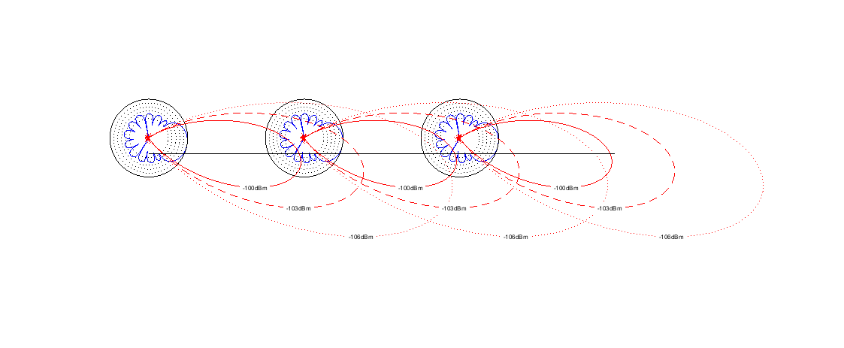

**Figure A1-3: Illustration of coverage provided by consecutive RRHs in a unidirectional SFN scenario.**

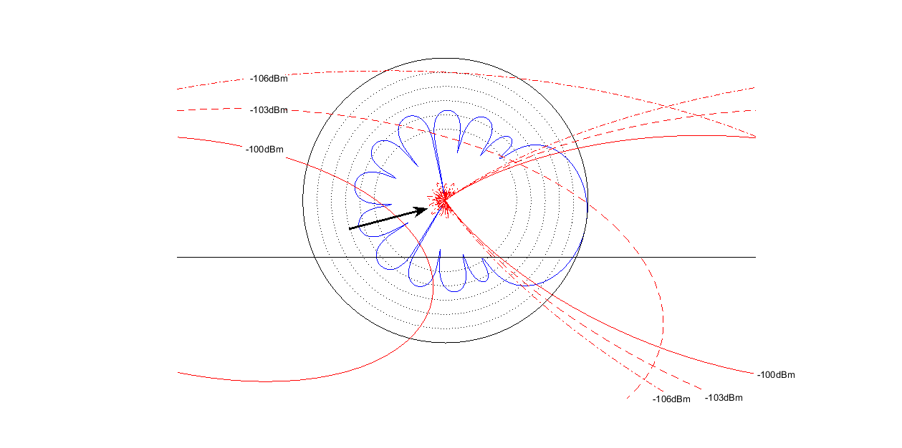

**Figure A1-4: Illustration of coverage overlap of adjacent RRHs. Geometries needs to be selected in such manner that the UE receives side-lobes at lower power level than it receives the main-lobe.**

The signal received by the UE for path i can be modelled as follows,

$y_{i}\left(t\right)=\sqrt{p_{i}\left(t\right)}∙e^{j2π{(f}_{c}t+\int_{0}^{t}{{\frac{d}{dτ}f}_{i}\left(τ\right)dτ+}α_{i}(t))}∙s_{b}\left(t-d_{i}\left(t\right)-n_{i}(t)∙Δ\right)$ (1)

where

$n_{i}\left(t\right)=floor\left(\frac{vt}{D_{S}}\right)+(i-1)$ (2)

where $α_{i}(t)$ is a semi-static channel phase, $p_{i}\left(t\right)$ is the combined effect of beam shape and path-loss, $f_{c}$ is the nominal carrier frequency, $f_{i}(t)$ is the instantaneous Doppler shift, $d_{i}\left(t\right)$ is the propagation delay, $n_{i}(t)∙∆$ is a deliberately introduced transmission time delay to compensate for the propagation time between two RRHs, $v$ is the speed of the UE, and where $s_{b}\left(t\right)$ is the baseband signal transmitted in the SFN cell. The transmission delay Δ compensates for the propagation delay difference between RRH i-1 and RRH i at the point in time when the UE is as closest to RRH i, and is defined as

$∆=\frac{\sqrt{D_{S}^{2}+D_{min}^{2}}-D_{min}}{c}$ (3)

where c is the speed of light. The other parameters are described further below.

## A1.3. Simulation assumptions for Unidirectional SFN

The link simulation assumptions for SFN with unidirectional RRH arrangement are provided in Tables A1-1 and A1-2 below. The purpose is to investigate UE receiver performance with respect to time and frequency tracking. The measured quantity is the throughput achieved for Physical Downlink Shared Channel (PDSCH) demodulation and decoding.

Table A1-1 states the simulation assumptions under outer loop link adaptation, and Table A1-2 states the simulation assumptions under fixed Modulation and Coding Scheme (MCS).

It shall be noted that the simulation assumptions below are just for performance investigations; future requirements may be tested under different assumptions that are agreed during the work item phase.

**Table A1-1: Simulation assumptions for UE demodulation performance evaluation under Unidirectional SFN scenario (Link adaptation)**

|  |  |  |  |
| --- | --- | --- | --- |
| Parameters | | Unit | Values |
| Bandwidth | | MHz | 10 |
| Duplex mode | |  | FDD (frequency division duplex) |
| MCS (modulation & coding scheme) | |  | Link adaptation with OLLA (outer-loop link adaptation)  Physical uplink control channel (PUCCH) 1-0 periodic channel quality indicator (CQI) feedback mode |
| Propagation condition and correlation matrix | Unidirectional SFN |  | Dynamic Unidirectional SFN channel as specified in Section A1.2:  ● Doppler shift, relative time delay and relative power change with time;  ● Static channel matrix as defined in B.1 in 3GPP TS 36.101;  ● Velocity of train:  - Option 1: 350 km/h  - Option 2: 500 km/h  - Option 3: 750 km/h |
| Antenna configuration | |  | 2x2 |
| Transmission mode | |  | TM3 |
| Reference receiver | |  | Minimum-mean-square-error (MMSE)-interference -rejection combining (IRC) |
| Noise estimation | |  | Practical |
| Time and frequency track | |  | Practical |

**Table A1-2: Simulation assumptions for UE demodulation performance evaluation under Unidirectional SFN scenario (fixed MCS)**

|  |  |  |  |
| --- | --- | --- | --- |
| Parameters | | Unit | Values |
| Bandwidth | | MHz | 10 |
| Duplex mode | |  | FDD |
| MCS | |  | MCS#19 (R.35-4 FDD) |
| Propagation condition and correlation matrix | Unidirectional SFN |  | Dynamic Unidirectional SFN channel as specified in Section A1.2:  ● Doppler shift, relative time delay and relative power change with time;  ● Static channel matrix as defined in B.1 in 3GPP TS 36.101;  ● Velocity of train:  - Option 1: 350 km/h  - Option 2: 500 km/h  - Option 3: 750 km/h |
| Antenna configuration | |  | 2x2 |
| Transmission mode | |  | TM3 |
| Reference receiver | |  | Minimum-mean-square-error (MMSE)-interference -rejection combining (IRC) |
| Noise estimation | |  | Practical |
| Time and frequency track | |  | Practical |

## A1.4. Simulation results

Simulation results for PDSCH demodulation performance in the Unidirectional SFN scenario and under assumptions stated in Section A1.3 are provided in Figure A1-5 through Figure A1-8 The simulation results for UE speeds 350, 500 and 750 km/h suggest that the receiver performance of a UE operating in a Unidirectional SFN is insensitive to the speed at which it is moving. To be noticed, f_d in the legend of following figures denotes the maximum Doppler frequency (in Hz).



**Figure A1-5: PDSCH demodulation performance for outer loop link adaptation**

**(Ds 1000 m, Dmin 30 m)**



**Figure A1-6: PDSCH demodulation performance for fixed MCS**

**(Ds 1000 m, Dmin 30 m)**



**Figure A1-7: PDSCH demodulation performance for outer loop link adaptation**

**(Ds 500 m, Dmin 15 m)**



**Figure A1-8: PDSCH demodulation performance for fixed MCS**

**(Ds 500 m, Dmin 15 m)**

## A1.5. Summary of evaluation

■ Unidirectional SFN scenario

The PDSCH demodulation simulation results [3] suggest that the receiver performance of a UE operating in a Unidirectional SFN network would be insensitive to the speed at which it is moving.

## A1.6. IMT 5G systems

At 3GPP, new radio system for 5G has also discussed the scenario of high-mobility. It became a study case for new radio system design. Specific definition of the scenario is provided as follows, cited from “[3GPP TR 38.913 Release 16, “5G; Study on Scenarios and Requirements for Next Generation Access Technologies”.](https://www.3gpp.org/ftp/Specs/archive/38_series/38.913/38913-g00.zip) This provides a valuable basis for IMT-system upgrading in the future.

The high-speed deployment scenario focuses on continuous coverage along track in high speed trains. The key characteristics of this scenario are consistent passenger user experience and critical train communication reliability with very high mobility. In this deployment scenario, dedicated linear deployment along railway line and the deployments including SFN scenarios captured in Section 6.2 of reference document [3] are considered, and passenger UEs are located in train carriages. For the passenger UEs, if the antenna of relay node for eNB-to-Relay is located at top of one carriage of the train, the antenna of relay node for Relay-to-UE could be distributed to all carriages.

Some of its attributes are listed in Table A1-3.

**Table A1-3: Some attributes in high speed deployment scenario**

|  |  |
| --- | --- |
| Attributes | Values or assumptions |
| Carrier Frequency NOTE1 | Macro NOTE2 only: Around 4 GHz  Macro NOTE2+ relay nodes:  1) For base-station (BS) to relay: Around 4 GHz  For relay to UE: Around 30 GHz or Around 70 GH or Around 4 GHz  2) For base-station (BS) to relay: Around 30 GHz  For relay to UE: Around 30 GHz or Around 70 GHz or Around 4 GHz |
| Aggregated system bandwidth NOTE3 | Around 4 GHz: Up to 200 MHz (DL+UL)  Around 30 GHz or Around 70 GHz: Up to 1 GHz (DL+UL) |
| Layout | Macro only:  - Around 4 GHz: Dedicated linear deployment along the railway line as in Figure A1-9.  RRH site to railway track distance: 100 m  Macro + relay nodes:  - Around 4 GHz: Dedicated linear deployment along the railway line as in Figure A1-9.  RRH site to railway track distance: 100 m  - Around 30 GHz: Dedicated linear deployment along the railway line as in Figure A1-10.  RRH site to railway track distance: 5 m. |
| Inter-site-distance (ISD) | - Around 4 GHz: ISD 1732 m between RRH sites, two TRxPs per RRH site. See Figure A1-9.  - Around 30 GHz: 1732 m between BBU sites, 3 RRH sites connected to 1 BBU, one TRxP per RRH site, inter RRH site distance (580 m, 580 m, 572 m). See Figure A1-10.  - Small cell within carriages: ISD = 25 m. |
| Base-station (BS) antenna elements NOTE4 | Around 30 GHz: Up to 256 Tx and Rx antenna elements  Around 4 GHz: Up to 256 Tx and Rx antenna elements |
| UE antenna elements NOTE4 | Relay Tx: Up to 256 antenna elements  Relay Rx: Up to 256 antenna elements  Around 30 GHz: Up to 32 Tx and Rx antenna elements  Around 4 GHz: Up to 8 Tx and Rx antenna elements |
| User distribution and UE speed | 100% of users in train  For non-full buffer, 300 UEs per macro cell (assuming 1000 passengers per high-speed train and at least 10% activity ratio)  Maximum mobility speed: 500 km/h |
| Service profile | Alt 1: Full buffer  Alt 2: FTP model 1/2/3 with packet size 0.5 Mbytes, 0.1 Mbytes (other value is not precluded)  Other traffic models are not precluded, e.g., for critical train communications. |

NOTE1: The options noted here are for evaluation purpose, and do not mandate the deployment of these options or preclude the study of other spectrum options. A range of bands from 24.25 GHz – 52.6 GHz identified for WRC-19 are currently being considered and around 30 GHz is chosen as a proxy for this range. A range of bands from 66 GHz – 86 GHz identified for WRC-19 are currently being considered and around 70 GHz is chosen as a proxy for this range. A range of bands from 3300 – 4990 MHz identified for WRC-15 are currently being considered and around 4 GHz is chosen as a proxy for this range.

NOTE2: For Macro, it is assumed RRH sharing the same cell ID or having different cell ID.

NOTE3: The aggregated system bandwidth is the total bandwidth typically assumed to derive the values for some key performance indicators (KPI) such as area traffic capacity and user experienced data rate. It is allowed to simulate a smaller bandwidth than the aggregated system bandwidth and transform the results to a larger bandwidth. The transformation method should then be described, including the modelling of power limitations.

NOTE4: The maximum number of antenna elements is a working assumption. 3GPP needs to strive to meet the target with typical antenna configurations. (Base-band-unit (BBU))

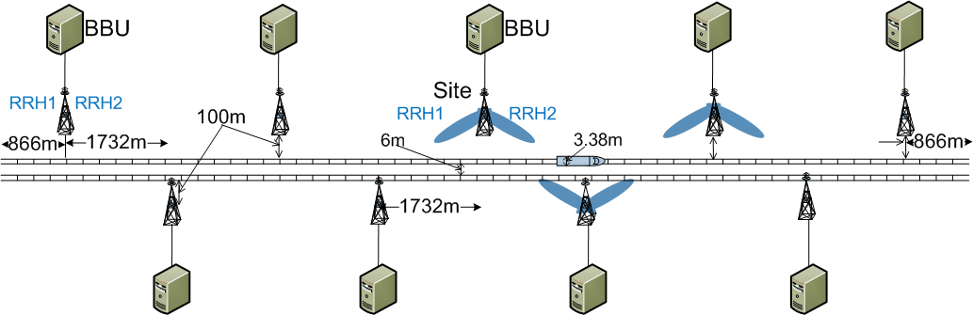

**Figure A1-9: 4 GHz deployment**

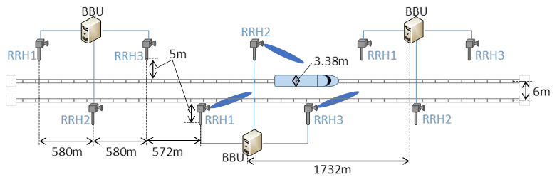

**Figure A1-10: 30 GHz deployment**

__________________

1. For demonstration video for passengers Internet service system utilizing FACS in KOREA, see: <https://www.youtube.com/watch?v=3_inHOP3els&feature=youtu.be>