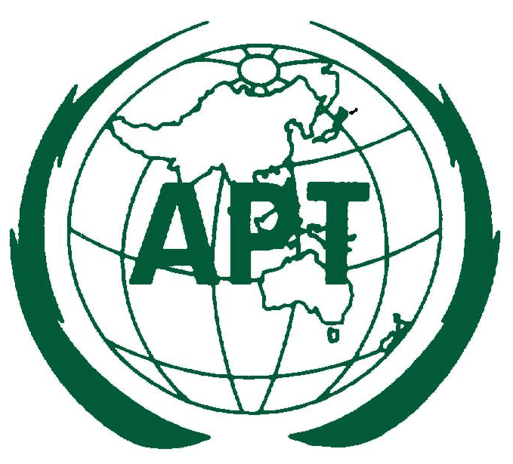

The 29th Meeting of the APT Wireless Group (AWG-29)
21 - 29 March 2022, Virtual/Online Meeting

INFORMATION FOR PARTICIPANTS

The 29th Meeting of APT Wireless Group (AWG-29) is scheduled to be held from 21 to 29 March 2022. Please, find the following information for the convenience of participants:

MEETING PLATFORM

The 29th Meeting of the APT Wireless Group (AWG-29) will be organized virtually by using APT Zoom Meeting. The Introduction to APT Zoom Meeting is attached. Detailed information to access the virtual meeting will be sent directly to registered participants in due course.

PARTICIPATION

All APT Members, Associate Members and Affiliate Members may participate in the meeting. Organizations which have MoU with the APT or other relevant international or regional organizations may send representatives to attend the meeting.

For Members, Associate Members and International/Regional Organizations, it is kindly requested to send the official list of members in your delegation.

Participation of Non-Members: Non-Members may participate as an “Observer” at the discretion of the Chairman of AWG and the Secretary General of APT in consultation with the relevant Member Administration, as appropriate.

REGISTRATION

Registration can be done online at https://www.apt.int/content/online-registration. Please, complete the registration form by 7 March 2022 in order to make necessary arrangements. Once the registration is accepted, APT Secretariat will provide the participants with 1) confirmation of the registration by email with access information to the meeting documents (upon confirmation), and 2) access information to the virtual meeting (one week prior to the meeting). Only duly registered participants are entitled to join the meeting.
MEETING WEBSITE, MEETING DOCUMENTS AND CONTRIBUTION GUIDELINES

Related information about the meeting and provisional meeting documents will be available at the APT Website at: https://www.apt.int.

Members, Associate Members, Affiliate Members and International/Regional Organizations who wish to submit contributions on the agenda items, should prepare their contribution(s) in Microsoft Word and/or PowerPoint, English version and in proper template provided by APT Secretariat and send it to aptawg@apt.int. The template is available on APT website. The deadline for submission of contributions is 14 March 2022. Contributions will be posted on APT Website prior to the starting of the meeting.

CONTACT INFORMATION:

For any further information about AWG-29, please contact to:

Mr. Forhadul Parvez, Programme Officer (Email: parvez@apt.int)
Mr. Tawhid Hussain, Project Coordinator (Email: tawhid@apt.int)

APT Secretariat
12/49, Soi 5, Chaeng Watthana Road
Lak Si, Bangkok 10210
Thailand
Phone: +66 2 573 0044
Fax: + 66 2 573 7479

