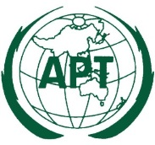 | ASIA-PACIFIC TELECOMMUNITY | Document No.:
 | The 3rd Meeting of the APT Preparatory Group for PP-22 (APT PP22-3) | APT PP22-3/INP-xx
 | 9-12 May 2022, Tokyo, Japan | xx March 2022

Country

Title

- ABSTRACT

[Please provide a short abstract of your proposal in this section]

- INTRODUCTION

[Please provide introduction of your proposal in this section]

- PROPOSAL

[Please provide details of your proposal in this section]

