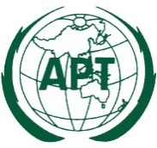 | ASIA-PACIFIC TELECOMMUNITY
The Meeting of the SATRC Working Group on
Spectrum
 | 21 – 23 June 2022, New Delhi, India (Republic of) | 7 April 2022

Chair, SATRC Working Group on Spectrum

Provisional Agenda

- Opening

- Approval of agenda

- Overview of the Strategic Plan of APT for 2021-2023

- Outcomes of the 22nd Meeting of SATRC (SATRC-22)

- Overview of the SATRC Action Plan Phase VIII (SAP-VIII)

- Review the previous activities of Working Group on Spectrum

- Discussion and adoption of the terms of reference for each Work Items and detail work plan:

- Approaches towards spectrum harmonization for 5G bands
- Evaluation of spectrum utilization in SATRC Member countries
- Regulatory approaches for sharing, trading, and leasing of spectrum
- Cross-border coordination for interference in SATRC countries
- SATRC action plans for the development of spectrum management infrastructure, procedure, and tools

- Related presentations by the Experts

- Discussion on the draft outcomes of the Work Items

- Any other matters

- Closing

