APT Report on

OPERATIONAL SCENARIOS AND RELEVANT NATIONAL REGULATORY EXPERIENCES UPON SYSTEMS OF TRAIN POSITIONING APPLICATION OF RSTT IN SOME APT COUNTRIES

No. APT/AWG/REP-108(Rev.1)
Edition: September 2022

Adopted by

28th Meeting of APT Wireless Group
6 – 14 September 2021, Virtual/Online Meeting

(Source: AWG-28/OUT-02)

First Revision at

30th Meeting of APT Wireless Group
5 – 9 September 2022, Bangkok, Thailand

(Source: AWG-30/OUT-04)

APT Report on
OPERATIONAL SCENARIOS AND RELEVANT NATIONAL REGULATORY EXPERIENCES UPON SYSTEMS OF TRAIN POSITIONING APPLICATION OF RSTT IN SOME APT COUNTRIES

Scope
Train positioning is one of the four main categories of RSTT application. This APT report provides information on operational scenarios of systems of train positioning application of RSTT in some APT countries, as well as their relevant national regulatory experiences.

Operational scenarios and relevant national regulatory experiences in Korea

2.1 Overview
Train position detection technology has been developed mainly for speed control of trains and train protection to prevent from the collision. Train control systems use various positioning technologies such as track circuit, axel counter, Doppler radar, and GNSS, etc and try to incorporate wireless communication technology such as balise, RF tag, etc.
Korean railway uses some train position technologies in the field. Basically, train positioning system on high speed train, e.g. KTX, is based on Balise operating at the 27.09-27.10 MHz in KNR (Korea National Railway) and KORAIL. Some railway systems have used WiFi technology and LTE-R system to get more accurate position, especially in subway line and/or Busan Metro.
Table 2-1 List of positioning system used in Korea
Detector | Medium | Positioning method | Transmission | Application | Remark
Infrastructure | Track circuit | Track circuit | Wired | Train control | block based detection
 | Axel Counter | Axel Counter | Wired | Sosa-Wonsi line, etc
 | Wi-Fi | Wi-Fi + Balise (compensation) | Wireless | Kimpo line
 | Loop coil | Loop coil | Wired | Uijeongbu line
Train Equipment | Balise | Balise + achometer | Wireless | KTCS-3 | Detection train movement continuously
 | Tag | Tag+ Tachometer | Wireless | Shinbundang line
 | GPS | GPS + Tachometer | Wireless | Korail
Train Equipment +  Infrastructure | Wi-Fi  GPS  LTE-R | Wi-Fi + GPS + LTE-R | Wireless | Busan Metro(Line 1)  (Aid driver) | Ground/Underground
 | Wi-Fi  LTE-R | Wi-Fi + LTE-R +  Tachometer | Wireless | Hanam line  (TTC backup) | Underground

Table 2-2 Wireless positioning system in Korea
No. | Name of the System | Frequency bands in use | Standards
1 | Balise | 27.09-27.10 MHz | KRCS C244-05
2 | WiFi | 2.4 GHz band
3 | LTE-R | 718-728 MHz (uplink),  773-783 MHz (downlink) | TTAS.KO-06.0438
4 | GPS | 1.5 GHz band

2.2 Position systems

2.2.1 Track circuit
Many trains operating in Korea is controlled by track circuit. Track circuit is installed by infrastructure and its usage is for train control.

2.2.2 Balise
Korail has developed and operates a standard which is a standardized train control system of the European Traffic Control System (ETCS) based on the European Railway Traffic Management System (ERTMS), which is called APT (Automatic Train Protection Trackside System).
Balise system is a vital system providing position information between train and trackside.
The system consists of the balise and the transmission equipment. Balises can provide fixed or variable content. The on-board transmission equipment consists of the antenna unit and the Balise Transmission Module (BTM). A reader device normally mounted in proximity to the track for communications with passing trains.
The balise is a transmission device that sends telegrams to the in-vehicle subsystem and is a ground device that transmits information in one direction (Up-link). Balise has two types : One is fixed balise always transmits a telegram stored in the balise itself and the other one is transparent data balise or controllable balise is connected to a Lineside Electronics Unit (LEU), which transmits dynamic data to the train, such as signal indications.
Since the balise has not direction dependent with respect to transmission through the air gap, it can be mounted horizontally where the short side of the balise is parallel to the track as much as possible and can also be mounted vertically.
The mounting surface of the sleeper must be flat. If the surface is not flat, there is a risk that the balise bends during installation, and it may cause the balise to fail. If the mounting surface is uneven, it is necessary to smooth the surface before mounting the balise.
A group of several balises close to each other is called a balise group where the balise transmits information to a higher-level system. Several balises (independently transmitting information) are called a balise group. Within the balise group, the minimum and maximum spacing must be observed between the balise and the minimum gap between the last and first balise of neighboring balise groups must be observed.
Table 2-3 Distance between balise
Item | Values | Condition (Speed)
Distance between balises in a specific balise group | dmin =2.3 m  dmax=12.0 m | Up to 160 km/h
 | dmin =3.0 m  dmax=12.0 m | 160 ~ 300 km/h
 | dmin =5.0 m  dmax=12.0 m | 300 ~ 500 km/h

In order to prevent balise crosstalk with in-vehicle balise equipment on both tracks, the balise must maintain a minimum distance between the two tracks.
The products manufactured in YooKyung Control (Inc) started one by one in a laboratory in Belgium in Europe. As a result, the decision of product acceptance and development documents went through the strict procedure of the final certification body, and finally received the Eurobalise SIL4.TSI certificate, the first in Korea.
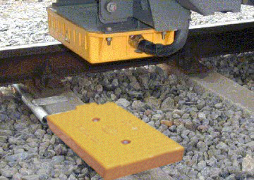
Figure 2-1 shows balise produced by YooKyung Control (Inc).

2.2.3 LTE-R
As Busan Metro has developed a positioning system collaborated with SK Telecom, this system has been operating in commercial lines in Busan.
As LTE based 700 MHz band system, LTE based Railway communication (LTE-R), provides position information based on radiocommunication services among railway entities including control centre, base station, or drivers in high-speed train. LTE-R system uses single channel for uplink and downlink.
Positioning information from LTE-R is complementary information to provide more accurate information of trains to control center. Basically, subway or Metro systems use position information from TTC (Telemetry Train Control) to deliver to the location server. At the same time, LTE-R communication module provides speed (distance) information from TCMS (Train Control Management System) to location server. Additionally, LTE-R communication module provides to location server position information through RSRP of RU in LTE-R System to trains. Then, location server decides present train position based on 3 types of information.
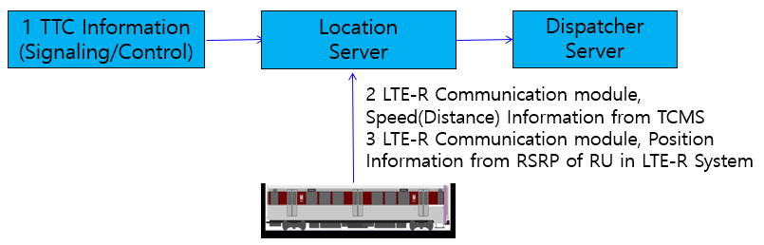
Figure 2-2 LTE based Railway Positioning System Architectural Concept

This LTE system is based on the 3GPP Release 13.

TABLE 2-4 Technical characteristics of LTE-R system
Parameter | System 1: (LTE-R)
Frequency range (MHz) | Uplink: 718-728 MHz  Downlink: 773-783 MHz
Number of channels | 1
Channel separation (kHz) | 10 MHz
Antenna gain (dBi) | –
Polarization | –
Transmitting radiation power (dBm) | 23 dBm (UE), 46 dBm (BS)
e.i.r.p. (dBm) | –
Receiving noise figure (dB) | –
Transmission data rate | Downlink: Max 75 Mbit/s,  Uplink: Max 37 Mbit/s
Transmission distance (km) | Above 2 km
Modulation | Downlink: OFDMA  Uplink: SC-FDMA
Multiplexing method | Full Duplex FDD

2.2.4 WiFi
Kimpo line, Busan Metro and Hanam line, etc are using WiFi system for positioning of trains with other systems.

Operational scenarios and relevant national regulatory experiences in China

3.1 Overview
In Railway industry, obtaining real-time position information of trains is very important to the safe and stable railway operation and organization. Nowadays, the railway networks increase the operational density so as to provide better services. It also brings the heavy burden of train controlling, system monitoring, and dispatching. Therefore, the application of train positioning is very important. In China, typical implementations of train positioning application are Balise system, and Automatic Equipment Identification system (AEI).

3.2 Balise System
China implements Balise system in railway industry. The system has the balise installed at intervals along the track and the transmission equipment (reader) installed on the train. When the train passes by the balises, the on-board reader will read and store the position data information so as to realize the train positioning. By using the Balise system, the Chinese Train Control System Level 3 (CTCS-3) supported by GSM-R technology can provide real-time train position information. The operating frequency used for this system are: 27.095 MHz (for on-board equipment), and 3.951 MHz/4.516 MHz (for balise in the tracks).
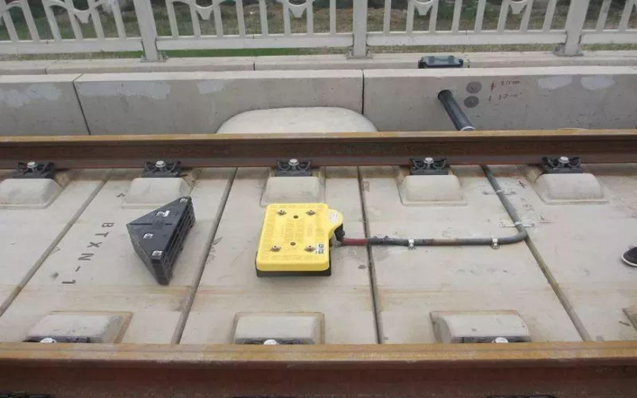
Figure 3-1 Balise used in Chinese high-speed railways

3.3 Automatic Equipment Identification (AEI) System
The AEI system in China is mainly designed for the freight rail’s automatic identification of train numbers and coach numbers, through which the relevant railway staff can identify the position of the train. This information provides much help to the railway transportation management system.
The AEI system is also a RFID-like system, and composed of on-board electronic tags, between-track AEI equipment, and other auxiliary elements. The operating frequency of AEI system is 910.1 MHz, 912.1 MHz, and 914.1 MHz, with occupation bandwidth of 5 kHz.
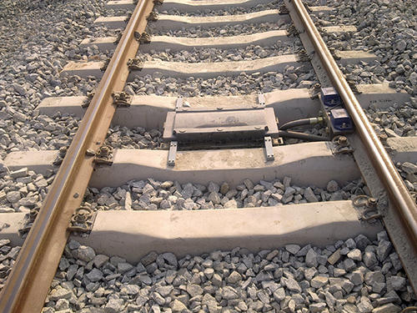
Figure 3-2 AEI equipment used in Chinese freight railways

Operational scenarios and relevant national regulatory experiences in Japan

4.1 Overview
In order to operate trains safely, it is necessary to know the position of the train. The train positioning systems related to the RSTT used in Japan are shown at table 4-1. Although the systems that transmit information by wire, such as track circuits of the most used train position detection system in Japan, axle counters and loop coils are not included in the definition of RSTT, these are also introduced in Section 4.2 for reference.

Table 4-1 List of positioning system used in Japan
Detector | Medium | Positioning method | Transmission | Application | Remark
Train Equipment | Balise | Balise  + Tachometer | Wireless | JRTC | continuous train movement detection
 |  |  | Wireless  (one way) | Onboard system of ATS-Dx
Train Equipment  + Infrastructure | Track Circuit  Balise  Tachometer | Track Circuit  + Balise  + Tachometer | Wireless  (one way) | Onboard system of Digital ATC | continuous train movement detection  In some systems, balise is not used

4.2 Positioning systems

4.2.1 Balise
The balise system installs a position-correcting ground coil to prevent the accumulation of errors in the method of calculating the distance of the run by the tachometer generator.

4.2.2 Track circuit
The track circuits system uses the rails as part of the electrical circuit to detect changes in the impedance between the rails as the wheels short-circuit the rails when a train is present within a certain section. It is the most popular train position detection system in Japan.

4.2.3 Axle Counter
The axle counter system detects trains by installing a detector on the rail and counting the number of wheels.

4.2.4 Loop coil
The loop coil system uses transmitters at the front and rear of the train and a loop coil on the ground to detect the train by receiving radio waves from the vehicles. The detected information is transmitted by wire.

Summary

The knowledge of the positions of all trains and other vehicles on the tracks in normal and high-speed operations is one of the essential information to provide for railway traffic control, passenger safety, and security of train operations. The information in this report are examples of APT Members’ implementation of train poisoning application, for reference.

Reference
- Subset 036, ERTMS/ETCS Class 1 FFFIS for Eurobalise, ERA, Sep 27, 2007
- Report ITU-R M.2442 Current and future usage of railway radiocommunication systems between train and trackside
- http://www.ykcontrol.com/
- http://www.neotrans.kr/eng/
- https://www.ulrt.co.kr/
- https://www.sosawonsi.co.kr/
- http://www.korail.com
- https://www.shinbundang.co.kr/eng/index.jsp
- http://gimpogoldline.com/
- https://www.humetro.busan.kr/english/main.do
- TB/T 3485-2017-Technical Specification of Balise Transmission System

__________________

