The 5th Meeting of the APT Conference Preparatory Group for WRC-23 (APG23-5)
20 – 25 February 2023, Busan, Republic of Korea

INFORMATION FOR PARTICIPANTS

The 5th Meeting of the APT Conference Preparatory Group for WRC-23 (APG23-5) will be held from 20 to 25 February 2023 in Busan, Republic of Korea. The meeting will be organized by the Asia-Pacific Telecommunity (APT) and hosted by the Ministry of Science and ICT (MSIT), Republic of Korea. APG23-5 will be held with physical attendance as well as virtual/online participation through Zoom meeting platform (i.e., hybrid meeting).

The detailed arrangements are as follows:

- VENUE

BEXCO Exhibition Center 2
Address: 30, APEC-ro, Haeundae-gu, Busan, Korea (48060)
Phone: +82 51 740 7300
URL: BEXCO Exhibition CenterⅡ

- PARTICIPATION

All APT Members, Associate Members, Affiliate Members, International/Regional Organizations, and Eligible Non-Members can participate in the meeting by registering online through the APT Website.

Administrations of Members and Associate Members and International/Regional Organizations are kindly requested to send the official list of delegations for the meeting and to nominate Head of Delegation (HoD) and Alternate HoD. If any APT Affiliate Member is included in the National Delegation, please clearly mention in the List of Delegation.

Participation of Non-Members: Non-Members cannot attend the meeting. Non-Member participants under national delegation are allowed once their names are included in the official list of delegation. Non-member participation from the host country, Republic of Korea, are allowed as ‘Observers’ once they are approved by the Ministry of Science and ICT, Republic of Korea.

Please indicate the mode of your participation at the online registration form. Please check the latest information on COVID-19 measures for travelling to Republic of Korea. Since the number of physical attendances influences some preparations for the meeting venue and other arrangements, your administration/organization is kindly requested to register delegates for physical attendance preferably by the date specified in the following section.

Virtual participation will be arranged by using Zoom meeting platform. Detail information for virtual participation will be sent to the registered delegates who wish to attend virtually.

- REGISTRATION:

Registration of delegates can be done online at https://www.apt.int/content/online-registration.
For planning and logistical arrangements it is suggested to register on or before 1 February 2023.

- HOTELS FOR ACCOMODATION:

Following hotels are recommended for the accommodation of the delegates during the meeting:

  - Centum Premier Hotel (Recommended Accommodation)

Address: 17, Centum1-ro, Haeundae-gu, Busan, Republic of Korea (48060)
Phone : +82 51 755 9000
Email: premier_rsvn@premierhotel.co.kr
Website: http://www.premierhotel.co.kr/

< Centum Premier Hotel for APG23-5 Rates >
Room Type | Rates / Night | Deadline of Reservation
Superior Double | KRW 77,000 | 20 January 2023
Superior Twin | KRW 88,000
Deluxe Double | KRW 99,000
Deluxe Twin | KRW 110,000
- Breakfast is available with extra charge of KRW 17,600 each person.
- Weekend rate : + KRW 11,000

  - Haeundae Centum Hotel

Address: 20, Centum3-ro, Haeundae-gu, Busan, Republic of Korea (48060)
Phone : +82 51 720 9907
Email: ecentumhotel@gmail.com
Website: www.ecentumhotel.com
< Haeundae Centum Hotel for APG23-5 Rates >
Room Type | Rate / Night | Deadline of Reservation
Deluxe Double | KRW 110,000 | 3 February 2023
Deluxe Twin | KRW 110,000
- Breakfast is not available.
- Weekend rate : + KRW 30,000

  - Paradise Hotel Busan

Address: 296, Haeundaehaebyeon-ro, Haeundae-gu, Busan, Republic of Korea (48060)
Phone : +82 51 742 2121
Email: res@paradisehotel.co.kr
Website: https://www.busanparadisehotel.co.kr/

< Paradise Hotel Busan for APG23-5 Rates >
Room Type | Rates / Night | Deadline of Reservation
Deluxe(City) Double, Twin | KRW 229,900 | 20 February 2023
Deluxe(Ocean) Double | KRW 254,100
Deluxe(Ocean Terrace) | KRW 302,500
- Breakfast is available with extra charge of KRW 42,350 each person.
- Weekend rate : + KRW 48,400
Accommodation rates quoted are:
- All rates are tax-inclusive
- All rooms with free Wi-Fi service
- Please see the hotel reservation form enclosed to this for detailed information

- TRANSPORTATION FROM THE AIRPORT TO THE VENUE:

Delegates are encouraged to arrange their own airport transfer to the venue. Transfer from the airport to the venue will take approximately 1 hour (depending on traffic).

For your information, the following transportation options are available from the Gimhae Airport to the venue:
- Taxi
There is a taxi rank directly as you exit the terminal. You can expect to pay KRW 30,000 each way. It is approximately a 45minute trip.

- Subway
Airport Station(Busan-Gimhae Line) →Sasang Station(Line 2) → Centum City(BEXCO) Station : Exit No.1 / The fare is KRW 2,000 and it is approximately 55minuate trip.

< Subway Lines >
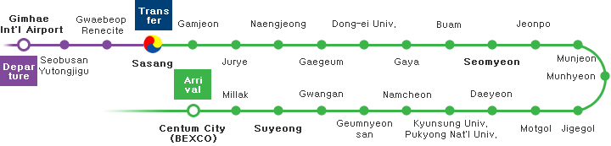

- VENUE LOCATION MAP

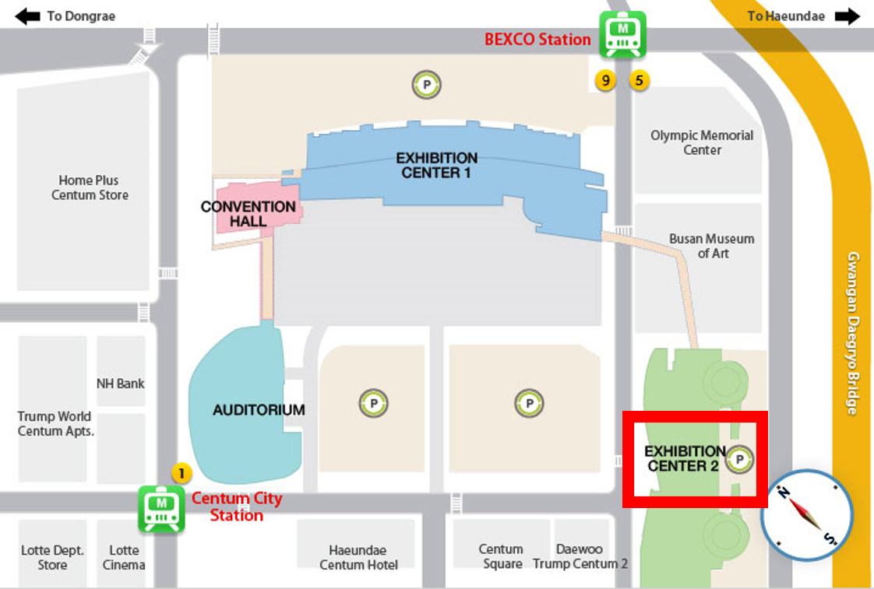

- Centum City (BEXCO) Station, Line 2 > Exhibition Center 2 : Exit No. 1, Centum City Station; approx. 380m to Exhibition Center 2 next to Auditorium

- BEXCO Station, Line 2 > Exhibition Center 2 : Exit No. 5, BEXCO Station; approx. 453m to Exhibition Center 2 next to Busan Art Museum

- MEETING WEBSITE, MEETING DOCUMENTS AND CONTRIBUTION GUIDELINE

Related information about the meeting and provisional meeting documents will be available at the APT Website at: https://www.apt.int/2023-APG23-5

Contributions for the meeting from APT Members, Associate Members, Affiliate Members, regional and International Organizations are welcome. You are requested to use the proper document template for your contribution. Please refer to the ‘Information for submitting contributions to APG23-5’ for detail process of submitting the contribution. The ‘Information for submitting contributions to APG23-5’ is available at the website mentioned above and embedded here as well. Contributions will be posted on APT Website prior to the starting of the meeting.

Last date of receipt of your contributions by the APT Secretariat is 13 February 2023. To submit contributions and any information on the documentation, please contact us as aptapg@apt.int.

In order to facilitate efficient meeting management and document handling process, the APT encourages the use of electronic documents during the meeting. Electronic copies of the meeting documents will be available online.

- WIRELESS LAN:

Internet Access over wireless network will be available during the meeting. Participants who wish to utilize the wireless facility are kindly requested to bring their own laptop computers with Wi-Fi capability.

- VISA AND IMMIGRATION INFORMATION:

A visa may be necessary for participants from some countries to enter Republic of Korea. To check the visa requirements please contact the Republic of Korean Embassy in your country. Kindly visit the Ministry of Foreign Affairs at https://www.visa.go.kr/ for more details.

Those participants who need the visa-supporting documents for entering Korea are strongly advised to fill out completely the “Visa Supporting Letter Request Form in Annex I” and send the form together with a “Copy of your passport (photograph page)” to the contact point below by 7 February 2023. As requirements for visa application in your country change from time to time, please check with your nearest Embassy of the Republic of Korea for your visa requirements before departure. Advance submission of applications is recommended.

For VISA support, please contact at:
Local Secretariat (Korea)

Korea Radio Promotion Association (RAPA)
3, Mokdongjungang-ro 13na-gil, Yangcheon-gu, Seoul 07969, Rep. of Korea
Phone: +82 2 317 6052
Fax: +82 2 317 6061
Email: apg23-5@rapa.or.kr

- INSURANCE AND MEDICAL EMERGENCIES:

Due to the procedural difficulties and budgetary constraints, the APT and Local Secretariat are not able to bear the cost of insurance for the participants, any medical expenses or any other expenses. The APT and Local Secretariat, therefore, request your administrations/organizations to kindly make necessary arrangements for insurance and medical coverage of your participants before traveling to Republic of Korea.

- PRACTICAL INFORMATION:

Tourist Information: Busan is the largest port city of the Republic of Korea, filled with endless excitement and pleasant surprises. Every year, tens of thousands of visitors from home and abroad flock to the city’s glistening beaches to relax or to enjoy marine activities. The city annually hosts internationally renowned events such as the Busan International Film Festival (BIFF) and Busan One Asia Festival (BOF) to add more joy and fun for visitors.

For more information, you are encouraged to check out the following website:
https://www.bto.or.kr/eng/Main.do

Climate: The average temperature in Busan in February is between 0 and -3 degree Celsius. Please take a look at http://web.kma.go.kr/eng/index.jsp

Time Zone: UTC+9 hours

Banks & Currency: The unit of Korean currency is Korean Won (KRW). The exchange rate as of Oct 2022 is KRW 1,427.50 to 1 USD. Automated teller machines (ATM) are widely accessible throughout Republic of Korea.

Electricity: Supply voltage is 220V, 60Hz. Please ensure you bring the correct adapter for your equipment.

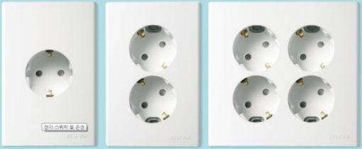 Korean outlet and power cord.

Emergencies: Police 112, Fire Department 119, Medical Emergencies 1339

Business Hours: Government offices are open from Monday to Friday between the hours of 09:00 and 18:00. Most private businesses open anywhere from 08:30 to 22:00. Banks are a major exception. Their business hours are from 09:30 to 15:30 on weekdays. They are closed Saturdays and Sundays. Major departments stores are usually open from 10:30 to 20:00, including Sundays, but smaller shops open earlier and close later every day of the week.

- MICE INFO:
Location: BEXCO Auditorium 1st Floor
Language Service: Korean, English, Chinese
Onestop Service: International conference schedule information, airport bus usage information, tourist program information, accommodation facility information, shopping facility information, cultural facility information

- CONTACT INFORMATION:

APT Secretariat  Asia-Pacific Telecommunity (APT)  12/49 Soi: 5 Chaeng Watthana Road  Bangkok 10210, Thailand  Phone: + 66 2 573 0044  Fax: +66 2 573 7479  E-mail: aptapg@apt.int | Local Secretariat (Korea)  Korea Radio Promotion Association (RAPA)  3, Mokdongjungang-ro 13na-gil, Yangcheon-gu, Seoul 07969, Rep. of Korea  Phone: +82 2 317 6052  Fax: +82 2 317 6061  Email: apg23-5@rapa.or.kr

ANNEX I
*Please fill in the following form and attach a copy of your passport to get support on your visa application. Please be informed that this is NOT THE REGISTRATION FORM. Registration can be done only online.
The 5th Meeting of the APT Conference Preparatory Group for WRC-23 (APG23-5)
20 – 25 February 2023, Busan, Republic of Korea
VISA SUPPORTING LETTER FORM
PERSONAL INFORMATION:
First Name (Mr./Ms./Mrs./Dr.) ____________________________ Last Name :
Administration/Organization
Present Post (Title)
Business Address
Country _______________________________ Phone No
Fax No _______________________________ E-mail address
Are you representing your Country’s Administration? : Yes No
If “Yes” what’s your position in the delegation: Head of Delegation (HoD) Alternate HoD Delegate
MEMBERSHIP STATUS: (Please tick which is appropriate for your membership status.
Non-Members please contact the APT Secretariat for participation with Registration Fees.)
1. Administration 2. Associate Member 3. Affiliate Member
4. International/Regional Organization 5. Non Member _________________________________________
PASSPORT INFORMATION FOR VISA: (Do not Provide if Visa Request Letter not Required)
Passport No. ____________________ Date of Issue _________________ Expiry Date
Place of Issue ___________________ Date of Birth _________________ Place of Birth
Nationality _____________________ Place of getting visa
If the first time to Rep. of Korea? Yes No
FLIGHT INFORMATION:
Arrival Flight (Flight No./Date/Time)
Departure Flight:(Flight No./Date/Time)
HOTEL ACCOMMODATION:
Centum Premier Hotel Haeundae Centum Hotel Busan Paradise Hotel
Other
Check-in Date Check-out Date Period of Stay : nights
PARTICIPATION IN THE WELCOME DINNER on 20 Feb (Monday) Yes No
DIETARY PREFERENCE Vegetarian Halal No dietary preference
Signature. __________________________________________________________ Date
Please use CAPITAL LETTERS to complete the form and return it to Korea Radio Promotion Association (RAPA) (Email: apg23-5@rapa.or.kr). Please do not send it to the APT Secretariat.

