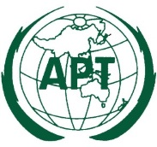 | ASIA-PACIFIC TELECOMMUNITY | Document No.:
 | The 10th Meeting of the Working Group of Management Committee on APT Legal Instruments (WGMC-10) | WGMC-11/ADM-01
 | 1 – 2 August 2023, Bangkok, Thailand | 9 June 2023

Chair, Working Group of Management Committee on
APT Legal Instruments (WGMC)

PROVISIONAL AGENDA

- Opening

- Adoption of the Agenda

- Outcomes of the 46th Session of Management Committee of the APT relevant to the WGMC

- Guideline on Selection of External Auditor

- Issues Relevant to Code of Conduct

- APT legal instruments, working methods of Preparatory groups and existing MoUs

  - Arrangement of Preparatory Meetings

- Date and Venue of WGMC-12

- Any other matters
  - Hosting Requirement of APT Work Programme

- Closing

