

**APT REPORT ON**

**ultra wide band (uwb)**

**No. APT/AWG/REP-01(Rev.3)  
Edition: March 2024**

**Adopted by**

**32nd Meeting of APT Wireless Group  
4 – 8 March 2024, Pattaya, Thailand**

***(Source: AWG-32/OUT-14)***

**APT REPORT ON**

**ULTRA WIDE BAND (UWB)**

**TABLE OF CONTENTS**

1 INTRODUCTION 3

**1.1** **Commercial UWB Products** 3

**1.2** **Social and Economic Impact** 3

2 UWB APPLICATIONS 4

**2.1** **UWB Ranging systems** 4

**2.2** **UWB Communications Systems** 5

**2.3** **UWB Imaging Systems** 5

**2.4** **UWB Automotive Radar** 5

3 Regulatory Activities by APT Members 5

4 CONCLUSION 6

5 REFERENCES 7

6 ANNEXES 10

Annex A: UWB REGULATORY DEVELOPMENTS 10

**A.1** **Federal Communications Commission (FCC)** 10

**A.2** **Electronic Communications Committee (ECC)** 10

**A.3** **International Telecommunication Union (ITU)** 11

Annex B: Japan’s UWB Emission Mask 13

Annex C: Korea’s UWB Emission Mask 14

Annex D: China’s UWB Technical Requirements 15

Annex E: FCC’s UWB Emission Mask 16

Annex F: Europe’s UWB Emission Mask 17

Annex G: UWB Regulatory Framework in APT and other regions 21

1 INTRODUCTION

Traditional radio systems use dedicated frequency spectrum for sending and receiving radio signals in order to mitigate interference effects. Contrary to this approach, Ultra-Wideband (UWB) technology, as its name suggests, operates by spreading its radio signals across a very large frequency band (typical bandwidth > 500 MHz). UWB transmissions will usually be low-power and will operate in frequency bands already allocated to other radiocommunication (e.g. satellite services, microwave links and radiolocation), including those licensed exclusively to commercial entities for their use (e.g. cellular mobile operators and wireless broadband access operators).

Therefore, UWB transmission is designed to not cause interference to other radiocommunication services and not claiming any protection from those services.

**1.1 Commercial UWB Products**

Commercial UWB products are starting to be widely available with bandwidth of more than 500 MHz. In 2019 Jaguar Land Rover first launched vehicles equipped with UWB for secure entry solutions which now includes BMW and Hyundai among others while Apple, Google, Samsung and Xiaomi began releasing mobile phones with UWB since 2019. For the automotive industry, many manufacturers such as Mercedes Benz are using UWB technology for collision avoidance world-wide.

**1.2 Social and Economic Impact**

One data point that supports the expected growth of UWB is from ABI Research. Figure 1 shows that UWB-enabled devices shipped globally are poised to grow to over 1 billion devices by 2025. In fact, the UWB market is projected to grow by double digit percentages for the foreseeable future.[1]

**Figure 1** UWB-Enabled Device Shipments, 2020 to 2026

Source: ABI Research

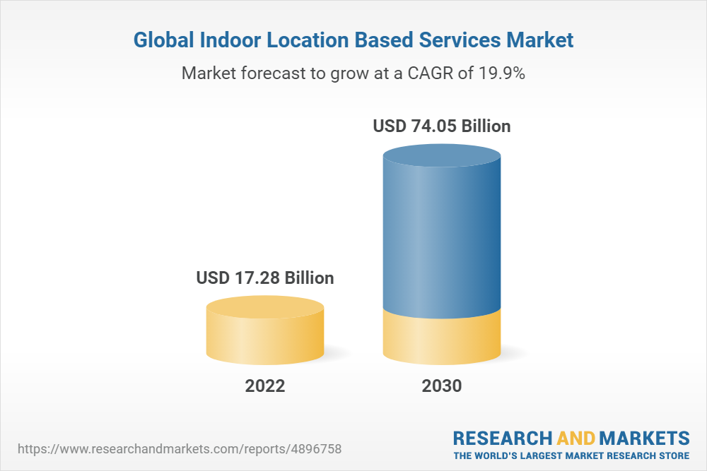

The other segments driving growth of UWB are Internet of Things (IoT) and Real-Time Location Systems (RTLS). There is a rising demand for UWB technology in RTLS applications. In a report published in April 2023, MarketsandMarkets estimated that the global indoor location market will grow from about $8.8 billion in 2022 to $24 billion by 2027, a CAGR of 22.4%.[2]

Furthermore, as shown in Figure 2 to the right, a report from Research and Markets indicated that the global indoor location-based services market size was estimated at USD 17.28 billion in 2022, and is projected to grow at a CAGR of 19.9% to reach USD 74.05 billion in 2030.[3]

**Market forecast to grow at CAGR of 19.9%**

**Figure 2** The Global Indoor Location-Based Services Market

Source: Research and Markets

# 2 UWB APPLICATIONS

In general, UWB devices can be broadly categorised based on different types of UWB applications, according to its potential to cause interference to the existing radiocommunications services. UWB applications can be categorised into communications systems, imaging and vehicular radar. Accordingly, specific emission limits and operation guidelines can be designed to mitigate interference for each type of UWB application.

**2.1 UWB Ranging systems**

Utilizing the wide bandwidth (>500 MHz) characteristics, UWB technology has further evolved from the high data rate wireless communication system to an impulse radio technology which can support accurate distance measurement between devices or an infrastructure. This spatial context capability can be utilized by a variety of applications, including hands-free access control, location-based services, and device-to-device (peer-to-peer) services. In terms of commercialization initial solutions based on UWB ranging were deployed for industrial indoor asset tracking. In recent years, UWB secure ranging based on IEEE 802.15.4z has been implemented and deployed in mobile handsets, automotive entry systems as well as IoT devices. To further facilitate the adoption of UWB ranging technologies and its associated applications, leading industry members have joined together to create industry consortiums such as FiRa Consortium or Car Connectivity Consortium.

**2.2 UWB Communications Systems**

Consumer UWB devices are generally categorised as being short-range UWB communications systems that will be used for high data rate wireless connections between computers, digital cameras, players, displays and various consumer products meant for the mass market. The primary advantage is low power consumption and thus provides longer battery life for portable devices. However, it should be noted that in contrast to the originally assumed use cases the deployment of UWB has mainly focused on location tracking and low data rate communications (see 2.1). High and ultra-high data rate UWB systems did not materialise. Rather, WAS/RLAN systems became the dominant technologies for high and ultra-high data rate transmissions. This means a significant reduction of the number of devices and assumed activity factors used in Report ITU-R SM.2051.

**2.3 UWB Imaging Systems**

The use of UWB imaging systems in the frequency bands below 960 MHz and 3.1GHz – 10.6 GHz has now expanded from military to public security and protection purposes. UWB radar systems can be used to detect people buried underground or behind walls after disasters or accidents. It is also commonly used in the construction and maintenance industry to detect and locate reinforcement bars, electric wiring and pipes inside concrete/walls. Nowadays, UWB imaging systems is being developed for innovative types of imaging systems for medical diagnostic and industrial use.

**2.4 UWB Automotive Radar**

A global alliance of motor vehicle and electronics manufacturers has established an international standard known as Short-range Automotive Radar frequency Allocation (SARA). Its aim is to push forward the adoption and worldwide implementation of automotive collision avoidance radar systems for enhancing the safety of drivers and passengers. UWB automotive radar-enabled vehicle is already available in some European countries, USA and Australia. With regard to spectrum allocation, the FCC and ECC have opened up the 79 GHz bands for the operation of automotive short range radar.

# 3 Regulatory Activities by APT Members

In Asia Pacific region, some APT member countries like Japan and Korea have implemented regulatory framework to permit unlicensed use of UWB devices in indoor environment, while others like Singapore and Hong Kong have established UWB trials within localised zones. In the case of Singapore, a UWB Friendly Zone (UFZ) was created in 2003 in the Science Park II for UWB developers to conduct realistic field experiments, and later defined a Technical Specification to allow the use of UWB. Hong Kong, on the other hand, allocates the 3.1-10.6 GHz band for UWB indoor trials and the 4.2-10.6 GHz band for outdoor trials around 2008 and defined the performance specifications in 2018.

In Japan, the preliminary mask for UWB was announced back in September 2005. Subsequent compatibility studies show that UWB devices operating in the 3400-4200 MHz band should incorporate interference mitigation techniques. However, devices were allowed to operate in the 4200-4800 MHz band without mitigation techniques until end of December 2010. Other technical conditions are imposed for UWB radio systems operating in the 3.4 to 10.25 GHz band. It had been limited to indoor use, however, in recent years, along with the diversification of wireless communication applications, high-precision positioning and object detection are expected to be installed in mobile devices and automobiles. As the needs for outdoor usage have increased, in 2018, the technical conditions for enabling outdoor use of frequencies from 7.587 GHz to 8.4 GHz were studied and the outdoor UWB radio system was institutionalized in 2019. Furthermore, in response to the need for band expansion for outdoor use and the need for radiolocation applications such as human sensors, the outdoor UWB radio system with including radiolocation from 7.25 GHz to 9.0 GHz was institutionalized with the condition that it’s operated without causing harmful interference to SRS earth stations, RAS stations, RLS stations and RNS stations in 2021 (see Annex B for Japan’s emission mask).

For Korea, the spectrum allocation for UWB starts in the frequency band from 4.2 to 10.2 GHz. The Ministry of Science and ICT (MSIT) of republic of Korea announced the revised UWB regulation in December 2022[4]. Under the previous UWB regulation, only Channel 9 of UWB (7737.6 ~ 8236.8 MHz) was allowed for mobile device usage. To expedite the new UWB technology upon the requests from industries, the MSIT opened up more UWB bands for mobile device from 6 to 8.8 GHz.

For China, Ministry of Industry and Information Technology (MIIT) has open the public consultation for “Ultra-Wideband (UWB) Equipment Radio Management Regulations” in 2023[5]. The Ultra-wideband (UWB) radio transmission equipment as mentioned in this regulation refers to radio transmission equipment with a transmit signal bandwidth (-10dB bandwidth) of not less than 500MHz, mainly used in short-distance high-speed wireless data communication, positioning, ranging, sensing and other application fields. The operating frequency band is from 7235 MHz to 8750 MHz. The use of UWB shall not cause harmful interference to other radio services, nor claim protection from other radio services. If any interference generated from UWB to other services, the UWB device should stop operation immediately, and could resume operation only when the harmful interference is mitigated. The UWB is prohibited to use in the distance of 1 km from the RAS stations. The UWB is prohibited to use on the aircraft.

Annex G contains the UWB regulatory framework in some of the APT members and other regions.

# 4 CONCLUSION

In view of the UWB product and regulatory developments, APT members should actively prepare for pervasive use of UWB devices and formulate a regulatory framework to manage the risk of interference from UWB devices to the existing radiocommunication services while operating in a non-interference and non-protection basis. The ITU recommends that Administrations consider a regulatory framework with minimal administrative procedures, technical specifications and national regulations, which still provides the regulation and mitigation necessary to protect existing services. The USA, Europe, Korea , Japan and many others have already adopted a regulatory approach of allowing licence-exempt or class licence operation of UWB devices. Further evolutions to the regulatory framework have also been implemented, e.g. in Europe.

Whilst some countries have restricted the use of unlicensed UWB devices to indoor environment, it is possible that such restrictions are likely to be relaxed in future when mitigation techniques (e.g. minimum separation distance with affected services) are proven to be effective in reducing interference. In this regard, APT members may introduce operating restrictions based on individual regulatory requirements and use Annex G to assist in formulating a UWB regulatory framework. APT members might provide their findings to the AWG with regard the impact of UWB devices on existing services and vice versa. This information would provide APT members with additional information in choosing an appropriate regulatory framework for UWB devices

Going forward, it is suggested that APT members look into harmonising the UWB regulatory framework considering the following guidelines:

1. To allow deployment of UWB devices in parts of the bands below 10.6 GHz while ensuring protection of existing and planned stations of radiocommunication services nor claim protection from other radio services in band and in adjacent band.
2. To adopt licence-exempt or class licensing approach for operating UWB devices;
3. To license UWB Imaging devices on a case-by-case basis;
4. To cap the maximum e.i.r.p. spectral density in a range of -90 dBm/MHz to -41.3 dBm/MHz for licence-exempt or class licence devices - depending on different bands, different UWB applications **whilst incorporating notching requirements , limitations and/or sharing mechanisms to ensure protection of existing** and planned stations of other radiocommunication services in the bands and adjacent bands where UWB is to be operated; and
5. To conduct studies to evaluate coexistence between UWB and other radio services, considering the expected massive use of UWB devices;
6. To consider implementing other mitigation techniques to protect the existing and planned radiocommunication services allocated in relevant frequency bands (for indoor/outdoor systems).

# 5 REFERENCES

[1] FCC 02-48, “Revision of Part 15 of the Commission’s Rule Regarding Ultra-Wideband Transmission Systems”, First Report and Order, ET 98-153; adopted: February 14, 2002; released: April 22, 2002.

[2] FCC 04-285, “Revision of Part 15 of the Commission’s Rule Regarding Ultra-Wideband Transmission Systems”, Second Report and Order and Second Memorandum Opinion and Order, ET 98-153; adopted: December 15, 2004; released: December 16, 2004.

[3] ECC Report 64, “The Protection Requirements of Radio-Communications Systems Below 10.6 GHz from Generic UWB Applications” by Helsinki, February 2005.

[4] ECC/DEC/(06)04, “ECC Decision of 24 March 2006 amended 6 July 2007 at Constanta on the harmonised conditions for devices using Ultra-Wideband (UWB) technology in bands below 10.6 GHz”, released: March 2006 and amended 18 November 2022.

[5] ECC/DEC/(07)01, “Report from CEPT to the European Commission in response to the Fifth Mandate to CEPT on ultra-wideband technology”, released: March 2007 and amended 1 July 2022

[6] Commission Implementing Decision (EU) 2019/785 of 14 May 2019

[7] ECC Report 094, “The technical requirements for UWB LDC devices to ensure the protection of FWA systems”, by Nicosia,December 2006.

[8] Commission Decision 2007/131/EC on allowing the use of the radio spectrum for equipment using ultra-wideband technology in a harmonised manner in the Community, released: February, 2007.

[9] Recommendation ITU-R SM.1754,” Measurement techniques of ultra-wideband transmissions”.

[10] Recommendation ITU-R SM. 1755,” Characteristics of ultra-wideband technology”.

[11] Recommendation ITU-R SM. 1756,” Framework for the introduction of devices using ultra-wideband technology”.

[12] Recommendation ITU-R SM. 1757,” Impact of devices using ultra-wideband technology on systems operating within radiocommunication services”.

[13] AWF-3/14, “Technical Conditions on UWB Radio Systems in Japan”, by MIC, Japan.

[14] AWF-3/23(Rev.1), “Proposed Working Document Toward Preliminary Draft Recommendation APT [UWB] Spectrum Use For Ultra Wideband (UWB) Technology”, by Republic of Korea.

[15] AWF-4/INP-23, “Proposed Modification of Draft AWF Report on Ultra-Wideband (UWB)”, by Republic of Korea.

[16] [AWG-25/INP-87(Rev.1)](https://www.apt.int/sites/default/files/2019/06/AWG-25-INP-87Rev.1_VTN-7.docx), “Proposal of updating the Status of Viet Nam to APT Report on Ultra Wide Band (APT/AWG/REP-01Rev.1)’’ by Viet Nam (S.R.of).

[17] CEPT Report 084, “Ultra-Wideband technology review in view of a potential update of Commission Implementing Decision (EU) 2019/785”, by ECC, approved on 7 July 2023

[18] ECC Report 094 (‘Technical requirements for UWB LDC devices’, December 2006)

[19] ECC Report 120 (Technical requirements for UWB DAA (Detect and Avoid) devices, Jun 2008)

[20] ECC Report 167 (Practical implementation of UWB LT2 systems, May 2011)

[21] ECC Report 170 (Location Tracking Applications for Emergency Services (LAES), location tracking applications type 2 (LT2) and location tracking and sensor applications for automotive environments (LTA), Oct 2011)

[22] ECC Report 175 (UWB applications inside aircraft, Mar 2012)

[23] ECC Report 234 (Analyses of LDC UWB mitigation techniques, May 2015)

[24] ECC Report 251 (The impact of UWB applications on board aircraft, Mar 2016)

[25] ECC Report 278 (Location tracking and sensor applications (LTA) for vehicular access systems, April 2018)

[26] ECC Report 327 (Update of the UWB regulatory framework in the band 6.0 GHz to 8.5 GHz, Oct 2021)

[27] AWG-32/INP-38, “Proposed modification to APT Report on Ultra-Wide Band (UWB) ” by Indonesia (Republic of).

# 6 ANNEXES

# Annex A: UWB REGULATORY DEVELOPMENTS

**A.1 Federal Communications Commission (FCC)**

In view of the unclear impacts cause by UWB devices, the FCC adopted a cautious approach in devising its standards in the First Report & Order (R&O) on UWB technology. FCC believes that the combination of technical standards and operational restrictions will help to ensure that UWB devices can coexist and give adequate protection to other radiocommunication services.

Since 2004, there has been significant change in UWB use cases. UWB initially was expected to be used for wireless communication and in wall/ground penetrating devices. However, today UWB innovations are being driven by low-power, precision location and sensing applications, which demand different regulatory limitations.

Therefore, while the FCC rules have not changed, there have been a large number of FCC waiver requests, to enable the deployment of new UWB use cases and applications. Especially, in recent years, FCC has granted many waivers to facilitate such deployments.

**A.2 Electronic Communications Committee (ECC)**

In comparison with the FCC rules and technical specification, the ECC recommendations appear to be more stringent. Unlike the FCC which has 3 types of UWB devices, ECC considers 4 main types of UWB systems that operate below 10.6 GHz:

1) Generic UWB systems; 2) radio determination and radio location systems; 3) vehicular UWB systems and 4) UWB material sensing systems.

ECC regularly updates its Decision to address the evolving needs of the UWB industry based on sharing and compatibility studies documents in ECC Reports [18 - 26] in section 5.

ECC Decision (06)04 now contains regulatory conditions for

* Generic UWB applications (No fixed outdoor, no aviation and no vehicular use)
* UWB applications in road and rail vehicles (3 complementary sets of conditions)
* Specific applications involving fixed outdoor installations
* Specific applications involving enhanced indoor devices (allowing 10 dB extra transmit power)

In addition, ECC has a separate ECC Decision (07)01 [5] for UWB based material sensing applications based on:

* ECC Report 123 (The impact of Object Discrimination and Characterization (ODC) applications, Oct 2008)
* CEPT Report 045 (Report from CEPT to the European Commission in response to the Fifth Mandate to CEPT on ultra-wideband technology, June 2013)
* CEPT Report 069 (Report from CEPT to the European Commission in response to the Mandate on UWB, October 2018).

Both ECC Decisions are also integrated in a European Commission Decision on UWB [6] and are therefore harmonized across the entire European single market. This EC Decision is expected to be updated based on CEPT Report 084 [17] which was finalized in July 2023.

**A.3 International Telecommunication Union (ITU)**

As resolved at the ITU, UWB devices should not cause harmful interference to a radiocommunication service and shall not claim protection from interference to which they may be subjected. In other words, UWB devices are expected to operate on a non-interference and non-protection basis. The ITU, however, is unable to concur on a common emission mask (a set of maximum power limits for UWB to operate in the different frequency bands).

ITU has completed its work on the UWB framework which should be used as a guide by administrations when considering the introduction of devices using UWB technology. While the recommended framework aims to protect the existing radiocommunication services from interference, it is not intended to hinder the development of devices using UWB technology nor prevent innovative solutions offered by UWB while maintaining the regulatory framework. In this regard, the administrations will have to make their own analysis on mitigation factors and parameter sets that is most suitable for their respective situations.

A brief description of the Recommendations is as follows:

* 1. ITU-R [SM.1754](http://www.itu.int/rec/R-REC-SM/recommendation.asp?lang=en&parent=R-REC-SM.1754) [9] recommends measurement techniques for generating UWB signals with various modulation and randomisation schemes. This document includes both frequency domain and time domain measurement techniques of the PSD of UWB transmissions for all UWB signal types;
  2. ITU-R [SM.1755](http://www.itu.int/rec/R-REC-SM/recommendation.asp?lang=en&parent=R-REC-SM.1755) [10] recommends the general characteristics of UWB technology;
  3. ITU-R SM.1756[11] recommends the framework and provides guidance to administrations considering the introduction of devices using UWB technology; and
  4. ITU-R [SM.1757](http://www.itu.int/rec/R-REC-SM/recommendation.asp?lang=en&parent=R-REC-SM.1757) [12] recommends methodologies which assess the impact of UWB devices on systems operating in the spectrum band concerned. It includes a summary of both theoretical analyses and measurement studies carried out in the laboratory and in the field.

In developing a national framework for UWB, ITU-RSM.1756 put forward 2 possible implementations: 1) a generalised regulatory; and 2) an application-dependent regulatory. For the generalised regulatory implementation, the administrations may consider imposing usage restrictions, technical limits and controls (i.e. activity factors and UWB power spectral density), and mitigation techniques to address interference concerns. For application-dependent regulatory implementation, the approach is to restrict the use of certain UWB devices (i.e. imaging devices and automotive short-range radar) in certain premises and allow specific group of people to operate these devices.

The recommendation from ITU-R SM.1757 outlines a summary of studies in relation to the impact of devices using UWB on radiocommunication services. The emphasis is to evaluate the permissible UWB EIRP density in order to ensure proper protection of existing radiocommunication services operating within the frequency band. ITU-R TG 1/8 proposes three general categories of victim receivers, as listed in Table 1.

|  |  |  |  |
| --- | --- | --- | --- |
| **Category** | **Designation** | **Victim Service/Application** | **Dominant Interference Scenarios** |
| A | Mobile and portable stations | - Mobile handset (GSM, DCS1800, IMT-2000, MSS, RNSS),  - Portable broadcasting receiver (ATSC-DTV, T‑DAB, DVB-T, Analogue TV, Digital FM, ISDB-T, ISDB-TSB),  - RLAN, Indoor FWA | Single-entry interference |
| B | Fixed outdoor stations | - FS station (P-P, P-M-P)  - Base station from the mobile service  - Radio astronomy station  - Earth station (FSS, MSS)  - Broadcasting fixed outdoor receiver  - Radar station | Aggregate interference from surrounding UWB  Single-entry interference |
| C | Satellite/aeronautical on-board receivers | - Satellite receiver (EESS, MSS, FSS)  - Aircraft stations | Aggregate interference from large scale area |

Table 1: Categories of Victim Receivers

Table 1 shows the impact on the different categories of victim receivers from single device and the aggregate effects from multiple UWB devices in different pre-defined deployment scenarios. The objective of the study is to provide a guideline for administrations on the maximum EIRP density and separation distance that should be observed for each category of victim receivers.

# Annex B: Japan’s UWB Emission Mask

Note: For devices not equipped with any interference mitigation techniques, the average power shall be -70 dBm/MHz and the peak power shall be -64 dBm/MHz in the 3400 – 4800 MHz Band [13]. Devices for outdoor use have to be operated without causing harmful interference to SRS earth stations, RAS stations, RLS stations and RNS stations in the 7.25 – 9GHz band.

# Annex C: Korea’s UWB Emission Mask

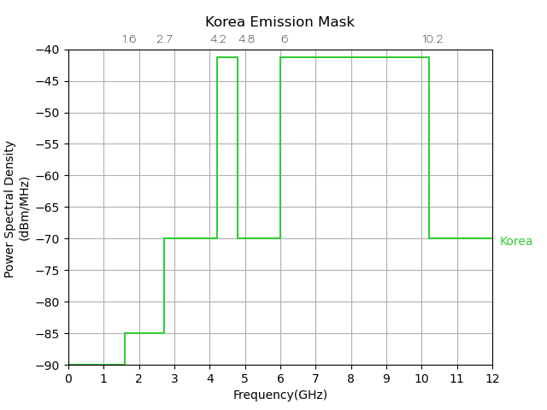

# Annex D: China’s UWB Technical Requirements

Operation frequency range: 7235-8750MHz

Transmission signal bandwidth (-10dB bandwidth): minimum 500MHz

e.i.r.p. spectral density: maximum -41 dBm/MHz

Out of band emission limit:

|  |  |
| --- | --- |
| **Spectrum Range** | **Limit (e.i.r.p)** |
| 5.925-7.125 GHz (7.125 GHz included) | -70 dBm/MHz |
| 7.125-7.235 GHz | -51 dBm/MHz |
| 8.750-9 GHz | -51 dBm/MHz |
| 9-10.6 GHz (9 GHz included) | -70 dBm/MHz |

# Annex E: FCC’s UWB Emission Mask



Source: FCC First Report &Order

# Annex F: Europe’s UWB Emission Mask

**ECC/DEC/(06)04: A1.1: GENERAL CASE**

* **ECC/DEC/(06)04: Generic UWB < 10GHz without mitigation or with mitigation (LDC and/or DAA)**

Mitigations in ECC/DEC/(06)04

* Table 1, NOTE 1: LDC, details in Annex 2 of ECC/DEC/(06)04
* Table 1, NOTE 2: DAA, details in Annex 3 of ECC/DEC/(06)04

Mean e.i.r.p spectral density [dBm/MHz]

Frequency [MHz]

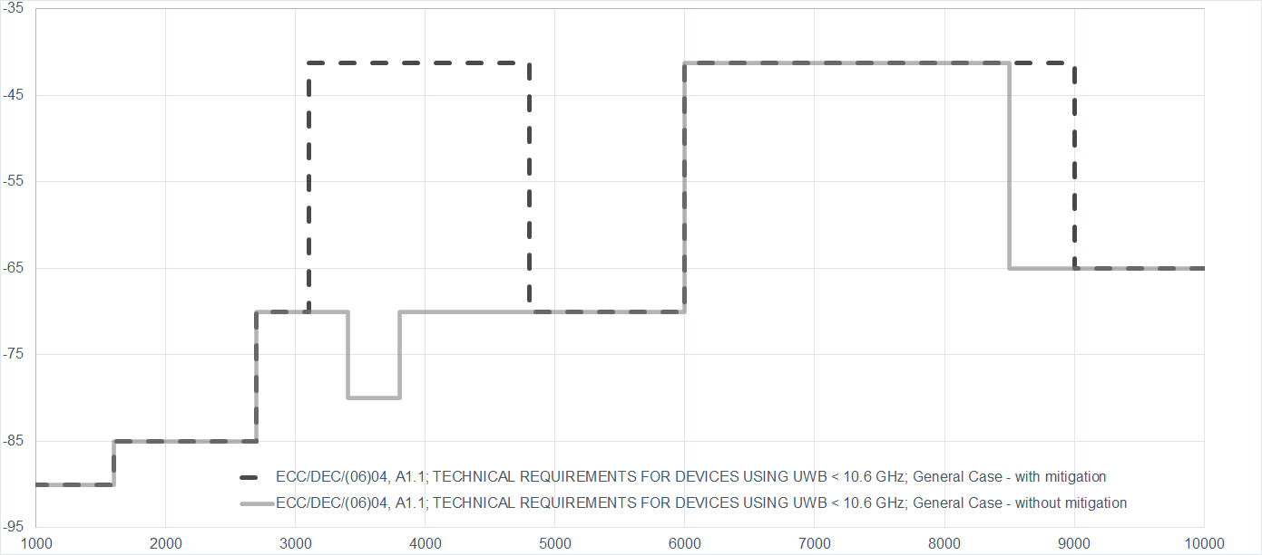

**ECC/DEC/(06)04: A1.2 VEHICULAR APPLICATION, INCLUDING UWB DEVICES INSTALLED IN ROAD AND RAIL VEHICLES**

* **ECC/DEC/(06)04: General case for UWB devices installed in road and rail vehicles**

Mitigations in ECC/DEC/(06)04

* Table 2, NOTE 1: LDC, details in Annex 2 of ECC/DEC/(06)04
* Table 2, NOTE 2: DAA, details in Annex 3 of ECC/DEC/(06)04
* Table 2, NOTE 3: TPC, details in Annex 4 of ECC/DEC/(06)04
* Exterior Limit, details in Annex 5 of ECC/DEC/(06)04

Mean e.i.r.p spectral density [dBm/MHz]

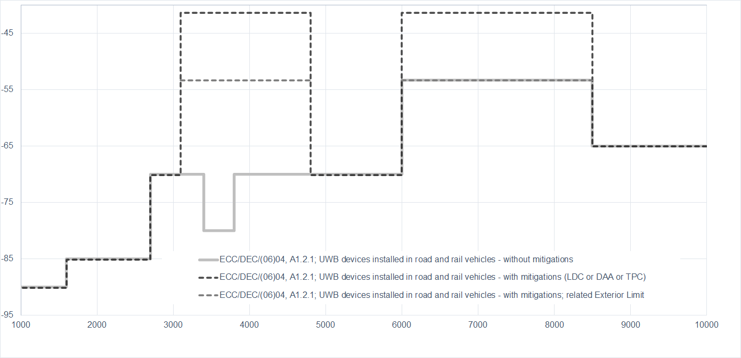

Frequency [MHz]

* **ECC/DEC/(06)04: A1.2.2 Specific vehicular access systems using trigger-before-transmit**

Mitigations and requirements in ECC/DEC/(06)04, Table 3

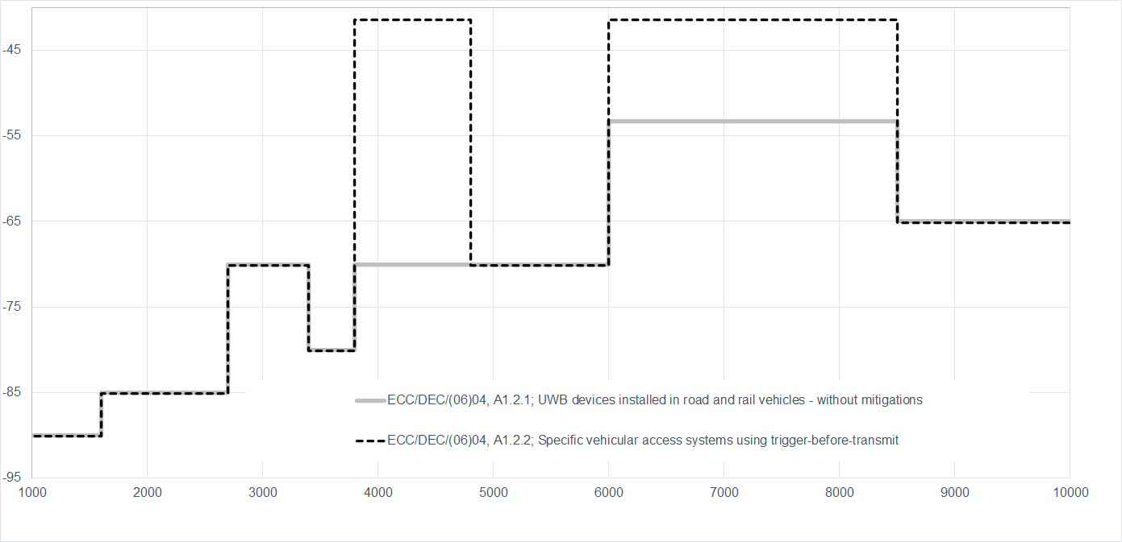

Mean e.i.r.p spectral density [dBm/MHz]

Frequency [MHz]

* **ECC/DEC/(06)04: A1.2. Other vehicular applications, including applications involving infrastructure to vehicle and vehicle to vehicle communications in 6-8.5 GHz**

Mitigations and requirements in ECC/DEC/(06)04, Table 4

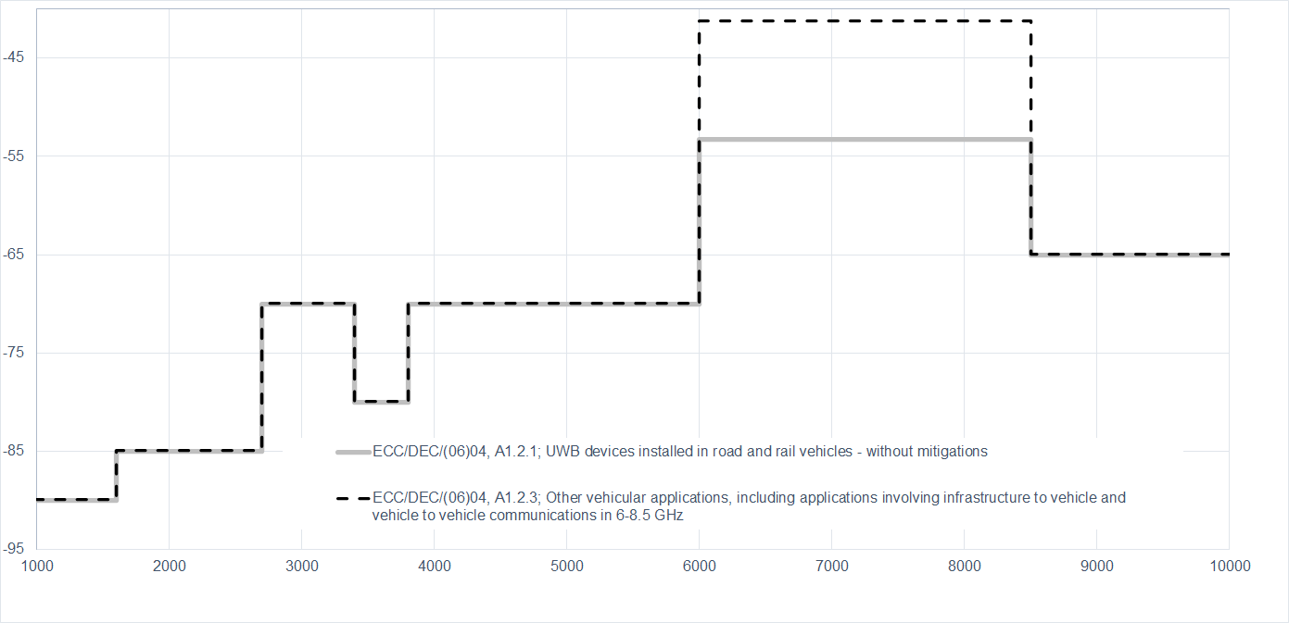

Mean e.i.r.p spectral density [dBm/MHz]

Frequency [MHz]

**ECC/DEC/(06)04: A1.3: SPECIFIC RADIODETERMINATION, LOCATION TRACKING, TRACING AND DATA ACQUISITION APPLICATIONS IN 6-8.5 GHz**

* **ECC/DEC/(06)04: A1.3.1 Specific applications involving fixed outdoor installations**

Mitigations and requirements in ECC/DEC/(06)04, Table 5

Mean e.i.r.p spectral density [dBm/MHz]

Frequency [MHz]

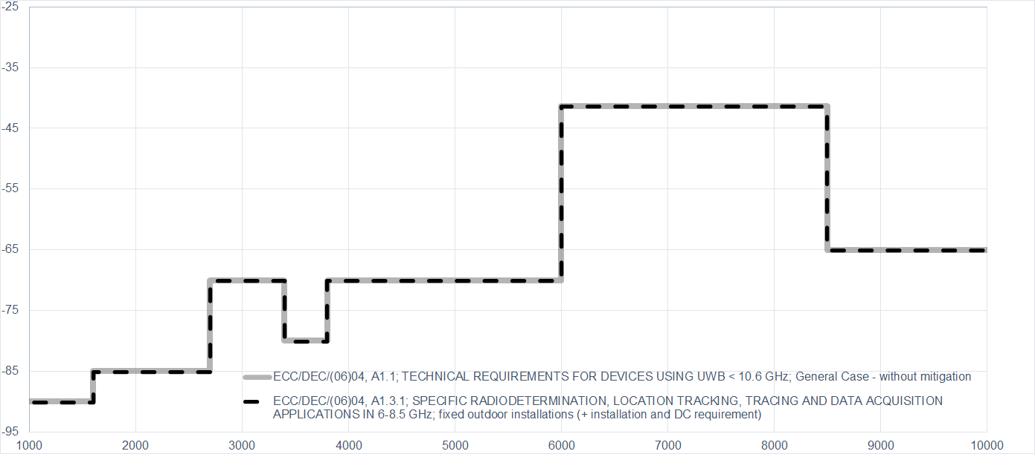

* **ECC/DEC/(06)04: A1.3.2 Specific applications involving enhanced indoor devices**

Mitigations and requirements in ECC/DEC/(06)04, Table 6

Mean e.i.r.p spectral density [dBm/MHz]

Frequency [MHz]

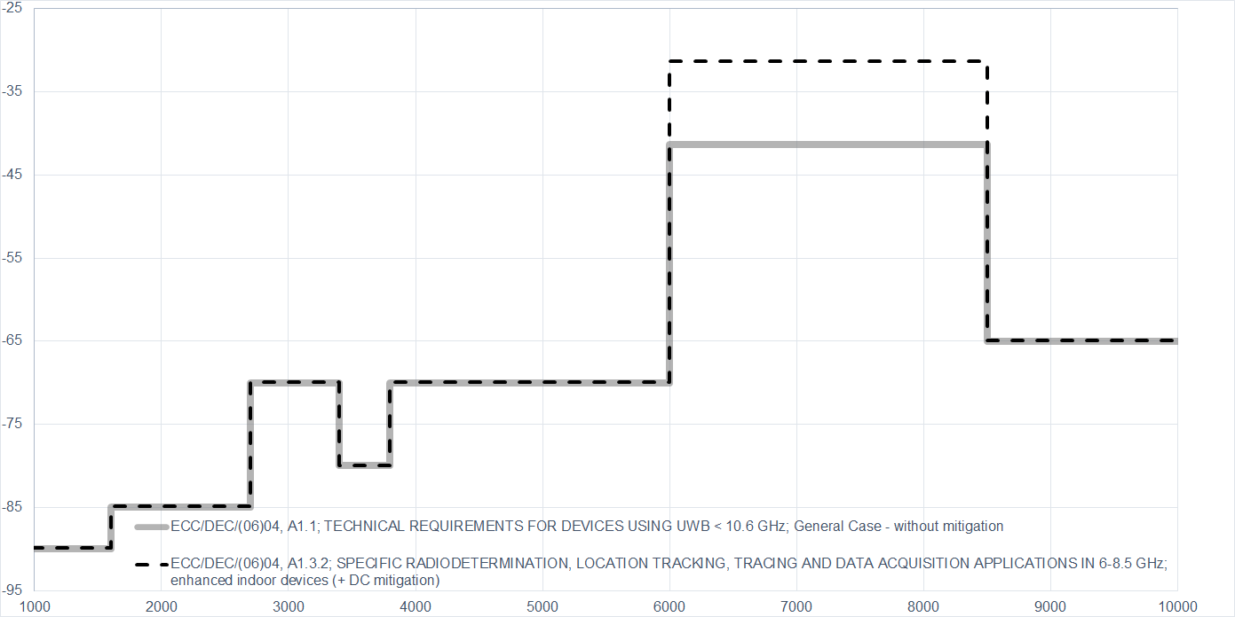

**ECC/DEC/(07)01: Material Sensing Devices using Ultra-Wideband (UWB) technology (July 2022)**

* **ECC/DEC/(07)01: Table 1 : Limits for contact based UWB material sensing devices**

Mitigations and requirements in ECC/DEC/(06)04, Table 1

There are several combinations of mitigations measures possible to operate under different power level e.i.r.p (-50 or -41.3 dBm/MHz) or to e.g. operate outdoor.

The emissions are outside the specified usage scenarios in the related harmonised standard

Frequency [MHz]

Mean e.i.r.p spectral density [dBm/MHz]

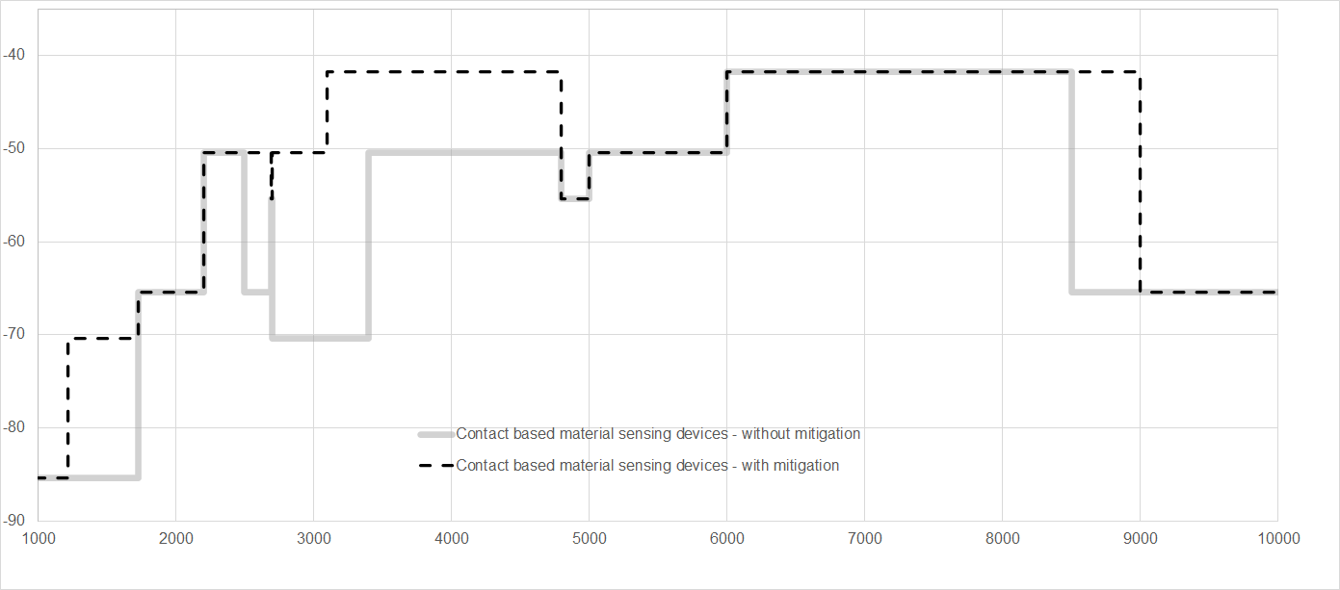

* **ECC/DEC/(07)01: Table 2: Limits for non-contact based UWB material sensing devices**

Mitigations and requirements in ECC/DEC/(06)04, Table 2

There are several combinations of mitigations measures possible to operate under different power level e.i.r.p (-50 or -41.3 dBm/MHz) or to e.g. operate outdoor.

The emissions are outside the specified usage scenarios in the related harmonised standard

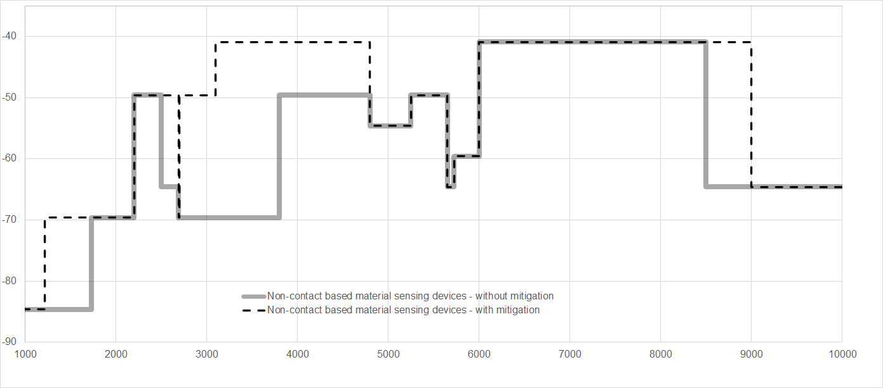

Mean e.i.r.p spectral density [dBm/MHz]

Frequency [MHz]

# Annex G: UWB Regulatory Framework in APT and other regions

|  |  |  |  |  |  |
| --- | --- | --- | --- | --- | --- |
| **Frequency Identification for Systems using UWB technology** | | | | | |
| **Country / Region** | **Frequency Band**  **(GHz)** | **Power Spectral Density Limit (e.i.r.p./MHz)** | **Regulations** | **Targeted Date for Spectrum Allocation** | **Remarks** |
| **Afghanistan** | 6.4 – 10.7 | -41.3 | Licenses only for Indoor use | 2010 | For radio equipment with low density power to avoid interference to other services. |
| **Australia** | 3.1 – 4.8 | -70/-801/-41.32 | [Radiocommunications (Low Interference Potential Devices) Class Licence 2015](https://www.legislation.gov.au/Details/F2022C00281) | Decided | Ultra-wideband transmitters  Note 1: 3.4~3.8GHz  Note 2: with mitigate techniques for whole band  Refer to EN 302 065 |
| 6 – 9 | -41.3/-653 | Ultra-wideband transmitters  Note 3: Without mitigation techniques in 8.5~9GHz  Refer to EN 302 065 |
| 6-8.5 | Various* | Ultra-wideband transmitters onboard aircraft  *Refer to EN 302 065-5 |
| 4.2 – 4.8  6 – 6.8 | -62 | In-ground ultra-wideband transmitters  *Refer to EN 302 065 Part 2 |
| 2.2-8.5 | Various* | Building material analysis transmitters using UWB  *Refer to EN302 435 |
| 22 -26.5 | Various* | Short‑range vehicle radar systems.  *Refer to EN302 288 |
| **Brunei**  **Darussalam** | Various* | -41.3** | [Telecommunications Notification 2018](https://www.agc.gov.bn/AGC%20Images/LAWS/Gazette_PDF/2018/S039.pdf) | Decided | * Check [Telecommunications Notification 2018](https://www.agc.gov.bn/AGC%20Images/LAWS/Gazette_PDF/2018/S039.pdf) for frequency ranges.  **-41.3dBm/MHz at below ranges:  3.4 – 4.2 GHz with interference mitigation techniques  4.2 – 4.8 GHz,  6 – 9 GHz,  21.65 – 29.5GHz |
| -3* |  | *77 – 81GHz |
| **Cambodia** |  |  |  |  |  |
| **China (Mainland)** | <=1.6  1.6 – 10.6  >10.6 | -41* | [MIIT Wireless File 354 (2008)](https://www.miit.gov.cn/n1146295/n1146592/n3917132/n4062354/n4062391/n4062397/n4062399/c4148163/part/4148165.pdf) | Decided | *-41dBm/MHz for below ranges:  6 – 9 GHz.  4.2 – 4.8 GHz with interference mitigation techniques  China’s regulatory information may be updated when the latest regulation document is published. |
| **China (Hong Kong)** | 4.2 – 4.8  6 – 8.5 | -41.3 | [HKCA 1080](https://www.ofca.gov.hk/filemanager/ofca/en/content_401/hkca1080.pdf) | Decided | The equipment shall meet the technical requirements in accordance with the appropriate standards in below list:  ETSI EN 302 065-1/2/3/4 standards,  FCC Part 15 Subpart F. |
| **China (Macao)** | 4.2 – 4.8  6 -8.5 | -41.3 | [CTT#198](https://bo.io.gov.mo/bo/i/2014/28/despce_cn.asp#198) | Decided |  |
| **Fiji** |  |  |  |  |  |
| **India** | <=1.6  1.6 – 10.6  >10.6 | -90  -41.3*  -85 | [GSR 1046(E)](https://dot.gov.in/sites/default/files/License%20Exemption%20for%20UWB%20Device%20G_S_R_1046%28E%29%20dated%2018th%20October%2C%202018_0.pdf) | Decided | Generic ultra-wideband device usage  *-41.3 dBm/MHz at below ranges:  6 – 8.5GHz  3.1 – 3.4GHz (with LDC or DAA)  3.4 – 3.8GHz (with LDC or DAA)  3.8 – 4.8GHz (with LDC or DAA)  8.5 – 9GHz (with DAA)  Limit is lower for the rest frequency ranges. |
| <=1.6  1.6 – 10.6  >10.6 | -90  -41.3*  -85 | Location tracking system  *-41.3 dBm/MHz at below ranges:  6 – 8.5GHz  8.5 – 9GHz using DAA, otherwise -65dBm/MHz.  Limit is lower for the rest frequency ranges. |
| <=1.6  1.6 – 10.6  >10.6 | Various* | *Check GSR 1046(E) for Ultra-wideband device installed in Road and Rail Vehicle, Material sensing device using ultra-wideband technology and Building material analysis device. |
| **Indonesia** | 3.1 – 3.4 | ***\*see remarks*** | [Regulation of Minister of Communications and Informatics of The Republic of Indonesia Number 2 of 2023 on The usage of radio frequency spectrum based on class licenses](https://jdih.kominfo.go.id/produk_hukum/unduh/id/862/t/peraturan+menteri+komunikasi+dan+informatika+nomor+2+tahun+2023) | Allocated | *The limit of the Power Spectral Density is specified in the Technical Standard, which is currently under development.  UWB operates under a class license. |
| 3.4 – 3.8 |
| 3.8 – 6.0 |
| 6.0 – 8.5 |
| 8.5 – 10.6 |
| **Japan** | 3.4 – 4.8*  7.25 – 10.25 | -41.3 | [The Ordinance for Regulating Radio Equipment](https://www.tele.soumu.go.jp/resource/e/equ/tech/orre.pdf) | Allocated | For Land Mobile Radio Services, Data Communication only for Indoor use. *DAA is required for 3.4 – 4.8GHz |
| 7.587-8.4 | -51.3/-41.3* | For Land Mobile Radio Services, Data Communication for Indoor and Outdoor use.  *-51.3dBm/MHz for 7.587-7.662GHz -41.3 dBm/MHz for 7.662-8.4GHz |
| 7.25 – 9.0 | -41.3 | For Land Mobile Radio Services, Data Communication, Sensing, Radiolocation for Indoor and Outdoor use.  Required to be operated without causing harmful interference to SRS earth stations, RAS stations, RLS stations and RNS stations. |
| 24.25 – 29.0 | -41.3 | Automotive Short Range Radar systems |
| **Republic of Korea** | 4.2 – 4.8 | - 41.3 | [Technical Standards of Wireless Equipment for Unlicensed Wireless Radio Stations (MSIT notice 2022-75)](https://www.law.go.kr/행정규칙/신고하지아니하고개설할수있는무선국용무선설비의기술기준) | Allocated | DAA or LDC shall be used |
| 6 – 10.2* | - 41.3 |  | * 6-7.2 GHz UWB: LDC shall be used. Not allowed for fixed outdoor.  UWB range of 6.0 ~ 8.8 GHz is available for mobile device |
| **Lao PDR** |  |  |  |  |  |
| **Malaysia** | 3.1 – 3.4 | -70 | *by way of [Class Assignment (CA)](https://www.mcmc.gov.my/en/spectrum/assignment-of-spectrum/class-assignment) | Allocated | General UWB Communication Device  Frequency band 3.1 – 10.6 GHz:  Additional requirement for general UWB Communication device:  shall only be used in confined areas of buildings or localised on-site operations. Use of outdoor mounted antennae is not permissible. |
| 3.4 – 3.8 | -80 |
| 3.8 – 6.0 | -70 |
| 6.0 – 8.5 | -41.3 |
| 8.5 – 10.6 | -65 |
| 3.1 – 3.4 | -70 | UWB Device in Road and Rail Vehicles  Additional requirements for UWB device in road and rail vehicles   * for short range communications in road and rail vehicles, which include devices mounted inside or at the surface; * does not apply to fixed road infrastructure installations; * does not apply to fixed outdoor locations, for use in flying models, aircraft and other form of aviation; and   The maximum mean EIRP spectral density for the emission outside the vehicle at elevation angles higher than 0 degree. The reference plane for the 0 degree is the sensor mounting height. |
| 3.4 – 3.8 | -80 |
| 3.8 – 6.0 | -70 |
| 6.0 – 8.5 | -53.3 |
| 8.5 – 10.6 | -65 |
| 21.65 – 22 | -61.3 | Automotive Radar Device |
| 22 – 29.5 | -41.3 |
| 76 – 77 | 50 |
| 77 – 81 | -3 |
| 0.03 – 0.23 | -65 | *by way of Apparatus Assignment (AA) |  | For the use of ground probing radar device, in-wall probing radar device, and through-wall probing radar device |
| 0.23 – 0.96 | -60 |
| 2.17 – 3.4 | -51.3 |
| 3.4 – 5.0 | -41.3 |
| 5.0 – 6.0 | -51.3 |
| 6 – 10.6 | -65 |
| 2.17 – 10.6 | -41.3 | For the use of medical imaging device and surveillance device |
| **Myanmar** | 5.8 | Less than 100mW |  |  | Not be used in landing and not to interfer to the existing systems. The system will be approved by the Department by the official letter. |
| **Nepal** | 6 – 8.5 | -41.3 | [Radio Frequency Policy of Telecommunication Services, 2080](https://nta.gov.np/content/radio-frequency-policy-of-telecommunication-services-2080) |  | 6 – 8.5 |
| **New Zealand** | 0.000009 - 1.6 | -90 | [Radiocommunications Regulations (General User Radio Licence for Ultra Wide](https://www.gazette.govt.nz/notice/id/2017-go406)  [Band Devices) Notice 2017](https://www.gazette.govt.nz/notice/id/2017-go406) | Allocated | Note 1: 3.1 – 4.8 GHz, devices implementing low duty cycle mitigation techniques :  1. a maximum permitted mean power spectral density of -41.3 dBm/MHz e.i.r.p.; and  2. a maximum power of -30 dBW e.i.r.p.  Note 2: Road and rail vehicles:  1. For devices installed in road and rail vehicles, where transmit power control is implemented:  a. the maximum permitted mean power spectral density is -41.3 dBm/MHz e.i.r.p;  b. the maximum power is -30 dBW e.i.r.p.; and  c. the transmit power control must operate with a dynamic range of at least 12 dB below the maximum  mean e.i.r.p. spectral density.  2. For devices installed in road and rail vehicles, where transmit power control is not implemented:  a. the maximum permitted mean power spectral density is -53.3 dBm/MHz e.i.r.p.; and  b. the maximum power is -42 dBW e.i.r.p.  Note 3: Within the bands 4.2 – 4.8 GHz and 6.0 – 6.8 GHz, fixed outdoor transmitters installed in-ground are  permitted for operation below the horizontal plane with:  1. a maximum permitted mean power spectral density of -62 dBm/MHz e.i.r.p.; and  2. a maximum power of -52 dBW e.i.r.p. |
| 1.6 - 2.7 | -85 |
| 2.7 - 3.4 | -70/-41.31 |
| 3.4 - 3.8 | -80/-41.31 |
| 3.8 - 4.2 | -70/-41.31 |
| 4.2 - 4.8 | -70/-41.31，2/-53.32/-623 |
| 4.8 - 6.0 | -70/-41.31 |
| 6 - 8.5 | -41.3/-41.32/-53.32/-623 |
| 8.5 -10.6 | -65 |
| 10.6 - 100 | -85 |
| **Pakistan** | <=1.6  1.6 – 10.6  >10.6 | -90  -41.3*  -85 | [Regulatory Framework for Short Range Devices (SRD) & Terrestrial Internet of Things (IoT) Services](https://www.pta.gov.pk/assets/media/iot_srd_regulatory_framework_01-06-2022.zip) | Allocated | *-41.3 dBm/MHz at below ranges:  3.1 – 3.4 GHz (LDC or DAA)  3.4 – 3.8 GHz (LDC or DAA)  3.8 – 4.8 GHz (LDC or DAA)  8.5 – 9 GHz (LDC or DAA)  6 – 8.5 GHz.  Limit is lower for the rest frequency ranges. |
| **Philippines** | 6 – 8.5 | -41.3 | [MC 06-08-2018](https://ntc.gov.ph/wp-content/uploads/2018/MC/MC-06-08-2018.pdf) | Allocated |  |
| **Singapore** | 3.4 – 4.2  4.2 – 4.8  4.8 – 6  6.0 – 9.0 | -70, -41.3*  -41.3  -70  - 41.3 | [IMDA TS UWB](https://www.imda.gov.sg/-/media/imda/files/regulation-licensing-and-consultations/ict-standards/telecommunication-standards/radio-comms/imda-ts-uwb.pdf?la=en)  Class licence.  For localised use only. Imaging devices shall be licensed on a case-by-case basis. | Allocated | Generic UWB devices.  *with mitigation technology |
| 21.65 – 26.65  77 – 81 | - 41.3  - 3 | Automotive Short Range Radar systems Automotive Short-Range Radar (SRR) systems that are vehicular radar systems intended for collision mitigation and traffic safety applications |
| Various* | Various* | Ground and Wall Probing Radar (GPR and WPR) systems used in survey and detection applications  *Check UWB Emission Mask and Table in IMDA TS UWB. |
| **Sri Lanka** | 1.6 – 10.6  > 10.6 | - 41.3*  -85 | [Radio And Telecommunications Terminal Equipment(RTTE) Type Approval Rules 2020](https://www.trc.gov.lk/images/SM/RTTE_GAZETTE-English.pdf) | Allocated | *-41.3 dBm/MHz at below range: 6 – 8.5GHz.  Limit is lower for the rest frequency ranges. |
| **Thailand** | 1.6 – 2.0 | -41.3 | [1.NBTC Notification on Criteria for UWB 1.6-10.6 GHz](https://www.ratchakitcha.soc.go.th/DATA/PDF/2562/E/001/T_0009.PDF)  [2.NBTC Notification on Technical Standard for UWB 1.6-10.6 GHz](https://www.ratchakitcha.soc.go.th/DATA/PDF/2562/E/001/T_0011.PDF) | Allocated | The technical requirements for the radiocommunication equipment shall comply with one or more of the following standards:  EN 302 065-1/2/3/4,  FCC Part 15 Subpart F Ultra-Wideband Operation |
| 2.0 – 2.2 | -62.0 |
| 2.2 – 3.4 | -41.3 |
| 3.4 – 4.2 | -77.0 |
| 4.2 – 4.5 | -41.3 |
| 4.5 – 4.8 | -77.0 |
| 4.8 – 10.6 | -41.3 |
| **Vietnam** | 4.2 – 4.8 GHz  7.2384 – 8.5  8.5 – 9  7.2384 – 9 | -70 , -41.3*  -41.3  -65  -41.3* | Unlicensed.  [MIC Circular No. 08/2021/TT-BTTTT](https://mic.gov.vn/Upload_Moi/VanBan/08TT.PDF) | Allocated | Use the device in an indoor environment or an environment with equivalent radio shields; Not to be allowed to active the device in the aircraft.  *with mitigation technology |
| **Europe** | < 1.6  1.6 – 2.7  2.7 – 3.4  3.4 – 3.8  3.8 – 4.2  4.2 – 4.8  4.8 – 6  6.0 – 8.5  8.5 – 10.6  > 10.6 | -90  -85  -70  - 80  -70  -70  -70  -41.3  (Note 1and 2)  -65  -85 | Unlicensed.  Not to be used at fixed outdoor location.  [ECC/DEC/(06)04](https://docdb.cept.org/document/397) | Allocated | **Note 1**: In case of devices installed in road and rail vehicles, operation is subject to the implementation of Transmit Power Control (TPC) with a range of 12 dB with respect to the maximum permitted radiated power and an exterior limit of the maximum mean e.i.r.p. spectral density of -53.3 dBm/MHz.  **Note 2:** For vehicular access systems trigger-before-transmit operation and LDC ≤ 0.5% (in 1h) or TPC are required  For details see ECC Dec (06)04. |
| **USA** | 3.1 – 10.6 | - 41.3 | Indoor Systems  [FCC 47 CFR 15.517](https://www.law.cornell.edu/cfr/text/47/15.517)  Handheld Systems  [FCC 47 CFR 15.519](https://www.ecfr.gov/current/title-47/chapter-I/subchapter-A/part-15/subpart-F/section-15.517) | Allocated |  |

Note: Information is compiled as of 6 March 2024 and is subject to changes.

1. https://[www.allaboutcircuits.com/uploads/articles/UWBWP.pdf](http://www.allaboutcircuits.com/uploads/articles/UWBWP.pdf)
2. https://[www.marketsandmarkets.com/Market-Reports/indoor-location-market-989.html?gclid=EAIaIQobChMIutrnsoSw9wIVl21vBB](http://www.marketsandmarkets.com/Market-Reports/indoor-location-market-989.html?gclid=EAIaIQobChMIutrnsoSw9wIVl21vBB) 3KNw-mEAAYASAAEgLoIPD_BwE
3. https://[www.researchandmarkets.com/reports/4896758/indoor-location-based-services-market-research#rela0-5427261](http://www.researchandmarkets.com/reports/4896758/indoor-location-based-services-market-research#rela0-5427261)

  
4. [MSIT website](https://www.msit.go.kr/bbs/view.do?sCode=user&mId=108&mPid=103&pageIndex=3&bbsSeqNo=83&nttSeqNo=3175661&searchOpt=ALL&searchTxt=): Public Notice 2022-75 (in Korean)
5. MIIT website: [Attachment 2 (miit.gov.cn)](https://www.miit.gov.cn/cms_files/filemanager/1226211233/attach/202212/8244392f3533437b8a8ab75db81ab6d5.pdf)