The 1st Meeting of the APT Conference Preparatory Group for WRC-27
(APG27-1)
3 – 6 June 2024, Shanghai, People’s Republic of China

INFORMATION FOR PARTICIPANTS

The 1st Meeting of the APT Conference Preparatory Group for WRC-27 (APG27-1) will be held from 3 to 6 June 2024 in Shanghai, People’s Republic of China. The meeting will be organized by the Asia-Pacific Telecommunity (APT) and hosted by the Ministry of Industry and Information Technology (MIIT), People’s Republic of China. APG27-1 will be held with physical attendance as well as virtual/online participation through Zoom meeting platform (i.e., hybrid meeting). Please note that Head of Delegates (HoD) meeting(s), if any, will be organized for physical attendance only.

The detailed arrangements are as follows:

- VENUE

The Longemont Shanghai of China
Address: No.1116 West YanAn Road, Shanghai, China
TEL: +86-21-61159988*8665
Fax: +86-21-61159739
URL: www.longzhimenghotel.com.cn

- PARTICIPATION

All APT Members, Associate Members, Affiliate Members, International/Regional Organizations, and Eligible Non-Members can participate in the meeting by registering online through the APT Website before the deadline.

Administrations of Members and Associate Members and International/Regional Organizations are kindly requested to send the official list of delegations for the meeting and to nominate Head of Delegation (HoD) and Alternate HoD. If any APT Affiliate Member is included in the National Delegation, please clearly mention it in the List of Delegation.

Participation of Non-Members: Non-Members cannot attend the meeting. Non-Member participants under national delegation are allowed if their names are included in the official list of delegation. Non-member participation from the host country, People’s Republic of China, are allowed as ‘Observers’ if they are approved by the Ministry of Industry and Information Technology, People’s Republic of China.

Please indicate the mode of your participation (physical or virtual) on the online registration form. Since the number of physical attendances impacts on some arrangements for the meeting venue and other preparations, your administration/organization is kindly requested to register delegates for physical attendance before the deadline specified in the following section.

Virtual participation will be arranged by using Zoom meeting platform. Detail information for virtual participation will be sent to the registered delegates who wish to attend virtually.

- REGISTRATION:

Registration of delegates can be done online at https://www.apt.int/content/online-registration.
The deadline for registration is by 20 May 2024.

- HOTELS FOR ACCOMODATION:

Following hotels are recommended for the accommodation of the delegates during the meeting:

- The Longemont Shanghai of China

The Longemont Hotel Shanghai is the venue for the 1st Meeting of the APT Conference Preparatory Group for WRC-27 (APG27-1). To get the special rates given below, please make your reservation as soon as possible and no later than 20 May, 2024.

Please make your reservation through the methods below:
a. Make a reservation using the Link
www.imm-cloud.com:8080/webroom_en.html?id=ROY9999_031
b. Send the Hotel Reservation form (Annex II) directly to the hotel via email.
reservation.sh@longemonthotels.com
*It is highly recommended to make your reservation through the hotel official link provided above.

< The Longemont Hotel Shanghai for APG27-1 Rates>

No | Room Type | Special Room Rate | Remarks
1 | Deluxe Room - King | RMB 700.00 | Includes breakfasts for two and Wi-Fi.
2 | Premium Room - Twin | RMB 750.00 | Includes breakfasts for two and Wi-Fi.
3 | Club Room-King | RMB 1000.00 | Includes breakfasts for two and Wi-Fi.  Club lounge
Accommodation rates quoted are:
- Tax included
- Please see the hotel reservation form (Annex II) for more detailed information.
* Please note that the local secretariat is NOT responsible for the hotel reservation. Participants are encouraged to make the reservation as early as possible.

- Radisson Collection Hotel, Xing Guo Shanghai

Address: No.78 Xing Guo Road, Shanghai, China.
To get the special rates given below, please make your reservation as soon as possible and no later than 3 May, 2024.

Please make your reservation through the method below:
Send the Hotel Reservation form (Annex II) directly to the hotel through the email. reservation@radissoncollection-xingguo.com
< Radisson Collection Hotel, Xing Guo Shanghai for APG27-1 Rates>

No | Room Type | Special Room Rate | Remarks
1 | Standard King Bed Room | RMB 1000.00 | Includes breakfast for one and Wi-Fi.
2 | Business Class Room  (King/Twin) | RMB 1280.00 | Includes breakfast for one and Wi-Fi.
3 | Collection Panorama Room (King/Twin) | RMB 1700.00 | Includes breakfast for one and Wi-Fi.  Executive Benefits
Accommodation rates quoted are:
- Tax included
- Please see the hotel reservation form attached for more detailed information.
* Please note that the local secretariat is NOT responsible for the hotel reservation. Participants are encouraged to make the reservation as early as possible.

- YITEL Premium Shanghai Zhongshan Park

Address: No.1119 West YanAn Road, Shanghai, China.
To get the special rates given below, please make your reservation as soon as possible and no later than 3 May, 2024.

Please make your reservation through the method below:
Send the Hotel Reservation form (Annex II) directly to the hotel through the e-mail. sd0210m8@yazhugongyu.com

< YITEL Premium Shanghai Zhongshan Park for APG27-1 Rates>

No | Room Type | Special Room Rate | Remarks
1 | Business King Room | RMB 480.00 | Includes breakfast for two and Wi-Fi.
2 | Twin Room | RMB 520.00 | Includes breakfast for two and Wi-Fi.
3 | Deluxe Room | RMB 520.00 | Includes breakfast for two and Wi-Fi.
4 | Deluxe Twin Room | RMB 560.00 | Includes breakfast for two and Wi-Fi.
Accommodation rates quoted are:
- Tax included.
- Please see the hotel reservation form enclosed to this for detailed information
* Please note that the local secretariat is NOT responsible for the hotel reservation and participants are encouraged to make the reservation as early as possible
* The hotel is located within a 4-minute walking distance.

- TRANSPORTATION FROM THE AIRPORT TO THE VENUE:

Shanghai has two international airports: Pudong International Airport and Hongqiao International Airport. Detailed transportation guidance from these airports to the meeting venue are provided below.

- From Shanghai Pudong International Airport

- By Metro (about 100 mins)
Transfer to Line 2 of the Shanghai Metro and travel for 21 stops until reaching Jiangsu Road Station.
Then take Exit 4 from the station and proceed to walk approximately 1.4 kilometers to reach The Longemont Hotel Shanghai.
Note: It is also recommended to take a taxi from Jiangsu Road Station to the meeting venue. The taxi fare is around 20 RMB.

- By Taxi (60-90 mins)
The fare from Shanghai Pudong International Airport to the meeting venue is around 220 RMB and varies depending on traffic conditions.

- From Shanghai Hongqiao International Airport

- By Metro (about 60 mins)
Take Line 2 of the Shanghai Metro from Hongqiao International Airport Terminal 2 Station and travel for 8 stops to Jiangsu Road Station.
Then take Exit 4 from the station and proceed to walk approximately 1.4 kilometers to the meeting venue.
Note: It is also recommended to take a taxi from Jiangsu Road Station to the meeting venue. The taxi fare is around 20 RMB.

- By Taxi (15-30 mins)
The fare from Shanghai Hongqiao International Airport to the meeting venue is around 90 RMB and varies depending on traffic conditions.

- VISA AND IMMIGRATION INFORMATION:

A visa may be required for participants from certain countries to enter People’s Republic of China. To check the visa requirements, please contact the Chinese Embassy/Consulate in your respective country.

Participants requiring VISA supporting documents for entering China are highly recommended to complete the “VISA Supporting Letter Form” detailed in ANNEX Ⅰ and submit it to the contact person shown below along with a scanned copy of the photograph page of your passport at earliest convenience and no later than 7 May, 2024. Since VISA application requirements in your country may vary over time, please ensure you fulfill the most updated VISA requirements by contacting the nearest Chinese Embassy/Consulate prior to departure.

For VISA support, please contact at:

Ms. Wang Li, Ms. Yanqi ZHANG
Ministry of Industry and Information Technology
No.13 West Chang’an Road, Xicheng District, Beijing, China
Phone: +86-15862820699
Email: radiomanagement@miit.gov.cn

- MEETING WEBSITE, MEETING DOCUMENTS AND CONTRIBUTION GUIDELINE

Related information about the meeting and provisional meeting documents will be available at the APT Website at: https://www.apt.int/2024-APG27-1.

Contributions for the meeting from APT Members, Associate Members, Affiliate Members, regional and International Organizations are welcome. You are requested to use the proper document template for your contribution. Please refer to the ‘Information for submitting contributions to APG27-1’ for detail process of submitting the contribution. The ‘Information for submitting contributions to APG27-1’ is available at the website mentioned above and embedded here as well. Contributions will be posted on APT Website prior to the starting of the meeting.

The deadline for submission of your contributions is 27 May 2024 (should be received by the APT Secretariat (Bangkok time)). If you have any questions in submitting contributions or any other information related to the documentation above (“Information for submitting contributions”), please contact us as aptapg@apt.int.

- WIRELESS LAN:

Internet Access over wireless network will be available during the meeting. Participants who wish to utilize the wireless facility are kindly requested to bring their own laptop computers.

- WELCOME RECEPTION:

A Welcome Reception will be held in the evening of the first day, Monday, 3 June 2024 by courtesy of Ministry of Industry and Information Technology (MIIT), People’s Republic of China.

- INSURANCE AND MEDICAL EMERGENCIES:

The APT and Local Secretariat of the APG27-1 don’t bear the cost of insurance for the participants, any medical expenses or any other expenses. The APT and Local Secretariat, therefore, request your administrations/organizations to kindly make necessary arrangements for insurance and medical coverage of your delegates before traveling to the People’s Republic of China.

- PRACTICAL INFORMATION:

About Shanghai: The city of Shanghai, is a modern international metropolis with a spirit of inclusiveness, pursuit of excellence, broad-mindedness, and humility. Located at the estuary of the Yangtze River in East China and facing the Pacific Ocean, Shanghai forms part of the Yangtze River Delta, one of China's most robust, open and innovative regions. As China's largest economic powerhouse and an important international financial center, it is one of the country's most international cities, with 962 headquarters of multinational companies and 561 foreign-invested R&D centers established by the end of 2023. Shanghai is also a leading international trade and consumption center and important global shipping center. Nowadays, Shanghai is making significant progress in building an international science and technology innovation center and an internationally influential digital city. For more detailed information about Shanghai, please refer to the provided web link here.

Climate: The average temperature in Shanghai in early June ranges from 20 to 30 degrees Celsius. During this time, there can be a combination of sunny days with scattered showers or overcast skies, as the region enters its rainy season.

Time Zone: UTC/GMT+8:00

Banks & Currency: The official currency accepted in China is RMB. Major foreign currencies may be exchanged to RMB at banks. Official banking hours can vary slightly, but in general are from 9 a.m. to 5 p.m. Some banks are open from Monday to Friday, although some branches may remain open on Saturdays. Please contact your bank’s hotline for confirmation.

The currency exchange rate is approximately 7.19 RMB to 1 USD as of March 2024. Cash can be easily withdrawn 24/7 from the numerous ATMs spread in the city.

Electricity: In China, the standard power supply is 220 volts with a frequency of 50Hz. The power outlets are shown below.

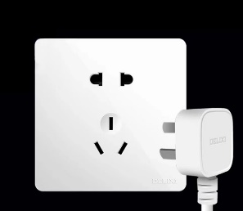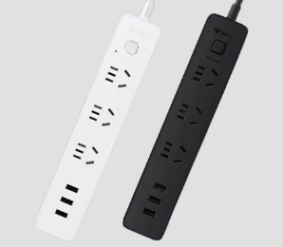
Two-Hole Outlet & Three-Hole Outlet Wiring Board

Emergencies: Police 110, Fire Department 119, Medical Emergencies 120

- CONTACT INFORMATION:

APT Secretariat  Asia-Pacific Telecommunity (APT)  12/49 Soi: 5 Chaeng Watthana Road  Bangkok 10210, Thailand  Phone: + 66 2 573 0044  Fax: +66 2 573 7479  E-mail: aptapg@apt.int | Local Secretariat (People’s Republic of China)  Ms. Wang Li, Ms. Yanqi ZHANG  Ministry of Industry and Information Technology  No.13 West Chang’an Road, Xicheng District, Beijing, China  Phone: +86-15862820699  Email: radiomanagement@miit.gov.cn

ANNEX I
Required Information Form for Visa Application
The 1st Meeting of the APT Conference Preparatory Group for WRC-27 (APG27-1)
(June 3 – 6, 2024, Shanghai, China)
Family Name:
Given Name:
Gender:
Date of Birth:
Nationality:
Present Position (Job Title and Department/ Division):
Organization:
Passport Number:
- mail Address:
Telephone Number:
Arrival Date in Shanghai:
Departure Date from Shanghai:
Stay City (include transit city):
Have you visited in China before?: [Yes/No]
Apply forth with for visa at the xxx（Embassy /Consulate General/Consulate /Office）of P.R. of China in xxx.
e.g.: Apply forth with for visa at the Embassy of P.R.China in Thailand.
* FOR VISA AND IMMIGRATION INFORMATION: Participants must be in possession of a valid passport or travel document with a minimum validity of six months beyond the period of stay and need to check visa requirements before entering the country.
ANNEX II
Hotel Application Form_ The Longemont Shanghai of China
To secure a room at The Longemont Shanghai of China, please complete the form and send to Reservation department.

Reservation
Tel | +86 21 6115 9988*8665
Fax | +86 21 6115 9739
Email | reservation.sh@longemonthotels.com
CC | nicole.yang@royal-event.cn

No | Room Type | Special Room Rate | Remarks
1 | Deluxe Room-King | RMB 700.00 | Includes breakfast for two and Wi-Fi.
2 | Premium Room-Twin | RMB 750.00 | Includes breakfast for two and Wi-Fi.
3 | Club Room-King | RMB 1000.00 | Includes breakfast for two and Wi-Fi. Club lounge
- All rates are tax-inclusive.
GUEST INFORMATION
Last Name |  | First Name
Telephone |  | E-mail
Nationality |  | Fax
ROOM REQUIREMENT
Arrival Date |  | Departure Date
Preferences | Deluxe Room-King Premium Room- Twin Club Room-King
Special request for Room
CREDIT CARD GUARANTEE
Credit Card Type | American Express Master Card Visa Others
Credit Card Number |  |  | Expiry Date |  | /
*All Reservations must be accompanied by prepayment either by credit card or bank transfer to “The Longemont Shanghai” as guaranteed booking. Please also fill in the attachment for“Authorization Form”and ensure all information is correct.

CUT OFF DATE
Reservations from attendees must be received before 20th of May, 2024. At the cut-off date, Hotel will review the reservation pick-up for the Event, release the unreserved rooms for general sale, and determine whether it can accept reservations on a space available basis after this date.
Note: after the cut-off date, reserved prices will no longer benefit from special rates and may be subject to market fluctuations.

CANCELLATION POLICY
All reservations must be accompanied by full deposit, guaranteed with a major credit card.
Canceling your reservation before 72 hours will result in no charge. Canceling your reservation within 72 hours will charge first night deposit. Canceling your reservation within 24 hours or failing to show, will result in a charge equal to the entire stay per room to your credit card. Failing to call or show before check-out time after the first night of a reservation will result in cancellation of the remainder of your reservation.
I understand that I am liable all for room expenses, tax, and service charge, which will be deducted from my credit card if I fail to arrive (no-show) or cancel the room reservation. Registering with the Hotel and all room and incidental expenses will be paid upon check-out.

SIGNED FOR AND ON BEHALF OF:

SIGNATURE DATE ______________________

Authorization Form _ The Longemont Shanghai of China

I hereby authorize | The Longement Shanghai  上海龙之梦大酒店 | to charge from my below credit
card as Third-Party Payment in settlement for:

（ ）on（ ）Hotel’s Accommodation.
GUEST NAME DATE

Credit Card Information (please attach a copy of both sides of credit card and your passport)

Credit Card Number | :

Cardholder’s Name | :

Expiry Date | : |  |  |  |  | (MM /YY)
Type of Card  Issuing Bank | :  : | American Express / Master card / Visa / Others

Amount Authorized | : | RMB

Authorized Signature | :
(Same as the signature planet of the card)

Date | :

Remarks :

*I understand that I am liable all for room expenses, tax, and service charge, which will be deducted from my credit card if I fail to arrive (no-show) or cancel the room reservation. Registering with the Hotel and all room and incidental expenses will be paid upon check-out.

** Please sign and return by email to: reservation.sh@longemonthotels.com

The Longemont Shanghai of China
1. Deluxe Room - King 42㎡
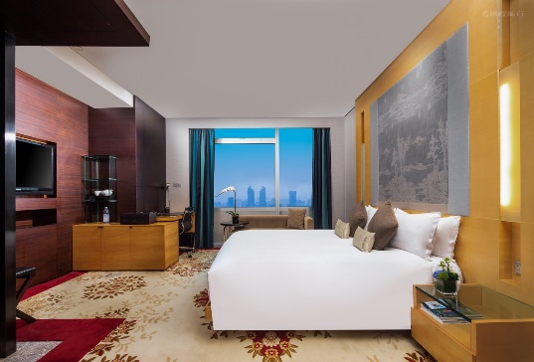 | 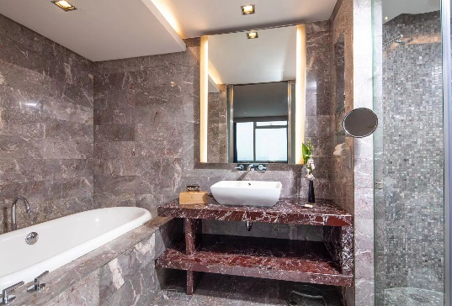
- Premium Room - Twin 45㎡
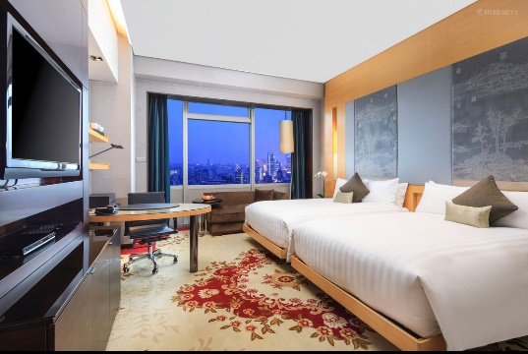 | 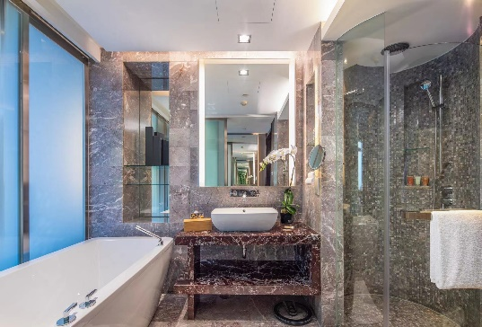
3. Club Room - King 45㎡
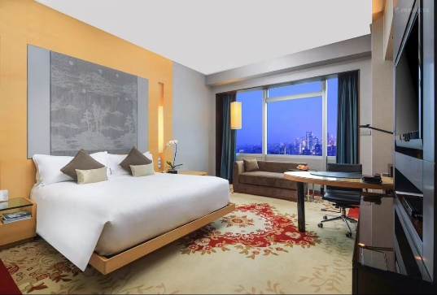 | 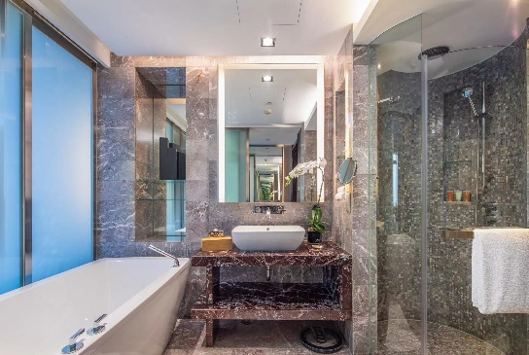

*The hotel room type may vary slightly.
Hotel Application Form_ Radisson Collection Hotel, Xing Guo Shanghai

To secure a room at Radisson Collection Hotel, Xing Guo Shanghai, please complete the form and send to Reservation department.
Reservation
Tel | +86 21 62129998-3128
Email | reservation@radissoncollection-xingguo.com, nora.hu@radissoncollection-xingguo.com
CC | nicole.yang@royal-event.cn

No | Room Type | Special Room Rate | Remarks
1 | Standard King Bed Room | RMB 1000.00 | Includes breakfast for one and Wi-Fi.
2 | Business Class Room (King/Twin) | RMB 1280.00 | Includes breakfast for one and Wi-Fi.
3 | Collection Panorama Room (King/Twin) | RMB 1700.00 | Includes breakfast for one and Wi-Fi.  Executive Benefits
•All rates are tax-inclusive.

GUEST INFORMATION
Last Name |  | First Name
Telephone |  | Fax
Nationality |  | RHG Rewards No.
E-mail
ROOM REQUIREMENT
Arrival Date |  | Departure Date
Room Type No.
Preferences
CREDIT CARD GUARANTEE
Credit Card Type | American Express JCB MASTER VISA
Credit Card Number |  |  | Expiry Date |  | /

CUT OFF DATE
Reservations by attendees must be received before 3 May, 2024. At the cut-off date, Hotel will review the reservation pick-up for the Event, release the unreserved rooms for general sale, and determine whether it can accept reservations on a space available basis after this date.
Note: after the cut-off date, reserved prices will no longer benefit from special rates and may be subject to market fluctuations.

CANCELLATION POLICY
For guaranteed reservations, in the event of no-show, a one night's room charge and tax will be imposed unless amendment/cancellation is made 72 hours prior to arrival.

SIGNED FOR AND ON BEHALF OF:

SIGNATURE DATE ______________________

FYI: It is highly recommended to make a reservation via the E-mail.

Radisson Collection Hotel, Xing Guo Shanghai
1. Standard King Bed Room 30-35㎡
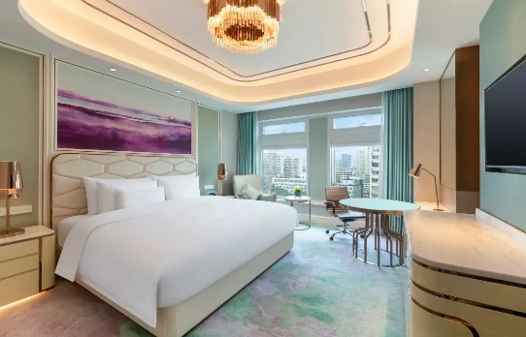 | 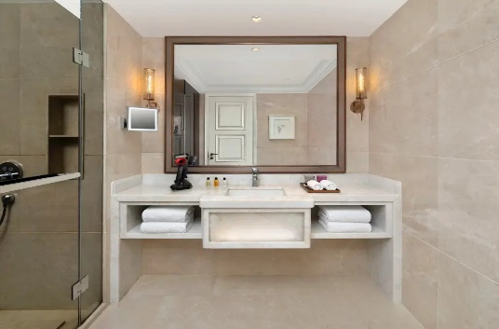
2. Business Class Room(King/Twin) 42㎡
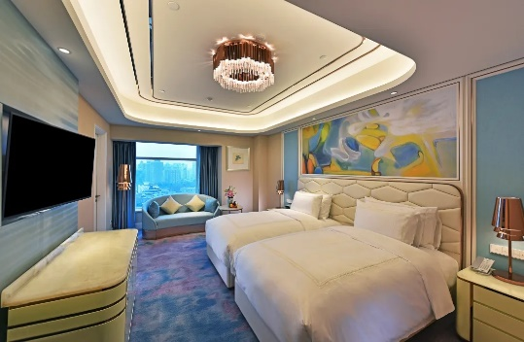 | 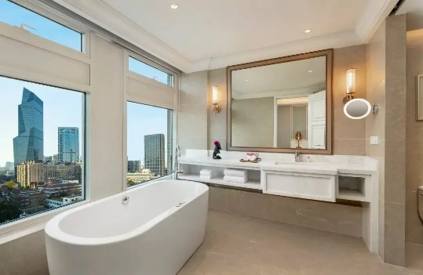
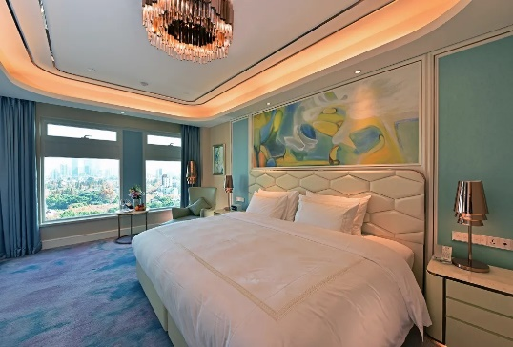 | 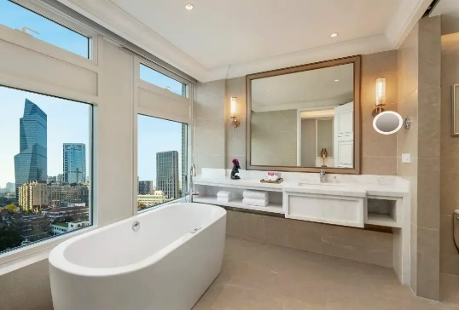
3. Collection Panorama Room (King/Twin) 45㎡
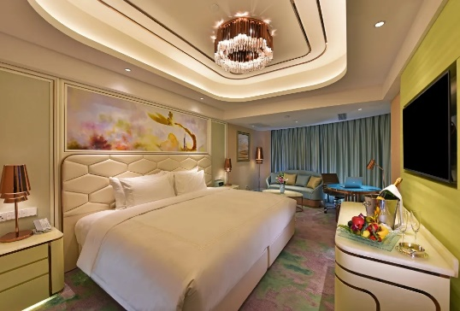 | 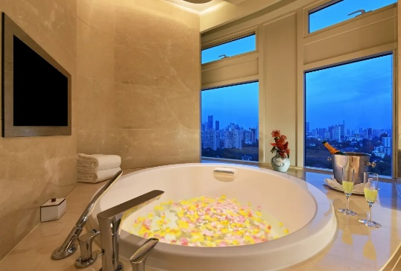
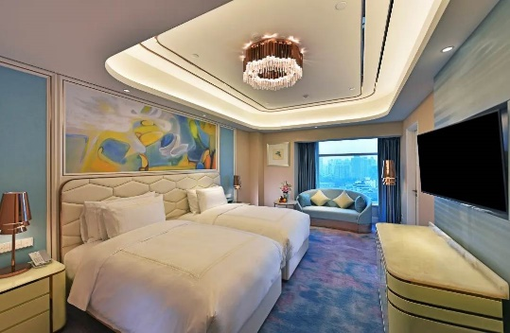 | 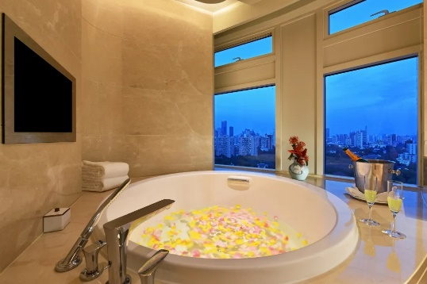
*The hotel room type may vary slightly.
Hotel Application Form_ YITEL Premium Shanghai Zhongshan Park
To secure a room at YITEL Premium Shanghai Zhongshan Park, please complete the form and send to Reservation department.
Reservation
Tel | +86 21 55698889
Email | sd0210m8@yazhugongyu.com
CC | nicole.yang@royal-event.cn

No | Room Type | Special Room Rate | Remarks
1 | Business King Room | RMB 480.00 | Includes breakfast for two and Wi-Fi.
2 | Twin Room | RMB 520.00 | Includes breakfast for two and Wi-Fi.
3 | Deluxe Room | RMB 520.00 | Includes breakfast for two and Wi-Fi.
4 | Deluxe Twin Room | RMB 560.00 | Includes breakfast for two and Wi-Fi.
- All rates are tax-inclusive.

GUEST INFORMATION
Last Name |  | First Name
Telephone |  | Fax
Nationality |  | E-mail
ROOM REQUIREMENT
Arrival Date |  | Departure Date
Room Type No.
Preferences
CREDIT CARD GUARANTEE
Credit Card Type | American Express Master Card Visa
Credit Card Number |  |  | Expiry Date | /

CUT OFF DATE
Reservations by attendees must be received before 3 May, 2024. At the cut-off date, Hotel will review the reservation pick-up for the Event, release the unreserved rooms for general sale, and determine whether it can accept reservations on a space available basis after this date.
Note: after the cut-off date, reserved prices will no longer benefit from special rates and may be subject to market fluctuations.

CANCELLATION POLICY
All reservations must be accompanied by full deposit, guaranteed with a major credit card.
Canceling your reservation before 72 hours will result in no charge. Canceling your reservation within 72 hours will charge first night deposit. Canceling your reservation within 24 hours or failing to show, will result in a charge equal to the entire stay per room to your credit card. Failing to call or show before check-out time after the first night of a
reservation will result in cancellation of the remainder of your reservation.

SIGNED FOR AND ON BEHALF OF:

SIGNATURE DATE ______________________

FYI: It is highly recommended to make a reservation via the E-mail.
YITEL Premium Shanghai Zhongshan Park
1. Business king room 18-20㎡
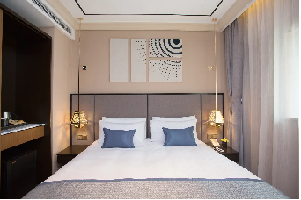 | 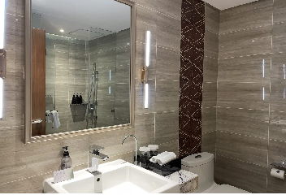
- Twin room 20-23㎡
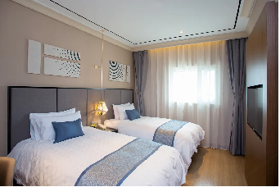 | 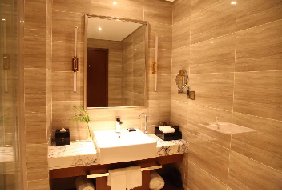
3. Deluxe room 20-28㎡
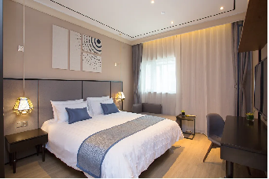  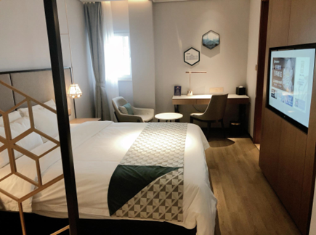 | 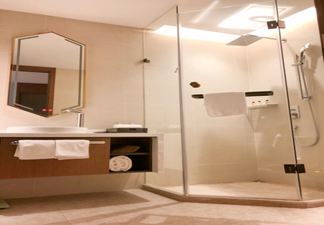  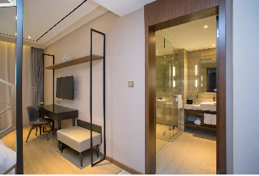
4. Deluxe twin room 20-28㎡
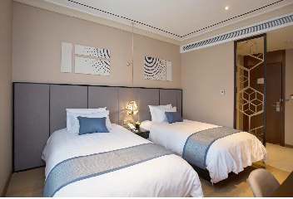  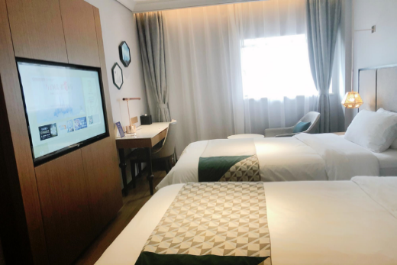 | 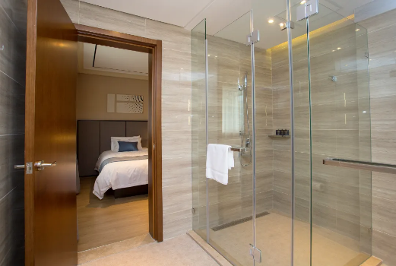  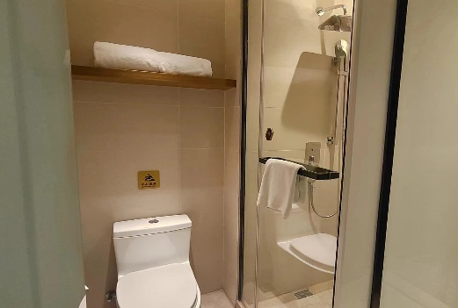

*The hotel room type may vary slightly.

