

APT REPORT ON
THE CO-EXISTENCE OF BROADBAND WIRELESS ACCESS NETWORKS IN THE 3400-3800 MHZ BAND AND FIXED SATELLITE SERVICE NETWORKS IN THE 3400-4200 MHZ BAND

No. APT/AWF/REP-5
Edition: March 2008

 | ASIA-PACIFIC TELECOMMUNITY
 | The APT Wireless Forum |  | REPORT  APT/AWF/REP-05
 |  |  | March 2008
Source: AWF-IM4/OUT-7

APT REPORT

THE CO-EXISTENCE OF BROADBAND WIRELESS ACCESS NETWORKS IN THE 3400-3800 MHZ BAND AND FIXED SATELLITE SERVICE NETWORKS IN THE 3400-4200 MHZ BAND

Introduction
Broadband Wireless Access (BWA) systems have been introduced or are currently being considered in many countries worldwide in all or portions of the 3 400-3 800 MHz band for fixed, nomadic or mobile user terminals. Currently in some countries in the Asia-Pacific region, in particular the lower part of this band, 3 400-3 600 MHz, is being considered.

The 3 400-4 200 MHz band is currently heavily used by the Fixed Satellite Service (FSS) for downlinks and introduction of BWA networks in portions of the 3 400-3 800 MHz band may have an impact on FSS reception in the entire 3 400-4 200 MHz band. As BWA is being introduced, harmful interference and loss of service for FSS receivers have been reported, also from countries within the Asia-Pacific region. The reported cases cover interference both for BWA in overlapping frequency bands and in non-overlapping bands. A case study of practical observed interference at some locations in Indonesia and as described in an input by Pakistan are provided in attachments 3 and 4. Another case study in attachment 5 provides the results of a set of experiments carried out regarding the impact of interference into a commercial TVRO terminal in the 3 400-4 200 MHz band in Japan, where interference is caused by terrestrial station in the mobile service.

Studies and field tests have been conducted within the APT Wireless Forum (AWF) and other organizations on the technical implications of co-existence of the two services in this frequency band. References and links to the studies outside AWF can be found in the Attachment 6 of this report.

- List of abbreviations

BS BWA base station
BWA Broadband Wireless Access
C/N Carrier-to-noise power ratio
C/I Carrier-to-interference power ratio
DTH Direct to home
EIRP Effective isotropic radiated power
FDD Frequency division duplex
FSS Fixed-satellite service
G/T (Satellite) Receiver figure of merit (gain/system noise temperature)
IMT International Mobile Telecommunications
(one particular application under the BWA umbrella)
ITU-R International Telecommunication Union, Radiocommunication Sector
LNA Low noise amplifier
LNB Low noise block downconverter
pfd power flux density
SMATV Satellite master antenna television
TDD Time division duplex
TS BWA (user) terminal station
VSAT Very small aperture terminal

Regulatory information
The ITU-R Radio Regulations defines radiocommunication services and allocates different services in different frequency bands. Administrations may select a subset of these allocations for their own national use.
3.1 Definitions
Some selected definitions in Article 1 of the Radio Regulations relevant for BWA applications:
1.20 fixed service: A radiocommunication service between specified fixed points.
1.24 mobile service: A radiocommunication service between mobile and land stations, or between mobile stations (CV).
1.26 land mobile service: A mobile service between base stations and land mobile stations, or between land mobile stations.
1.66 fixed station: A station in the fixed service.
1.67 mobile station: A station in the mobile service intended to be used while in motion or during halts at unspecified points.
1.69 land station: A station in the mobile service not intended to be used while in motion.

1.71 base station: A land station in the land mobile service.
1.73 land mobile station: A mobile station in the land mobile service capable of surface movement within the geographical limits of a country or continent.

BWA technologies may be used for fixed, nomadic or mobile applications. Following the definitions of the Radio Regulations, a fixed service is limited to communication between fixed specified points.

BWA user terminals deployed at unknown locations (without individual licensing of fixed user terminals, ubiquitously deployed, nomadic or mobile) therefore will operate in the mobile service. Consequently, base stations or “land stations” communicating with such user terminals will also operate in the mobile service.

Fixed BWA user terminals deployed at specified locations (e.g. with a list of the geographic coordinates for all user terminals) will operate in the fixed service and the associated base stations likewise.

BWA networks will operate within either the fixed or the mobile service as defined by the Radio Regulations, depending on the type of BWA technology used by operators and the regulatory regime for licensing of BWA service in individual administrations.

3.2 Table of allocations

Below, the various allocations in the 3 400-4 200 MHz range and the associated footnotes as contained in Article 5 of the Radio Regulations as it was revised by WRC-07 are shown.
ITU-R Region 3 covers Oceania and Asia from Iran and eastwards, excluding the RCC countries and Mongolia, including most of the APT countries. Allocations shown in upper case refer to “primary” allocations while allocations shown in lower case refer to “secondary” allocations. The Radio Regulations contain criteria and procedures (e.g. hard power flux density (pfd) limits or coordination triggers/procedures) to be used to regulate co-existence between users of services of the same priority. With respect to co-existence of users of services of different priority,

Stations of a secondary service:
a) shall not cause harmful interference to stations of primary services to which frequencies are already assigned or to which frequencies may be assigned at a later date;
b) cannot claim protection from harmful interference from stations of a primary service to which frequencies are already assigned or may be assigned at a later date; ]

In Region 3, it can be seen that:
- The 3 400-4 200 MHz band is allocated to the fixed and the fixed-satellite services on a primary basis.
- The 3 500-4 200 MHz band is allocated to the mobile service on a primary basis. (See also footnote 5.433A.)

The 3 400-3 500 MHz band is generally allocated to the mobile service on a secondary basis, but is allocated to the mobile service on a primary basis in Japan, republic of Korea and Pakistan (footnote 5.432) and, in Bangladesh, China, India, Iran (Islamic Republic of), New Zealand, Singapore and French Overseas Communities in Region 3 (See footnotes 5.432A and 5.432B).
Table 1
Table of frequency allocations in the 3 400-4 200 MHz band

2 700-4 800 MHz
Allocation to services
Region 1 | Region 2 | Region 3
…
3 400-3 600  FIXED  FIXED-SATELLITE  (space-to-Earth)  Mobile 5.430A  Radiolocation  5.431 | 3 400-3 500  FIXED  FIXED-SATELLITE (space-to-Earth)  Amateur  Mobile 5.431A  Radiolocation 5.433  5.282 | 3 400-3 500  FIXED  FIXED-SATELLITE (space-to-Earth)  Amateur  Mobile 5.432B  Radiolocation 5.433  5.282 5.432 5.432A
 | 3 500-3 700  FIXED  FIXED-SATELLITE (space-to-Earth)  MOBILE except aeronautical mobile  Radiolocation 5.433 | 3 500-3 600  FIXED  FIXED-SATELLITE (space-to-Earth)  MOBILE except aeronautical mobile 5.433A  Radiolocation 5.433
3 600-4 200  FIXED  FIXED-SATELLITE  (space-to-Earth)  Mobile |  | 3 600-3 700  FIXED  FIXED-SATELLITE (space-to-Earth)  MOBILE except aeronautical mobile  Radiolocation 5.433  5.435
3 700-4 200
FIXED
FIXED-SATELLITE (space to-Earth)
MOBILE except aeronautical mobile

5.282 In the bands 435-438 MHz, 1 260-1 270 MHz, 2 400-2 450 MHz, 3 400-3 410 MHz (in Regions 2 and 3 only) and 5 650-5 670 MHz, the amateur-satellite service may operate subject to not causing harmful interference to other services operating in accordance with the Table (see No. 5.43). Administrations authorizing such use shall ensure that any harmful interference caused by emissions from a station in the amateur-satellite service is immediately eliminated in accordance with the provisions of No. 25.11. The use of the bands 1 260-1 270 MHz and 5 650-5 670 MHz by the amateur-satellite service is limited to the Earth-to-space direction.
5.430A Different category of service: in Albania, Algeria, Germany, Andorra, Saudi Arabia, Austria, Azerbaijan, Bahrain, Belgium, Benin, Bosnia and Herzegovina, Botswana, Bulgaria, Burkina Faso, Cameroon, Cyprus, Vatican, Congo (Rep. of the), Côte d'Ivoire, Croatia, Denmark, Egypt, Spain, Estonia, Finland, France and French Overseas Departments and Communities in Region 1, Gabon, Georgia, Greece, Guinea, Hungary, Ireland, Iceland, Israel, Italy, Jordan, Kuwait, Lesotho, Latvia, The Former Yugoslav Republic of Macedonia, Liechtenstein, Lithuania, Malawi, Mali, Malta, Morocco, Mauritania, Moldova, Monaco, Mongolia, Montenegro, Mozambique, Namibia, Niger, Norway, Oman, Netherlands, Poland, Portugal, Qatar, the Syrian Arab Republic, Slovakia, Czech Rep., Romania, United Kingdom, San Marino, Senegal, Serbia, Sierra Leone, Slovenia, South Africa, Sweden, Switzerland, Swaziland, Chad, Togo, Tunisia, Turkey, Ukraine, Zambia and Zimbabwe, the band 3 400-3 600 MHz is allocated to the mobile, except aeronautical mobile, service on a primary basis subject to agreement obtained under No. 9.21 with other administrations and is identified for International Mobile Telecommunications (IMT). This identification does not preclude the use of this band by any application of the services to which it is allocated and does not establish priority in the Radio Regulations. At the stage of coordination the provisions of Nos. 9.17 and 9.18 also apply. Before an administration brings into use a (base or mobile) station of the mobile service in this band, it shall ensure that the power flux-density (pfd) produced at 3 m above ground does not exceed −154.5 dB(W/(m²  4 kHz)) for more than 20% of time at the border of the territory of any other administration. This limit may be exceeded on the territory of any country whose administration has so agreed. In order to ensure that the pfd limit at the border of the territory of any other administration is met, the calculations and verification shall be made, taking into account all relevant information, with the mutual agreement of both administrations (the administration responsible for the terrestrial station and the administration responsible for the earth station), with the assistance of the Bureau if so requested. In case of disagreement, the calculation and verification of the pfd shall be made by the Bureau, taking into account the information referred to above. Stations of the mobile service in the band 3 400-3 600 MHz shall not claim more protection from space stations than that provided in Table 21-4 of the Radio Regulations (Edition of 2004). This allocation is effective from 17 November 2010. (WRC-07)
5.431A Different category of service: in Argentina, Brazil, Chile, Costa Rica, Cuba, Dominican Republic, El Salvador, Guatemala, Mexico, Paraguay, Suriname, Uruguay, Venezuela and French Overseas Departments and Communities in Region 2, the band 3 400-3 500 MHz is allocated to the mobile, except aeronautical mobile, service on a primary basis, subject to agreement obtained under No. 9.21. Stations of the mobile service in the band 3 400-3 500 MHz shall not claim more protection from space stations than that provided in Table 21-4 of the Radio Regulations (Edition of 2004). (WRC-07)
5.432 Different category of service: in Korea (Rep. of), Japan and Pakistan, the allocation of the band 3 400-3 500 MHz to the mobile, except aeronautical mobile, service is on a primary basis (see No. 5.33). (WRC-2000)
5.432A In Korea (Rep. of), Japan and Pakistan, the band 3 400-3 500 MHz is identified for International Mobile Telecommunications (IMT). This identification does not preclude the use of this band by any application of the services to which it is allocated and does not establish priority in the Radio Regulations. At the stage of coordination the provisions of Nos. 9.17 and 9.18 also apply. Before an administration brings into use a (base or mobile) station of the mobile service in this band it shall ensure that the power flux-density (pfd) produced at 3 m above ground does not exceed −154.5 dB(W/(m²  4 kHz)) for more than 20% of time at the border of the territory of any other administration. This limit may be exceeded on the territory of any country whose administration has so agreed. In order to ensure that the pfd limit at the border of the territory of any other administration is met, the calculations and verification shall be made, taking into account all relevant information, with the mutual agreement of both administrations (the administration responsible for the terrestrial station and the administration responsible for the earth station), with the assistance of the Bureau if so requested. In case of disagreement, the calculation and verification of the pfd shall be made by the Bureau, taking into account the information referred to above. Stations of the mobile service in the band 3 400-3 500 MHz shall not claim more protection from space stations than that provided in Table 21-4 of the Radio Regulations (Edition of 2004). (WRC-07)
5.432B Different category of service: in Bangladesh, China, India, Iran (Islamic Republic of), New Zealand, Singapore and French Overseas Communities in Region 3, the band 3 400-3 500 MHz is allocated to the mobile, except aeronautical mobile, service on a primary basis, subject to agreement obtained under No. 9.21 with other administrations and is identified for International Mobile Telecommunications (IMT). This identification does not preclude the use of this band by any application of the services to which it is allocated and does not establish priority in the Radio Regulations. At the stage of coordination the provisions of Nos. 9.17 and 9.18 also apply. Before an administration brings into use a (base or mobile) station of the mobile service in this band it shall ensure that the power flux-density (pfd) produced at 3 m above ground does not exceed −154.5 dB(W/(m²  4 kHz)) for more than 20% of time at the border of the territory of any other administration. This limit may be exceeded on the territory of any country whose administration has so agreed. In order to ensure that the pfd limit at the border of the territory of any other administration is met, the calculations and verification shall be made, taking into account all relevant information, with the mutual agreement of both administrations (the administration responsible for the terrestrial station and the administration responsible for the earth station) with the assistance of the Bureau if so requested. In case of disagreement, the calculation and verification of the pfd shall be made by the Bureau, taking into account the information referred to above. Stations of the mobile service in the band 3 400-3 500 MHz shall not claim more protection from space stations than that provided in Table 21-4 of the Radio Regulations (Edition of 2004). This allocation is effective from 17 November 2010. (WRC-07)
5.433 In Regions 2 and 3, in the band 3 400-3 600 MHz the radiolocation service is allocated on a primary basis. However, all administrations operating radiolocation systems in this band are urged to cease operations by 1985. Thereafter, administrations shall take all practicable steps to protect the fixed-satellite service and coordination requirements shall not be imposed on the fixed-satellite service.
5.433A In Bangladesh, China, Korea (Rep. of), India, Iran (Islamic Republic of), Japan, New Zealand, Pakistan and French Overseas Communities in Region 3, the band 3 500-3 600 MHz is identified for International Mobile Telecommunications (IMT). This identification does not preclude the use of this band by any application of the services to which it is allocated and does not establish priority in the Radio Regulations. At the stage of coordination the provisions of Nos. 9.17 and 9.18 also apply. Before an administration brings into use a (base or mobile) station of the mobile service in this band it shall ensure that the power flux-density (pfd) produced at 3 m above ground does not exceed −154.5 dB(W/(m²  4 kHz)) for more than 20% of time at the border of the territory of any other administration. This limit may be exceeded on the territory of any country whose administration has so agreed. In order to ensure that the pfd limit at the border of the territory of any other administration is met, the calculations and verification shall be made, taking into account all relevant information, with the mutual agreement of both administrations (the administration responsible for the terrestrial station and the administration responsible for the earth station), with the assistance of the Bureau if so requested. In case of disagreement, the calculation and verification of the pfd shall be made by the Bureau, taking into account the information referred to above. Stations of the mobile service in the band 3 500-3 600 MHz shall not claim more protection from space stations than that provided in Table 21-4 of the Radio Regulations (Edition of 2004). (WRC-07)
5.434 (SUP - WRC-97)
5.435 In Japan, in the band 3 620-3 700 MHz, the radiolocation service is excluded.

3.3 International protection of FSS receive earth stations

International protection of FSS earth stations and their coordination are governed by Nos 9.17 and 9.18 of the Radio Regulations, which are applicable to specific FSS earth stations (those whose geographical coordinates are known). The thresholds/conditions to be used to trigger coordination are those specified in Appendix 5 of the Radio Regulations, together with the calculation method of coordination contours (contained in Appendix 7 of Radio Regulations). Examples of such coordination contours are shown below for two practical earth stations in the ITU-R Master Register. This coordination procedure is a regulatory concept.

As specified in No 9.6 of the Radio Regulations, an administration intending to bring into use terrestrial services, e.g., BWA network, whose territory falls within the coordination contours of the earth stations under the coordination or notification procedure or notified under Articles 9 and 11 of the Radio Regulations, shall effect coordination with other administrations having these earth stations. The Radio Regulations do not provide any criteria or procedures for how this bilateral coordination is to take place.

It should be noted that the coordination area is not an exclusion zone within which the sharing of frequencies between the earth station and terrestrial stations or other earth stations is prohibited, but a means for determining the area within which more detailed calculations need to be performed. In most cases a more detailed analysis will show that sharing within the coordination area is possible since the procedure for the determination of the coordination area is based on unfavourable assumptions with regard to the interference potential (see § 1.1 of Appendix 7 of the Radio Regulations)..

For countries intending to introduce the mobile service, as defined in the Radio Regulations (see section 3.1 above), through the footnotes 5.AAA, 5.AAA1, 5.BBB or 5.CCC (see section 3.2 above) it may be noted that in addition to the coordination contours, these footnotes of the Radio Regulations prescribe that before these administrations bring into use a (base or mobile) station of the mobile service in the specified band, it shall ensure that the pfd produced at 3 m above ground does not exceed −154.5 dB(W/(m²  4 kHz)) for more than 20 % of the time at the border of the territory of any other administration. This limit may be exceeded on the territory of any country whose administration has so agreed.

In order to ensure that the pfd limit at the border of the territory of any other administration is met, the calculations and verification shall be made, taking into account all relevant information, with the mutual agreement of both administrations (the administration responsible for the terrestrial station and the administration responsible for the earth station), with the assistance of the Bureau if so requested. In case of disagreement, the calculation and verification of the pfd shall be made by the Bureau, taking into account the information referred to above.

General information about FSS systems

There is extensive utilization by the FSS of the frequency band 3 625-4 200 MHz in all ITU Regions of the world (except certain countries in Europe and in Asia) and of the frequency band 3 400-3 625 MHz in ITU Region 1 (except parts of Europe) and Region 3 (except some countries of Asia). At the time of development of this Report, there were approximately160 geostationary satellites operating in the bands 3 400–4 200 MHz. Nearly two out of three of the commercial satellites under manufacturing (2006) will use FSS allocation in this part of the spectrum. In addition, there are many satellites operating in other bands but having their telemetry operations (Telemetry, Tracking and Ranging) in the 3 400-4 200 MHz range. In the Asia-Pacific (except some countries), there is extensive deployment of FSS earth stations in the FSS band 3 625-4 200 MHz and the 3 400-3 625 MHz band is becoming more and more used by satellite operators in some countries. The band, in particular the lower part of the band, is also used for feederlinks to satellites in the Mobile Satellite Service.

The low atmospheric absorption in the 3 400-4 200 MHz band enables highly reliable space-to-earth communication links with wide service coverage, particularly in, but not limited to, geographical areas with severe rain fade conditions. Also, for areas where the population is low and scattered (e.g. the islands in the Pacific), the wide coverage beams of satellites in this band is the only option available. For these reasons, this band is the band of choice in such regions for a multitude of services, including VSAT networks, internet providers, point-to-multipoint links, satellite news gathering, TV and data broadcasting to SMATV and DTH receivers. In many countries, receive only earth stations or VSAT terminals are not individually licensed and their number, location or detailed characteristics are not known.

However, in some countries like Japan and Korea (Rep. of), there are a limited number of operating FSS earth stations in the country with known, specific locations.

Types of earth stations
Four different types of FSS receive earth stations could be foreseen:
a) Earth stations deployed ubiquitously and/or without individual licensing or
registration.
Such earth stations would normally be expected to accept a lower availability than the other types of earth stations. On the other hand; since these earth stations are likely to be deployed in large numbers and their location is not known, it is more difficult to provide protection to them.
b) Individually licensed earth stations.
Such earth stations would normally expect a much higher availability and can accept fewer cases of interference. On the other hand, the location of these earth stations is known and site shielding and other mitigation techniques may be taken into account.
c) Telemetry earth stations.
These earth stations are part of the control system for the satellite and responsible for its safe operation. This type of earth station can tolerate very little interference. However, there are very few earth stations of this type and just like other individually licensed earth stations, their specific location is known and can be taken into account to mitigate the interference.
d) Feeder links for mobile satellite systems.
A number of mobile satellite operators use C-band for their feeder links. Because of the nature of the service, a very high degree of availability is required and very little interference can be tolerated. However, again these are a limited number of earth stations in known locations and case-by-case measures to reduce the interference can be implemented.
Types of interference
Three possible interference problems have been identified, namely:
(a) co-frequency emissions from BWA causing in-band interference to FSS systems;
Due to the long distance to the satellite and the power limitations of the satellite, the incoming power flux density at the earth station location is very low. Terrestrial equipment which will be much closer to the earth station may produce significantly higher power levels at the FSS receiver input.
(b) out-of-band emissions from BWA;
Due to the very large difference in incoming signal levels and finite out-of-band filtering capabilities, terrestrial emissions in one part of the 3 400-3 800 MHz band can create interference in non-overlapping parts of the 3 400-4 200 MHz band due to out-of-band emissions (e.g. spurious emissions). More stringent requirements for filtering of the BWA signals will reduce the impact on FSS reception, but will complicate the BWA equipment and make it more expensive.
(c) signals from nearby BWA transmitters causing overdrive of FSS receivers.
Satellite LNA’s and LNB’s are designed for reception of very low satellite signals and the dynamic range is set accordingly. Typically, an LNA or LNB will reach the 1 dB compression point with a total incoming power of around -50 dBm. Accordingly, the LNA’s or LNB’s will start to show a non-linear behaviour, creating intermodulation products and suppression of carriers at a total incoming power about 10 dB lower than the saturation power; about -60 dBm.
Traditional LNA’s and LNB’s receive the entire 3 400-4 200 MHz band. LNA’s and LNB’s specified for reception of only the 3 700-4 200 MHz band normally have the filtering at the IF side. Terrestrial signals in any part of the 3 400-4 200 MHz band therefore will affect the operating point of the LNA or LNB. Because of the huge differences in power levels, they can overdrive satellite earth station LNA’s and LNB’s or bring them into non-linear operation. This will block reception of signals anywhere in the entire 3 400-4 200 MHz band, even if the terrestrial signal is not overlapping with the FSS signal.
Waveguide bandpass filters to be mounted between the FSS receive antenna and the LNA/LNB to filter out signals outside the wanted frequency band (e.g. 3 700-4 200 MHz) are available. Field trials have indicated that they can reduce the BWA signal by about 10 dB. Such filters will however reduce the figure of merit (G/T) for the FSS earth station which may require a change to larger antennas. Some earth stations, in particular smaller earth stations also commonly have the LNB and the feedhorn molded together in one unit. In this case, insertion of a filter in between is not physically possible. The cost of inserting filters (about USD 500 – 1000 per filter at the time of development of this Report) also would add considerably to the cost of many antenna installations and can for DTH applications exceed the cost of the entire receiver installation.

- Sharing studies
Two sharing studies have been submitted to AWF (ref. [1] and [2]).
The detailed methodology, assumptions and results for the two studies submitted to AWF is contained in attachments 1 and 2 to this report. Both studies are based upon the methodology described in ITU-R Recommendation SF.1486 , but FSS and BWA parameters and criteria are different from standard ITU-R values in some cases, or no ITU-R recommended value exists. The key FSS and BWA parameters used in these two studies are summarized in the tables below. It may be noted that the BWA network parameters are slightly different in the two studies. BWA networks implemented with parameters different from these values can give rise to more or less interference than that of these studies.
FSS parameters
Frequency | 3 400-4 200 MHz
Bandwidth | 36 MHz (study 1)  153.6 kHz (study 2)
Noise temperature | 100 K
Earth station antenna radiation pattern | ITU-R Recommendation BO.1213 (study 1)  Appendix 8 of Radio Regulations (for D/λ <50) (study 2)
Antenna diameter | 1.8 m (study 1)  2.4/3m (study 2)
Antenna elevation angle | 62.6º, 40.1º (study 1)  50º, 40º, 30º (study 2)

BWA System Parameters
Transmitting frequency |  |  | 3 500 MHz (study 1)  3 350 and 3 500 MHz (study 2)
Mode of operation |  |  | TDD (study 1)  FDD (study 2)
Channel bandwidth |  |  | 7 MHz (study 1)  3.5 MHz (study 2)
Total bandwidth assigned per operator |  |  | 21 MHz (study 1)  10.5 MHz (study 2)
Base Station
- Maximum transmitter EIRP |  |  | 8W (39 dBm) (study 1)  4W (36 dBm) (study 2)
- TDD downlink traffic percentage for BS |  |  | 50%
- Frequency bandwidth used per BS |  |  | 21 MHz
- BS antenna |  |  | Directional
- No. of sectors per BS |  |  | 6 (6 x 60°) (study 1)  3 (3 x 120º) (study 2)
- Frequency used per sector |  |  | 7 MHz (frequency reuse for opposite sectors in a BS) (study 1)  10.5 x 4/3 MHz (study 2)
- Cell radius of coverage |  |  | 0.5 – 1.2 km (mean is 0.85) (study 1)  N/A (study 2)
Terminal Station
- Maximum transmitter EIRP |  |  | 4W (36 dBm) for Outdoor TS (study 1)  1W (30 dBm) for Indoor TS (study 1)  2 W (33 dBm) (study 2)
- TDD uplink traffic percentage for TS |  |  | 50% (study 1)
- TS antenna |  |  | Directional
- No. of TS supported by each BS |  |  | 1500 (study 1)
- No. of TS supported by each sector |  |  | 250 (study 1)
Multiple BWA Transmitters Affecting a FSS System
Maximum number of BWA operators |  |  | 6 (study 1)  4 (study 2)
Base Station
- Maximum number of BS affecting FSS per sector |  |  | 6 (study 1)  4 (study 2)
Terminal Station
- Percentage of Outdoor TS |  |  | 1 % (study 1)  N/A (study 2)
- Maximum no. of Outdoor TS affecting FSS per sector |  |  | (1 % x 250 x 50% x 50%) x 6 = 4  (study 1)  N/A (study 2)
- Percentage of Indoor TS |  |  | 99 % (study 1)  N/A (study 2)
- Maximum no. of Indoor TS affecting FSS per sector (within 100m in a 60° sector of 0.85km) (Note 1-3) |  |  | (99 % x 250 x ratio of 100m circle to 0.85km sector x 50% x 50%) x 6 = 31 (study 1)  N/A (study 2)
Unwanted emission limits for BWA
Base Station |  | Antenna gain |  | 18 dBi | (study 1)
 |  | (a) Unwanted emission (antenna port) |  | -80 dBW / MHz | (study 1)
 |  | Unwanted emission (EIRP) |  | -62 dBW / MHz | (study 1)
 |  | (b) Unwanted emission with filter (antenna port) |  | -89 dBW / MHz | (study 1)
 |  | Unwanted emission with filter (EIRP) |  | -71 dBW / MHz | (study 1)
 |  | Maximum permissible out-of-band emission (antenna port) |  | -89 dBW / MHz | (study 2)
 |  | Maximum permissible out-of-band emission (EIRP) |  | -71 dBW / MHz | (study 2)
Terminal Station | Outdoor | Antenna gain |  | 15 dBi | (study 1)
Terminal Station | Outdoor | Unwanted emission (antenna port) |  | -70 dBW / MHz | (study 1)
Terminal Station | Outdoor | Unwanted emission (EIRP) |  | -55 dBW / MHz | (study 1)
Terminal Station | Indoor | Antenna gain |  | 8 dBi | (study 1)
Terminal Station | Indoor | Unwanted emission (antenna port) |  | -70 dBW / MHz | (study 1)
Terminal Station | Indoor | Unwanted emission (EIRP) |  | -62 dBW / MHz | (study 1)
Terminal Station |  | Maximum permissible out-of-band emission (antenna port) |  | -68 dBW / MHz | (study 2)
 |  | Maximum permissible out-of-band emission (antenna port) |  | -50 dBW / MHz) | (study 2)

Note 1 : Since indoor TS has a relatively weak level of emission compared with outdoor TS and BS, only those indoor TS located within 100m of the FSS would be considered.
Note 2 : Since directional antenna is used by TS, only those TS pointing at the front of a FSS (assumed to be 50% of total TS) will be considered.
Note 3: Assuming that TS are located at varying heights of different buildings and not all might have direct line of sight with a victim FSS system only those TS having an elevation higher than the FSS (assumed to be 50% of total TS) will be considered.

The interference criteria used in the studies submitted to AWF are based only on the long term criteria contained in Recommendation ITU-R S.1432; an interference allowance corresponding to 6% of the satellite system noise and do not consider apportioning of this interference allowance between BWA and other services (equivalent to an interference-to-noise ratio (I/N) of -12.2 dB). Study 2 also used an interference allowance of 10% in addition to 6%.

In addition, in accordance with Recommendation ITU-R SF.1006, ITU-R recommends that the short term interference criterion also be considered. The short term criteria will have an impact in particular on the in-band interference situation where separation distances may extend beyond the horizon and ducting and scattering may give rise to low propagation losses for short periods of time. Using the short term criterion gives rise to considerably longer required separation distances than those obtained using only the long term criterion.

However, it should be noted that, in the case of calculations using short-term criterion, distances derived using a flat earth model are considered to be the maximum range of distances and should not be applied by default to define an exclusion zone around an earth station, since it is not representative of all areas around the world. The studies submitted to AWF have not taken into account the short term interference criterion and the results in this report are based only on the long-term interference criterion.

The propagation of interference signal from a BWA system to a FSS system is based on Recommendation ITU-R P.452, using the clear-sky line-of-sight model without sub-path diffraction, multipath or focusing effects, with and without clutter loss.

It is recognized that BWA transmission near the antenna of an FSS system may fall into the near-field region (R < 2·D²/λ) where the radio propagation and antenna characteristics may exhibit differences from the far field region. However, for simplicity, only far-field formulae were used for the calculation of the interference signal level, while recognizing that this can lead to somewhat inaccurate results. The field trials however indicated good correspondence between calculated results and observed behaviour.

Required separation distances
To ensure protection of the FSS earth station, the BWA base stations and user terminals in all cases needs to be separated from the FSS receive earth station. The magnitude of this separation distance depends on the system parameters in the various scenarios. From the two studies submitted to AWF, the required separation distances between BWA stations working in the 3.5 GHz band and FSS earth stations working in the 3 400–4 200 MHz band are summarised as follows:

- Co-frequency Emission Problem

Interference will be caused by BWA working in 3 400–3 800 MHz to FSS systems receiving satellite signals by the same frequencies. Separation distances of at least tens of kilometres will be required if no shielding arrangement can be implemented at the earth stations. If there are only limited number of licensed earth stations in an area, the required separation distance to protect individual earth stations could be less than the worst case figures since it can be worked out on a case-by-case basis depending on the geographical and operating characteristics of the specific earth station as well as those of BWA stations.

- Out-of-band Emission Problem

Out-of-band emissions from BWA operating in 3 400–3 800 MHz can also affect FSS systems receiving signals in the adjacent bands within the entire 3 400–4 200 MHz. Assuming that normal BWA equipment with out-of-band emissions conforming to European standards (ETSI EN 301 390) are deployed, a separation distance of up to about 2 km between BWA transmitters and FSS receiving stations would be required. If additional filtering can be implemented at the BWA base stations to reduce the unwanted emission levels and the use of outdoor BWA terminal stations is prohibited, the distance may be shortened to about 0.5 km. For specific earth stations, clutter loss and shielding effects can also be taken into account to further reduce the separation distance.

- FSS Receiver Overdrive Problem

Signals from nearby BWA equipment transmitting in the 3 400–3 800 MHz band will also cause overdrive of FSS receivers with their LNBs operating in the 3 400–4 200 MHz range. Although a number of technical solutions (e.g. filter, shielding etc) may be available in principle to minimize / overcome the problem, the most practical one is to add a waveguide bandpass filter in front of the FSS receiver (if technically possible). According to a field test conducted, an off-the-shelf filter can reduce the interference level by 10 dB. With this solution, a separation distance of about 0.5 – 0.6 km is required between BWA and FSS systems. For those FSS systems without implementing the filter solution, a separation distance of about 1.2 km would be required.

Requirements for co-existence

7.1 Individually licensed / registered FSS earth stations at specific locations

When the FSS earth stations are individually licensed or registered such that the locations of the stations are known, the protection of the FSS earth stations can be achieved by means of ensuring minimum separation distances between the BWA systems and FSS earth stations, in addition to other mitigation measures (e.g. site shielding). According to the two studies described, if BWA should be allocated to work in the 3.5 GHz band under a primary allocation, the following technical limitations and mitigation measures could be applied to facilitate coexistence of BWA and FSS in the same area:

- BWA systems within an area of at least tens of kilometers around existing licensed earth stations operating in the same frequencies may cause interference to the latter, if no shielding arrangement can be implemented at the earth stations. BWA operators shall carry out careful coordination on a case-by-case basis such that harmful in-band interference will not be caused to these earth stations.

- To overcome interference due to the overdrive and out-of-band emission problems which may potentially affect all FSS systems with LNBs with operation in the 3 400–4 200 MHz range, BWA systems shall be separated from FSS systems by up to 2 km if no mitigation measures are implemented.

- To reduce the separation between BWA and FSS in (b) to a more manageable distance of 0.5 km, the following measures are required :

  - A waveguide bandpass filter need to be retrofitted at an interfered FSS system
  - Additional filtering need to be implemented at BWA base station to reduce out-of-band emission to not exceeding -89 dBW/MHz
  - Outdoor BWA terminal stations need to be prohibited

- If the separation distance and proposed measures in (c) are considered acceptable, a location database of FSS earth stations needs to be available. BWA operators shall check the database to identify any nearby FSS stations, observe the separation distance and comply with other coordination requirements for installation of BWA systems.

- Protection by separation distance is only meaningful for fixed BWA stations as assumed in this assessment but not for mobile BWA stations. If there is no practical solution that can be identified to prevent the risk of interference by mobile BWA stations to FSS systems, the former will need to be prohibited.

7.2 BWA stations and/or FSS earth stations deployed in a ubiquitous manner and/or
without individual licensing or registration

The studies have shown that when no particular shielding or blocking with respect to the interfering signal can be guaranteed, the required separation distance would be at least in the order of tens of kilometers in the case of co-frequency operation and a few kilometers in the case of adjacent band operation. When the BWA stations and/or FSS earth stations are deployed in a ubiquitous manner and/or without individual licensing or registration, the locations of the stations are not known and no such minimum separation distance can be guaranteed. Coexistence between FSS and BWA would be difficult in general. In situations where BWA may be introduced on a regional basis, the following measures may be considered:

- To prohibit BWA deployment in areas known to have high density of FSS earth stations, such as urban areas. BWA systems might be allowed in other areas where there is low density of deployment, subject to (b) and adoption of measures as described in 6.1

- To establish a location database for FSS earth stations such that those earth stations with known locations in the database would be offered protection through measures as described in7.1.

Conclusions

BWA networks may operate within the fixed and/or mobile service as defined by the Radio Regulations, depending on the type of technology and licensing regime adopted in individual administrations. BWA user terminals deployed at unknown locations (without individual licensing of fixed user terminals, ubiquitously deployed, nomadic or mobile) and the associated base stations will operate in the mobile service while BWA user terminals deployed at fixed, specified locations, and their associated base stations will operate in the fixed service.

In ITU-R Region 3, the band 3 500-4 200 MHz is allocated by the ITU to the Mobile Service on a primary basis. The 3 400-3 500 MHz band is generally allocated to the Mobile Service on a secondary basis in Region 3, but is allocated to the mobile service on a primary basis in Japan, republic of Korea and Pakistan, Bangladesh, China, India, Iran (Islamic Republic of), New Zealand, Singapore and French Overseas Communities in Region 3. The entire 3 400-4 200 MHz band is allocated to the Fixed and the Fixed Satellite Service on a primary basis.

Appendix 7 of the Radio Regulations define coordination contours around FSS receive earth stations inside which coordination is required for terrestrial services.

As specified in No 9.6 of the Radio Regulations, an administration intending to bring into use terrestrial services, e.g., BWA network, whose territory falls within the coordination contours of the earth stations under the coordination or notification procedure or notified under Articles 9 and 11 of the Radio Regulations, shall effect coordination with other administrations having these earth stations.

Countries with a footnote in the Radio Regulations prescribing the pfd limit for mobile applications in certain frequency bands, need to observe and demonstrate compliance with the limit within the territories of other administrations taking into account all relevant information, if they intend to introduce mobile services (as defined by the Radio Regulations) within their own territory. The limit may be exceeded on the territory of any country whose administration has so agreed.

Sharing studies and field trials have been performed related to co-existence of BWA networks being deployed in portions of the 3 400-3 800 MHz band and FSS networks in the bands 3 400-4 200 MHz. Three different types of interference were identified, i.e., in-band interference, out-of-band emissions, and FSS receiver overdrive.
To provide protection of the FSS receive earth stations, some separation distance between the stations of the BWA network and the FSS receive earth stations is required. The magnitude of this separation distance depends on the parameters of the networks, the protection criteria of concerned satellite networks and the deployment of the two services and if the two services operate in the same or in adjacent frequency bands. With the parameters and assumptions used in the studies in this report, the required separation distance is at least in the order of tens of kilometers in the case of co-frequency operation and a few kilometers in the case of adjacent band operation when there is no shielding or blockage with respect to the interfering signal.
When the BWA stations and/or FSS earth stations are deployed in a ubiquitous manner and/or without individual licensing or registration, the locations of the stations are not known and hence, no minimum separation distance can be guaranteed. Coexistence of BWA networks operating within the 3 400-3 800 MHz range and FSS networks operating in any part of the 3 400-4 200 MHz range therefore in this case becomes difficult within the same geographical area.

When the FSS earth stations are individually licensed or registered such that the locations of the stations are known and the location of the BWA base stations and user terminals can be controlled, protection of the FSS earth stations can be achieved by means of ensuring a minimum separation distance, taking into account specific site shielding and propagation conditions as well as imposing other means to control and reduce the interference. As a part of this, BWA systems within several kilometers of an FSS receive earth station operating in the same frequency band would need to carefully conduct coordination on a case-by-case basis. Moreover, to avoid interference in non-overlapping frequency bands, with the assumptions used in the two studies, a minimum separation distance of 2 km needs to be ensured with respect to all FSS receivers. This distance can be reduced to about 0.5 km if a waveguide bandpass filter is retrofitted to all FSS receivers, the BWA base station has additional filtering of spurious emissions and outdoor BWA user terminals are prohibited.

The effectiveness of the mechanisms for co-existence between FSS and BWA is dependent on its application to individual site situations. Further studies would be necessary to determine the circumstances which would permit the effective use of such mechanisms, on a case by case basis.

It should be understood that new FSS earth stations installed after installation of a BWA system may or may not be offered protection. Finally, BWA in the band or a portion of band 3 400–3 800 MHz, if deployed, may pose limitations on possible future deployment of FSS not only in the band 3 400–3 800 MHz but also in the band 3 800–4 200 MHz.
REFERENCES:

[1] Document AWF-3/17 “Assessment of potential interference between Broadband Wireless Access (BWA) in 3.4-3.6 GHz band and Fixed Satellite Service (FSS) in 3.4-4.2 GHz band”, Office of the Telecommunications Authority (OFTA) Hong Kong, September 2006

[2] Document AWF-3/34 “Sharing study between Broadband Wireless Access systems and Fixed Satellite Services”, The Socialist Republic of Vietnam, September 2006

[3] Document AWF-3/18 “Protection of FSS earth stations in accordance with Appendix 7 of the Radio Regulations”, AsiaSat, September 2006

[4] Document AWF-3/19 “Proposed Working document towards a Report on the impact of BWA in the 3-4 GHz range on FSS reception”, AsiaSat, September 2006

[5] Document AWF-IM2/50 “Report for Spectrum SWG 4 dealing with broadband and SDR”, AWF SWG 4, February 2006

[6] Document AWF-IM2/09 “ Impact of Broadband Wireless Access systems in the 3.5 GHz range on FSS receive earth stations”, AsiaSat February 2006

- Recommendation ITU-R SF.1486, Sharing Methodology between Fixed Wireless Access Systems in the Fixed Service and Very Small Aperture Terminals in the Fixed Satellite Service in the 3400 – 3700 MHz Band

- Recommendation ITU-R S.1432, Apportionment of the Allowable Error Performance Degradations to Fixed-Satellite Service (FSS) Hypothetical Reference Digital Paths Arising From Time Invariant Interference for Systems Operating Below 15 GHz

- Recommendation ITU-R P.452, Prediction Procedure for the Evaluation of Microwave Interference between Stations on the Surface of the Earth at Frequencies above about 0.7 GHz

- Recommendations ITU-R BO.1213, Reference Receiving Earth Station Antenna Patterns for Planning Purposes to be Used in the Revision of the WARC BS-77 Broadcasting-Satellite Service Plans for Regions 1 and 3

- ETSI EN 301 390, Fixed Radio Systems; Point-to-point and Multipoint Systems; Spurious emissions and receiver immunity limits at equipment / antenna port of Digital Fixed Radio Systems

- ECC Recommendation (04)05, Guidelines for Accommodation and Assignment of Multipoint Fixed Wireless Systems in Frequency Bands 3.4-3.6 GHz and 3.6–3.8 GHz

- NTIA Report TR-99-361, Technical Characteristics of Radiolocation Systems Operating in the 3.1 – 3.7 GHz Band and Procedures for Assessing EMC with Fixed Earth Stations Receivers

- WiMAX Forum, WiMAX Deployment Considerations for Fixed Wireless Access in the 2.5 GHz and 3.5 GHz Licensed Bands”, June 2005

Attachment 1

(Document AWF-3/17, OFTA Hong Kong)

 | ASIA-PACIFIC TELECOMMUNITY
 | The 3rd Meeting of the APT Wireless Forum | Document  AWF-3/17
 | 27 – 30 September 2006, Hanoi, Vietnam SR | 27 September 2006

ASSESSMENT OF POTENTIAL INTERFERENCE BETWEEN
BROADBAND WIRELESS ACCESS (BWA) IN 3.4 – 3.6 GHZ BAND AND
FIXED SATELLITE SERVICE (FSS) IN 3.4 – 4.2 GHZ BAND

by

Office of the Telecommunications Authority (OFTA)
Hong Kong, CHINA

This attached paper presents the results of an assessment by a government-industry working group on the potential interference problems caused by the proposed deployment of broadband wireless access (BWA) systems in the 3.4 – 3.6 GHz band (“3.5 GHz band”) to fixed satellite service (FSS) systems in 3.4 – 4.2 GHz band in Hong Kong. The paper may serve as a reference to those APT administrations considering to introduce BWA service in the 3.5 GHz band.

____________

Assessment of Potential Interference between
Broadband Wireless Access (BWA) in 3.4 – 3.6 GHz Band and
Fixed Satellite Service (FSS) in 3.4 – 4.2 GHz Band

1. Purpose

This paper presents the results of an assessment on the potential interference problems caused by the proposed deployment of broadband wireless access (BWA) systems in the 3.4 – 3.6 GHz band (“3.5 GHz band”) to fixed satellite service (FSS) systems in 3.4 – 4.2 GHz band in Hong Kong.

2. Background

The Office of the Telecommunications Authority (OFTA) has carried out consultation with the industry on the licensing of BWA service in Hong Kong (Reference [10]). Regarding the proposed spectrum to be allocated, the 3.5 GHz band is one of the possible candidates for introducing the service (Reference [9]). At present, the band is primarily used for FSS service. OFTA has proposed to re-designate the 3.5 GHz band as a primary allocation for BWA while the existing FSS service in the same frequency band will be changed to secondary allocation. The FSS service in the 3.6 – 4.2 GHz will continue to operate on a primary status.

In response to OFTA’s proposal, a number of industry submissions (Reference [11]) have raised the concern on the potential impact caused by BWA on FSS receiving stations including earth stations for telemetry, tracking, command and monitoring (TTC&M), earth stations for external fixed telecommunications network services, Satellite Master Antenna Television (“SMATV”) systems and Television Receive Only (“TVRO”) systems (collectively called “FSS systems”). The impact will not only be for those FSS systems receiving signals in 3.4 – 3.6 GHz, but also for all FSS systems with operating range in the entire 3.4 – 4.2 GHz range. Three possible interference problems have been identified, namely, (a) co-frequency emissions from BWA causing in-band interference to FSS systems; (b) out-of-band emissions from BWA; and (c) signals from nearby BWA transmitters causing receiver saturation of FSS systems. To carry out assessment of the impact, a government-industry working group (“the WG”) has been set up under the Radio Spectrum Advisory Committee (RSAC) of OFTA to take up the work. This paper summarises the major results and findings by the WG.

3. Assumptions and Methodology

A deterministic approach is used to assess the concerned interference problems and the potential of sharing between BWA and FSS in the same or adjacent frequency bands in the 3.4 – 4.2 GHz range. The assessment methodology is based on adaptation of the method given in Recommendation ITU-R SF.1486 [1] for calculating the separating distances between an FSS VSATs and P-MP FWA systems to enable sharing between the two types of systems in the 3.4 – 3.7 GHz band.

3.1 BWA System Parameters

The system parameters for BWA are given in Tables 1 – 3. The following assumptions should be noted :

- The BWA system parameters are based on a configuration of BWA system operating in TDD mode as proposed by the industry.

- The base stations (BS) and terminal stations (TS) of the BWA system are assumed to be operating at fixed locations.

- Multiple BWA transmitters are evaluated in order to assess the aggregated interference which may have impact on a specific FSS system in the worst case. The maximum number of interfering BWA transmitters on a FSS system will depend on the number of BWA operators and the deployment scenario.

- Assuming that large frequency separation will be achieved between the operating frequencies of BWA and FSS, the out-of-band emissions should be those unwanted emissions in the spurious domain. The emission limits for BS (-80 dBW/MHz) and TS are (-70 dBW/MHz) based on ETSI EN 301 390 [5]. Reference is also made to ECC Rec (04)05 [6] which applies a more stringent limit for BS (-89 dBW/MHz) for specific deployment scenarios by additional filtering at the BS to improve coexistence of adjacent frequency blocks.
Table 1 – BWA System Parameters
Transmitting frequency | 3500 MHz
Mode of operation | TDD
Channel bandwidth | 7 MHz
Total bandwidth assigned per operator | 21 MHz
Base Station
- Maximum transmitter e.i.r.p | 8W (39 dBm)
- TDD downlink traffic percentage for BS | 50%
- Frequency bandwidth used per BS | 21 MHz
- BS antenna | Directional
- No. of sectors per BS | 6 (6 x 60°)
- Frequency used per sector | 7 MHz (frequency reuse for opposite sectors in a BS)
- Cell radius of coverage | 0.5 – 1.2 km (mean is 0.85 km)
Terminal Station
- Maximum transmitter e.i.r.p | 4W (36 dBm) for Outdoor TS  1W (30 dBm) for Indoor TS
- TDD uplink traffic percentage for TS | 50%
- TS antenna | Directional
- No. of TS supported by each BS | 1500
- No. of TS supported by each sector | 250

Table 2 – Multiple BWA Transmitters Affecting a FSS System
Maximum number of BWA operators | 6
Base Station
- Maximum number of BS affecting FSS per sector | 6
Terminal Station
- Percentage of Outdoor TS | 1 %
- Maximum no. of Outdoor TS affecting FSS per sector | (1 % x 250 x 50% x 50%) x 6 = 4
- Percentage of Indoor TS | 99 %
- Maximum no. of Indoor TS affecting FSS per sector (within 100m in a 60° sector of 0.85km) (Note 1-3) | (99 % x 250 x ratio of 100m circle to 0.85km sector x 50% x 50%) x 6 = 31
Note 1 : Since indoor TS has a relatively weak level of emission compared with outdoor TS and BS, only those indoor TS located within 100m of the FSS would be considered.
Note 2 : Since directional antenna is used by TS, only those TS pointing at the front of a FSS (assumed to be 50% of total TS) will be considered.
Note 3: Assuming that TS are located at varying heights of different buildings and not all might have direct line of sight with a victim FSS system only those TS having an elevation higher than the FSS (assumed to be 50% of total TS) will be considered.

Table 3 – Unwanted emission limits for BWA
Base Station | Antenna gain | 18 dBi
Base Station | (a) Unwanted emission (antenna port) | -80 dBW / MHz
Base Station | Unwanted emission (EIRP) | -62 dBW / MHz
Base Station | (b) Unwanted emission with filter (antenna port) | -89 dBW / MHz
Base Station | Unwanted emission with filter (EIRP) | -71 dBW / MHz
Outdoor Terminal Station | Antenna gain | 15 dBi
Outdoor Terminal Station | Unwanted emission (antenna port) | -70 dBW / MHz
Outdoor Terminal Station | Unwanted emission (EIRP) | -55 dBW / MHz
Indoor Terminal Station | Antenna gain | 8 dBi
Indoor Terminal Station | Unwanted emission (antenna port) | -70 dBW / MHz
Indoor Terminal Station | Unwanted emission (EIRP) | -62 dBW / MHz

3.2 FSS System Parameters

The system parameters of a FSS system operating in 3.4 – 4.2 GHz are given in Table 4. The parameters are assumed to be those of a typical TVRO system receiving digital satellite TV signals with the use of a 3m antenna.

Table 4 – FSS System Parameters
Frequency band | 3.4 - 4.2 GHz
Channel bandwidth | 36 MHz
Noise temperature | 100 K
On-axis antenna gain | 35.5 dBi (based on ITU-R BO.1213)
Reference antenna pattern | Based on ITU-R BO.1213  - Off-axis sidelobe gain 29-25logφand flat at -5 dBi (22.9°<φ<70°) and 0 dBi (70°<φ<180°)  - For multiple TS, antenna gain is assumed to be 0 dBi
Elevation angle for reception | Typical elevation angles for satellite TV reception in local urban areas:  - high elevation – 62.6°  - low elevation – 40.1°

3.3 Interference Criteria

3.3.1 In-band Interference

Based on Recommendation ITU-R S.1432 [2], an interference-to-noise ratio (I/N) of -12.2 dB is taken which means that the interference corresponds to 6% of the satellite system noise. Therefore, assuming that the system noise is the thermal noise floor calculated by the formula kBT, the maximum allowable in-band interference ( I_{inband} ) under the worst case scenario is given by:

I_{inband} = N + (I/N) dBW = [10*log(kTB) – 12.2] dBW

where k = Boltzmann’s constant (1.38 x 10E-23)
T = 100 K
B = 36 MHz

Hence I_{inband} = [-133 – 12.2 ] dBW / 36 MHz = - 220.8 dBW/Hz

The above threshold criteria would only apply where the received carrier power (C) and the required carrier-to-noise ratio (C/N) for a specific FSS system is unknown. However, for evaluation of in-band interference to a specific FSS system where the operating parameters are known, the maximum allowable in-band interference can be derived from the received carrier signal level at the FSS system (C) and the required carrier-to-noise ratio (C/N) necessary to maintain acceptance performance as follows:

I_{inband} = C - (C/N) + (I/N) dBW = [C – (C/N) – 12] dBW

3.3.2 FSS Receiver Saturation

Based on the inputs of the local industry, the maximum level of interference signal (I_{saturation}) which may be allowed at the FSS frontend receiver before saturation or overload occurs is taken to be

I_{saturation} = – 60 dBm.

3.4 Propagation Models

(a) Far Field Formula

There are comments from the industry that BWA transmission near the antenna of an FSS system may fall into the near-field region where the radio propagation characteristics may exhibit differences from the far field region. For simplicity, it is considered that only far-field formula will be used for the calculation of the interference signal level, while measurement results should be referred for verification of the calculation results, in particular for interference source located closely to the FSS antenna.

(b) Path Loss

The propagation of interference signal from a BWA system to a FSS system is based on a clear-air line-of-sight model based on Recommendation ITU-R P.452 [3]. The path loss L_{BWA}(d ) is calculated by the following formula :

L_{BWA}(d ) = 92.5 + 20 log ( f ) + 20 log (d) + Ah dB
where
(i) f : frequency of signal (GHz),
(ii) d : the distance (km), and
(iii) Ah : the clutter loss (dB) which is taken to be
0 dB for free air propagation and 18.5 dB for dense urban areas

For indoor TS, an excess path loss of 15 dB will be taken to account for building penetration and non-optimal installation locations.

3.5 Interference Power Received by FSS

Based on the Recommendation ITU-R SF.1486 [1], the interference power ( I ) received by a FSS system from a BWA system is given by:
I = e.i.r.p._{BWA} – L_{BWA}(d ) + G_{VS}( α) – R dBW
where:
(i) e.i.r.p._{BWA} : off-axis e.i.r.p. from the BWA antenna (dBW).
For considering worst case situation, a maximum gain is assumed for the BWA antenna .
(ii) L_{BWA}(d ) : path loss between the FSS and BWA (dB)
which is calculated by the formula in 3.4 (b).
(iii) G_{VS} ( α) : FSS system off-axis antenna receiving gain (dBi)
- (iv) R : the isolation achieved by site shielding (dB)
- which is taken as 0 dB, 30 dB and 40dB for calculations.

In the case of FSS receiver saturation, a bandpass filter may be used as one remedy measure to reduce the BWA interference signal presented to the RF input of the FSS receiver. If such a filter is added, the above interference power ( I ) will be adjusted by an attenuation of the filter outside its passband at the concerned transmission frequency of the BWA.

3.6 Separation Distance between BWA and FSS

Following from 3.4 and 3.5, the required separation distance ( d ) between a BWA system and a FSS system to avoid interference is calculated by :

20log(d) = – I + e.i.r.p._{BWA} – 92.5 – 20log( f ) – Ah + G_{VS}( α) – R

when the interference power ( I ) is equal to the threshold interference criteria given in 3.3.1 and 3.3.2 for inband interference ( I_{inband} ) and receiver saturation (I_{saturation}).

4. Results of Calculations

Using the technical assumptions and methodology as stated above, the required separation distances between the BWA and FSS systems have been calculated to avoid the following three types of interference problems:

- Co-frequency emissions from BWA causing in-band interference to FSS
- Out-of-band emissions from BWA causing in-band interference to FSS
- Signals from BWA causing FSS receiver saturation

In order to assess the feasibility of sharing between FSS and BWA under the scenarios of different number of BWA operators, the calculations have been performed for :

- A maximum of 6 BWA operators (n = 6), assuming that each operator is assigned with one frequency block of 21 MHz in the 3400 – 3550 MHz range;
- A maximum of 4 BWA operators (n = 4), assuming that each operator is assigned with one frequency block of 21 MHz in the 3400 – 3500 MHz range;

A summary of the calculated separation distances between the FSS and BWA systems to avoid harmful interference to the FSS system is given in Table 5.

Table 5 - Summary of Required Separation Distances between FSS and BWA
Interference Scenarios | Required Separation Distance (km)  (n = no. of BWA operators)
 | High FSS elevation angle | Low FSS elevation angle
1. Co-frequency Emission from BWA
- Single BS, shielding loss = 40 dB | 0.7 km | 0.7 km
- Single BS, shielding loss = 30 dB | 2.1 km | 2.1 km
- Single BS, shielding loss = 0 dB | 66.5 km | 66.5 km
- Multiple BS, shielding loss = 40 dB | 1.6 km (n = 6)  1.3 km (n = 4) | 1.6 km (n = 6)  1.3 km (n = 4)
- Multiple BS, shielding loss = 30 dB | 5.2 km (n = 6)  4.2 km (n = 4) | 5.2 km (n = 6)  4.2 km (n = 4)
- Multiple BS, shielding loss = 0 dB | 162.9 km (n = 6)  133.0 km (n = 4) | 162.9 km (n = 6)  133.0 km (n = 4)
2. Out-of-band (OOB) Emission from BWA
- Multiple BS only | 1075 m (n = 6)  875 m (n = 4) | 1075 m (n = 6)  875 m (n = 4)
- Multiple BS and both Indoor and Outdoor TS | 2275 m (n = 6)  1945 m (n = 4) | 2275 m (n = 6)  1945 m (n = 4)
- Multiple BS (with filter) and Indoor TS only | 580 m (n = 6)  475 m (n = 4) | 580 m (n = 6)  475 m (n = 4)
3. FSS Receiver Saturation
- Single BS without LNB filter | 430 m | 540 m
- Single BS with LNB filter | 215 m | 405 m
- Multiple BS without LNB filter | 1050 m (n = 6)  855 m (n = 4) | 1050 m (n = 6)  855 m (n = 4)
- Multiple BS with LNB filter | 335 m (n = 6)  270 m (n = 4) | 525 m (n = 6)  490 m (n = 4)
- Multiple BS and TS without LNB filter | 1220 m (n = 6)  1010 m (n = 4) | 1220 m (n = 6)  1010 m (n = 4)
- Multiple BS and TS with LNB filter | 385 m (n = 6)  320 m (n = 4) | 560 m (n = 6)  520 m (n = 4)

Some observations on the calculated values in Table 5 are as follows:

- Co-frequency emissions

For a single BWA BS, the required separation distances are 0.7 km and 2.1 km respectively if isolation loss of 40 dB and 30 dB can be achieved by suitable shielding arrangement at the FSS site. If no shielding loss is assumed, the required separation can be up to a maximum of 66.5 km.

- Out-of-band emissions

Under the worst case scenario of multiple BWA BS and TS affecting a single FSS system, the required separation distance between the BWA transmitters and the FSS system is about 2.3 / 1.95 km (n = 6 / 4) for normal BWA equipment conforming to the ETSI standards. If additional filtering can be implemented at the BWA BS to lower the unwanted emission level and outdoor TS are prohibited, the separation distances can be reduced to 0.58 / 0.48 km (n = 6 /4).

- FSS receiver saturation

Under the same worst case scenario of multiple BWA interferers, the required separation distances between the BWA systems and the interfered FSS system are 1.2 / 1.0 km (n = 6 / 4, without filter) if no protection measures are implemented. If a bandpass filter giving 10 dB attenuation of the BWA signal is added before the low noise block (LNB) down-converter of the FSS system, the separation distances are reduced to 0.56 / 0.52 km (n = 6 / 4, with filter).

5. Field Test on FSS Receiver Saturation Problem

OFTA conducted a field test in April 2006 to measure the interference generated by a BWA transmitter operating in 3.4 – 3.6 GHz and located at various distances from a TVRO system receiving C-band satellite TV signals in the 3.6 – 4.2 GHz range. The effect of adding a LNB filter to tackle the saturation problem was also assessed. Representatives of the WG participated in the concerned test.

The details of this field test are described in Annex 1. The field test showed the BWA signals would cause saturation to the FSS receive in a way that is consistent with calculations. Also, the fitting of a bandpass filter at the LNB frontend of the FSS receiver could achieve reduction of the interference signal by a figure of 10 dB.

6. Field Test on Co-frequency Emissions from BWA

OFTA conducted another field test in June 2006 jointly with a satellite operator to measure the interference of co-frequency emissions from a BWA transmitter placed at a distance of several kilometres away from the affected FSS earth station.

The details of the field test are given in Annex 2. The field test showed that the BWA signals would cause in-band interference to the FSS earth station in a way that is consistent with calculations. For protection of the affected earth station, a coordination zone of several kilometres will need to be set up around the earth station. To prevent harmful interference of BWA to the earth station, installation of any BWA stations within the coordination zone would be allowed only if they do not cause harmful interference to the earth station.

7. Summary

According to the above assessment, the potential interference issues of the proposed allocation of BWA in the 3.5 GHz band to the existing FSS working in the 3.4 – 4.2 GHz band are summarised as follows:

- Co-frequency Emission Problem

Interference will be caused by BWA working in 3.4 – 3.6 GHz to FSS systems receiving satellite signals by the same frequencies. Separation distances of tens of kilometres will be required if no shielding arrangement can be implemented at the earth stations in the worst case. If there are only limited number of licensed earth stations in an area, the required separation distance to protect individual earth station could be less than the worst case figures and might be worked out case by case depending on the geographical and operating characteristics of the specific earth station. From the specific assessment and field test conducted with a satellite operator in Hong Kong, a separation distance of several kilometres is required in practice. As such kind of geographical separation may not be achievable in a dense urban environment, it is considered that co-frequency sharing between BWA and FSS in the 3.5 GHz band is not feasible in the latter case.

- Out-of-band Emission Problem

Out-of-band emissions from BWA operating in 3.4 – 3.6 GHz can also affect FSS systems receiving signals in the adjacent band of 3.6 – 4.2 GHz. Assuming a scenario of 4 BWA operators and that normal BWA equipment with out-of-band emissions conforming to European standards are deployed, a separation distance of about 2 km between BWA transmitters and FSS receiving stations would be required. If additional filtering can be implemented at the BWA base stations to reduce the unwanted emission levels and the use of outdoor BWA terminal stations is prohibited, the distance may be shortened to about 0.5 km.

- FSS Receiver Saturation Problem

Signals from nearby BWA equipment transmitting in the 3.4 – 3.6 GHz band will also cause saturation of FSS receivers with their LNB operating in the 3.4 – 4.2 GHz range. Although a number of technical solutions (e.g. filter, shielding etc) may be available in principle to minimize / overcome the problem, the most practical one is add a bandpass filter in front of the FSS receiver. According to a field test conducted, an off-the-shelf filter can reduce the interference level by 10 dB. With this solution and assuming 4 BWA operators are licensed with 4 x 21 MHz blocks assigned in 3.4-3.5 MHz, a separation distance of about 0.5 km is required between BWA and FSS systems. For those FSS systems without implementing the filter solution, a separation distance of 1 km would be required.

8. Technical Constraints on Deployment of BWA in 3.5 GHz Band

According to the assessment results, if BWA should be allocated to work in the 3.5 GHz band on a primary basis, the following technical constraints should be observed for coexistence of BWA and FSS in the same area:

- BWA equipment within an area of several kilometers around existing licensed earth stations operating in the same frequencies may cause interference to the latter. BWA operators shall carry out careful coordination on a case-by-case basis such that harmful in-band interference will not be caused to these earth stations.

- To overcome interference due to the saturation and out-of-band emission problems which may potentially affect all FSS systems with LNB with operation in the 3.4 – 4.2 GHz range, BWA equipment shall be separated from FSS systems by up to 2 km if no mitigation measures are implemented.

- To reduce the separation between BWA and FSS in (b) to a more manageable distance of 0.5 km, the following measures are required :

  - A LNB bandpass filter need to be retrofitted at an interfered FSS system
  - Additional filtering need to be implemented at BWA base station to reduce out-of-band emission to not exceeding -89 dBW/MHz
  - Outdoor BWA terminal stations need to be prohibited

- If the separation distance and proposed measures in (c) are considered acceptable, a register of FSS systems need to be set up. BWA operators shall check the register to identify any nearby FSS systems, observe the separation distance and comply with other coordination requirements for installation of BWA stations.

- Protection by separation distance is only meaningful for fixed BWA stations as assumed in this assessment but not for mobile BWA stations. If there is no practical solution that can be identified to prevent the risk of interference by mobile BWA stations to FSS systems, the former will need to be prohibited.

9. Conclusion

Based on the assessment in this paper, there are interference problems caused by the proposed allocation of BWA in the 3.4 – 3.6 GHz band to the reception of satellite signals by FSS systems in the 3.4 – 4.2 GHz band. For the coexistence of the two services in the same territory, some technical constraints must be observed (see paragraph 8). The technical constraints would imply significant costs to be incurred by both BWA operators and FSS users and they may make it difficult for a wide and cost-effective deployment of BWA systems in a dense urban environment like city areas in Hong Kong.

Finally, it has been noted that the concerned interference problems have been increasingly reported in other administrations in the Asia Pacific and have been brought to the attention of industry organisation like the WiMAX Forum. The development of any practical solutions should be observed in order for the regulator to make a decision on whether to allocate the 3.5 GHz band for BWA service.
____________

10. References

- Recommendation ITU-R SF.1486, Sharing Methodology between Fixed Wireless Access Systems in the Fixed Service and Very Small Aperture Terminals in the Fixed Satellite Service in the 3400 – 3700 MHz Band
- Recommendation ITU-R S.1432, Apportionment of the Allowable Error Performance Degradations to Fixed-Satellite Service (FSS) Hypothetical Reference Digital Paths Arising From Time Invariant Interference for Systems Operating Below 15 GHz
- Recommendation ITU-R P.452, Prediction Procedure for the Evaluation of Microwave Interference between Stations on the Surface of the Earth at Frequencies above about 0.7 GHz
- Recommendations ITU-R BO.1213, Reference Receiving Earth Station Antenna Patterns for Planning Purposes to be Used in the Revision of the WARC BS-77 Broadcasting-Satellite Service Plans for Regions 1 and 3
- ETSI EN 301 390, Fixed Radio Systems; Point-to-point and Multipoint Systems; Spurious emissions and receiver immunity limits at equipment / antenna port of Digital Fixed Radio Systems
- ECC Recommendation (04)05, Guidelines for Accommodation and Assignment of Multipoint Fixed Wireless Systems in Frequency Bands 3.4-3.6 GHz and 3.6–3.8 GHz
- NTIA Report TR-99-361, Technical Characteristics of Radiolocation Systems Operating in the 3.1 – 3.7 GHz Band and Procedures for Assessing EMC with Fixed Earth Stations Receivers
- WiMAX Forum, WiMAX Deployment Considerations for Fixed Wireless Access in the 2.5 GHz and 3.5 GHz Licensed Bands”, June 2005
- OFTA, RSAC Paper 3/2006, Frequency Bands for Broadband Wireless Access (http://www.ofta.gov.hk/en/ad-comm/rsac/paper/rsac3-2006.pdf)
- OFTA, Second Consultation Paper on Licensing Framework for Deployment of Broadband Wireless Access, 31 August 2005 (http://www.ofta.gov.hk/en/report-paper-guide/paper/consultation/20050831.pdf)
- OFTA, Submissions on Consultation Paper on Licensing Framework for Deployment of Broadband Wireless Access - Analysis of Comments Received, Preliminary Conclusions and Further Consultation, 25 Nov 2005 (http://www.ofta.gov.hk/en/report-paper-guide/paper/consultation/20051125_2/table.html)

____________

Annex 1

Field Test for Measurement of BWA to FSS Interference

Objective

The objective of the field test is to measure the interference generated by a BWA transmitter operating in 3.4 – 3.6 GHz into a fixed satellite service (FSS) station receiving signals in 3.6 – 4.2 GHz. The effect of a bandpass filter will also be examined.

Date and Place of Test

2. The test was conducted by OFTA in the Radio Monitoring Unit (RMU) at Kwun Tong during 6-10 April 2006.

Participants in the Test

3. Apart from the technical staff of OFTA, representatives of the following four companies participated in the test :
(a) Asia Satellite Telecommunications Company Limited
(b) STAR Group Limited
(c) Reach Networks Hong Kong Limited (“REACH”)
(d) New World Telecommunications Limited

Test Equipment and Set Up

4. The following equipment has been used during the test. The test set up is shown in Figure 1.

Item | Description | Brand Name | Model
 | 3-metre Diameter  Mesh Antenna | Eight Limited | ST – 10
 | C-band Dual Feedhorn | Eight Limited | PAS C DUAL
 | LNB in 3.4 – 4.2 GHz Band | California Amplifier | LNB 140194
 | Bandpass Filter in  3.6 – 4.2 GHz Band | Microwave Limited | 11383
 | BWA Base  Station Equipment | Alvarion | BreezeMAX 3500
 | BWA Base Station Antenna | Alvarion | 3.3 to 3.7 GHz 90/V
 | Double-Ridged Waveguide Horn Antenna 11966E | Hewlett Packard | 3115
 | Spectrum Analyzer | Advantest | U3661
 | Digital Satellite Receiver | Pacific Satellite | DSR2882S
 | Television Set | National | TC-485XR
 | Digital TV and SAT  Level Meter | PROMAX | Prolink-4C Premium

Methodology of Test

5. The interference effect to satellite signal reception from AsiaSat 3S (elevation angle : 62.6⁰) has been measured in the test. The BWA transmitter was set up at several locations and transmitting frequencies used for the test is 3550 MHz. The C/N, BER and digital power of a satellite TV channel were measured directly from the LNB output.

6. The following outlines the steps taken in each of the test cases:

- Align the satellite antenna to receive program channel of 3725 MHz
- Measure from the LNB output the C/N, BER and digital power of 3725 MHz.
- Place the BWA transmitter at varying distances and angles from the satellite antenna (see Figures 2, 3 and 4) :
- about 36 metres with horizontal angle of 132⁰
- about 130 metres with horizontal angle of 28⁰
- about 350 metres with horizontal angle of 93⁰
- Set the BWA transmitter to 3550 MHz at various output power.
- Measure the C/N, BER and digital power of 3725 MHz and record the TV picture quality.
- Measure the power level of 3550 MHz from the spectrum analyzer placed at the satellite antenna.
- Repeat the above procedures when filter is used.

Test Results

7. The measurements on the satellite channel were taken and recorded. The measurements are compared with the calculated figures and they are summarised in Table 1.

Table 1 - Summary of Measurements in Field Test

Distance and horizontal angle of BWA from FSS | Measured EIRP of BWA to trigger interference to FSS (dBm) |  | Calculated EIRP of BWA to cause FSS receiver saturation (dBm) (*1)
 | Picture quality criteria | BER criteria
- 36m (132°) – no LNB filter | < 28 (*2) | < 28 (*2) | 14
- 36m (132°) – with LNB filter | < 28 (*2) | < 28 (*2) | 24
- 130m (28°) – no LNB filter | 28 | <28 | 30
- 130m (28°) – with LNB filter | 33-38 | 28-33 | 40
- 350m (93°) – no LNB filter | >43 (*3) | 38-43 | 34 (*4)
- 350m (93°) – with LNB filter | >43 (*3) | 38-43 | 44

*1: The LNB filter is assumed to give a 10 dB attenuation for BWA interference.
*2: The BWA EIRP for causing interference at 36m (132°) cannot be measured because the minimum EIRP setting of BWA transmitter equipment used for the test is 28 dBm
*3 : The BWA EIRP for causing interference at 350m (93°) cannot be measured because the maximum EIRP setting of BWA transmitter equipment used for the test is 43 dBm
*4: In test case (5), the propagation path may not be entirely clear and line-of-sight. This accounts for the measured BWA signal being higher than the calculated one based on free space propagation.
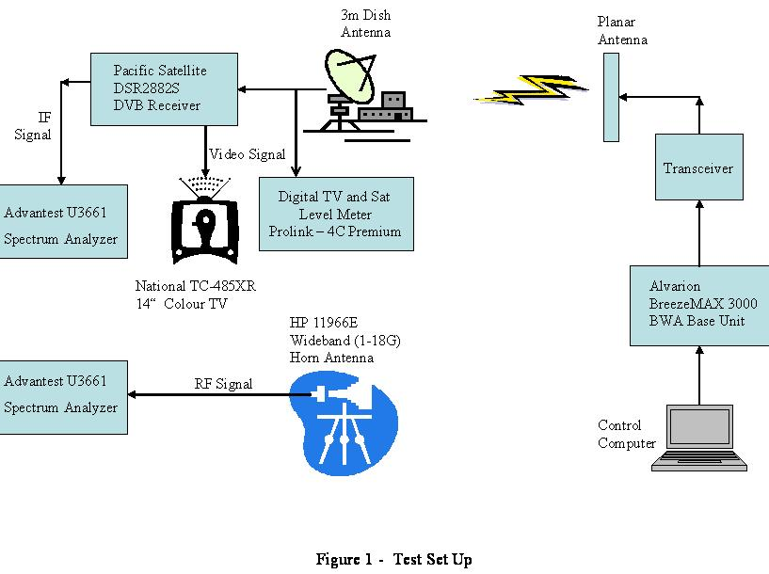
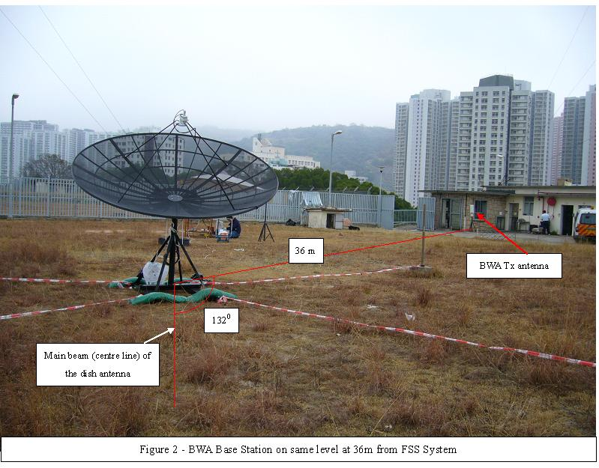
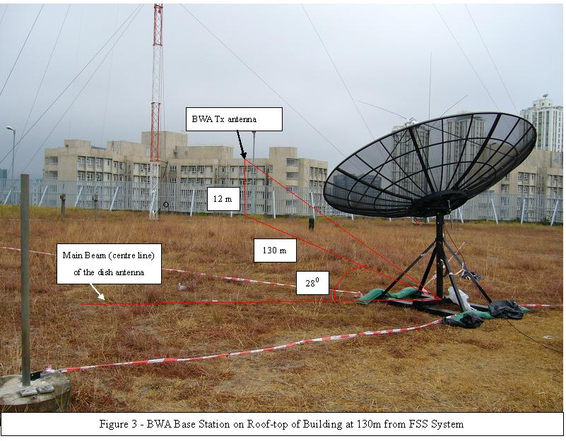
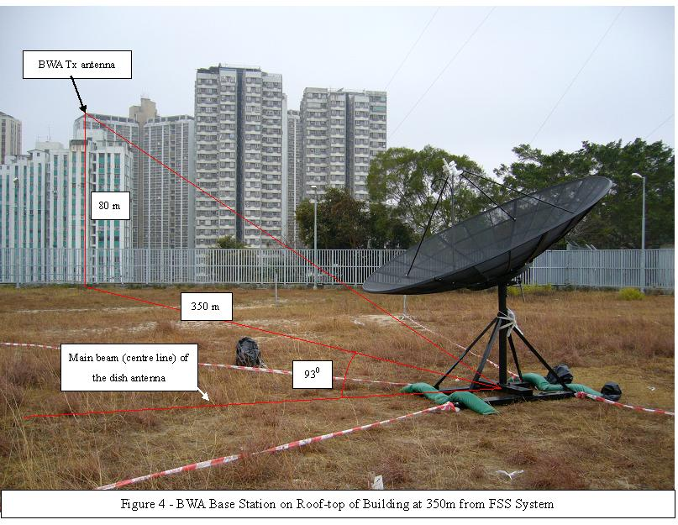
Annex 2

Field Test for Measurement of In-band Interference
From BWA to FSS

Objective

The objective of the field test is to measure the interference generated by a BWA transmitter operating in 3.4 – 3.6 GHz into a fixed satellite service (FSS) station receiving signals by the same frequencies by taking measurement of the relevant parameters of the received satellite signals (noise floor, digital power, C/N and BER).

Date and Place of Test

2. The test was jointly conducted by OFTA and APT Satellite Holdings Limited (“APT”) on 29 June 2006 at the APT Satellite Control Centre in Tai Po Industrial Estate, Hong Kong.

Test Equipment and Set Up

3. The following equipment was used during the test. The earth station was located in the APT Satellite Control Centre in Tai Po. A BWA base station equipment was set up on the roof top of a building in Ma On Shan area as shown in Figure 1.

Item | Description | Brand Name | Model
 | 13-metre diameter TT&C earth station
 | Satellite signal analyzer
 | BWA Base  Station Equipment | Alvarion | BreezeMAX 3500
 | BWA Base Station Antenna | Alvarion | 3.3 to 3.7 GHz 90/V

Methodology of Test

4. The BWA transmitting frequency used for the test was set to be 3510 MHz. The polarization of the BWA was aligned with the horizontal polarization of the 13 meter earth station antenna in order to evaluate the worst-case interference. The transmitting power of the BWA was adjusted from the lowest value (13 dBm) to the highest value (28 dBm) and the impact on the C-band reception at the 13 meter antenna was assessed for the following four cases:

- Interference to the satellite downlink, transponder 17A/17B of APSTAR-VI is shut down:

(1) BWA antenna pointing with direct line-of-sight to the 13 meter antenna
(2) BWA antenna pointing away (90, 180 degrees) from direct line-of-sight to the 13 meter antenna

- Interference to overall satellite link, transponder 17A/17B is powered on:

(3) BWA antenna pointing with direct line-of-sight to the 13 meter antenna
(4) BWA antenna pointing away (90, 180 degrees) from direct line-of-sight to the 13 meter antenna

5. For each of the test cases, the relevant parameters (noise floor, carrier power, C/N, BER) of the received satellite signals of the 13-metre TT&C earth station were measured. Assessment was made whether the interference threshold (ΔT / T = 25%) was reached.

Test Results

6. Table 1 summarises the measurement results for the 13m earth station.

Table 1 : Measurements of BWA interference to APT’s 13m earth station
ΔT/T_{criteria} = 25% |  | BWA Tx Power  13 dBm (*1) | BWA Tx Power 18 dBm (*1) | BWA Tx Power 23 dBm (*1) | BWA Tx Power 28 dBm (*1)
Case1 | I₀/N₀ | 7.75 | 13.14 | 17.87 | 22.49
Case1 | ΔT / T | 596.21 % | 2058.93 % | 6124.56 % | 17743.28 %
Case1 | Harmful I₀ | harmful | harmful | harmful | harmful
Case2 | I₀/N₀ | -16.99 | -2.86 | 1.99 | 6.36
Case2 | ΔT / T | 2.00 % | 51.79 % | 158.02 % | 432.46 %
Case2 | Harmful I₀ | acceptable | Harmful | Harmful | harmful
Case3 | I₀/N₀ | -2.26 | 5.99 | 9.27 | 13.04
Case3 | ΔT / T | 59.49 % | 397.63 % | 845.52 % | 2015.85 %
Case3 | Harmful I₀ | harmful | Harmful | Harmful | harmful
Case4 | I₀/N₀ | -16.99 | -16.99 | -16.99 | 3.37
Case4 | ΔT / T | 2.00 % | 2.00 % | 2.00 % | 217.23 %
Case4 | Harmful I₀ | acceptable | acceptable | Acceptable | harmful
*1: The concerned transmitter power is referred at the BWA antenna port. An antenna gain of 15dB should be added to derive the power in EIRP.

7. It was found when the BWA was pointed away from the direction of direct line of sight (LOS) with the APT earth station, the 180 degree case had similar interference level as the 90 degree case.

Comparison with Calculations

8. Based on the interference threshold of (ΔT / T = 25%) and the estimated distance (about 5.06 km) between the BWA transmitting equipment and the APT’s earth station, the threshold power of the BWA transmission to cause interference is worked out and compared with the results obtained in the field test. Table 2 summarises the results.

Table 2 : Power of Single BWA Base Station to cause interference
ΔT/T_{criteria} = 25%  Distance = 5.06 km | Measured BWA Power in EIRP (dBm) | Calculated BWA Power in EIRP (dBm)
BWA pointing with direct LOS at APT earth station  (Case 3) | < 28 dBm (*2) | 10 dBm
BWA pointing away from APT earth station (assumed to have 15 dB antenna discrimination)  (Case 4) | 38-43 dBm (*3) | 25 dBm
*2 : The adjustable range of transmitter power of the BWA test equipment at the antenna port is 13 – 28 dBm. Adding an antenna gain of 15 dB, the adjustable power of the BWA test equipment is 28 – 43 dBm in EIRP.
* 3: From Table 1, harmful interference occurs when the BWA transmitter power is within 23 – 28 dBm. Adding an antenna gain of 15 dB, the power in EIRP to cause interference is 38 – 43 dBm.

Conclusion

9. From the field test conducted, it can be concluded that :

- when a BWA base station is located 5 km away and pointing directly to Tai Po earth station, it will cause harmful interference to the FSS in all tested power levels (28 – 43 dBm in EIRP). This is in line with the calculated figure.

- when the BWA base station is pointed 90 degrees or 180 degrees away from the direct LOS to the Tai Po earth station, a power level of up to 38 dBm in EIRP will not cause harmful interference to the FSS. This is within the calculated figure.

- End -

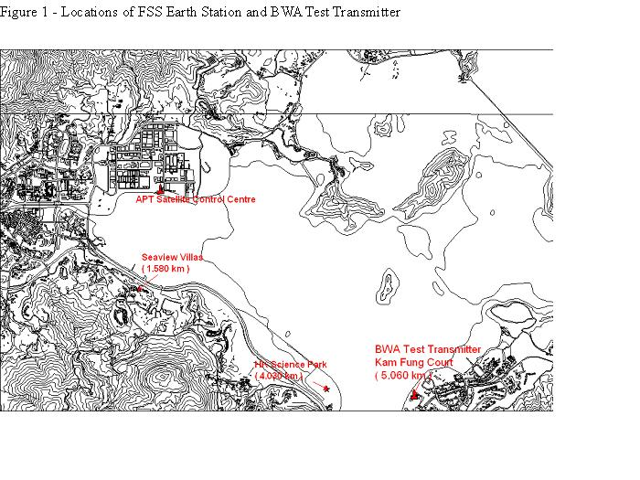

Attachment 2

(Document AWF-3/34, Vietnam)

 | ASIA-PACIFIC TELECOMMUNITY
 | The 3rd Meeting of the APT Wireless Forum |  | Document  AWF-3/34
 | 27 – 30 September 2006, Hanoi, Vietnam SR |  | 15 September 2006

sharing study between broadband wireless access systems and FIXED satellite services
by

The Socialist Republic of Vietnam

- Introduction
Recently, the development of broadband wireless access (BWA) technologies has attracted great attention. One of the most interested in BWA technologies is Wimax. BWA/Wimax may operate in various frequency bands, including 2-11 GHz for the 802.16d and 2-6 GHz for 802.16e. Wimax operators would prefer the lower frequency bands because they will enable better penetration particularly for in-door use and operation without a direct view to the base station. Currently, many countries are considering implementing BWA/Wimax somewhere in the 3.3 – 3.8 GHz. However, the 3.4 – 4.2 GHz band is allocated for FSS (downlink) on a primary basis. The use of 3.3 – 3.8 GHz band for BWA may cause harmful interference into FSS receivers in the 3.4 – 4.2 GHz. In Asia, FSS services can be provided efficently with a high reliability in the 3.4 – 4.2 GHz, including VSAT networks, internet providers, point-to-multipoint links, satellite news gathering, TV and data broadcasting to SMATV and DTH receivers. Therefore, any impact of BWA systems on FSS receivers would produce an adverse effect on satellite services.
The purpose of this paper is to evaluate the potential interference between BWA systems and FSS receivers in order to determine whether co-existence between BWA and FSS becomes feasible. For this purpose, calculations have been made for the three different cases, in-band and out –of- band interference, saturation of receiver.
- Interference analysis
The use of 3.3 – 3.8 GHz band for BWA systems may cause interference to FSS receivers in the three different forms, in-band interference, out-of-band interference and saturation of receivers.
Out-of-band, or non-overlapping interference, may occur when the frequency of BWA systems is adjacent to that of FSS receivers (e.g., BWA operates in 3.3-3.4GHz, FSS in 3.4-4.2GHz, or BWA in 3.5GHz and FSS in 3.6-4.2GHz). Out of band or spurious energy emitted from the BWA transmitters falls within the bandpass of the FSS earth stations receivers. This energy then passes through the receiver front-end with little or no attenuation. When the unwanted emissions levels are high relative to the wanted emission levels, a performance degradation to the receiver can occur.
In-band interference occurs when BWA systems and FSS receivers operate in the same frequency. The 3.5 GHz band is considered for BWA in some countries. For this reason, the frequency 3.5 GH is used for in-band interference calculations.
Saturation of receiver may be occurred when BWA systems working 3.5 GHz band saturate the low-noise amplifiers (LNA) or low-noise block down-converters (LNB) of FSS earth stations operating in the 3.4 – 4.2 GHz. This is because the vast majority of installed LNB’s for TV reception in some countries are designed to receive the entire 3.4- 4.2 GHz instead of 3.7 – 4.2 GHz band only.
In addition, there are two interference scenarios. The first one is BTS – FSS scenario, the interference from BTS into FSS receivers. The other is CPE – FSS scenario, the interference from CPE into FSS receivers.
- Methodology of interference assessment between BWA and FSS
Methodology of interference calculation between BWA and FSS is based on Recommendation ITU-R SF.1486. The methodology is summarized as follow:
Suppose that I is the total interference power from the BWA at the LNB of earth stations
and I_{threshold} is the permissible interference level of earth stations
If I > I_{threshold} then harmful interference may occur
Else If I < I_{threshold} then harmful interference would not be occurred
I = e.i.r.p.BWA(α) – LBWA(d ) + GVS(ϕ) – R
where
e.i.r.p.BWA(α): eirp of BWA transmitters toward earth stations
LBWA(d): propagation pathloss from BWA to earth stations, applied to the following formula:
LBWA(d) = 92.5 + 20 log ( f ) + 20 log (d) + Ah dB
Ah is clutter loss and is given in Recommendation ITU-R P.452
GVS (ϕ) is gain of earth station antenna toward BWA station.
R is site shielding loss
- Assumptions on BWA systems and FSS receivers, protection criterion for FSS receivers and propagation model between BWA and FSS receivers
BWA systems
Parameters of BWA systems, taken from the parameters of Wimax networks that are bring into service in the future in Vietnam, are summarized in the Table 1. These parameters may not be representative all of BWA systems.
Maximum permissible out-of-band (OOB) emissions from BWA systems are in accordance with the draft ECC Recommendation (04)05 on “Guidelines for Accommodation and Assignment of Multipoint Fixed Wireless Systems in Frequency Bands 3.4 – 3.6 GHz and 3.6 – 3.8 GHz”.
Table 1: Parameters of BWA systems

Frequency | 3350 MHz and 3500 MHz
Bandwidth | 3.5 MHz
CPE power | 2 W
BTS power | 4 W
Total bandwidth/ operator | 2x10.5
Number of sectors/ system | 3
Total operators | 4
Total bandwidth/ sector | 10.5*4/3
Maximum permissible out-of-band emission for BTS | - 89 dB/MHz
Maximum permissible out-of-band emission for outdoor CPE | - 68 dB/MHz

FSS earth stations
Parameters of FSS earth stations, taken from Recommendation ITU-R SF.1486, are summarized in the Table 2. For technical sharing study, different cases have been separately calculated for different values of antenna diameter and elevation angles.
Table 2: Parameters of FSS earth stations
Frequency | 3.4-4.2 GHz
Bandwidth | 153.6 kHz
Noise temperature | 100 K
Antenna radiation pattern | Appendix 8 of Radio Regulations (for D/λ <50)
Antenna diameter | 2.4/3m
Antenna elevation angle | 50⁰, 40⁰, 30⁰

4.3 Protection criterion for FSS earth stations
Two FSS protection criteria are taken into account: noise increase dT/T = 6 % and dT/T = 10%
Propagation model between BWA and FSS
Three following propagation models are considered for possible propagation environments:
Line of sight, Ah = 0 dB.
Line of sight with clutter loss, Ah = 18.5 dB, taken from Recommendation ITU-R SF.1486.
Line of sight with clutter loss, Ah = 10 dB, taken from measures conducted in Hanoi.
- Calculation results
As a key factor for interference evaluation, separation distance, the distance beyond which BWA transmitters would not cause interference to FSS earth stations, has been calculated for both out – of- band, in-band interference and saturation of receivers cases, basing on the above-mentioned assumptions.
Out of band calculation results
Figure 1 shows calculation results for the case of interference from BWA BTS transmitters into FSS earth stations, with FSS antenna diameter = 3m, line of sight propagation model. The results indicate that separation distance strongly depends on the elevation angle of the earth station. For example, for elevation = 50⁰, FSS protection criterion for the noise increase dT/T =10 % is exceeded at a distance of more than 153 m while 275 m for elevation = 30⁰.

Detail calculations for this case are as follow.
Threshold interference level, I_{threshold}, is given by:
dT/T = I/N → I = N.(dT/T) = kTB.(dT/T)
I_{theshold} = 10log(1.38x10⁻²³x100x153.6x1000x10/100) = -166.7 dBW/ 153 kHz
= -166.7 + 10log(1000/153) = - 158.5 dBW/MHz
Suppose that the difference in height between BWA BTS and FSS earth station is 100 m, the off-axis angle,α, is given by:
ϕ = abs (50 – atan (100/153 )) = abs(50 – 33,17) = 16.8⁰
For D/λ < 50 m, gain of earth station, G_{VS}(ϕ), is given by ( in accordance with appendix 8 of Radio Regulations):
G_{VS}(ϕ) = 52 – 10log(D/λ) – 25log(α) = 52 – 10log(3/(3.10^8/3.5x10^9)) – 25log(16.8) = 5.65 dB
L_{BWA}(d) = 92.5 + 20log(f) + 20log(d) = 92.5 + 20log(3.5) + 20 log(0.153) = 87.06 dB
If Maximum permissible out-of-band emission, OOB e.i.r.p, is -89dBW/MHz , then
Total OOB e.i.r.p per sector
= Total OOB e.i.r.p per (10.5x4/3) MHz
= - 89 + 10log(10.5x4/3) = -77.53 dBW
Therefore, total interference power from BWA BTS into FSS, I, is as follows :
I = e.i.r.p.BWA(α) – LBWA(d ) + GVS(ϕ) – R
= - 77.53 – 87.06 + 5.65 = - 158.94 dBW < I_{theshold} = -158.5 dBW
Separation distance is shown in the following Table 3 and Table 4 for specific cases.
Table 3: Separation distance from earth station to BWA BTS (m)
Elevation angle |  |  | 50⁰ | 40 | 30⁰
Antenna diameter | BTS- ES propagation model | ^{dT/T} | 50⁰ | 40 | 30⁰
D=2.4 m | Line of sight | 10% | 158 | 205 | 290
D=2.4 m | Line of sight | 6% | 175 | 225 | 320
D=2.4 m | Clutter loss =10dB | 10% | 117 | 156 | 220
D=2.4 m | Clutter loss =10dB | 6% | 122 | 162 | 227
D=2.4 m | Clutter loss = 18.5 dB | 10% | 100 | 130 | 150
D=2.4 m | Clutter loss = 18.5 dB | 6% | 105 | 137 | 175
D=3 m | Line of sight | 10% | 153 | 200 | 280
D=3 m | Line of sight | 6% | 167 | 220 | 300
D=3 m | Clutter loss =10dB | 10% | 113 | 154 | 217
D=3 m | Clutter loss =10dB | 6% | 120 | 160 | 225
D=3 m | clutter loss= 18.5 dB | 10% | 95 | 133 | 175
D=3 m | clutter loss= 18.5 dB | 6% | 100 | 138 | 192

Table 4: Separation distance from earth station to BWA CPE (m)

Elevation angle |  |  | 50⁰ | 40⁰ | 30⁰
Antenna diameter | CPE-ES propagation model | ^{dT/T}  ^{(%)} | 50⁰ | 40⁰ | 30⁰
D=2.4 m | Line of sight | 10% | 512 | 650 | 925
D=2.4 m | Line of sight | 6% | 660 | 825 | 1175
D=2.4 m | Clutter loss =10dB | 10% | 162 | 206 | 292
D=2.4 m | Clutter loss =10dB | 6% | 208 | 160 | 375
D=2.4 m | Clutter loss = 18.5 dB | 10% | 62 | 80 | 108
D=2.4 m | Clutter loss = 18.5 dB | 6% | 80 | 100 | 138
D=3 m | Line of sight | 10% | 465 | 575 | 825
D=3 m | Line of sight | 6% | 595 | 750 | 1050
D=3 m | clutter loss =10 dB | 10% | 150 | 183 | 262
D=3 m | clutter loss =10 dB | 6% | 188 | 234 | 334
D=3 m | clutter loss= 18.5 dB | 10% | 56 | 70 | 100
D=3 m | clutter loss= 18.5 dB | 6% | 72 | 88 | 130
The results in the Table 3 and Table 4 show that the separation distance varies between 95 and 320 for BTS, and between 56 and 1175 for CPE, depending values of input parameters such as elevation angle, antenna diameter, propagation model, protection criteria.
5.2 In -band calculation results
Figure 2 shows in-band calculation results with different values of shielding loss, elevation angle = 50⁰, clutter loss = 18.5 dB . Results in the Table 5 indicate that the separation distance is strongly depending on shielding loss and elevation angle of earth station. With VSAT elevation is 50⁰, separation distance varies about 0.55 km with shielding loss R = 40 dB, about 4 km with shielding loss R = 20 dB and about 45 km if there is no shielding loss (R=0 dB) to VSAT stations. The respective separation distances are longer if VSAT elevations are lower.
Detail calculations for the case of shielding loss = 40 dB are as follow:
Off-axis angle ϕ = abs (50 – atan (100/550)) = 39.69⁰
G_{VS}(ϕ) = = 52 – 10log(3/(3.10^8/3.5x10^9)) – 25log(39.69) = -3.41 dB
L_{BWA}(d) = 92.5 + 20log(3.5) + 20 log(0.55) + 18.5= 116.68 dB
I = e.i.r.p.BWA(α) – LBWA(d ) + GVS(ϕ) – R
= 10log 4 -10log(3.5) – 116.68 – 3.41 - 40 = - 159.51 dBW < I_{theshold} = -158.5 dBW
Table 5: Separation distance from earth station to BWA (m)
Elevation angle |  |  | 50⁰ | 40⁰ | 30⁰
Antenna diameter | Shielding loss | ^{dT/T} | 50⁰ | 40⁰ | 30⁰
D=2.4 m | 0 dB | 10% | 45000 | 56000 | 81000
D=2.4 m | 0 dB | 6% | 60000 | 76000 | 105000
D=2.4 m | 20 dB | 10 % | 4400 | 5650 | 8000
D=2.4 m | 20 dB | 6 % | 5725 | 7200 | 10000
D=2.4 m | 30 dB | 10 % | 1575 | 1950 | 2750
D=2.4 m | 30 dB | 6 % | 1875 | 2400 | 3625
D=2.4 m | 40 dB | 10 % | 600 | 750 | 1075
D=2.4 m | 40 dB | 6 % | 725 | 975 | 1325
D=3 m | 0 dB | 10% | 41000 | 51000 | 72000
D=3 m | 0 dB | 6% | 53000 | 65000 | 93000
D=3 m | 20 dB | 10 % | 3875 | 5050 | 7225
D=3 m | 20 dB | 6 % | 4950 | 6400 | 9225
D=3 m | 30 dB | 10 % | 1400 | 1775 | 2400
D=3 m | 30 dB | 6 % | 1725 | 2300 | 3125
D=3 m | 40 dB | 10 % | 550 | 700 | 1025
D=3 m | 40 dB | 6 % | 650 | 875 | 1225

5.3 Saturation calculation results
Because of the large free space losses from the satellite, received satellite signals have very low power densities. The dynamic range of FSS LNA’s and LNB’s has been designed to take this into account. Typical LNB’s are saturated by an input signal of about - 50 dBm. About -60 dBm, the LNB’s will start to show non-linear behavior which among others lead to suppression of small signals and generation of intermodulation products.
Figure 3 shows the calculation results for the case of interference from BWA into FSS receivers, with elevation angle of 50⁰ and antenna diameter of 2.4 m. The results show that FSS would be saturated at the distance of less than about 400 m for single BTS case and about 650 m for multiple BTS case.
Detail calculations for single BTS case are as follows:
Off-axis angle ϕ = abs (50 – atan (100/400)) = 35.96⁰
G_{VS}(ϕ) = = 52 – 10log(3/(3.10^8/3.5x10^9)) – 25log(35.96) = -1.37 dB
L_{BWA}(d) = 92.5 + 20log(3.5) + 20 log(0.4) = 95.42 dB
I_{BWA} = e.i.r.p.BWA(α) – LBWA(d ) + GVS(ϕ)
= 10log 4 -95.42 – 1.37 + 30 = - 60.77 dBm
suppose that, under normal conditions, the received satellite signal, I_{FSS} = -79.9 dBm
Total power falling into the filter of LNB is given by
I_{Total} = 10*log (10^{-60.77/10}+10^{-79.9/10}) = -60.71 dBm < -60 dBm.
To alleviate the saturation problem, one remedial measure would be using a suitable bandpass filter (with pass band in 3.6 – 4.2 GHz) to reduce the level of the 3.5 GHz signals to the LNB working in the entire C band (3.4 – 4.2 GHz).
Assuming a filter attenuates the BWA signal by 10 dB, the results in figure 4 show that the separation distance reduces to about 207 m for single BTS and about 300 m for multiple, under the same conditions.

Calculation results for other cases are summarized in the Table 5.
Table 5 : Separation distance from BWA BTS to FSS receivers (m, for saturation of receivers)
 |  | Elevation = 30⁰ | Elevation = 40⁰ | Elevation = 50⁰
Without filters | -60 dBm criterion, single BTS | 710 | 500 | 400
Without filters | -60 dBm criterion, Multiple BTS | 1200 | 830 | 650
With filters | - 60 dBm criterion, single BTS | 370 | 270 | 207
With filters | - 60 dBm criterion, multiple BTS | 530 | 390 | 300

6. Conclusions
Calculations have been made to assess the interference from BWA system to receiving FSS earth station for cases of out-of-band, in-band interference and saturation of receiver.
For out-of-band interference, the separation distance between BWA and FSS varies between 95 m and 320 m for BTS, and between 56 m and 1175 m for CPE, depending values of elevation angle, antenna diameter, cluster loss. In case FSS earth stations have elevation angle of more than 50⁰ and that BWA systems are implemented in urban areas, propagation loss would increase due to clutter loss, the separation distance decrease, down to 56 m for CPE and 150 m for BTS. Taking into account that these conditions resulted in worst case assumption, it is concluded that interference due to out-of-band emissions from BWA to FSS could be overcome if suitable emission limits are adopted.
For in-band interference, the results show that BWA transmitters situated within 1400 m of FSS earth stations would cause in-band interference to FSS stations even though there is no direct line of sight (18.5 clutter loss) and reasonable shielding arrangement (30 dB shielding loss) has been implemented. However, a shielding loss of 30 dB may be difficult to obtain in practice in particular for FSS antennas mounted on roof-tops. The lower shielding loss achieved, the longer separation needed. In practice, the required separation distance for in-band interference in the order of more than 1 km is considered unfeasible in urban areas because of massive deployment of BWA systems. Therefore, it is concluded that BWA systems can not coexist with FSS reception in the 3.5 GHz band.
For saturation of receivers, assuming that elevation angle of 50⁰ and line-of-sight propagation from BTS to FSS, the results in the Table 5 show that the required separation distance is of the order of 650 m without LNB filter added at the front end, making BWA operation become unfeasible. If LNB filters are used, the separation distance would reduce to the order of 300 m. Therefore, it is concluded that FSS receiver saturation due to BWA emissions would be overcome if LNB filters are added.
In conclusion, BWA and FSS could not normally use the same 3.4-3.6GHz band. In case this band is allocated to BWA, due attention need to be taken to avoid interference to FSS earth station operating in 3.6-4.2Ghz and band pass filter may need to be installed at the front end of the earth station. Taking into account the fact that C band (3.4-4.2Ghz) is a good band for FSS due to low rain attenuation, it may not be suitable to allocate 3.5GHz to BWA in tropical countries.

____________

Attachment 3

(Document AWF-4/INP-17, Indonesia)

This report presents practical experienced cases of interference from BWA into FSS receivers at some locations in Indonesia.

Since 2000, BWA was licensed in the 3 400-3 600 MHz in Indonesia. As the networks were being implemented, interference into FSS receivers was seen to increase. In 2003, Indonesia surveyed the interference situation for some FSS receivers at some locations. Starting in 2005, Indonesia started to require BWA operators to take into account FSS receivers and their need for protection. In 2006, Indonesia again conducted a survey of the interference situation. This document shows the results of the surveys conducted in 2003 and 2006.

These results in 2003 were obtained using a horn antenna in the specified locations. In 2006, the results were taken from the output of the LNA of operational earth stations receiving satellite signals. The results show the practical operational scenario in these locations. The location of the sources of the BWA interference was in most cases not known and the results do therefore not provide calibrated results for determination of required separation distances.

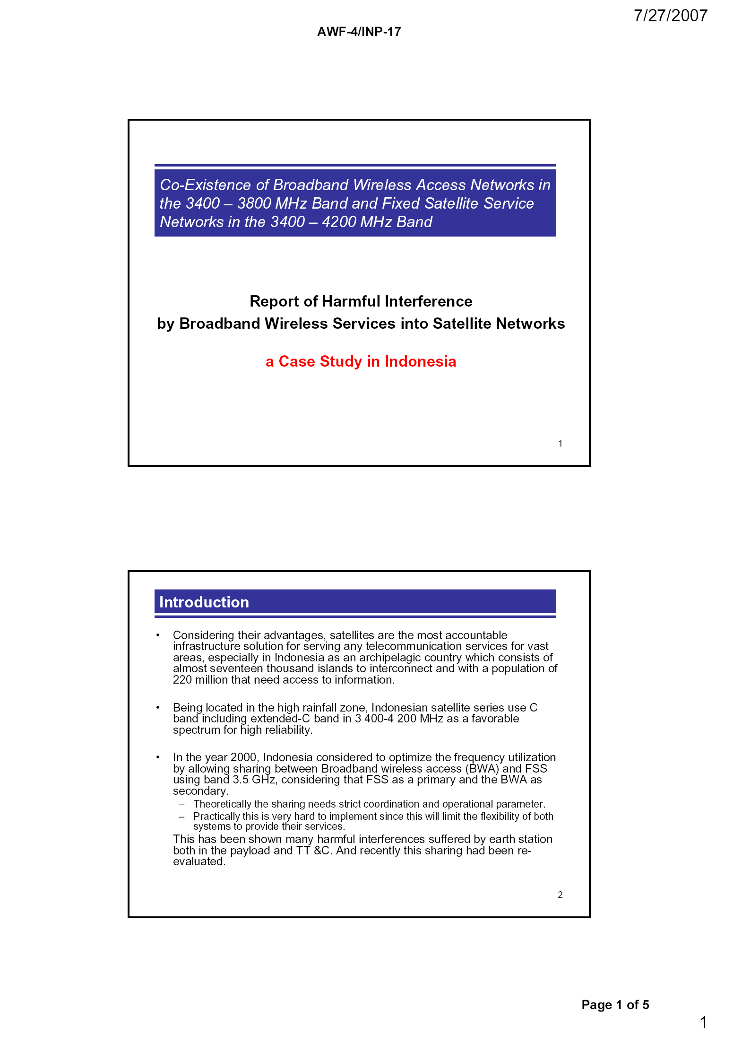
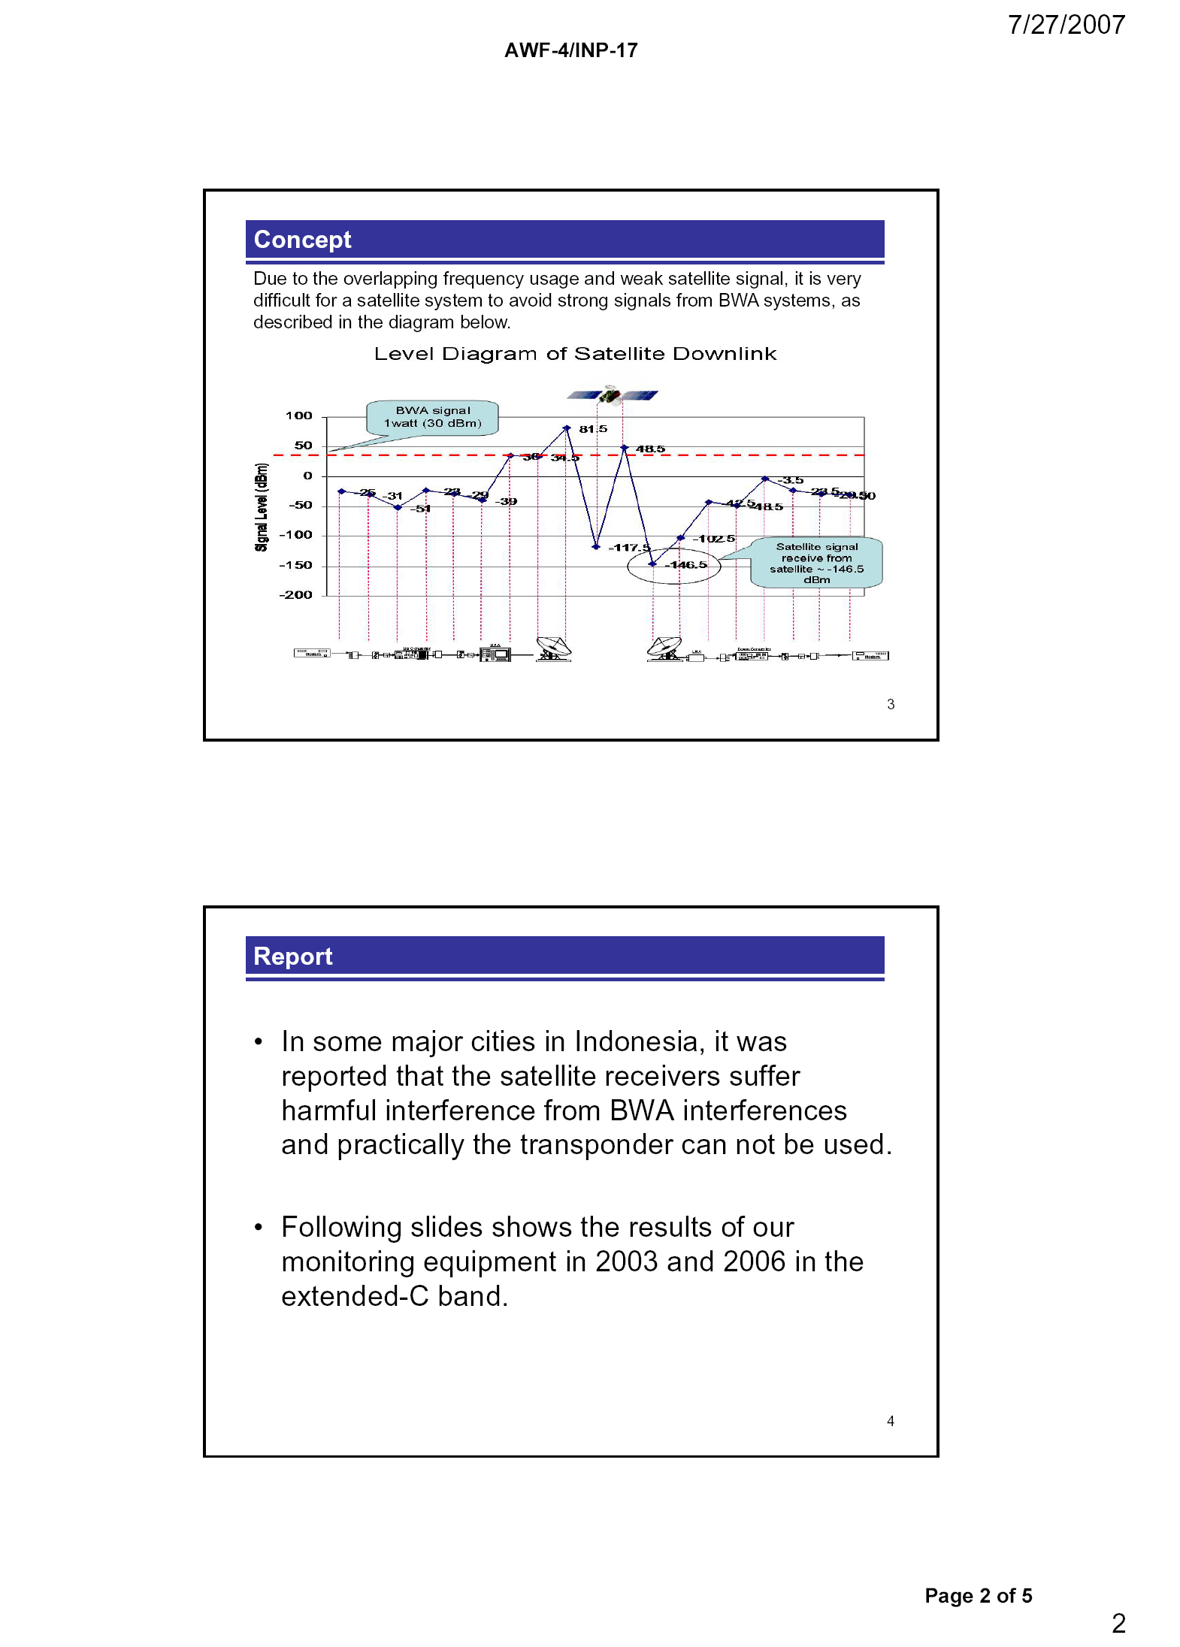
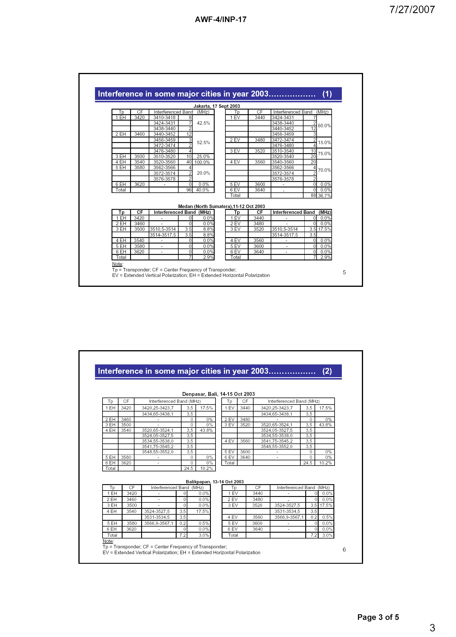
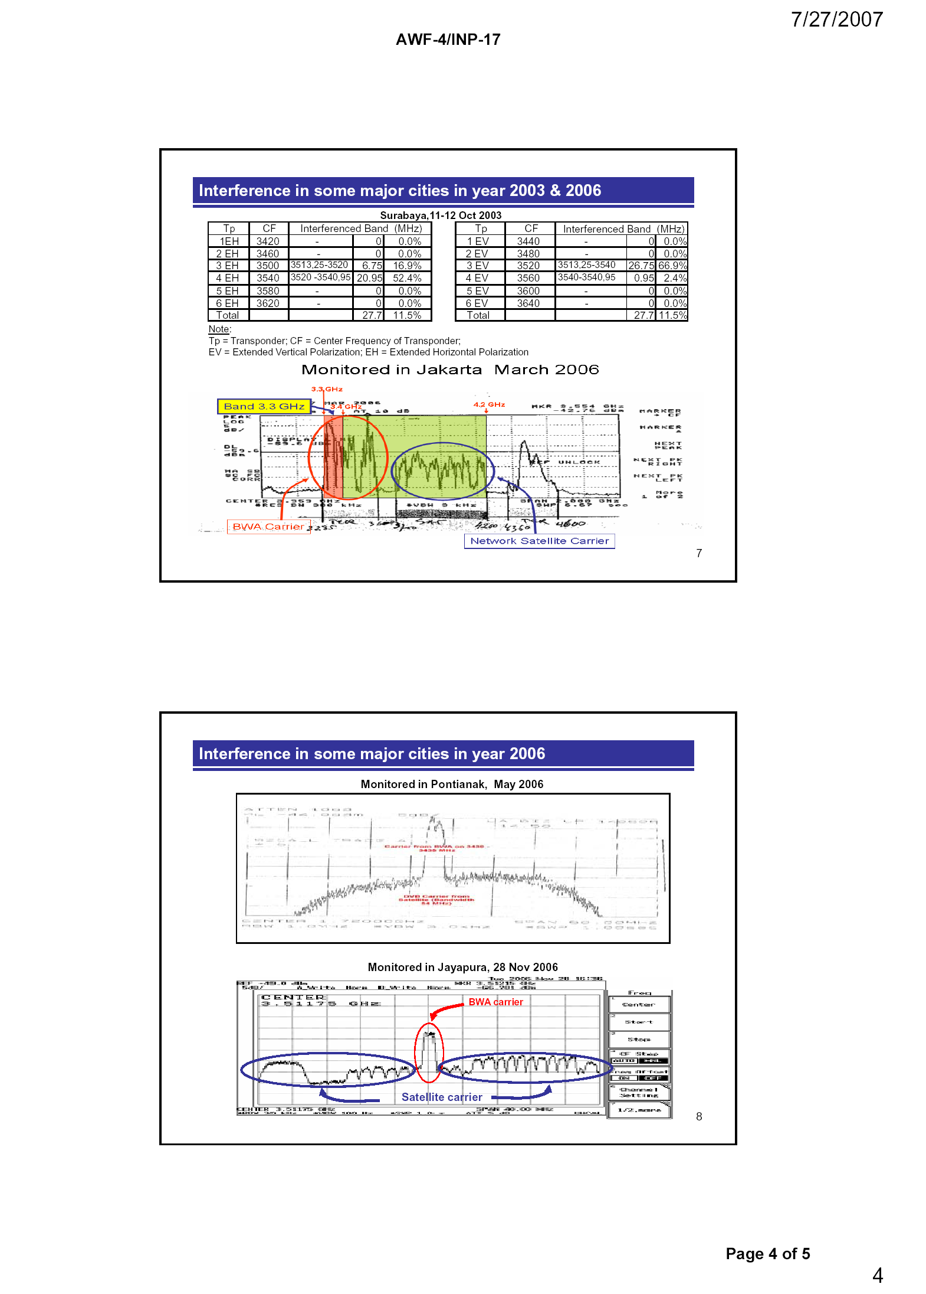
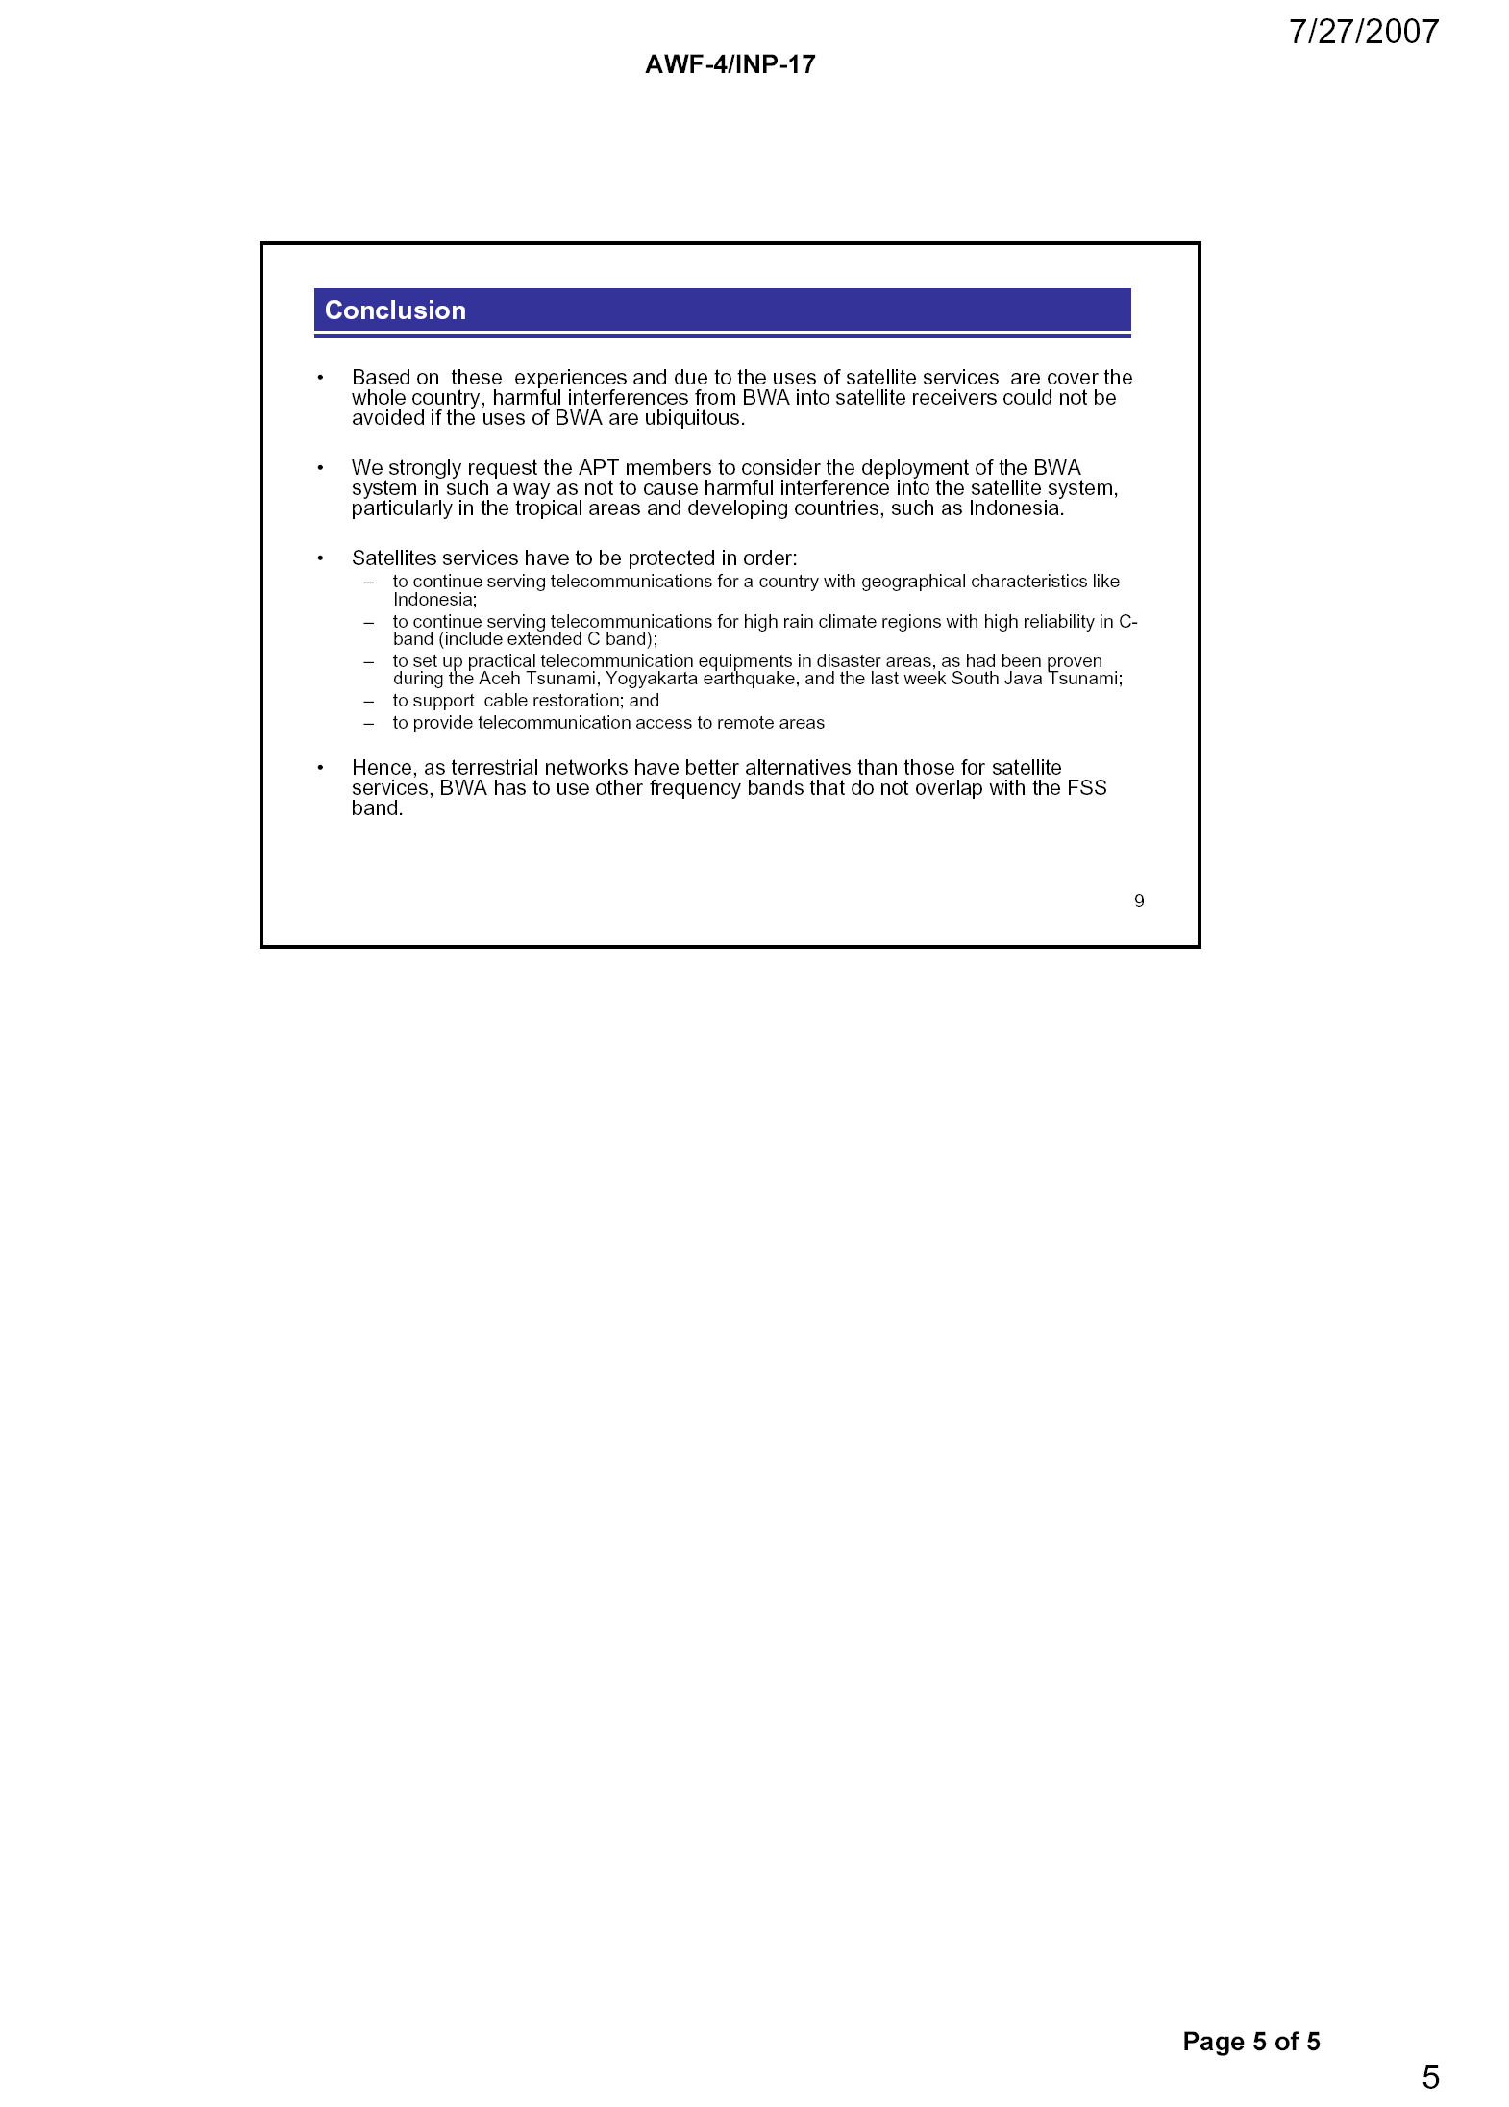
Attachment 4

(Document AWF-4/INP-13, Pakistan)

 | ASIA-PACIFIC TELECOMMUNITY
 | The 4th Meeting of the APT Wireless Forum |  | Document No :  AWF-4/INP-13
 | 31 July – 3 August 2007, Jakarta, Indonesia. |  | 31July 2007

FIXED SATELLITE SERVICE AND WIMAX COEXISTANCE IN
3400-4200 mHZ BANDS

By

Pakistan

Introduction
In recent times, WIMAX has emerged as one of the most promising broadband wireless access (BWA) technologies. Primarily WIMAX enabled infrastructure and devices are destined to operate in 3400-3600 MHz and 5725–5850MHz bands. While 3400-4200 MHz bands are extensively used by the Fixed-Satellite Service (FSS) throughout Asia. The band 3400 – 3700 MHz is often called the “extended C-band” while the band 3700 – 4200 MHz is known as the “standard C-band” for satellite services.

Issue
As mentioned in preamble, the 3600 to 4200 MHz bands are extensively used by the Fixed-Satellite Service (FSS) through ITU recommendations while at the same time BWA operators are using /intending to use these bands to provide WIMAX services. The same frequency usage by FSS and WIMAX can cause significant interference related issues for both Satellite and WIMAX service providers.
Through studies, three possible types of interference problems have been identified. These are (i) co-frequency emissions from BWA which can cause in-band interference with FSS services, (ii) The out of band emissions or spurious emission in one part of 3400 to 3800 MHz band of BWA can create interference in non-overlapping parts of the 3400 to 4200 MHz bands used by FSS services and (iii) BWA signals in vicinity of FSS systems can cause their receivers to saturate and operate non linearly.

IMT-2000 and IMT-Advanced include broadband wireless access technologies (BWA). Any inclusion of these bands in IMT 2000 and IMT-Advanced systems could cause interferences for FSS-based satellite applications in C-band. When FSS earth stations are deployed in a region then there is no mechanism to ensure minimum separation for spectrum sharing. Collocation of Wimax systems with FSS earth stations in way that both are utilizing separate portion of the band is not feasible as well because the widespread deployment of both services may lead to earth station earth station receiver amplifier saturation/ compression problems. This will again end up as interference problems for FSS satellite systems because of their inherent low powered signals as compared to WIMAX signals.

In addition to these, the frequency band 3.4 - 4.2 GHz is important for the FSS because atmospheric absorption is lower in this band. Even in severe rain-fade conditions this band provides increased reliability and coverage area to these systems. Another popular band for satellite services is KU band. This band is split into multiple segments broken down into geographical regions, as determined by the ITU (International Telecommunication Union).The Ku band is a portion of the electromagnetic spectrum in the microwave range of frequencies ranging from 11.7 to 12.7GHz. (downlink frequencies) and 14 to 14.5GHz (uplink frequencies).
Although used extensively for satellite services it cannot provide the same communications capabilities if utilized in place of C-band for torrential rain areas. Many developing countries including Pakistan rely heavily on satellite links in this band to provide connectivity for national and international information transfers and linkages. Over 160 satellites are using these bands for communications worldwide and inclusion of these bands in IMT 2000 and IMT- Advanced can cause severe problems for such existing systems around the globe.

The Following table shows Pakistan’s frequency allocations in3400 to 4200 bands.
Allocation to Services
Frequency | ITU – Region 3 | Pakistan’s Allocations
3400 – 3500 | FIXED  FIXED-SATELLITE (space-to-Earth)  Amateur  Mobile  Radiolocation | FIXED  FIXED-SATELLITE (space-to-Earth)  Amateur  Mobile  Radiolocation  MOBILE-except aeronautical mobile  PAK29
3500 – 3700 | FIXED  FIXED-SATELLITE (space-to-Earth)  MOBILE except aeronautical mobile  Radiolocation | FIXED  FIXED-SATELLITE (space-to-Earth)  MOBILE except aeronautical mobile  Radiolocation  PAK29
3700 – 4200 | FIXED  FIXED-SATELLITE (space-to-Earth)  MOBILE except aeronautical mobile | FIXED  FIXED-SATELLITE (space-to-Earth)  MOBILE except aeronautical mobile

5725-5850MHz band is also recommended for WIMAX by WIMAX forum. The utilization of this band in Pakistan is as follows.
Allocation to Services
Frequency | ITU – Region 3 | Pakistan’s Allocations
5725 – 5830 | RADIOLOCATION  Amateur | RADIOLOCATION  FIXED  MOBILE  Amateur  PAK32
5830 – 5850 | RADIOLOCATION  Amateur  Amateur-satellite (space-to-Earth) | RADIOLOCATION  FIXED  MOBILE  Amateur  Amateur-satellite (space-to-Earth)  PAK32

Recommendation

As mentioned earlier, IMT-2000 and IMT-Advanced include broadband wireless access technologies (BWA). Based on earlier discussion and viewing current frequency allocations it is clear that inclusion of 3400-4200MHz in the list of candidate bands for identification for IMT-2000 and IMT-Advanced systems can cause severe problems to existing FSS earth stations.
It is recommended that
- region wide studies be intensified, in continuation of the earlier work carried out both at APT and ITU, to explore the possibilities and methodologies of spectrum sharing between BWA systems and various FSS services.
- Practical recommendations for APT administrations should result from the study on ways to implement the interference mitigation and sharing schemes developed thus far.
- Elaborate coordination mechanisms be proposed for cross border interference between terrestrial BWA systems operating in one country and the FSS services operating in the other with specific application of interference prediction procedure approved by APT in last management committee meeting.
Attachment 5

(Document AWF-5/INP-24, Japan)

 | ASIA-PACIFIC TELECOMMUNITY
 | The APT Wireless Forum Interim Meeting 2008 |  |  | Document  AWF-IM4/INP-24
 | 04 – 05 March 2008, Bangkok, Thailand |  |  | 04 March 2008

Experimental Evaluation on robustness against potentail interference to TVRO terminal from terrestrial station in the 3 400-4 200 MHz band

by

Japan

- Introduction

In Annex G of Report ITU-R M.2109, “Sharing studies between IMT-Advanced systems and geostationary satellite networks in the fixed-satellite service in the 3 400-4 200 and 4 500-4 800 MHz frequency bands,” Japan contributed the experimental evaluation on robustness against potential interference to TVRO terminal from IMT-Advanced transmitter in the 3 400-4 200 MHz band. Although this experimental evaluation was included in the report on the sharing studies between IMT-Advanced and FSS systems, some characteristics of IMT-Advanced stations and those of BWA stations will be similar, for e.g., transmission power, antenna characteristics, and deployment scenario. Therefore, the results in this experimental evaluation would be useful to consider co-existence of BWA in the 3 400-3 800 MHz band and FSS networks in the 3 400-4 200 MHz band.

- Proposal

The Attachment to this contribution summarizes the essence of Annex G of Report ITU-R M.2109, which was originally contributed by Japan. Japan proposes to include this Attachment into the draft report on the co-existence of BWA and FSS (AWF-IM4/TMP-13(Rev.1)) as a case study of practical robustness of TVRO terminal from interference caused by terrestrial station in the mobile service at some locations in Japan.
Attachment

EXPERIMENTAL EVALUATION ON ROBUSTNESS AGAINST POTENTAIL INTERFERENCE TO TVRO TERMINAL FROM TERRESTRIAL STATION IN THE MOBILE SERCIE IN THE 3 400-4 200 MHZ BAND

- Introduction

The contents of this Attachment are based on Annex G of Report ITU-R M.2109 which was originally contributed by Japan. Although this experimental evaluation was included in the report on the sharing studies between IMT-Advanced and FSS systems, some characteristics of IMT-Advanced stations and those of BWA stations will be similar, for e.g., transmission power, antenna characteristics, and deployment scenario. Therefore, the results in this experimental evaluation would be useful to consider co-existence of BWA in the 3 400-3 800 MHz band and FSS networks in the 3 400-4 200 MHz band.

- Specification of a TVRO terminal

A commercial TVRO terminal which is typically available is used in the experiment. Tables 1 to 3 summarize the overall specifications of the TVRO terminal, TVRO antenna and LNB, respectively. As shown in Table 3, two types of LNBs having the different specifications are employed in the experiment.
TABLE 1
Specification of TVRO terminal
System capabilities | Fully DVB compliant
LNB tuner input | Connector | IEC 169-24 female
LNB tuner input | Frequency range | 950 MHz to 2 150 MHz
LNB tuner input | Signal level | –65 dBm to –25 dBm
LNB tuner input | LNB supply | 14/ 18 V, Max 400 mA
LNB tuner input | LNB switch control | 22 KHz, 0/ 12 V
LNB tuner input | DISEqC | Ver 1 2 and Ver 1.0 compatible
Demodulator | Frontend | QPSK
Demodulator | Symbol rate | 2 Msps to 45 Msps
Demodulator | SCPC and MCPC capable
Demodulator | Spectral inversion | Auto conversion
Video decoder | MPEG 2 | Main profile @ Main level
Video decoder | Data rate | Up to 15M bits/s
Video decoder | Resolution | 720 x 576, 720 x 480
Video decoder | Video format | NTSC, PAL
Video decoder | Aspect ratio | 4:3, 16:9
Teletext | DVB compliant
MPEG audio | MPEG 1 layer 1 and 2
MPEG audio | Type | Mono, Dual mono, Stereo, Joint stereo
MPEG audio | Sampling rate | 32,441 and 48 kHz

TABLE 2
Specification of TVRO terminal antenna
Antenna size | 2.4 m (96 in.)
Operating frequency | 3 625 to 4 200 MHz
Midband gain | 37.5 dBi (±0.2 dB)
3 dB beamwidth | 2.1°
Antenna noise temperature | 20° elevation 33K  30° elevation 31K
Feed interface | CPR 229F
Cross-polarization | >30 dB (on axis)
First sidelobe | –20 dB typical
Insertion loss | 0.2 dB Max
VSWR | 1.3:1 Max

TABLE 3
Specification of LNB
 | LNB (Type A) | LNB (Type B)
Input frequency | 3 400 to 4 200 MHz | 3 400 to 4 200 MHz
Output frequency | 950 to 1 750 MHz | 950 to 1 750 MHz
Noise figure | 17 K to 20 K @25° | 30 K(Max)
Gain | 65 dB typical | 60 dB(Min) to 72 dB(Max)  variation 6 dB(p-p)
Gain flatness | ±1.5 dB Max | ±1 dB/ 36 MHz
Image rejection | -- | 45 dB
RF band pass filter | Yes
Output VSWR | 2.0:1 Typical, 75 ohm
1 dB compression point | +10 dBm Min | 3 dBm
3rd order intercept point | +20 dBm Min
L0 frequency | 5 150 MHz | 5 150 MHz
L0 frequency stability | ±500 kHz Typical –40° C to +60° C | ±500 kHz(25° C)  ±1.5 MHz (–30° C to 60° C)
Phase noise | –73 dBc/Hz @ 1 kHz  –95 dBc/Hz @ 10 kHz  –110 dBc/Hz @ 100 kHz | –70 dBc/Hz @ 1 kHz  –90 dBc/Hz @ 10 kHz  –105 dBc/Hz @ 100 kHz
DC feed | +16 to +28 VDC | +12 to +20 VDC
Current | 210 mA Max | 150 mA Max
Operating temperature | –40° C to +60° C | –30° C to 60° C
Input interface | Flange, WR 229G | Flange, CPR-229G
Output interface | 75 Ohm, Type “F” Female Gold plated | 75 ohm Type “F” Female

- Specification of an interfering terrestrial station

In the experiment, the implemented transmitter having the specification shown in Table 4 is used as an interfering terrestrial station into TVRO terminal.

TABLE 4
Specification of an interfering terrestrial station
Center frequency | 3.9 GHz
Frequency bandwidth | 100 MHz
Polarization | Vertical
Transmit power | 40 dBm/100 MHz
Antenna gain | 15 dBi
Antenna 3 dB width | 60°
Antenna height | 2.8 m
Modulation | OFDM
PAPR | 12 dB

- Evaluation scenarios
In the experimental evaluation, three TV channels having the different frequency ranges and coding rate of forward error correction (FEC) code are selected, which are summarized in Table 5.
TABLE 5
Parameters of TV channels used in experiment
Channel name | Center frequency | Intermediate frequency | Polarization | Symbol rate | Coding rate | Channel bandwidth
TV channel A | 3 904 MHz | 1 246 MHz | Vertical | 4.420 | 7/8 | 5.05 MHz
TV channel B | 3 895 MHz | 1 255 MHz | Vertical | 6.813 | 3/4 | 9.08 MHz
TV channel C | 3 834 MHz | 1 316 MHz | Vertical | 4.420 | 3/4 | 6 MHz

In the experiment, the TVRO terminal receives both the radio signal of TV channels from the satellite and the interference signal of the terrestrial station through the TVRO antenna as shown in Fig. 1. The power level of interfering signal is dynamically changed due to distance-dependent propagation loss, slow shadow-fading and fast fading phenomena caused in a real environment.
FIGURE 1
Configuration of dynamic test scenario
The experimental evaluation is based on subjective assessments so called Mean Opinion Score (MOS), which is adopted in Recommendation ITU-R BT.500-11 and ITU-T Recommendation P.800. In this experimental evaluation, the MOS uses five-grade quality scale with Excellent (5), Good (4), Fair (3), Poor (2) and Bad (1). The numbers in the bracket represent the quality scale. In the experiment, the MOS quality grade having the quality grade of the received TV picture shown in Table 6 is employed.

TABLE 6
Definition of MOS quality grade in experiment
Quality grade of received TV picture | Conditions
5 | No influence
4 | Flickering or mosaic appeared once in a minute
3 | Flickering or mosaic appeared once in twenty seconds
2 | Flickering or mosaic appeared once in a second
1 | No picture

- Experimental results

The TVRO terminal with the antenna diameter of 2.4 m was placed at the rural location of E140.41.33.6/ N36.41.88.1 as shown in Table 7. The experiment was conducted under the weather condition of clear-sky.

TABLE 7
Test location of dynamic test scenario
TVRO antenna location | Ibaraki, E140.41.33.6/ N36.41.88.1
Topographical statistics | mean 83 m / standard deviation 109 m
Antenna height (a.m.s.l) | 56 m
Antenna direction | 33.7° (elev.) / 229.7°(hor)
Weather | Clear-sky

In the experiment, different 26 locations were selected in order to place the interfering terrestrial station, where each location is shown in Fig. 2. Furthermore, the location of the TVRO terminal is shown at the center of this figure, where the direction of the arrow indicates the antenna-direction of TVRO terminal to receive the signal from satellite. By changing the location of the interfering terrestrial station, point-to-point interference measurement is conducted at each location.
FIGURE 2
Location of TVRO terminal and interfering terrestrial station

Table 8 summarizes the quality of TV picture measured by the MOS quality grade obtained by the measurement conducted at each location. As shown in the table, among 26 locations, the MOS quality grade of 5, i.e., no influence on the received TV quality, is observed at 25 and 24 locations in the case of co-channel interference scenarios with FEC coding rate of 3/4 and 7/8, respectively. Furthermore, in the case of adjacent-channel interference scenario, no influence on the received TV picture is observed at all the locations.
TABLE 8
MOS quality grade at respective locations
Location of  interfering terrestrial station | MOS quality grade
Location of  interfering terrestrial station | Co-channel,  FEC = 7/8 | Co-channel,  FEC = 3/4 | Adjacent-channel, FEC = 3/4
1 | 5 | 5 | 5
2 | 5 | 5 | 5
3 | 5 | 5 | 5
4 | 5 | 5 | 5
5 | 1 | 5 | 5
6 | 5 | 5 | 5
7 | 5 | 5 | 5
8 | 5 | 5 | 5
9 | 5 | 5 | 5
10 | 5 | 5 | 5
11 | 5 | 5 | 5
12 | 5 | 5 | 5
13 | 5 | 5 | 5
14 | 1 | 1 | 5
15 | 5 | 5 | 5
16 | 5 | 5 | 5
17 | 5 | 5 | 5
18 | 5 | 5 | 5
19 | 5 | 5 | 5
20 | 5 | 5 | 5
21 | 5 | 5 | 5
22 | 5 | 5 | 5
23 | 5 | 5 | 5
24 | 5 | 5 | 5
25 | 5 | 5 | 5
26 | 5 | 5 | 5

- Summary of study
The study on the robustness against interference to a TVRO terminal in the 3 400-4 200 MHz band based on the field experiment performed in one country is summarized as follows:
a) When the distance between an interfering terrestrial station and a TVRO terminal is ranged from 345 to 5,420 m comprising different 26 locations, no influence on the quality of the received TV picture is observed at 25 and 26 locations in the case of the co-channel and adjacent interference scenarios, respectively, with FEC coding rate of 3/4.
b) TV channel employing FEC coding rate of 3/4 has more robustness against the increase in the co-channel interference power level by approximately 2 dB compared to that of 7/8 in order to maintain the same quality of the received TV picture.
c) The influence on the quality of the received TV picture for adjacent-channel interference scenario is smaller compared to that for co-channel scenario. In order to maintain the same quality of the received TV picture, approximately 14 dB more power of an interfering terrestrial station is permitted in the adjacent-channel interference scenario compared to the co-channel interference scenario.

____________

Attachment 6

Technical studies by other organizations

In addition to AWF, technical studies and/or field trials have been or are being conducted within ITU-R, the WiMax Forum, CEPT, CITEL and SUIRG on compatibility between BWA or IMT and FSS.
It should also be noted that the studies conducted by these other organizations are based upon some different technical parameters, deployment scenarios and interference tolerances and also deviate from the studies submitted to AWF. The results obtained in these studies are therefore not directly comparable between themselves or with the AWF studies.
- ITU-R
ITU-R has adopted Report ITU-R M.2109, “Sharing studies between IMT-Advanced systems and geostationary satellite networks in the fixed-satellite service in the 3 400-4 200 and 4 500-4 800 MHz frequency bands”
http://www.itu.int/publ/R-REP-M.2109-2007/en or http://www.apt.int/Program/AWF/DOCUMENTS/2008/(6A)R-REP-M.2109-2007-MSW-E.doc
- WiMax Forum
The WiMax Forum adopted a sharing study and in 2007 developed a “White Paper” on compatibility between WiMax and satellite services in the 2.3-2.7 GHz and 3.3-3.8 GHz bands. The “White Paper” is available on the APT web site (http://www.apt.int/Program/AWF/DOCUMENTS/2008/(6B)SatelliteWhitePaper.pdf) as well as at http://www.wimaxforum.org/technology/downloads/SatelliteWhitePaper.pdf
- CEPT
CEPT in the ECC Report 100, adopted in February 2007, presents a study on the compatibility between BWA systems and FSS receivers in the 3400-3800 MHz band. The report is available on the APT web site (http://www.apt.int/Program/AWF/DOCUMENTS/2008/(6C)ECCREP100.DOC) as well as at http://www.erodocdb.dk/Docs/doc98/official/Word/ECCREP100.DOC
http://www.erodocdb.dk/Docs/doc98/official/pdf/ECCREP100.PDF
http://www.erodocdb.dk/Docs/doc98/official/zip/ECCREP100.ZIP
- CITEL
In the June 2006 meeting of CITEL CCP.II-Radio a study on the compatibility between BWA systems and FSS receivers in the 3400-4200 MHz band was presented. (see the APT web site: http://www.apt.int/Program/AWF/DOCUMENTS/2008/(6D)CITEL%20BWA-FSS%20Report.doc)
- SUIRG
The Satellite Users Interference Reduction Group (SUIRG), in cooperation with the Global VSAT Forum (GVF), the US Navy and others in 2007 conducted a field trial to assess the impact of BWA on FSS reception. The test plan and procedures are available on the APT web site (http://www.apt.int/Program/AWF/DOCUMENTS/2008/(6E1)WiMAX%20Field%20Test%20Report%20by%20SUIRG.pdf) as well as at http://www.suirg.org/pdf/SUIRG_WIMAXTestProcedures.pdf
and the results and conclusions on the APT web site (http://www.apt.int/Program/AWF/DOCUMENTS/2008/(6E2)SUIRG_WIMAXTestProcedures.pdf) as well as at http://www.suirg.org/pdf/SUIRG_WiMaxFieldTestReport.pdf
F ITU-R WP 4A/5A/5C
ITU-R Working Party 4A at its June 2007 meeting initiated a study on compatibility between BWA networks and FSS networks in the 3400-4200 MHz band. This study is contained as a working document towards a “Preliminary Draft New Report” (PDNR) in Annex 1 of the Chairman’s Report of Working Party 4A June 2007 meeting (document ITU-R 4A/429 for the 2003-2007 study period) (http://www.itu.int/md/choice_md.asp?id=R03-WP4A-C-0429!N01!MSW-E&lang=en&type=sitems or http://www.apt.int/Program/AWF/DOCUMENTS/2008/(6F1)R03-WP4A-C-0429!N01!MSW-E.doc). At the invitation of WP 4A, Working Parties 5A and 5C (addressing non-IMT mobile and fixed terrestrial applications respectively) within the provisional new working party structure, at their February 2008 meetings agreed in principle to conduct sharing studies and suggested that one common sharing study was developed in cooperation between the three working parties. Working Party 5A furthermore developed a working document towards a “Preliminary Draft New Report” (PDNR) in Annex 9 to the Chairman’s Report of the February 2008 meeting (document ITU-R 5A/45 for the 2007-2011 study period) (http://www.itu.int/md/R07-WP5A-C-0045/en or http://www.apt.int/Program/AWF/DOCUMENTS/2008/(6F2)R07-WP5A-C-0045!N09!MSW-E.doc). It may be noted that the outline of this draft report follows an approach similar to that of Report ITU-R M.2109 (see A above) and deviates substantially from the text prepared by Working Party 4A.

_______________

For example, in study 1, by taking the acceptable interference threshold to be 25% of the FSS receiving system noise instead of 6%, the required separation distance to protect the C-band reception of one specific earth station used for an in-band interference field test in Hong Kong was estimated to be about 8.5 km.
See NTIA Report TR-99-361 on “Technical Characteristics of Radiolocation Systems Operating in the 3.1 – 3.7 GHz Band and Procedures for Assessing EMC with Fixed Earth Stations Receivers”, p.14
The 15 dB loss figure for indoor TS is based on the document “WiMAX Deployment Considerations for Fixed Wireless Access in the 2.5 GHz and 3.5 GHz Licensed Bands” (June 2005) issued by the WiMAX Forum (http://www.wimaxforum.org/news/downloads/DeploymentConsiderations_White_PaperRev_1_4.pdf).
According to a field test (see paragraph 5), a typical LNB filter with passband in 3.6 – 4.2 GHz available on the market can give an attenuation of 10 dB to the BWA signals with centre frequency at 3550 MHz
The concerned separation distance should be observed for the deployment of base stations and outdoor terminal stations.
For example, the BWA stations may be installed if they are not pointing in the direction of the earth stations or there is sufficient natural shielding to reduce the interference signals.
For example, by taking the acceptable interference threshold to be 25% of the FSS receiving system noise, the required separation distance to protect the C-band reception of an earth station used for an inband interference field test in Hong Kong is estimated to be about 8.5 km.
The unit cost of a LNB filter with passband in 3.6 – 4.2 GHz available on the market is estimated to be about US$ 500.
Recommendation ITU-R S.1432 states that the noise temperature raise caused by aggregation of interference from all sources should not exceed 25% of the noise temperature. In the present case, it has been agreed with APT that the acceptable interference threshold is taken to be ΔT / T = 25%.

