

APT SUREVEY REPORT

On

RADIO SPECTRUM MONITORING WORKS IN THE ASIA-PACIFIC REGION

No. APT/AWF/REP-13
Edition: April 2010

Adopted by

The 8th APT Wireless Forum Meeting
29 March – 01 April 2010
Tokyo, Japan

 | ASIA-PACIFIC TELECOMMUNITY
 | APT Wireless Forum |  |  | Document  APT/AWF/REP-13
 |  |  |  | April 2010
Source: AWF-8/OUT-14

APT SURVEY REPORT ON
RADIO SPECTRUM MONITORING WORKS IN THE ASIA-PACIFIC REGION

I. Introduction

During the AWF interim meeting 2008 in Bangkok, It was decided to perform a survey on general information of radio spectrum monitoring works in Asia-Pacific region. The survey is composed of two parts. Part One requested responses from Administrations as to the general information on the spectrum monitoring work in their countries. Part Two requests information as to the frequency usage for mobile phone service in the Asia-Pacific region. Concerning part two, it should be noted that the frequency bands relate to this part occupies only a small portion of the whole radio spectrum, but are very important and densely used. However, it is naturally the responsibility for the spectrum monitoring department in Administrations to monitor emissions across the entire spectrum. Therefore further similar survey(s) may be conducted if deemed necessary.

The questionnaire was sent to all of APT member administrations. Responses for the questionnaire have been submitted from 8 administrations, China, Hong Kong, Indonesia, Japan, Myanmar, the Republic of Korea, Thailand and Viet Nam (in alphabetic order). This report is a compilation of these survey results.

II. Survey Results (country names listed in alphabetic order)

Part One: Survey on general information of radio spectrum monitoring works in Asia-Pacific region

1.1Organisational information
Q1.1.1. Name of the Organization for radio spectrum monitoring.

Response:
Administration | name of the spectrum monitoring organization
China | The State Radio Monitoring Center, Ministry of Industry and Information Technology as well as spectrum monitoring organizations at the provincial levels
Hong Kong | Office of the Telecommunications Authority
Indonesia | Radio Frequency Spectrum Monitoring, Directorate General of Posts And Telecommunication
Japan | Radio Monitoring Office, Radio Department, Telecommunications Bureau, Ministry of Internal Affairs and Communications
Myanmar | Posts and Telecommunications Department
Republic of Korea | Central Radio Management Office
Thailand | Radio Monitoring Department
Viet Nam | Radio Frequency Directorate

Q1.1.2 Internet website of the organization

Response:
Administration | Internet website of the organization
China | http://www.srrc.org.cn/ (SRMC)
Hong Kong | http://www.ofta.gov.hk
Indonesia | http://www.postel.go.id
Japan | http://www.tele.soumu.go.jp/e/index.htm
Myanmar | http://www.mcpt.gov.mm/ptd
Republic of Korea | http://www.crmo.go.kr
Thailand | http://www.ntc.or.th
Viet Nam | http://www.rfd.gov.vn/

Q1.1.3 Number of the Sub-organizations (local branches)

Response:
Administration | Number of the Sub-organizations
China | 9 HF monitoring stations and 2 space monitoring stations (SRMC)
Hong Kong | No sub-organizations
Indonesia | 35
Japan | 12
Myanmar | N/A
Republic of Korea | 1 Satellite Radio Monitoring Center  12 Regional Radio Monitoring Office
Thailand | 14 branches
Viet Nam | 8 Radio Frequency Centres

Q1.1.4 Total number of employees

Response:
Administration | Number of the Sub-organizations
China | about 190 (SRMC)
Hong Kong | 313
Indonesia | 930
Japan | about 300
Myanmar | 60
Republic of Korea | about 1000
Thailand | about 500
Viet Nam | about 300

Q1.1.5 Please introduce your facilities or automation systems for spectrum monitoring

Response:

China
N/A

Hong Kong
Remote controlled fixed Spectrum Monitoring & Direction Finding System is being used for radio signal monitoring and measurement covering frequency range from 20 to 3000 MHz.
Besides spectrum monitoring and signal analysis, the direction-finding capabilities of the System helps to locate sources of interference within Hong Kong or at the neighboring area of Hong Kong, as a result, illicit and harmful interference can be eliminated efficiently.

Indonesia
Radio monitoring system (HF, VHF, UHF), fixed and mobile stations are available.

Japan
The monitoring system configuration in Japan can been found in Figure 1, 2 and 3.
Figure 1 the DEURAS (Detect Unlicensed Radio Stations) System

Figure 2 the DEURAS-H (Detect Unlicensed Radio Stations - HF) DF System for HF Bands

Figure 3 the Space Radio Monitoring Facility System

Myanmar
N/A

Republic of Korea:

Monitoring Systems | Fixed | Mobile
Radio Monitoring | 70 | 11
Direction Finding | 18 | 19

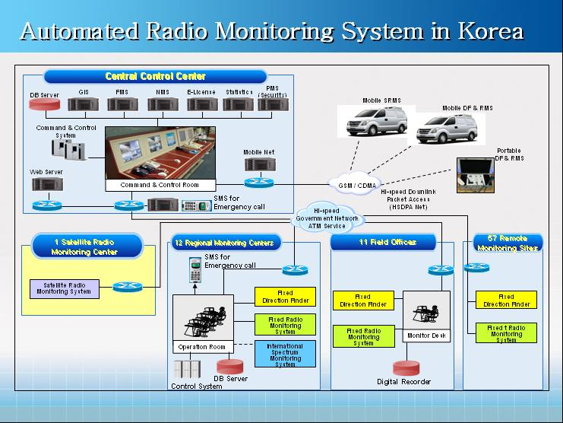
Figure 4 Radio Monitoring Systems in Korea

Thailand
Fix and mobile station for radio monitoring system and direction finding system (HF , VHF AND UHF) are available.

Viet Nam
Spectrum monitoring systems: Rohde & Schwartz, Thales, Tadiran and TCI. Spectrum monitoring facilities: HP, Rohde & Schwartz Spectrum Analyzer.

1.2 statistical information
Q1.2.1 Number of the licensed radio stations in your country

Response:
Administration | Number of licensed radio stations
China | about 3,200,000(not including mobile phones)
Hong Kong | as of June 2008: 7,108 fixed/base stations; 114,180 mobile stations; 21,000 cellular base stations
Indonesia | 248,068
Japan | 106,012,080
Myanmar | 6,720
Republic of Korea | 1,013,000
Thailand | N/A
Viet Nam | 40,000

Q1.2.2 Number of the detected illegal radio stations per year

Response:
Administration | Number of illegal radio stations/year
China | N/A
Hong Kong | 290
Indonesia | 773 (2008)
Japan | 12,083
Myanmar | N/A
Republic of Korea | 1,263
Thailand | 6,235
Viet Nam | 600

Q1.2.3 What type of radio station is the most of the illegal radio

Response:
Administration | Type of illegal radio stations
China | Two-way radios
Hong Kong | Cellular Base Stations
Indonesia | Cellular And Broadcasting
Japan | Unlicensed Personal Radio
Myanmar | Land Mobile Station
Republic of Korea | Land Mobile Station
Thailand | Community Radio
Viet Nam | Private Networks

Q1.2.4 Number of reported interference events per year

Response:
Administration | Number of reported interference events per year
China | about 2,900
Hong Kong | 2,712 (2006/2007)
Indonesia | 51 (2008)
Japan | 2876
Myanmar | 6
Republic of Korea | 324
Thailand | 342
Viet Nam | 100

Q1.2.5 Number of reported interference events between neighboring countries per year

Response:
Administration | Number of reported interference events per year
China | N/A
Hong Kong | 8(2007)
Indonesia | 1(2008)
Japan | 597
Myanmar | 3
Republic of Korea | 525
Thailand | 15
Viet Nam | 3

Q1.2.6 What type of service is the most of reported interference events between neighboring countries

Response:
Administration | type of service with the most of reported interference events between neighboring countries : 1. broadcasting 2.mobile 3. satellite 4. other
China | Broadcasting
Hong Kong | Mobile
Indonesia | Broadcasting
Japan | Other
Myanmar | Mobile
Republic of Korea | Broadcasting
Thailand | aeronautical mobile radio and aeronautical radionavigation
Viet Nam | Broadcasting, HF station, VHF Aeronautical station.

Part Two Frequency usage for mobile phone service in Asia-Pacific region

Q2.1. What bands are licensed and how to use the bands for mobile phone service (GSM, CDMA, TDMA , WCDMA, etc) in your country?

Q2.1.1. For single band Type

*Please write the system name and add lines if have muti-bands

Response:
China | Frequency band: TD-SCDMA 1880-1920MHz, 2010-2025MHz
China | Channel bandwidth per FA : 1.6MHz (TD-SCDMA)
China | Guard bandwidth between operators in band: N/A
China | Guard bandwidths between the system and the adjacent other systems of in the outband: N/A
Hong Kong | Frequency band : 2 GHz band; 1904.9 – 1919.9 MHz and 2019.7 – 2024.7 MHz
Hong Kong | Channel bandwidth per FA : 5 MHz per operator
Hong Kong | Guard bandwidth between operators in band: No guard band is required.
Hong Kong | Guard bandwidths between the system and the adjacent other systems of in the outband: No guard band is required.
Indonesia | Frequency band : N/A
Indonesia | Channel bandwidth per FA : N/A
Indonesia | Guard bandwidth between operators in band : N/A
Indonesia | Guard bandwidths between the system and the adjacent other systems of in the outband : N/A
Japan | Frequency band : TD-SCDMA, TD-CDMA 2010~2025MHz
Japan | Channel bandwidth per FA : 5MHz / 10MHz
Japan | Guard bandwidth between operators in band : 0MHz
Japan | Guard bandwidths between the system and the adjacent other systems of in the outband : 0MHz
Myanmar | Frequency band : 1800-1900 MHz
Myanmar | Channel bandwidth per FA : 25 kHz
Myanmar | Guard bandwidth between operators in band : 200 kHz
Myanmar | Guard bandwidths between the system and the adjacent other systems of in the outband : 20 MHz
Rep. of Korea  WiMax | Frequency band : 2,300-2,400MHz
Rep. of Korea  WiMax | Channel bandwidth per FA : N/A
Rep. of Korea  WiMax | Guard bandwidth between operators in band : N/A
Rep. of Korea  WiMax | Guard bandwidths between the system and the adjacent other systems of in the outband : N/A
Thailand | Frequency band : N/A
Thailand | Channel bandwidth per FA : N/A
Thailand | Guard bandwidth between operators in band : N/A
Thailand | Guard bandwidths between the system and the adjacent other systems of in the outband : N/A
Viet Nam  Citiphone using PHS technology; IMT-2000 systems | Frequency band : 1895-1900 MHz, 1900-1920 MHz
Viet Nam  Citiphone using PHS technology; IMT-2000 systems | Channel bandwidth per FA : 5 MHz
Viet Nam  Citiphone using PHS technology; IMT-2000 systems | Guard bandwidth between operators in band : included in bands given to the operator
Viet Nam  Citiphone using PHS technology; IMT-2000 systems | Guard bandwidths between the system and the adjacent other systems of in the outband : N/A

Q2.1.2. For pair band Type (GSM/CDMA/WCDMA..)

*Please write the system name and add lines if have muti-bands

Response:

China
1) Frequency band :
CDMA2000/WCDMA:
Uplink: 1920-1980MHz Downlink: 2110-2170MHz
CDMA:
Uplink: 825-835MHz Downlink: 870-880MHz
M:
Uplink:890-915MHz,1710-1755MHz
Downlink: 935-960MHz,1805-1850MHz
2) Channel bandwidth per FA :
1.25MHz(CDMA,CDMA2000)/5MHz(WCDMA)/200kHz(GSM)
3) Guard bandwidth between operators in band : N/A
4) Guard bandwidths between the system and the adjacent services of in the outband : N/A

Hong Kong

1) Frequency band : 900 MHz Uplink: 890 – 915 MHz Downlink: 935 – 960 MHz

Frequency band : 1.8 GHz Uplink: 1710 – 1785 MHz Downlink: 1805 – 1880 MHz
2) Channel bandwidth per FA : 2 x 8.5 MHz per operator
3) Guard bandwidth between operators in band :

No guard band is required.
4) Guard bandwidths between the system and the adjacent services of in the outband :

A guard band of 3 MHz is reserved between BRx of EGSM and BTx of CDMA2000 extension block.
Note：A copy of the Hong Kong band plan can be downloaded from the link: http://www.ofta.gov.hk/en/freq-spec/freq-allocations.pdf

Indonesia

1) Frequency band : GSM 900 and DCS 1800
Uplink: 890 – 915 MHz Downlink: 935 – 960 MHz
Uplink: 1710 – 1785 MHz Downlink : 1805 – 1880 MHz
2) Frequency band : CDMA 800
Uplink: 825 – 845 MHz Downlink: 870 – 890 MHz
3) Frequency band : WCDMA
Uplink: 1920 – 1955 MHz Downlink : 2110 – 2145 MHz

2) Channel bandwidth per FA : GSM/DCS : 200 KHz, CDMA 800 :
1.25 MHz, WCDMA : 5 MHz
3) Guard bandwidth between operators in band : NO GUARBAND
4) Guard bandwidths between the system and the adjacent services of in the outband : NO GUARBAND

Japan

1) Frequency band :
CDMA2000
Uplink: 815~830 MHz Downlink: 860~875 MHz
Uplink:1925~1940 MHz Downlink: 2115~2130 MHz
WCDMA
Uplink: 830~845 MHz Downlink: 875~890 MHz
Uplink:1759.9~1764.9 MHz Downlink:1854.9~1859.9 MHz
Uplink: 1769.9~1784.9MHz Downlink:1864.9~1879.9 MHz
Uplink: 1940~1960 MHz Downlink: 2130~2150 MHz
Uplink: 1965~1980 MHz Downlink: 2155~2170 MHz
2) Channel bandwidth per FA : CDMA2000 1.48 MHz, WCDMA 5 MHz
3) Guard bandwidth between operators in band : 0MHz
4) Guard bandwidths between the system and the adjacent services of in the outband : Depend on the individual systems.

Myanmar

GSM | 1) Frequency band :  Uplink: 890-915 MHz Downlink: 935-960 MHz
GSM | 2) Channel bandwidth per FA : 25 kHz
GSM | 3) Guard bandwidth between operators in band : -
GSM | 4) Guard bandwidths between the system and the adjacent services of in the outband : -
CDMA | 1) Frequency band :  Uplink: 825-835 MHz Downlink: 870-880 MHz
CDMA | 2) Channel bandwidth per FA : 125 kHz
CDMA | 3) Guard bandwidth between operators in band : 30kHz
CDMA | 4) Guard bandwidths between the system and the adjacent services of in the outband : 1MHz
WCDMA | 1) Frequency band  Uplink: 1920-1980MHz Downlink: 2110-2170 MHz
WCDMA | 2) Channel bandwidth per FA : 5MHz
WCDMA | 3) Guard bandwidth between operators in band : -
WCDMA | 4) Guard bandwidths between the system and the adjacent services of in the outband : -
450 MHz CDMA | 1) Frequency band :  Uplink: 454-457 MHz Downlink: 464-467 MHz
450 MHz CDMA | 2) Channel bandwidth per FA : 125 kHz
450 MHz CDMA | 3) Guard bandwidth between operators in band : 30kHz
450 MHz CDMA | 4) Guard bandwidths between the system and the adjacent services of in the outband : 1MHz

Rep. of Korea
CDMA | 1) Frequency band :  Uplink: 824-849MHz Downlink: 869-894MHz
CDMA | 2) Channel bandwidth per FA : 1.23MHz
CDMA | 3) Guard bandwidth between operators in band : -
CDMA | 4) Guard bandwidths between the system and the adjacent services of in the outband : 40KHz
CDMA | 1) Frequency band :  Uplink: 1,750-1780MHz Downlink: 1840-1870MHz
CDMA | 2) Channel bandwidth per FA : 1.25MHz
CDMA | 3) Guard bandwidth between operators in band : 1.25MHz
CDMA | 4) Guard bandwidths between the system and the adjacent services of in the outband : 625KHz
WCDMA | 1) Frequency band :  Uplink: 1,940-1980MHz Downlink: 2130-2170MHz
WCDMA | 2) Channel bandwidth per FA : 5MHz
WCDMA | 3) Guard bandwidth between operators in band : 2.5MHz
WCDMA | 4) Guard bandwidths between the system and the adjacent services of in the outband : N/A

Thailand
N/A

Viet Nam
1) Frequency band : CDMA 450 MHz, CDMA 850 MHz, GSM 900 MHz, GSM 1800 MHz, IMT-2000 2 GHz
Uplink: Downlink:
453.08-457.37 MHz/463.08-467.37 MHz
824-885 MHz/869-880 MHz
880-915 MHz/ 925-960 MHz
1710-1785 MHz/1805-1880 MHz
1920-1980 MHz/ 2110-2170 MHz
2) Channel bandwidth per FA :vary dependent on each operators
3) Guard bandwidth between operators in band : included in each operator’s allocation
4) Guard bandwidths between the system and the adjacent services of in the outband :270 kHz in CDMA 450 MHz,

Q2.2. If you have experienced any interference between the mobile systems or the mobile system and other adjacent systems, Please introduce the cause and how to eliminate of the interference.
a) Interference phenomenon b)How to eliminate？

Response:

China
N/A

Hong Kong
No interference between mobile systems or mobile systems with adjacent systems.

Indonesia
a) Interference phenomenon :
Two different systems in adjacent bands, ex : CDMA 800 and GSM 900, DCS 1800 and PCS 1900 (previously)
b) How to eliminate:
1. Using filter
2. Realigning the antenna

Japan
N/A

Myanma
a) Interference phenomenon
Fixed Wireless Access to Mobile
b)How to eliminate
1 . Location Diversity
2. Directional Diversity
3. Spectrum Redeployment

Rep. of Korea

- Interference phenomenon
This case is that a second harmonic generated from a lower band mobile base station (A) causes harmful interference to a higher band mobile station (B).
- Repeater of base Station (A) using 880Mhz band (uplink) generated second harmonic
- The second harmonic flew to the mobile station using 1760MHz band (downlink)
- Repeater Amplifier of station (A) was tuned, the harmonic interference removed.

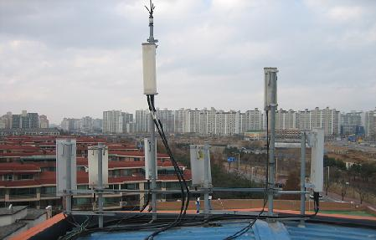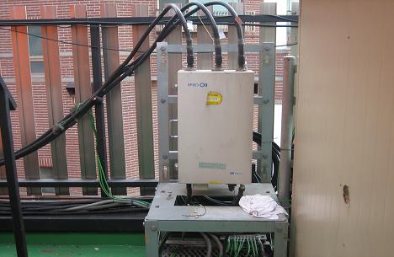
Figure 4 Antenna of mobile station and repeater Amplifier (source of interference)

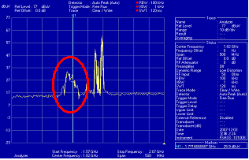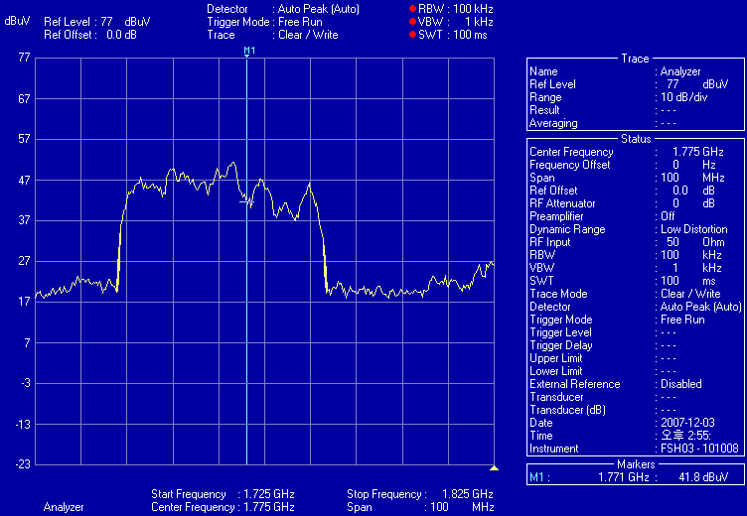
Figure 5 Harmonic waves by the source of interference

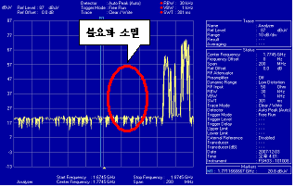
Figure 6 after removing the harmonic
b)How to eliminate
Find out the position of the interfere source with Direction finder
Indentify how the interference was generated and remove the source.

Thailand

a)Interference phenomenon:
interference that caused from inter-modulation between two community radio broadcasting
b)How to eliminate:
improvement of radio transmitter

Viet Nam

a) Interference phenomenon
The interference happened in 2006, an GSM 900MHz Network was interfered with high IOI (Interference On Idle) levels.
As the GSM Network was EGSM, so the received RF filters had band 880MHz- 915MHz that included the band was licensed for an CDMA Network (TX Band: 880-890MHz). The CDMA 800MHz signals came into the GSM system caused overloaded the GSM system.

b)How to eliminate
The solution was setup or changed received EGSM filter by an PGSM filter (890MHz -915MHz) so that reduced and excluded the CDMA frequencies.

____________

