APT report on narrowband ppdr applications and systems in BANDS below 1Ghz

No. APT/AWG/REP-88
Edition: September 2018

Adopted by

24th Meeting of APT Wireless Group
17 – 21 September 2018, Bangkok, Thailand

(Source: AWG-24/OUT-21)

APT report on narrowband ppdr applications and systems in BANDS below 1Ghz

- Background

Resolution 646 was first adopted by WRC-2003 that recognized the importance of harmonized spectrum for PPDR organizations by resolving “to strongly recommend administrations to use regionally harmonized bands for public protection and disaster relief to the maximum extent possible, taking into account the national and regional requirements and also having regard to any needed consultation and cooperation with other concerned countries”. At that time the focus of Resolution 646 (WRC-2003) was on radio frequencies for narrowband and wideband radiocommunications. WRC-2015 further revised Resolution 646 (Rev. WRC-15) to include the harmonisation of spectrum for broadband PPDR by resolving “to encourage administrations to consider parts of the frequency range 694-894 MHz, as described in the most recent version of Recommendation ITU-R M.2015, when undertaking their national planning for their PPDR applications, in particular broadband, in order to achieve harmonization, …..” With the approval of Resolution 646 (Rev. WRC-15) the ITU (WP 5A) and APT (AWG) proceeded to make consequential revisions to their reports and recommendation.

Disaster Management is one of 8 Work Items of the Strategic Plan of the Asia-Pacific Tele-community (2015-2017). APT has produced many Recommendations and Reports on the Public Protection and Disaster Relief (PPDR) through various work programs such as AWG and ASTAP.

- Introduction
PPDR radiocommunication systems are vital to the maintenance of law & order, response to emergency situations, protection of life and property and response to disaster relief events. Modern societies depend on utilities to securely and reliably provide electricity/gas/water; public transportation systems to be safe and reliable; and manufacturing companies to operate safely and efficiently. Common to all these sectors is that their failures could jeopardize human lives or have significant impact on society or the economy. In some countries, utilities, oil & gas, and public transport are considered as critical infrastructures; for example, liquefied petroleum gas (LPG) depots, high-voltage electricity lines, and nuclear power plants (along with their fuel/waste cycle) are considered critical infrastructures.
Public safety usually comprises police, fire fighters, ambulance/emergency medical, and rescue services making use of mobile communications in a voice-centric manner with an increasing demand for data applications.
- PPDR user requirements and applications
Report ITU-R M.2377-1 (11-2017), discusses the objectives and requirements of PPDR applications for the implementation of future advanced solutions to satisfy the operational needs of PPDR organizations, by addressing:
- the categorization of operational, technical and functional objectives and requirements relating to PPDR systems;
- the use of PPDR systems, not only in terms of generic capabilities, but also as they vary according to narrowband, wideband and broadband capabilities
- the development of mobile broadband PPDR services and applications enabled by the evolution of advanced broadband technologies;
- the efficient and economical use of the radio spectrum; and
- the needs of developing countries.

Report ITU-R M.2377-1 contains descriptions of PPDR operations and these descriptions can be found in Annexes 1, 2 and 3 of that report. PPDR applications and related examples, and PPDR requirements can be found in Annexes 4 and 5, respectively of the ITU-R Report.
Report ITU-R M.2377-1 also includes:
- Annex 4 that consist of tables of PPDR applications and related examples that are divided into their applicability for narrowband, wideband and broadband systems. In Table A4-1 are applications that can be covered by narrowband systems and these applications are considered as generic and should also be covered by wideband and broadband systems. Tables A4-2 contains applications that can be covered by wideband and broadband system, and Table A4-3 contains applications that can be covered by broadband systems; and
- Annex 5 that contain tables of requirements indicating the degree of importance attaching to particular requirements under the three radio operating environments: “Day-to-day operations", “Large emergency and/or public events", and “Disasters". The degree of importance attributed to each requirement may be different between administrations. It is up to the administrations to make a choice regarding the relative importance of these requirements. The tables in Annex 5 are divided into generic user requirements supported by narrowband, wideband and broadband communications (Table A5-1) and additional requirements that are supported by broadband communications only (Table A5-2). Table A5-3 contains the capabilities to be provided in Localized Communication Services Mode.
- Developing countries and the impact of disasters in remote and inaccessible areas.
A disaster is a sudden, calamitous event that seriously disrupts the functioning of a community or society and causes human, material, and economic or environmental losses that exceed the community’s or society’s ability to cope using its own resources. Though often caused by nature, disasters can have human origins. The combination of hazards, vulnerability and inability to reduce the potential negative consequences of risk results in disaster.
It should be noted that many developed countries have the financial resources to plan for recurring disasters and are able to deploy communication systems that can be used in their time of need. Many developing countries are not able to finance and deploy the necessary communication systems for many of the disasters that occur, especially in remote or inaccessible areas where people still need aid. It is therefore important that cost-effective and deployable communication systems be readily available for developing countries for use in any area where there is no communications service. For many developing countries, the minimum operational requirement for effective PPDR emergency response is group voice capability. Narrowband PPDR technologies are still today the most cost-effective technology available for such scenarios.
Further, many developing countries, due to their small size and/or their limited resources, have areas that are remote and some of these areas are susceptible to natural hazards. The growth and development of these remote areas are impeded by high transportation and communication costs. As a result communities living in these areas are susceptible to disasters caused by natural hazards such as earthquake and floods.

In addition, some developing countries have large geographical areas and are surrounded by long coast lines have inadequate resources to cope with unexpected disasters.
According to World Disasters Report 2013 by the International Federation of Red Cross and Red Crescent Societies (IFRC) “The most difficult period of a disaster is in the immediate aftermath. During this period, humanitarian action needs to be prompt and targeted, and making the right decisions can make the difference between life and death. Yet it is during these times that decision-makers frequently have to make uninformed decisions, most often due to lack of available information about the situation at hand.

Information and communication technologies can play a key role in these environments and enable better management of the limited resources available to respond. Since the technologies used during response and recovery are in many ways similar, they are considered together, focusing in particular on how technology plays an ever-increasing role in making humanitarian action in the immediate aftermath of a disaster more effective through:
  - Improved understanding of the situation
  - Improved understanding of the needs of the affected community
  - Improved coordination of the overall humanitarian response efforts and the available resources at hand
  - Improved ability to mobilize financial support to the response efforts
  - Improved ability to involve the affected communities and enable them to respond more effectively themselves.”

In this context, the issue of harmonized spectrum and interoperability is important to developing countries wishing to deploy PPDR systems to meet the challenges of law & order situation as well as disaster management in remote areas. It is essential that the widest possible range of equipment at the lowest possible cost is available to these countries.

- Narrowband PPDR systems
PPDR communications that support the protection of human life and property are considered mission critical. Regardless of technology or network deployment type, mission critical communications must be secure, reliable and readily available.
Many countries, particularly developing countries, have narrowband PPDR infrastructure in that will continue to be used for many years to come. Hence, it is crucial to provide necessary guidance to these countries for effectively utilizing their narrowband PPDR communications infrastructure effectively.

According to Report ITU-R M.2377, requirements that may be deemed essential for providing mission critical PPDR operations are:
- to provide fast call set-up, one-touch broadcasting (PTT to group) and group call features;
- to provide for emergency calls, one-touch emergency alert (emphasizing that this function is used in life threatening situations and should receive the highest level of priority), emergency voice PTTs, and emergency data PTTs (e.g. sending images, real-time video) during PPDR events;
- to provide audio quality that ensures the listener is able to understand without repetition, identify the speaker, detect stress in a speaker’s voice, and hear background sounds without interfering with the primary voice communications.
- to provide the ability to communicate radio‐to‐radio directly when out of range of a wireless network OR when working in a confined area where direct unit‐to‐unit communications is required.
- to provide portability and transportability to remote or inaccessible areas where communications may be non-existent so that temporary communications can be rapidly setup for the duration of the disaster response.
Voice communication plays a dominant role in PPDR services. It is the most common and most suitable mode of communication for the real-time transmission of short messages and it has minimal equipment requirements. Due to its narrow (25 kHz or less) bandwidth the receiver of a narrowband radio is more sensitive and can operate over longer ranges compared to those using broader bandwidths. This makes narrowband radio systems very cost-effective for the benefits that are provided by such technology. In the area of emergency management and disaster response, narrowband radio is still considered to be the most useful tool for rapid and effective communications. Broadband is considered to supplement to narrowband radio for applications where broadband applications will be most effective and cost-justified. Therefore, the need for narrowband systems continues to be a requirement for all PPDR situations.
A key advantage of narrowband (two-way) radio systems is the simple and reliable implementation. A basic (simplex) conventional radio system requires no infrastructure at all. Users can arrive on-site, turn on their radios and talk directly to each other. For group voice calls narrowband radios will continue to provide cost-effective, simple and reliable systems.
Narrowband PPDR radio systems are dispatch radio systems that typically operate on 12.5 kHz or 25 kHz channelization; some of these systems are capable of using wider channels for data communications. These narrowband systems can be analog or digital and can be conventional or trunked systems.
The first land mobile radio systems used are conventional systems. In the 1970s analog trunked systems were developed to achieve more spectrally efficient land mobile systems. Later in the 1990s, digital trunked systems were developed that are more spectrum efficient, and with more functions than analog systems.
Recommendation ITU-R M.1808 contains technical and operational characteristics of conventional and trunked land mobile systems operating in the mobile service allocations below 869 MHz to be used in sharing studies.
Recommendation ITU-R M.2009 “Radio interface standards for use by public protection and disaster relief operations in some parts of the UHF band in accordance with Resolution 646 (Rev.WRC-15)” identifies radio interface standards applicable for public protection and disaster relief (PPDR) operations in some parts of the UHF band.
Report ITU-R M.2014 provides the technical and operational characteristics for digital dispatch systems and it also provide details of systems being introduced throughout the world. Some of the systems described in the report are narrowband systems.

- PPDR frequency arrangements

Recommendation ITU-R M.2015-2 has been developed by ITU in accordance with Resolution 646 (Rev.WRC 15) which resolved “that PPDR frequency arrangements within the frequency ranges specified in resolves 2 and 3, as well as countries’ frequency arrangements for PPDR, should be included in Recommendation ITU R M.2015”
APT report APT/AWG/REP-73(Rev.1) provides guidance on the frequency arrangements for PPDR radiocommunications in Region 3. It should be noted that frequency arrangements in Recommendation M.2015-2 for Region 3 are based on this revised APT/AWG/REP-73.

- Benefits of digital for narrow band two way radio systems

Analogue narrowband two-way radios have been in use for decades. Due to technical advances narrowband radios have made a huge leap forward in the form of digital radios. Digital radios have all the features of analogue radios and additional digital features.
The main benefits of digital radios are:

- More spectrum efficient than analogue radios
A digital radio operating with a 12.5 kHz channel can provide up to two voice channels compared to a single voice channel of an analogue radio. For example, migrating a 12.5 kHz narrowband PPDR system from analogue to digital technology will effectively double the capacity of the system with twice the number of voice paths.
- Improved audio quality:
Digital technology can reduce external background noise in noisy environments, such as deep inside manufacturing and processing plants, or outdoors in windy conditions.
The audio quality of an analogue radio is dependent on its received signal strength; as the receiving station moves away from the transmitting station, the audio quality of the receiving station will drop. In contrast a digital radio, through forward error correction, can maintain its audio quality at a further distance from a transmitting station, as shown in the figure below.
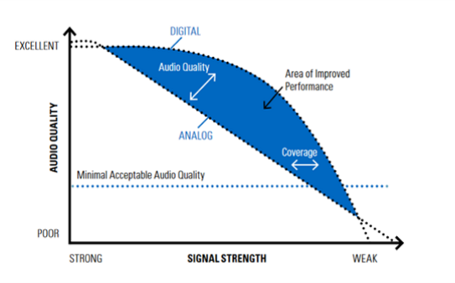

- Better communication security
Digital technology has effectively replaced old analogue methods of voice encryption and using complex algorithms, digital voice encryption has become much more secure and efficient.
- Longer battery life
Digital radios employing TDMA have longer battery performance compared to analog radios. In TDMA a channel is divided into two or more timeslots and the radio only transmit on one of the timeslots. This allows a digital radio to deliver a battery life that is significantly longer than an equivalent analogue radio on a single charge.
- Applications for additional functions
Software applications can be installed in digital radios for additional functional features, such as, for dispatch, work order management, location tracking, worker safety and integration with IP networks.
- Smooth Transition
During transition from analogue to digital radio systems, digital LMR equipment that operate using 25 kHz or 12.5 kHz channel bandwidth can utilize the same existing analogue LMR frequency arrangements that use 25 kHz or 12.5 kHz channels. In this scenario the probability of interference due to the upgrade to digital system is no worse than the existing analog system.
- Transition from Analog to Digital for Narrow Band Systems
Transition from analog radio systems to digital radio systems can be implemented in one of two ways:
1) Complete replacement – This method requires that the system owner to completely deploy a new digital radio system in one phase. The primary advantage of this method is speed to changeover from analog to digital as this method changes the entire analog radio system all at once. The primary disadvantage is cost. The system owner must secure enough funds to support the immediate changeover. This could be extremely costly if the system is very large. To facilitate the migration from analog to digital, the new digital system must run in parallel with the analog system so that end-users can still use the radios for daily operations. Once the digital radio system is ready for use, all end-users can move to the new digital radio system at one time. This method requires new sets of frequencies to facilitate the movement from one system to another system. An example of this type of migration is moving from analog radio to TETRA.
2) Phased replacement over time – This method allows the system owner to slowly change the analog radio system over a few years to digital. This method requires that the new digital radio technology should be backwards compatible with analog radios. The primary advantage to this method is cost-savings as the system owner can manage the funding of the migration over several years. The primary disadvantage to this method is the slow migration to digital over time as the owner cannot use the additional features until the migration is completed. Private radio system owners benefit greatly from this method financially. A secondary advantage to this method is that the underlying technology remains backwards compatible with analog radios so that the new digital radio users have the possibility of maintaining analog radio interoperability with other organizations that have not migrated to digital. From a frequency perspective, this method does not require additional frequencies; current licensees can migrate from analog to digital using their existing licenses. An example of this type of migration is moving from analog radio to APCO P25 or DMR.

- Narrowband -Broadband interoperability for PPDR systems
Interoperability is an important requirement of PPDR operations. PPDR interoperability is the ability of PPDR personnel from one agency/organization to communicate with voice and share data and multimedia in different management levels by radio with personnel from another agency/organization, on demand (planned and unplanned) and in real time.
PPDR organisations are increasingly reliant on data applications that use text, image and video to improve safety, efficiency and effectiveness in the field. The use of text, image and video serve to provide more information and situational awareness to key decision-makers so that the most informed decisions can be made rapidly and appropriately. Both data and voice communications must be supported by a reliable, secure communications infrastructure in order to ensure mission critical operations. To meet broadband data needs PPDR systems owners/operators must be able to build on their existing technology investments as they introduce higher speed network technologies.
Narrowband-broadband interoperability can be achieved through:
- Equipment and infrastructure supporting multiple modes (e.g. capability to provide services using different technologies in the same equipment);
- There are mobile terminals that integrate narrowband two-radio and broadband technologies (example: TETRA and LTE) into one device. Some manufacturers have taken the approach to keep narrowband and broadband technologies separate (in separate handsets) in order to meet current user requirements, functionally, technically, and financially.
- Today, there are no foreseen plans to develop common RF infrastructure that can support both narrowband and broadband modulations and different protocols. This is most likely because the design philosophies of narrowband LMR and mobile broadband differ greatly, where LMR focuses on high-power designs for maximum coverage and mobile broadband focuses on lower-power cell designs to achieve higher capacities for the number of mobile terminals and higher bandwidths. Because of the differing approaches of the technologies, the RF infrastructure will be design-optimized for their environments.
- Interconnection via standard interfaces between narrow band and broadband PPDR systems;
  - In a traditional interconnect between a narrowband land mobile radio (LMR) system and a Public Switched Telephone Network (PSTN), a user in the LMR system can communicate with a subscriber in the PSTN by dialing the number of the subscriber (and conversely a PSTN subscriber can contact a LMR user by dialing the LMR user’s number).
  - With technological advancement, such as cloud-based computing, and IP-based broadband mobile networks, there are interconnection solutions that can provide interconnection between narrowband LMR systems and broadband systems to provide functionalities such as broadband push-to-talk (PTT). Through this type of interconnection disparate networks, such as narrowband LMR and broadband mobile networks, can be connected to enable communications between two-way radios, smartphones, computers, or landlines, and other devices that can connect to the internet; it allows PPDR users connected to their narrowband PPDR system to extend their communications to non-radio users through their preferred device so that critical information can reach those that needed to be kept informed. The primary advantage to this design approach is that the LMR and the mobile broadband infrastructure can maintain their unique strengths and technology benefits, while allowing for a certain level of connectivity for mission-critical PPDR voice and data.
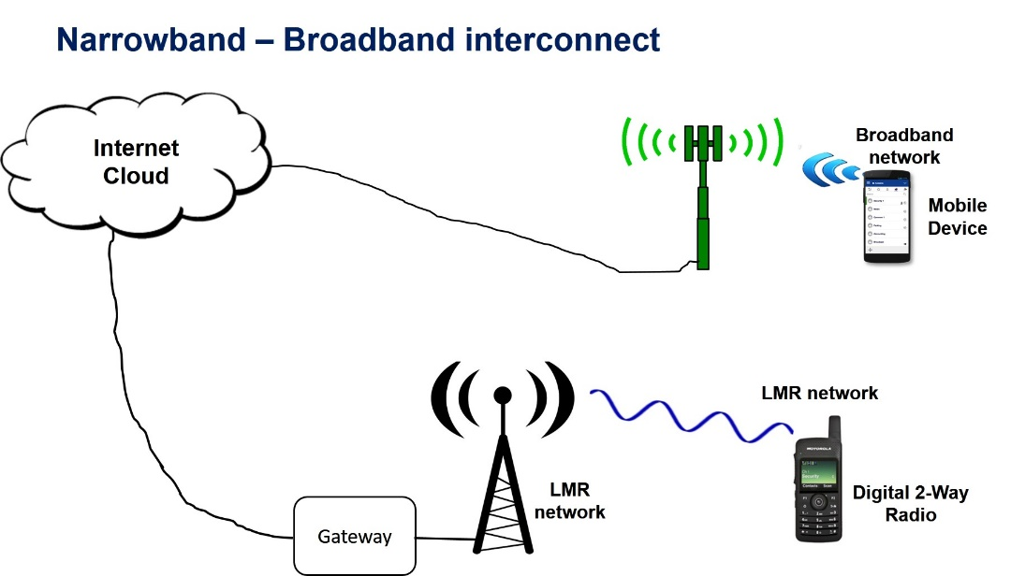

- Future direction of narrowband PPDR applications and systems
Mission critical voice communication will remain the primary requirement of PPDR users. It may take many years before dedicated broadband networks are able to provide mission critical coverage equal to narrowband PPDR LMR networks. It is expected to take many years before mobile broadband networks can achieve the level of financial affordability that LMR systems today have.

The advent of 5G technologies will see greater use of IP based interconnections to enable interoperability between narrowband and broadband PPDR systems.

REFERENCES

- APT Report on "Possible Harmonized Use of Bands 406.1-430 MHz, 806-824/851-869 MHz, 4940-4990 MHz, 5850-5925 MHz for PPDR Application in some APT Countries" APT/AWF/REP-08 04/2009
- APT Report on "Technical Requirements for Mission Critical Broadband PPDR Communications" APT/AWG/REP-38(Rev.1) Revised 02/2016
- APT Report on Harmonization of Frequency Ranges Use by Wireless PPDR Applications in Asia-Pacific Region APT/AWG/REP-73 09/2017
- APT Recommendation on Radiocommunication Systems for Early Warning and Disaster Relief Operations APT/ASTAP/REC-01(Rev.1) 11/2012
- APT Report on Use and Examples of Radiocommunication Systems for Early Warning and Disaster Relief Operations APT/ASTAP/REPT-02 2011
- APT Report on "Handbook to Introduce ICT Solutions for the Community in Rural Areas" APT/ASTAP/REPT-13 (Rev.1) August 2014, Revision September 2015
- Resolution 646 (Rev.WRC 15) Public protection and disaster relief
- Recommendation ITU-R M.1808 “Technical and operational characteristics of conventional and trunked land mobile systems operating in the mobile service allocations below 869 MHz to be used in sharing studies”
- Recommendation ITU-R M.2009 “Radio interface standards for use by public protection and disaster relief operations in some parts of the UHF band in accordance with Resolution 646 (Rev.WRC-12)”
- Recommendation ITU-R M.2015-2 Frequency arrangements for public protection and disaster relief radiocommunication systems in UHF bands in accordance with Resolution 646 (Rev.WRC-15)
- Report ITU-R M.2377-1 (11/2017) Radiocommunication objectives and requirements for Public Protection and Disaster Relief
- Report ITU-R M.2014-3 (11/2016) Digital land mobile systems for dispatch traffic
- Report ITU-R M.2291-1 (11/2016) The use of International Mobile Telecommunications (IMT) for broadband Public Protection and Disaster Relief (PPDR) applications

International Red Cross and Red Crescent Societies (http://www.ifrc.org/en/what-we-do/disaster-management/about-disasters/what-is-a-disaster/ )
Report ITU-R M.2377, Section 3.3.7

