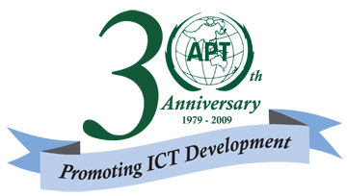
ASIA-PACIFIC TELECOMMUNITY

2nd APT PREPARATORY MEETING FOR ITU PLENIPOTENTIARY CONFERENCE 2010
1 – 4 December 2009, Bangkok, Thailand

APT Common Position

Title: The role of ITU-T Study Group

Introduction
According to the provision depicted in No. 192 of CV, ITU-T Study Group shall study questions and prepare draft recommendations. However, during WTSA-08 it was proposed to extend the role of ITU-T Study Group by studying topics identified in a resolution or a recommendation of WTSA based on the role of ITU-R Study Groups depicted in No. 149A of CV.
APT Member countries indicated above are of the view that the proposal to extend the role of ITU-T Study Groups, by analogy with ITU-R Study Groups, is not consistent with the objectives and purposes as contained in CV 192. In particular, the need to adopt questions describing the details and scope of the studies to be taken up/carried out by the relevant study group even if there are approved resolutions or recommendations of the WTSA.

Position

The provision of CV 192 should be maintained without any change.

NOC

192  PP-98 | 1 1) Telecommunication standardization study groups shall study questions adopted in accordance with a procedure established by the world telecommunication standardization assembly and prepare draft recommendations to be adopted in accordance with the procedure set forth in Nos. 246A to 247 of this Convention.

This APT Common Position should be converted into APT Common Proposal, when there shall be reason associated with it, such as contrary proposal submitted by another Regional group or Member State.

