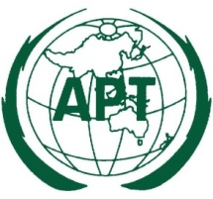 | The 34th Session of the Management Committee of the Asia-Pacific Telecommunity  30 November – 3 December 2010, Macao, China | 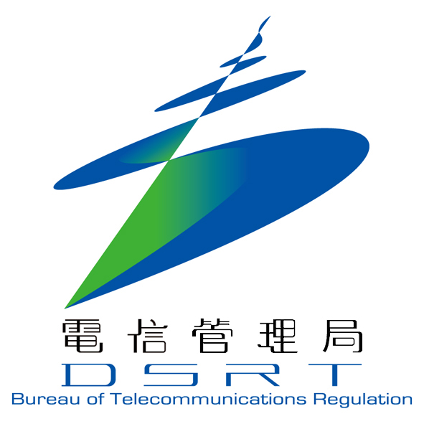

Doc. No. MC-34/10.2

REPORT OF APT PREPARATIONS FOR
THE ITU PLENIPOTENTIARY CONFERENCE (PP-10)
(Item 10 of the Provisional Agenda of the Management Committee of the APT)

Note by the Secretary General

The Report of APT Preparations for the ITU Plenipotentiary Conference (PP-10) is presented to the Management Committee for its consideration.

Dated, 3 November 2010, Bangkok Toshiyuki Yamada
Secretary General
REPORT OF APT PREPARATIONS FOR ITU PLENIPOTENTIARY CONFERENCE 2010 (PP-10)

- Introduction
The objective of the APT Preparatory Activities for ITU Plenipotentiary Conference 2010 (PP-10) was to harmonize regional views and develop APT Common Proposals for the Conference. The preparatory group was formed in 2009 under the chairmanship from Dr. Jason Ashurst of Australia. During the two years of preparatory process four preparatory meetings were held to discuss the issues related to PP-10 and to develop APT Common Proposals. The process was followed by a series of APT coordination meetings during PP-10. APT submitted total 72 common proposals for the Conference among which there were a number of new resolutions. PP-10 was very much successful in the sense that almost all of the proposals submitted by APT were accepted by the Conference. This success has raised the level of APT among other regional organizations involved in the preparatory works of the conference.

This report gives a brief overview of the whole preparatory process and achievement of APT from PP-10.

- Structure for PP-10 Preparatory Activities

APT preparatory group for PP-10 was set up on 08th May 2009 at the First APT Preparatory Meeting for PP-10. The group was consists of plenary as well as five correspondence groups. Following table shows the list of the officer bearers:

Group | Office Bearers
Plenary Chairman | Dr. Jason Ashurst (Australia)
CG1: Finance and Organization Issues | Mr. Masanori Kondo (Japan)
CG2: Strategy and Policy Issues | Dr. Jason Ashurst (Australia)
CG3: Standardization Sector Issues | Dr. Jongbong Park (Republic of Korea)
CG4: Radiocommunication Sector Issues | Mr. Alireza Darvishi (Islamic Republic of Iran)
CG5: Development Sector Issues | Ms. Tran Than Ha (Socialist Republic of Vietnam)

The correspondence rapporteurs were assisted by a number of assistant rapporteurs. The complete list of the office bearers can be found from APT website.

- Preparatory Meetings in 2010
During two years of preparatory process four preparatory meetings were held: first meeting on 08 May 2009 in Kuala Lumpur, second meeting on 01-04 December 2009 in Bangkok, third meeting on 22-25 June 2010 in Cairns and fourth meeting on 23-24 August 2010 in Bangkok.

3.1 The 3rd APT Preparatory Meeting for PP-10:
This meeting, held in Cairns, Australia was hosted by the Department of Broadband, Communications and the Digital Economy (DBCDE), Government of Australia. The meeting was attended by 86 delegates from APT member administrations, affiliate members, ITU and other regional organizations. The meeting discussed the input contributions from member administrations and developed 42 preliminary APT common proposals and number of APT common positions. Further, it discussed the coordination mechanism necessary for the member administrations during PP-10.

3.2 The 4th APT Preparatory Meeting for PP-10:
This meeting, held in Bangkok, Thailand was organized by APT in support of the Ministry of Information and Communication Technology, Thailand. The meeting was attended by 93 delegates from APT member administrations, affiliate members, ITU and other regional organizations. The meeting discussed the input contributions from member administrations and developed 18 preliminary APT common proposals and number of APT common positions. Further, it finalized the schedule of APT coordination meetings during PP-10 and list of the leading and supporting countries for the common proposals. Besides the meeting also finalized the nomination list of the PP-10 office bearers from APT region.

- Results of PP-10

4.1 Increased number of Council Seat from APT Region:

Considering the fact that the Democratic Republic of Timor-Leste joined the ITU, thereby increasing the number of the Union’s Member States to 192. Consequently, the maximum number of council seats allowed by the Convention is now 48, which is exactly 25% of 192. The addition of Timor-Leste to the ranks of the Member States of the Union has also resulted in an increase in the number of Member States in Region E from 49 to 50. Applying the methodology of allocation of council seats, APT proposed to increase the number of Council seats for Region E from 12 to 13. The proposal was accepted by the conference and one additional council seat was allocated to Region E.

4.2 PP-10 Office Bearers from APT Region:

APT Region was well represented in the officer bearer’s rolls at the Conference. Dr. Jason Ashurst of Australia was elected as one of the vice chairman of the Conference. Dr. Kyu Jin Wee of Republic of Korea was elected as the chairman of COM3 (Budget Committee). Ms. Pricilla F. Demition of Philippines served as vice chair of COM2 (Credential Committee), Mr. Kavouss Arasteh of Islamic Republic of Iran served as vice chairman of COM5 (Policy and Regal Matters), Mr. R. N. Jha of India served as vice chairman of COM6 (Administration and Management) and Mr. Tran Quang Cuong of Vietnam served as the vice chairman of WG of Plenary. Besides a number of ad hoc groups and drafting groups under various committee were chaired by the APT member Administrations. Japan, Republic of Korea and Thailand also served as the tellers of the elections held at PP-10.

4.3 APT Common Proposals:

APT’s preparation and submission of the proposals to the conference were well ahead of the preparation of other regional organizations. APT submitted 72 common proposals for the work of the conference. Except 4 proposals all others were accepted by the Conference with minor changes or as consolidated text with other similar proposals from other regions..

The proposals include;
- 10 new Resolutions,
- 19 modifications to existing Resolutions (4, 25, 30, 36, 48, 66, 71, 72, 91, 123,130, 135, 136, 139, 151, 153, 157, 158) and Decision 5.
- 13 proposals for no change Constitution (CS 1002, 1010, 1012, 1015, 1016), Convention ( CV 84, 197A, 334, 468B, 1003, 1005) and Resolutions (86 and 118).
- 15 proposals for suppression of Resolutions (47, 49, 88, 93, 107, 108, 110, 141, 142, 147, 149, 150) and Decisions (6, 7 and 10).

A summary of the outcome of the ACPs including the list of leading and supporting countries are included in Annex of this document. Further details of the ACPs are available at APT website http://www.apt.int/APT-PP.

One of the APT’s major achievements in PP-10 was the acceptance of APT’s detail proposal for the stabilization of the Constitution of ITU. APT was the only among regional organizations who submitted very detailed proposals and roadmap on this issue. It was discussed in length and a consensus based resolution was adopted to form a Council Working Group for Stabilizing the Constitution and its terms of reference. Mr. Kavouss Arasteh of Islamic Republic of Iran played an important role on behalf of APT on this significant issue. Other important Resolutions and Decisions adopted by the Conference from APT Common proposals are:

- The number of Vice-chairmen of sector advisory groups, study groups and other groups;
- Admission of academia, universities and their associated research establishments to participate in the work of three sectors of ITU;
- Free online access to ITU publications;
- Telecommunication/information and communication technology accessibility for persons with disabilities;
- The role of telecommunications/information and communication technologies on climate change and protection of the environment;
- Telecommunication/ICT applications for e-health;
- Definition of ICT and the definition of cybersecurity.

In order to facilitate the process to stabilize the Constitution of ITU, APT submitted minimum number of proposals, which were absolutely necessary, to modify the CS and CV and all of them were accepted by the Conference. Besides there were number of proposals to modify and suppress existing PP Resolutions/Decisions most of which were accepted.

- APT Activities during PP-10

APT Secretariat was represented at the Conference under the leadership of Mr. Toshiyuki Yamada. APT organized a series of coordination meetings during the duration of the conference. The objectives of those meetings were to discuss the progress of ACPs, points of negotiations on the proposals and issues related to the interest of region as whole. The meetings were attended by delegates of the APT member Administrations with the attitude of cooperation in the region. APT Members also supported whole heartedly the proposal of the Republic of Marshall Islands to address the arrears of its ITU contribution. While there were concerns expressed by other regions, due to the continuous support of APT Members the payment policy for arrears was relaxed for Marshall Islands.

- Reflections on the APT Preparatory Process

The last APT coordination meeting during the conference reflected on the APT’s preparatory process and noted the following issues:
- The importance of meeting the ITU deadlines for contributions, recognizing that in general the APT met these deadlines, and often in advance of other regions.
- The importance of coordination with other regions and the need for active participation of and collaboration with other regions in the APT’s preparatory process.
- The need to consider and include the financial implications of proposals in the preparations for PP-14.
- The required number of preparatory meetings given the issues noted above.

- Conclusion
APT’s preparatory process and submission of proposals for the PP-10 was well advanced than that of other regional organizations. It was appreciate by others. PP-10 Conference is a big success for the APT. All the APT Members worked hard and enthusiastically for the success of the region and for the Conference. It has alleviated the status of APT as regional organization. Chairman of the preparatory groups and other office bearers gave their full expertise and hard works during the whole preparatory process. The success in PP-10 would create further cooperation and collaboration among APT Members.

______________

