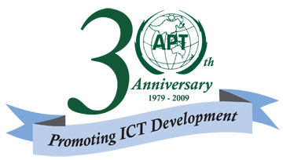
ASIA-PACIFIC TELECOMMUNITY

APT Common Proposal

Title: DEFINITION OF ICT

Plenipotentiary Conference (PP-10)  Veracruz, 4-22 October 2010 | 
PLENARY MEETING | Document
PLENARY MEETING | [date]
PLENARY MEETING | Original: English
ASIA-PACIFIC TELECOMMUNITY
COMMON PROPOSALS FOR THE WORK OF THE CONFERENCE
ACP-02
Definition of ICT
Submitted by the following Member States:

Afghanistan, Australia, India (Republic of), Indonesia (Republic of), Iran (Islamic Republic of), Japan, Korea (Republic of), Malaysia, Maldives (Republic of), Marshall Islands (Republic of the), Myanmar (Union of), Nepal (Federal Democratic Republic of), New Zealand, Papua New Guinea, Philippines (Republic of the), Samoa (Independent State of), Singapore (Republic of), Thailand, Tonga (Kingdom of) and Vietnam (Socialist Republic of)
______________

Introduction

The Council Working Group on Terminology: Use in the Constitution and Convention, in their report to the 2009 session of Council (document C09/09), proposed two options:
(a) to include a possible definition of ICT in either the CS or CV; or
(b) to retain flexibility reflecting the changing impact of ICT and ICT applications in the ITU.

In contribution 36 to PP-06 (Proposal ACP/36/3), APT Member States indicated that “telecommunication” remains the most appropriate and useful descriptor of the ITU’s mandate. It was also noted that the word “telecommunication” is in fact a very broad and inclusive term that covers all the network-related aspects of information and communications technology.

APT Members wish to indicate their appreciation for the work undertaken by the Council Working Group on Terminology: Use in the Constitution and Convention.

Proposal

ACP/XX/03

APT Member States whose names are listed above propose no change to the CS or CV to include a possible definition of ICT in order to retain flexibility reflecting the changing impact of ICT and ICT applications in the ITU.

