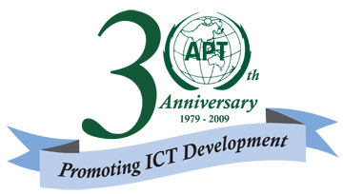
ASIA-PACIFIC TELECOMMUNITY

APT Common Proposal

Title: DEFINITION OF CERTAIN TERMS USED IN THE CONSTITUTION AND THE CONVENTION

No.1002 of Annex to CS

Plenipotentiary Conference (PP-10)  Veracruz, 4-22 October 2010 | 
PLENARY MEETING | Document
PLENARY MEETING | [date]
PLENARY MEETING | Original: English
ASIA-PACIFIC TELECOMMUNITY
COMMON PROPOSALS FOR THE WORK OF THE CONFERENCE
ACP-05
Definition of Certain Terms Used in the Constitution and the Convention
No.1002 of Annex to CS
Submitted by the following Member States:

Afghanistan, India (Republic of), Indonesia (Republic of), Iran (Islamic Republic of), Japan, Korea (Republic of), Malaysia, Maldives (Republic of), Marshall Islands (Republic of the), Myanmar (Union of), Nepal (Federal Democratic Republic of), Papua New Guinea, Philippines (Republic of the), Samoa (Independent State of), Singapore (Republic of), Thailand, Tonga (Kingdom of) and Vietnam (Socialist Republic of)
______________

Introduction
During various Union’s meeting, the delegation of some State Member stated that Quote
the Term, “Administration” ( with Capital /Upper case “A” ) signifies / refers to the State Member and the term “administration” ( with small / lower case “a” ) signifies / refers to Sector Member .
Unquote
Having carefully considered the matter, such interpretation / understanding does not seem to be appropriate due to the fact that the term “Administration “or “administration” irrespective whether it is written with capital / upper case “A” or with small / lower case “a” shall only refers to any governmental department or service responsible for discharging the obligations undertaken in the Constitution of the International Telecommunication Union, in the Convention of the International Telecommunication Union and in the Administrative Regulations.
Such misinterpretation / misunderstanding needs to be corrected.

Proposal

ACP/XX/06
The clarification should be included in the minutes of the plenary meeting of PP-10 dealing with No.1002 of Annex to the Constitution.

