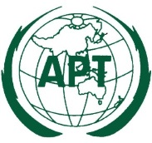 | ASIA-PACIFIC TELECOMMUNITY
 | APT Conference Preparatory Group for WRC-15 (APG-15)

APT Coordination Meetings during RA-15/WRC-15

AGENDA OF THE 4th APT COORDINATION MEETING FOR WRC-15
13:00 – 13:50 Hours, 9 November 2015
Venue: Room C, ITU Tower Building

- Approval of agenda

- Update of the APT Coordination Meeting on AI 10

- Report from the AI Coordinators and issues for consideration

  - COM 4: AI 1.1, AI 1.3, AI 1.16, AI 1.17 (final),

  - COM 5: AI 1.6, AI 1.8, AI 1.9.2, AI 1.10, AI 1.11, AI 1.13 (final), AI 1.14, AI 7, AI 9.1 (Issues 9.1.1, 9.1.2, 9.1.3, 9.1.5, 9.1.7, 9.1.8)

  - COM 6: AI 2, AI 4, AI 8, AI 9.1.6, AI 10

- Any other issues for consideration

- Next coordination meeting

- Closing

____________

