APT REPORT

On

Case Study of ICT applicationS
IN Shipbuilding industry in Korea

No. APT/ASTAP/REPT-10
Edition: March 2013
Source Document: ASTAP-21/OUT-26

Adopted by

The 21st APT Standardization Program Forum (ASTAP-21)
11 – 15 March 2013, Bangkok, Thailand

I. Introduction: IT Convergence

Directions of IT Evolution
IT(Information Technology) is developing toward 3 directions; mobility, intelligence, and embedment. The internet limited by network develops toward the future Internet beyond the limitations of space. And IT as functional instrument develops towards as intelligently supporting assistant and from the IT only technology to the catalytic technology for convergence.

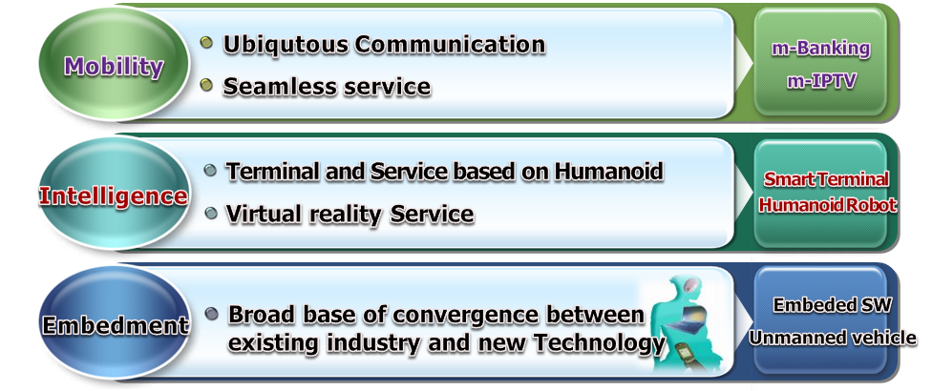
Figure 1. Directions of IT Convergence
* IPTV : Internet Protocol Television, SW : Software
Characteristics of IT Convergence
IT convergence means the birth of goods or services which create new utility through cooperation between different industrial sectors based on IT. There are three directions of IT convergence. First one is IT plus new technology, for example, IT+BT(Biology Technology), IT+NT(Nano Technology), IT+CT(Culture Technology), IT+GT(Green Technology) can create new business opportunities. Second one is convergence with IT, for example, voice + data, fixed + mobile, broadcasting + telecommunications can provide smart service. Since the 2000s, technologies and services have been evolving under the new framework of convergence. The emergence of devices and technologies like the smartphone, tablet PC(Personal Computer), smart TV(Television) and 3DTV(Three-dimensional Television), in particular, did much to accelerate this erasing of the boundaries between telecommunications and the media. This phenomenon is characterized by convergence, two-way interactivity, smartness, realism and emphasis on emotional satisfaction. The convergence between telecommunications and media, meanwhile, is likely to give momentum to the constructive development of smart media. Third one is IT + existing industries, for example, IT + medical, IT + shipbuilding, IT + construction, IT + robot, etc., can improve productivity for the existing industries.

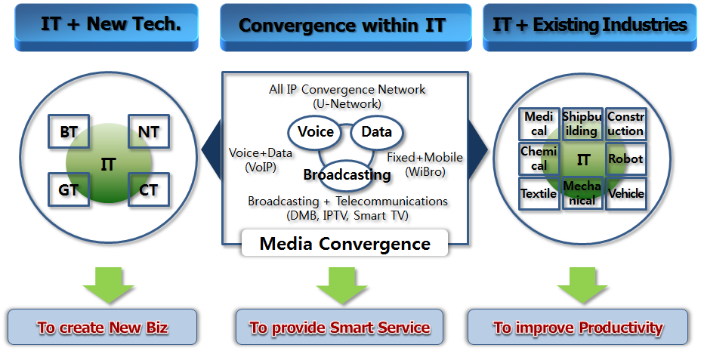
Figure 2. Characteristics of IT Convergence
* IP : Internet Protocol, VoIP : Voice over Internet Protocol
* WiBro : Wireless Broadband Internet, DMB : Digital Multimedia Broadcasting

Role of IT Convergence
IT convergence emerged as a solution to social issues as it expanded. For example, by using IT we can achieve traffic efficiency, resource conservation work efficiency, and production process improvement etc.

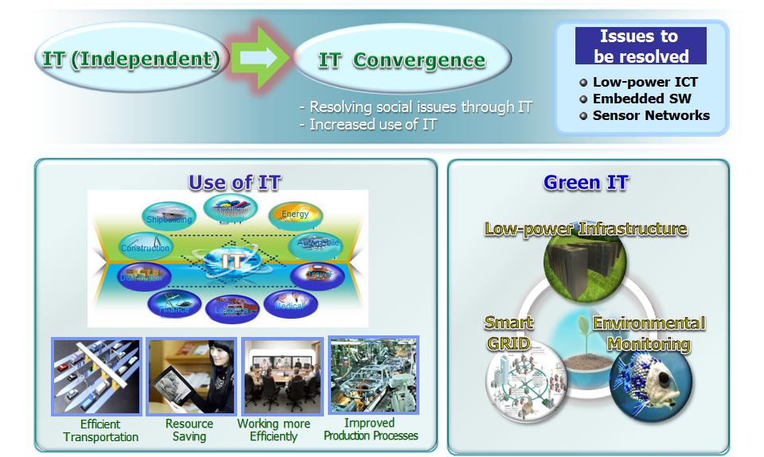
Figure 3. Role of IT Convergence
Convergence between IT and existing industry
Convergence between IT and existing industry not only improves the productivity and efficiency of that industry but also contributes to the creation of new services. A typical example is u-city service. IT convergence between IT and medical service, then u-health service can be created.
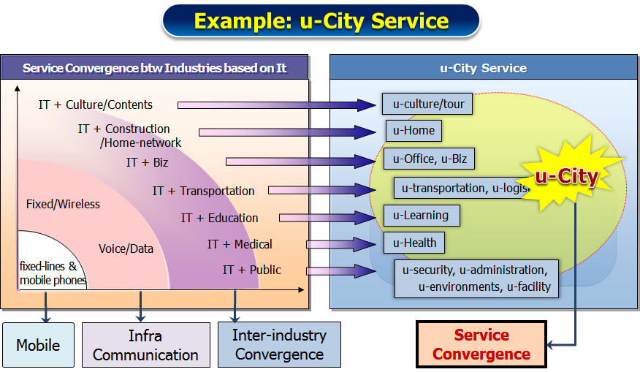
Figure 4. Convergence between IT and existing industry

II. IT and Shipbuilding

Circumstance of Shipbuilding
In the 2000s, Korea’s shipbuilding industry maintained the world No. 1 position. Since 2005, China has been following us as the third largest shipbuilder in the world. 13.5% of the world market thanks to dramatic governmental investment and low labor costs. Thus, it is necessary for shipbuilding industry to adopt IT convergence technology to maintain the world’s No.1. In doing so, the industry and academy are necessary to jointly prepare next-generation high-value-added shipbuilding industry.

Why IT + Shipbuilding?
With this situation why do we need IT + shipbuilding? We are strong for shipbuilding, for example, both ship order volume and shipbuilding volume are No. 2 in 2010. We are also strong for IT, for example, semiconductors, mobile phone and displays. However, we are still weak for shipbuilding IT, for example, no domestic production of high value-added equipment, low localization of key software and lack of ship communication equipment technology. Another interesting circumstance of shipbuilding is that technology of shipbuilding or marine equipment for next generation IT Ship changes from machine-based technology to machine-IT convergence technology;

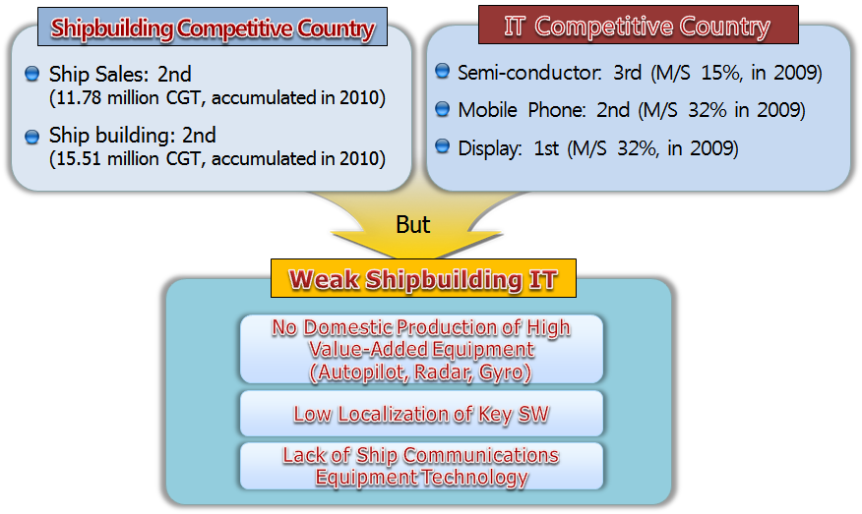
Figure 5. Reason for IT + Shipbuilding

Next Generation IT Ship
Our vision of next generation IT ship is to strengthen global competitiveness by convergence between IT with shipbuilding. In order to achieve this vision, we have four objectives; planning & designing visualization, global A/S system, cutting-edge production technology, and operating system localization. We call these as digital ship lifecycle management. For localization of operation system ETRI develops SAN(Ship Area Network) technology and for cutting-edge production technology ETRI develops YAN(Yard Area Network) technology.

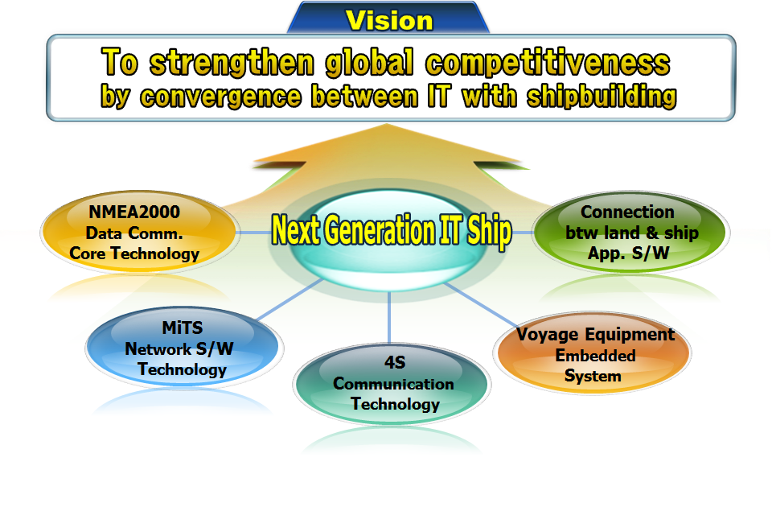
Figure 6. Our vision of the next generation IT Ship
* NMEA : National Marine Electronics Association
* App : Application
* S/W : Software

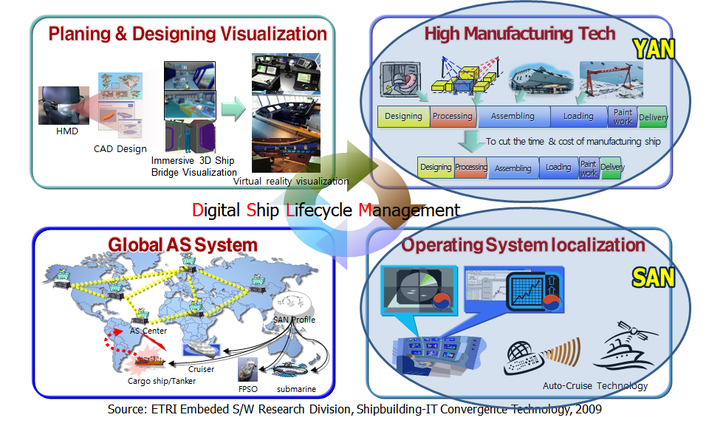
Figure 7. Four objectives
* HMD : Head mounted Display
* CAD : Computer Aided Design
* FPSO : Floating Production Storage and Offloading

III. Case Study: SAN (Ship Area Network) of ETRI

Concept of SAN (Ship Area Network)
SAN is defined as the mobile and fixed technologies which enable to create the next generation value-added service by connecting all equipments and systems of a ship with them. By these technologies we transform separated ship area network to integrated ship area network. Separated Ship Area Network is characterized as Field Area Network oriented individual SAN, no interconnection

Figure 8. Concept of SAN
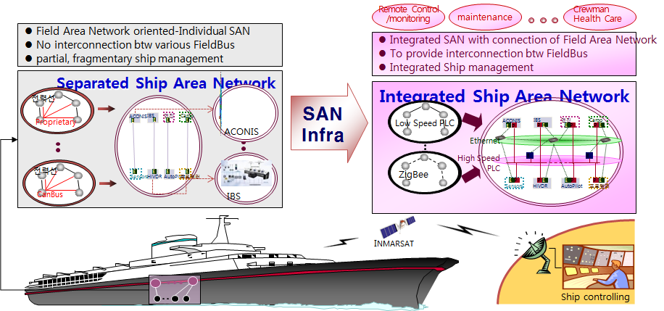
* IBS : Intelsat Business Service
* ACONIS : AMS(Alarm Monitoring System) is the general name.
The system monitors the status of a ship via numerous sensors to the devices of
engine and cargo, etc.
* PLS : Power Line Communication

between various FieldBus, and partial, fragmentary ship management, while Integrated Ship Area Network is characterized as connection of Field Area Network, provision of interconnection between FieldBus, and Integrated Ship management.

Two Major Outcomes
ETRI developed two prototypes; One is Integrated Gateway Prototype for Ship, which is network device linking a ships internal system with the STAR structure. Application area is establishment of a ship’s backbone. Another is Remote Ship Maintenance Service Prototype, which is a service for monitoring and repairing ship equipment on land. Application area is real-time maintenance service for ship equipment.

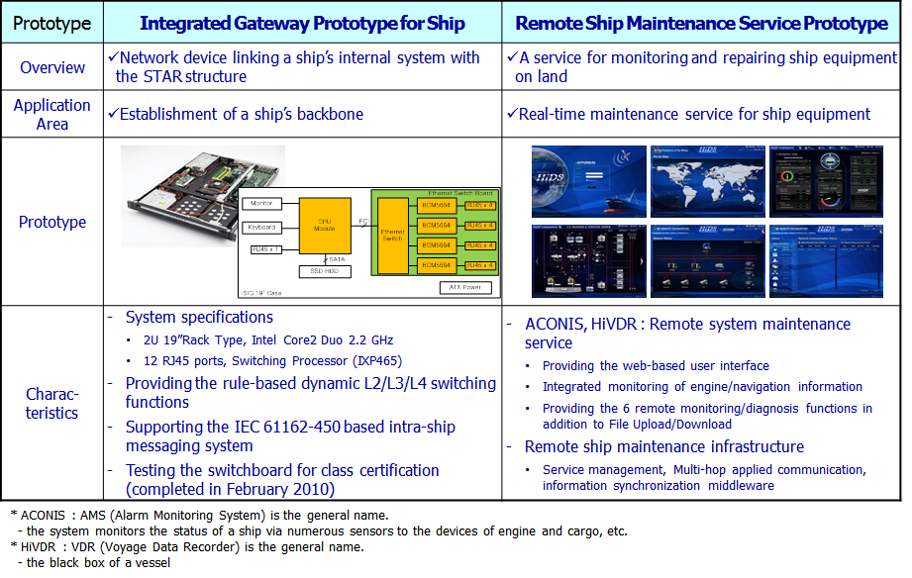
Figure 9. Two Major Outcomes
* L2/L3/L4 : Layer2/Layer3/Layer4
* IEC : International Engineering Consortium
* HiDVR : VDR(Voyage Data Recorder) is the general name. The black box of a vessel

Successful Testing
ETRI successfully performed the SAN integrated test of the remote maintenance system by using satellite on 4 occasions at Seonam plant in Ulsan from September 2009 to January 2010. We also successfully performed the field test with the SAN on the Tam Yang from July to August 2010.

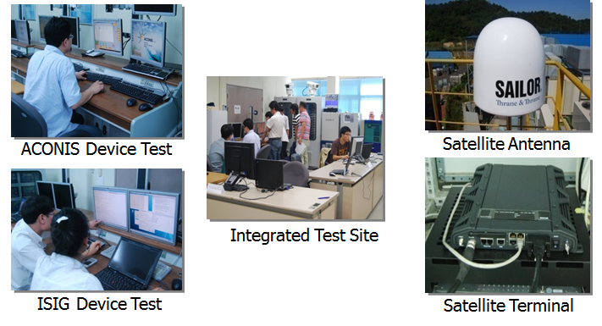
Figure 10. Successful Testing
Schedule of Commercialization
The contract to install the ACONIS (Alarm Monitoring System) system of the HHI in the 18 container ships of DSME, as ordered by AP Moller (The SAN-based remote maintenance service played a critical role in the order.) at July 2009. At September AP Moller requested the remote maintenance service for the BMS (Bridge Manoeuvring System) system, which would be installed in 18 of DSME’s ships. Then at November, AP Moller also requested the remote maintenance service for the 24 ships of HHI they had already ordered. At October, 2010 the ISIG(Intra-Ship Integrated Gateway) system and the remote maintenance service were installed in the ships of the DSME. Finally, at March, 2011 the DSME ship was delivered to AP Moller.

IV. Case Study: YAN (Yard Area Network) of ETRI

Concept of YAN (Yard Area Network)
YAN is defined as the developing technology for the real-time monitoring of blocks and transporters to improve the efficiency of shipbuilding processes in the shipyard and the developing group communication technology for real-time PoP (Point of Production) based on the optimal wire-wireless infrastructure

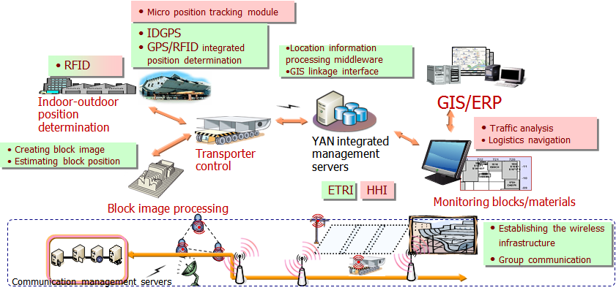
Figure 11. Concept of YAN
* IDGPS : Inverted DGPS(Differential GPS)
* GPS : Global Positioning System
* RFID : Radio Frequency Identification
* GIS : Geographic Information System
* ERP : Enterprise Resource Planning

Two Major Outcomes
The major outcome is YAN Infra. Its positioning is the building real-time location tracking infra. of block/TP(Transport Protocol) for shipbuilding. And the integrated management is developing YAN Integrated management platform for shipyard monitoring.
Systems for YAN
The major outcome is YAN Infra. Its positioning is the building real-time location tracking infra. of block/TP for shipbuilding. And the integrated management is developing YAN Integrated management platform for shipyard monitoring.

Figure 12. Systems for YAN
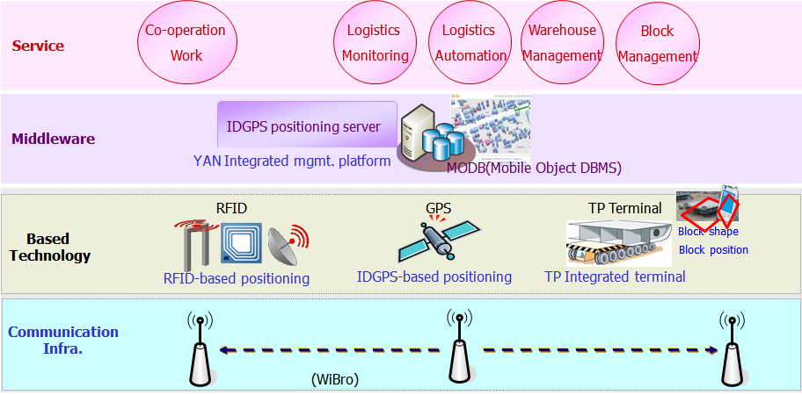
* DBMS : Data Base Management System
* AP : Access Point
* STA : Station

Expected Effects
We can obtain 3 economic effects of YAN. One is the growth of productivity through timeliness block import/export. Second one is improvement of logistics processes through real-time logistics monitoring. Third one is logistics cost reduction through optimal routing.

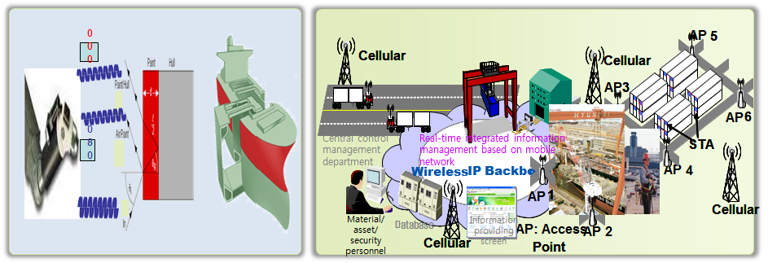
Figure 13. Expected Effects

V. Conclusion

IT-Shipbuilding Convergence Technologies, including SAN and YAN, are the foundation of the Next-Generation IT Ship. Convergence technology will establish Korea as the world’s No.1 shipbuilder and contribute to sales of USD(United States dollar) 11 billion. Korea hopes to capture a 40% market share of the global shipbuilding and marine industries, while firmly maintaining its position as the world’s No. 1 ship-building nation. This can be achieved by improving the competitiveness of the shipbuilding and marine industries based on the digital ship/shipbuilding technology – primarily via the new technology development aimed at grafting information technology onto the shipbuilding and marine industries.

Improvement of production competitiveness is expected, with an annual sales increase of over USD 11 million, by improving productivity by reducing the duration of the shipbuilding process and enhancing production efficiency by cost savings. Revenue impact worth USD 45 billion is expected, including the establishment of an intelligent integrated navigation system, via localization of equipment and fostering of the related domestic related industry. Additional revenue over 30% of a ship’s price is expected by increasing the repurchase rate of ship’s owners via ship maintenance improvement.

