APT REPORT
ON
PRECISION TIME AND FREQUENCY SYNCHRONIZATION
IN FUTURE TRANSPORT NETWORKS

No. APT/ASTAP/REPT-33
Edition: May 2018

Adopted by

30th APT Standardization Program Forum (ASTAP-30)
21 – 25 May 2018, Bangkok, Thailand
Source Document: ASTAP-30/OUT-20

Table of Contents
1. Introduction 3
2. Scope 3
3. Abbreviations and acronyms 3
4. Overview of synchronization technologies 4
4.1 Frequency-synchronization technologies 5
4.2 Time-synchronization technologies 5
4.2.1 PTP 5
5. Standardization activity of ITU-T SG15 7
6. Use cases of high-precision time synchronization 8
6.1 APT operator use cases 9
7. Deployment of time-synchronization networks 9
7.1 APT operator solutions to synchronization-network deployment 11
8. Requirements of synchronization accuracy 14
8.1 Time-synchronization accuracy 14
8.2 Frequency-synchronization accuracy 14
8.3 APT operator requirements of synchronization accuracy 15
9. Synchronization-network management 15
9.1 GNSS errors 15
9.2 Time holdover of PRTC 16
9.3 Network failure 17
9.4 APT operator network-management requirements 18
10. Conclusion 19

1. Introduction

Synchronization technologies are fundamental to supporting the network services of telecommunication operators. In legacy transmission technologies, such as SDH and ATM, it has been necessary to synchronize the frequencies among the network equipment to multiplex/de-multiplex several signals in such equipment.

ITU-T SG 15 established a recommendation to achieve frequency synchronization on a network, and it is a key technology to provide various services of telecommunication operators such as public telephones and leased lines.

In recent years, however, telecom operators have been promoting migration to asynchronous networks using packet-based technology due to increased failure of legacy technology devices, such as SDH, and increased maintenance cost. Asynchronous networks have become mainstream for major communication operators, requirements of network services, such as mobile and IoT, have become diversified, and in addition to frequency synchronization, time synchronization has become required as synchronization technology.

2. Scope

ITU-T SG15 has established recommendations related to time synchronization using packet-based technology to expand the requirements of time synchronization, and it is an important transport technology. This report focuses on time-synchronization technology, which is increasingly in demand among synchronization technologies. Frequency synchronization for supporting time synchronization is also considered.

In this report, we will be for introducing future requirements, use cases, technology-deployment costs, and technologies for constructing a synchronization network that uses time- and frequency-synchronization technologies for telecom operators in Asian countries and extracts common requirements of synchronization technology in the Asian region.

3. Abbreviations and acronyms

SDH: Synchronous Digital hierarchy
ATM: Asynchronous Transfer Mode
IoT: Internet of things
M2M: Machine to Machine
UTC: Coordinated Universal Time
CoMP: Coordinated Multi-Point
OTDOA: Observed Time Difference Of Arrival
EEC: Ethernet Equipment Clock
eEEC: enhanced Ethernet Equipment Clock
NTP: Network Time Protocol
PTP: Precision Time Protocol
T-BC: Telecom-Boundary Clock
T-TC: Telecom-Transparent Clock
T-TSC: Telecom-Time Slave Clock
GNSS: Global Navigation Satellite System
GPS: Global Positioning System
PRTC: Primary Reference Time Clock
ePRTC: enhanced Primary Reference Time Clock
GM: Grand Master
TD-LTE: Time Division Long Term Evolution
TDM: Time Division Multiplexing
FTS: Full Timing Support
PTS: Partial Timing Support
A-PTS: Assisted-Partial Timing Support

4. Overview of synchronization technologies

Synchronization technologies are mainly classified into frequency synchronization, phase synchronization, and time synchronization, as shown in Figure 1. Frequency synchronization are technologies in which the traveling speed of clock hands matches between two systems, and phase synchronization are technologies of matching up the time of clocks. Time synchronization ensures that the time matches UTC.

Table 1 shows these main synchronization technologies. These synchronization technologies of Table 1 differ depending on frequency synchronization and time synchronization. In particular, attention is focused on the PTP for achieving time synchronization on a packet network with high accuracy.

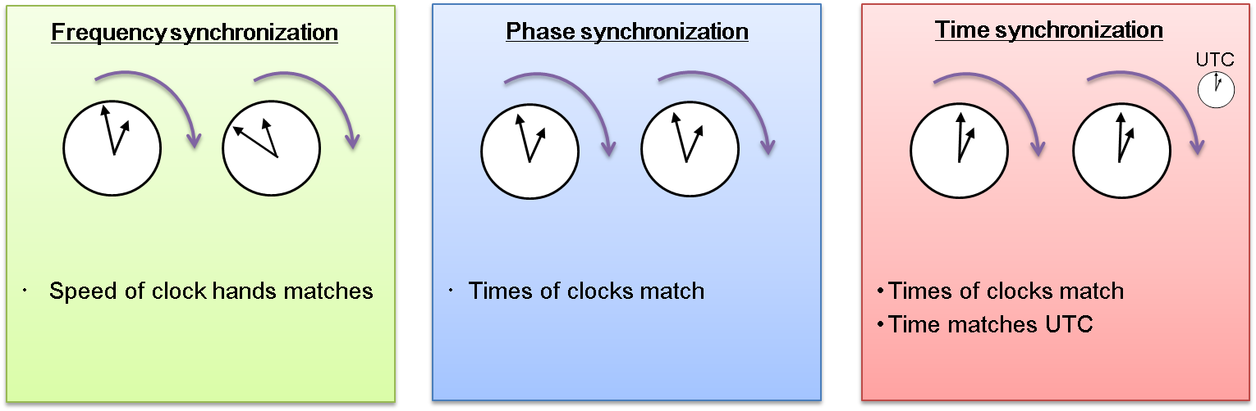
Figure 1 Classification of synchronization technologies

Table 1 Synchronization technologies
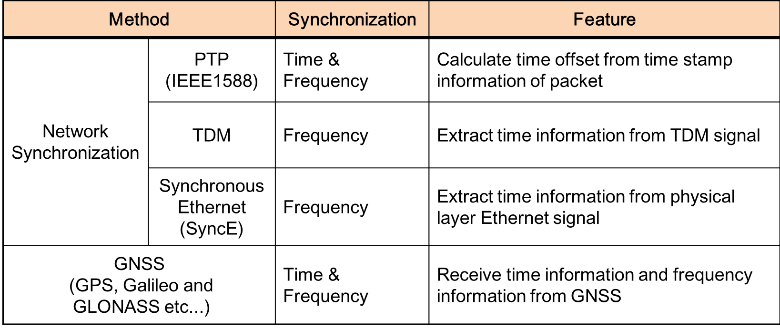

4.1 Frequency-synchronization technologies

In frequency synchronization, the reference clock device in the network is called the PRC. The technologies of frequency synchronization include master-slave synchronization, independent synchronization, and mutual synchronization. Master-slave synchronization is generally the standard, and all clock devices in the network need to be synchronized with the PRC. Cesium atomic clocks are often used as PRCs.

Regarding master-slave frequency synchronization, ITU-T specifies synchronous Ethernet (SyncE) technology for frequency synchronization on Ethernet, in addition to the TDM technologies, which are legacy technologies. SyncE is a method of extracting frequency information from the signal of the physical layer of an Ethernet frame. A clock device that enables SyncE is called an EEC.

4.2 Time-synchronization technologies

Regarding time/phase synchronization technology, there is a protocol called the NTP via the Internet, but since a public network is used, the accuracy of the NTP is on the order of milliseconds. On the other hand, the PTP achieves time synchronization on the network with higher accuracy. The PTP for industrial use is defined as IEEE 1588v2. When delivering the time synchronized with UTC, the reference time of UTC as the time source is generally received from a GNSS such as GPS.

4.2.1 PTP

The PTP is a protocol that provides time synchronization by exchanging round trip packets between MASTER and SLAVE, as shown in Figure 2.
In the PTP, each device that performs time synchronization has MASTER and SLAVE states. Each device exchanges PTP messages with time information (t₁ to t₄) attached. The SLAVE device calculates the delay between devices and the time offset between MASTER and SLAVE based on the transmission and reception time of the PTP packet, and sets the time of the SLAVE to the MASTER. As shown in Figure 2, the PTP calculates the offset from the following formula by sending four types of packets that give time information by the MASTER and SLAVE.

Offset = ((t₂ - t₁)-(t₄ - t₃))/2 (1)

With the PTP, in addition to the hardware time-stamping function, high-precision time synchronization of microseconds to nanoseconds can be achieved by correcting the delay of the transmission path.

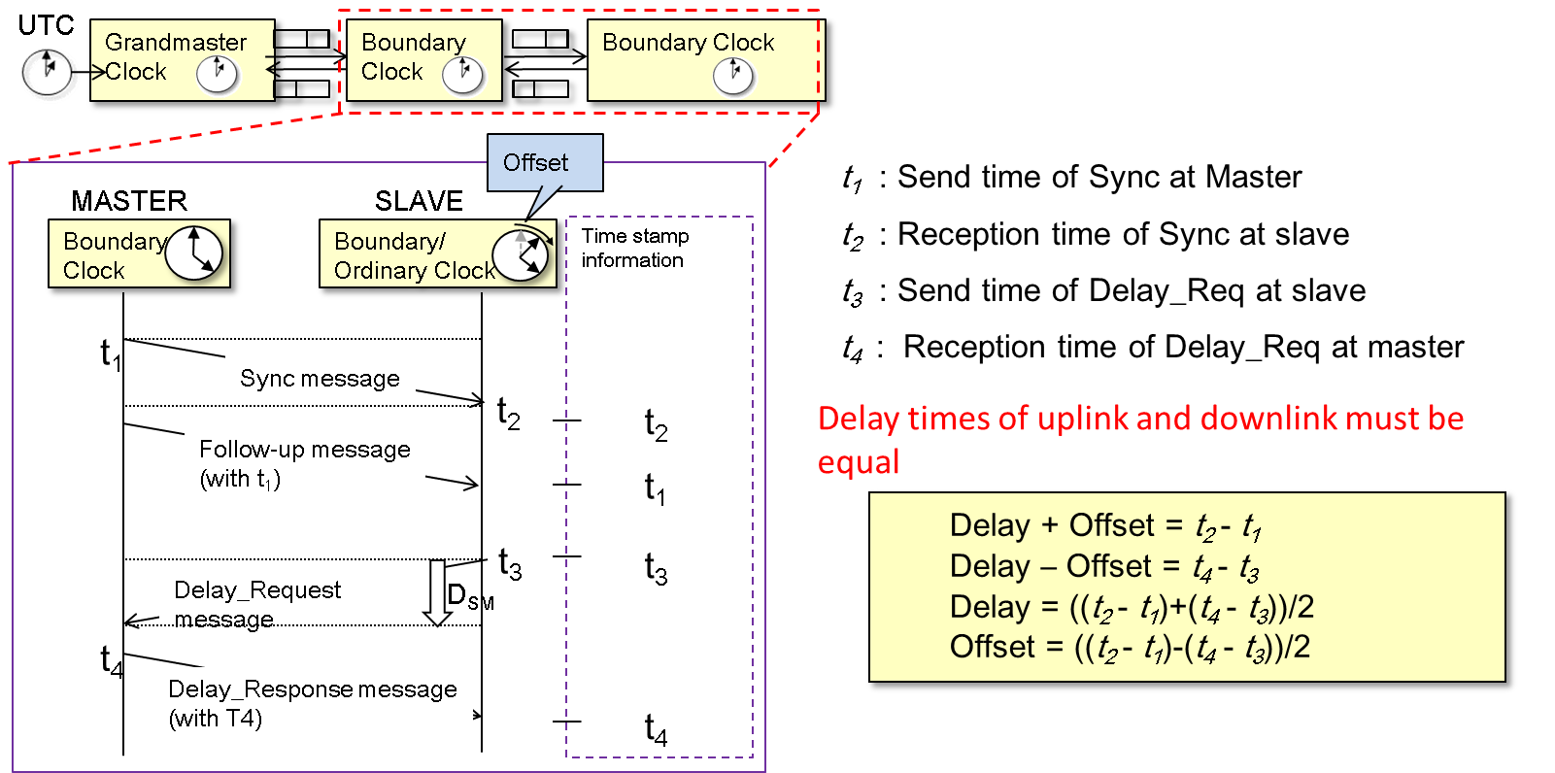
Figure 2 Overview of PTP mechanism

Therefore, the PTP, which is superior to the NTP in terms of synchronization accuracy, is attracting attention from every business field requiring high-precision time synchronization such as mobile, finance and connected car, and in ITU-T, the PTP is defined for use in the telecommunication field.

ITU-T defines several types of time-synchronization devices that execute the PTP, as shown in Figure 3. The device that references time is called the PRTC/T -GM. The T-BC and T-TC are devices that receive PTP packets from T-GM and synchronize and distribute time information to lower devices. The T-BC terminates the PTP packet from upstream and synchronizes with the upper device as the SLAVE. It also transmits PTP packets to the downstream device based on the time synchronized as the MASTER. The T-TC has an algorithm that creates time stamps at the input and output of the device and corrects intra-device delay. Since the T-TC can reduce the function of terminating PTP packets, the cost of devices can be reduced compared with the T-BC. The T-TSC finally terminates the time-synchronization information and supplies the information to the end application.

In telecom networks, there are several problems to be solved to achieve high-precision time/phase synchronization by the PTP. For example, when non-aware PTP devices and WDM devices are installed in synchronization networks, it is necessary to correct the delay asymmetry of uplink and downlink. In addition, packet-delay fluctuation due to congestion in the network and loss of the PTP packets greatly affects synchronization accuracy. ITU-T is actively carrying out discussions on issues that are particularly affected by such telecom networks.

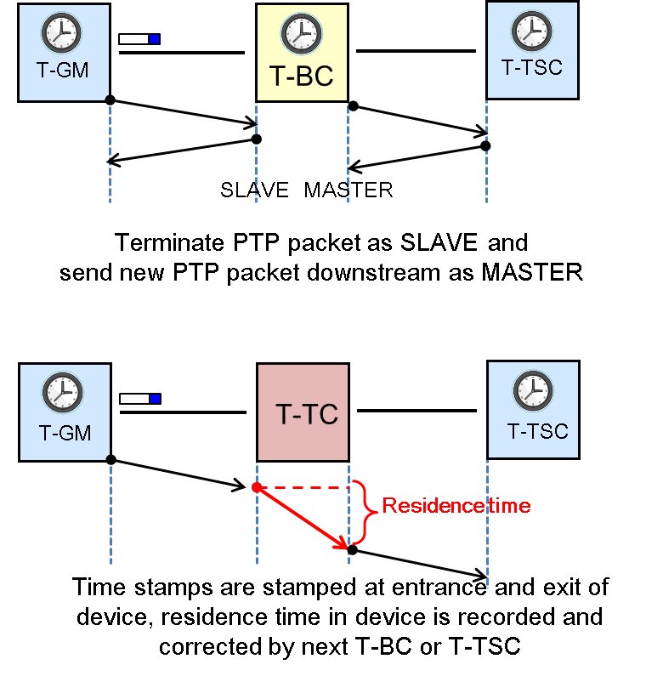
Figure 3 T-BC and T-TC

5. Standardization activity of ITU-T SG15

ITU-T SG15 specifies synchronization requirements, clock devices, synchronization network architecture, and measurement methods. Almost all recommendations on frequency synchronization have been completed, and it is the maintenance phase. We are discussing new recommendations for new services regarding time synchronization such as 5G and IoT.

Figure 4 shows the relationship between ITU-T and other organizations. ITU-T has discussed liaising with IEEE because it discusses expanding the PTP (IEEE 1588v2) prescribed for industrial application in IEEE to telecom for time synchronization consideration. ITU-T is also exchanging information with 3GPP to obtain future mobile requirements.

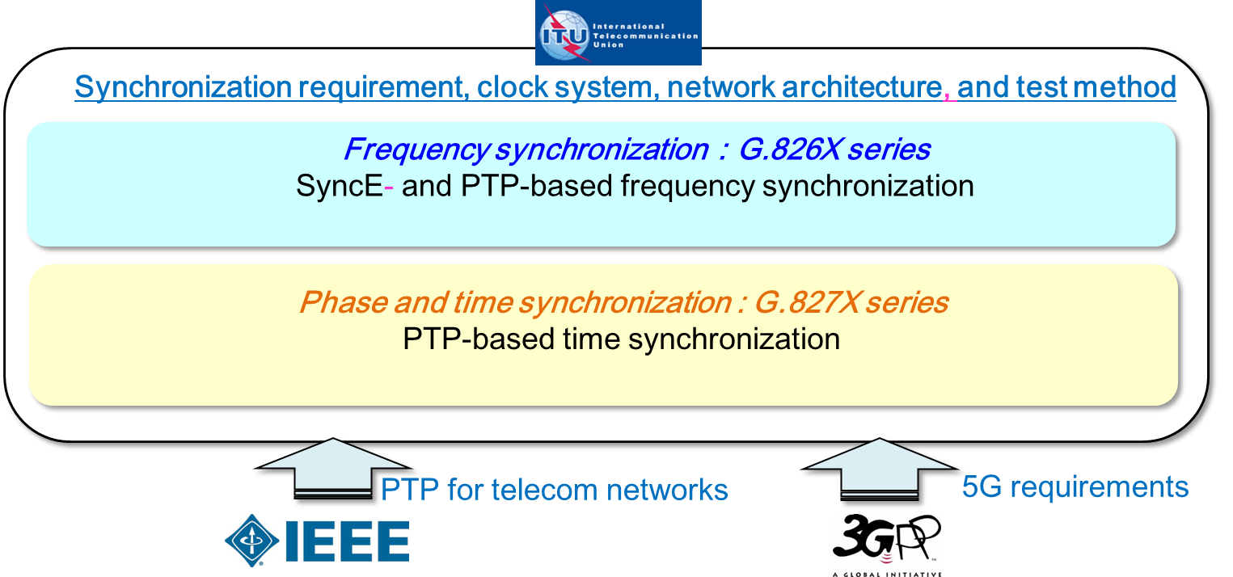
Figure 4 Relationship between ITU-T and other standards organizations

6. Use cases of high-precision time synchronization

When using TDD-LTE in 4G, time synchronization is required between the terminal and base station in uplink/downlink switching since uplink and downlink are communicated at the same frequency. Its accuracy is said to be 1.5 microseconds error with UTC. In 5G, larger capacity and higher speed communication than 4G will be required; therefore, more accurate time synchronization will be required. In CoMP, which suppresses radio-wave interference from multiple base stations when a user’s mobile phone is at the boundary of a cell, highly accurate time synchronization between base stations is required, as shown in Figure 5. Also, in specifying the position of a cellular phone, there is a method called OTDOA that simultaneously outputs radio waves from several base stations to specify the position, and in this case, high-precision time synchronization between the base stations is necessary. In these use cases, the time error between base stations must be only several hundred nanoseconds.

In high-frequency transactions in financial securities trading, transactions are executed from several hundred to several thousand times per second, so high-precision time-stamp information must be stamped in addition to low latency.

For driver-assist and self-driving cars, highly accurate time synchronization is required for communication with roadside infrastructure, automobile communication, and synchronization between various sensors for obstacle detection and automatic parking.

For power generation, it is necessary to determine the efficient demand and supply in a smart grid and synchronize the storage and supply times; therefore, time synchronization between major bases in a power network is necessary.

Time synchronization for distributing calculations among several data centers is required.

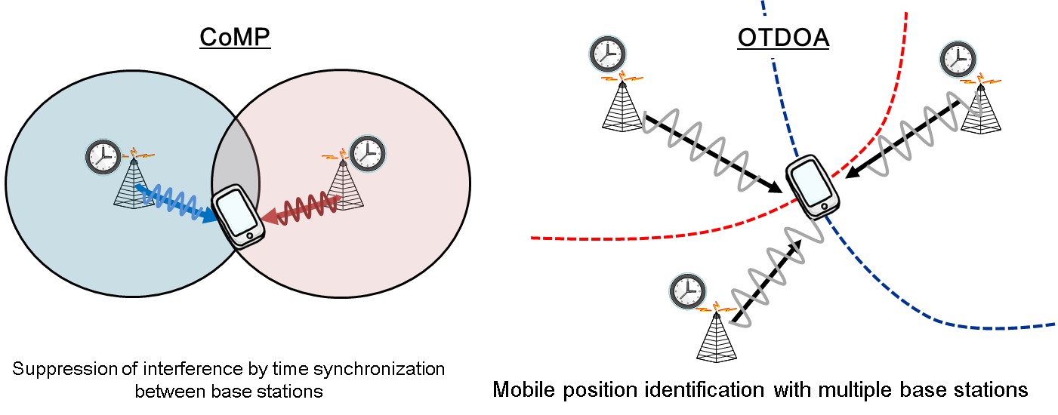
Figure 5 Mobile applications that use time synchronization

6.1 APT operator use cases

We interviewed APT operators regarding their services and interests based on these time-synchronous use cases, as shown in Figure 6. Interests in using TDD-LTE in 4G, 5G, and IoT/M2M are strong. Also, automatic driving and smart grids may have use of time synchronization. In addition, since frequency synchronization is also used for 3G mobile use and TDM services, such as telephone and leased lines, it is necessary frequency synchronization in the future as well as time synchronization.

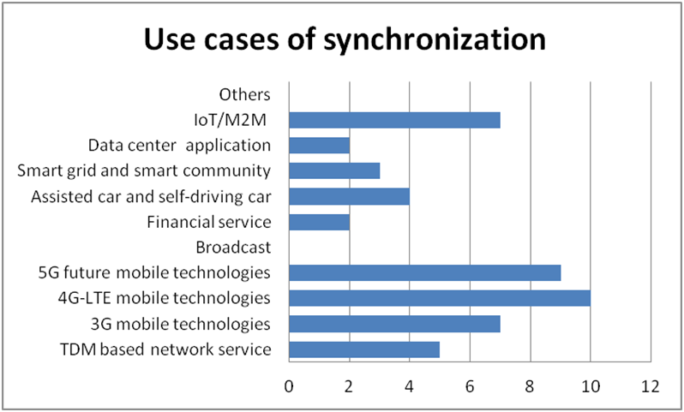
Figure 6 Questionnaire results (use cases)

7. Deployment of time-synchronization networks

There are two main architectures for constructing time-synchronization networks, as shown in Figure 7. One is to place a PRTC/T-GM close to the end application and receive and distribute time (Distributed GM). The other architecture is to aggregate the PRTC/T-GMs in the core network and transmit and distribute time using the PTP over the network (Network distribution). These network architectures are described in G.8275. The operator must consider the time-synchronization architecture according to the deployment cost and status of deployment of network devices in each country.

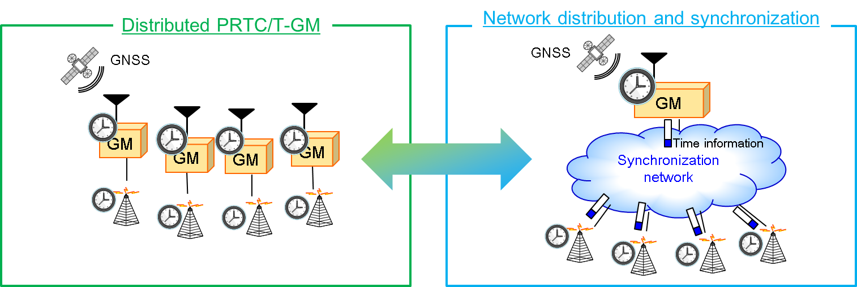
Figure 7 Architectures of time synchronization network

Distributed PRTC/T-GM
A distributed PRTC/T-GM includes a GPS antenna directly connected to a service area, device, or application that requires time synchronization and receiving and supplying UTC time information.

Network distribution and synchronization
In the case of distributing time information by the PTP in the network, the network profile is one of the important factors of network construction. ITU-T defines three time-synchronization-network profiles by using the PTP, as shown in Figure 8. One is Full Timing Support (FTS) in which all devices in the network correspond to the PTP. The second is Partial Timing Support (PTS) in which some devices in the network do not support the PTP. The third is Assisted-PTS (A-PTS). A-PTS is a profile that places a PRTC/T-GM near the end application and makes the PTS network a PRTC/T-GM backup.

The telecom operator can select a profile for the current synchronous network. In the case of FTS, since all devices must execute the PTP, it is necessary to provide a PTP function to a system already introduced or to renew a new device. It is necessary to select a profile for telecom operators based on the equipment-deployment situation and cost.

At same time, by simultaneously performing frequency synchronization by SyncE., time synchronization is possible with high accuracy and reliability. Also, when using EEC SyncE-compliant devices, it is necessary to migrate current legacy frequency-synchronization networks, such as SDH and ATM technologies, to packet-based networks. In SyncE, frequency synchronization cannot be achieved unless all devices on the frequency-synchronization path of the network support SyncE. Network operators need to consider the migration scenario of the new packet-based synchronous network while maintaining the existing TDM network.

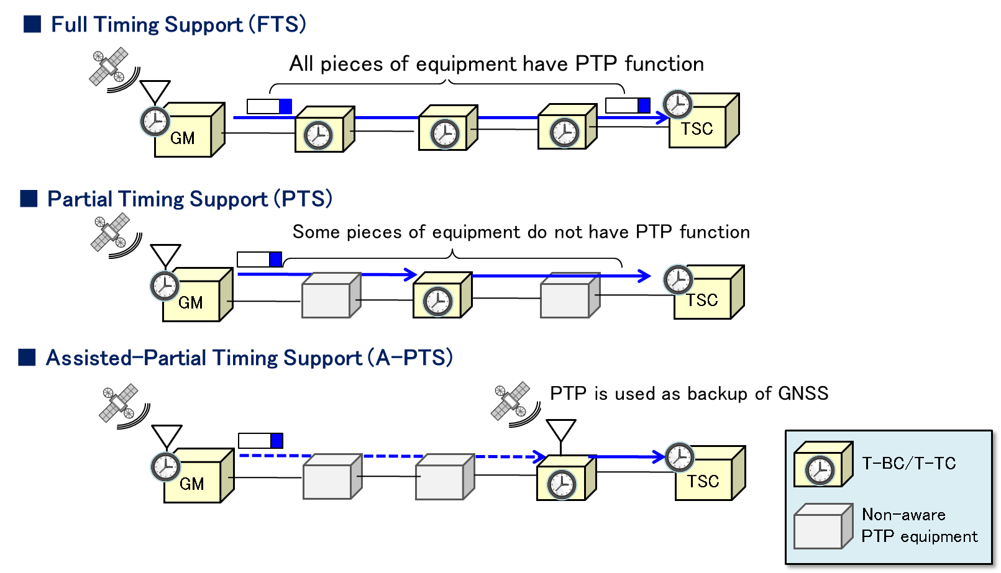
Figure 8 PTP telecom profile overview

7.1 APT operator solutions to synchronization-network deployment

Synchronization methods and network architecture
Synchronization adoption of each country, as shown in Figure 9, is achieved using distributed T-GMs (GNSS synchronization) and network distribution by using the PTP and SyncE. The reason for this is related to the introduction situation of the synchronous network in each country, cost, etc.

Generally, when the GNSS antenna is close to the end application, time information can be transmitted with high accuracy, but there is a problem with GNSS reliability. In distribution by the network, although it is possible to reliably distribute the time by reducing the number of T-GMs and using the redundancy, it is difficult to distribute time errors in the network including error factors such as link asymmetry and packet-delay fluctuation. Therefore, network design including time-synchronization accuracy must be done accurately. The synchronization-accuracy requirements are described in Chapter 8.

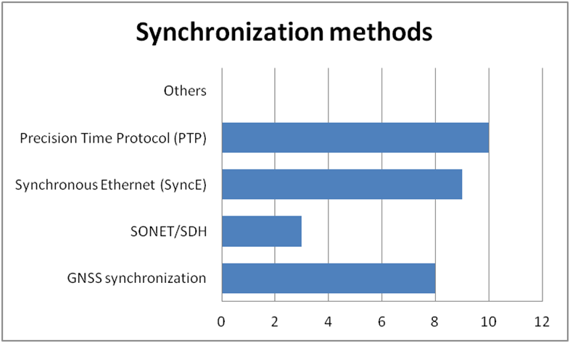
Figure 9 Questionnaire results (synchronization method)

Network migration
Responses concerning the migration of the synchronous network are shown in Figures 10 and 11. There are two types of APT operators, i.e., some operators having a legacy network, such as SDH based network, and others construct a new synchronous network. Therefore, maintenance and migration of a legacy network are not serious problems for some operators building a new time-synchronization network. There are many problems for operators who continue SDH-based services, such as migration and emulation of legacy-system transport technology. In accordance with the presence or absence of such migration, it is necessary to carefully select the architecture of a future synchronization network, e.g., by considering the utilization of the legacy synchronization network or constructing a new-time synchronization network independently of the legacy network.

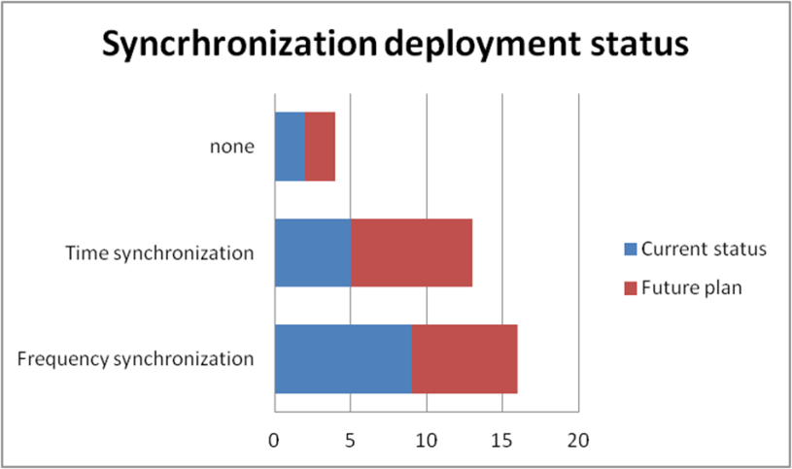
Figure 10 Questionnaire results (deployment status)

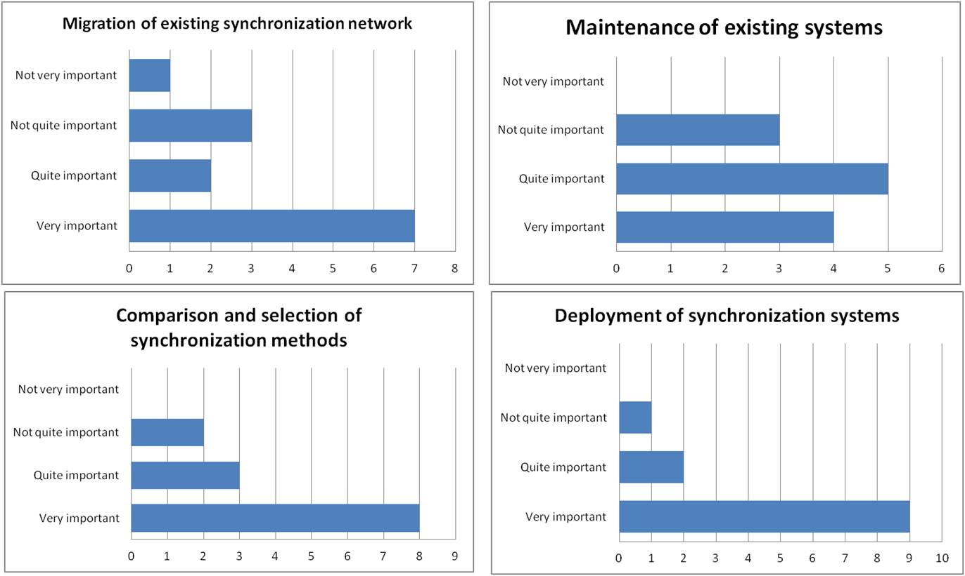
Figure 11 Questionnaire results (importance of maintenance and migration)

CAPEX and OPEX
The opinions of the APT operators on the cost of the synchronous network are shown in Figure 12. Many operators placed importance on the cost of constructing and operating a time-synchronization network. Such operators need to compare the equipment-deployment cost of PTS and FTS on the premise of the required time synchronization accuracy. Also, the time-synchronization device can be a T-BC or T-TC, and a T-TC can further reduce cost.

Some operators who did not emphasize cost believe that the cost of the synchronous device is not high compared with that of the main signal included in high-capacity networks.

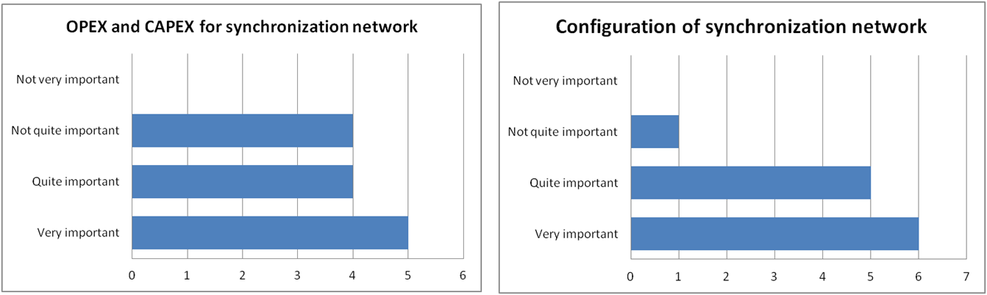
Figure 12 Questionnaire results (cost and configuration)

8. Requirements of synchronization accuracy

8.1 Time-synchronization accuracy

Time-synchronization errors of a network are defined by the accumulation of time errors from the T-GM/PRTC receiving GPS to the end application, as shown in Figure 13. A time-synchronization device has a time error per hop, and when a chain of time-synchronization devices are connected, time errors corresponding to the number of stages accumulate. ITU-T specifies the time error up to the end application with UTC and determined based the time-synchronization-accuracy level stipulated in G.8271, as shown in Table 2. Currently, G.8271 stipulates accuracy level 4 as up to 1.5 μsec. The time error is defined for each section in the network. For example, when achieving time synchronization of ± 1.5 μsec for end-to-end, the time error budget is ± 0.1 μsec in the PRTC/ T-GM section, ±1.1 μsec in the transport network section, and ± 0.4 μsec in the end application section. When a telecom operator interconnects with other operators and services, it is necessary to comply with this budget regulation. Regarding the accuracy requirements of levels 5 and 6 (1 μsec or less), it is necessary to embody 5G, IoT, and M2M applications, and is currently undefined in ITU-T.

Table 2 Time synchronization accuracy levels
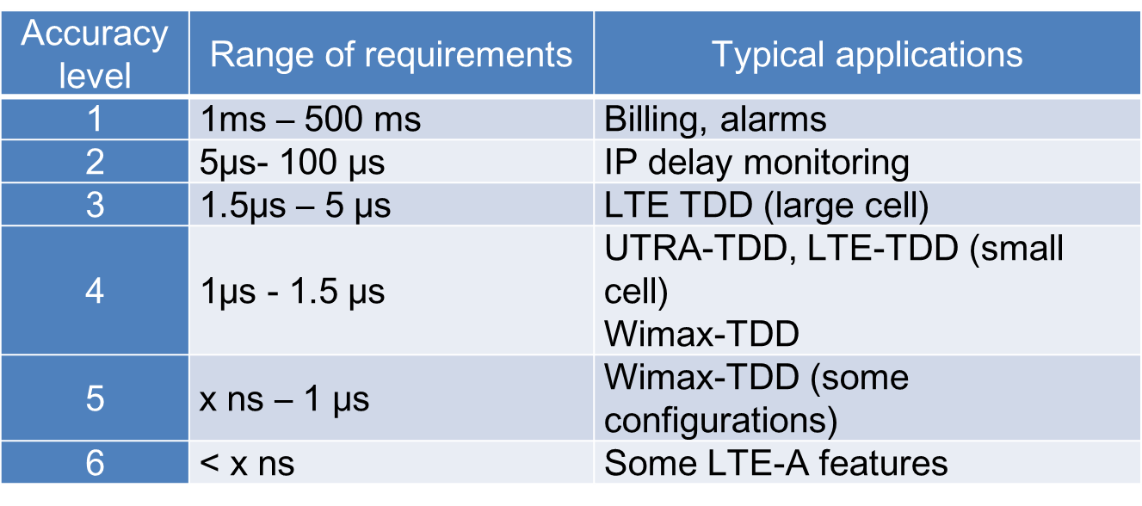

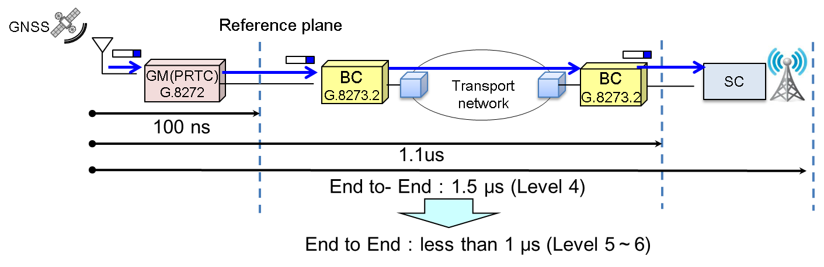
Figure 13 Definition of time synchronization accuracy

8.2 Frequency-synchronization accuracy

The frequency-synchronization requirement is defined by ITU-T G.811 and is achieved with a standard cesium oscillator placed in the network. Currently, 10⁻¹¹ is the standard of the frequency accuracy of PRC. Regarding the frequency synchronization used for time synchronization, high-precision frequency synchronization is required to maintain the time with high accuracy when the PTP packet cannot be received or when the reception of the GPS signal is stopped. High-precision regulation of a cesium oscillator was formulated in ITU-T G.811.1. Accuracy improved 10 times that of G.811, which is 10⁻¹².

8.3 APT operator requirements of synchronization accuracy

The time-synchronization requirement is 1.5 μsec in 4G-LTE assuming that there are many requirements from each APT country. Based on the information from 3 GPP and the discussion at ITU-T, the target synchronization accuracy of 5 G is currently set at 1.5 μsec, which is the same as that of 4G. This value should also be set as the first target in APT. The accuracy requirement for IoT/M2M is under discussion in ITU-T.

APT also requires 10⁻¹¹ to 10⁻¹² as the frequency-synchronization accuracy, which has already been specified by ITU-T.

9. Synchronization-network management

Synchronization-network management is high in importance regarding GNSS and network failures, which indicates that there are common problems. In ITU-T, some measures against quality deterioration of time synchronization are described in the ITU-T Recommendation, which is an effective method for APT operators.

9.1 GNSS errors

The following are various error factors in the reception of satellite signals (also shown in Figure 14). It is necessary to remove these errors.

i) Satellite error
The errors of the satellite section may include satellite-clock and ephemeris errors. These errors can be corrected by the navigation message received from the GNSS satellite.

ii) Propagation delay
Ionospheric delay and troposphere delay, which are the space through which the GNSS radio waves propagate, also affect the time-synchronization accuracy. Ionospheric delay can be corrected using the cosine model and installation of dual band receivers corresponding to the two frequency bands L1 and L2. In particular, when solar activity temporarily becomes active, i.e., when a solar flare occurs, the ionospheric delay increases and time-synchronization error may increase over a wide range.

iii) Antenna and receiver error
Multiple paths due to reflection and refraction of radio waves due to high-rise buildings are also affected on the ground section. This is because an error occurs in calculating the time when the delay time of the radio wave increases due to reflection. Therefore, when highly accurate time synchronization is required, it is necessary to install an antenna where there are no obstacles. Local jamming and spoofing are also problems, and several solutions with enhanced security against jamming are provided by some commercial products as countermeasures.

ITU-T summarizes the GNSS error factors and their countermeasures as technical report “TR-GNSS”.

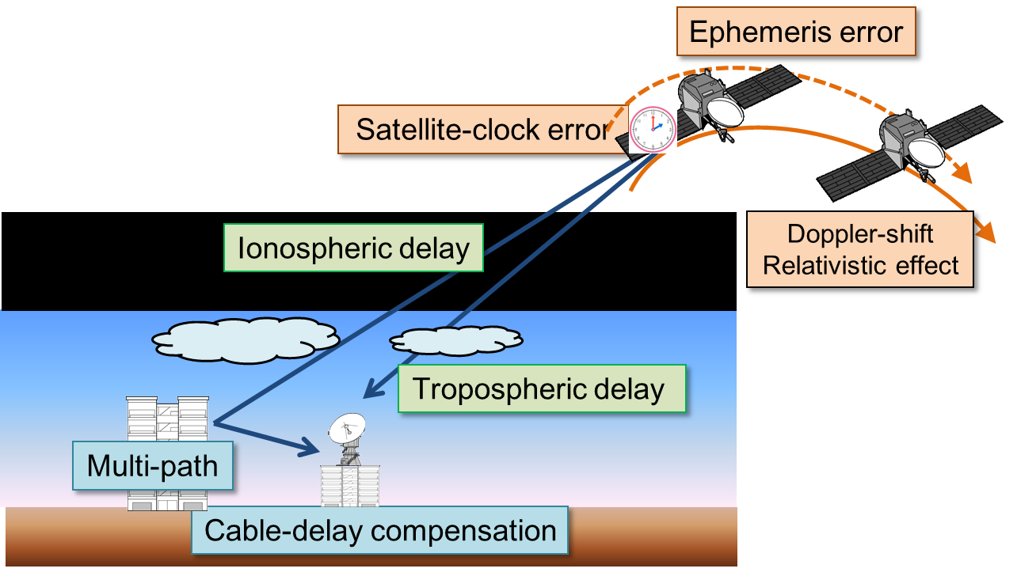
Figure 14 GNSS error factors

9.2 Time holdover of PRTC

When the time information cannot be received from the GPS, the T-GM/PRTC enters the time-holdover state. In this state, it is possible to accumulate time information at the normal condition status and maintain time synchronization for a certain period based on the information. If the frequency of the oscillator equipped in the PRTC at this time or the frequency signal is received from the PRC, the time is ticked with frequency precision. If there is no frequency assist and time information cannot be received from the GPS, the time may significantly deviate. For enhanced PRTC (ePRTC), which is the high-precision PRTC specified in G.8272.1, frequency input from an external autonomous clock (e.g. PRC) is indispensable, as shown in Figure 15. The time synchronization can be maintained for a long time by using the frequency from the cesium atomic clock installed at the same location. This Recommendation defines maintaining time synchronization within 100 ns for two weeks.

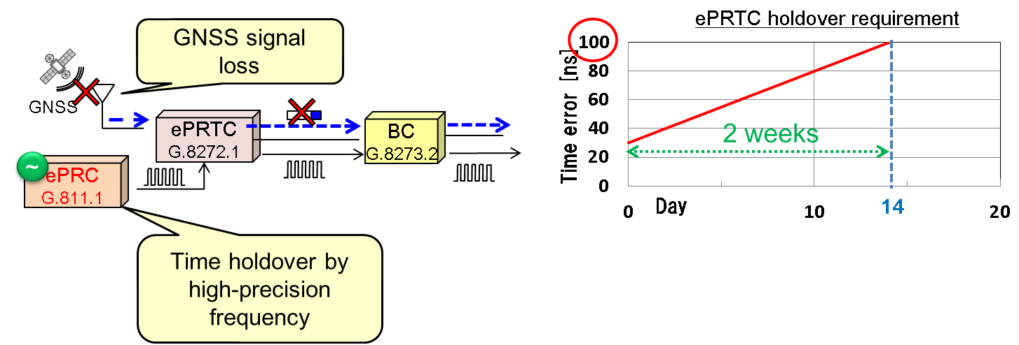
Figure 15 ePRTC holdover requirements

9.3 Network failure

PTP packets are lost due to packet collision and network congestion in the case of time holdover in a network. In the T-BC the time synchronization is maintained by frequency synchronization or an oscillator built into the T-BC. When the EEC is installed in the same place as the BC, the frequency-accuracy requirement is specified in G.8262. To improve the frequency-synchronization accuracy, we discuss the eEEC in ITU-T as a new Recommendation.

ITU-T also specifies scenarios in which the time- and frequency-synchronization paths are superimposed and in which they do not overlap. They are called congruent and non-congruent scenarios, respectively. Since the time- and frequency-synchronization paths are independent in the non-congruent scenario, the frequency can be supplied and the time synchronization can be maintained for a fixed time even if the time-synchronization path fails. Also, by installing multiple GMs in the network, the T-BC can be protected, as shown in Figure 16. The architecture concerning protection is described in G.8275.

As time and frequency synchronization cannot be continued due to fiber cutting or oscillator failure, redundancy is necessary. ITU-T summarizes synchronization-network management and maintenance requirements as Sync OAM. The monitoring-alarm items of a synchronization network are summarized in Sync OAM document, and the quality of the time synchronization network can be confirmed similar to the main signal system. Table 3 lists examples of alarms concerning time and frequency synchronization prescribed by Sync OAM. The alarms are defined so that the synchronous state, quality of the PTP offset, and fault conditions of the clock device are immediately detected to enable an operator to address them.

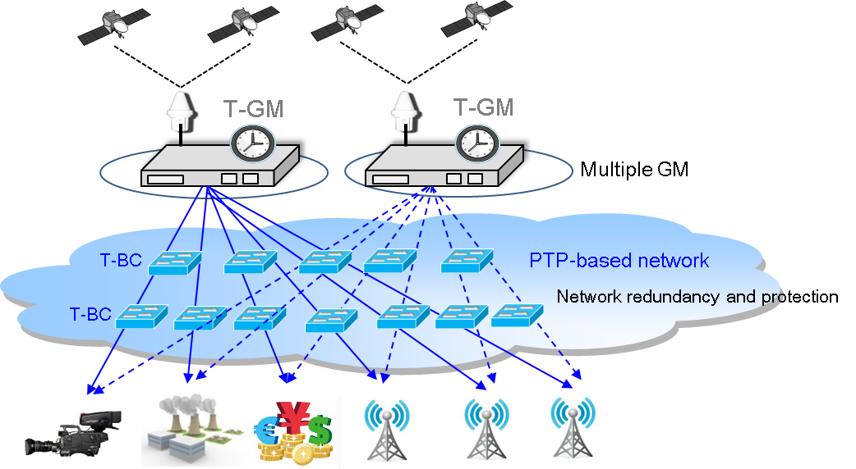
Figure 16 Redundancy of synchronization network

Table 3 Examples of synchronization alarms
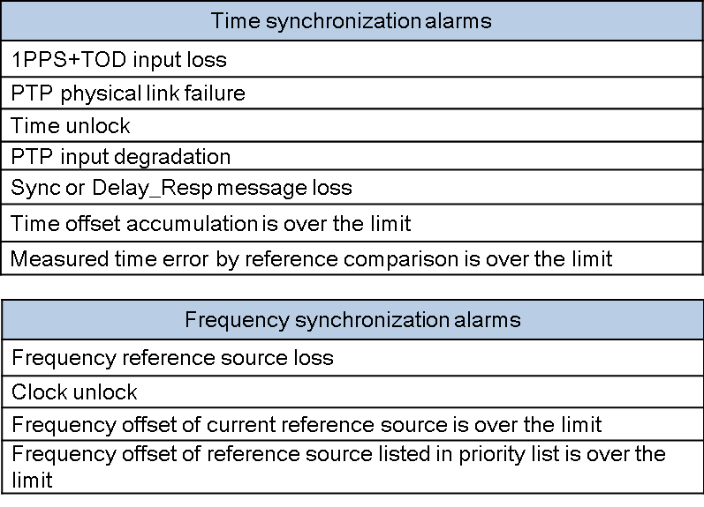

9.4 APT operator network-management requirements

Figure 17 shows the investigation results regarding the importance of synchronization-network management to APT operators. APT operators also have great interest in synchronization-network and synchronization-device failures and network management, and the Sync OAM prescribed by the ITU-T is useful information for APT operators regarding synchronous-network maintenance. It is considered that the same condition as ITU-T is applicable for failure cases and ePRTC holdover performance during failure. Fiber cutting, which is regarded as a problem in APT countries, should be avoided by devising network redundancy and time- and frequency-synchronization-path construction scenarios.

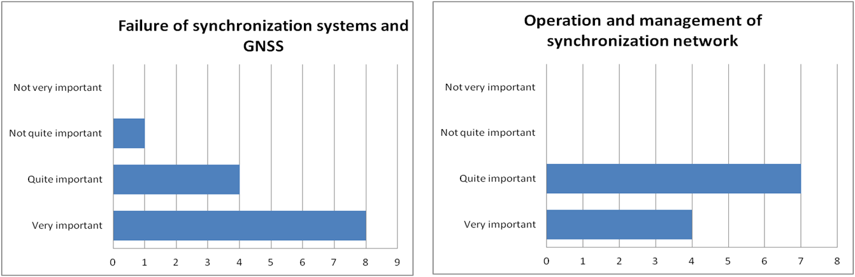
Figure 17 Questionnaire results (management)

10. Conclusion

High-precision synchronization technologies are important for supporting future network services such as 5G and IoT. We summarized the use cases and requirements for high-precision time-synchronization technologies discussed in ITU-T SG 15 and solicited requirements important to APT operators. It was found that APT operators agree on synchronization-accuracy requirement, synchronization-device-introduction scenario, and network-management discussed in ITU-T SG15. We hope to continue to smoothly deploy high-precision time-synchronization technologies by actively collaborating and sharing information with ITU-T SG15.

______________________

