APT REPORT

ON

BROADBAND RAILWAY COMMUNICATION SYSTEMS
USING RADIO OVER FIBER TECHNOLOGIES

APT/ASTAP/REPT-38
Edition: June 2019

Adopted by

31st APT Standardization Program Forum (ASTAP-31)
11 – 15 June 2019, Tokyo, Japan

(Source Document: ASTAP-31/OUT-10)

Contents

1. Introduction 3
2. Scope 3
3. References 3
4. Abbreviations and acronyms 3
5. System architecture 4
6. Proof-of-concept demonstration and discussion 6
7. Conclusion 17

Introduction
The aim of this contribution is to propose the radio over fiber (RoF) technologies for millimeter-wave radio signal delivery to the radio transceiver along the trackside over an optical fiber link for application of the broadband railway communication system (RCS) to a high-speed train.

Scope
This Report provides technical guidance to configure broadband RCSs between train and trackside using radio over fiber technologies which are a part of the wired and wireless seamless access communication systems. Design, configuration, experimental demonstration and deployment scenario of these technologies for the broadband RCSs are also addressed as examples.

References
[APT/ASTAP/REPT-03(Rev.4)]: APT Report (2015), Characteristics and requirement of optical and electrical components for millimeter-wave Radio on Fiber systems
[APT/ASTAP/REPT-04]: APT Report (2011), Technology trends of telecommunications above 100 GHz
[APT/ASTAP/REPT-11]: APT Report (2013), Wired and wireless seamless connections using millimeter-wave Radio over Fiber technology for resilient access networks
[APT/ASTAP/REPT-19]: APT Report (2015), Integration of Radio over Fiber with WDM PON for seamless access communication system
[APT/ASTAP/REPT-20]: APT Report (2015), RoF relay link for indoor communication systems
[APT/ASTAP/REPT-25]: APT Report (2017), Fronthaul/backhaul using millimeter-wave radio over fiber technologies
[ITU-T G.9803]: ITU-T Recommendation G.9803, Radio over fiber systems
[ITU-T G.694.1]: ITU-T Recommendation G.694.1, Spectral grids for WDM applications: DWDM frequency grid
[ITU-R F.2106] Recommendation ITU-R F.2106. Fixed service applications using free-space optical links
[3GPP TS 36.104 version 10.9.0 release 10]: Evolved Universal Terrestrial Radio Access (E-UTRA); Base Station (BS) radio transmission and reception
[IEC 61375] IEC 61375-1:2012 Electronic railway equipment – Train communication network (TCN) – Part 1: General architecture

Abbreviations and acronyms
This Report uses the following abbreviations and acronyms:
AWG Arbitrary waveform generator
AWGC Arrayed waveguide grating coupler
CU Central unit
CS Control station
DEMUX De-multiplexer
DBM Double balanced mixer
DSB Double sideband
DWDM Dense wavelength-division multiplexing
EDFA Erbium-doped fiber amplifier
E/O Electrical-to-optical converter
EVM Error vector magnitude
IF Intermediate frequency
IFoF Intermediate frequency over fiber
IQM Optical IQ modulator
LO Local oscillator
MUX Multiplexer
MZM Mach–Zhender interferometer-type intensity modulator
NBS Node base station
OCS Optical carrier station
ODC Operation direction center
ODN Optical distribution network
O/E Optical-to-electrical converter
QAM Quadrature amplitude modulation
RCS Railway communication system
RoF Radio over fiber
SMF Single-mode optical fiber
SSMF Standard single-mode optical fiber
SSB Single sideband
TLD Tunable laser diode
TLI Train local information
TS-RAU Track-side remote access unit
WDM Wavelength division multiplexing

System architecture
5.1 System overview
A network topology of a typical broadband RCS with a radio access system is shown in Fig. 1. A central unit (CU) located in an operation direction center (ODC) transmits, receives and manages all the communication signals. The signals are transmitted to an optical carrier station (OCS) via an optical fiber link; the OCS is worked as a repeater. Typical distance between the OCSs will be much longer than 10 km, whose length will be limited by an optical transceiver output power. A node base station (NBS), which is controlled by a control station (CS) directly connected to the OCS, is worked as a radio base station to transport the signal to track-side radio access units (TS-RAUs) located along a railway trackside. The network for connection between the NBS and TS-RAUs is a bus-type wireline network, a passive-single-star-type network, or point-to-point links to each TS-RAU. The TS-RAU is a frontend to transmit and receive radio signals from/to radio transceivers on the train. In general, distance between the TS-RAUs depends on a coverage size of the TS-RAU; for instance, the distance will be much longer than 1 km if microwave-band radio systems are implemented. In this configuration, an optical fiber network will be suitable for configuring network for between CS and NBSs, and between NBS and TS-RAUs for high-speed railway systems.

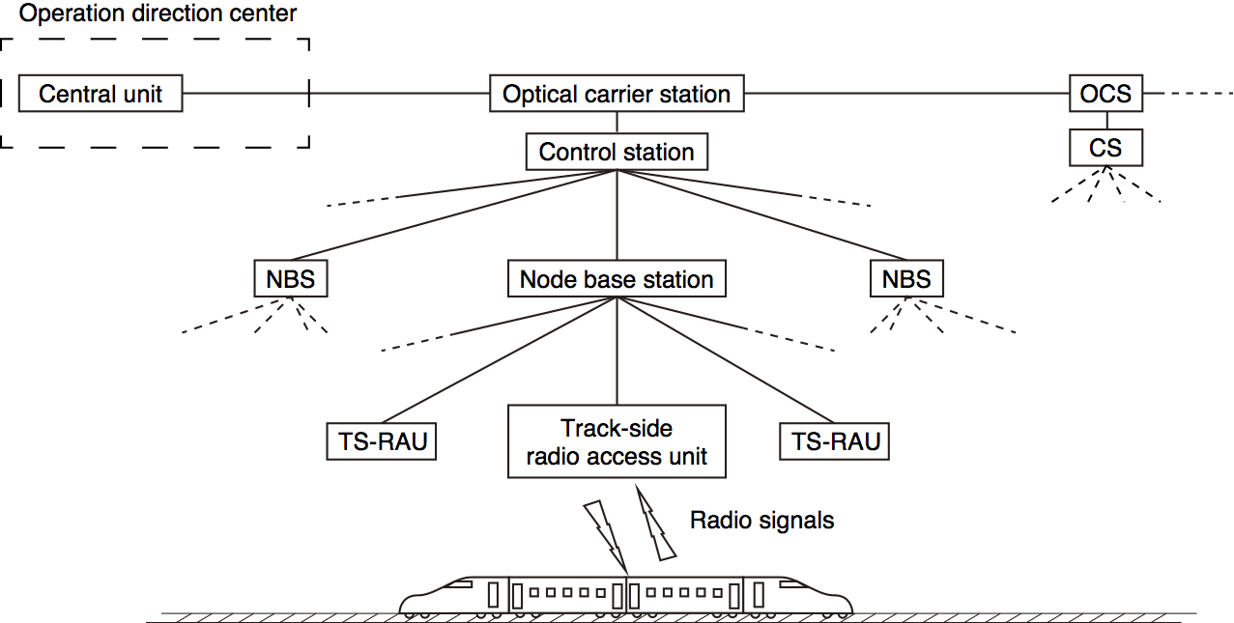

Figure 1 Conceptual diagram of a broadband RCS.

5.2 Concept of railway communication system using radio over fiber technologies
As following the RCS configuration described in section 5.1, a typical network configuration based on a wavelength-division multiplexing (WDM)-RoF system is shown in Fig. 2. The CU in the ODC, OCS/CS and NBS are mutually connected by an optical fiber network with analog or digital technologies. In general, as the distance between the OCS/CSs and OCS-NBS is longer than 20 km, a digital optical transceiver technology is suitable to be deployed with 10-Gb/s-based or 100-Gb/s-based optical transport systems.

In the optical fiber network between the NBS and TS-RAUs, a WDM-RoF-based single-star configuration is proposed with an optical dynamic routing feature. In the NBS, a RoF signal or an intermediate frequency (IF) signal for radio signal formation is generated to transport to the suitable TS-RAU, which is located along the trackside. A logical point-to-point link between the NBS and TS-RAU is assigned to an optical link between the optical transceivers in the NBS and TS-RAU, which have different wavelength channels. An active optical WDM routing technique should be implemented in the network between the NBS and the TS-RAUs for tracking the high-speed moving train. The ODC, where the CU is located, collects a train local information (TLI) including a real-time location and velocity of the trains. Each NBS can share this information via an optical network through the CU and OCS/CSs.

Two techniques have been proposed for an optical dynamic routing in the broadband RCS. The first one is to use a passive WDM multiplexer (MUX) and de-multiplexer (DEMUX), and a wavelength channel of the optical transceiver in the NBS is switched to the suitable channel because the assigned wavelength channels of the TS-RAUs are fixed. The second is to use an active WDM router. The wavelength channels are fixed for the optical transceivers in the NBS. The WDM router operated as the WDM MUX/DEMUX switches the optical output port connected to the TS-RAU. In this case, the wavelength channels in the TS-RAUs are also switched simultaneously. In the optical dynamic routing techniques in the network describe above, the logical point-to-point link between the NBS and the suitable TS-RAU for signal delivery can be assigned, and the NBS additionally controls the optical path to the TS-RAU using the predicted train location by the TLI.

The prediction-based signal delivery architecture helps realize a hand-over-free radio access between the NBS and train. In typical radio access system such as a mobile communication, prospected location of the mobile terminal cannot be predicted because a cell configuration is spread to two-dimensional area and detailed information of the location is not provided by the terminal and central unit. Therefore, a hand-over process is required when the mobile terminal is moved to the other cell. On the other hand, in the train system, because a train exactly stays on the railway tracks, the cell configuration for such radio system should be configured one-dimensional located cells, so-called “linear cell.” In addition, the train location is easily predicted by the TLI stored in the ODC. Therefore, the communication signal can be formed in the NBS and be delivered to the next TS-RAU in advance. Due to the broadband signal transmission capability of the RoF systems, the microwave and millimeter-wave radio spectrums can be transmitted to and received from the train.

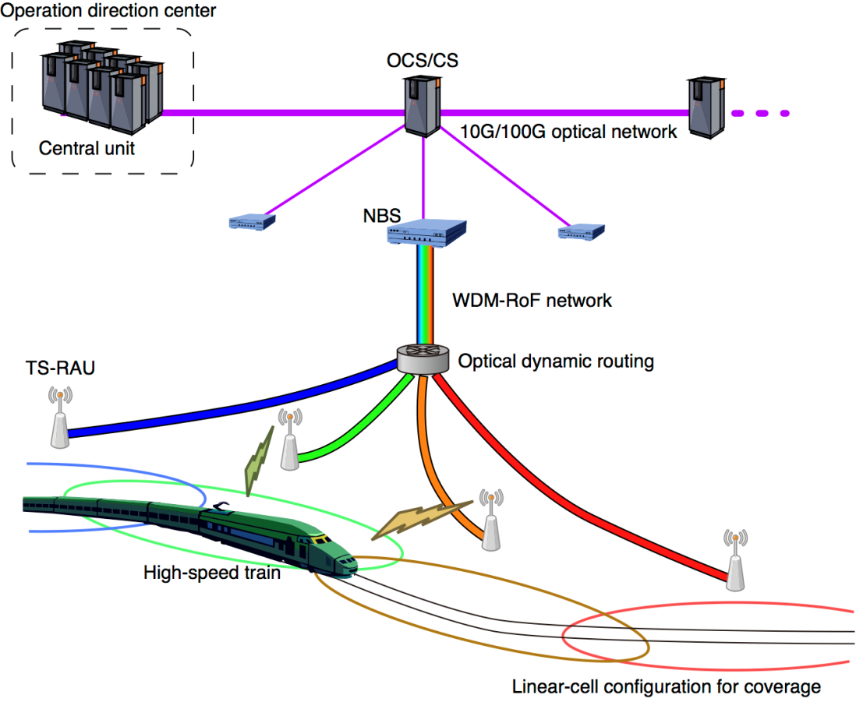

Figure 2 Broadband RCS employed with WDM-RoF and millimeter-wave systems between train and trackside.

5.3 System specifications
This section provides the system specifications of the broadband RCSs, in particular, those of the radio over fiber link between TS-RAU and NBS which is a part of the communication link between train and trackside.

Proof-of-concept demonstration and discussion
Modulation frequency is a key parameter for generation of optical signals in an RoF manner. This frequency could be decided by interface specifications of TS-RAUs for signal reception and conversion to millimeter-wave signals. Moreover, transmission impairments of optical fiber networks is also a key for the specifications. In general, an optical fiber has chromatic dispersion characteristics, which provides refractive index changes in wavelengths. Particularly in double-sideband (DSB) modulation signals, transmission over an optical fiber provides relative temporal delay between lower-sideband and upper-sideband components. In optical-to-electrical conversion, converted signals between carrier components and each sideband component has also temporal delay at a same frequency due to phase changes by the chromatic dispersion of the optical fiber, and therefore, an amplitude of the signal combined in a phasor space has dependence of the relative delay; a combined signal could be vanished at specific transmission length of the fiber. In a standard single-mode optical fiber (SSMF), a chromatic dispersion is typically 17 ps/nm/km, which means the relative delay is 17 ps with a wavelength separation of 1 nm after a transmission of 1-km-length optical fiber. Figure 3 shows calculated RF power throughput of 2-GHz and 15-GHz DSB modulation signal. It should be noted that a transmission loss of 0.2 dB/km is also evaluated in the figure.

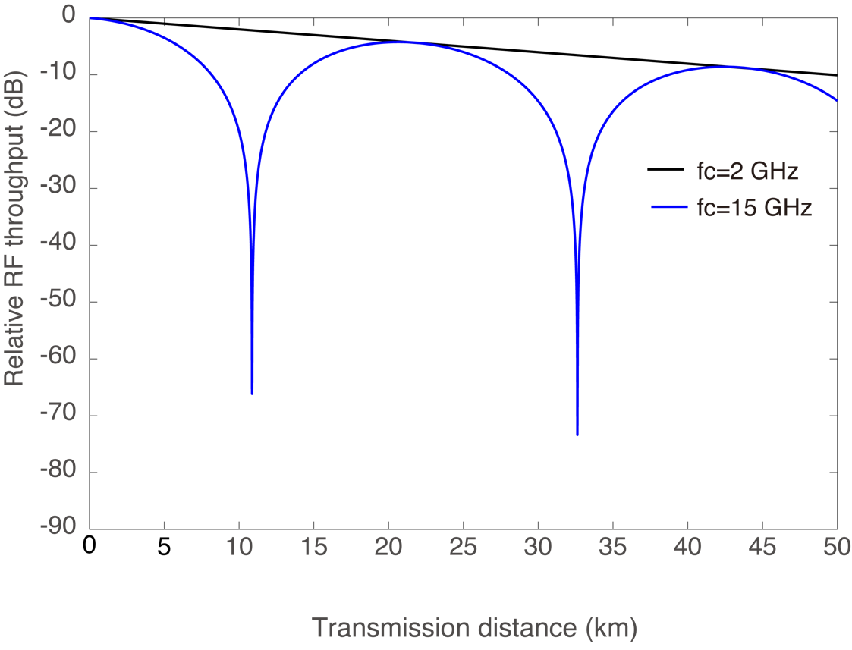
Figure 3 RF power throughput of 2-GHz (black) and 15-GHz (blue) DSB signal after the transmission of SSMF.

A 2-GHz DSB signal has a dominant loss of the throughput of the transmission loss; there is no effect on the chromatic dispersion in the optical fiber transmission up to 50 km. On the other hand, in 15-GHz DSB signals, the chromatic dispersion causes specific dips of the throughput at approximately 11 GHz and 33 GHz in the figure. This indicates that IF signal generation and distribution at higher frequencies could not be suitable for the RSTT system that the TS-RAU would be deployed at every 1 km along with tracksides. However, low-frequency carrier signals has relatively high fractional bandwidth rather than the high-frequency carrier scheme; it has difficulty on conversion circuits from optical to electrical signals in a TS-RAU under high fractional bandwidth configuration. This report discusses two cases: broadband IF signal generation and a single-sideband (SSB) modulated-based IF signal generation.

6.1 Broadband IFoF configuration
As shown in Figure 3, 2-GHz-carrier DSB modulation has no effect on the chromatic dispersion of the optical fiber with a transmission distance up to 50 km. However, a fractional bandwidth is achieved 50% when the modulation bandwidth of the data is 1 GHz; it is not matched to conventional IFoF systems. Therefore, evaluation of the quality of generated and distributed signals should be discussed in such broad-bandwidth IFoF systems [1].
Figure 4 shows a schematic diagram of a broadband IFoF system at low carrier frequency range. In the IFoF signal domain, an electrical-to-optical converter (E/O) driven by an arbitrary waveform generator (AWG), which forms an orthogonal frequency division multiplexed (OFDM) signals at a center frequency of 2 GHz with a sampling frequency of 1 GHz using 16-ary quadrature amplitude modulation (QAM). An IFoF signal is transmitted over an SSMF, and then, an electrical-to-optical converter (O/E) regenerates the 2-GHz IF signal. In 90-GHz conversion, a double-balanced mixer (DBM) operated by a local oscillator (LO) at a frequency of 90 GHz performs a frequency up-conversion from 2 GHz to 92 GHz.

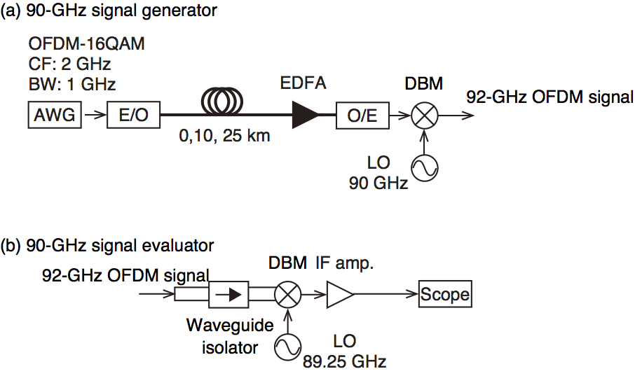
Figure 4 Schematic diagrams of (a) broadband IFoF signal generation, transmission and its conversion to 90-GHz signals, and (b) signal evaluator for 90 GHz signals.

For evaluation of the 90-GHz signals, the evaluator shown in Figure 4(b) is configured. Incoming 90-GHz signal is passed through a waveguide isolator to a DBM operated by 89.5-GHz LO. A frequency down-converted signal from 92 GHz to 3.75 GHz is amplified by an IF amplifier, and then, a digital storage oscilloscope captures and analyzes the signals. Obtained optical spectrum after the E/O is shown in Figure 5(a). The detail of the DSB modulation at 2 GHz could not be obtained owing to limitation of the resolution bandwidth of 0.2 nm of an optical spectrum analyzer. The occupied bandwidth is less than 0.1 nm. Achieved spurious suppression ratio is achieved 40 dB, and this is enough for signal conversion in the millimeter-wave band.

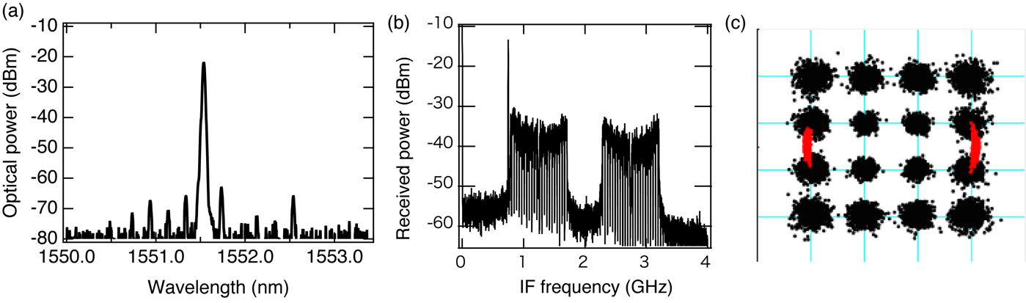
Figure 5 (a) Obtained optical spectrum of 2-GHz DSB signal, (b) received IF spectrum obtained just before an oscilloscope in the evaluator, and (c) demodulated constellation maps of OFDM-16QAM under a 10-km-long SSMF transmission configuration.

Figure 5(b) shows an IF spectrum at the receiver. It should be noted that the DSB signal is generated in the 90-GHz signal generator: lower-sideband at 88 GHz and upper-sideband at 92 GHz with a 90-GHz carrier component. After heterodyning at the LO of 89.25 GHz provides the lower-sideband at 1.25 GHz as an image component, the carrier component at 0.75 GHz, and the upper-sideband at 2.75 GHz, respectively: 92-GHz signal is down-converted to 2.75 GHz. The obtained constellation map of the OFDM-16QAM is also shown in Figure 5(c). Obtained EVM is achieved 11%. It should be noted that red symbols indicate the binary phase-shift-keying signal in preambles of a packet frame. Figure 6 shows variation of constellation maps with several lengths of the SSMF. There is no drastic change on obtained constellation maps and EVMs under the transmission distance up to 25 km. Therefore, the broadband IFoF configuration, which has a fractional bandwidth broader than 25%, is a promising candidate for the broadband signal transmission over the optical fiber network.

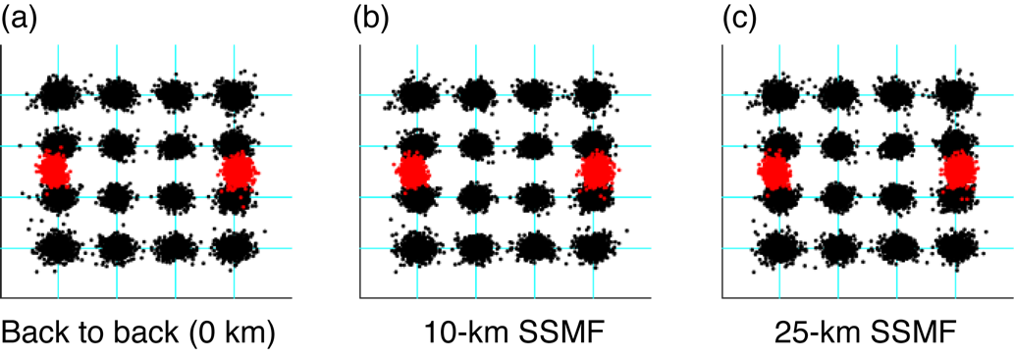
Figure 6 Obtained constellation maps of OFDM-16QAM under (a) optical back-to-back (0 km) configuration, (b) 10-km-SSMF transmission and (c) 25-km-SSMF transmission configurations.

6.2 Single-sideband-modulation-based IFoF configuration
To mitigate a chromatic dispersion of an optical fiber, an SSB signal modulation is another candidate. This is because two optical signals resulting an RF signal have no interference in the optical-to-electrical conversions. We have two methods for formation of the SSB signal: DSB modulation with an optical bandpass (notch filter) and a direct modulation using the modulator including dual-drive Mach–Zhender interferometer-type intensity modulator (MZM) and an optical IQ modulator (IQM). In the former case, unnecessary modulation components are suppressed by the optical filter after the conventional modulation. In the case, there are issues on the modulation frequency. In general, conventional optical filters have a pass-(notch-) bandwidth of approximately 10 GHz, and thus, the optical signal should be modulated at a frequency larger than 10–20 GHz. In addition, a center frequency of the filter should be stabilized by tracking the wavelength or setting the filter in constant thermal bases. The instability directly affects the quality of the signal as well as the throughput.
The modulator technique for direct generation of the SSB is an easier way than the filter insertion in implementation. In principle, the dual-drive modulator as well as the IQM can provide the SSB signal with two electrical inputs, whose phases have 90-degree differences. These input signals are generated by numerical Hilbert transformer in a digital signal processor in a transmitter side or an electrical 90-degrees hybrid coupler with an input signal. For the RoF and IFoF applications, the electrical hybrid coupler is capable for preparation of the input signals.
Figure 7 shows a concept block diagram of the SSB signal generation for the IFoF configuration. The RF signal input into the 90-degree hybrid coupler to split two signals: sine and cosine components. The optical IQM is operated with the two signal under a bias condition: quadrature transmission point for nested (I and Q) MZM as well as for the main MZM. Resultant optical signal contains a carrier component and one sideband: SSB modulation. The slope (positive or negative) as a bias set point in the main MZM can change the suppressed sideband (upper or lower).

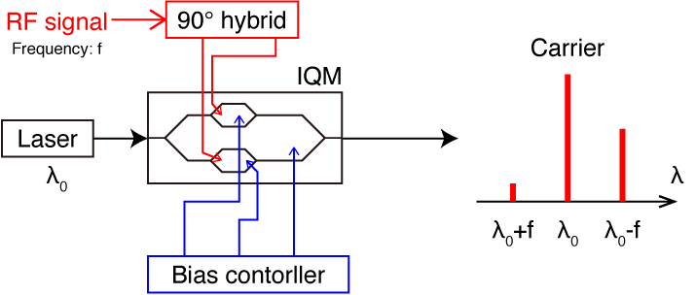
Figure 7 Conceptual diagram of the SSB modulation using the IQM

Figure 8 shows obtained optical spectra of the SSB signal at a input frequency of 15 GHz. Launched signal as an RF signal is modulated with 1-Gbaud QPSK (rectangular pulse shape). Complete suppression of unnecessary upper-sideband signal is performed, and resultant suppression ratio is achieved larger than 30 dB. It should be noted that the bias set points can be adjustable for optimization of the carrier-sideband power ratio using the IQM. In principle, for high RF throughput, the ratio should be set as small as possible. The bias-optimized spectrum is also shown in the figure. Resultant signal to noise ratio of the sideband is improved approximately 5 dB; however, the suppression ratio of the unnecessary sideband is degraded.

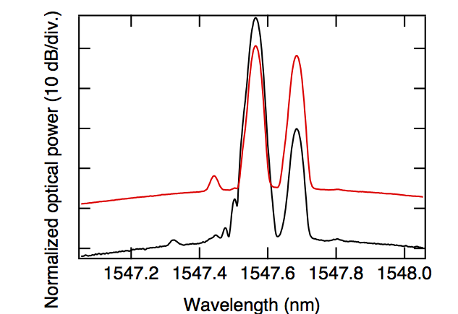
Figure 8 Optical spectra of the SSB signal under (black) conventional SSB and (red) optimized bias conditions.

Regenerated electrical spectra by the SSB optical signals are shown in Fig. 9. 1-Gbaud rectangular pulse has a bandwidth of 10 GHz with a sinc function. Clear main lobe components at a center frequency of 15 GHz are shown with adjacent side lobe components. Obtained signal to noise ratio is achieved approximately 20 dB and 30 dB for optimized and unoptimized bias conditions, respectively. Demodulated constellation maps are also shown in the figure. Resultant error vector magnitude (EVM) are approximately 17% and 22% for optimized and unoptimized bias conditions, respectively. These results indicate the SSB modulation by the IQM can be useful for the IFoF system and optimized bias operation will enhance the signal quality.

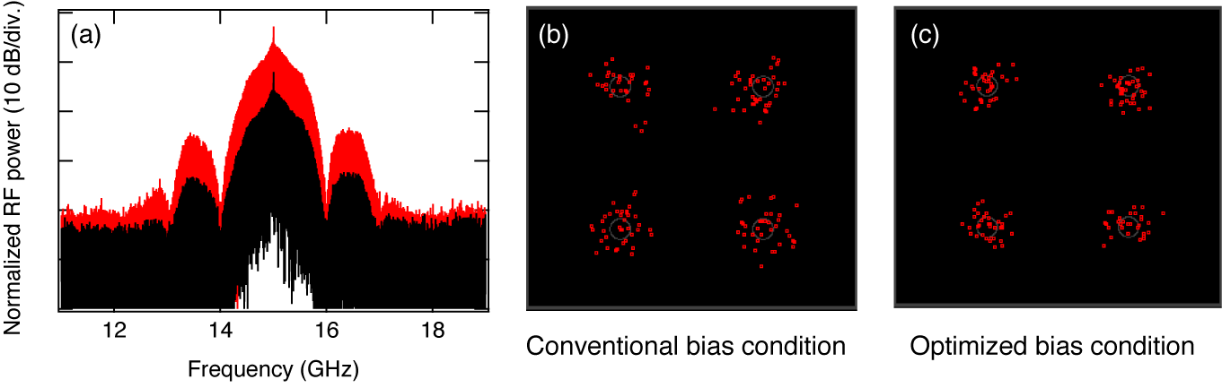
Figure 9 (a) Observed electrical spectra under (black) conventional and (red) optimized bias conditions. Demodulated constellation maps for (b) conventional and (c) optimized bias conditions are also shown.
6.3 Single-sideband-modulation-based RoF configuration
For configuring the high-spectral-efficient network, there is a tradeoff relationship between the IF frequency and a number of WDM channels. However, millimeter-wave RoF configuration helps realizing simple configuration and frequency flexibility in the TS-RAU. Therefore, the system based on the RoF should be also discussed.
Figure 10 shows an optical spectrum of the SSB-IF signal (LD1 and IF) and an optical reference provided by the other free-running laser (LD2) [2]. The IF signal is generated at a frequency of 14.08 GHz with a modulation scheme compliant to IEEE802.11ad, as transmitted from an NBS. The optical reference signal with a frequency separation of approximately 97 GHz from the SSB sideband component is also transmitted from the NBS with the same fiber. At the TS-RAU, high-speed PD with a frequency response of 100 GHz converts this RoF signal into the 97-GHz millimeter-wave signal directly. The broadband PD also regenerates the 14.08-GHz IF signal at the output; however, the insertion of the electrical filter after the PD can suppress this unwanted component to irradiate the millimeter-wave to the air.

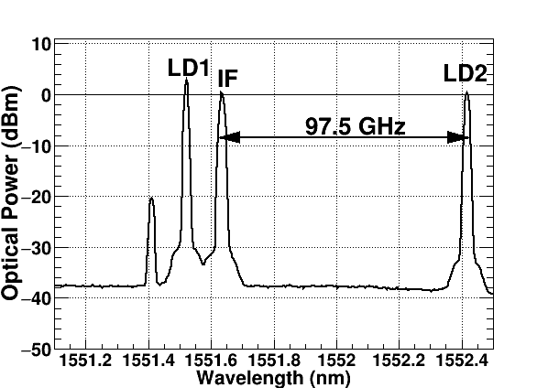
Figure 10 Optical spectrum of the RoF signal.

Figure 11 shows the demodulated constellation maps at 97 GHz for OFDM-16QAM and OFDM-64QAM, which waveforms are compliant with the IEEE802.11ad packet format. It should be noted that the results are obtained under a back-to-back configuration in the millimeter-wave domain. Observed EVMs are within 8% less than the limitation of the transmitter EVM. Therefore, the RoF system is also available for the RCS.

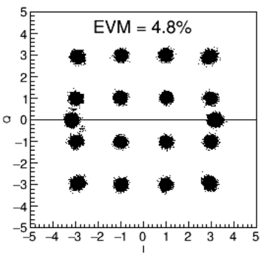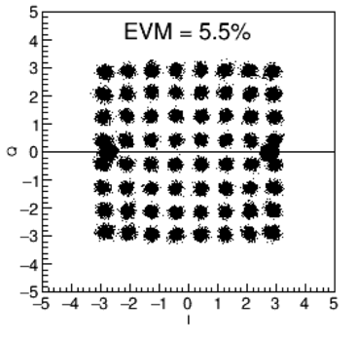
Figure 11 Observed constellation maps for (left) OFDM-16QAM and (right) OFDM-64QAM, which signal forms are compliant with IEEE802.11ad, at 97.5 GHz.

The results also show availability of the laser as a LO shown in Fig. 4 (Fig. 12). In principle, an electrical LO and mixer has a limited bandwidth: for instance, frequency tunability within 10% of the fractional bandwidth. However, broadband PD with a frequency response of DC–100 GHz can convert the RoF signal in microwave to millimeter-wave bands directly, and therefore, broadband frequency-tunable TS-RAU over the radio bands can be configured in 40 GHz, 60 GHz, and 100 GHz simultaneously. It should be noted that wavelength (optical frequency) deviation of the laser has still large; for instance, 1-kHz-linewidth fiber laser has a deviation of 100 kHz by thermal fluctuation effect. To follow radio regulations, selection and frequency-locking feature of the lasers should be implemented.

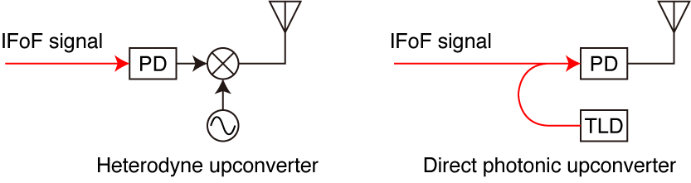
Figure 12 Frequency conversion configuration in TS-RAU based on (left) electrical heterodyne technique and (right) photonic heterodyne technique.

6.4 IF signal transmission over WDM-RoF configuration
For distribution of the RoF signal to remote TS-RAUs using limited number of optical fiber cables, WDM-based configuration should be implemented. Moreover, in such millimeter-wave TS-RAUs, a cell size for coverage by each TS-RAU is also limited: typically, several km even in longitudinal axis of the cell shape. When an NBS is set at every 30–50 km, a number of WDM channels should be at least 30. G In general, an optical C-band (wavelength of 1530–1565 nm) with 100-GHz-spacing grid followed by ITU-T Recommendation G.694.1 has approximately 44 channels, and therefore, it is insufficient for this application. Thus, high spectral-efficient RoF signal generation and distribution is indispensable. In the Section 6.1 and 6.2, IFoF configuration with occupied frequency-bandwidth less than at most 50 GHz is described; this configuration is suitable for gathering many WDM channels.
Figure 13 shows a schematic of DWDM-based IFoF signal distribution system. In typical, all the WDM transceiver unit is combined by an arrayed waveguide grating coupler (AWGC) to employ a single-core SMF for transmission and distribution in a transmitter side. In an optical distribution network (ODN), the WDM signals are transmitted and split by an AWGC to each remote TS-RAU, which is assigned at a unique wavelength in the WDM channel. The transceiver in the TS-RAU has a “color-less” reception feature implemented with no optical filter for suppression of unwanted WDM channels.
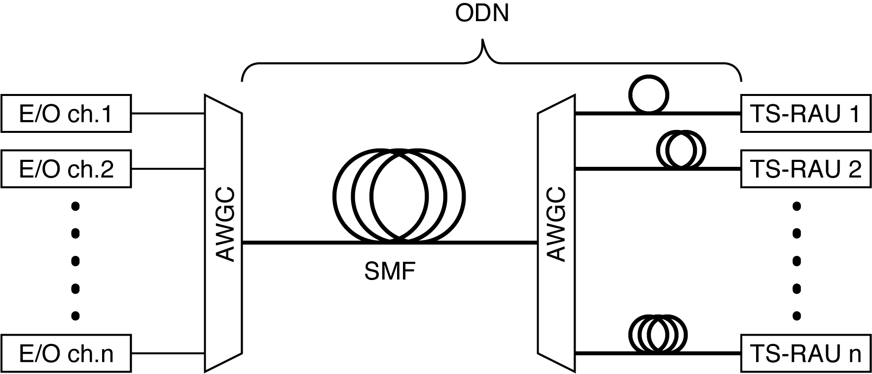
Figure 13 Concept block diagram of WDM-based signal distribution network.

Figure 14 shows a proof-of-concept demonstration of 10-channels DWDM system followed by 50-GHz DWDM grid, whose possible number of channels in the optical C-band is 88, under a broadband IFoF configuration, which has a fractional bandwidth larger than 25%. For proof-of-concept evaluation, WDM signals are generated under cyclic configuration; odd and even channels have same waveform to reduce the number of demonstration equipment and to suppress the interference effect between adjacent channels. Received signals are evaluated by the IFoF signal directly and 90-GHz up-converted signal as similar to Section 6.1. It should be noted that the AWGC used in the demonstration has 9 channels in output ports.
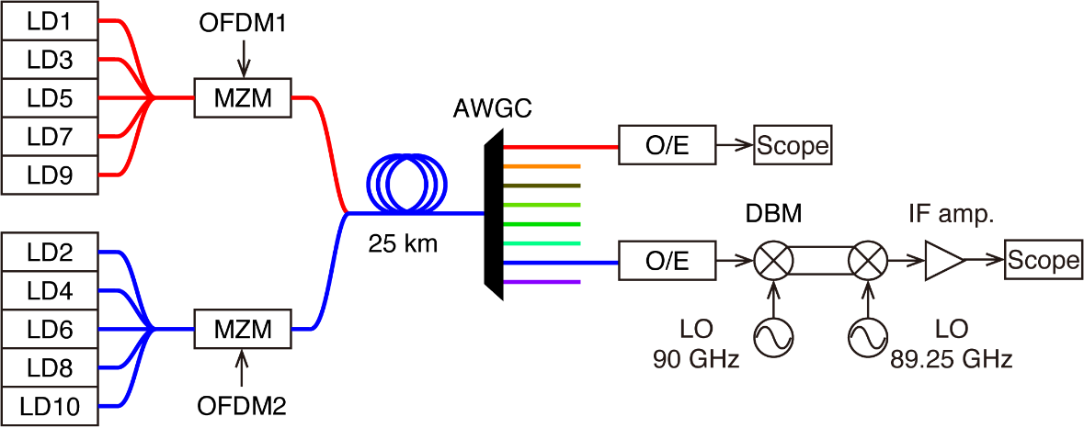
Figure 14 Schematic diagram of proof-of-concept demonstration of 10-channels WDM-IFoF network.

Obtained optical spectra are shown in Figure 15. Occupied spectrum bandwidth is approximately less than 0.2 nm, which corresponds to 25 GHz. Therefore, this configuration can be followed by 50-GHz WDM grid: totally 176 channels available in the optical C-band. Demodulated 90-GHz OFDM signals are successfully obtained in Figure 16, and therefore, the WDM-IFoF network configuration is a promising solution to distribute the radio signal with high optical spectral efficiency.
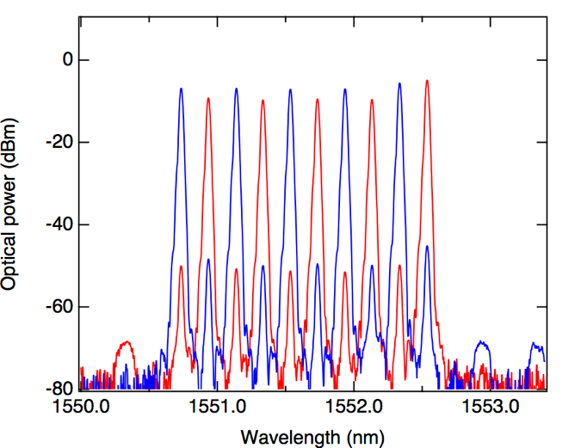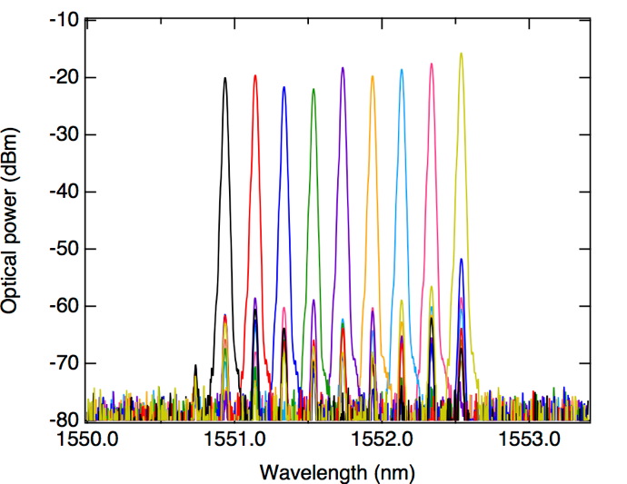
Figure 15 Optical spectra of (left) 10-channels WDM signal before the transmission and (right) split 9 signals after the AWGC.
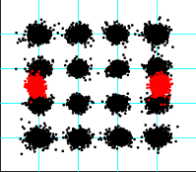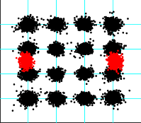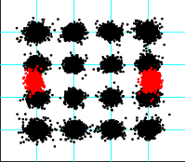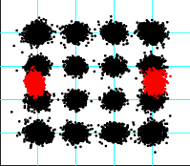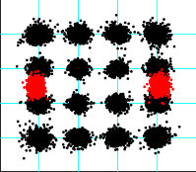
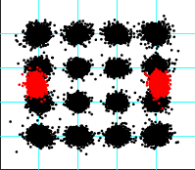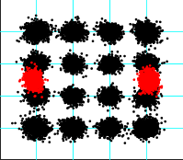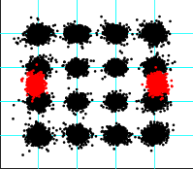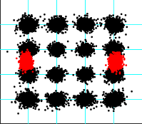
Figure 16 Demodulated constellation maps of 9 WDM channels with the waveform of OFDM-16QAM.

For the WDM-SSB signal transmission, four wavelength channels are used for proof-of-concept demonstration. Configuration of the evaluation system is shown in Fig. 17. Four WDM sources (channel separation of 50 GHz) are launched into the IQM operated at an RF frequency of 15 GHz with 1-Gbaud 16-QAM signal. The modulated signals are transmitted over the SMF with several meters, and then, are input to the AWGC for wavelength channel separation. The output signals are input into the O/E converter and are captured by a four-channel oscilloscope to demodulate simultaneously.

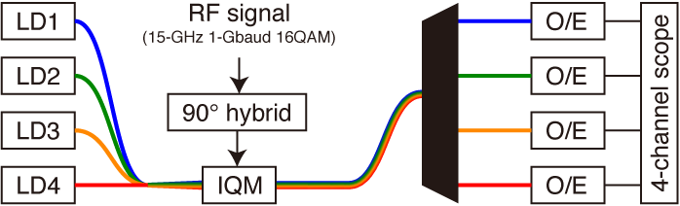
Figure 17 Experimental setup for 4-channel WDM-SSB signal transmission

Figure 18 shows an optical spectrum of the four channels signal obtained just before the AWGC. Clear SSB signals with a separation of 50 GHz, which corresponds to 0.4 nm in the wavelength, are obtained. The suppression ratio between carrier and unnecessary sideband components is achieved approximately 25 dB. No wavelength dependence is shown in the figure, and therefore, the IQM-based SSB generation is insensitive to the input wavelengths.

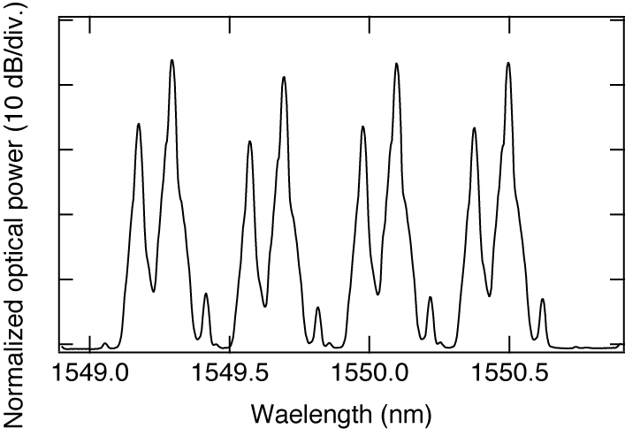
Figure 18 Optical spectrum of four-channel WDM SSB signals obtained at the input port of the AWGC.

Figure 19 shows resultant constellation maps demodulated by the offline digital signal processing with the signal captured by the oscilloscope. Clear symbol separation with the EVM less than 8% are obtained with post equalization processes. Therefore, the WDM-SSB configuration is also available for the WDM IFoF system as well as the broadband IFoF configuration describe above.

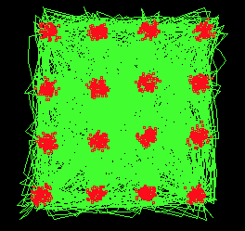
Figure 19 Obtained constellation maps of 4-channel WDM SSB signals with 15-GHz 1-Gbuad 16QAM.

6.5 Optical dynamic routing
Optical path routing technique is indispensable to deliver the signal to the TS-RAU near the train car adaptively. For realization of uninterrupted communication systems, a fast switching speed is a key factor. Moreover, scalability of the routing paths is also important to receive many TS-RAUs installed along the railway track. From the viewpoint, two fundamental techniques are available for the router: WDM and optical switch. The details are described as follows.

6.5.1 WDM routing
Configuration of wavelength switchable IFoF network is shown in Fig. 20 using an ultra-fast wavelength-tunable laser diode (TLD). In the NBS, a routing controller deciding an optical path from the NBS to suitable TS-RAU provides a wavelength channel information to the TLD, and then, the TLD changes its irradiating wavelength. The seed signal is launched into an optical modulator (MZM or IQM) operated by an IF signal. A generated IFoF signal is transmitted over an optical fiber. As the AWGC works as a wavelength channel splitter to deliver the IFoF signal to the TS-RAU.

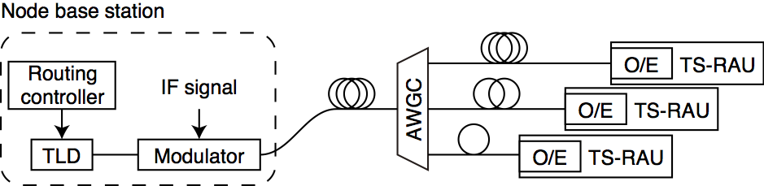
Figure 20 Concept of fast wavelength routing using wavelength-tunable laser

The IFoF signals with different wavelength channels are shown in Fig. 21. The IFoF signal is provided under the SSB configuration using the IQM operated at a center frequency of 15 GHz with 1-Gbaud QPSK. In the system, the bias condition is the same as the conventional SSB modulation, not optimized configuration. Spurious suppression ratio of the signals is larger than 40 dB, and is enough for QPSK as well as 16QAM modulation. Relative intensity noise at a wavelength of 1550.5 nm in 1550.1-nm signal is obtained, however, it is negligible for the signal quality because the suppression ratio between the noise component and wanted sideband component is larger than 30 dB.

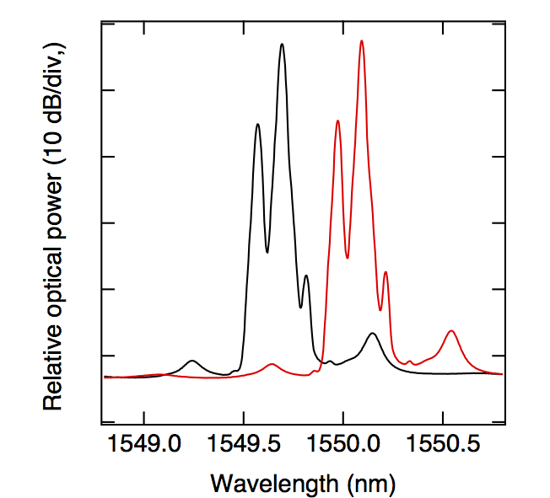
Figure 21 Optical spectra of wavelength-switched signals for (black) 1549.7 nm and (red) 1550.1 nm.

Evaluation of a number of WDM channels using the ultra-fast TLD is shown in Fig. 22 [3]. In this evaluation setup, the 16-QAM OFDM signal at a center frequency of 7 GHz with a sampling frequency of 6 GHz is utilized as an IF signal. 50-GHz grid WDM configuration can provide 50 WDM channels in 1549–1570 nm. When the system would be used in the full C-band (1530–1565 nm), 80 channels or more can be available for configuring the WDM-IFoF network. Finally, a virtually connected cell with the coverage longer than 80 km will be realized using a fiber core by this technique.

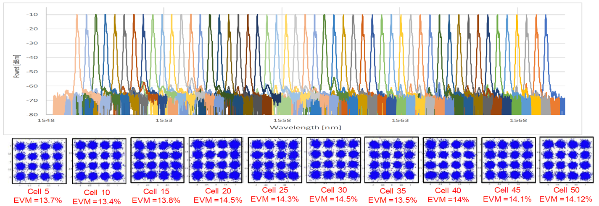
Figure 22 Optical spectra for WDM signals using the ultra-fast TLD. Demodulated constellation maps related to the wavelength cells are also shown.

6.5.2 Optical switches
Optical switch is a simplest way to change the optical path in the network. As typical switching time of the optical switch utilized in an optical fiber communication system is 10s–100s milliseconds, enough guard time between the communication frames and packets could accept the switching time. Figure 23 shows a typical block diagram of the optical-switch-based router in the RCS network.

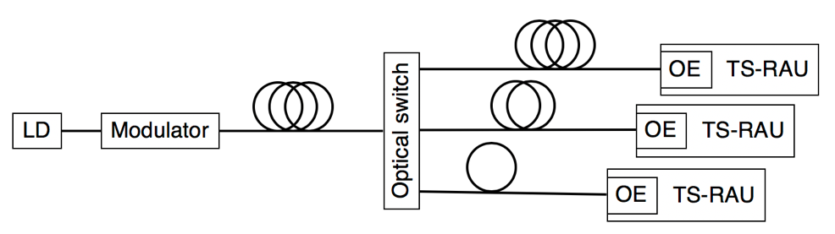
Figure 23 Concept of optical-switch-based routing system

In the field trial test with a Japanese Shinkansen traveling at 240-km/h, the optical switch-based routing has been evaluated [4]. Figure 24 shows time-developed spectra, whose signals are received at a node base station, under four TS-RAUs installed along the railway track: the TS-RAU installed at every 240–470 m. It should be noted that the signal form is based on the DSB modulation, because the fiber length in the field trial is less than 2 km even at an IF frequency of 13 GHz; no significant quality degradation due to the fiber chromatic dispersion effects. Optical switch control successfully changes the path route from the nearest TS-RAU to the node base station. Established link between the TS-RAU and an onboard terminal in the train car has never been interrupted, and therefore, the optical-switch-based routing is also capable in the RCS network for the high-speed train traveling at a speed faster than 240 km/h.

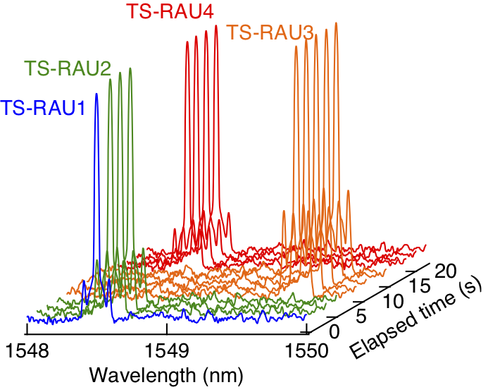
Figure 24 Obtained optical spectra received at a node base station in the Shinkansen field trial test.

Conclusion
Broadband RCS using the RoF technology is discussed and evaluated by proof-of-concept demonstrations. The IFoF system is a promising candidate for realization of long-distance fiber transmission without throughput degradation caused by a fiber dispersion effect. Both broadband IFoF system at a frequency of several GHz and SSB system are evaluated, and finally, WDM channel number up to 80 can be realized by both systems. Also, the optical-switch-based routing system is evaluated for the realization of the uninterrupted communications in the field trial test. This APT Report will be a guideline for considering future broadband RCS from the viewpoint of the optical network.

Bibliography:
- A. Kanno, et al., “Millimeter-Wave Radio-Over-Fiber Network for Linear Cell Systems,” IEEE/OSA Journal of Lightwave Technology, vol. 36, no. 2, pp. 533–540, January 2018.
- K. Fujiwara, et al., “IEEE802.11ad packet transmission based SSB optical modulation on Radio-over-Fiber in 90 GHz band,” Proceedings of European Microwave Conference 2018, doi:10.23919/EuMC.2018.8541782.
- P. T. Dat, et al., “High-Speed and Uninterrupted Communication for High-Speed Trains by Ultrafast WDM Fiber-Wireless Backhaul System,” Journal of Lightwave Technology, vol. 37, no. 1, pp. 205–217, January 2019.
- A. Kanno et al., “Field Trial of 1.5-Gbps 97-GHz Train Communication System Based on Linear Cell Radio Over Fiber Network for 240-km/h High-Speed Train,” Optical Networking and Communication Conference (OFC) 2019, San Diego, USA, Th4C.2, March 2018.

