APT REPORT

ON

SURVEYING MOBILE ACCESSIBILITY IN THE AP REGION

No. APT/ASTAP/REPT-51
Edition: June 2021

Adopted by
The 33rd APT Standardization Program Forum (ASTAP-33)
7 – 15 June 2021, Virtual/Online Meeting

(Source: ASTAP-33/OUT-24)

Report of Surveying Mobile Accessibility in The AP Region

SUMMARY
This report seeks to develop a greater understanding of the current mobile accessibility conformance status of APT member countries’ representative applications and mobile websites. The scope of this survey is to analyze the accessibility compliances status of most commonly used mobile applications of each participating country. Total of 37 mobile applications from seven (7) respondents were identified according to the survey. As a result, total of 315 screens were analyzed. Within the 315 screens, total of 7,653 components were analyzed for alternative texts, and total of 10,023 components were analyzed for focus issues. Overall, the mobile websites and applications are somewhat prepared to comply with known international accessibility guidelines. However, some mobile applications still fail to provide basic functions such as providing correct focus information and alternative text.

Table of Contents
1. Introduction 4
2. Survey process 4
3. Scope 5
4. Methods 5
5. Sample selection 5
6. Accessibility features considered 6
7. Survey results 8
8. Current status of accessibility policy 8
9. Observations on samples 8
10. Alternative texts issues 10
13. Issues on Focus 13
17. Conclusion 17

List of Figures
Figure 1 Example of no alternative texts available 12
Figure 2 Example of inappropriate alternative texts 13
Figure 3 Example of focus sequence not logically consistent with the screen 15
Figure 4 Example of unnecessarily focused components 16
Figure 5 Example of no focus assigned to necessary components 17

List of Tables
Table 1 Analysis Compliances with WCAG 2.0 7
Table 2 Testing Environment 7
Table 3 Summary of current status of accessibility policy for participating countries 8
Table 4 Descriptive Statistics of Applications Analyzed 10
Table 5 Analysis Results - Alternative Texts 11
Table 6 Analysis Results - Focus 14

Report of Surveying Mobile Accessibility in The AP Region

Introduction
Accessibility issues for persons with disabilities dealing with information and communications technologies (ICT) are an important topic worldwide, as stressed in the United Nations (UN) Convention on the Rights of Persons with Disabilities—an international human rights treaty [b-UNCRPD]. In addition, the Incheon Strategy of the UN Economic and Social Commission for Asia and the Pacific (UNESCAP) also stresses ICT use by, and accessibility for, persons with disabilities. ICT accessibility, in the past, has focused on retrofitting to rectify the lack of access to ICT for disabled individuals.
However, information technology (IT) environments are constantly developing. Every day, IT companies are introducing new technologies such as services and applications related to smart mobile devices and the Internet of things. Properly tracking and reviewing these technologies is critical to ensuring persons with disabilities easily adopt innovative ITs. Since the introduction of smart phone, usage of mobile phone platform has been revolutionized. Electronic commerce, social networks, and information services are now widely available on mobile devices, and these devices are gradually taking over roles once played by laptops and desktop personal computers.
The increased use of smart devices, such as smartphones, tablets, and smart televisions, has now changed the way people use information. Handy smart devices featuring tremendous computing and networking power enable individuals to access a vast range of information anytime, anywhere. However, minorities, including persons with disabilities, may not enjoy access to this information revolution due to many barriers. According to a 2014 World Health Organization report, over one billion people in the world endure some level of disabilities, and many also suffer from the resulting economic difficulties.
Accessibility, in this context, refers to the design of products or services that ensures “ability to access” for everyone, including persons with disabilities and those with specific needs. Accessibility guarantees direct access to products or services or, alternatively, indirect access that utilizes assistive technology. Although the concept of accessibility is focused on persons with disabilities, the resulting advantages can benefit everyone.
Mobile accessibility, according to the World Wide Web Consortium’s (W3C) definition, “refers to making websites and applications more accessible to persons with disabilities when they are using mobile phones.” As IT have evolved, the means of information distribution has moved from computers to mobile devices. Although the Internet enabled increasing information circulation in the 1990s, the popularization of smartphones in the 2000s triggered unbound information circulation without temporal and spatial constraints. This IT revolution has brought about many changes in individuals’ everyday life.
This report seeks to develop a greater understanding of the current mobile accessibility conformance status of APT member countries’ representative applications and mobile websites. This knowledge may help determine the level of mobile applications’ accessibility, which can be used as the basis for future strategic planning.

Survey process
This report is based on the survey on the current status of the APT countries' mobile accessibility, which the questionnaire was approved by the 29th APT Standardization Program Forum (ASTAP-29/OUT-12), held on 22-25 August 2017, Bangkok, Thailand. The work program to propose the circulation of a questionnaire based on the discussions from the ASTAP-28 (ASTAP-28/INP-64) and the revised work plan of EG AU (ASTAP-26/OUT-07). Messrs. Yong Jick Lee, Jee-In Kim and Hark Sohn from Republic of Korea were chosen as rapporteurs conducting the survey and preparing the report. Annex 1 contains the original questionnaire that was sent to APT member states.
The questionnaire was sent to all APT member states on 30 August 2017 and asked to respond by January 15, 2018. The target responders were stated as the APT member countries’ government officials who are responsible for policy development on ICT accessibility for persons with disabilities (PWDs). As of April 20, 2018, we have received four (4) responses from Iran, Japan, Korea (Rep. of) and Mongolia. The ASTAP-30 Expert Group on Accessibility and Usability (EG AU) have decided to extend the timing, to encourage more participation from the member countries. Three (3) more responses from China, Kiribati and Thailand, were submitted during this extension. Eventually, seven (7) responses were submitted for this report.

Scope
The scope of this survey is to analyze the accessibility compliances status of most commonly used mobile applications of each participating country in two distinct categories of smart mobile environments—mobile websites and Android mobile applications. Even though many other possible platforms are available in the market, this survey focused on these websites and operating systems because they have been widely adopted in the Asia-Pacific region. They are the most popular in part because many leading manufacturers of mobile devices utilizing Android operating systems originated from this region and many smart devices are available at affordable prices. Mobile websites, in contrast, are widely used because they are independent of device specific technologies and operable on practically any device.
This report is based on limited research on accessibility to mobile applications, so statistical implications are not part of the results. Rather, this report seeks to illustrate some common accessibility issues for persons with disabilities while using mobile applications based on a sample of well-known and widely used mobile websites and applications in the Asia-Pacific region. A few of these were chosen for analysis because they are reported to be commonly used by persons with disabilities.
The accessibility performance of any individual website or application mentioned in this report cannot be judged based on the results presented in this document alone. Instead, this report’s main interest is in common practices of websites and applications that may affect the usability and accessibility of mobile websites or applications. The specific examples presented in this report serve only as illustrations for the findings.
The purpose of the survey is to examine the current accessibility status of mobile applications commonly used by persons with disabilities. Institutions concerning accessibility policy can use this report to understand the current situation in detail. The results will provide essential information that could help each country (1) establish mobile accessibility strategies and (2) respond effectively to international standard movements promoted through the ITU-T, W3C, ISO/IEC and other international standardization development organizations.

Methods
This survey partially uses an automated tool -- forApp. This tool is designed to expedite while maintain the accuracy of testing of the accessibility features of mobile applications using automated technology. The research involved examining each participating APT member country’s common mobile websites and applications for the use of accessibility technologies, including, among others, alternative texts, focus correctness, and multi-touch accuracy according to well-established guidelines (e.g., W3C’s accessibility guidelines). The solution can automatically evaluate mobile webpages and applications and hybrid—that is, mobile applications that embed mobile websites—mobile applications and provide detailed reports on accessibility issues and weaknesses. The forApp is the only mobile accessibility evaluation tool listed on the W3C’s Web Accessibility Evaluation Tools list at the time of publishing this report (see https://www.w3.org/WAI/ER/tools/index.html).

Sample selection
On 30 August 2017, questionnaire was sent to each APT member country through APT secretariat. The questionnaire included a request for a list of minimum five (5) to maximum ten (10) mobile websites and mobile applications that are developed in their country (preferably) or global web services that are customized for local services (more than just language translation). The questionnaire also asked to indicate the categories of mobile website or mobile application. Three categories are presented as (TYPE A) Web services to benefit persons with disabilities, (TYPE B) Public web services such as transportation, communication, banking, etc., and (TYPE C) Most popular web services.
Each participating country, thus, provided website and application lists for analysis. Total of 39 applications from seven (7) respondents were identified according to the survey. The rapporteurs then processed the sample generated using the aforementioned automated solution.

Accessibility features considered
Two key accessibility components – namely, the “focus” issues and the “alternative text” issues – has been examined. Even though there are many accessibility components that should be examined, the two fundamental accessibility components are the starting points of the mobile accessibility. W3C’s Web Contents Accessibility Guidelines were cited as a guiding principle of the analysis.
Although many other features need to be adjusted to maintain accessibility, developers need first to check their source codes for two key components—focus and alternative text—to maintain compatibility with the system-provided accessibility tools. Persons with visual disabilities often cannot adjust their natural eye focus on the screen, and they must rely on the machine’s assisted focus. The issue, in this context, is that the operating system is not smart enough to understand how the user interface components are organized and how the screen reader needs to interpret the order of these components. Thus, the application developer is responsible for ensuring the order of assisted focus is consistent with what actually appears on the screen.
Moreover, the screen reader “reads” the screen, which means that all the graphical elements of the user interface should have labels and descriptions that can be provided to users who cannot see the screen. This is termed “alternative text.”
These two components, focus and alternative text, are the key elements necessary for applications to execute well with built-in screen reading features of operating systems for mobile devices. Applications consist of many screens, and each screen has many user interface components—content, labels, graphics, and input components. Even extremely small applications can have hundreds of these components. Without proper development strategies and evaluation tools, application developers may ignore alternative text or make focus errors, resulting in applications that are incompatible with system accessibility functionalities. Once an application is fully developed, altering it to comply with accessibility features is even more difficult. Developers must scan the entire source code and run a full conformance test on the application to find the missing elements.
Alternative text and focus issues are just two of the many considerations involved in developing applications compatible with built-in screen reading features. Utilizing accessibility features supported by the operating system solves many of the accessibility issues of mobile applications. However, the persons with visual disabilities are often limited to use mobile devices, as the user interfaces for most smart mobile devices rely on a high-resolution touch screen. Thus, increasing emphasis has been placed on mobile accessibility especially developed for persons with visual disabilities.
In a mobile environment, some of WCAG 2.0’s guideline may not be relevant on mobile application context while many of web related guidelines still applies on mobile web contents. W3C provides a set of guidelines that can be applied when developing mobile contents including Web Contents Accessibility Guidelines (WCAG), User Agent Accessibility Guidelines (UAAG), Authoring Tool Accessibility Guidelines (ATAG), and Accessible Rich Internet Applications (WAI-ARIA). UAAG focuses on platform level accessibility issues, ATAG covers authoring tools, and WAI-ARIA is more of design science approach on dynamic web contents. While the most relevant guideline that are available is W3C’s WCAG 2.0, it only concerns accessibility on the Web contents. Table 1 summarizes the analysis performed in this report and its compliances with W3C’s WCAG 2.0 [b-W3C WCAG 2.0].
Category | WCAG 2.0  Relevance | Inspection  Type
Existence of Alternative Texts | 1.1, 1.2 | Automatic
Appropriateness of alternative texts | 1.3, 3.1 | Automatic/Manual
Focus sequence consistent with logical sequence of the screen | 2.4 | Automatic
Unnecessarily focused components | 2.4, 3.1 | Automatic/Manual
No focus assigned to necessary components | 2.4, 3.1, 3.2 | Automatic
Other Issues – Application | 1.4, 2.1, 2.2, 2.3 | Manual
Other Issues – Platform related | 3.3, 4.1 | Manual
Table 1 Analysis Compliances with WCAG 2.0
The automated tool that are used in this survey is a user interface analysis tool for mobile applications. It supports user interface improvement by analyzing each user interface unit of mobile applications. This tool provides automated analysis reports of accessibility issues to help mobile application developers and operators improve their applications.
The automated tool classifies mobile accessibility results by version information, tested devices, and applications’ screen-specific information. When necessary updates occur, companies can keep track of their complete accessibility compliance history. This allows firms and developers to evaluate their accessibility compliance and manage old and current versions concurrently.
In this report, the hardware and operating systems shown in Table 2 were used in analyses. These environments were kept consistently the same to avoid creating any variance in analyses caused by differences in hardware and operating systems. Note that the Android 7.0 is used to ensure the compatibility for greater user base.
Attribute | Value
Device Model | SM-G920S
Device Manufacturer | Samsung
OS Version | Android 7.0
Display Resolution | 1440 X 2560
Table 2 Testing Environment

Survey results

Current status of accessibility policy
Every country has different accessibility policy of their own according to their specific status. Thus, before examining the compliance of accessibility to an international standard, existence of local policy, regulation, standards and guidelines and its impact to current mobile webpages and/or applications needs to be examined. Thus, the questionnaire asked each country to report its status of accessibility policy.
The questionnaire asked whether or not the country developed or plan to develop (1) a general ICT accessibility standard/regulation/guideline (The term “general” refers to an overall ICT environment that are not specific to any platforms such as PC, web, mobile, etc.), (2) accessibility standard/regulation/guideline that are specific to personal computing (PC) software environment, (3) accessibility standard/regulation/guideline that are specific to the world wide web (WWW) environment, (4) accessibility standard/regulation/guideline that are specific to mobile environment, (5) non-governmental (i.e. industry) accessibility standards/guidelines (either general ICT accessibility or specific to a platform accessibility).
Table 3 summarizes current status of accessibility policy for participating countries.

 | (1)  General | (2)  PC | (3)  WWW | (4)  Mobile | (5)  Non-Gov
China | PLAN* | PLAN* | ACTIVE** | PLAN* | IMPL§
Iran | ACTIVE** | ACTIVE** | ACTIVE** | PLAN* | NO***
Japan | ACTIVE** | ACTIVE** | ACTIVE** | ACTIVE** | NO***
Kiribati | PLAN* | PLAN* | PLAN* | ACTIVE** | NO***
Korea  (Rep. of) | ACTIVE** | ACTIVE** | ACTIVE** | ACTIVE** | INPL§
Mongolia† | PLAN*/  ACTIVE** | PLAN* | PLAN*/  ACTIVE** | PLAN*/  ACTIVE** | NO***
Thailand | NO*** | NO*** | ACTIVE** | NO*** | NO***
*PLAN: Plan to have one in near future or under development.
** ACTIVE: Developed and enforced (applicable).
*** NO: No plan.
§ IMPL: Non-governmental (industry) standards/regulations are implemented.
† Thailand replied that they are intended to use international standards available.
‡ Mongolia submitted duplicated responses.
Table 3 Summary of current status of accessibility policy for participating countries
Japan and Republic of Korea indicated that they have all general, PC, WWW and Mobile accessibility standards, regulations or guidelines available. Other countries except for Thailand reported that they have some standards, regulations or guidelines available while some are under development. Thailand replied that they only implemented local accessibility WWW standard, regulation or guideline. For others, they are intended to use international standards available rather than implementing their local standards, regulations or guidelines.
Note that the questionnaire did not ask for detailed explanation of each participating countries policy, and how they approach to the accessibility issues related to ICT. Further study on how each countries’ strategy to ICT accessibility maybe of interest, but at this moment, this report only illustrates each countries’ status as it is, and no further analysis has been done as it is out of scope of this report.

Observations on samples
In the clause 7.2, some use cases of common mistakes that causes accessibility issues related to alternative texts and focus are illustrated with number of incidences that are found from the analysis are reported.
Brief statistics of mobile applications and websites that were analyzed are listed in Table 4. Total of 37 applications were examined. For each application, maximum of ten screens were chosen for analysis. The sample consists of the main screen that are shown when the application starts up, and its trailing screens that are used to navigate through the core information of the applications. Among the 37 applications, nine of them were analyzed only one or few screens. Reasons for limited analysis are:
- Some applications require subscription.
- Foreign language cannot be translated/understood.
As a result, total of 315 screens were analyzed. Within the 315 screens, total of 7,653 components were analyzed for alternative texts, and total of 10,023 components were analyzed for focus issues.

Country Code | App Code | Number of Screens  Reviewed | Number of UI Components Needs Alternative Text | Number of UI Components with Focus
A | 001 | 10 | 271 | 354
 | 002 | 10 | 2733 | 3706
 | 003 | 10 | 148 | 227
 | 004 | 10 | 169 | 223
 | 005 | 10 | 245 | 341
 | 006 | 10 | 355 | 658
 | 007 | 10 | 197 | 293
 | 008 | 10 | 89 | 129
 | 009 | 10 | 112 | 133
B | 010 | 4 | 33 | 45
 | 011 | 7 | 83 | 101
 | 012 | 10 | 87 | 136
 | 013 | 10 | 106 | 182
 | 014 | 10 | 155 | 267
 | 015 | 10 | 130 | 179
 | 016 | 10 | 83 | 100
 | 017 | 10 | 112 | 136
 | 018 | 10 | 114 | 147
 | 019 | 5 | 63 | 86
 | 020 | 10 | 101 | 125
 | 021 | 4 | 49 | 53
C | 022 | 10 | 176 | 220
 | 023 | 10 | 74 | 130
 | 024 | 10 | 143 | 235
 | 025 | 10 | 215 | 298
D | 026 | 1 | 2 | 3
 | 027 | 10 | 92 | 144
 | 028 | 10 | 102 | 161
 | 029 | 10 | 98 | 128
E | 030 | 8 | 102 | 137
F | 031 | 10 | 134 | 153
 | 032 | 10 | 93 | 107
 | 033 | 2 | 4 | 8
G | 034 | 10 | 302 | 361
 | 035 | 1 | 8 | 22
 | 036 | 3 | 24 | 26
 | 037 | 10 | 188 | 269
Table 4 Descriptive Statistics of Applications Analyzed

Alternative texts issues
Two distinctive issues related to alternative texts are examined. First is the existence of alternative text, and the second is the appropriateness of alternative texts. Detailed explanations of the two issues are illustrated in following sub-clauses.
Among the 7,653 user interface components that requires alternative texts analyzed from the 315 screens of 37 applications, 7,192 user interface conforms alternative text requirements while 461 user interface reveals one of the two main issues addressed above. Descriptive statistics are provided in Table 5. Note that due to the lack of understanding foreign language, further analysis was not possible. Thus, we only provide high-level observations on issues of alternative texts in this document. However, following sub-clauses presents the examples of each issues using the result of the analysis. On average, 91.05% of the user interfaces that requires alternative text were found to be appropriate. It means 8.95% of the user interfaces that requires alternative text have some level of issues. This number may seem good enough, but 100% should be the target.

App Code | Number of Screens | Number of Components with Correct Alt Text | Number of Components with Alt Text Issues | Number of Components needs Alt Text | Correct  Ratio
001 | 10 | 271 | 2 | 273 | 99.27%
002 | 10 | 2733 | 45 | 2778 | 98.38%
003 | 10 | 148 | 17 | 165 | 89.70%
004 | 10 | 169 | 9 | 178 | 94.94%
005 | 10 | 245 | 28 | 273 | 89.74%
006 | 10 | 355 | 25 | 380 | 93.42%
007 | 10 | 197 | 3 | 200 | 98.50%
008 | 10 | 89 | 2 | 91 | 97.80%
009 | 10 | 112 | 4 | 116 | 96.55%
010 | 4 | 33 | 8 | 41 | 80.49%
011 | 7 | 83 | 1 | 84 | 98.81%
012 | 10 | 87 | 11 | 98 | 88.78%
013 | 10 | 106 | 48 | 154 | 68.83%
014 | 10 | 155 | 42 | 197 | 78.68%
015 | 10 | 130 | 31 | 161 | 80.75%
016 | 10 | 83 | 7 | 90 | 92.22%
017 | 10 | 112 | 7 | 119 | 94.12%
018 | 10 | 114 | 10 | 124 | 91.94%
019 | 5 | 63 | 10 | 73 | 86.30%
020 | 10 | 101 | 3 | 104 | 97.12%
021 | 4 | 49 | 1 | 50 | 98.00%
022 | 10 | 176 | 6 | 182 | 96.70%
023 | 10 | 74 | 35 | 109 | 67.89%
024 | 10 | 143 | 1 | 144 | 99.31%
025 | 10 | 215 | 2 | 217 | 99.08%
026 | 1 | 2 | 0 | 2 | 100.00%
027 | 10 | 92 | 17 | 109 | 84.40%
028 | 10 | 102 | 12 | 114 | 89.47%
029 | 10 | 98 | 8 | 106 | 92.45%
030 | 8 | 102 | 22 | 124 | 82.26%
031 | 10 | 134 | 1 | 135 | 99.26%
032 | 10 | 93 | 0 | 93 | 100.00%
033 | 2 | 4 | 1 | 5 | 80.00%
034 | 10 | 302 | 15 | 317 | 95.27%
035 | 1 | 8 | 2 | 10 | 80.00%
036 | 3 | 24 | 0 | 24 | 100.00%
037 | 10 | 188 | 25 | 213 | 88.26%
Total | 315 | 7,192 | 461 | 7,653 | 91.05% (Average)
Table 5 Analysis Results - Alternative Texts

Common issues - existence of alternative texts
When a component has focus and a meaningful function, it needs also to have meaningful descriptive alternative text or descriptions. Alternative text is used to describe text or labels directly, and content description is used to describe screen content that does not have text. Alternative text is recommended for text labels and text content, and text description is recommended for non-text content such as images and videos. Developers have no reason to include both alternative text and content description, but at least one should be in place to describe the meaning of the focused components.
WCAG 2.0 Guideline 1.1 Text Alternatives: Provide text alternatives for any non-text content so that it can be changed into other forms people need, such as large print, braille, speech, symbols or simpler language.
WCAG 2.0 Guideline 1.2 Time-based Media: Provide alternatives for time-based media.

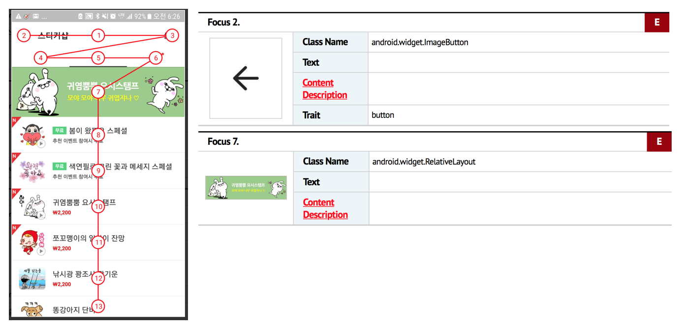
Figure 1 Example of no alternative texts available
Figure 1 depicts two alternative text issues on an application page. Though it has focus (i.e. focus 2 and focus 7), no text information or contents description available makes user no clue on those images. the Focus 2 item is also related to navigation (the back button).

Common issues - appropriateness of alternative texts
Sometimes alternative text or content descriptions are present, but the text description does not properly illustrate the use of the components. Sometimes, developers insert placeholder text such as “1” or “a” and forget to change this into meaningful text before the final release. This type of mistake results in no access to the components. The most common error of this type is to leave an alternative text of a button component as “button.” Even though users recognize that the button exists, they cannot sense the button’s function.
Notably, due to the language barrier, any quantitative analysis of this error is not reported. A more detailed analysis is required for full, detailed inspection results. Many global applications are highly dependent on automated translation functions when localizing components, and this often causes grammatical and contextual errors when translating their services.
WCAG 2.0 Guideline 1.3 Adaptable: Create content that can be presented in different ways (for example simpler layout) without losing information or structure.
WCAG 2.0 Guideline 3.1 Readable: Make text content readable and understandable.
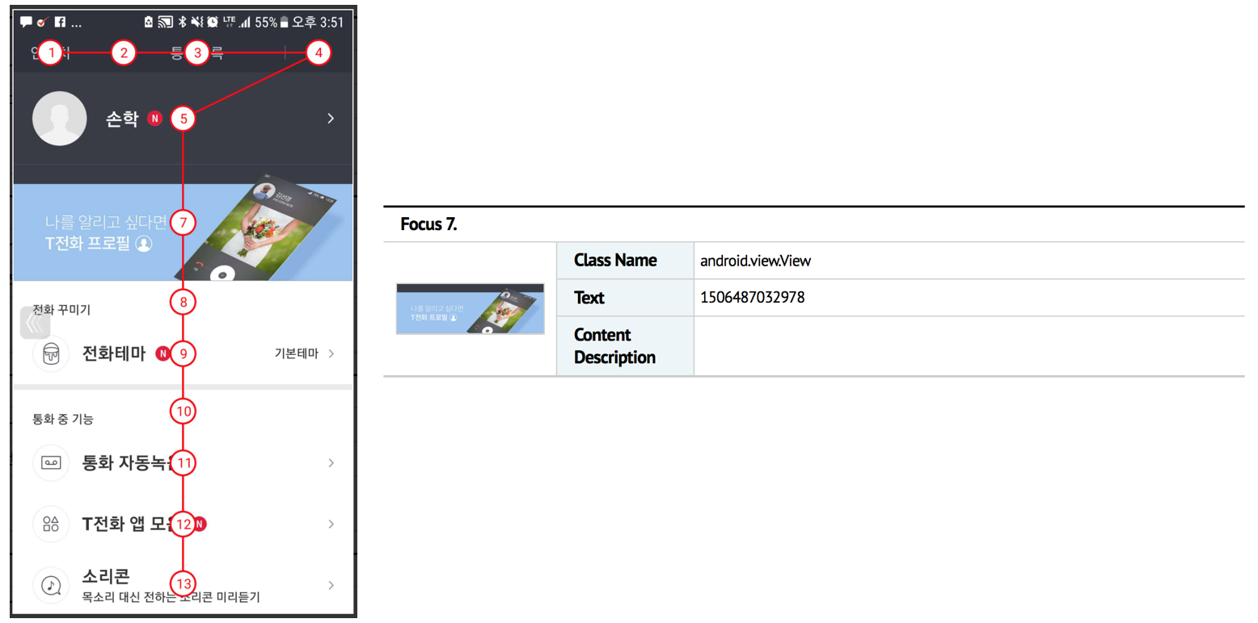
Figure 2 Example of inappropriate alternative texts
In Figure 2, the focus 7 item is an advertisement banner image with meaningless numbers as alternative texts. It will confuse users who is relying on the alternative texts to understand the screen.

Issues on Focus
Issues related to focus sequence structure are examined. Common issues include focus sequence consistent with logical sequence of the screen, unnecessarily focused components, and no focus assigned to necessary components. Detailed explanations of those issues are illustrated in following sub-clauses. Among the 10,023 user interface components that has focus analyzed from the 315 screens of 37 applications, 7,662 user interface conforms focus structure requirements while 2,361 user interface reveals one of the three main issues addressed above. Descriptive statistics are provided in Table 6. Note that due to the lack of understanding foreign language, further analysis was not possible. Thus, we only provide high-level observations on issues of focus structure in this document. However, following sub-clauses presents the examples of each issues using the result of the analysis. On average, 20.06% of the user interface that has focus have some level of issues.
App Code | Number of Screens | Number of Components with Correct Alt Text | Number of Components with Alt Text Issues | Number of Components needs Alt Text | Correct Ratio
001 | 10 | 273 | 81 | 354 | 77.12%
002 | 10 | 2778 | 928 | 3706 | 74.96%
003 | 10 | 165 | 62 | 227 | 72.69%
004 | 10 | 178 | 45 | 223 | 79.82%
005 | 10 | 273 | 68 | 341 | 80.06%
006 | 10 | 380 | 278 | 658 | 57.75%
007 | 10 | 200 | 93 | 293 | 68.26%
008 | 10 | 91 | 38 | 129 | 70.54%
009 | 10 | 116 | 17 | 133 | 87.22%
010 | 4 | 41 | 4 | 45 | 91.11%
011 | 7 | 84 | 17 | 101 | 83.17%
012 | 10 | 98 | 38 | 136 | 72.06%
013 | 10 | 154 | 28 | 182 | 84.62%
014 | 10 | 197 | 70 | 267 | 73.78%
015 | 10 | 161 | 18 | 179 | 89.94%
016 | 10 | 90 | 10 | 100 | 90.00%
017 | 10 | 119 | 17 | 136 | 87.50%
018 | 10 | 124 | 23 | 147 | 84.35%
019 | 5 | 73 | 13 | 86 | 84.88%
020 | 10 | 104 | 21 | 125 | 83.20%
021 | 4 | 50 | 3 | 53 | 94.34%
022 | 10 | 182 | 38 | 220 | 82.73%
023 | 10 | 109 | 21 | 130 | 83.85%
024 | 10 | 144 | 91 | 235 | 61.28%
025 | 10 | 217 | 81 | 298 | 72.82%
026 | 1 | 2 | 1 | 3 | 66.67%
027 | 10 | 109 | 35 | 144 | 75.69%
028 | 10 | 114 | 47 | 161 | 70.81%
029 | 10 | 106 | 22 | 128 | 82.81%
030 | 8 | 124 | 13 | 137 | 90.51%
031 | 10 | 135 | 18 | 153 | 88.24%
032 | 10 | 93 | 14 | 107 | 86.92%
033 | 2 | 5 | 3 | 8 | 62.50%
034 | 10 | 317 | 44 | 361 | 87.81%
035 | 1 | 19 | 3 | 22 | 86.36%
036 | 3 | 24 | 2 | 26 | 92.31%
037 | 10 | 213 | 56 | 269 | 79.18%
Total | 315 | 7,662 | 2,361 | 10,023 | 79.94% (Average)
Table 6 Analysis Results - Focus

Common issues - focus sequence consistent with logical sequence of the screen
The focus sequence must be logically consistent with the screen. If the focus is not aligned correctly, the content’s logical structure will not be properly presented, and users of screen readers may be misled by the information provided or may be unable to use the service or content altogether.
For the focus sequence analysis, a visual inspection had to be performed to identify whether the focus sequence generated by the screen reader program was consistent with the content’s logical sequence. In addition, the number of sequence steps had to be considered. For example, if too many focus steps are involved in one screen, this may be overwhelming for individuals with disabilities trying to understand the screen’s structure.
WCAG 2.0 Guideline 2.4 Navigable: Provide ways to help users navigate, find content, and determine where they are.

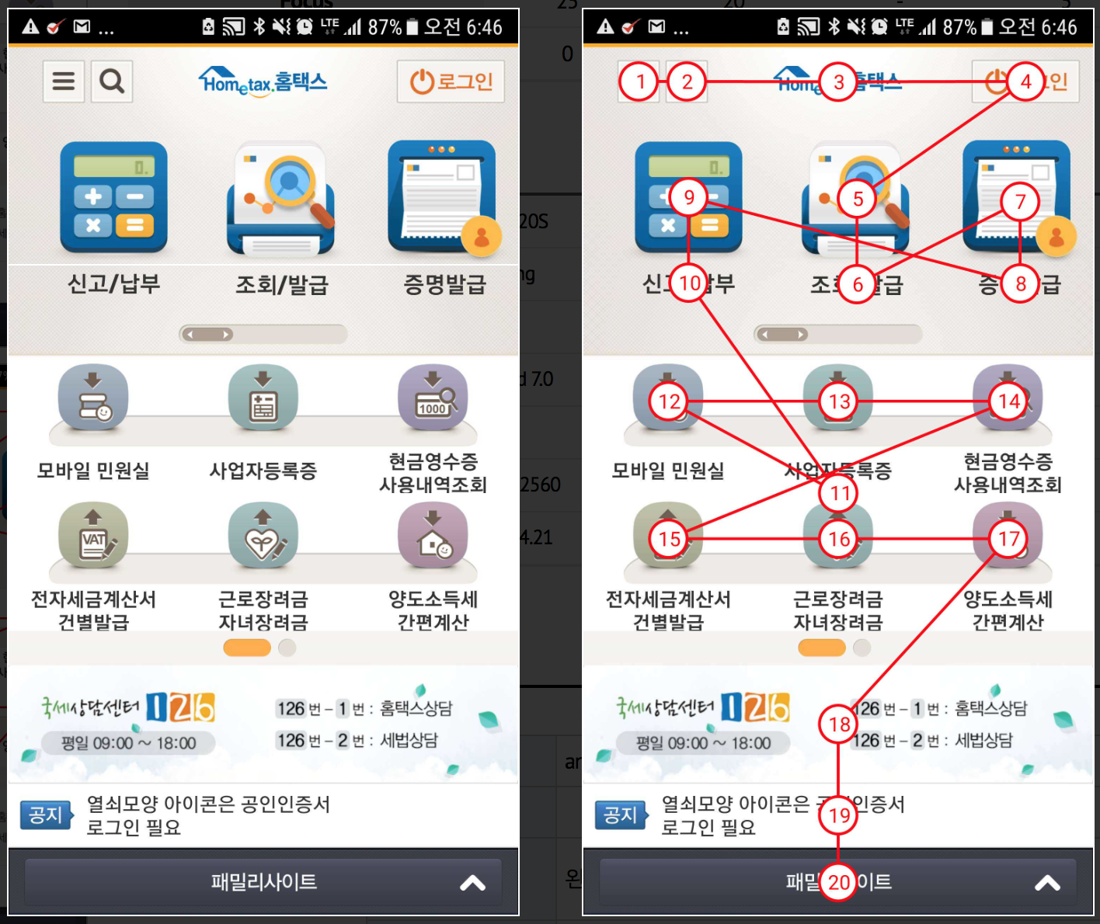
Figure 3 Example of focus sequence not logically consistent with the screen

In figure 3, three functions represented by three icons (focuses 5, 7, 9) are ordered as focus 5 (center), focus 7 (right) then focus 9 (left). The next row focuses 12, 13, 14 and 15, 16, 17 are from left to right. Such arrangement of focus structure is illogical and confuses users.

Common issues - unnecessarily focused components
Some user interface components may either have focus unnecessarily or be unnecessary themselves. Background image components, meaningless decorative components, and other unnecessary components do not require a focus. Sometimes, garbage components from prior versions or components inserted for test purposes may exist and have focus, which can confuse users. Notably, due to the language barrier, any quantitative analysis of this type of error is not reported. A more detailed analysis is required for a full, detailed inspection.
WCAG 2.0 Guideline 2.4 Navigable: Provide ways to help users navigate, find content, and determine where they are.
WCAG 2.0 Guideline 3.2 Predictable: Make Web pages appear and operate in predictable ways.
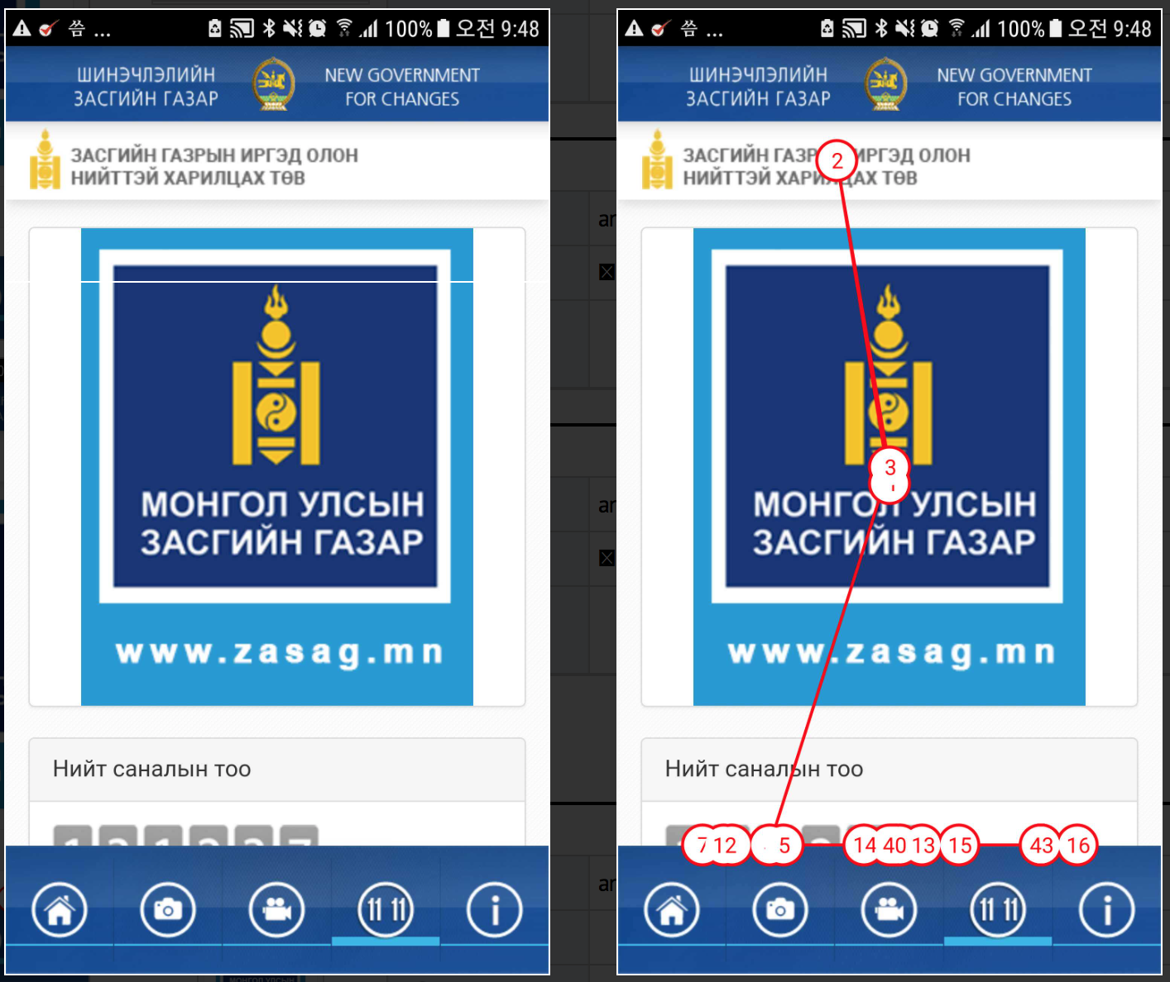
Figure 4 Example of unnecessarily focused components
In figure 4, there are total of 43 components available on this screen many of them are redundant or meaningless.

Common issues - no focus assigned to necessary components
Conversely, some necessary components may not have focus. If this is the case, users cannot access necessary functions or content.
Guideline 2.4 Navigable: Provide ways to help users navigate, find content, and determine where they are.
Guideline 3.1 Readable: Make text content readable and understandable.
Guideline 3.2 Predictable: Make Web pages appear and operate in predictable ways.

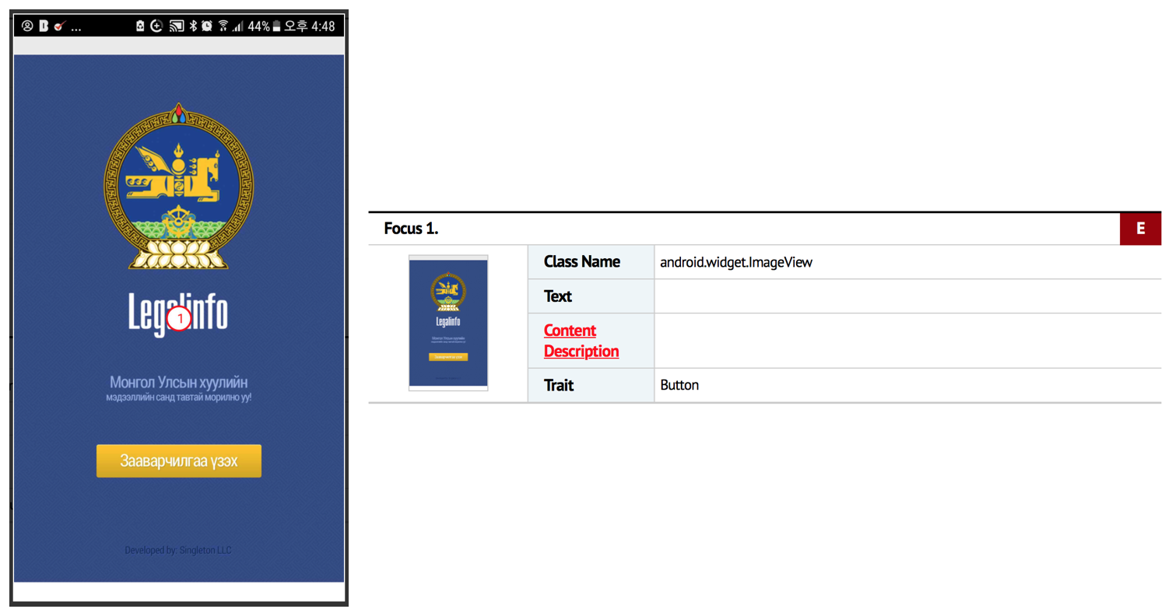
Figure 5 Example of no focus assigned to necessary components

In figure 5, only one focus item exists, which do not even have any alternative text information. Texts in this page are not accessible to those who rely on screen-to-text assistive technology.

Conclusion
The concept of information accessibility is that all individuals need to be able to take advantage of information without experiencing discrimination against minorities, including persons with disabilities. The definition of disability is expanding with the development of medicine and social welfare. Social risks have increased with the development of industry. And, disabilities related to aging is increasing as increase in life expectancy. All those means that the population of persons with disabilities is gradually increasing worldwide. However, smart mobile device accessibility and usability for persons with disabilities have been greatly reduced as the main information and communication environments have moved from personal computers to mobile environments. Thus, the issue of mobile accessibility is now affecting fundamental human rights of social equality.
Overall, the mobile websites and applications are somewhat prepared to comply with known international accessibility guidelines. However, some mobile applications still fail to provide basic functions such as providing correct focus information and alternative text. This is a situation that calls for extensive improvement. Governments and regulators need to play an important role in improving accessibility as these improvements benefit all of society. With the increase in accessibility, those who are vulnerable to information can be protected from discrimination, while others might simply benefit from increased ease of use. Therefore, governments and regulators should seek for ways to mediate the misaligned perspectives of firms and consumers by legislating guidelines and regulations.
This report should not be limited to a single publication, but it is necessary to continue to share standards, technologies, and trends related to mobile accessibility among Asia-Pacific countries in line with continuous surveys to improve accessibility and mobile development. Further collaborations with other SDOs and member states should also be considered in the area of collecting and propagating good practices and use cases of accessible mobile applications. We hope that these activities will serve as a foundation for improving the accessibility of mobile applications in operation around the world, and ultimately strive to create results that substantially improve the quality of life of all people, including the persons who are vulnerable to information communication, worldwide.

REFERENCES

[b-UNCRPD] United Nations (2006), Convention on the Rights of Persons with Disabilities.
http://www.un.org/disabilities/convention/conventionfull.shtml
[b-W3C WCAG 2.0] W3C WCAG 2.0 (2008) | ISO/IEC 40500:2012, Information technology – W3C Web Content Accessibility Guidelines (WCAG) 2.0.
http://www.w3.org/TR/WCAG20/
[b-W3C UAAG 2.0] W3C UAAG 2.0 (2015), W3C User Agent Accessibility Guidelines (UAAG).
http://www.w3.org/TR/UAAG20/

ANNEX 1
QUESTIONNAIRE ON
CURRENT STATUS OF THE APT COUNTRIES' MOBILE ACCESSIBILITY
Approved questionnaire on current status of the APT countries’ mobile accessibility is electronically attached.

