 | ASIA-PACIFIC TELECOMMUNITY | Document:  ASTAP-28/OUT-11
The 28th APT Standardization Program Forum
(ASTAP-28)
 | 6-10 March 2017, Bangkok, Thailand | 10 March 2017

Working Group on Policy, Strategy and Coordination (WG PSC)

questionNairE on smart city applications
for the future case study report
(APT/ASTAP/REPT-13)

This document is the result of WG PSC in ASTAP-28 based on (ASTAP-28/INP-42). Annex 1 is the questionnaire on smart city application for the future case study report (APT/ASTAP/REPT-13).

Target Responder for this questionnaire is APT Members / Associate Members / Affiliate Members.

Deadline of Response is 30 May 2017

WG PSC proposes this questionnaire to the plenary to be approved as an output document of ASTAP 28.

Reference:

(APT/ASTAP/REPT-13) APT: “Handbook to introduce ICT solutions for the community in rural area”, APT/ASTAP/REPT-13 (Rev.1) (September 2015)
(ASTAP-28/INP-42) NTT,OKI, NEC: “ PROPOSAL OF REVISED WORKPLAN ON A CASE STUDY (APT/ASTAP/REPT-13) TO ADD SMART CITY AND CIRCULATION OF A QUESTIONNAIRE”, ASTAP-28/INP-42 (Rev.1) (March 2017).

Annex 1

QUESTIONNAIRE ON THE CASE STUDY FOR
ICT POLICY AND DEVELOPMENT PROJECT OF SMART CITIES

Section 1: Elementary Part

1. Introduction (Background)
Only three ASEAN countries (Singapore, Vietnam and Malaysia) in the top 50 in e-participation globally, according to the United Nations 2016 e-participation index . This figure indicates that ASEAN occasionally lags behind in engaging citizens on the ICT policy issues of smart cities planning. As a result, the planning, promoting and implementing of smart cities policy is a big issue in each country of Asia-Pacific region.
In this questionnaire, the objective is to collect the ICT policy and development project, model design and verification test methods from such countries (i.e., Malaysia, Thailand, Vietnam, and Myanmar) that are pioneering to promote the smart cities policy in Asia-Pacific region according to the standard ISO 37120 Sustainable Development of Communities. In order to share the latest information within those countries, a workshop in Japan will plan to be held for discussing and sharing the information among countries about the ICT policy and development project of smart cities in terms of as follow:
1. Energy management – annual electricity consumption of capita (kilowatt-hours per person), annual electricity consumption in public facilities (kilowatt-hours), and percentage of renewable energy consumption (%);
2. Environment management – air quality of PM 2.5 concentration of smart cities (micrograms per cubic meter) and greenhouse gas emissions per capita (%);
3. Education management – female gross enrolment ratio (%) and percentage of secondary education graduates (%);
4. Transportation management – annual number of private passenger cars per capita (cars per person), number of large-scale public transportation systems per 100,000 people (public transportation systems per 100,000 people), and annual number of used times of public transportation systems (times per public transportation system); and
5. Healthcare management– average life (year old), number of beds per 100,000 people (beds per 100,000 people), and number of physicians per 100,000 people (persons per 100,000 people).
It is important to open the fruitful discussions and harness ideas in order to formulate best questionnaire solutions. In the meeting of EG-BSG of ASTAP-28 (March 2017), “ PROPOSAL OF REVISED WORKPLAN ON A CASE STUDY (APT-ASTAP-REP-13) TO ADD SMART CITY AND CIRCULATION OF A QUESTIONNAIRE ON IT” (ASTAP-28/INP-xx) will be introduced. The contents of the proposal is as follow:

Background
Information and communication technology (ICT) that is used in smart city is not limited to urban area. It can be applied to rural areas. However it seems that such case study that is related with smart city applications for rural areas is not so popular. If the case study on smart city for rural area will be included in the ICT handbook, “Handbook to introduce ICT solutions for the community in rural area”, it becomes more useful for the community in rural area. Smart city is closely related with the policy of each country. This point is different from other projects such as e-agriculture, e-learning, and so on. When collecting the case study of smart city applications, the smart city policy of the country should be taken into account.

Proposal
This contribution proposes to revise the work plan of ICT handbook work item to extend the scope and timelines to include smart city, and circulate a questionnaire on smart city in Asia-Pacific region. The questionnaire on smart city applications covers not only case study but also policy in the country.
The questionnaire is requesting ASTAP members to input your case studies in order to build smart city case study section in the ICT handbook, “Handbook to Introduce ICT Solutions for the Community in Rural Areas”.

2. Objective of the Questionnaire
EG BSG requests ASTAP members of filling out the questionnaire enclosed in order to collect case studies about ICT policy and development project for smart cities from all Asia-Pacific region. Based on collected case studies, the group identifies requirements and build smart city case study section in the ICT handbook. For instance, the case study that may contain an energy management system is able to generate more renewable energy consumption in the smart cities area, an transportation management system is able to support a large-scale number of passengers in the public transportation system for daily activities in the smart cities site, and so on. The request is not limited to case studies in actual practices but pilot project for smart cities. Very early ideas could also be submitted for further refinements.

3. Responsible Group
Expert Group on Bridging the Standardization Gap (EG BSG)

4. Rapporteur of the Questionnaire
Mr. Hideyuki Iwata | hideyuki.iwata.jp@hco.ntt.co.jp | Nippon Telegraph and Telephone Corporation (NTT), Japan
Mr. Kazunori Tanikawa | k-tanikawa@cq.jp.nec.com | NEC Corporation (NEC), Japan
Mr. Hideki Yamamoto | yamamoto436@oki.com | Oki Electric Industry Co., Ltd. (OKI), Japan
Mr. Masatoshi Mano | mano@ttc.or.jp | The Telecommunication Technology Committee (TTC), JAPAN

5. Approval Meeting
Expert Group on Bridging the Standardization Gap (EG BSG)

6. Target Responder
APT Members / Associate Members / Affiliate Members

7. Deadline of Response
30 May 2017

__________

Section 2: Questionnaire Part

Smart City Case Study Suggestion

1. Primary Contact Information

Date |  | Country
Organization |  | Name
Email |  | Telephone

2. General Information

Name of Smart Cities
Population (est. year)
Main Source

3. Current themes for building smart cities (choose more than one if necessary)

 | Economy |  | Education |  | Energy
 | Environment |  | Recreation |  | Safety
 | Shelter |  | Solid Waste |  | Urban Planning
 | Finance |  | Fire and Emergency Response |  | Governance
 | Health |  | Transportation |  | Telecommunications and Innovation
 | Wastewater |  | Water and Sanitation

4. Standard(s) or Standard Project(s) for Smart Cities
Standard(s) or standard project(s) to be developed over the next 3 to 5 years for smart cities at the system of systems (city) level. Example:

Reference No. | Title | Standard/  Approved | Date for Publication | Reference to International Standards

5. Case Study Information
Title
Abstract
Details (optional)
Assumptions
Procedures
Results
Issues

6. Additional Information (e.g., table, picture)
Please attach the best picture(s) in describing your idea(s) using diagrams, pictures, flow charts, architectures or relevance.
__________

Smart City Case Study Suggestion

[SAMPLE]

1. Primary Contact Information

Date | 8 March, 2017 | Country | Japan
Organization | Japan Advanced Institute of Science and Technology (JAIST) | Name | Yuto Lim
Email | ylim@jaist.ac.jp | Telephone | +81-761-51-1285

2. General Information

Name of Smart Cities | Tokyo Metropolitan
Population (est. year) | 13,378,584 persons (est. October 1, 2014)
Main Source | - [online] Statistic of Tokyo, Tokyo Metropolitan Government  http://www.toukei.metro.tokyo.jp/tnenkan/2014/tn14q3e002.htm  - [online] Electricity Consumption of Tokyo, Agency for Natural Resources and Energy  http://www.enecho.meti.go.jp/statistics/energy_consumption/ec002/results.html#headline1

3. Current themes for building smart cities (choose more than one if necessary)

 | Economy |  | Education |  |  | Energy
 | Environment |  | Recreation |  |  | Safety
 | Shelter |  | Solid Waste |  |  | Urban Planning
 | Finance |  | Fire and Emergency Response |  |  | Governance
 | Health |  | Transportation |  |  | Telecommunications and Innovation
 | Wastewater |  | Water and Sanitation

4. Standard(s) or Standard Project(s) for Smart Cities
Standard(s) or standard project(s) to be developed over the next 3 to 5 years for smart cities at the system of systems (city) level. Example:

Reference No. | Title | Standard/  Approved | Date for Publication | Reference to International Standards
None

5. Case Study Information
Title | Energy Management Theme
Abstract | The objective is to calculate the annual electricity consumption per capita in Tokyo Metropolitan
Details (optional)
Assumptions | If the annual electricity consumption per capita cannot be obtained directly from a source. The calculation of the annual electricity consumption per capita is depending on the values that are obtained from the online sites.
Procedures | The calculation can be computed through a data processing software (e.g., MS Excel).
Results | In 2014, 0.006725 kWh per capita
Issues | None

6. Additional Information (e.g., table, picture)
Please attach the best picture(s) in describing your idea(s) using diagrams, pictures, flow charts, architectures or relevance.

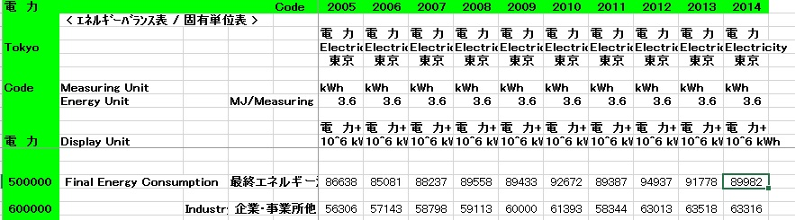
Table 1: Total electricity consumption of Tokyo Metropolitan

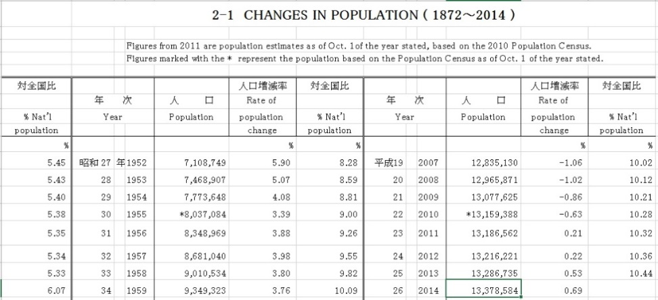
Table 2: Total population of Tokyo Metropolitan
__________

https://publicadministration.un.org/egovkb/en-us/Data-Center

