

**APT report on**

**frequency arrangements for terrestrial IMT in frequency bands 1920 – 2010 and 2110 - 2200 MHz**

**No. APT/AWG/REP-124  
Edition: September 2022**

**Adopted by**

**30th Meeting of APT Wireless Group  
5 – 9 September 2022, Bangkok, Thailand**

***(Source: AWG-30/OUT-15)***

**APT report on**

**frequency arrangements for terrestrial IMT in frequency bands 1920 – 2010 and 2110 - 2200 MHz**

# 1 Background

The World Administrative Radio Conference 1992, held in Málaga-Torremolinos (WARC-92), decided in footnote 746A that frequency bands of 1 920-2 010 MHz and 2 110-2 200 MHz are intended for use, on a worldwide basis, by administrations wishing to implement the Future Public Land Mobile Telecommunication Systems (FPLMTS).

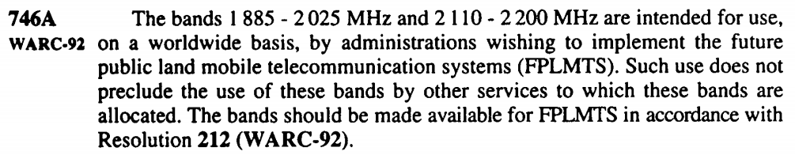

The abbreviation of FPLMTS was later changed to International Mobile Telecommunications (IMT) and today the footnote in question in the ITU Radio Regulations (2020) is changed to:

5.388The frequency bands 1 885-2 025 MHz and 2 110-2 200 MHz are intended for use, on a worldwide basis, by administrations wishing to implement International Mobile Telecommunications (IMT). Such use does not preclude the use of these frequency bands by other services to which they are allocated. The frequency bands should be made available for IMT in accordance with Resolution **212 (Rev.WRC‑15)**\* (see also Resolution **223 (Rev.WRC‑15)**\*). \**Note by the Secretariat:*  This Resolution was revised by WRC-19.

At the WRC-19 and during the revision of the Resolution 212 (Rev. WRC-19) “Implementation of IMT in the frequency bands 1 885-2 025 MHz and 2 110-2 200 MHz” an agreement was made with the addition of the Annex of this Resolution “Guidance on the implementation of technical and operational measures to facilitate coexistence between terrestrial and satellite components of IMT in the frequency bands 1 980-2 010 MHz and 2 170-2 200 MHz”. This Annex provides important advice on the situation when neighbouring countries use different services since the range 1980 – 2010 / 2170 – 2200 MHz (for APT countries / Region 3) is also allocated to Mobile-Satellite service on a primary basis;

5.389A The use of the bands 1 980-2 010 MHz and 2 170-2 200 MHz by the mobile-satellite service is subject to coordination under No. **9.11A** and to the provisions of Resolution **716 (Rev.WRC‑2000)**[1]**.

The Resolution 212 (Rev. WRC-19), and its Annex, and Resolution 223 (Rev. WRC-19), will be further discussed in this Report in Section 6 and are for convenience included as Attachment 1 and Attachment 2.

At the Radiocommunication Assembly (RA-19) in October 2019, the ITU Recommendation M.1036 revision 6 was approved as “Frequency arrangements for implementation of the terrestrial component of International Mobile Telecommunications in the bands identified for IMT in the Radio Regulations” and it recommends the frequency arrangements for implementation of terrestrial mobile communication systems in the range 1 710-2 200 MHz. There are two band plans covering the range for this Report for APT countries, namely; B1 for the bands 1920 – 1980 / 2110 – 2170 MHz and B6 for the band 1980 – 2010 / 2170 – 2200 MHz. The configuration as described in Recommendation M.1036-6 are shown in Figure 1 and Table 1 below.

Figure 1: The frequency arrangements as shown in Rec M.1036-6



Table 1: The frequency arrangements in Table format as given by Rec. M.1036-6

|  |  |  |  |  |  |  |
| --- | --- | --- | --- | --- | --- | --- |
| Frequency  arrangements | Paired arrangements (FDD) | | | | Un-paired arrangements  (TDD) (MHz) | Relevant Notes |
| Mobile station transmitter (MHz) | Centre gap (MHz) | Base station transmitter (MHz) | Duplex separation (MHz) |
| B1 | 1 920-1 980 | 130 | 2 110-2 170 | 190 | 1 880-1 920; 2 010-2 025 | 1, 2, 4 |
| B6 | 1 980-2 010 | 160 | 2 170-2 200 | 190 | None | 4, 5 |

The notes 1, 2, 4, and 5 in Table 1 are included in Attachment 3 in this Report and discussed in Section 6 related to co-existance guidance.

The band plan B1, 1920 – 1980 / 2110 – 2170 MHz, was introduced as the first 3G band and has been widely used for mobile cellular networks worldwide, also in all APT countries. Around the world, more than 180 countries have deployed about 470 IMT networks (including WCDMA, LTE and LTE-Advanced) in this band. Additionally, there is now also a migration started towards 5G NR and currently (March 2022) there are forty-two operators that have been investing in 5G in this band (3GPP band 1920 – 1980 UL/ 2110 – 2170 MHz DL), and thirty-eight of those are known to have launched 5G NR and there are already now over 1000 5G devices[2].

There is a need of additional bandwidth for expanding the capacity of LTE-Advanced system or deploying 5G NR systems, which could provide better user experience of the mobile broadband service. The adjacent bands, 1980 – 2010 MHz and 2170 – 2200 MHz, are identified for both terrestrial and satellite IMT in ITU Radio Regulation. Some APT countries are considering or have these bands available for terrestrial IMT. Some others are considering or have these bands available for satellite IMT. ITU-R has recognized that satellite component is an integral part of IMT. Resolution 212 (Rev. WRC-19) states that the availability of the satellite component of IMT in the frequency bands 1980 – 2010 MHz and 2170 – 2200 MHz simultaneously with the terrestrial component of IMT in the frequency bands identified in RR No. 5.388 would improve the overall use of IMT. The combination of B1 and B6 would create the largest contiguous band for the terrestrial IMT below the 3 GHz frequency range. This has been studied and specified in 3GPP and is described further in Section 5 of this Report. The frequency band 1980 – 2 010 MHz and 2 170 – 2 200 MHz is the only available frequency band for the satellite component of IMT in 2.1GHz band. The satellite component of IMT is very important to several APT countries, such as some countries with the depopulated and economically underdeveloped areas, or islands. The existing and the planned satellite and terrestrial IMT systems shall be protected from harmful interference from each other and from other relevant services.

# 2 Scope

This Report covers aspects related to the implementation of terrestrial IMT in the band 1920 – 2010 / 2110 – 2200 MHz. The objective is to develop possible harmonized frequency arrangements in this range for Asia Pacific Region based on the frequency allocation and arrangement in ITU and other Regions, for those countries in the APT region that wish to implement terrestrial IMT in the existing allocation to the mobile service on a primary basis in Region 3 taking account of regulatory guidelines from Resolution 212 (Rev.WRC-19) and sharing and compatibility with other services/systems.

**3 Vocabulary of terms**

APT Asia Pacific Telecommunity

IMT International Mobile Telecommunications

RA Radiocommunication Assembly

WRC World Radiocommunication Conference

AMS Aeronautical Mobile Service

MMS Maritime Mobile Service

TDD Time-Division Duplex

**4 References**

ITU-R Radio Regulations (2020)

Recommendation ITU-R M.1036-6 (10/2019), “Frequency arrangements for implementation of the terrestrial component of International Mobile Telecommunications (IMT) in the bands identified for IMT in the Radio Regulations (RR)”.

Resolution 212 (Rev.WRC-19) Implementation of International Mobile Telecommunications in the frequency bands 1 885-2 025 MHz and 2 110-2 200 MHz

APT/AWG/REP-125: APT Report of study on technical and operational measures for coexistence between terrestrial and satellite IMT systems deployed in the frequency bands of 1 980-2 010 MHz and 2 170-2 200

**5. Key Considerations for the Frequency Arrangement in frequency bands 1920 –2010/2110 –2200 MHz**

In frequency bands 1920 – 2010 and 2110 - 2200 MHz, Recommendation ITU-R M.1036-6 has frequency arrangements of B1 to B7 to facilitate the implementation of terrestrial IMT systems, as in Table 1; but it does not have combination of B1 and B6. Recommendation ITU-R M.1036 does not preclude the usage of multiple band plans among B1 to B7.

Frequency arrangements for 2GHz frequency band have existed since approval of Recommendation ITU-R M.1036-2 in 2003. ITU-R studies for WRC-19 Agenda Item 9.1 issue 9.1.1 was conducted with the acknowledgement of the existence of B1 in Recommendation ITU-R M.1036 and actual implementation of B1 in many countries. ITU-R studies for WRC-19 Agenda Item 9.1 issue 9.1.1 was conducted without taking into account of the existence of B1 in Recommendation ITU-R M.1036 because adjacent band interference is not dominant.

The frequency arrangement B6 in the bands 1 980 – 2 010 MHz and 2 170 – 2 200 MHz, which have been identified for both the satellite component of IMT and the terrestrial component of IMT. Co-coverage, co-frequency deployment of independent satellite and terrestrial IMT components is not feasible unless appropriate mitigation techniques are applied. When these components are deployed in adjacent geographical areas in the same frequency bands, technical or operational measures need to be implemented if harmful interference is reported.

The sharing and compatibility studies of the new frequency arrangement of 1920MHz – 2010 MHz and 2110MHz – 2200 MHz between the terrestrial component of IMT and the satellite component of IMT have not been carried out.

Table 1: Frequency arrangements in the band 1 710-2 200 MHz of Recommendation ITU-R M.1036-6

|  |  |  |  |  |  |  |
| --- | --- | --- | --- | --- | --- | --- |
| Frequency  arrangements | Paired arrangements | | | | Un-paired arrangements  (e.g. for TDD) (MHz) | Relevant Notes |
| Mobile station transmitter (MHz) | Centre gap (MHz) | Base station transmitter (MHz) | Duplex separation (MHz) |
| B1 | 1 920-1 980 | 130 | 2 110-2 170 | 190 | 1 880-1 920; 2 010-2 025 | 1, 2, 4 |
| B2 | 1 710-1 785 | 20 | 1 805-1 880 | 95 | None | 1 |
| B3 | 1 850-1 920 | 10 | 1 930-2 000 | 80 | 1 920-1 930 | 1, 2, 5 |
| B4 (harmonized with  B1 and B2) | 1 710-1 785 1 920-1 980 | 20 130 | 1 805-1 880 2 110-2 170 | 95 190 | 1 880-1 920; 2 010-2 025 | 1, 2, 4 |
| B5 (harmonized with B3 and partially harmonized with the downlink of B1 and the uplink of B2) | 1 850-1 920 1 710-1 780 | 10 330 | 1 930-2 000  2 110-2 180 | 80 400 | 1 920-1 930 | 1, 2, 3, 5 |
| B6 | 1 980-2 010 | 160 | 2 170-2 200 | 190 | None | 4, 5 |
| B7 | 2 000-2 020 | 160 | 2 180-2 200 | 180 | None | 5 |

*Note 4:* The bands 1 980-2 010 MHz and 2 170-2 200 MHz in the frequency arrangement B6 are intended to be used in combination with the frequency arrangements B1 or B4 which provides even further optimization of the use of spectrum for paired IMT operation (see Note 1).

*Note 5:* A unique situation exists for the frequency arrangements B6 and B7 and parts of arrangements B3 and B5 in the bands 1 980-2 010 MHz and 2 170-2 200 MHz, which have been identified for the terrestrial component of IMT and the satellite component of IMT as outlined in recognizing d). Co‑coverage, co‑frequency deployment of independent satellite and terrestrial IMT components is not feasible unless appropriate mitigation techniques are applied. When these components are deployed in adjacent geographical areas in the same frequency bands, technical or operational measures need to be implemented if harmful interference is reported. Further studies may be carried out by ITU‑R, as appropriate, taking into account the results of WRC-19.

Resolution 212 (Rev. WRC-19) states that “administrations should take the technical and operational measures, such as those found in the Annex to this Resolution, to facilitate coexistence and compatibility between the terrestrial and satellite components of IMT in the frequency bands 1 980-2 010 MHz and 2 170‑2 200 MHz” and that, “in the event of harmful interference, the concerned administrations should investigate and take technical and operational measures, as appropriate, to reduce interference to an acceptable level”. The Annex in Resolution 212 (Rev. WRC-19) also states that " Set the transmission direction for the use of the frequency band 1 980-2 010 MHz with regard to the IMT base station to operate in receive mode as found in relevant ITU‑R Recommendations.”

For Technical and Operational Measures for Coexistence Between Terrestrial and Satellite IMT Systems Deployed in the Frequency Bands of 1 980-2 010 MHz and 2 170-2 200 MHZ in the Asia-Pacific Region, refer to the APT/AWG/REP-125.

As indicated in section 6 Possible solutions in Asia-Pacific region, for those administrations wishing to implement the terrestrial component of IMT in the bands 1 980 – 2 010 MHz and 2 170 – 2 200 MHz, the frequency arrangement B6 in Recommendation ITU-R M.1036 is the only possible solution in Asia Pacific region. When the Satellite and Terrestrial components of IMT are deployed in adjacent geographical areas in the same frequency bands, technical or operational measures may need to be implemented to improve the coexistence and compatibility of the two components of IMT in border areas.

To date, there have been more than 160 5G commercial launches across the world. The population coverage by the end of 2020 was approximately 15 percent, equivalent to over 1 billion people. 5G coverage build-out can be divided into three broad deployments; new bands in the sub-6GHz range, mmWave frequency bands, existing LTE bands. There are big differences between countries in how service providers have started to deploy 5G. In the US, all three of these categories have been used, resulting in 5G coverage for a large part of the population. In Europe, many countries have deployed in existing bands to create substantial coverage. New bands in the sub-6GHz range – often referred to as mid-bands – are available in many markets, offering a good mix of network coverage, capacity, and speed. If a legacy technology is shut down, the corresponding spectrum band will be used for a newer IMT technology and have no negative impact on network coverage. As described in Figure 2 the global population coverage by technology for terrestrial mobile cellular systems for 4G LTE is estimated to be around 95% and for 5G NR around 60% by 2026. The frequency band 1920 – 1980 / 2110 – 2170 MHz is a key band today for 3G/IMT-2000, 4G/IMT-Advanced and now also 5G/IMT-2020.

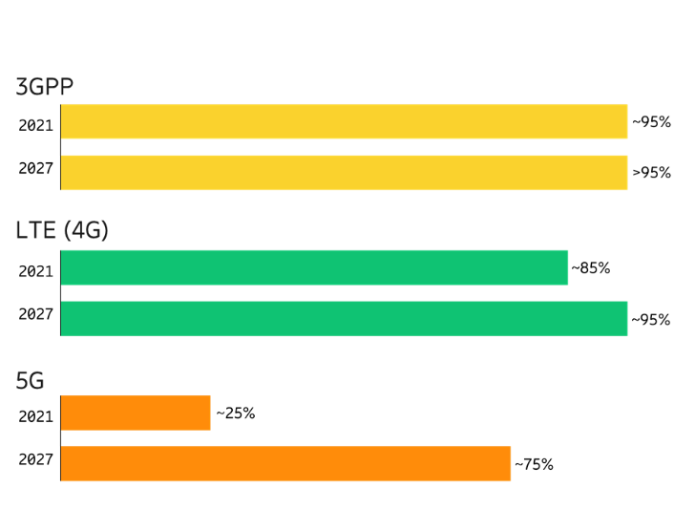

Fig 2. World population coverage by technology. The figures refer to coverage of each technology. The ability to utilize the technology is subject to factors such as access to devices and subscriptions

The 5G NR coverage comparison between 3500 MHz and some lower bands show that mobile operators, especially in developing countries, would benefit from deploying 5G NR in an extended 2100 MHz band to quickly have a nation-wide 5G coverage.

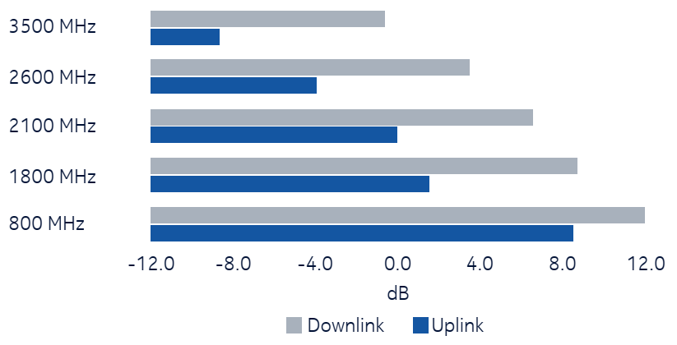

Figure 3: Coverage comparison for some bands between 3500 MHz to 800 MHz

The frequency range 1920 – 2010 / 2110 – 2200 MHz has been specified by 3GPP for both LTE and 5G NR as band 65 and n65, respectively, and thus provides an efficient 2x90 MHz arrangement with good capacity and large bandwidths for 4G-LTE as well as better coverage for 5G-NR systems with attractive and limited investment. The 3GPP TR 36.681 contains the study results for making 1980 – 2010 / 2170 – 2200 MHz available for terrestrial use in Region 3. The TR aimed to cover the feasibility of having a full band that would also include Band 1, i.e., what would eventually become the new Band 65, for LTE. The TR investigated implementation aspects such as duplexer options as well as co-existence issues with neighbouring bands. See TR 36.681 for the details. As a result of the study, a full band 3GPP Band 65 was seen feasible to be specified.

This extension of 3GPP Band 1/n1 is shown Figure 4 (taken from TR 38.891, Figure 5.1, that contains the study results when NR was introduced as Band n65). The figure also shows the nearby 3GPP bands.

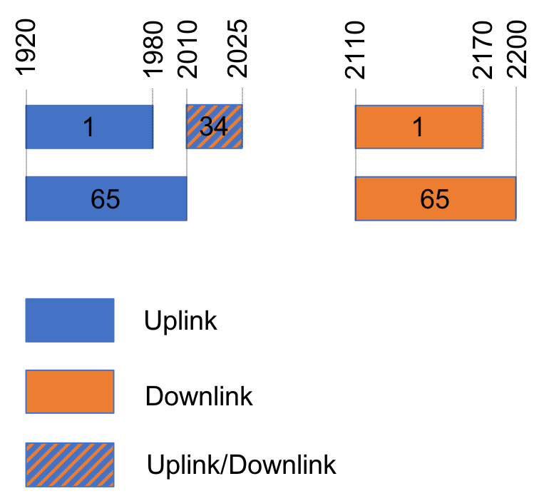

Figure 4: 3GPP bands nearby Band 65/n65

3GPP has done co-existence studies for the related 3GPP bands between the terrestrial systems of IMT. PHS has also been considered in Region 3, located below the uplink portion, where the same protection as used for the Band n1 is applied. To protect the terrestrial systems and bands the commonly used power reduction technique, Additional Maximum Power Reduction (A-MPR), is used. Out-of-band emissions masks have been defined to support co-existence between the terrestrial systems. For NR the outcome of the Band n65 feasibility study is captured in Technical Report (TR) 38.819.

The unwanted emission limits are the same for Bands 65 and n65; for Band n65 an additional UE requirement is added for protection of 1900-1920 MHz from emissions from the 50 MHz channel bandwidth also supported by n65. The in-band requirements are the essentially same for Band 65 and n65 with due modifications for differences between the radio interfaces (e.g. spectrum utilization is higher for NR). The details can be found in the specifications: LTE Band 65 can be found in 3GPP technical specifications (TS) 36.101 and 36.104 for the UE and BS respectively. For the NR Band n65 the specifications can be found in the TSs 38.101-1 and 38.104. AAS details can be found in the 3GPP TS 37.105.

It is noted that the NR spectrum utilization is more efficient as more contiguous bandwidth is available, thus, the combination of B1 and B6 increases the spectral efficiency of mobile cellular networks. In the next table is presented the bandwidth utilization for different NR carriers’ bandwidths assuming a subcarrier separation of 30 kHz as defined in the TS 38.104.

**Table 2: NR utilization of channel bandwidth**

|  |  |  |  |  |
| --- | --- | --- | --- | --- |
| **Channel BW per operator** | **Number of resource blocks (RBs)** | **Transmission BW (MHz)** | **Guard band BW (MHz)** | **Utilization (%)** |
| 20 MHz | 51 | 18.36 | 1.64 | 91.8 |
| 40 MHz | 106 | 38.16 | 1.84 | 95.4 |
| 50 MHz | 133 | 47.88 | 2.12 | 95.8 |
| 60 MHz | 162 | 58.32 | 1.68 | 97.2 |
| 80 MHz | 217 | 78.12 | 1.88 | 97.7 |
| 90 MHz | 245 | 88.20 | 1.80 | 98.0 |

Products needs to comply with the regulatory requirements concerning coexistence between satellite and terrestrial use. LTE and NR has been specified with requirements to coexist in same band. The coexistence means including mitigation techniques included in Resolution 212 (Rev. WRC-19) such as using guard bands and power levels, if necessary, can be provided by both LTE and NR.

Another aspect needs to be noted that 3GPP Rel-17 specifications are support 5G NR based satellite access deployed in FR1 bands serving handheld devices for global service continuity. The frequency range 1980-2010/2170-2200MHz has been specified as n256 for satellite-based NR Non-terrestrial networks (NTN) deployment.

1. **Considerations on the terrestrial and satellite use in the 2 GHz band**

In Recommendation M.1036-6 the range 1920 – 2010 / 2110 – 2200 MHz is described in Section 5 of the Annex and the most relevant notes for consideration are Notes 4 and 5 (See Table 1 in this Report and Attachment 3). Note 4 describes that the bands 1 980-2 010 MHz and 2 170-2 200 MHz in the frequency arrangement B6 are intended to be used in combination with the frequency arrangements B1 (1920 – 1980 / 2110 – 2170 MHz) which provides even further optimization of the use of spectrum for paired IMT operation. Note 5 states that a unique situation exists for the frequency arrangements B6 in the bands 1 980-2 010/2 170-2 200 MHz, which have been identified for the terrestrial component of IMT and the satellite component of IMT. Co‑coverage, co‑frequency deployment of independent satellite and terrestrial IMT components is not feasible unless appropriate mitigation techniques are applied. When these components are deployed in adjacent geographical areas in the same frequency bands, technical or operational measures need to be implemented if harmful interference is reported. This is also mentioned in the Resolution 212 (Rev. WRC-19).

As described in the Background Section 1, the footnotes related to the 1920 – 2010 / 2110 – 2200 MHz range for terrestrial IMT use in Region 3 in the ITU Radio Regulations (2020) from WRC-19 are No. 5.388 and 3.389A and they refer to the Resolutions 212, 223, and 716.

Resolution 212 (REV. WRC-19) handle the “implementation of IMT in the frequency bands 1 885-2 025 MHz and 2 110-2 200 MHz” and states that “administrations should take the technical and operational measures, such as those found in the Annex to this Resolution, to facilitate coexistence and compatibility between the terrestrial and satellite components of IMT in the frequency bands 1 980-2 010 MHz and 2 170‑2 200 MHz” and that, “in the event of harmful interference, the concerned administrations should investigate and take technical and operational measures, as appropriate, to reduce interference to an acceptable level”.

The Annex in Resolution 212 (REV. WRC-19) provides the guidance to concerned administrations on the technical, operational and other applicable measures in the deployment of terrestrial and satellite components of IMT for reducing the potential of harmful interference between the terrestrial and satellite components of IMT in the frequency bands 1 980-2 010 MHz and 2 170-2 200 MHz considering four interference scenarios. This Annex then list measures to be taken for the terrestrial component of IMT as well as the satellite component of IMT.

Resolution 223 (REV WRC-19) describes some additional frequency bands identified for IMT and the terrestrial IMT technology members.

Resolution 716 (REV WRC-12) describes the “Use of the frequency bands 1 980-2 010 MHz and 2 170-2 200 MHz in all three Regions and 2 010-2 025 MHz and 2 160-2 170 MHz in Region 2 by the fixed and mobile-satellite services and associated transition arrangements” and addresses the terrestrial mobile and fixed services when introducing mobile satellite systems using IMT in this frequency range.

Recommendation ITU-R M.1167 also identified that, rather than being shared with terrestrial component of IMT, the bands 1 980‑2 010 MHz and 2 170-2 200 MHz may be dedicated to use by the satellite component of IMT.

The results of sharing studies and co-existence measures could need to be considered to limit the impact with each other.

**7 Possible harmonized frequency arrangements for terrestrial IMT in the bands 1920 – 2010 / 2110 – 2200 MHz in Asia Pacific Region**

The frequency arrangements in the frequency band 1920 – 2010 / 2110 – 2200 MHz are based on the Recommendation ITU-R M.1036-6. Possible harmonized frequency arrangements for implementation of terrestrial IMT in the band 1 920 – 2 010 MHZ and 2 110 - 2 200 MHz are summarized in the following:

**Option 1:**

A harmonized band plan for implementation of terrestrial IMT systems in the frequency band 1920 – 2010 / 2110 – 2200 MHz of 2x90 MHz is provided in Figure 2, which create the largest contiguous band for IMT in the sub 3 GHz frequency range, therefor could support the development of telecommunication infrastructure in many countries and crucial in developing countries. This band plan is aligned with a combination of frequency arrangements B1 and B6 in the ITU-R Recommendation M.1036-6. 3GPP has specified this range as band 65/n65 as described in Section 5. Countries consider the use of this band plan could taking into account coexistence measures, as appropriate, between IMT systems operating in this band and the existing systems operating in this and adjacent bands as outlined in the ITU Resolutions 212 (revised WRC-19) and 223 (revised WRC-19).

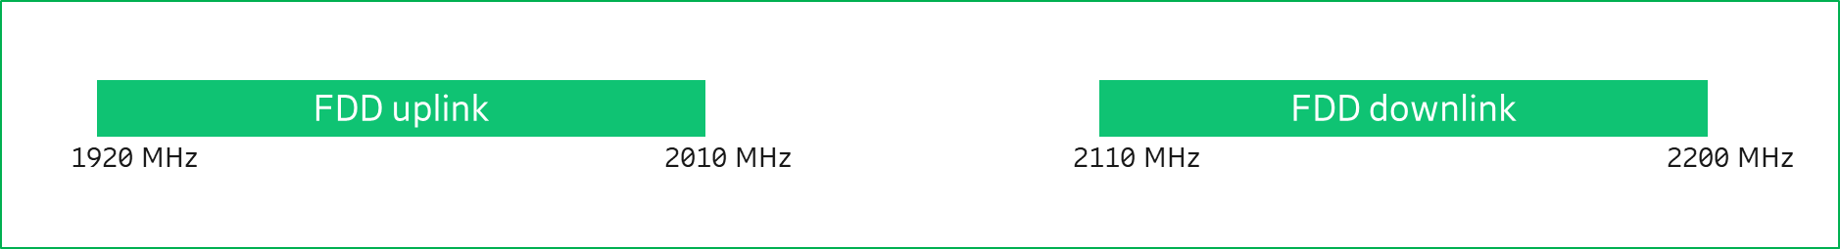

Figure 5: A possible harmonized frequency arrangement for the 1920 – 2010 / 2110 – 2200 MHz band in Asia Pacific Region

Use of this band plan should take into account coexistence measures, as appropriate, between IMT systems operating in this band and the existing systems operating in this and adjacent bands as outlined in the ITU Resolutions 212 (revised WRC-19), 223 (revised WRC-19), and Recommendation ITU M.1036-6 and the results of AWG sharing studies in Report XYZ.

**Option 2:**

Based on the APT Report-46 Rev.2 "*APT Frequency Usage of the Bands* *1 980 – 2 010 MHZ and 2 170 - 2 200 MHz in Asia Pacific Region*", several countries in the Asia-Pacific region have deployed or are planning to deploy satellite IMT systems in these bands. It is clear that there is another frequency arrangement in Asia-Pacific region which is the implementation of terrestrial component IMT systems in the frequency band 1920 – 1980 / 2110 – 2170 MHz of 2x60 MHz and the implementation of satellite component of IMT systems in the frequency band 1980 – 2010 / 2170 – 2200 MHz of 2x30 MHz. In the frequency band 1 920-1980 MHz and 2110 – 2170 MHz, the B1 arrangement is implemented.



Figure 6: A possible harmonized frequency arrangement for the 1920 – 2010 / 2110 – 2200 MHz band in Asia Pacific Region

________________

**ATTACHMENT 1**

RESOLUTION 212 (REV.WRC‑19)

Implementation of International Mobile Telecommunications in the frequency bands 1 885-2 025 MHz and 2 110-2 200 MHz

The World Radiocommunication Conference (Sharm el-Sheikh, 2019),

considering

*a)* that Resolution ITU‑R 56 defines the naming for International Mobile Telecommunications (IMT);

*b)* that the ITU Radiocommunication Sector (ITU‑R), for WRC‑97, recommended approximately 230 MHz for use by the terrestrial and satellite components of IMT;

*c)* that ITU‑R studies forecast that additional spectrum may be required to support the future services of IMT and to accommodate future user requirements and network deployments;

*d)* that ITU‑R has recognized that the satellite component is an integral part of IMT;

*e)* that, in No. **5.388**, WARC‑92 identified frequency bands to accommodate certain mobile applications defined as IMT,

noting

*a)* that both the terrestrial and satellite components of IMT have already been deployed or are being considered for deployment within the frequency bands 1 885-2 025 MHz and 2 110‑2 200 MHz;

*b)* that the availability of the satellite component of IMT in the frequency bands 1 980‑2 010 MHz and 2 170-2 200 MHz simultaneously with the terrestrial component of IMT in the frequency bands identified in No. **5.388** would improve the overall use of IMT,

noting further

*a)* that co‑coverage, co-frequency deployment of independent satellite and terrestrial IMT components is not feasible unless techniques, such as the use of an appropriate guardband or other mitigation techniques, are applied to ensure coexistence and compatibility between the terrestrial and satellite components of IMT, but that co-coverage, co-frequency deployment of terrestrial and satellite components of IMT could be feasible if deployed as integrated networks supported by a system providing the management of frequency utilization by both components;

*b)* that, when the satellite and terrestrial components of IMT are deployed in the frequency bands 1 980-2 010 MHz and 2 170-2 200 MHz, technical or operational measures may need to be implemented to avoid harmful interference,

resolves

1 that administrations which implement IMT:

*a)* should make the necessary frequencies available for system development;

*b)* should use those frequencies when IMT is implemented;

*c)* should use the relevant international technical characteristics, as identified by Recommendations of ITU‑R and of the ITU Telecommunication Standardization Sector;

2 that administrations should take the technical and operational measures, such as those found in the Annex to this Resolution, to facilitate coexistence and compatibility between the terrestrial and satellite components of IMT in the frequency bands 1 980-2 010 MHz and 2 170‑2 200 MHz;

3 that, in the event of harmful interference, the concerned administrations should investigate and take technical and operational measures, as appropriate, to reduce interference to an acceptable level,

invites the ITU Radiocommunication Sector

to study possible technical and operational measures to improve co-existence and compatibility between the terrestrial and satellite components of IMT in the frequency bands 1 980-2 010 MHz and 2 170‑2 200 MHz where those frequency bands are shared by the mobile service and the mobile-satellite service in different countries, in particular for the deployment of independent satellite and terrestrial components of IMT and to facilitate development of both the satellite and terrestrial components of IMT,

invites administrations

1 to give due consideration to the accommodation of other services currently operating in these frequency bands when implementing IMT;

2 to facilitate coexistence of the satellite component of IMT with the terrestrial component of IMT in the frequency band 1 980-2 010 MHz, by the concerned administrations, as appropriate, considering the following:

*a)* to apply an uplink direction from user equipment to IMT base stations as provided in the latest version of Recommendation ITU‑R M.1036, for the user equipment belonging to the terrestrial component of IMT in the frequency band 1 980-2 010 MHz (see the Annex to this Resolution);

*b)* that, in the event of harmful interference to the satellite component of the IMT space station, the concerned administrations may take additional steps to facilitate the reduction of harmful interference to an acceptable level;

3 to facilitate coexistence of the terrestrial component of IMT stations with the satellite component of IMT in the frequency band 2 170-2 200 MHz, by the concerned administrations, as appropriate, considering the following:

*a)* to apply an appropriate power flux-density value to the IMT space stations in the frequency band 2 170-2 200 MHz (see the Annex to this Resolution);

*b)* that, in the event of harmful interference to the terrestrial component of IMT, the concerned administrations may take additional steps to facilitate the reduction of harmful interference to an acceptable level.

Annex to Resolution 212 (Rev.WRC-19)

Guidance on the implementation of technical and operational measures to facilitate coexistence between terrestrial and satellite components of International Mobile Telecommunications in the frequency bands 1 980-2 010 MHz and 2 170-2 200 MHz

This Annex provides guidance to concerned administrations on the following technical, operational and other applicable measures in the deployment of terrestrial and satellite components of International Mobile Telecommunications (IMT) for reducing the potential of harmful interference between the terrestrial and satellite components of IMT in the frequency bands 1 980-2 010 MHz and 2 170-2 200 MHz for the interference scenarios indicated in the table below, noting the applicability of any relevant Article **9** coordination procedures for scenarios A2, B1 and B2. The identified measures may be applicable for some scenarios and may not be applicable to other scenarios, and may or may not be implementable in satellite and terrestrial IMT system designs.

Interference scenarios

| Scenario | From | To |
| --- | --- | --- |
| A1 | Terrestrial IMT base station or mobile station | Satellite IMT space station |
| A2 | Terrestrial IMT base station | Satellite IMT mobile earth station |
| B1 | Satellite IMT mobile earth station | Terrestrial IMT base station or user equipment |
| B2 | Satellite IMT space station | Terrestrial IMT user equipment |

1) Measures for the terrestrial component of IMT:

a) Use base station antennas with improved sidelobe performance as shown in relevant ITU‑R Recommendations and Reports (e.g. improved antenna patterns compared with those contained in Recommendation ITU‑R F.1336).

b) Consider the orientation in elevation and/or in azimuth of the IMT base station antenna pointing in the coexistence analysis with a view to reducing the interference level from the IMT base station above the horizon.

c) Consider the impact of the actual deployment scenario, including the activity factor values of the terrestrial component of IMT, on the coexistence.

d) Consider attenuation from terrain and clutter taking into account the deployment environments and propagation effects in the coexistence analysis.

e) Consider reducing the equivalent isotropically radiated power in the frequency band 1 980-2 010 MHz to a level sufficient for coexistence, for example, nominally to −10 dB(W/5 MHz)[3]1.

f) Set the transmission direction for the use of the frequency band 1 980-2 010 MHz with regard to the IMT base station to operate in receive mode as found in relevant ITU‑R Recommendations.

g) Implement other applicable interference mitigation techniques.

2) Measures for the satellite component of IMT:

a) Use narrower spot beams and steeper roll-off from the boresight of the satellite antenna (i.e. not only reducing the interference level from the antenna sidelobe but also increasing frequency reuse and resilience to interference).

b) Antenna steering, where such capability exists in the satellite design.

c) Beamforming and/or beam nulling of the satellite antenna (e.g. digital processing of multi‑element beamforming technique, which has the capability to suppress received interference from regions on the Earth).

d) Dynamic frequency management paired with geographical separation (e.g. monitoring interference in real time and dynamically assigning channels and/or beams).

e) Consider reducing the power flux-density to a level sufficient for coexistence, for example to nominally −122 dBW/m2 for 1 MHz[4]2 for the protection of some base stations or nominally −108.8 dBW/m2 for 1 MHz for the protection of some user equipment on the Earth’s surface on the territories of other administrations using this frequency band for the terrestrial IMT component.

f) Consider an appropriate elevation angle model of an earth station and handover method by a satellite control system in the coexistence analysis.

g) Consider actual activity factor values, which may result in a reduction of interference.

h) Apply a polarization of the satellite antenna different from that of the terrestrial station receiver (for example, use of linear polarization by the terrestrial station receivers and circular polarization by the satellite may provide some benefit).

i) Implement other applicable interference mitigation techniques.

**ATTACHMENT 2**

RESOLUTION 223 (REV.WRC‑19)

Additional frequency bands identified for International   
Mobile Telecommunications

The World Radiocommunication Conference (Sharm el-Sheikh, 2019),

considering

*a)* that International Mobile Telecommunications (IMT), including IMT-2000, IMT‑Advanced and IMT-2020, is the ITU vision of global mobile access;

*b)* that IMT systems provide telecommunication services on a worldwide scale regardless of location, network or terminal used;

*c)* that IMT provides access to a wide range of telecommunication services supported by fixed telecommunication networks (e.g. public switched telephone network (PSTN)/integrated services digital network (ISDN), high bit rate Internet access), and to other services which are specific to mobile users;

*d)* that the technical characteristics of IMT are specified in ITU Radiocommunication Sector (ITU‑R) and ITU Telecommunication Standardization Sector (ITU‑T) Recommendations, including Recommendations ITU‑R M.1457 and ITU‑R M.2012, which contain the detailed specifications of the terrestrial radio interfaces of IMT;

*e)* that the evolution of IMT is being studied within ITU‑R;

*f)* that the review of IMT-2000 spectrum requirements at WRC‑2000 concentrated on the frequency bands below 3 GHz;

*g)* that at WARC‑92, 230 MHz of spectrum was identified for IMT-2000 in the frequency bands 1 885-2 025 MHz and 2 110-2 200 MHz, including the frequency bands 1 980-2 010 MHz and 2 170-2 200 MHz for the satellite component of IMT-2000, in No. **5.388** and under the provisions of Resolution **212 (Rev.WRC‑19)**;

*h)* that since WARC‑92 there has been a tremendous growth in mobile communications including an increasing demand for broadband multimedia capability;

*i)* that the frequency bands identified for IMT are currently used by mobile systems or applications of other radiocommunication services;

*j)* that Recommendation ITU‑R M.1308 addresses the evolution of existing mobile communication systems to IMT-2000, and that Recommendation ITU‑R M.1645 addresses the evolution of the IMT systems and maps out their future development;

*k)* that harmonized worldwide frequency bands for IMT are desirable in order to achieve global roaming and the benefits of economies of scale;

*l)* that the frequency bands 1 710-1 885 MHz, 2 500-2 690 MHz and 3 300-3 400 MHz are allocated to a variety of services in accordance with the relevant provisions of the Radio Regulations;

*m)* that the frequency band 2 300-2 400 MHz is allocated to the mobile service on a co‑primary basis in the three ITU Regions;

*n)* that the frequency band 2 300-2 400 MHz, or portions thereof, is used extensively in a number of administrations by other services including the aeronautical mobile service (AMS) for telemetry in accordance with the relevant provisions in the Radio Regulations;

*o)* that IMT has already been deployed or is being considered for deployment in some countries in the frequency bands 1 710-1 885 MHz, 2 300-2 400 MHz and 2 500-2 690 MHz and equipment is readily available;

*p)* that the frequency bands 1 710-1 885 MHz, 2 300-2 400 MHz and 2 500-2 690 MHz, or parts thereof, are identified for use by administrations wishing to implement IMT;

*q)* that technological advancement and user needs will promote innovation and accelerate the delivery of advanced communication applications to consumers;

*r)* that changes in technology may lead to the further development of communication applications, including IMT;

*s)* that timely availability of spectrum is important to support future applications;

*t)* that IMT systems are envisaged to provide increased peak data rates and capacity that may require a larger bandwidth;

*u)* that ITU‑R studies forecasted that additional spectrum may be required to support the future services of IMT and to accommodate future user requirements and network deployments;

*v)* that the frequency band 1 427-1 429 MHz is allocated to the mobile, except aeronautical mobile, service in all three Regions on a primary basis;

*w)* that the frequency band 1 429-1 525 MHz is allocated to the mobile service in Regions 2 and 3 and to the mobile, except aeronautical mobile, service in Region 1 on a primary basis;

*x)* that the frequency band 1 518-1 559 MHz is allocated in all three Regions to the mobile-satellite service (MSS) on a primary basis[5]1;

*y)* that WRC-15 identified the frequency band 1 427-1 518 MHz for use by administrations wishing to implement terrestrial IMT systems;

*z)* that there is a need to ensure the continued operations of the MSS in the frequency band 1 518‑1 525 MHz;

*aa)* that appropriate technical measures to facilitate adjacent frequency band compatibility between the MSS in the frequency band 1 518-1 525 MHz and IMT in the frequency band 1 492‑1 518 MHz need to be studied;

*ab)* Report ITU‑R RA.2332, on compatibility and sharing studies between the radio astronomy service and IMT systems in the frequency bands 608-614 MHz, 1 330-1 400 MHz, 1 400‑1 427 MHz, 1 610.6-1 613.8 MHz, 1 660-1 670 MHz, 2 690-2 700 MHz, 4 800-4 990 MHz and 4 990‑5 000 MHz;

*ac)* that WRC-15 and this conference identified the frequency band 3 300-3 400 MHz for use by administrations wishing to implement terrestrial IMT systems in Nos. **5.429B**, **5.429D** and **5.429F**;

*ad)* that the frequency band 3 300-3 400 MHz is allocated worldwide on a primary basis to the radiolocation service;

*ae)* that a number of administrations use the frequency band 3 300-3 400 MHz, or portions thereof, which is allocated to the fixed and mobile services on a primary basis in No. **5.429**;

*af)* that the frequency band 4 800-4 990 MHz is allocated worldwide to the mobile and fixed services on a primary basis;

*ag)* that WRC‑15 and this conference identified the frequency band 4 800-4 990 MHz for use by administrations wishing to implement terrestrial IMT systems in countries listed in Nos. **5.441A** and **5.441B**;

*ah)* that appropriate technical measures may be considered by administrations at a national level to facilitate adjacent frequency band compatibility between radio astronomy receivers in the frequency band 4 990-5 000 MHz and IMT systems in the frequency band 4 800‑4 990 MHz,

emphasizing

*a)* that flexibility must be afforded to administrations:

– to determine, at a national level, how much spectrum to make available for IMT from within the identified frequency bands;

– to develop their own transition plans, if necessary, tailored to meet their specific deployment of existing systems;

– to have the ability for the identified frequency bands to be used by all services having allocations in those frequency bands;

– to determine the timing of availability and use of the frequency bands identified for IMT, in order to meet particular user demand and other national considerations;

*b)* that the particular needs of developing countries must be met;

*c)* that Recommendation ITU‑R M.819 describes the objectives to be met by IMT‑2000 in order to meet the needs of developing countries,

noting

*a)* Resolutions **224 (Rev.WRC‑19)** and **225 (Rev.WRC‑12)**, which also relate to IMT;

*b)* that the sharing implications between services sharing the frequency bands identified for IMT in No. **5.384A**, as relevant, will need further study in ITU‑R;

*c)* that studies regarding the availability of the frequency band 2 300-2 400 MHz for IMT are being conducted in many countries, the results of which could have implications for the use of those frequency bands in those countries;

*d)* that, due to differing requirements, not all administrations may need all of the IMT frequency bands identified at WRC‑07, or, due to the usage by and investment in existing services, may not be able to implement IMT in all of those frequency bands;

*e)* that the spectrum for IMT identified by WRC‑07 may not completely satisfy the expected requirements of some administrations;

*f)* that currently operating mobile communication systems may evolve to IMT in their existing frequency bands;

*g)* that services such as the fixed service, the mobile service (second-generation systems), the space operation service, the space research service and the AMS are in operation or planned in the frequency band 1 710‑1 885 MHz, or portions thereof;

*h)* that in the frequency band 2 300-2 400 MHz, or portions thereof, there are services such as the fixed, mobile, amateur and radiolocation services which are currently in operation or planned to be in operation in the future;

*i)* that services such as the broadcasting-satellite service (BSS), the BSS (sound), the MSS (in Region 3) and the fixed service (including multipoint distribution/communication systems) are in operation or planned in the frequency band 2 500-2 690 MHz, or portions thereof;

*j)* that the identification of several frequency bands for IMT allows administrations to choose the best frequency band or parts thereof for their circumstances;

*k)* that further study of the technical and operational measures regarding adjacent frequency band compatibility between IMT systems operating below 3 400 MHz and fixed-satellite service earth stations operating above 3 400 MHz may be required;

*l)* that ITU‑R has identified additional work to address further developments in IMT;

*m)* that the IMT terrestrial radio interfaces as defined in Recommendations ITU‑R M.1457 and ITU‑R M.2012 are expected to evolve within the framework of ITU‑R beyond those initially specified, to provide enhanced services and services beyond those envisaged in the initial implementation;

*n)* that the identification of a frequency band for IMT does not establish priority in the Radio Regulations and does not preclude the use of the frequency band for any application of the services to which it is allocated;

*o)* that the provisions of Nos. **5.317A**, **5.384A**, **5.388**, **5.429B**, **5.429D**, **5.429F**, **5.441A** and **5.441B** do not prevent administrations from having the choice to implement other technologies in the frequency bands identified for IMT, based on national requirements,

recognizing

that for some administrations the only way of implementing IMT would be spectrum refarming, requiring significant financial investment,

resolves

1 to invite administrations planning to implement IMT to make available, based on user demand and other national considerations, additional frequency bands or portions of the frequency bands above 1 GHz identified in Nos. **5.341B**, **5.384A**, **5.429B**, **5.429D**, **5.429F**, **5.441A** and **5.441B** for the terrestrial component of IMT; due consideration should be given to the benefits of harmonized utilization of the spectrum for the terrestrial component of IMT, taking into account the services to which the frequency band is currently allocated;

2 to acknowledge that the differences in the texts of Nos. **5.341B**, **5.384A** and **5.388** do not confer differences in regulatory status;

3 that in the frequency bands 4 800-4 825 MHz and 4 835-4 950 MHz, in order to identify potentially affected administrations when applying the procedure for seeking agreement under No. **9.21** by IMT stations in relation to aircraft stations, a coordination distance from an IMT station to the border of another country equal to 300 km (for land path)/450 km (for sea path) applies;

4 that in the frequency band 4 800-4 990 MHz, in order to identify potentially affected administrations when applying the procedure for seeking agreement under No. **9.21** by IMT stations in relation to fixed-service stations or other ground-based stations of the mobile service, a coordination distance from an IMT station to the border of another country equal to 70 km applies;

5 that the power flux-density (pfd) limits in No. **5.441B**, which is subject to review at WRC‑23, shall not apply to the following countries: Armenia, Brazil, Cambodia, China, Russian Federation, Kazakhstan, Lao P.D.R., Uzbekistan, South Africa, Viet Nam and Zimbabwe,

invites the ITU Radiocommunication Sector

1 to conduct compatibility studies in order to provide technical measures to ensure coexistence between the MSS in the frequency band 1 518-1 525 MHz and IMT in the frequency band 1 492-1 518 MHz, including guidance on the implementation of frequency arrangements for IMT deployment in the frequency band 1 427-1 518 MHz, taking into account the results of these studies;

2 to study the technical and regulatory conditions for the protection of stations of the AMS and the maritime mobile service (MMS) located in international airspace or waters (i.e. outside national territories) and operated in the frequency band 4 800-4 990 MHz;

3 to continue providing guidance to ensure that IMT can meet the telecommunication needs of developing countries and rural areas;

4 to include the results of the studies mentioned in *invites the ITU Radiocommunication Sector* above in one or more ITU‑R Recommendations and Reports, as appropriate,

invites the 2023 World Radiocommunication Conference

to consider, based on the results of the studies referred to in *invites the ITU Radiocommunication Sector* above, possible measures to address, in the frequency band 4 800-4 990 MHz, protection of stations of the AMS and MMS located in international airspace and waters from other stations located within national territories and to review the pfd criteria in No. **5.441B**.

**ATTACHMENT 3**

**Notes in the ITU Recommendation M.1036-6 that are relevant for the frequency range 1920 – 2020 / 2110 – 2200 MHz (See Table 1 in Section 1 Background).**

*Note 1*: In the band 1 710-2 025 MHz and 2 110-2 200 MHz three basic frequency arrangements (B1, B2 and B3) are already in use or planned to be used by public mobile cellular systems including IMT. Based on these three arrangements, different combinations of arrangements are recommended as described in B4 and B5. The B1 arrangement and the B2 arrangement are fully complementary, whereas the B3 arrangement partly overlaps with the B1 and B2 arrangements.

For administrations having implemented the B1 arrangement, B4 enables optimization of the use of spectrum for paired IMT operation.

For administrations having implemented the B3 arrangement, the B1 arrangement can be combined with the B2 arrangement. B5 is therefore recommended to optimize the use of the spectrum:

– B5 enables the use of spectrum to be maximized for IMT in administrations where B3 is implemented and where the band 1 770‑1 850 MHz is not available in the initial phase of deployment of IMT in this frequency band.

*Note 2:* TDD may be introduced in unpaired bands and also under certain conditions in the uplink bands of paired frequency arrangements and/or in the centre gap between paired bands.

*Note 4:* The bands 1 980-2 010 MHz and 2 170-2 200 MHz in the frequency arrangement B6 are intended to be used in combination with the frequency arrangements B1 or B4 which provides even further optimization of the use of spectrum for paired IMT operation (see Note 1).

*Note 5:* A unique situation exists for the frequency arrangements B6 and B7 and parts of arrangements B3 and B5 in the bands 1 980-2 010 MHz and 2 170-2 200 MHz, which have been identified for the terrestrial component of IMT and the satellite component of IMT as outlined in recognizing d). Co‑coverage, co‑frequency deployment of independent satellite and terrestrial IMT components is not feasible unless appropriate mitigation techniques are applied. When these components are deployed in adjacent geographical areas in the same frequency bands, technical or operational measures need to be implemented if harmful interference is reported. Further studies may be carried out by ITU‑R, as appropriate, taking into account the results of WRC-19.

_______________

1. ** *Note by the Secretariat:*  This Resolution was revised by WRC-12.
2. Global mobile Suppliers Association (GSA)
3. 1 See user terminal characteristics in Report ITU-R M.2292.
4. 2 See Resolution **539 (Rev.WRC**‑**19)** for the frequency band 2 605-2 655 MHz.
5. 1 See Table **21‑4** for applicable pfd limits.