

**the APT REPORT ON “THE USAGE OF ITS in APT COUNTRIES”**

**No. APT/AWG/REP-18(Rev2)  
Edition: April 2018**

**Adopted by**

**10th Meeting of the APT Wireless Group**

**22 – 25 March 2011, Bangkok, Thailand**

***(Source: AWG-10/OUT-02)***

**First Revision at**

**14th APT Wireless Group Meeting**

**18 – 21 March 2013**

**Bangkok, Thailand**

***(Source: AWG-14/OUT-06)***

**Second Revision at**

**23rd Meeting of APT Wireless Group  
9 – 13 April 2018, Da Nang City, Socialist Republic of Viet Nam**

***(Source: AWG-23/OUT-06)***

**the APT REPORT ON “THE USAGE OF ITS in APT COUNTRIES”**

TABLE OF CONTENTS

xx April 2018 1

1 Scope 3

2 Background 3

3 Related documents 3

4 List of acronyms and abbreviations 4

5 Overview of ITS radiocommunication and automotive radar 5

5.1 ITS radiocommunication 6

5.1.1 Terms and definitions 6

5.1.2 Technical characteristics 7

5.2 Automotive radar 7

5.3 Global Navigation Satellite Systems in ITS 8

6 Legacy ITS radiocommunication - ETC 9

6.1 Overview 9

6.1.1 Technical characteristics 9

6.1.2 Standardization 10

6.1.3 Applications 10

6.2 Asia-Pacific 11

6.2.1 Technical characteristics 11

6.2.2 Frequency usage 14

6.2.3 Standardization 15

6.2.4 Applications 16

7 Advanced ITS radiocommunication 17

7.1 Overview 17

7.1.1 Technical characteristics 21

7.1.2 Frequency usage 33

7.1.3 Best practice and experiences on the usage of the bands between ITS and other applications / services 35

7.1.4 Standardization, technical specifications, technical reports and ITU deliverables 35

7.1.5 Applications 38

7.2 Asia-Pacific 49

7.2.1 Technical Characteristics 49

7.2.2 Frequency usage 51

7.2.3 Standardization 52

8 Millimetre-wave automotive radar 53

8.1 Overview 53

8.1.1 Technical characteristics 54

8.1.2 Frequency usage 58

8.1.3 Standardization 59

8.1.4 Applications 59

8.2 Asia-Pacific 60

8.2.1 Frequency usage 60

8.2.2 Standardization 61

8.2.3 Applications 61

9 Results of Studies 64

# 1 Scope

This report addresses the usages of Intelligent Transport System (ITS) radiocommunication applications, such as vehicle to infrastructure, vehicle to vehicle, vehicle to pedestrian communications for traffic safety related and traffic efficiency applications as well as electronic tolling systems and automotive radars for collision avoidance in APT Member countries.

This report identifies current and planned usage of ITS technologies, frequency bands, status of standardization, applications and deployments in ITU Member States.

# 

# 2 Background

Asia-Pacific Telecommunity (APT) published APT Report on “The usage of intelligent transport systems in APT Countries” [Revision 1 ([APT/AWG/REP-18](http://www.aptsec.org/sites/default/files/2016/09/AWG-20-TMP-44_ITS_USAGE_Consolidated_R2_clear.docx))].

Since May 2014, Working Party 5A (WP 5A) started developing new Report ITU-R M.[ITS USAGE] Intelligent transport systems (ITS) usage in ITU Member States.

During the WRC-15 in November 2015, WRC-19 agenda item (A.I.) 1.12 – ITS applications was approved. Under A.I. 1.12, WP 5A is responsible group to consider global or regional harmonized frequency bands, to the maximum extent possible, for the implementation of evolving ITS under existing mobile-service allocations in accordance with Resolution **237 (WRC-15)**.

To consider global or regional harmonized frequency bands for the implementation of evolving ITS, this new Report ITU-R M.[ITS USAGE] “ITS usage in ITU Member States” will be an important reference material. To meet A.I. 1.12, new Report ITU-R M.[ITS USAGE] should be published as early as possible.

# 3 Related documents

**ITU-R Recommendations:**

ITU-R M.1890 Intelligent transport systems – Guidelines and objectives

ITU-R M.1452 Millimetre wave radiocommunication systems for Intelligent Transport Systems applications

ITU-R M.1453 Intelligent Transport Systems – dedicated short-range communications at 5.8 GHz

ITU-R M.2057 Systems characteristics of automotive radars operating in the frequency band 76 - 81 GHz for intelligent transport systems applications

ITU-R M.2084 Radio interface standards of vehicle-to-vehicle and vehicle-to-infrastructure communication for intelligent transport systems applications

ITU-R M.2084 Working document towards a preliminary draft new Recommendation ITU-R M.[ITS_FRQ] Harmonization of frequency arrangements for Intelligent Transport Systems in the mobile service

**ITU-R Report:**

ITU-R M.2228 Advanced intelligent transport systems (ITS) radiocommunication

ITU-R M.2322 Systems characteristics and compatibility of automotive radars operating in the frequency band 77.5 - 78 GHz for sharing studies

ITU-R F.2394 Compatibility between point-to-point applications in the fixed service operating in the 71 - 76 GHz and 81 - 86 GHz bands and automotive radar applications in the radiolocation service operating in the 76 - 81 GHz bands

**ITU-R Handbook:**

Land Mobile (including Wireless Access) - Volume 4: Intelligent Transport Systems

# 4 List of acronyms and abbreviations

3GPP The 3rd Generation Partnership Project

APT Asia-Pacific Telecommunity

ARIB Association of Radio Industries and Businesses (Japan)

ATIS Alliance for Telecommunications Industry Solutions (U.S.A.)

AWG APT Wireless Group

C-ITS Cooperative ITS communication

C2C- CC CAR-to-CAR Communication Consortium

CAMP Crash Avoidance Metric Partnership

CCSA China Communications Standards Association

CEN European Committee for Standardization

CEPT European Conference of Postal and Telecommunications Administrations

D2D Device-to-device

ECC Electronic Communications Committee

ETSI European Telecommunications Standards Institute

FCC Federal Communications Commission

IEEE Institute of Electrical and Electronics Engineers

IMDA Infocomm Media Development Authority (Singapore)

ISO International Organization for Standardization

ITS Intelligent Transport Systems

LTE Long Term Evolution

LTE-V2X LTE based Vehicle to Infrastructure/Vehicle/Network/Pedestrians and

others

MBSFN Multicast-Broadcast Single-Frequency Network

OoC Out of coverage

PC5 Device-to-Device Direct Link

RLAN Radio Local Area Network

SC-PTM Single Cell Point To Multipoint

TIA Telecommunications Industry Association (U.S.A.)

TSAC Telecommunications Standards Advisory Committee (Singapore)

TTA Telecommunication Technology Association (Korea, (Republic of))

Uu Link between Base Station and Device

V2I Vehicle to Infrastructure

V2N Vehicle to Network

V2P Vehicle to Pedestrians

V2V Vehicle to Vehicle

V2X Vehicle to Infrastructure/Vehicle/Network/Pedestrians and others

WAVE Wireless Access in Vehicular Environments

WLAN Wireless Local Area Network

# 5 Overview of ITS radiocommunication and automotive radar

Since several decades ago, traffic congestion has been increasing all over the world as results of increased motorization, urbanization, population growth, and changes in population density. Congestion reduces efficiency of transportation infrastructure and increases travel time, air pollution, and fuel consumption. Interest in ITS comes from the problems caused by traffic congestion and a synergy of new information technology for simulation, real-time control, and communications networks. Namely, ITS is system to support transportation of goods and humans with information and communication technologies in order to efficiently and safely use the transport infrastructure and transport means (cars, motorcycles, bicycles, trains, planes, ships, and other)[1].

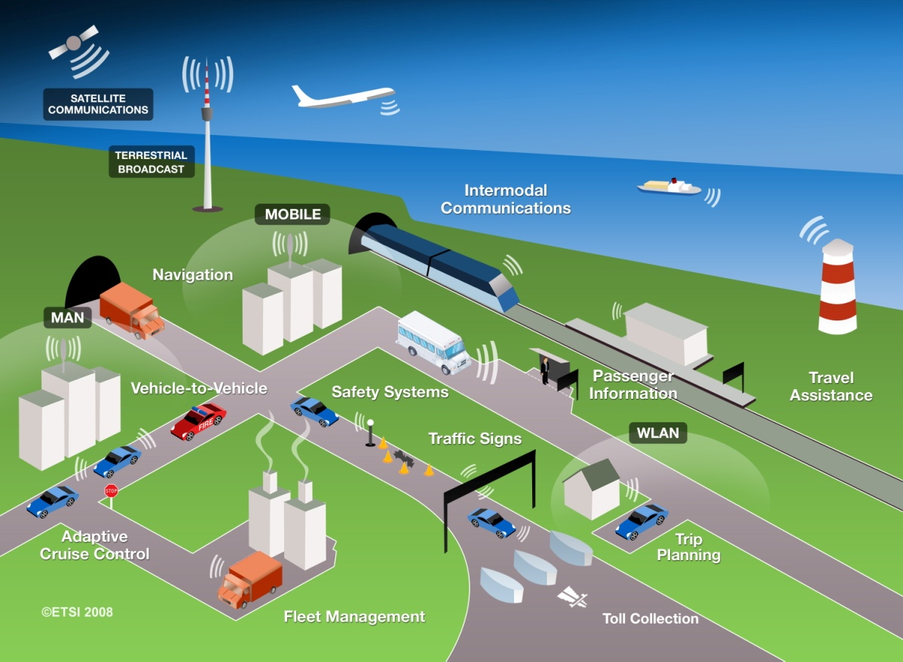

**Figure 1 Communication technologies and services for ITS[2]**

ITS have been standardized and studied in various standards development organizations. As an international level, ITU-R ISO TC 204, and IEEE are working on developing the standards, recommendations and reports.

In Asia-Pacific, AWG is working as a regional level as well as ARIB, TTA, IMDA TSAC and other standard organizations in each country and region. In Europe, ETSI TC ITS and CEN TC278 are working as a regional level.

This report identifies current and planned usage of ITS technologies, frequency bands, status of applications and deployment in APT member countries.

The major deployed ITS in the world were classified as electronic toll collection, automotive radar, and vehicle information & communication. In this report, we described applications overview, established standards, frequency plan, and implication in each ITS.

## 5.1 ITS radiocommunication

Electronic toll collection allows the manual in-lane toll collection process to be automated in such a way that drivers do not have to stop and pay cash at a toll booth. ETC systems improve traffic flow at toll plazas, and the level of pollution by reducing fuel consumption. In addition, allowing traffic to pass through the gate without stopping can increase road capacity by three or four times and relieve traffic congestion at the tollgate. It is also expected that ETC systems will reduce the operating costs of toll roads by replacing manual toll collection.

Since 1996, Vehicle Information and Communication System (VICS) has been used in Japan for delivering traffic and travel information to road vehicle drivers.

Nowadays, to extend beyond the existing ITS applications and to achieve traffic safety enhancement and reduce the environmental impact by the transportation sector, vehicle-to-vehicle (V2V), vehicle-to-infrastructure (V2I), infrastructure-to-vehicle (I2V) communications are studied. According to this progress, ITU-R WP 5A has developed report on advanced ITS radiocommunication [3]. In the report, legacy ITS and advanced ITS are classified by their technical characteristics as shown in Table 1, Wireless Access in Vehicular Environments (WAVE) and Continuous Access for Land Mobiles (CALM) technologies and ITS Connect could be inclusive in advanced ITS category.

### 5.1.1 Terms and definitions

|  |  |
| --- | --- |
| Dedicated Short Range Communication (DSRC) | **Europe:** road tolling and similar applications |
| **North America**: vehicle-to-vehicle and vehicle-to-infrastructure communication based on IEEE 802.11p / WAVE technology in 5.9 GHz, comparable to C-ITS based on IEEE 802.11p / ITS-G5 in Europe. |
| **Japan**: technology for ETC, road tolling and vehicle-to-infrastructure traffic information systems |

|  |  |
| --- | --- |
| Legacy ITS | * TTT: Transport and Traffic Telematic, mainly in Region 1, also called DSRC in Europe   + CEN DSRC tolling   + HDR DSRC tolling, * ETC: In Japan, Korea and China * VICS: In Japan |
| Advanced ITS | Cooperative ITS (C-ITS) building on ad hoc networks with vehicle-to-vehicle (V2V) and vehicle-to-infrastructure communication (V2I), together called vehicle-to-X (V2X), e.g.   * V2X (ETSI ITS-G5, IEEE 802.11p) * V2X (LTE based V2X) * V2X (WAVE, IEEE 802.11p), also called DSRC in US * V2X (ITS Connect, ARIB STD-T109) |

It should be noted that the term DSRC has different meanings in various regions. All ITS technologies in this document are structured in the legacy ITS (already existing in the market for several years) and advanced ITS (shortly deployed or in deployment phase).

### 5.1.2 Technical characteristics

**Table 1 Technical characteristics of legacy ITS and advanced ITS**

|  |  |  |
| --- | --- | --- |
| Items | Legacy ITS | Advanced ITS |
| Technology Name | TTT  ETC  VICS | ETSI ITS-G5 (IEEE 802.11p)  WAVE (IEEE 802.11p)  DSRC (ARIB STD-T75)  ITS Connect (ARIB STD-T109)  LTE-V2X (3GPP 36-series Rel.14 and beyond) |
| ITS Connectivity Scope | V2I | V2I  V2V  V2P  V2NNote 1, 2 |
| **Radio Performance** | | |
| Typical Coverage Range | Up to 100m | 20 - 1000 m |
| Data Rate Note 3 | 1.2 kbps up to 4 Mbps | 1-1000 Mbps |
| Packet size | Around 100 bytes | Up to 2048 bytes |
| Latency | Not defined | 2-100 mSec Note 4 |

Note 1: Available only with LTE-V2X/V2N technology, to date.

Note 2: Peak rate varies with available V2N channel bandwidth, in the selected IMT band(s) in each country, which may be different to the V2V/V2I/V2P frequency bands.

Note 3: The peak bit rate and effective range may vary with available channel bandwidth, in the selected band(s) in each country, which may be different to the V2V/V2I/V2P frequency bands.

Note 4: LTE V2X is designed to meet latency requirement independent of congestion level.

## 5.2 Automotive radar

Automotive radar facilitates various functions that increase the driver’s safety and convenience.

Exact measurement of distance and relative speed of objects in front, beside, or behind the car allows the realization of systems which improve the driver’s ability to perceive objects during bad optical visibility or objects hidden in the blind spot during parking or changing lanes. Radar technology has proved its ability for automotive applications for several years. Automotive radar systems are of two categories according to the applications and frequency band

− Adaptive Cruise Control 'long-range radar' (usually operating at 76 GHz band).   
This enables a vehicle to maintain a cruising distance from a vehicle in front.

− Anti-collision 'short-range radar' (usually operating at 24 GHz and 79 GHz bands).   
This is being developed as part of a system to warn the driver of a pending collision, enabling avoiding action to be taken. In the event where collision is inevitable, the vehicle may prepare itself (for example by applying brakes, pre-tensioning seat belts) to minimize injury to passengers and others.

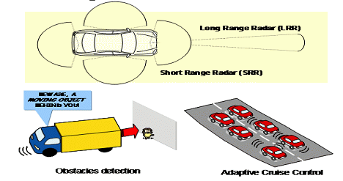

**FIGURE 2 AUTOMOTIVE RADAR**

## 5.3 Global Navigation Satellite Systems in ITS

It is common knowledge that devices installed in cars used by motorists employ the use of satellites to pinpoint their location anywhere on the earth. There are also numerous mobile applications on smartphones, making the service more accessible, that make use of Global Navigation Satellite Systems (GNSS), together with the terrestrial network, to provide motorists real time traffic congestion information to direct these people to the most efficient, if not the most convenient, route towards their destination.

The use of satellite positioning is not only limited to motorists or in cars, but also caters to commuters. GNSS assists these people in their day-to-day travel, stating the timing of public vehicles’ departure and arrival which helps these busy people plan their schedule accordingly.

Various entities have developed several GNSS already; Europe has Galileo, USA has Global Positioning System (GPS), Russia had Global'naya Navigatsionnaya Sputnikovaya Sistema (GLONASS) and China has BeiDou Navigation Satellite System. Each of these systems is comprised of a constellation of satellites working together and transmitting signals from space to the earth which are then intercepted and utilized by receivers to determine the receiver’s precise location. In later developed devices, information on the speed and direction of travel are also indicated to the user.

Due to their wide footprints, these systems are able to provide global coverage, encompassing areas with little population not often reached by terrestrial networks. This inherent nature of satellites, together with the capability of broadcasting data, ensures that signals can be received anywhere, anytime by many, including the numerous ITS nodes.

From the simple yet essential legacy ITS applications to the advanced ITS services integrating sophisticated features brought by modernization, this ability to identify position is and will continue to be fundamental to any ITS system. Now more than ever, especially when travelling is already within an arm’s reach, this technology is undeniably indispensable.

# 6 Legacy ITS radiocommunication - ETC

## 6.1 Overview

Electronic toll collection (ETC) allows for the manual in-lane toll collection process to be automated in such a way that drivers do not have to stop and pay cash at a toll booth. ETC systems improve traffic flow at toll plazas, and the level of pollution by reducing fuel consumption. In addition, allowing traffic to pass through the gate without stopping can increase road capacity by three or four times and relieve traffic congestion at the tollgate. It is also expected that ETC systems will reduce the operating costs of toll roads by replacing manual toll collection.

There are many similar words related to ETC. In Europe, Electronic Fee Collection (EFC) is popularly used. They think that EFC covers ETC, Electronic Parking System (EPS), Electronic Road Pricing. Electronic Road Pricing is usually referred to the electronic toll collection scheme adopted in Singapore for purposes of congestion management. To avoid confusion, these terminologies need to define clearly.

In Japan, Mobile Service using DSRC with the frequency bands between 5 770 and 5 850 MHz, the applications for ETC (Electronic Toll Collection) and safe driving assistance have been widely used for daily life.

### 6.1.1 Technical characteristics

DSRC refers to a dedicated short range communication between a roadside infrastructure and vehicles or mobile platforms for ITS applications.

The two major components of DSRC are on-board equipment (OBE) and roadside equipment (RSE).

**On-board equipment (OBE):** OBE is installed near the dashboard or on the windshield of the vehicle, and consists of radiocommunication circuits, an application processing circuit and so on. It usually has a human-machine interface, including switches, displays and buzzer.

**Roadside equipment (RSE):** RSE is installed above or alongside the road and communicates with passing OBE by use of radio signals. RSE consists of radiocommunication circuits, an application processing circuit and so on. It usually has a link to the roadside infrastructure to exchange data.

DSRC systems operate by transmitting radio signals for the exchange of data between vehicle mounted OBE and RSE. This exchange of data demands high reliability and user privacy as it may involve financial and other transactions.

### 6.1.2 Standardization

**Table 2 GLOBAL STANDARD ON ETC**

|  |  |  |
| --- | --- | --- |
| **SDO** | **Standard No.** | **Standard Title** |
| ITU | ITU-R M.1453-2 | Intelligent transport systems – dedicated short range communications at 5.8 GHz |

Dedicated Short Range Communication (DSRC) refers to any short-range radiocommunication technology from a roadside infrastructure to a vehicle or a mobile platform [4]. Although DSRC can be applied to various application of ITS (e.g. parking payment, gas (fuel) payment, in-vehicle signing, traffic information, etc). ETC is the most typical one. Table 2 shows the established DSRC standards.

### 6.1.3 Applications

DSRC is the use of non-voice radio techniques to transfer data over short distances between roadside and mobile radio units to perform operations related to the improvement of traffic flow, traffic safety and other intelligent transport service applications in a variety of public and commercial environments. DSRC services include vehicle control systems, traffic management systems, traveller information systems, public transportation systems, fleet management systems, emergency management systems and electronic payment services.

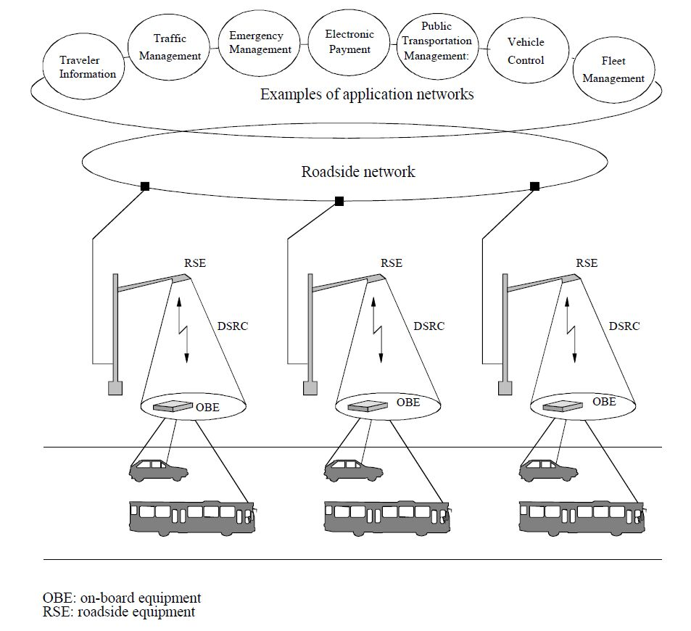**Figure 3 INTERRELATION OF DSRC WITH ITS COMMUNICATION NETWORKS**

## 6.2 Asia-Pacific

### 6.2.1 Technical characteristics

**(1) Technical Characteristics of the Japanese Active Method**

Technical characteristics of the Japanese active (transceiver) method are shown in Table 3, which is also an excerpt from Recommendation ITU-R M.1453-2. In this table, there are two specifications in RF carrier spacing column. Wide spacing (10 MHz channel separation) is mainly for current ETC application with the ASK (Amplitude Shift Keying) modulation method. Narrow spacing (5 MHz channel separation) is for multiple purpose DSRC applications services with the ASK and/or QPSK (Quadrature Phase Shift Keying) modulation method. Specifications for the 5 MHz narrow spacing was replaced with 10 MHz spacing added in October 2000, when the Japanese Ministry of Posts and Telecommunications (now MIC) revised the radio law according to the proposal of the Telecommunications Technology Council on general purpose DSRC system applications. The revision was adopted by the ITU-R as the modified DSRC Recommendation ITU-R M.1453-1 in August 2002.

The maximum communication zone of DSRC is recommended to be within 30 meters to promote effective use of frequencies by reducing the re-use distance of RSE. FDD (Frequency Division Duplex) systems are also adopted to promote effective use of radio frequencies.

**Table 3**

**TECHNICAL CHARACTERISTICS OF 5.8GHZ BAND DSRC (DEDICATED SHORT RANGE) SYSTEM**

|  |  |
| --- | --- |
| **Item** | **Technical characteristic** |
| Carrier frequencies | 5.8 GHz band for downlink and uplink |
| RF carrier spacing (channel separation) | 5 MHz |
| Allowable occupied bandwidth | Less than 4.4 MHz |
| Modulation method | ASK, QPSK |
| Data transmission speed (bit rate) | 1 024 kbit/s/ASK, 4 096 kbit/s/QPSK |
| Data coding | Manchester coding/ASK  , NRZ/QPSK |
| Duplex separation | 40 MHz in case of FDD |
| Communication type | Transceiver type |
| Maximum e.i.r.p.(1) | ≤ 30 dBm (downlink)  (For a transmission distance of 10 m or less. Power supplied to antenna ≤ 10 dBm) |
| ≤ 44.7 dBm (downlink)  (For a transmission distance of more than 10 m. Power supplied to antenna ≤ 24.77 dBm) |
| ≤ 20 dBm (uplink)  (Power supplied to antenna ≤ 10 dBm) |
| (1) European Radiocommunications Committee (ERC) Recommendation 70-03 specifies values of 2W e.i.r.p. for active and 8 W e.i.r.p. for passive systems. | |

Figure 4 shows channel arrangement of ITS applications using DSRC at 5.8 GHz band in Japan.

**FIGURE 4**

CHANNEL ARRANGEMENT OF DSRC FOR ITS APPLICATIONS IN JAPAN AT 5.8 GHZ BAND



**(2) Technical Characteristics of the Chinese ETC System**

The Chinese ETC System adopts the active (transceiver) method. Both RSE and OBE work in 5.8 GHz band. There are two classes specified in the physical layer. Class A with ASK modulation should meet the basic requirement of ETC application. Class B with FSK modulation should meet the requirement of high speed data transmission. Technical characteristics of downlink and uplink are shown in Table 4 and 5 respectively.

**TABLE 4 TECHNICAL CHARACTERISTICS OF DOWNLINK**

|  |  |  |  |
| --- | --- | --- | --- |
| **Item** | | **Class A** | **Class B** |
| Carrier frequencies | Channel 1 | 5 830 MHz | 5 830 MHz |
| Channel 2 | 5 840 MHz | 5 840 MHz |
| Allowable occupied bandwidth | | ≤5 MHz | ≤5 MHz |
| Modulation method | | ASK | FSK |
| Data transmission speed (bit rate) | | 256 kbit/s | 1 Mbit/s |
| Data coding | | FM0 | Manchester |
| e.i.r.p. | | ≤ +33 dBm | ≤ +33 dBm |

**TABLE 5 TECHNICAL CHARACTERISTICS OF UPLINK**

|  |  |  |  |
| --- | --- | --- | --- |
| **Item** | | **Class A** | **Class B** |
| Carrier frequencies | Channel 1 | 5 790 MHz | 5 790 MHz |
| Channel 2 | 5 800 MHz | 5 800 MHz |
| Allowable occupied bandwidth | | ≤5 MHz | ≤5 MHz |
| Modulation method | | ASK | FSK |
| Data transmission speed (bit rate) | | 512 kbit/s | 1 Mbit/s |
| Data coding | | FM0 | Manchester |
| e.i.r.p. | | ≤ +10 dBm | ≤ +10 dBm |

### 6.2.2 Frequency usage

The usage status of ETC in APT countries is shown in Table 6. Many APT countries adopted ETC in frequency band of 2.4, 5.8, 5.9 and 24 GHz. For ETC in some APT countries, DSRC technology and 5.8 GHz band has been used.

**TABLE 6 LEGACY ITS COMMUNICATION IN ASIA PACIFIC**

|  |  |  |  |  |
| --- | --- | --- | --- | --- |
| **Country** | **Frequency Band** | **Technology/**  **Standard** | **Application** | **Deployment or Plan Year** |
| Australia | 5 725 - 5 795 MHz,  5 815 - 5 875 MHz,  24 - 24.25 GHz | - | Electronic tolling | - |
| China | 5 725 - 5 850 MHz | DSRC | ETC (Electronic Toll Collection) | Enacted in 2003 |
| Hong Kong, China | 2 400 - 2 483.5 MHz | Exemption from Licensing Order | Electronic toll collection services | 1998 |
| Japan | 76 - 90 MHz  (FM multiplex broadcasting) | VICS (Vehicle Information and Communications System) | Traffic information | Enacted in 1994  (*VICS will not be available at 2 499.7 MHz after 31 March 2022.) |
| 2 499.7 MHz* (Radio beacon) |
| 5 770 – 5 850 MHz | DSRC  (Dedicated Short Range Communication) | ETC (Electronic Toll Collection) | Enacted in 1997 |
| -Collect highway toll - Provide various information (Communication, Broadcast) | Enacted in 2001  (Revised 2008) |
| Korea | 5 795 – 5 815 MHz | DSRC/  TTA Standard  (TTAS.KO-06.0025/R1) | ETC (Electronic Toll Collection)  BIS(Bus Information System) | 2006  (Highpass Tolling) |
| Singapore | 2 350 – 2 483.5 MHz | - | Electronic Road Pricing (ERP) Systems | 1998 |
| 5 855 – 5 925 MHz | DSRC  (Dedicated Short Range Communication) | Next Generation Electronic Road Pricing (ERP) Systems | 2020 (estimated) |
| Thailand | 5 470 - 5 850 MHz | Compliance Standard:  ETSI EN 300 440-1 or FCC Part 15.247 or  FCC Part 15.249 | RFID (e.g. Electronic Toll Collection) | 2008 |
| Viet Nam | 920 - 923 MHz | RFID | ETC (Electronic Toll Collection) | 2016 |

### 6.2.3 Standardization

**TABLE 7 STANDARD FOR ETC IN ASIA PACIFIC**

|  |  |  |
| --- | --- | --- |
| **SDO** | **Standard No.** | **Standard Title** |
| TTA | TTAS.KO-06.0025/R1 | Standard of DSRC Radio Communication between Road-side Equipment and On-board Equipment in 5.8 GHz band |
| TTAS.KO-06.0052/R1 | Test specification for DSRC L2 at 5.8 GHz |
| TTAS.KO-06.0053/R1 | Test specification for DSRC L7 at 5.8 GHz |
| ARIB | STD-T75 | Dedicated Short Range Communication (DSRC) System |
| SAC (Standardization Administration of China) | GB/T 20851.1-2007 | Electrical toll collection – Dedicated short range communication – Part 1: Physical layer |
| GB/T 20851.2-2007 | Electrical toll collection – Dedicated short range communication – Part 2: Data link layer |
| GB/T 20851.3-2007 | Electrical toll collection – Dedicated short range communication – Part 3: Application layer |
| GB/T 20851.4-2007 | Electrical toll collection – Dedicated short range communication – Part 4: Equipment application |
| GB/T 20851.5-2007 | Electrical toll collection – Dedicated short range communication – Part 5: Test methods of the main parameters in physical layer |
| IMDA TSAC | IMDA TS DSRC | Technical Specification for Dedicated Short-Range Communications in Intelligent Transport Systems |

### 6.2.4 Applications

As in Europe, Electronic toll collection (ETC) using DSRC is a forerunner of ITS applications in Japan. ETC service in Japan started in March 2001 and by the end of March 2003, the service covered approximately 900 toll gates through which 90% of expressway users pass. This indicates that the service was deployed nationwide in approximately two years. As of the end of March 2004, the number of toll gates increased to 1 300 and as of December 2005, the number of OBEs (ETC subscribers) reached ten million.

ETC in Japan, started in 2000 and the number of on-board equipment have reached 57 million out of 80 million vehicles, is used by 7.5 million vehicles every day for the payment of the tolls on 9 000 km long expressways. The amount of the payment is US$50 million a day and $20 billion a year. The penetration ratio is more than 90 % and it is one of the fundamental systems for industrial and daily living use. ETC has become an essential thing in our lives.

The ETC system is operated as the one with high communication reliability since one single passenger car payment often surpasses a couple of hundred dollars where the toll is expensive as $23 for every 100 km drive. Therefore, the system cannot be troubled due to radiocommunication interference or else, and if it happens, the toll system could lose the trust of the users and trigger opposition, and also there is a concern of rear-end collision accidents due to troubles of the gate bars.

Regarding to the safe driving assistance, various measures are being taken such as the alert of forward warning of accident or congestion at a point of frequent traffic accidents, the provision of the real time images of snow and foggy conditions, and the dissemination of emergency messages at the time of earthquake. Regarding to the provision of traffic information, the congestion and appropriate route selection information for wide area is provided, which contributes to congestion reduction.

The vehicle driving history data is collected as the big data by the vehicle probe system, and is used to make congestion countermeasures by grasping the points of accurate congestion bottlenecks and queue length based on the vehicle speed data, and also is used to analyze the data, for instance abrupt braking or steering, and to take measures to prevent accidents. The route information whether travel by a vehicle is possible or not is provided from the probe data in case of big disasters. Therefore, the 5.8 GHz DSRC greatly contributes to traffic safety in these various use cases, and more various kinds of applications, such as effective congestion countermeasures by the use of probe data, are being deployed.

1

**FIGURE 5 DSRC MULTIPLE APPLICATIONS BEING STUDIED IN JAPAN**

Since 1996, Vehicle Information and Communication System (VICS) has been operating in Japan for delivering traffic and travel information to road vehicle drivers. The following nine application fields are being studied in Japan to extend applications in the vehicle. (Refer to Figure 5):

(1) Parking lot management

(2) Gas filling station

(3) Convenience store

(4) Drive-through

(5) Logistics management

(6) Pedestrian support

(7) Specific region entry charging (Zone tolling)

(8) Information providing: semi-stationary state

(9) Information providing: high speed driving

# 7 Advanced ITS radiocommunication

## 7.1 Overview

After the deployments of DSRC basic applications such as ETC, to extend beyond the existing ITS applications and to enhance traffic safety and reduce the environmental impact by the transportation sector, vehicle-to-vehicle (V2V), vehicle-to-infrastructure (V2I), infrastructure-to-vehicle (I2V), vehicle-to-network (V2N), vehicle-to-pedestrian (V2P) communications are studied. According to this progress, ITU-R has developed report on advanced ITS radiocommunications. In the report, advanced ITS are classified by its technical characteristics as shown in Table 8. V2X (WAVE), V2X (ETSI ITS-G5), V2X (ITS Connect) and LTE based V2X (LTE-V2X) technologies could be inclusive in advanced ITS category.

WAVE is a dedicated mobile radiocommunication system for providing non-voice communications among vehicles that travel on roads, rails, or other dedicated facilities; as well as between those vehicles and the transportation infrastructure. WAVE is therefore a fundamental technology for ITS communications, helping link roads, traffic and vehicles covered by ITS deployment with coordinated, interoperable information technology. This particular wireless technology could be transformational to the evolution of transportation systems, since it provides very localized, low latency communications capabilities on a peer-to-peer basis. These capabilities are intended to support the planned, as well as the still unforeseen, data needs of the evolving, more automated, future transportation system. WAVE systems specifically utilize the broadcast mode of operations as the primary means to support public benefits; and also communicate using two-way communications between vehicles and infrastructure, including the ability to provide lower priority messages related to the specific units involved in a variety of public and private transportation environments.

WAVE is being pursued in the United States “to improve traveller safety, decrease traffic congestion, facilitate the reduction of air pollution, and help to conserve vital fossil fuels”6, and as a particular focus in the United States, to reduce highway fatalities7. Although not yet widely deployed, the United States has developed multiple applications, a number of which have been tested in large-scale field tests or operated in model deployments[1]. This progress has provided the United States with extensive knowledge of these applications that contribute to transportation safety, mobility and environmental stewardship in the context of advanced ITS. The WAVE ITS applications are designed to perform operations related to the improvement of traffic safety and traffic flow, as well as other intelligent transport service applications, including enhancing transportation systems efficiencies and operations (for example, facilitating roadway freight movements or transportation management during emergency responses). The main points of focus for the US deployment of advanced ITS applications using WAVE communications include: nationwide interoperability; long-term technical stability; voluntary industry standards; and support for public benefits.

**Cooperative** ITS communication (C-ITS) has to be based on standardized and interoperable wireless ad-hoc communication systems. The interoperability has to be guaranteed at least in the different worldwide regions. This interoperability requirement does not imply the use of exactly the same system in all regions, e.g. C-ITS in Europe in 5.9 GHz is mainly based on IEEE 802.11p and ETSI ITS-G5, whereas the US implementation in 5.9 GHz is based on the slightly different IEEE 802.11p and WAVE system as described above. For these technologies the standards are finished, intensive testing and validation has taken place, first implementations done and deployment is planned. Most of the actual discussed systems are based on a well-established access layer (PHY-layer and MAC-layer) standardised by IEEE802 as IEEE802.11p, which is part of the IEEE802.11-2012 set of standards.

In certain APT countries, a frequency band in the range between 5 850 - 5 925 MHz (up to 75 MHz bandwidth) has been chosen/picked as the main band of operation for the upcoming traffic-safety related C-ITS. In addition, the frequency band 63 GHz to 64 GHz has been designated for traffic safety related applications under the Mobile Service in CEPT.

Worldwide a broad range of standardisation organisation are involved in the standardisation of C‑ITS. The main actors with a strong support from the Automotive Industry are the US activities around IEEE/WAVE/SAE and the European activities around ETSI TC ITS. These activities are backed by industry consortia CAMP (Crash Avoidance Metric Partnership) in the US and the C2C‑CC (CAR-to-CAR Communication Consortium) in Europe.

The C2C-CC as an industry driven, non-profit association of 16 European vehicle manufacturers, 37 suppliers and 28 research organisations, dedicated to realise cooperative road traffic and herewith increase traffic safety, efficiency and driving comfort. The C2C-CC plays an important role in the development of European standards for C-ITS and cooperates closely on C-ITS with the CAMP consortium in the US. To align and harmonise the C-ITS roll-out in vehicles and traffic infrastructure in Europe by 2019 the consortium engages in the Amsterdam Group. This is a strategic alliance of the CAR 2 CAR Communication Consortium, the ASECAP (Association of operators of toll road infrastructures), CEDR (Conference of European Directors of Roads) and POLIS (European Cities and Regions Networking for Innovative Transport Solutions). Furthermore, the consortium actively contributes to the work of the C-ITS Deployment Platform organised by the European Commission.

The C2C-CC participated in the initial design of vehicle-to-vehicle communications technologies through the publication of a manifesto. It also helps validating the C-ITS by getting involved in FOT (Field operational tests) and ongoing cross-border C-ITS corridor projects and focusing on interoperability testing.

In 2007, the CAR 2 CAR Communication Consortium published the Manifesto on its website[2]. The document built the basis for the first interoperability demonstration shown 2008 at the Opel testside in Dudenhofen.

The document describes the C-ITS scenarios for improving safety and traffic efficiency as well as using the communication system for infotainment and other purposes. From the scenarios, the system prerequisites and constraints are derived and the system architecture developed. The architecture describes the communication principles, the individual components, the layers’ architecture and related protocols. The further chapters describe the applications, the radio and communication system as well as data security and privacy.

This document specifies the standard profile that enables interoperability of C-ITS units. The first Basic System Profile (BSP) version was released for C2C-CC internal usage by end of 2014. The latest revised BSP version will be published by sharing it with the Basic Members of the consortium by May 2016. It contains a system specification complemented by a selection of standards and parameters. It allows to test the aspects that are going to be used by “day one” applications.

ITS Connect is a dedicated mobile radiocommunication system for V2X communication[3]. The ITS Connect is based on the ARIB STD-T109 which the formal name is 700 MHz BAND INTELLIGENT TRANSPORT SYSTEMS. 755.5-764.5MHz is assigned for the ITS Connect in Japan. Therefore, the standard uses “700MHz band” and its centre frequency is 760MHz in Japan. The ITS Connect several services had been deployed in Japan from 2015[4]. Road side equipment (RSE) had been installed by the National Police Agency of Japan. From the view point of the vehicle, one of the usage of the ITS Connect (V2X communication) is a “sensor of a vehicle” for undetectable objects (other vehicles, pedestrian, and others in Non Line Of Site (NLOS)), which own on board sensors (radar, camera, lidar, and others) is difficult to sense. UHF (760MHz) band could aid receiving messages from objects in NLOS with its diffractive features. Another usage of the ITS Connect (V2I communication) could also support passing the junction safely receiving traffic signal information and vehicle location information at junction in advance. These information aids appropriate actions for vehicles, and pedestrians before arriving at the junction. In the future automated driving era, the ITS Connect (V2X communication) must be important.

Advanced ITS is also supported by 3GPP technologies and worldwide standards. 3GPP has developed specifications to enable the use of LTE mobile networks to provide connectivity between vehicles, roadside infrastructure and pedestrians inside and around the connected vehicles, i.e. targeting all initial main V2X use cases and requirements studied by 3GPP: V2V, V2P, V2I and V2N.

3GPP Release 14 specification work about LTE-V2X service, including system and radio access requirements, has been completed in March 2017 and 3GPP will freeze the specification work on release 14 in June 2017. Both PC5 (device-to-device direct link) and Uu (link between base station and device) are included, supporting transmission in existing mobile allocations up to 6 GHz. Device-to-device direct link communication without network assistance is also supported. More details can be found in Section 7.1.2.3 below. The LTE based V2X communication over PC5 and Uu interface can be found in Figure 6.

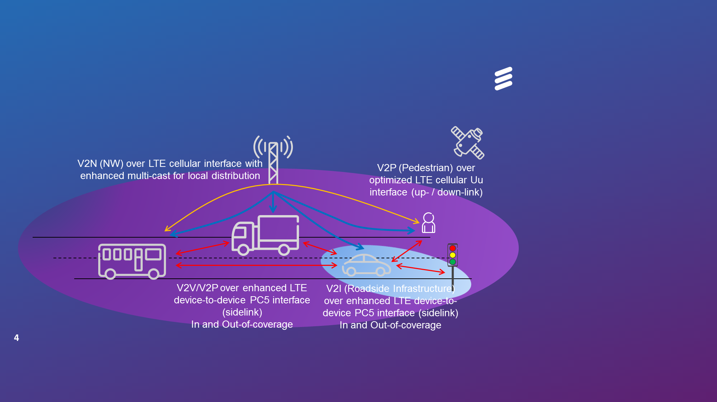

FIGURE 6 V2X COMMUNICATION OVER LTE-PC5 INTERFACE AND LTE-UU INTERFACE

3GPP is also looking at continuously evolving the V2X services in its coming releases including 5G. Future V2X releases will support, e.g. enhanced safety use cases at high vehicle speeds, challenging road conditions with its improved reliability, extended range, lower latency, and enhanced non-line-of-sight (NLOS) capabilities. Therefore, further 3GPP V2X enhancements are expected from Rel-15 onward.

China started to develop trials of LTE based V2X communication technology (LTE-V2X) to verify road safety and non-road safety applications from 2015. In November 2016, Chinese administration approved LTE-V2X trial projects in 5 905-5 925 MHz (20MHz). In 2017, radio frequency testing, communication link performance testing of LTE-V2X devices, and coexistence testing with incumbent services had been carried out in laboratory and field trials in 5.9 GHz. The results show that LTE-V2X devices can fulfill RF requirements and communication criteria according to 3GPP specifications. Multiple city scale LTE-V2X trials will be carried forward from 2018 in China.

### 7.1.1 Technical characteristics

Technical performance characteristics of the several ITS technologies will vary, depending on local environment, distance between transmitter and receiver, instantaneous traffic levels, and other factors. For example, higher bit-rates (using denser modulation methods) can be achieved over short and unobstructed line-of-sight distances where carrier-to-noise ratios are higher, compared to the case for longer distances and more obstructed paths. External noise and interference can also reduce effective bit-rates and throughput due to data errors and associated retransmissions[5]. The different ITS technologies may utilize differing error detection/correction schemes and signal coding/modulation methods, and also adopt differing approaches to congestion management, flow control, admission control, and other protocol features, which may lead to differing performance characteristics. There is a growing collection of academic and research literature focused on comparative performance evaluations, as noted below. However, some care is required when considering the various test environments associated with these comparative assessments, which may influence the reported results.

The following Table 8 presents a summary of the key performance characteristics of some major advanced ITS technologies:

**TABLE 8 TECHICAL CHARACTERISTIC OF SOME ADVANCED ITS TECHNOLOGIES**

|  |  |  |  |  |
| --- | --- | --- | --- | --- |
|  | ***ETSI ITS-G5*** | ***WAVE*** | ***ITS Connect*** | ***LTE-V2X*** |
| Base technology | IEEE 802.11p | IEEE 802.11p | IEEE 802.11p | 3GPP 36-series LTE Rel.14 and beyond |
| V2I | Yes | Yes | Yes | Yes |
| V2V | Yes | Yes | Yes | Yes |
| V2P | Yes | Yes | Yes | Yes |
| V2N | No | No | No | Yes |
| Bit rateNote 1 | 3-12 Mbps  (optional up to 27 Mbps) | 3-12 Mbps  (optional up to 27 Mbps) | 3-12 Mbps  (optional up to 27 Mbps) | Up to 42 Mbps (V2V, V2I, V2P)  Up to 1000 Mbps (V2N) |
| Packet Error Rate (PER)Note 2:  Eb/No = 2dB  Eb/No = 6dB | 0.8  0.15 | 0.8  0.15 | - | 0.2  0.009 |
| Operating Range (PRRNote 3 = 0.9)  (V2V, V2I, & V2P only)Note 1 | Up to 200m | Up to 200m | - Note 4 | 300-400mNote 5 |
| Error control methods | Convolutional coding (rate: 1/2,3/4, 2/3) | Convolutional coding (rate: 1/2,3/4, 2/3) | Convolutional coding (rate: 1/2,3/4) | HARQ & Turbo coding (rate: 1/3 to 0.93) |
| Modulation | BSK, QPSK, 16QAM, 64QAM | BSK, QPSK, 16QAM, 64QAM | BSK, QPSK, 16QAM | QPSK, 16QAM, 64QAMRel 15 |

Note 1: The peak bit rate and effective range may vary with available channel bandwidth, in the selected band(s) in each country, which may be different to the V2V/V2I/V2P frequency bands.

Note 2: For freeway case, both vehicles 60 km/h.

Note 3: PRR = Packet Reception Rate.

Note 4: ITS Connect uses UHF band, so propagation loss is typically lower, giving improved operating range.

Noted 5: Simulations have indicated operating range may be up to 1000m.

Further information on relative technical performance of ITS technologies can be found in a number of academic and research publications[6],[7],[8],[9].



**Figure 7 VEHICLE INFORMATION & COMMUNICATION (V2V, V2I, I2V)**

**7.1.1.1 V2X (WAVE)**

*On-board equipment (WAVE OBE)*: The OBE consists of communications and processing equipment installed in vehicles to enable WAVE communications with other vehicles and infrastructure, and support WAVE-enabled applications. OBEs may be most effective when integrated into the vehicle and able to interface with other on-board equipment such as the vehicle’s sensor suite, anti-lock braking system, and other subsystems, allowing it to complement these existing systems.

*Roadside unit (WAVE RSU)*: A WAVE RSU is installed above or alongside the road or other infrastructure and communicates with passing OBEs by the use of radio signals. An RSU consists of radio communication circuits, an application processing circuit and related equipment. It may have data linkages to traffic management centres (TMCs) and to other roadside equipment (such as traffic signal controllers), as well as to the Internet to exchange data and to maintain security credential information.

The WAVE systems operate by transmitting radio signals for the exchange of data among vehicle-mounted OBEs, and between OBEs and infrastructure-based RSUs. By adhering to requirements set by industry standards, these systems accomplish a data exchange that ensures that data is interoperable across a wide range of device and application manufacturers. Interoperability is key to support the rapid, standardized adoption of applications that deliver critical safety related, system and operational efficiencies, and other public benefits.

Much of the information to complete the following tables comes from Std 802.11-2016[10].

The modulation used for WAVE is ‘half-clocked’ OFDM on 10 MHz channels. Below are basic OFDM transmitter and receiver block diagrams.

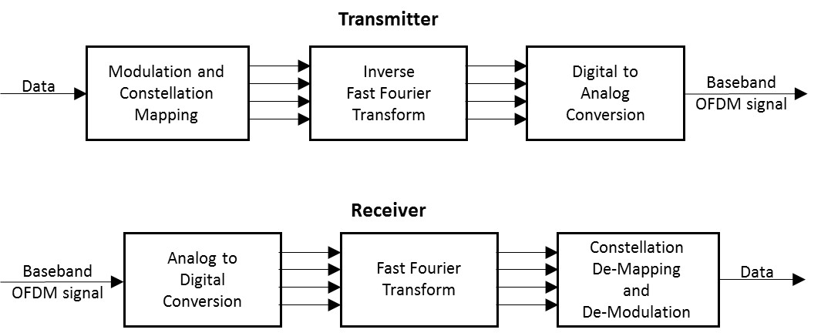

**FIGURE 8 TRANSMITTER AND RECEIVER[11]**

TABLE 9 TRANSMITTER CHARACTERISTICS[12]

| Parameter | Value | |
| --- | --- | --- |
| Emission 3 dB Bandwidth (MHz) | 10 MHz | |
| Power (Peak) (dBm) | 23 to 44.8 dBm e.i.r.p.[13] (Depending on Channel used, RSU or OBE[14] and government or private); also, transmissions shall use only the power necessary to support the particular application[15] | |
| Emission Spectrum  (Relative Attenuation (dB) as a Function of Frequency Offset from Center Frequency (ΔF) (MHz)) | **Attenuation** | **ΔF** |
| See footnote[16] | See footnote7 |
| Data Rate | 6 Mb/s[17] | |
| Modulation Parameters[18] | Modulation QPSK | Coding Rate 1/2 |
| Azimuth Off-Axis Antenna Pattern | Vehicles - omnidirectional (3600)[19]; sectorized antennas sometimes used with Infrastructure WAVE transmitter antennas | |
| Elevation Off-Axis Antenna Pattern | -6 to +10 degrees – vehicles Infrastructure – specification TBD | |
| Antenna Height (meters) | 1.5-15 m[20] | |
| Antenna Polarization | Primarily vertical (some right hand circular)[21] | |

TABLE 10 RECEIVER CHARACTERISTICS s

| Parameter | Value |
| --- | --- |
| Receiver Sensitivity | -92 dBm minimum, -94 dBm typical[22] |
| Receiver Selectivity | See following table on “Adjacent and Next-Adjacent Channel Rejection Receiver Characteristics” |
| Information Data Rate | 3, 4.5, 6, 9, 12, 18, 24 and 27 Mb/s (3, 6 and 12 Mb/s are mandatory)[23] |
| Antenna Characteristics | Note that the same antenna is typically used for both transmit and receive functions in WAVE systems – refer to antenna characteristics in the previous table for receiver antenna characteristics |

TABLE 11 ADJACENT AND NEXT-ADJACENT CHANNEL REJECTION RECEIVER CHARACTERISTICS[24]

|  |  |  |  |  |  |
| --- | --- | --- | --- | --- | --- |
| **Modulation** | **Coding Rate** | **Receiver Performance (dB)** | | **Optional Enhanced Receiver Performance (dB)** | |
| **Adjacent Channel Rejection** | **Next Adjacent Channel Rejection** | **Adjacent Channel Rejection** | **Next Adjacent Channel Rejection** |
| BPSK | 1/2 | 16 | 32 | 28 | 42 |
| BPSK | 3/4 | 15 | 31 | 27 | 41 |
| QPSK | 1/2 | 13 | 29 | 25 | 39 |
| QPSK | 3/4 | 11 | 27 | 23 | 37 |
| 16-QAM | 1/2 | 8 | 24 | 20 | 34 |
| 16-QAM | 3/4 | 4 | 20 | 16 | 30 |
| 64-QAM | 2/3 | 0 | 16 | 12 | 26 |
| 64-QAM | 3/4 | -1 | 15 | 11 | 25 |

TABLE 12 MAXIMUM STA TRANSMIT POWER CLASSIFICATION FOR THE 5 850 – 5925 MHZ BAND IN THE UNITED STATES[25]

|  |  |  |
| --- | --- | --- |
| **STA transmit power classification** | **Maximum STA transmit power**  **(mW)** | **Maximum permitted e.i.r.p.**  **(dBm)** |
| A | 1 | 23 |
| B | 10 | 33 |
| C | 100 | 33 |
| D | 760  Note that for this class higher power is permitted as long as the power level is reduced to this level at the antenna input and the emission mask specifications are met. | 33 for nongovernment  44.8 for government |

TABLE 13 SPECTRUM MASK DATA FOR 10 MHZ CHANNEL SPACING4

|  |  |  |  |  |  |
| --- | --- | --- | --- | --- | --- |
| **STA transmit power class** | **Permitted power spectral density, dBr** | | | | |
| **± 4.5 MHz offset (±f1)** | **± 5.0 MHz offset (±f2)** | **± 5.5 MHz offset (±f3)** | **± 10 MHz offset (±f4)** | **± 15 MHz offset (±f5)** |
| Class A | 0 | –10 | –20 | –28 | –40 |
| Class B | 0 | –16 | –20 | –28 | –40 |
| Class C | 0 | –26 | –32 | –40 | –50 |
| Class D | 0 | –35 | –45 | –55 | –65 |

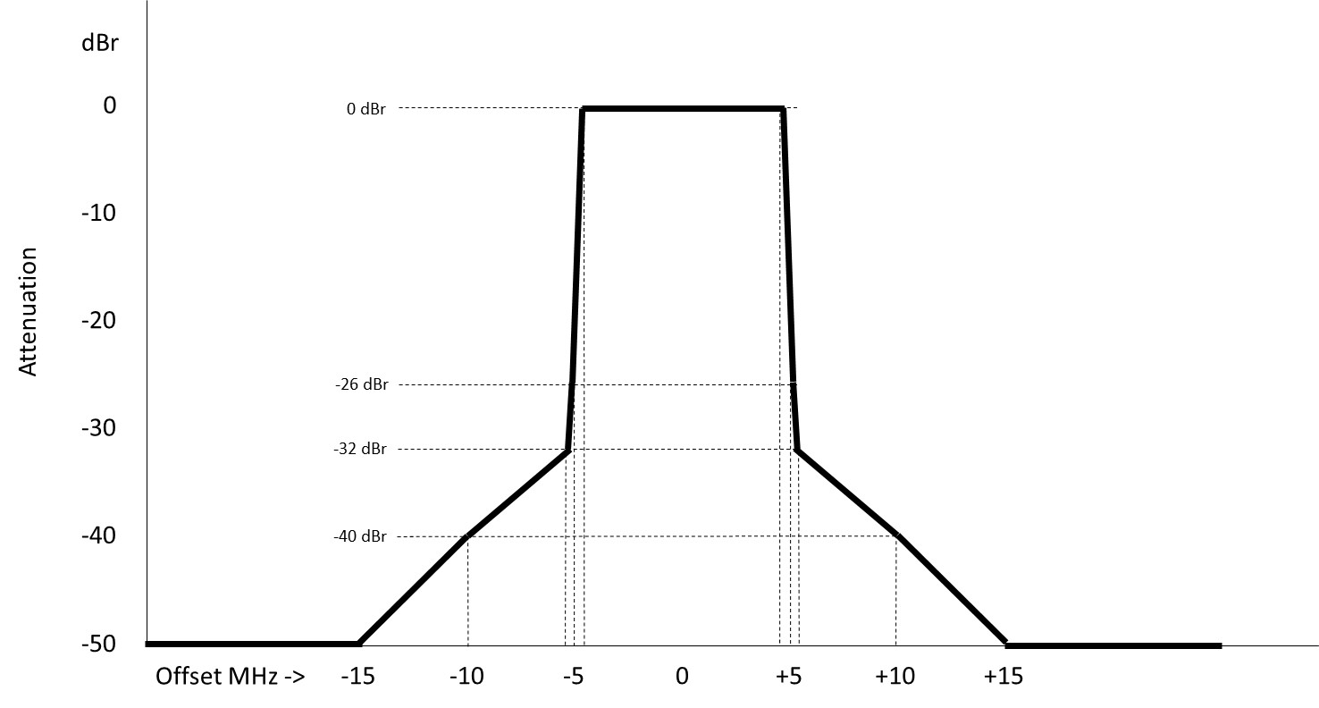

**FIGURE 9 TRANSMIT SPECTRUM MASK FOR 10 MHZ OBE TRANSMISSION (CLASS C TYPICAL)[26]**

**7.1.1.2 V2X (ITS Connect)**

ITS Connect is configured using road side units (RSUs) and On-board equipment (OBE). Basic functions of ITS Connect are the following:

* Conveyance and exchange of information that contributes to reduce the number of traffic accidents.
* Conveyance and exchange of information that contributes to assist safe driving
* Conveyance and exchange of information that contributes to smooth traffic flow

The OBE is installed in vehicle side. The OBE performs radio communication with the RSUs or other OBEs. The radio equipment of the OBE is composed of a transmitter, receiver, controller, antenna, and etc. The OBE sends vehicle information (such as position, speed, direction, and so on). The OBE receives signal from other OBE and RSUs. Then the vehicle can know the position and situation of other vehicle, and can provide adequate information or behavior to driver for assisting safe driving.

The RSU performs radio communication with OBEs or the other RSUs. The radio equipment of the RSU is composed of a transmitter, receiver, controller, antenna, and etc. The RSU is installed at roadside (mainly junction). One of the use case of Infrastructure to Vehicle (I2V) is to broadcast traffic signal information. For this use case, the RSU shall connect traffic signal control center. Another use case of I2V is to broadcast information of vehicle and pedestrian when the pedestrian crossing around junction that the RSU is installed. A sensor detects the vehicle and pedestrian, and the sensor transfers the information to the RSU.

ITS Connect uses one RF channel OFDM modulated signal. The occupied bandwidth shall be 9 MHz or less. Most OFDM parameter is same with the IEEE802.11p. The modulation and coding method is described on the Table 14. The transmission data rate shall be 5 Mb/s or more.

**TABLE 14 SPECIFICATION OF THE MODULATION AND CODING METHOD**

|  |  |
| --- | --- |
| Item | Parameter |
| Frequency band | 755.5 – 764.5 MHz (single channel) |
| Channel selection | Not required (fixed) |
| Error correction | Convolution FEC R=1/2, 3/4 |
| Modulation | BPSK/OFDM, QPSK/OFDM, 16QAM/OFDM |

The limit on secondary radiated emissions shall be as specified in Table 15 for a RSU and Table 16 for OBE.

**TABLE 15 LIMITS OF INCIDENTALLY PRODUCED RADIATION（RSU）**

|  |  |
| --- | --- |
| Frequency band | Limits of incidentally produced radiation |
| 770 MHz or less | 4 nW or less per 100 kHz bandwidth |
| More than 770 MHz and 810 MHz or less | 0.32 nW or less per 100 kHz bandwidth |
| More than 810 MHz and 1 GHz or less | 4 nW or less per 100 kHz bandwidth |
| More than 1 GHz | 4 nW or less per 1 MHz bandwidth |

**TABLE 16 LIMITS OF INCIDENTALLY PRODUCED RADIATION（OBE）**

|  |  |
| --- | --- |
| Frequency band | Limits of incidentally produced radiation |
| 1 GHz or less | 4 nW or less per 100 kHz bandwidth |
| More than 1 GHz | 4 nW or less per 1 MHz bandwidth |

Blocking characteristics of RSU and OBE are defined in Table 17 and Table 18.

**TABLE 17 BLOCKING CHARACTERISTICS（RSU）**

|  |  |
| --- | --- |
| Frequency band | Interference signal |
| More than 710 MHz and 748 MHz or less | -7 dBm |
| More than 773 MHz and 810 MHz or less | -7 dBm |

**TABLE 18 BLOCKING CHARACTERISTICS（OBE）**

|  |  |
| --- | --- |
| Frequency band | Interference signal |
| More than 710 MHz and 748 MHz or less | -21 dBm |
| More than 773 MHz and 810 MHz or less | -21 dBm |

The permissible values for unwanted emission intensity shall be as specified in Table 19 for a RSU and Table 20 for OBE.

**TABLE 19 UNWANTED EMISSION INTENSITY（RSU）**

|  |  |
| --- | --- |
| Frequency band | Emission limit (average power) |
| 710 MHz or less | 2.5 µW or less per 100 kHz bandwidth |
| More than 710 MHz and 750 MHz or less | 20 nW or less per 100 kHz bandwidth |
| More than 750 MHz and 755 MHz or less | 0.1 mW or less per 100 kHz bandwidth |
| More than 765 MHz and 770 MHz or less | 0.1 mW or less per 100 kHz bandwidth |
| More than 770 MHz and 810 MHz or less | 0.32 nW or less per 100 kHz bandwidth |
| More than 810 MHz and 1 GHz or less | 2.5 µW or less per 100 kHz bandwidth |
| More than 1 GHz | 2.5 µW or less per 1 MHz bandwidth |

**TABLE 20 UNWANTED EMISSION INTENSITY（OBE）**

|  |  |
| --- | --- |
| Frequency band | Emission limit (average power) |
| 710 MHz or less | 2.5 µW or less per 100 kHz bandwidth |
| More than 710 MHz and 750 MHz or less | 20 nW or less per 100 kHz bandwidth |
| More than 750 MHz and 755 MHz or less | 0.1 mW or less per 100 kHz bandwidth |
| More than 765 MHz and 770 MHz or less | 0.1 mW or less per 100 kHz bandwidth |
| More than 770 MHz and 810 MHz or less | 10 nW or less per 100 kHz bandwidth |
| More than 810 MHz and 1 GHz or less | 2.5 µW or less per 100 kHz bandwidth |
| More than 1 GHz | 2.5 µW or less per 1 MHz bandwidth |

These regulations are defied for co-existing with ITS Connect that using 755.5-764.5MHz and adjacent channel systems (LTE, Digital TV, radio mic, and so on).

Reception sensitivity is same with the IEEE802.11p. In this system, BPSK, QPSK and 16QAM of 10 MHz channel spacing shall be selected. Transmitting power for the operating frequency band shall be 10 mW or less per 1 MHz bandwidth on average.

In Japan, ITS Connect uses 755.5-764.5 MHz. The center frequency shall be 760 MHz. If the ITS Connect will be used in other country, for example, when lower than 1GHz band will be assigned, performance of communication distance on NLOS/LOS is similar with 760MHz, the system may be able to provide similar road safety and environmental effects.

**7.1.1.3 V2X (LTE based V2X)**

3GPP TSG RAN in RAN#73 completed work item “Support for V2V services based on LTE sidelink” , LTE based V2V device-to-device direct link communications are based on D2D communications defined as part of ProSe (proximity service) services in 3GPP Release-12[27] and Release-13[28]. As part of ProSe services, a new D2D interface was introduced in Release-14 and it has been enhanced for vehicular use cases, specifically addressing high speed (relative speeds up to 500 kph) and high density connection scenarios.A few fundamental modifications to LTE-V2V PC5 have been introduced.

* Additional DMRS symbols have been added to handle the high Doppler associated with relative speeds of up to 500 kph and at high frequency (5.9 GHz ITS band being the main target).
* The arrangement of scheduling assignment and data resources are designed to enhance the system level performance under high density scenarios while meeting the low-latency requirements of V2V.

Distributed scheduling (Mode 4), which is a sensing mechanism with semi-persistent transmission was introduced.

The 3GPP work item “LTE-based V2X services” specifies enhancements required to enable V2X services with LTE uplink and downlink, to enable LTE PC5 interface to support additional V2X services such as vehicle to pedestrian (V2P), and to support more operational scenarios for V2V services using LTE PC5. Specificially, the following are considered the main features of this work item:

* Uplink and PC5 enhancement to enable eNB to quickly change semi-persistent scheduling (SPS) in adapting to a change in the V2X message generation pattern;
* Introduction of shorter scheduling periods in downlink and PC5 for broadcasting V2X messages within latency requirements;
* Introduction of an additional resource allocation procedure in PC5 mode 4 for power saving in pedestrian UEs;
* Introduction of PC5 congestion control for operation in high traffic load;
* Enhancement to PC5 synchronization for operation outside GNSS or eNB coverage; and
* Support of simultaneous V2X operations over multiple carriers.

The PC5 interface for V2X supports QPSK and 16QAM in a 10 MHz or 20 MHz channel leading to a peak rate of 41.472 Mbps. The Uu interface for V2X reuses the existing LTE Uu interface, so the modulation scheme and the peak rate is the same.

As a result of this WI, the LTE radio specification supports the two LTE based V2X communication methods, both PC5 and Uu interface, illustrated in Figure 10 below. The interface communication supports direct link transmission when cellular network provides coverage for vehicles (in coverage), or when vehicles are out of coverage of a cellular network. LTE based V2X can support message transmission by both unicast and broadcast in Uu interface.



**FIGURE 10 V2X COMMUNICATION OVER PC5 INTERFACE AND UU INTERFACE**

### 7.1.2 Frequency usage

Among APT countries, Japan is using 760 MHz band and studying 5.8 GHz band for V2V and V2I communication to transmit safety related information. Also, Korea assigned 5 855 - 5 925 MHz for C-ITS (V2V and V2I communications) in 2016. China is also studying spectrum related aspects on V2X (LTE based V2X) communication technology in 5.9 GHz band, where V2X communication includesV2V, V2I, V2P, V2N applications. ITS spectrum study is under developing in multiple standard organizations in China, where the study includes ITS use cases, spectrum need, and coexistence study with incumbent services. In December 2016, China has identified 5 905 - 5 925 MHz as LTE-V2X experiment frequency band. TIAA (Telematics Industry Application Alliance) and IMT-2020 Promotion Group work closely with vehicle manufactories, telecommunication companies, research institutions and testing institutions to start road-test and verification work of technical characteristics of LTE-V2X, including radio power, efficiency, radiation, interference, effectiveness, *etc.* in six major cities.

On the other hand, Europe is using the 5 855 - 5 925 MHz frequency band for C-ITS (V2V and V2I communication) according to the ECC decision in 2008, and the U.S. use the frequency band 5 850 - 5 925 MHz for the WAVE providing ITS applications with specific channels for safety. For interoperability and global harmonization, some APT countries are (e.g. Australia, Singapore) also considering these band for cooperative ITS.

Regarding these activities, in Australia, the investigation has carefully examined the constraints created by existing and future service coordination requirements. These include, for example, the fixed-satellite service concerns over the unknown compounding effects of aggregated roadside and on-board units which could constructively interfere with the FSS, and/or raise the overall noise floor within which the FSS operates. Moreover, the need to protect intelligent transport systems may severely limit the deployment of future FSS earth stations in the band 5 850 - 5 925 MHz. While studies have indicated these impacts will be minimal, mitigation and appropriate licensing strategies are under consideration.

**7.1.2.1 V2X (WAVE)**

WAVE is being pursued in the United States “to improve traveller safety, decrease traffic congestion, facilitate the reduction of air pollution, and help to conserve vital fossil fuels”[29], and as a particular focus in the United States, to reduce highway fatalities[30]. In order to address the need for advanced ITS to provide these public benefits, a number of applications have been developed, with more still under development, to leverage the unique short range characteristics of WAVE. These applications include communications among vehicles and other mobile end users, as well as between mobile users and roadside infrastructure.

WAVE applications may have access to each of the seven 10 MHz channels on a dynamic assignment basis under the direction of the control channel as shown in the following tabulation, but do not use the 20 MHz combined channels, designated as Channels 175 and 181 in the tabulation. This band plan provides dedicated channels for crash-imminent safety-related (Channel 172) and high-powered public safety-related (Channel 184) applications[31], as well as flexible assignment of other service channels through the control channel mechanism to support the wide range of advanced ITS WAVE applications. Many applications will only partially use a particular assignable channel at a particular time and location, permitting sharing among WAVE applications on individual assignable service channels.

Safety-related applications which are not pre-assigned to the dedicated channels typically use the control channel to transmit very short, infrequent messages, or else use WAVE Service Announcements (WSA) on the control channel to indicate a service channel upon which to communicate, if those messages are less dependent upon having very low latency. Lower priority messages typically use WSAs on the control channel to be assigned to a service channel which is not fully occupied by safety-related communications at that location at that time. This flexible designation of application messages to different service channels in various locations facilitates spectral efficiency and reduces interference among WAVE applications.

|  |  |  |  |  |  |  |  |
| --- | --- | --- | --- | --- | --- | --- | --- |
| 5 850 MHz |  |  | |  |  | | 5 925 MHz |
|  | | CH175 | |  | CH181 | |  |
| 5 850-5 855  reserve 5 MHz | CH172  service 10 MHz | CH174  service 10 MHz | CH176  service 10 MHz | CH178  control 10 MHz | CH180  service 10 MHz | CH182  service 10 MHz | CH184  service 10 MHz |

**FIGURE 11 BAND PLAN FOR WAVE IN THE UNITED STATES[32]**

Note – This band plan may need to be revised if regulatory changes occur as a result of ongoing regulatory proceedings in the United States.

**7.1.2.2 V2X (ITS Connect)**

In Japan, 755.5-764.5 MHz is assigned for ITS Connect. All RSU and OBE share one RF channel. Time slot is divided into Vehicle to Vehicle (V2V) communication periods and I2V communication periods, then RSU and OBE can share the frequency without mutual interference. Figure 12 shows the sharing mechanism. The RSUs and OBEs carry out communications normally in a cycle of 100 ms. In the Figure 12, the RSU can use gray period. If the RSU does not use all 3024 us, OBE can use the time for V2V communication.



**FIGURE 12 RSU TRANSMITTING PERIODS**

In order to avoid collision between OBE to OBE, CSMA/CA protocol is used.

### 7.1.3 Best practice and experiences on the usage of the bands between ITS and other applications / services

#### 7.1.3.1 Coexistence study from China on LTE based V2X and Fixed-Satellite Service

In the year 2015, CCSA initiated and developed a technical report “Frequency requirement and coexistence study on intelligent transportation system V2V/V2I active safety application”, it was finalized in the year 2016. The report (yet to be made available in CCSA website) shows that the LTE based V2X system and Fixed-Satellite service could be co-existed in 5.9 GHz frequency band.

### 7.1.4 Standardization, technical specifications, technical reports and ITU deliverables

**Table 21 GLOBAL STANDARDS AND TECHNICAL SPECIFICATIONS ON ADVANCED ITS RADIO COMMUNICATION**

| **SDO** | **Document Number** | **Title** |
| --- | --- | --- |
| ASTM | E2213-03 | Standard Specification for Telecommunications and Information Exchange Between Roadside and Vehicle Systems – 5 GHz Band Dedicated Short Range Communications (DSRC) Medium Access Control (MAC) and Physical Layer (PHY) Specifications |
|  | [TS 102 637 series](http://webapp.etsi.org/WorkProgram/Frame_WorkItemList.asp?SearchPage=TRUE&butExpertSearch=++Search++&qETSI_STANDARD_TYPE=%27TS%27&qETSI_NUMBER=102+637&qTB_ID=&qINCLUDE_SUB_TB=True&includeNonActiveTB=FALSE&qWKI_REFERENCE=&qTITLE=&qSCOPE=&qCURRENT_STATE_CODE=&qSTOP_FLG=N&qSTART_CURRENT_STATUS_CODE=&qEND_CURRENT_STATUS_CODE=&qFROM_MIL_DAY=&qFROM_MIL_MONTH=&qFROM_MIL_YEAR=&qTO_MIL_DAY=&qTO_MIL_MONTH=&qTO_MIL_YEAR=&qOPERATOR_TS=&qRAPTR_NAME=&qRAPTR_ORGANISATION=&qKEYWORD_BOOLEAN=OR&qKEYWORD=&qPROJECT_BOOLEAN=OR&qPROJECT_CODE=&includeSubProjectCode=FALSE&qSTF_List=&qDIRECTIVE=&qMandate_List=&qSORT=HIGHVERSION&qREPORT_TYPE=SUMMARY&optDisplay=10&titleType=all) | Intelligent Transport Systems (ITS); Vehicular Communications; Basic Set of Applications |
| [EN 302 637-2](https://portal.etsi.org/webapp/WorkProgram/Report_WorkItem.asp?WKI_ID=37126&curItemNr=1&totalNrItems=1&optDisplay=10&qSORT=HIGHVERSION&qETSI_ALL=TRUE&SearchPage=TRUE&qETSI_NUMBER=302+637-2&qINCLUDE_SUB_TB=True&qINCLUDE_MOVED_ON=&qSTOP_FLG=&qKEYWORD_BOOLEAN) | ITS-Vehicular Communications; Basic Set of Applications; Part 2: Specification of Cooperative Awareness Basic Service. |
| [EN 302 637-3](https://portal.etsi.org/webapp/WorkProgram/Report_WorkItem.asp?WKI_ID=37127&curItemNr=1&totalNrItems=1&optDisplay=10&qSORT=HIGHVERSION&qETSI_ALL=TRUE&SearchPage=TRUE&qETSI_NUMBER=302+637-3&qINCLUDE_SUB_TB=True&qINCLUDE_MOVED_ON=&qSTOP_FLG=&qKEYWORD_BOOLEAN=&qCLUSTER_BOOLEAN=&qFREQUENCIES_BOOLEAN=&qSTOPPING_OUTDATED=&butSimple=Search&includeNonActiveTB=FALSE&includeSubProjectCode=&qREPORT_TYPE=SUMMARY) | ITS-Vehicular Communications; Basic Set of Applications; Part 3: Specifications of Decentralized Environmental Notification Basic Service. |
| [EN 302 665](http://webapp.etsi.org/WorkProgram/Frame_WorkItemList.asp?SearchPage=TRUE&butExpertSearch=++Search++&qETSI_STANDARD_TYPE=&qETSI_NUMBER=302+665&qTB_ID=&qINCLUDE_SUB_TB=True&includeNonActiveTB=FALSE&qWKI_REFERENCE=&qTITLE=&qSCOPE=&qCURRENT_STATE_CODE=&qSTOP_FLG=N&qSTART_CURRENT_STATUS_CODE=&qEND_CURRENT_STATUS_CODE=&qFROM_MIL_DAY=&qFROM_MIL_MONTH=&qFROM_MIL_YEAR=&qTO_MIL_DAY=&qTO_MIL_MONTH=&qTO_MIL_YEAR=&qOPERATOR_TS=&qRAPTR_NAME=&qRAPTR_ORGANISATION=&qKEYWORD_BOOLEAN=OR&qKEYWORD=&qPROJECT_BOOLEAN=OR&qPROJECT_CODE=&includeSubProjectCode=FALSE&qSTF_List=&qDIRECTIVE=&qMandate_List=&qSORT=HIGHVERSION&qREPORT_TYPE=SUMMARY&optDisplay=10&titleType=all) | Intelligent Transport Systems (ITS); Communications Architecture |
| [TS 102 636 series](http://webapp.etsi.org/WorkProgram/Frame_WorkItemList.asp?SearchPage=TRUE&butExpertSearch=++Search++&qETSI_STANDARD_TYPE=&qETSI_NUMBER=102+636&qTB_ID=&qINCLUDE_SUB_TB=True&includeNonActiveTB=FALSE&qWKI_REFERENCE=&qTITLE=&qSCOPE=&qCURRENT_STATE_CODE=&qSTOP_FLG=N&qSTART_CURRENT_STATUS_CODE=&qEND_CURRENT_STATUS_CODE=&qFROM_MIL_DAY=&qFROM_MIL_MONTH=&qFROM_MIL_YEAR=&qTO_MIL_DAY=&qTO_MIL_MONTH=&qTO_MIL_YEAR=&qOPERATOR_TS=&qRAPTR_NAME=&qRAPTR_ORGANISATION=&qKEYWORD_BOOLEAN=OR&qKEYWORD=&qPROJECT_BOOLEAN=OR&qPROJECT_CODE=&includeSubProjectCode=FALSE&qSTF_List=&qDIRECTIVE=&qMandate_List=&qSORT=HIGHVERSION&qREPORT_TYPE=SUMMARY&optDisplay=10&titleType=all) | Intelligent Transport Systems (ITS); Vehicular Communications; GeoNetworking; |
| [EN 302 636-4-1](https://portal.etsi.org/webapp/WorkProgram/Report_WorkItem.asp?WKI_ID=38232&curItemNr=1&totalNrItems=1&optDisplay=10&qSORT=HIGHVERSION&qETSI_ALL=TRUE&SearchPage=TRUE&qETSI_NUMBER=302+636-4-1&qINCLUDE_SUB_TB=True&qINCLUDE_MOVED_ON=&qSTOP_FLG=&qKEYWORD_BOOLEAN=&qCLUSTER_BOOLEAN=&qFREQUENCIES_BOOLEAN=&qSTOPPING_OUTDATED=&butSimple=Search&includeNonActiveTB=FALSE&includeSubProjectCode=&qREPORT_TYPE=SUMMARY) | Intelligent Transport Systems (ITS); Vehicular Communications; GeoNetworking; Part 4: Geographical Addressing and Forwarding for Point-to-Point and Point-to-Multipoint Communications; Sub-part 1: Media-Independent Functionality. |
| [TS 102 894-2](https://portal.etsi.org/webapp/WorkProgram/Report_WorkItem.asp?WKI_ID=43353&curItemNr=2&totalNrItems=3&optDisplay=10&qSORT=HIGHVERSION&qETSI_ALL=TRUE&SearchPage=TRUE&qETSI_NUMBER=102+894-2&qINCLUDE_SUB_TB=True&qINCLUDE_MOVED_ON=&qSTOP_FLG=&qKEYWORD_BOOLEAN=&qCLUSTER_BOOLEAN=&qFREQUENCIES_BOOLEAN=&qSTOPPING_OUTDATED=&butSimple=Search&includeNonActiveTB=FALSE&includeSubProjectCode=&qREPORT_TYPE=SUMMARY) | ITS-Users and applications requirements; Part 2: Applications and facilities layer common data dictionary. Dictionary of definitions used by other ETSI TC ITS standards. |
| [TS 102 890-3](https://portal.etsi.org/webapp/WorkProgram/Report_WorkItem.asp?WKI_ID=35130&curItemNr=1&totalNrItems=1&optDisplay=10&qSORT=HIGHVERSION&qETSI_ALL=TRUE&SearchPage=TRUE&qETSI_NUMBER=102+890-3&qINCLUDE_SUB_TB=True&qINCLUDE_MOVED_ON=&qSTOP_FLG=&qKEYWORD_BOOLEAN=&qCLUSTER_BOOLEAN=&qFREQUENCIES_BOOLEAN=&qSTOPPING_OUTDATED=&butSimple=Search&includeNonActiveTB=FALSE&includeSubProjectCode=&qREPORT_TYPE=SUMMARY) | ITS – Facilities layer function; facility position and time management. |
| [EN 302 895](https://portal.etsi.org/webapp/WorkProgram/Report_WorkItem.asp?WKI_ID=31914&curItemNr=1&totalNrItems=1&optDisplay=10&qSORT=HIGHVERSION&qETSI_ALL=TRUE&SearchPage=TRUE&qETSI_NUMBER=302+895&qINCLUDE_SUB_TB=True&qINCLUDE_MOVED_ON=&qSTOP_FLG=&qKEYWORD_BOOLEAN=&qCLUSTER_BOOLEAN=&qFREQUENCIES_BOOLEAN=&qSTOPPING_OUTDATED=&butSimple=Search&includeNonActiveTB=FALSE&includeSubProjectCode=&qREPORT_TYPE=SUMMARY) | Intelligent Transport Systems (ITS); Vehicular Communications; Basic Set of Applications; Local Dynamic Map (LDM) |
| [TS 101 556-1](https://portal.etsi.org/webapp/WorkProgram/Report_WorkItem.asp?WKI_ID=35131&curItemNr=1&totalNrItems=1&optDisplay=10&qSORT=HIGHVERSION&qETSI_ALL=TRUE&SearchPage=TRUE&qETSI_NUMBER=101+556-1&qINCLUDE_SUB_TB=True&qINCLUDE_MOVED_ON=&qSTOP_FLG=&qKEYWORD_BOOLEAN=&qCLUSTER_BOOLEAN=&qFREQUENCIES_BOOLEAN=&qSTOPPING_OUTDATED=&butSimple=Search&includeNonActiveTB=FALSE&includeSubProjectCode=&qREPORT_TYPE=SUMMARY) | Intelligent Transport Systems (ITS); I2V Applications; Electric Vehicle Charging Spot Notification Specification |
| [TS 101 556-2](https://portal.etsi.org/webapp/WorkProgram/Report_WorkItem.asp?WKI_ID=38839&curItemNr=1&totalNrItems=1&optDisplay=10&qSORT=HIGHVERSION&qETSI_ALL=TRUE&SearchPage=TRUE&qETSI_NUMBER=101+556-2&qINCLUDE_SUB_TB=True&qINCLUDE_MOVED_ON=&qSTOP_FLG=&qKEYWORD_BOOLEAN=&qCLUSTER_BOOLEAN=&qFREQUENCIES_BOOLEAN=&qSTOPPING_OUTDATED=&butSimple=Search&includeNonActiveTB=FALSE&includeSubProjectCode=&qREPORT_TYPE=SUMMARY) | Intelligent Transport Systems (ITS); Infrastructure to Vehicle Communication; Part 2: Communication system specification to support application requirements for Tyre Information System (TIS) and Tyre Pressure Gauge (TPG) interoperability |
| [TS 101 539-1](https://portal.etsi.org/webapp/WorkProgram/Report_WorkItem.asp?WKI_ID=35112&curItemNr=1&totalNrItems=1&optDisplay=10&qSORT=HIGHVERSION&qETSI_ALL=TRUE&SearchPage=TRUE&qETSI_NUMBER=101+539-1&qINCLUDE_SUB_TB=True&qINCLUDE_MOVED_ON=&qSTOP_FLG=&qKEYWORD_BOOLEAN=&qCLUSTER_BOOLEAN=&qFREQUENCIES_BOOLEAN=&qSTOPPING_OUTDATED=&butSimple=Search&includeNonActiveTB=FALSE&includeSubProjectCode=&qREPORT_TYPE=SUMMARY) | ITS – V2X Applications; Part 1: Road Hazard Signalling (RHS) application requirements |
| [TS 101 539-3](https://portal.etsi.org/webapp/WorkProgram/Report_WorkItem.asp?WKI_ID=35136&curItemNr=1&totalNrItems=1&optDisplay=10&qSORT=HIGHVERSION&qETSI_ALL=TRUE&SearchPage=TRUE&qETSI_NUMBER=101+539-3&qINCLUDE_SUB_TB=True&qINCLUDE_MOVED_ON=&qSTOP_FLG=&qKEYWORD_BOOLEAN=&qCLUSTER_BOOLEAN=&qFREQUENCIES_BOOLEAN=&qSTOPPING_OUTDATED=&butSimple=Search&includeNonActiveTB=FALSE&includeSubProjectCode=&qREPORT_TYPE=SUMMARY) | ITS – V2X Applications; Part 3: Longitudinal Collision Risk Warning (LCRW) application requirement specification. |
| [TS 102 792](https://portal.etsi.org/webapp/WorkProgram/Report_WorkItem.asp?WKI_ID=44131&curItemNr=1&totalNrItems=2&optDisplay=10&qSORT=HIGHVERSION&qETSI_ALL=TRUE&SearchPage=TRUE&qETSI_NUMBER=102+792&qINCLUDE_SUB_TB=True&qINCLUDE_MOVED_ON=&qSTOP_FLG=&qKEYWORD_BOOLEAN=&qCLUSTER_BOOLEAN=&qFREQUENCIES_BOOLEAN=&qSTOPPING_OUTDATED=&butSimple=Search&includeNonActiveTB=FALSE&includeSubProjectCode=&qREPORT_TYPE=SUMMARY) | Intelligent Transport Systems (ITS); Mitigation techniques to avoid interference between European CEN Dedicated Short Range Communication (CEN DSRC) tolling equipment and Intelligent Transport Systems (ITS) operating in the 5 GHz frequency range. |
| [EN 302 571](https://portal.etsi.org/webapp/WorkProgram/Report_WorkItem.asp?WKI_ID=43780&curItemNr=1&totalNrItems=3&optDisplay=10&qSORT=HIGHVERSION&qETSI_ALL=TRUE&SearchPage=TRUE&qETSI_NUMBER=302+571&qINCLUDE_SUB_TB=True&qINCLUDE_MOVED_ON=&qSTOP_FLG=&qKEYWORD_BOOLEAN=&qCLUSTER_BOOLEAN=&qFREQUENCIES_BOOLEAN=&qSTOPPING_OUTDATED=&butSimple=Search&includeNonActiveTB=FALSE&includeSubProjectCode=&qREPORT_TYPE=SUMMARY) | Intelligent Transport Systems (ITS); Radiocommunications equipment operating in the 5 855 - 5 925 MHz frequency band; Harmonised Standard covering the essential requirements of article 3.2 of Directive 2014/53/EU |
| [EN 302 686](https://portal.etsi.org/webapp/WorkProgram/Report_WorkItem.asp?WKI_ID=20587&curItemNr=1&totalNrItems=2&optDisplay=10&qSORT=HIGHVERSION&qETSI_ALL=TRUE&SearchPage=TRUE&qETSI_NUMBER=302+686&qINCLUDE_SUB_TB=True&qINCLUDE_MOVED_ON=&qSTOP_FLG=&qKEYWORD_BOOLEAN=&qCLUSTER_BOOLEAN=&qFREQUENCIES_BOOLEAN=&qSTOPPING_OUTDATED=&butSimple=Search&includeNonActiveTB=FALSE&includeSubProjectCode=&qREPORT_TYPE=SUMMARY) | Intelligent Transport Systems (ITS); Radiocommunications equipment operating in the 63 GHz to 64 GHz frequency band; Harmonised Standard covering the essential requirements of article 3.2 of the Directive 2014/53/EU  This standard is under revision and a final draft of the new release should be available until the end of the year 2016 |
| [EN 302 663](http://www.etsi.org/deliver/etsi_en/302600_302699/302663/01.02.01_60/en_302663v010201p.pdf) | Intelligent Transport Systems (ITS); European profile standard for the physical and medium access control layer of Intelligent Transport Systems operating in the 5 GHz frequency band |
| IEEE | IEEE 802.11-2016 | Wireless LAN Medium Access Control (MAC) and Physical Layer (PHY) Specifications |
| IEEE 1609 | Family of Standards for Wireless Access in Vehicular Environments (WAVE) |
| - IEEE 1609.0-2013 - IEEE Guide for WAVE - Architecture |
| - IEEE 1609.2-2016 - IEEE Standard for WAVE - Security Services for Applications and Management Messages |
| - IEEE 1609.3-2016 - IEEE Standard for WAVE - Networking Services |
| - IEEE 1609.4-2016 - IEEE Standard for WAVE - Multi-Channel Operations |
| - IEEE 1609.11-2010 - IEEE Standard for WAVE - Over-the-Air Electronic Payment Data Exchange Protocol for ITS |
| - IEEE 1609.12-2016 - IEEE Standard for WAVE - Identifier Allocations |
| SAE | J2735- March, 2016 | Dedicated Short Range Communications (DSRC) Message Set Dictionary |
| J2945/1 March, 2016 | On-board System Requirements for V2V Safety Communications |
| ARIB | ARIB STD-T109 | 700 MHz Band Intelligent Transport Systems |
| 3GPP | 22 Series | TS 22.185 Service requirements for V2X services |
| 23 Series | TS 23.285 Architecture enhancements for V2X services |
| 36 Series | TS 36.101 Evolved Universal Terrestrial Radio Access (E-UTRA); User Equipment (UE) radio transmission and reception  TS 36.133 Evolved Universal Terrestrial Radio Access (E-UTRA); Requirements for support of radio resource management  TS 36.211 Evolved Universal Terrestrial Radio Access (E-UTRA); Physical Channels and Modulation  TS 36.212 Evolved Universal Terrestrial Radio Access (E-UTRA); Multiplexing and channel coding  TS 36.213 Evolved Universal Terrestrial Radio Access (E-UTRA); Physical layer procedures  TS 36.214 Evolved Universal Terrestrial Radio Access (E-UTRA); Physical layer;  Measurements  TS 36.300 Evolved Universal Terrestrial Radio Access (E-UTRA) and Evolved Universal Terrestrial Radio Access Network (E-UTRAN); Overall description;  Stage 2  TS 36.302 Evolved Universal Terrestrial Radio Access (E-UTRA); Services provided by the physical layer  TS 36.304 Evolved Universal Terrestrial Radio Access (E-UTRA); User Equipment (UE) procedures in idle mode  TS 36.306 Evolved Universal Terrestrial Radio Access (E-UTRA); User Equipment (UE) radio access capabilities  TS 36.321 Evolved Universal Terrestrial Radio Access (E-UTRA); Medium Access Control (MAC) protocol specification  TS 36.322 Evolved Universal Terrestrial Radio Access (E-UTRA); Radio Link Control (RLC) protocol specification  TS 36.323 Evolved Universal Terrestrial Radio Access (E-UTRA); Packet Data Convergence Protocol (PDCP) specification  TS 36.331 Evolved Universal Terrestrial Radio Access (E-UTRA); Radio Resource Control (RRC); Protocol specification  TS 36.413 Evolved Universal Terrestrial Radio Access Network (E-UTRAN); S1 application protocol (S1AP)  TS 36.423 Evolved Universal Terrestrial Radio Access Network (E-UTRAN); X2 application protocol (X2AP)  36.443 Evolved Universal Terrestrial Radio Access Network (E-UTRAN); M2 Application Protocol (M2AP) |

**TABLE 22**

ITU DELIVERABLES AND TECHNICAL REPORTS ON ADVANCED ITS RADIOCOMMUNICATION

|  |  |  |
| --- | --- | --- |
| SDO/  ITU | Document number | title |
| ITU | ITU-R M.1890 | Intelligent transport systems - Guidelines and objectives |
| Report ITU-R M.2228 | Advanced intelligent transport systems (ITS) radiocommunications |
| ITU-R M.2084 | Radio interface standards of vehicle-to-vehicle and vehicle-to-infrastructure communication for intelligent transport systems applications |
| ETSI | [TR 102 638](http://webapp.etsi.org/WorkProgram/Frame_WorkItemList.asp?SearchPage=TRUE&butExpertSearch=++Search++&qETSI_STANDARD_TYPE=&qETSI_NUMBER=102+638&qTB_ID=&qINCLUDE_SUB_TB=True&includeNonActiveTB=FALSE&qWKI_REFERENCE=&qTITLE=&qSCOPE=&qCURRENT_STATE_CODE=&qSTOP_FLG=N&qSTART_CURRENT_STATUS_CODE=&qEND_CURRENT_STATUS_CODE=&qFROM_MIL_DAY=&qFROM_MIL_MONTH=&qFROM_MIL_YEAR=&qTO_MIL_DAY=&qTO_MIL_MONTH=&qTO_MIL_YEAR=&qOPERATOR_TS=&qRAPTR_NAME=&qRAPTR_ORGANISATION=&qKEYWORD_BOOLEAN=OR&qKEYWORD=&qPROJECT_BOOLEAN=OR&qPROJECT_CODE=&includeSubProjectCode=FALSE&qSTF_List=&qDIRECTIVE=&qMandate_List=&qSORT=HIGHVERSION&qREPORT_TYPE=SUMMARY&optDisplay=10&titleType=all) | Intelligent Transport Systems (ITS); Vehicular Communications; Basic Set of Applications; Definitions |
| [TR 101 607](https://portal.etsi.org/webapp/WorkProgram/Report_WorkItem.asp?WKI_ID=39332&curItemNr=1&totalNrItems=1&optDisplay=10&qSORT=HIGHVERSION&qETSI_ALL=TRUE&SearchPage=TRUE&qETSI_NUMBER=101+607&qINCLUDE_SUB_TB=True&qINCLUDE_MOVED_ON=&qSTOP_FLG=&qKEYWORD_BOOLEAN=&qCLUSTER_BOOLEAN=&qFREQUENCIES_BOOLEAN=&qSTOPPING_OUTDATED=&butSimple=Search&includeNonActiveTB=FALSE&includeSubProjectCode=&qREPORT_TYPE=SUMMARY) | Intelligent Transport Systems (ITS); Cooperative ITS (C-ITS); Release 1 |
| 3GPP | TR 22.885 | Study on LTE support for Vehicle to Everything (V2X) services |
| TR 23.785 | Study on architecture enhancements for LTE support of V2X services |
| TR 36.785 | Vehicle to Vehicle (V2V) services based on LTE sidelink; User Equipment (UE) radio transmission and reception |
| TR 36.786 | V2X Services based on LTE; User Equipment (UE) radio transmission and reception |
| TR 36.885 | Study on LTE-based V2X services |

### 7.1.5 Applications

The following application examples are taken from US Department of Transportation’s Connected Vehicle Reference Implementation Architecture (CVRIA)[33], which also provides further definitions and reference implementation information. Several applications are already deployed in Japan since 2015 by using the ITS Connect[34]. In addition, V2X services application based on 3GPP study[35] are also included.

#### 7.1.5.1 Safety Related Applications

##### 7.1.5.1.1 Blind Spot Warning + Lane Change Warning28

This application has been operated in model deployments to warn the driver of the vehicle during a lane change attempt if the blind-spot zone into which the vehicle intends to switch is, or will soon be, occupied by another vehicle.

##### 7.1.5.1.2 Control Loss Warning28

This application is being developed to enable a vehicle to broadcast a self-generated, control loss event to surrounding vehicles.

##### 7.1.5.1.3 Do Not Pass Warning28

Has been operated in model deployments to warn the driver of the vehicle when a slower moving vehicle, ahead and in the same lane, cannot be safely passed.

##### 7.1.5.1.4 Emergency Electronic Brake Light28

Has been operated in model deployments to enable a vehicle to broadcast a self-generated emergency brake event to surrounding vehicles.

##### 7.1.5.1.5 Emergency Vehicle Alert28

Has been developed and is planned for operation in pilot deployment to alert the driver about the location of and the movement of public safety vehicles responding to an incident so the driver does not interfere with the emergency response.

##### 7.1.5.1.6 Forward Collision Warning28

Has been operated in model deployments to warn the driver of the vehicle in case of an impending rear-end collision with another vehicle ahead in traffic.

##### 7.1.5.1.7 Intersection Movement Assist28

Has been operated in model deployments to warn the driver of a vehicle when it is not safe to enter an intersection due to high collision probability with other vehicles at stop sign controlled and uncontrolled intersections.

##### 7.1.5.1.8 Motorcycle Approaching Indication28

This application is intended to warn the driver of a vehicle that a motorcycle is approaching.

##### 7.1.5.1.9 Situational Awareness28

Has been developed and is planned for installation and operation in pilot deployment to determine if the road conditions measured by other vehicles represent a potential safety hazard for the vehicle containing the application.

**7.1.5.1.10 V2V Emergency Stop30**

This use case describes vehicles V2V communication used in case of emergency stop to trigger safer behaviour for other cars in proximity of the stationary vehicle.

**7.1.5.1.11 Wrong way driving warning30**

#### This use case describes V2V communication used between two vehicles driving in opposite directions warning wrong way driving and trigger safer behaviour for cars in proximity.

##### 7.1.5.1.12 Curve Speed Warning28

Has been operated in model deployments to allow a connected vehicle to receive information that it is approaching a curve along with the recommended speed for the curve.

##### 7.1.5.1.13 Emergency Vehicle Preemption28

Has been operated in model deployments to provide a very high level of priority for emergency first responder vehicles to facilitate safe and efficient movement through intersections.

##### 7.1.5.1.14 Enhanced Maintenance Decision Support System28

Is being developed to incorporate the additional information that can come from collecting road weather data from connected vehicles into existing Maintenance Decision Support System (MDSS) capabilities to generate improved plans and recommendations to maintenance personnel.

##### 7.1.5.1.15 Incident Scene Work Zone Alerts for Drivers and Workers28

Has been operated in model deployments to provide warnings and alerts relating to incident zone operations. One aspect of the application is an in-vehicle messaging system that provides drivers with merging and speed guidance around an incident. Another aspect is providing in-vehicle incident scene alerts to drivers and on-scene workers.

##### 7.1.5.1.16 In-Vehicle Signage28

Has been operated in model deployments to augment regulatory, warning, and informational signs and signals by providing information directly to drivers through in-vehicle devices.

##### 7.1.5.1.17 Oversize Vehicle Warning28

Has been developed to use external measurements taken by the roadside infrastructure, and transmitted to the vehicle, to support in-vehicle determination of whether an alert/warning is necessary.

##### 7.1.5.1.18 Pedestrian in Signalized Crosswalk Warning28

Has been developed and is planned for operation in pilot deployment to provide to the connected vehicle information from the infrastructure that indicates the possible presence of pedestrians in a crosswalk at a signalized intersection.

##### 7.1.5.1.19 Railroad Crossing Violation Warning28

Is being developed to alert and/or warn drivers who are approaching an at-grade railroad crossing if they are on a crash-imminent trajectory to collide with a crossing or approaching train.

##### 7.1.5.1.20 Red Light Violation Warning28

Has been operated in field tests and is planned for operation in pilot deployment to enable a connected vehicle approaching an instrumented signalized intersection to receive information regarding the signal timing and geometry of the intersection.

##### 7.1.5.1.21 Reduced Speed Zone Warning / Lane Closure28

Has been developed and is planned for operation in pilot deployment to provide connected vehicles which are approaching a reduced speed zone with information on the zone's posted speed limit and/or if the lane is closed or shifted.

##### 7.1.5.1.22 Restricted Lane Warnings28

Are being developed to provide the connected vehicle with travel lane restrictions, such as if the lane is restricted to high occupancy vehicles, transit, or public safety vehicles, or has defined eco‑lane criteria.

##### 7.1.5.1.23 Roadside Lighting28

This application is being developed to use the presence of vehicles based on V2I communications as an input to control of roadside lighting systems.

##### 7.1.5.1.24 Stop Sign Gap Assist28

Is being developed to improve safety at non-signalized intersections by helping drivers on a minor road stopped at an intersection understand the state of activities associated with that intersection by providing a warning of unsafe gaps on the major road.

##### 7.1.5.1.25 Stop Sign Violation Warning28

Is being developed to improve safety at intersections with posted stop signs by providing warnings to the driver approaching an unsignalized intersection.

##### 7.1.5.1.26 Transit Vehicle at Station/Stop Warnings28

Is being developed to inform nearby vehicles of the presence of a transit vehicle at a station or stop and to indicate the intention of the transit vehicle in terms of pulling into or out of a station/stop.

##### 7.1.5.1.27 Vehicle Turning Right in Front of a Transit Vehicle28

Has been operated in model deployments to determine the movement of vehicles near to a transit vehicle stopped at a transit stop and provide an indication to the transit vehicle operator that a nearby vehicle is pulling in front of the transit vehicle to make a right turn.

**7.1.5.1.28 V2I Emergency Stop30**

#### This use case describes V2I communication where a Service RSU notifies vehicles in vicinity in case of emergency stop to trigger safer behaviour

**7.1.5.1.29 Vulnerable Road User (VRU) Safety30**

#### This use case describes the scenario whereby a vehicular and a pedestrian are both equipped with V2P capabilities, and the vehicle detects the pedestrian's presence and alerts the driver, if an imminent threat is present. This capability extends the safety benefit of V2X to pedestrians and other vulnerable road users, e.g. bicyclists, wheelchair users, etc.

#### 7.1.5.2 Non-Safety Related Applications

##### 7.1.5.2.1 Cooperative Adaptive Cruise Control28

Is being developed to provide an evolutionary advancement of conventional cruise control systems and adaptive cruise control (ACC) systems by utilizing V2V communication to automatically synchronize the movements of many vehicles within a platoon.

##### 7.1.5.2.2 Intelligent Traffic Signal System28

Has been operated in model deployments to use both vehicle location and movement information from connected vehicles as well as infrastructure measurement of non-equipped vehicles to improve the operations of traffic signal control systems.

##### 7.1.5.2.3 Intermittent Bus Lanes28

Is being developed to provide dedicated bus lanes during peak demand times to enhance transit operations mobility.

##### 7.1.5.2.4 Pedestrian Mobility28

Has been developed and is planned for operation in pilot deployment to integrate traffic and pedestrian information from roadside or intersection detectors and new forms of data from wirelessly connected, pedestrian (or bicyclist) carried mobile devices (nomadic devices) to provide input to dynamic pedestrian signals or to inform pedestrians when to cross and how to remain aligned with the crosswalk based on real-time Signal Phase and Timing (SPaT) and MAP information.

##### 7.1.5.2.5 Performance Monitoring and Planning28

Has been operated in model deployments to use information collected from connected vehicles to support operational functions, including performance monitoring, transportation planning, condition monitoring, safety analyses, and research.

##### 7.1.5.2.6 Speed Harmonization28

Is being developed to determine speed recommendations based on traffic conditions and weather information. Recommendations can be regulatory (e.g. variable speed limits) or advisory in order to change traffic speed on links that approach areas of traffic congestion that affect flow.

##### 7.1.5.2.7 Transit Signal Priority28

Has been operated in model deployments to use V2I communications to allow a transit vehicle to request a priority at one or a series of intersections.

##### 7.1.5.2.8 Variable Speed Limits for Weather-Responsive Traffic Management28

Is being developed to provide real-time, location-specific information on appropriate speeds for current conditions and to warn drivers of imminent road conditions.

##### 7.1.5.2.9 Vehicle Data for Traffic Operations28

Is being developed to use information obtained from vehicles in the network to support traffic operations, including incident detection and the implementation of localized operational strategies.

##### 7.1.5.2.10 Eco-Approach and Departure at Signalized Intersections28

Has been developed to use wireless data communications sent from a roadside equipment (RSU) unit to connected vehicles to encourage "green" approaches to and departures from signalized intersections.

##### 7.1.5.2.11 Eco-Speed Harmonization28

Is being developed to determine eco-speed limits based on traffic conditions, weather information, greenhouse gas emissions, and criteria pollutant information.

##### 7.1.5.2.12 Low Emissions Zone Management28

Is being developed to support the operation of a low emissions zone that is responsive to real-time traffic and environmental conditions. Low emissions zones are geographic areas that seek to restrict or deter access by specific categories of high-polluting vehicles into the area to improve the air quality within the geographic area.

##### 7.1.5.2.13 Core Authorization28

Has been operated in model deployments to manage the authorization mechanisms to define roles, responsibilities and permissions for other connected vehicle applications. This allows system administrators to establish operational environments where different connected vehicle system users may have different capabilities. For instance, certain vehicle elements may be authorized to request signal priority, while those without those permissions would not.

##### 7.1.5.2.14 Location and Time28

Is being developed to show the external systems and their interfaces to provide accurate location and time to connected vehicle devices and systems.

##### 7.1.5.2.15 Security and Credentials Management28

Has been operated in model deployments to ensure trusted communications between mobile devices and other mobile devices or roadside devices and to protect data they handle from unauthorized access.

##### 7.1.5.2.16 Wireless Advertising*[36]*

The Wireless Advertising application would provide businesses and other entities located near a roadway the opportunity to deliver advertisements to the occupants of a passing vehicle. The application could restrict the recipients of these advertisements to only certain motorists to maximize the relevance of these advertisements to consumers.

##### 7.1.5.2.17 Vehicle-to-Infrastructure Internet Connection*[37]*

ITS spectrum and technologies could be used to provide Internet access to occupants of a moving vehicle by transmitting data to a network of roadside units or, potentially, using a vehicle-to-vehicle mesh network.

##### 7.1.5.2.18 Drive-Thru Payments*[38]*

The Drive-Thru Payments application would allow motorists to automatically pay for goods and services purchased from within the vehicle, such as at the “drive-thru” window of a restaurant.

##### 7.1.5.2.19 Vehicle-to-Vehicle Messaging*[39]*

If an occupant notices any problem (e.g. flat tire, missing gas cap, open trunk, etc.), it can send a message to the corresponding vehicle. The message could be chosen from a list of pre-defined or customized messages.

##### 7.1.5.2.20 Border Management Systems28

Have been developed to provide international border registration, pre-processing and border inspection capabilities.

##### 7.1.5.2.21 Electric Charging Stations Management28

Is being developed to provide an exchange of information between vehicle and charging station to manage the charging operation.

##### 7.1.5.2.22 Integrated Multi-Modal Electronic Payment28

Has been developed to use connected vehicle roadside and vehicle systems to provide the electronic payment capability for toll systems, parking systems, and other areas requiring electronic payments.

##### 7.1.5.2.23 Road Weather Information for Maintenance and Fleet Management Systems28

This application is being developed to be either a stand-alone application or as an adjunct to the Enhanced-MDSS. The data collected can be used by maintenance or fleet dispatchers to monitor the status of the maintenance operations, or the data can be used as an input to the Enhanced-MDSS application.

##### 7.1.5.2.24 Smart Roadside Initiative28

Is being developed to improve the efficiency and safety of the Nation's roadways by providing for the exchange of important safety related and operational information regarding commercial vehicles.

**7.1.5.2.25 Automated Parking System30**

The Automated Parking System (APS) contains a database which provides real-time information to vehicles in a metropolitan area on availability of parking spots, be it on the street or in public parking garages. Connected vehicles help maintain the real-time database of the occupancy of parking spaces, which can be accessed by means of smartphones and connected vehicles. APS allows a driver to reserve an available parking space, be guided to it via a navigation application, and make a hands-free payment for parking.

**7.1.5.2.26 Queue Warning30**

A queue of vehicles on the road may pose a potential danger and cause delay of traffic, e.g. when a turning queue extends to other lanes. Using the V2I Service, the queue information can be made available to other drivers beforehand. This minimizes the likelihood of crashes and allows for mitigation actions.

**7.1.5.2.27 Traffic Flow Optimisation30**

This use case describes vehicles V2N (Vehicle-to-Network) communication to a centralised ITS server referred here to as “entity” to optimize traffic flow when approaching intersections. This use case addresses the situation when approaching the vehicle has to stop even though there are no other cars around at an intersection or has to slow down because of explicit traffic lights signal absence.

**7.1.6 Options for Deployment and Operations**

Responsibility for deployment and operation of ITS in use today already varies between countries, and even between cities/states. Some ITS are deployed and operated by government agencies, while others are deployed and operated by other entities, including public and private road/freeway operators, commercial service providers, franchisees, and others. As more advanced ITS are deployed, involving greater functionality, wider coverage, an expanding variety of connected data servers, and offering a growing range of other applications and information, the approach to deployment and operations will become more complex, involve greater capital commitments, and therefore likely to involve consideration of alternative deployment options.

While the low-latency needs of emerging Advanced ITS functionality associated with safety and collision-avoidance will very likely rely on localized radiocommunications links – V2V and V2I involving direct communications and/or relay via roadside units (RSUs) – the broader city-wide and nationwide V2X functionality will necessarily require a ubiquitous wide-area backhaul ‘fabric’ to reliably interconnect all of the data servers, control centres, and other information sources involved in the future of transportation. Some of these data servers and control centres will be owned/operated by government agencies (roads & traffic authorities), but others will be operated by private transport/roads operators, applications/information providers and other service-provider entities. Increasing innovation will likely see many of the connected systems owned and operated by commercial enterprises offering new pay-as-you-go and subscription-based services, including everything from navigation/guidance, valet/concierge, traffic and convenience information services, to augmented driving and even driverless vehicle services.

In that context, the ubiquitous wide-area backhaul may also potentially be provided by non-government entities. In all likelihood, we will see a range of ownership/deployment and operation arrangements implemented within cities, across multiple cities, and even nationwide, in the future ITS environment – roadside units, ubiquitous broadband wireless network, data-servers, control centres, information centres, guidance/navigation, driverless services, and many more:

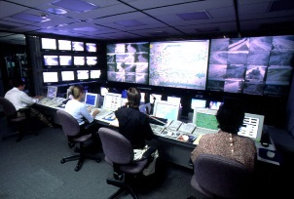

*Ubiquitous BB wireless network*

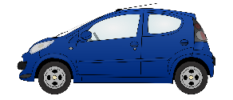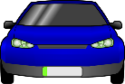

***RSU***

*5.9 GHz*

*5.9 GHz*

*5.9 GHz*

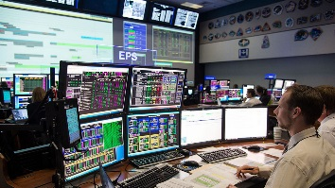

**FIGURE 13 MULTIPLE SERVICE PROVIDERS IN THE FUTURE ITS ENVIRONMENT**

The Car2Car-Communication Consortium (C2C-CC[40]) in Europe was founded in 2002 to collectively develop safety related information exchange and therefor developed a detailed expertise in the short-range road safety related information exchange, C-ITS requirements and ETSI ITS-G5 communications.

The C-Roads[41] Platform brings together road authorities and operators currently covering 16 Member States (Austria, Belgium, Czech Republic, Denmark, Finland, France, Germany, Hungary, Ireland, Italy, Portugal, Slovenia, Spain, Sweden, The Netherlands, Luxembourg, UK as well as Norway, Switzerland and Australia).

The objective of these European Member States is to realize the safe travel goal as expressed in the EU transport policy and reduce the amount of accidents via available ITS technologies that have been already tested and demonstrated on large scale. The aim of the C-Roads platform is to realize this road safety goal at a European level by aligning specifications for cooperative intelligent transport systems (C-ITS) to ensure European interoperability. A rapid deployment of harmonised C-ITS services is key to this objective. C-Roads Member States are focused at realizing flawless operation of C-ITS services cross border today and are building the foundations for connected and automated vehicles.

The C-Roads platform and its contributing Member States follow the European strategy (COM(2016) 766[42]), the European declaration of Amsterdam, and the European C-ITS deployment platform recommendations. Current deployments of C-ITS are based on available communication technologies IEEE802.11p/ETSI ITS-G5 as well as 3G and 4G cellular standards. In this combination, the short range communication technology ETSI ITS-G5 (as demonstrated in SCOOP and the C-ITS corridor) complements long range 3G/4G cellular communication (as demonstrated in NordicWay). This is shown in Figure 15.

Today ETSI ITS-G5 equipment is available in the market, and is implemented and operational in both Vehicular On-Board Units (OBU) and Road Site Systems (RSU). Just in France, Original Equipment Manufacturer OEM[43] 1 deliveres 1000 passenger vehicles into the market, with first vehicles delivered in 2017 (France only). OEM 2 will upgrade its vehicle´s series with ETSI ITS-G5 (about 1000) selling to the market. Authorities and others will retrofit another 1000 vehicles. These vehicles are equipped with dual channel ETSI ITS-G5 systems using two of the ETSI ITS G5A channels[44] (i.e. 5 875 to 5 885 MHz with IEEE channel number 176 and 5 895 MHz to   
5 905 MHz with IEEE channel number 180) (Figure 14 below) in the Scoop@F project. OEM 3[45] will introduce ETSI ITS-G5 equipment in mass market model before summer 2019 and in strong consensus the C2C-CC published[46] their commitment to start deploying C-ITS services in serial vehicles based on ETSI ITS-G5 technology. Many, mostly dual channel, ETSI ITS-G5 infrastructural systems have been installed in various European Member States, and an increasing number of Member States follow the European Hybrid Communication interoperability approach as agreed at the C-ROADS Platform. Austria has started to deploy ETSI ITS-G5 in 2016. From 2018, onwards 300 km of roads will be equipped with ETSI ITS-G5 (ASFINAG[47], Eco-AT[48]). Deployment in France, England, the Netherlands, Norway and Sweden also started in 2016 based on country projects, Germany and Slovenia are equipped in 2017, and Hungary was already implementing ETSI ITS-G5 in 2016. Other C-ROAD Member States will follow in 2018 (C-ROADS).The basic use cases, as defined in the ETSI TR 102 638, realize their information exchange by the simple CAM and DENM messages which are exchanged on channel 180. Additionally, based on the obligated PKI support, channel 176 is used for certificate exchange via ETSI ITS-G5.

**Figure 14**

C-ITS CHANNELS USED BY ETSI ITS-G5 IN EUROPE, STATUS 2017, WITH CORRESPONDING IEEE CHANNEL NUMBER66)

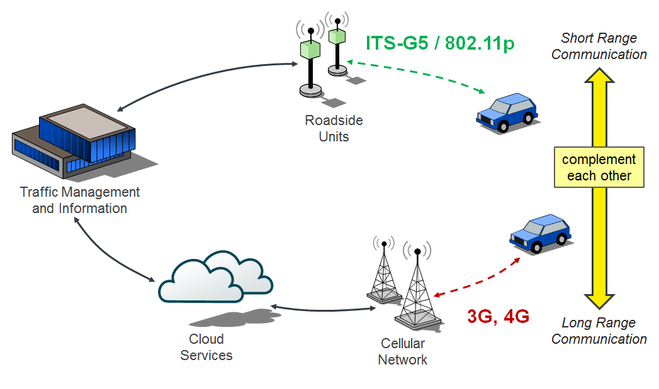

**FIGURE 15**

SHORT AND LONG RANGE COMMUNICATION COMPLEMENT EACH OTHER[49]

The European ITS Strategy as defined in the COM(2016) 766, a milestone towards cooperative, connected and automated mobility, is focused on the deployment of C-ITS services based on the existing ITS-G5 short-range communication for the tactical traffic safety related and efficiency related information exchange as proven in the many projects over the last 20 years. The C-ROADS Platform Member States are committed to follow the COM(2016) 766 European ITS strategy and the Declaration of Amsterdam[50]. The C-ROADS Member States are focused to deploy C-ITS applications based on the Hybrid Communication environment as agreed in the EU C-ITS platform Final Report phase 1 from 2016[51]. To accomplish this the C-ROADS Platform and the C2C-CC have agreed a Memorandum of Understanding (MoU[52]) to ensure the required European Interoperability.

Beside the commitment to start deploying ETSI ITS-G5 in 2019 by C2C-CC OEM’s, the motorcycle companies’ OEM’s expect to follow the vehicle, specifically for the realisation of ITS-G5 in their products, have organized themselves in the Motorcycle Consortium[53] and expressed to follow the car OEM’s in the C2C-CC with the realisation of ETSI ITS-G5. OEM 4 (world wide) and OEM 3123 (in Europe) officially announce their commitments to implement this technology and Score@F members have equipped products sold into the market and expects that this will be followed by others. Six truck OEMs (OEM 5, OEM 6, OEM 7, OEM 8, OEM 9, and OEM 10) have expressed to realize platooning based on ETSI ITS-G5 communication equipment. The Truck manufacturers are expecting to use multiple ETSI ITS-G5 channels as they need a higher CAM rate of up to 30Hz and additional platooning management information exchange.

## 7.2 Asia-Pacific

### 7.2.1 Technical Characteristics

#### 7.2.1.1 Technical characteristics in Korea

V2X communication technology has been developed for vehicle safety and Cooperative ITS applications.

In the Republic of Korea, the frequency band is 5 855 - 5 925 MHz for C-ITS (V2V and V2I communications) and can use 7 radio frequency channel with 10MHz channel bandwidth. In channel operation, control channel uses 5 895 - 5 905 MHz radio channel and the other 6 radio channel can be used for service channel. Also, the each RF channel has 20 dBm in radio transmit power level.

**TABLE 23 RADIO CHANNEL ASSIGNMENT FOR ITS IN KOREA**

|  |  |  |
| --- | --- | --- |
| **Channel Number** | **Frequency Band(MHz)** | **Channel Usage** |
| 1 | 5 855 - 5 865 | Service Channel |
| 2 | 5 865 - 5 875 | Service Channel |
| 3 | 5 875 - 5 885 | Service Channel |
| 4 | 5 885 - 5 895 | Service Channel |
| 5 | 5 895 - 5 905 | Control Channel |
| 6 | 5 905 - 5 915 | Service Channel |
| 7 | 5 915 - 5 925 | Service Channel |

#### 7.2.1.2 Technical characteristics in Singapore

The frequency band 5 855 - 5 925 MHz for ITS applications is split into channels with a bandwidth of 10 MHz per channel. The ITS service channelling arrangements and the RF transmit power could be found below.

**TABLE 24 SINGAPORE ITS SERVICE CHANNEL ALLOCATION**

|  |  |  |
| --- | --- | --- |
|  | Channel type | Frequency range  [MHz] |
| Non-Safety related | Service Channel | 5 855 to 5 865 |
| Service Channel | 5 865 to 5 875 |
| Traffic/Safety related | Service Channel | 5 875 to 5 885 |
| Control Channel | 5 885 to 5 895 |
| Service Channel | 5 895 to 5 905 |
| Service Channel | 5 905 to 5 915 |
| Service Channel | 5 915 to 5 925 |

Typical RF power limit of up to 33 dBm EIRP for traffic/safety related channels and 20 dBm EIRP for non-safety related channels.

#### 7.2.1.3 Technical characteristics in Japan

The frequency band 5 770-5 850 MHz for ITS applications (Refer to ITU-R M.1453-2, 2005) is split into channels with a carrier frequency spacing of 5 MHz at present.

The maximum transmission power for roadside equipment (RSE) should be less than 44.7 dBm e.i.r.p. The maximum transmission power for on-board equipment (OBE) should be less than 20 dBm e.i.r.p.

Table 25 shows channel arrangement of ITS applications using DSRC at 5.8 GHz band in Japan.

**Table 25 CHANNEL ARRANGEMENT FOR ITS APPLICATIONS AT 5 770 - 5 850 MHz BAND IN JAPAN**

|  |  |
| --- | --- |
|  | Carrier Frequency  [MHz] |
| Road Side Equipment Channel | 5 775 |
| 5 780 |
| 5 785 |
| 5 790 |
| 5 795 |
| 5 800 |
| 5 805 |
| On-Board Equipment Channel | 5 815 |
| 5 820 |
| 5 825 |
| 5 830 |
| 5 835 |
| 5 840 |
| 5 845 |

#### 7.2.1.4 Technical characteristics in Australia

The frequency band 5 855–5 925 MHz has been made available for use by ITS systems. Individual licensing is not required. However, the following conditions are to be met:

1. The ITS station must be operated:
   1. On a frequency, or within a range of frequencies, greater than 5 855 MHz and not greater than 5 925 MHz; and
   2. At a radiated power that does not exceed a maximum e.i.r.p. of 23 dBm/MHz;
2. The ITS station must not be operated within 70 kilometres of the Murchison Radioastronomy Observatory located at latitude 26⁰ 42’ 15” south, longitude 116⁰ 39’ 32” east;
3. The ITS station must comply with ETSI Standard EN 302 571; and

Other conditions concerned with general public exposure to electromagnetic radiation as defined in the [*Radiocommunications (Intelligent Transport Systems) Class Licence 2017*](https://www.legislation.gov.au/Details/F2018L00026).

### 7.2.2 Frequency usage

**TABLE 26 FREQUENCY USAGE ON ADVANCED ITS RADIOCOMMUNICATION IN ASIA-PACIFIC**

|  |  |  |  |  |
| --- | --- | --- | --- | --- |
| **Country** | **Frequency Band** | **Technology** | **Application** | **Status** |
| Japan | 5 770 - 5 850 MHz | V2V/V2I communication | Safety related information | Guidelines for field experiment in 2007 (revised 2013) |
| 755.5 - 764.5 MHz band | Enacted in 2011 (revised 2013) |
| Korea | 5 855 - 5 925 MHz | V2V/V2I communication | Vehicle Safety Related  C-ITS | Enacted in 2016 |
| China | 5 905 - 5 925 MHz | LTE based V2X | V2X communication | Field  Experiment in 2017 |
| Singapore | 5 855 - 5 925 MHz | V2V/V2I | Traffic/Safety Related Information | Enacted in 2017 |
| Australia | 5 855 – 5 925 MHz | V2V/V2I | Traffic/Safety related information | Enacted in January 2018 |

### 7.2.3 Standardization

**TABLE 27 STANDARDS ON ADVANCED ITS RADIOCOMMUNICATION IN ASIA PACIFIC**

|  |  |  |
| --- | --- | --- |
| **SDO** | **Standard No.** | **Standard Title** |
| TTA | TTAS.KO-06.0175/R1 | Vehicle Communication System Stage1: Requirements |
| TTAS.KO-06.0193/R1 | Vehicle Communication SystemStage2: Architecture |
| TTAS.KO-06.0216/R1 | Vehicle Communication System Stage3 : PHY/MAC |
| TTAS.KO-06.0234/R1 | Vehicle Communication System State 3 : Networking |
| TTAK.KO-06.0242/R1 | Vehicle Communication System Stage3 : Application Protocol Interface |
| TTAK KO-06.0344 | In-Vehicle Signage System for Vehicle Safety Guidance Stage 1: Requirements |
| TTAK KO-06.0344-Part2 | In-Vehicle Signage System for Vehicle Safety Guidance Stage 2: Data Exchange |
| ITS Info-communications Forum | ITS FORUM GUIDELINES | - ITS FORUM RC-008 Operation Management Guideline for Driver Assistance Communications System  - ITS FORUM RC-009 Security Guideline for Driver Assistance Communications System  - ITS FORUM RC-010 700MHz BAND INTELLIGENT TRANSPORT SYSTEMS ‐ Extended Functions Guideline  - ITS FORUM RC-013 700MHz BAND INTELLIGENT TRANSPORT SYSTEMS‐ Experimental Guideline for Inter‐vehicle Communication Messages |
| ITS Connect Promotion Consortium | ITS Connect TD-001 | ITS Connect TD-001 Inter-vehicle Communication Message Specifications |
| ARIB | STD T109 | 700 MHz Band Intelligent Transport System |
| CCSA | 2015-1616T-YD | General technical requirements of LTE-based vehicular communication |
| 2016-1853T-YD | Technical requirements of air interface of LTE-based vehicular communication |
| IMDA TSAC | IMDA TS DSRC | Technical Specification for Dedicated Short-Range Communications in Intelligent Transport Systems |

# 8 Millimetre-wave automotive radar

## 8.1 Overview

The millimetre-wave band of the electromagnetic spectrum corresponds to radio band frequencies of 30 GHz to 275 GHz (wavelength from 10 mm to 1 mm). Millimetre waves’ high frequency realizes small equipment size including the compact high gain antenna which makes this technology well suited for vehicular use. Particularly in radar system, the millimetre wave can easily create a narrow beam that is desirable to discriminate small distant objects.

Sensor technologies for monitoring and identifying objects in the proximity of vehicles are the most important safety-related base technologies for developing systems that will accommodate this purpose. Various types of sensors have been studied and developed, and through this research and development, it has become clear that a Radio Detection and Ranging (RADAR) using radio waves is suitable for this objective.

International efforts have been taken to make harmonized frequency ranges available for automotive radar applications. WRC-15 allocated the frequency range 77.5 - 78 GHz spectrum allocation to Radio Location Service (RLS) on a co-primary service under Agenda Item 1.18 (RR 5.559B). The frequency band 76 - 81 GHz band is for short-range high-resolution automotive radar applications. This radar can be used for variety of applications, such as reduce number of fatalities and traffic accidents.

Automotive radar sensors operating in the frequency band 76 - 81 GHz provide additional functions that contribute to enhance road safety for vehicle passengers and other vulnerable road users. Evolving demands related to automotive safety applications, including the reduction of traffic fatalities and accidents require a range resolution for automotive radar systems leading to a necessary bandwidth of up to 4 to 5 GHz. These high resolution automotive radars will be key sensors for autonomous driving vehicles.

In Europe, Ultra Wide Band (UWB) Short Range Radar (SRR) operating at 24 GHz (22 - 29 GHz) was considered to be a key technology for the rapid and cost-effective introduction of many intelligent vehicle safety related systems. In January 2005, the European Commission decided on the temporary time-limited (until 1 July 2013) use of the 24 GHz range radio spectrum band for the ultra-wide band part of short-range vehicle radar equipment as outlined in ECC /DEC (04)10. The decision was revised and the final deadline was set to 2018.

In parallel, it was decided that in future, SRR equipment is intended to operate in the frequency band 79 GHz (77 - 81 GHz) on a permanent base, see ECC/DEC/(04)03. When the temporary allocation for 24 GHz automotive radar was implemented, based on the conducted studies it was concluded that incumbent users operating in the 24 GHz band would increasingly suffer from significant levels of harmful interference if a certain level of penetration of vehicles using the 24 GHz range radio spectrum band for UWB short-range radars was to be exceeded.

According to CEPT (European Conference of Postal and Telecommunications Administrations), the sharing between earth exploration satellite services and UWB short-range vehicle radar could only be feasible on a temporary basis, based on the at that time foreseen low penetration rate for 24 GHz automotive radars.

In contrast to the above, 24.05-24.25 GHz ISM band automotive radars can be used worldwide without any time limitation.

China identified 77 - 81 GHz for experiment frequency band of millimetre-wave vehicular radar in December 2016. Laboratory test and road-test were launched in four major cities of China to verify technical characteristics, including electromagnetic compatibility and radio frequency matters, interference, and radar performance in typical scenarios, etc.

It is expected that in the near future further administrations will decide to implement the WRC-2015 decision of automotive radars.

### 8.1.1 Technical characteristics

(1) Low Power Automotive Radar at 24 GHz

Today the frequency allocation for automotive radar application is in a rebuilding phase. Due to technological and commercial constraints, the frequency allocation for these safety related applications has been done in the beginning of the last decade in the range of 24 GHz. In Europe, e.g. an allocation for the 24 GHz UWB band (21.65–26.65 GHz) has been done as an intermediate solution due to the incompatibility with the Radio Astronomy Service, EESS, the Fixed Service and military applications. Therefore, the cut-off date of 1st July 2013 has been defined. In July 2011, the ECC extended the cut-off date (for sensors with reduced frequency range of 24,25‑26,65 GHz) until 1st January 2018 by ECC decision 04(10) to allow the car manufacturers a seamless implementation of 79 GHz technology. The technological evolution during the last years led to the fact that with a similar effort a higher performance can be reached today.

It is to be noted that the 24 GHz ISM band (24.05-24.25 GHz) plays an import role, especially for affordable vehicles. As this band is an ISM band and globally harmonized, 24.05-24.25 GHz ISM band automotive radars can be used worldwide without any time limitation.

(2) High Resolution Short Range Automotive Radar operating at 79 GHz (77-81 GHz)

The 77-81 GHz band has already been implemented for this kind of automotive radar applications in many countries. It is expected that further countries will implement the WRC-2015 decision on 79 GHz automotive radars in the near future.

The 77-81 GHz band has been designated by CEPT in July 2004 (ECC/DEC/(04)03) for automotive radar applications. Also, the European Commission has adopted the decision 2004/545/EC on the harmonization of radio spectrum in the 79 GHz (77-81 GHz) range for the use of automotive radar. The harmonized standard EN 302 264 has been adopted by ETSI for short-range radar (SRR) operating in the 77-81 GHz band.

In March 2010, the Ministry of Internal Affairs and Communications (MIC) in Japan has started a study group in the Information and Communications Council for the introduction of high-resolution radar in the 77-81 GHz frequency band for national use. As a result of this activity the 78-81 GHz band was allocated to automotive radar in December 2012.

In October 2010, the Russian Federation identified the 77-81 GHz band for automotive radar.

(3) Ultra Wide Band (UWB) Radar

Generally UWB is defined as the radio signal whose fractional bandwidth is greater than 20% of the centre frequency or the 10 dB bandwidth occupies 500 MHz or more of spectrum.

UWB technology originally employed very narrow or short duration pulses that result in very large or wideband transmission bandwidths (refer to Figure 16, “UWB monocycle time and frequency domains”). For automotive radar, the pulsed-UWB technique is replaced step-by-step by very wideband frequency chirps (Frequency-modulated continuous-wave = FMCW or pulse compression radar) without the need for short duration pulses. With appropriate technical standards, UWB devices can operate using spectrum occupied by existing radio services without causing interference, thereby permitting scarce spectrum resources to be used more efficiently.

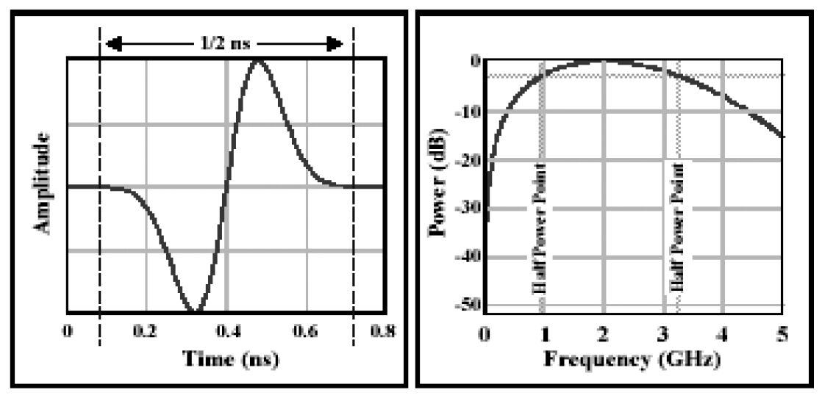

FIGURE 16 UWB MONOCYCLE TIME AND FREQUENCY DOMAINS   
(UWB, "A POSSIBLE AREA FOR STANDARDS", GSC 8 PRESENTATION BY FCC.)

**(4) Vehicle mounted radar**

Regarding functional and safety requirements, the automotive radar systems operating in the 76 ‑ 81 GHz band can be separated in two categories:

– **Category 1**: Adaptive Cruise Control (ACC) and Collision Avoidance (CA) radar, for measurement ranges up to 300 metres. For these applications, a maximum continuous bandwidth of 1 GHz is required. Such radars are considered to add additional comfort functions for the driver, giving support for more stress-free driving.

– **Category 2**: Sensors for high resolution applications such as Blind Spot Detection (BSD), Lane-Change Assist (LCA) and Rear-Traffic-Crossing-Alert (RTCA), detection of pedestrians and bicycles in close proximity to a vehicle, for measurement ranges up to 100 metres. For these high resolution applications, a necessary bandwidth of 4 GHz is required. Such radars directly add to the passive and active safety of a vehicle and are therefore an essential benefit towards improved traffic safety.

Depending on the number of radar sensors and their mounting position on the vehicle, it is possible to detect objects in sectors or even the complete surrounding of a car. The sensor signals are the basis not only for driver assistance systems like ACC but also for a broad variety of automotive applications of active and passive safety.

Systems for monitoring the proximity to vehicles will play an important role in ensuring driving safety. High resolution automotive radars will be a key sensor technology for autonomous driving vehicles. With its resistance to bad weather and dirt, automotive radar is suitable for vehicles driven in severe conditions.

Figure 17 shows the configuration of automotive radar.



**Figure 17 CONFIGURATION OF AUTOMOTIVE RADAR**

Subsystems are as follows:

– *Antenna/RF unit*

This part consists of a transmitting antenna, a receiving antenna, receiving equipment and transmission equipment. Signal modulations, conversions to high frequencies, radio‑wave transmission, and radio‑wave reception are handled in this part. This part could be equipped with several antennas and could perform beam scanning.

– *Signal processing unit*

This unit renders distance and speed by calculating signals handed over from the RF unit. Rendering of average distance and speed, and mitigation of interference are sometimes handled here. When the antenna performs beam scanning, this unit calculates the direction of detected objects.

– *Recognition unit*

This unit can select and arrange the most wanted or necessary data depending on the needs of each system. For example, the unit will recognize the most relevant objects, and can judge whether the vehicle in front is in lane. The unit occasionally averages figures gathered, filters interference, and enhances measuring accuracy and reliability of data by tracking objects and by data fusion with data from other sensors.

**(5) Radar for road incident detection system**[54]

Incident detection service deployed in Korea enables drivers in vehicles to receive real-time information for unexpected road situation (obstacle, stopped and wrong way vehicle, frozen-road etc.) through real-time and automatic detection system using radar sensors to prevent unexpected accidents. It also provides traffic information within 1 km from radar sensor. It supports driver in heavy rains and foggy weather to receive real-time information by incident detection system.

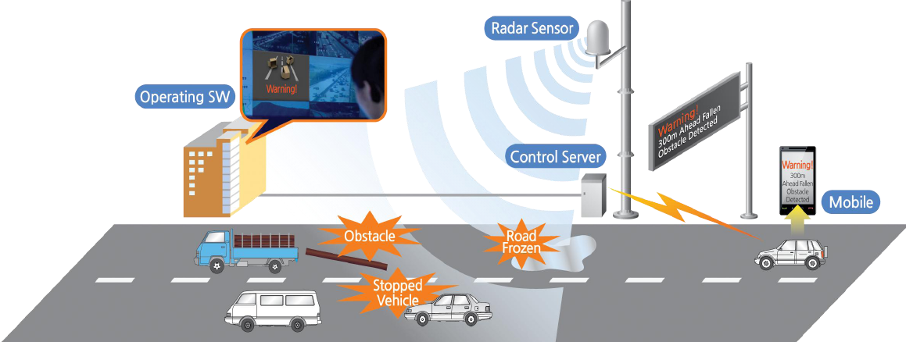

**FIGURE 18 INCIDENT DETECTION SERVICE**

Characteristics of 34 GHz incident detection radar are given in Table 28.

TABLE 28 ROAD RADAR SYSTEM

| Characteristic (Parameter) | Value |
| --- | --- |
| **Operational characteristics** | |
| Application/Service | Road Incident Detection System |
| Typical installation | Road Side Pole(or gantry) |
| **Technical characteristics** | |
| Max. range | 1 000 m |
| Frequency range | 34.275-34.875 GHz |
| Specified bandwidth (typical) | Up to 600 MHz |
| Peak Power (e.i.r.p) | Up to +55 dBm |
| Mean Power (e.i.r.p) | Up to +45 dBm |

**(6) Radar for Cooperative driving support**

In Japan, a cooperative driving support system is developed and deployed for intersection safety. The system consists of the millimetre wave radar as a roadside sensor to detect pedestrians, cyclists, and vehicles entering an intersection. The roadside sensor typically mounted at approximately the same height as traffic signals that have a wide field of view. The system also alerts motorists to potential hazards by using the ITS radio communication.

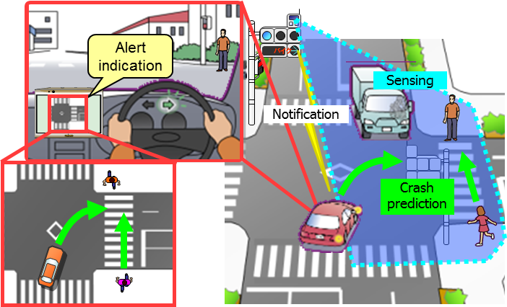

**FIGURE 19** **COOPERATIVE DRIVING SUPPORT**

### 8.1.2 Frequency usage

**(1) Automotive Radar at 77 GHz band**

Several millimeter-wave bands are considered for vehicular radar. The 76 - 77 GHz band has already been designated by the Federal Communications Commission (FCC) in the United States of America and by the Ministry of Internal Affairs and Communications (MIC) in Japan for these purposes. Up to October 2017 in the United States, vehicular radars operating in the 76 - 77 GHz band are regulated according to FCC 47 part 15.253 and as part 15 device; may not cause harmful interference and must accept interference that may be caused by the operation of an authorized radio system, by another intentional or unintentional radiator, by industrial, scientific and medical (ISM) equipment, or by an incidental radiator. In October 2017, FCC implemented a new rule for automotive radars under part 95M. In European spectrum requirements for Road Transport and Traffic Telematics (RTTT), ETSI has adopted European standards for automotive radar operating in the 76 - 77 GHz band (ETSI EN 301 091). In Europe, this band is covered under the short range device decision as latest version 2017/1483/EU. In Japan, the 76 - 77 GHz band is designated for this kind of application (ARIB STD-T48).

(2) High Resolution Automotive Radar at 79 GHz band

The industries are trying to seek globally or regionally harmonized frequency allocations for new automotive radar technologies. The following frequency bands are allocated to radio location service on a primary basis which are designated for use by automotive radar applications: The rationale for separating these applications into two different frequency bands is given in ECC Report 56, which reveals, that sharing studies have concluded that sharing is not achievable between Category 1 and Category 2 if operated in a common frequency band.

– 76 GHz to 77 GHz Long Range Radar (LRR) > 150 meter

– 77 GHz to 81 GHz Short Range Radar (SRR) < 150 meter (high resolution).

The rationale for separating these applications into two different frequency bands is given in ECC Report 56, which reveals, that sharing studies have concluded that sharing is not achievable between LRR and SRR if operated in a common frequency band.

In Japan, the 77 - 81 GHz band is also designated for safety related applications (ARIB STD-T111).

### 8.1.3 Standardization

**TABLE 29 GLOBAL STANDARD ON MILLIMETRE-WAVE AUTOMOTIVE RADAR**

|  |  |  |  |
| --- | --- | --- | --- |
| **SDO** | **Standard No.** | | **Standard Title** |
| ITU | Recommendation | ITU-R M.1452 | Millimetre wave radiocommunication systems for intelligent transport system applications |
| ITU-R M.2057 | Systems characteristics of automotive radars operating in the frequency band 76 - 81 GHz for intelligent transport systems applications |
| Report | ITU-R M.2322 | Systems Characteristics and Compatibility of Automotive Radars Operating in the 77.5 - 78 GHz Band for Sharing Studies |
| ITU-R F.2394 | Compatibility between point-to-point applications in the fixed service operating in the 71 - 76 GHz and 81 - 86 GHz bands and automotive radar applications in the radiolocation service operating in the 76 - 81 GHz bands |

### 8.1.4 Applications

Today’s automotive radar systems, operating in the millimetre-wave, are of two categories according to the measurement ranges and bandwidth:

– Category 1: Adaptive Cruise Control (ACC) and collision avoidance radar (CA), operating in the band 76-77 GHz, for measurement ranges up to 300 m.

– Category 2 “Short-range” radar for applications such as Blind Spot Detection (BSD), Lane-Change Assist (LCA), and Rear-Traffic-Crossing-Alert (RTCA), operating in the band 77‑81 GHz for measurement ranges up to 100 m.

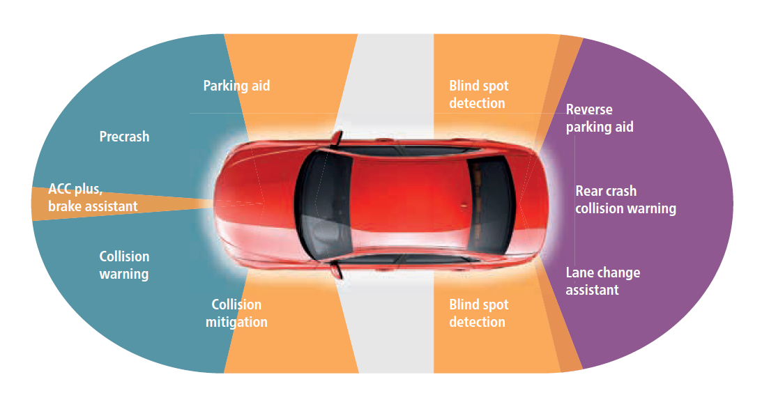

**FIGURE 20 AUTOMOTIVE RADAR APPLICATIONS**

## 8.2 Asia-Pacific

In some APT countries, frequency bands of 24, 60, 76 and 79 GHz have been used. For global harmonization of ITS, APT countries like Australia are considering European activities which use 79 GHz as a permanent band. Also, Hong Kong, China opened the 79 GHz band for automotive radar systems utilizing ultra-wideband technology in January 2017.

Based on the result of WRC-15, Japan has allocated 77 - 81 GHz band for short-range high-resolution radar in January 2017.

### 8.2.1 Frequency usage

**TABLE 30 FREQUENCY USAGE ON MILLIMETRE-WAVE AUTOMOTIVE RADAR IN ASIA-PACIFIC**

|  | **24.05 to 24.25 GHz ISM** | | **76 to 77 GHz** | | | **77 to 81 GHz** | | |
| --- | --- | --- | --- | --- | --- | --- | --- | --- |
|  | **Regulation** | **Standard** | **Regulation** | **Standard** | **Report/Notes** | **Regulation** | **Standard** | **Report/Notes** |
| Korea, Republic of |  | Article 103 | Rules on Radio Equipment (Article **29** Paragraph 9) (2013-01-03)” | Technical Standards for Radio Equipment  (RRL Notification 2006-84 (2006.8.23)) |  |  |  |  |
| China | Technical Specification for Micropower (Short Distance) Radio Equipments of Category G |  | Technical Specification for Micropower (Short Distance) Radio Equipments, part XIV |  |  |  |  |  |
| Japan | ARIB STD-T73 1.1 |  | Ordinance Regulating Radio Equipment Notification of MIC (643-1997) |  |  | Ordinance Regulating Radio Equipment, Notification of MIC (4432012) |  |  |
| Singapore |  |  | IMDA Technical Specification Short Range Devices | IMDA TS SRD |  | IMDA Technical Specification Ultra-Wideband (UWB) Devices | IMDA TS UWB |  |
| Thailand | Technical Standard of telecommunication device and equipment  Radar based Telecommunication device in vehicle (Vehicle Radar)  Section 2.1.1 | Vehicle Radar Standard NBTC 1011-2557  Section 2.1.1 | NTC TS 1011-2549 | Vehicle Radar Standard NBTC 1011-2557  Section 2.1.3 |  |  |  |  |
| Viet Nam | Regulation on technical and operational requirements for short range devices (Circular No. 46/2016/TT-BTTTT) |  | Regulation on technical and operational requirements for short range devices (Circular No. 46/2016/TT-BTTTT) |  |  | Regulation on technical and operational requirements for short range devices (Circular No. 46/2016/TT-BTTTT) |  |  |

### 8.2.2 Standardization

**TABLE 31 STANDARDS ON MILLIMETRE-WAVE AUTOMOTIVE RADAR IN ASIA PACIFIC**

|  |  |  |
| --- | --- | --- |
| SDO | Standard No. | Standard Title |
| ARIB | STD-T48 | Millimeter-Wave Radar Equipment for Specified Low Power Radio Station |
| STD-T111 | 79 GHz Band High-Resolution Radar |
| IMDA | IMDA TS SRD |  |
| IMDA TS UWB |  |

### 8.2.3 Applications

**Table 32 USAGE STATUS OF AUTOMOTIVE RADAR IN ASIA-PACIFIC**

|  |  |  |  |  |
| --- | --- | --- | --- | --- |
| **Country** | **Frequency Band** | **Technology/**  **Standard** | **Application** | **Deployment or Plan Year** |
| Australia | 22 - 26.5 GHz | Radiocommunications (Low Interference Potential Devices) Class Licence 2015 | Section 66  Ultra-wideband short-range vehicle radar systems transmitters | - |
| 24.0-24.25 GHz | Section 66  Radiodetermination transmitters |  |
| 76 - 77 GHz | Long-range vehicle radar (intelligent cruise control)  Section 69  Radiodetermination transmitters |  |
| 77 - 81 GHz | Section 70  Radiodetermination transmitters |  |
| China | 24.00 - 24.25 GHz | Notice on Promulgation of the Technical Specification for Micropower (Short Distance) Radio Equipments | Vehicular range radar | Enacted in 2005 |
| 76 - 77 GHz |
| 24.25 - 26.65 GHz | Ministry of Industry and IT, Notice regarding 24GHz frequency band short range automotive radar | Vehicular range radar | Enacted in 2012 |
| 77 - 81 GHz | Radar | Vehicular range radar | Field  Experiment in 2017 |
| 76 - 77 GHz | HKCA1075  Exemption from Licensing Order[55] | Vehicular radar systems | 2005 |
| 77 - 81 GHz | 2017 |
| Japan | 22 - 24.25 GHz* | Quasi-millimetre wave system | Detect obstacles (Sensor) | Enacted in 2010 |
| 24.0-24.25 GHz |
| 24.25 - 29 GHz |
| 60 - 61 GHz | Millimetre wave system | Enacted in 1997 |
| 76 - 77 GHz | Enacted in 2011  (Occupied band width: 500 MHz)  Revised in 2015  (Occupied band width: 1 GHz) |
| 77 - 81 GHz | Enacted in 2012 for 78-81 GHz  Revised in 2017 for inclusion above 77 GHz |
| Korea | 24.25 - 26.65 GHz | Radar | Vehicular collision avoidance radar | 2012  (The device for “Automotive radar” can be installed until 31st Dec. 2021 and this can be used until lifetime of this device.) |
| 76 - 77 GHz | 2008 |
| 77 – 81 GHz | 2016 |
| Singapore | 76 - 77 GHz | Radar  IMDA TS SRD | Short range radar systems such as automatic cruise control and collision warning systems for vehicle | 2002 |
| 77 - 81 GHz | Radar  IMDA TS UWB | Vehicular Radar | 2008 |
| Thailand | 5 725 - 5 875 MHz | - | Radar application | Regulation adopted in 2007 |
| 24.05 - 24.25 GHz | Vehicle Radar Standard NBTC 1011-2557- | Vehicle radar application | Regulation adopted in 2007 |
| 24.25 - 26.65 GHz | Vehicle Radar Standard NBTC 1011-2557 | Vehicle radar application | Regulation adopted in 2014 |
| 76 - 81 GHz | - | Radar application | Regulation adopted in 2007 |
| 76 - 77 GHz | Compliance Standard: FCC Part 15.253 or EN 301 091-1 | Vehicle radar application | Regulation adopted in 2006 |
| Viet Nam | 24.00 - 24.25 GHz | Low Interference Potential Devices | Non-specific short range applications including short range vehicular radar | Regulation adopted in 2009 |
| 76 - 77 GHz | Radar | Vehicular Radar | 2012 |
| 77 - 81 GHz | Radar | Vehicular Radar | 2016 |

# 9 Results of Studies

ITS attract many people’s interest because it could improve the safety of road traffic, ensure smoother traffic, reduce environmental burdens, and stimulate regional economic activity, etc. From the APT survey results, major deployed ITS in APT countries were classified as electronic toll collection, vehicle information, communication and automotive radar . As the importance of car safety is increasing, cooperative system is widely considered for international deployment. In addition to Europe and North America, some countries in Asia-Pacific region, frequency band 5 855 - 5 925 MHz was assigned for cooperative systems and many development project was performed toward deployment of autonomous driving vehicles in near future. Regarding these activities, APT administrations should study the optimal frequency spectrum for cooperative systems and try to reach regional/international harmonization of spectrum arrangements, which is the target of WRC-19 agenda item 1.12 – ITS Applications.

Regarding short-range high-resolution radar, additional spectrum of 77.5 - 78 GHz has been allocated for 79 GHz band radar under WRC-15 agenda item 1.18. The 79 GHz band radar can be used spectrum up to 5 GHz bandwidth (76‑77 GHz and 77-81 GHz) to give much higher resolution for radar.

**References**

[1] ETSI EN 302 665 V1.1.1, “Intelligent Transport Systems (ITS); Communications Architecture” (2010-09)

[2] <http://www.etsi.org/website/Technologies/IntelligentTransportSystems.aspx>

[3] Report ITU-R M.2228, “Advanced Intelligent Transport Systems (ITS) radiocommunication”

[4] Recommendation ITU-R M.1453, “Intelligent Transport Systems – dedicated short-range communications at 5.8 GHz”

[5] [APT/AWG/REP-18 [(Rev.2)](http://www.aptsec.org/sites/default/files/2016/09/AWG-20-TMP-44_ITS_USAGE_Consolidated_R2_clear.docx)] “The usage of intelligent transport systems in APT Countries”

___________________

1. "Collaborative Connected Vehicle Research Update" (<http://www.its.dot.gov/presentations/pdf/V2V_Collaborative_Research_MikeLukuc2013.pdf>) at 10-12; “Safety Pilot Model Deployment: Lessons Learned and Recommendations for Future Connected Vehicle Activities” (<http://ntl.bts.gov/lib/59000/59300/59361/FHWA-JPO-16-363.pdf>) at 11-12; “CV Applications Already Deployed by Responding Agencies” (<http://transops.s3.amazonaws.com/uploaded_files/V2I%20DC%20TWG%201%20-%20January%2028%2C%202016%20Webinar%20Slides%20V3.pptx>) at 30; “Maricopa County Department of Transportation (MCDOT) SMARTDriveSM Program” (<http://www.mcdot.maricopa.gov/business/connected-vehicles.aspx>); “Connected Vehicle Pilot Deployment Program Phase 1: Concept of Operations (ConOps) - New York City” (<http://ntl.bts.gov/lib/59000/59300/59360/FHWA-JPO-16-299.pdf>) at 36; “Connected Vehicle Pilot Deployment Program: ICF/Wyoming Concept of Operations” (<http://www.its.dot.gov/pilots/pdf/ICF_ConOpsWebinar_02042016.pdf>) at 34
2. <https://www.car-2-car.org/index.php?id=31>
3. https://www.itsconnect-pc.org/en/about_its_connect/
4. http://newsroom.toyota.co.jp/en/detail/9676551/
5. Noting that, for safety applications, the IEEE 802.11p technology standards also rely on broadcast mode without any acknowledgement and no retransmissions.
6. J. Gozalvez, M. Sepulcre, R.Molina, O. Altinas, *Heterogeneous V2X Networks for Connected and Automated Vehicles*, Universidad Miguel Hernandez de Elche, Spain
7. R. Blasco, H. Do, S. Shalmashi, S. Sorrentino, Y. Zang, *3GPP Enhancements for V2V and Comparison to IEEE 802.11p*, Paper # EU-SP0264, 11th ITS European Congress, Glascow, Scotland, June 2016
8. T. Shimizu, H. Lu, J. Kenney, *Preliminary Comparison of Suitability of DSRC and LTE-V2X*, Paper # ITS-AM-TP0308, 23rd ITS World Congress, Melbourne, Australia, October 2016
9. 3GPP TR 22.886 *3rd Generation Partnership Project; Technical Specification Group Services and System Aspects*; *Study on Enhancement of 3GPP Support for 5G V2X Services* (Release 15)
10. IEEE Std 802.11TM-2016, IEEE Standard for Information technology - Telecommunications and information exchange between systems - Local and metropolitan area networks - Specific requirements Part 11: Wireless LAN Medium Access Control (MAC) and Physical Layer (PHY) Specifications.
11. USDOT diagram based upon Std 802.11-2016 and generic OFDM principles.
12. Based upon information from IEEE Std 802.11TM-2016, IEEE Standard for Information technology - Telecommunications and information exchange between systems - Local and metropolitan area networks - Specific requirements: Part 11: Wireless LAN Medium Access Control (MAC) and Physical Layer (PHY) Specifications, 47 CFR [B9], Part 90, Sections 90.371–383, ASTM E2213 – 03 (as noted), SAE J2945TM/1 MAR2016, On-Board System Requirements for V2V Safety Communications, and field experience.
13. 47 CFR, Part 90, Section 90.377.
14. Portable, hand-carried OBEs are limited to 1.0 mW maximum output power – 47 CFR, Part 95, Subpart E, Section 95.639.
15. Note that for OBEs transmitting Basic Safety Messages (BSM)s on the dedicated V2V safety channel, the requirement is for maximum e.i.r.p. of 20 dBm - SAE J2945TM/1 MAR2016 (Table 21).
16. Per IEEE Std 802.11-2016, §17.3.9.3, p. 2305: Spectrum mask for 10 MHz channels, the transmitted spectral density shall have a 0 dBr bandwidth not exceeding 9 MHz and shall not exceed the spectrum mask created using the permitted power spectral density.
17. Society of Automotive Engineers (SAE), Surface Vehicle Standard, J2945™/1, March 2016, § 6.3.2 p. 57 and § 7, Table 21, p. 77.
18. For vehicles transmitting BSMs on the dedicated V2V safety channel, 6 Mbps data rate applies and IEEE Std 802.11-2016 (Table 17-4, p. 2285) specifies modulation-dependent parameters as shown.
19. Society of Automotive Engineers (SAE), Surface Vehicle Standard, J2945™/1, March 2016, § 6.4.1 p. 71.
20. 47 CFR [B9], Part 90, Sections 90.371–383: “A Road Side Unit (RSU) may employ an antenna with a height exceeding 8 meters but not exceeding 15 meters provided the e.i.r.p. specified in the table below is reduced by a factor of 20 log(Ht/8) in dB where Ht is the height of the radiation center of the antenna in meters above the roadway bed surface. The e.i.r.p. is measured as the maximum e.i.r.p. toward the horizon or horizontal, whichever is greater, of the gain associated with the main or center of the transmission beam. The RSU antenna height shall not exceed 15 meters above the roadway bed surface.
21. ASTM E2213 – 03: Standard Specification for Telecommunications and Information Exchange Between Roadside and Vehicle Systems — 5 GHz Band Dedicated Short Range Communications (DSRC) Medium Access Control (MAC) and Physical Layer (PHY) Specifications
22. SAE J2945/1, § 6.4.2, p. 73, and § 7, Table 21, p. 79.
23. IEEE Std 802.11-2016, Table 17-16, p. 2303.
24. Based upon information from IEEE Std 802.11TM-2016, IEEE Standard for Information technology - Telecommunications and information exchange between systems - Local and metropolitan area networks - Specific requirements Part 11: Wireless LAN Medium Access Control (MAC) and Physical Layer (PHY) Specifications; at pages –2310 - 2311.
25. IEEE Std 802.11TM-2016, IEEE Standard for Information technology - Telecommunications and information exchange between systems - Local and metropolitan area networks - Specific requirements Part 11: Wireless LAN Medium Access Control (MAC) and Physical Layer (PHY) Specifications; Annex D.
26. USDOT diagram based upon Std 802.11-2012.
27. 3GPP RP-142043, Revised Work Item Description: LTE Device to Device Proximity Services
28. 3GPP RP-150441, Revised WI: Enhanced LTE Device to Device Proximity Services
29. FCC Report and Order, October 1999, ET Docket No. 98-95.
30. Press Release, U.S. Transportation Secretary Mineta Announces Opening of Crash-Preventing “Intelligent Intersection” Test Facility (June 24, 2003) (<http://www.its.dot.gov/press/fhw2003.htm>).
31. FCC 06-110; MEMORANDUM OPINION AND ORDER; July 2006; ET Docket No. 98-95.
32. FCC 03-324 REPORT AND ORDER, December 2003, ET Docket No. 98-95.
33. <http://www.iteris.com/cvria/html/applications/applications.html>.
34. https://www.itsconnect-pc.org/en/about_its_connect/service.html
35. 3GPP TR 22.885 Study on LTE support for Vehicle to Everything (V2X) services
36. *See, e.g.*, GM Global Technology Operations, Inc., *Using V2X In-Network Message Distribution and Processing protocols to Enable Geo-Service Advertisement Applications*, U.S. Patent Appl. No. 12/415,756 (filed 31 Mar. 2009), <https://www.google.com/patents/US20100250346>; Mitsubishi Denki Kabushiki Kaisha, *Vehicle-Roadside Service Providing System*, U.S. Patent No. 6,768,934 (issued 27 July 2004), <http://www.google.com/patents/US6768934>.
37. *See, e.g.*,Comments of Oakland County Michigan at 5, ET Docket No. 13-49 (filed 5 July 2016).
38. NAT’L HIGHWAY TRAFFIC & SAFETY ADMIN., Vehicle Safety Communications Project Task 3 Final Report—Identify Intelligent Vehicle Safety Applications Enabled by DSRC at 14 (Mar. 2005) (“NHTSA DSRC Applications Report”), <https://www.nhtsa.gov/DOT/NHTSA/NRD/Multimedia/PDFs/Crash%20Avoidance/2005/CAMP3scr.pdf>; Presentation by Jinhua Guo, Director of Vehicular Networking Systems Research Lab, University of Michigan-Dearborn, 2006 US Army VI Winter Workshop, *Vehicle Safety Communications in DSRC* at 25 (2006); see also Jinhua Guo and Nathan Balon, University of Michigan – Dearborn, *Vehicular Ad Hoc Networks and Dedicated Short-Range Communication* at 18 (26 June 2006), <http://nathanbalon.net/projects/cis695/vanet_chapter.pdf>; GM Global Technology Operations, LLC, *Vehicular Wireless Payment Authorization Method*, U.S. Patent Appl. No. 12/631,680 (filed 4 Dec. 2009), <https://www.google.com/patents/US20110136429>; Henry Bzeih, Kia Motors America, *Safety Applications in a Connected Vehicle* at 13, http://www.in-vehicle-infotainment-summit.com/media/downloads/42-day-2-henry-bzeih-kia-connected-car.pdf (last accessed 24 June 2016).
39. NHTSA DSRC Applications Report at 34.
40. 21 OEMs, 39 Suppliers and additional development members
41. <https://www.c-roads.eu/platform.html>
42. <https://ec.europa.eu/energy/sites/ener/files/documents/1_en_act_part1_v5.pdf>
43. OEM is here the vehicle manufacturer
44. EN 302 663, table 3
45. [https://www.volkswagenag.com/en/news/2017/06/pwlan.html#](https://www.volkswagenag.com/en/news/2017/06/pwlan.html)
46. <https://www.car-2-car.org/index.php?eID=tx_nawsecuredl&u=0&g=0&t=1510698932&hash=94c3a14630805b58a47027100699c3829ee8e417&file=fileadmin/downloads/PDFs/C2C-CC_Press_Information_on_EC_Masterplan_final.pdf>
47. <https://www.asfinag.at>
48. <http://www.eco-at.info/>
49. Source: https://www.c-roads.eu/fileadmin/user_upload/media/Dokumente/C-Roads_Position_paper_on_59GHz_final.pdf
50. <https://www.government.nl/topics/mobility-public-transport-and-road-safety/question-and-answer/what-is-the-declaration-of-amsterdam-on-selfdriving-and-connected-vehicles>
51. <https://ec.europa.eu/transport/sites/transport/files/themes/its/doc/c-its-platform-final-report-january-2016.pdf>
52. MOU between C2C-CC and the C-ROADS project:   
    <https://www.car-2-car.org/index.php?eID=tx_nawsecuredl&u=0&g=0&t=1510698932&hash=f35f83f8bcff26ea64b5acc9cafc2832d08fa8e1&file=fileadmin/downloads/PDFs/C-ITS_Cooperation_between_C2C-CC_and_C-Roads_Platform.pdf>
53. <http://www.cmc-info.net>
54. Technical regulation on radio equipment without license: [Enforcement 2017.9.1] [Ministry of Science and ICT Notice 2017-10, 2017.9.1, Revision]; Article number 7 Radio equipment without license: Radar for detection of road information. The technical regulation is revised whenever necessary, therefore its number indicated may be changeable
55. This frequency usage is for Hong Kong, China